Supplementary information
“Photon Energy-Dependent Ultrafast Magnetization Dynamics in Magnetic Heterostructures”

In Cheol Yu^{1†}, San Ko^{1†}, Won Tae Kim¹, Byong-Guk Park², Byoung S. Ham³, Kab-Jin Kim^{1*}, and Fabian Rotermund^{1*}
¹Department of Physics, Korea Advanced Institute of Science and Technology (KAIST), Daejeon 34141, Republic of Korea
²Department of Materials Science and Engineering, Korea Advanced Institute of Science and Technology (KAIST), Daejeon 34141, Republic of Korea
³School of Electrical Engineering and Computer Science, GIST, Gwangju 61005, Republic of Korea

†These authors contributed equally to this work
*Corresponding authors: rotermund@kaist.ac.kr (F.R.); kabjin@kaist.ac.kr (K.-J.K.)

Note 1. Influence of sample geometry on THz emission
Spin-orbit coupling in the nonmagnetic (NM) layer causes spin-up and spin-down electrons to deflect in opposite directions. This deflection converts a spin current $j_{s}$ into a transverse charge current $j_{c}=γj_{s}×M/{\left|M\right|}$ via the inverse spin Hall effect (ISHE) [1, 2], where $γ$ represents the spin Hall angle, which corresponds to the spin-Hall conductivity, and $M/{\left|M\right|}$ denotes the initial magnetization direction. Reversing $j_{s}$ is expected to invert the polarity of the THz field $E_{THz}$ generated from $j_{c}$. In Fig. S1, we maintained a fixed laser propagation direction while flipping either the magnetization or the sample orientation of a Co/Pt bilayer. Consequently, this reversal of spin polarization or $j_{s}$ direction resulted in an oppositely polarized $E_{THz}$ field (Fig. S1b and S1c).
The THz fields generated from opposite sample geometries in Fig. S1c exhibited asymmetry, attributed to variations in laser absorption rates depending on the sample orientation. We emphasize that this asymmetry is not caused by demagnetization-induced magnetic dipole radiation, whose polarity remains independent of the $j_{s}$ direction. THz emission measurements on a single Co layer, where $j_{s}$ is absent, confirmed that the $E_{THz}$ contribution from magnetic dipole radiation is negligible compared to that from the ISHE (Fig. S1c).
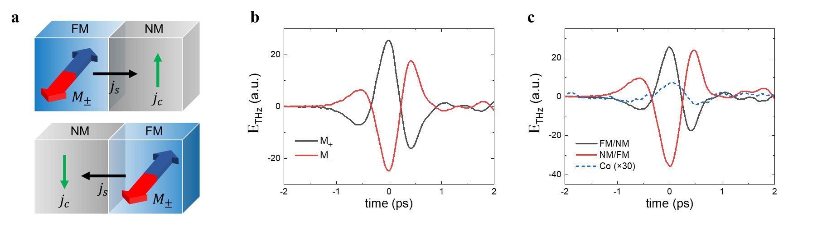Figure S1| a, Spin current direction depending on sample geometry (FM|NM and NM|FM). b, THz emission dependence on magnetization and c, sample geometry in a Co/Pt bilayer (solid lines), compared to the THz emission from a single Co layer (dashed lines).

Note 2. Time-dependent change of THz spectrum
We performed double-pump THz emission spectroscopy on a TbCo/Pt bilayer (Fig. S2a). The THz electric fields generated by 400-nm and 1500-nm laser pulses were directed using a pair of off-axis parabolic mirrors and detected via electro-optic sampling in a ZnTe crystal with 800-nm probe pulses. In addition to the superposition of the original THz fields generated by each laser pulse ($E_{0}^{400 nm}$, $E_{0}^{1500 nm}$), an additional contribution arising from magnetization change ∆M can alter the THz field dynamics. We measured these changes in the THz electric field while varying the time delay $∆t$ between the two laser pulses (Fig. S2b).
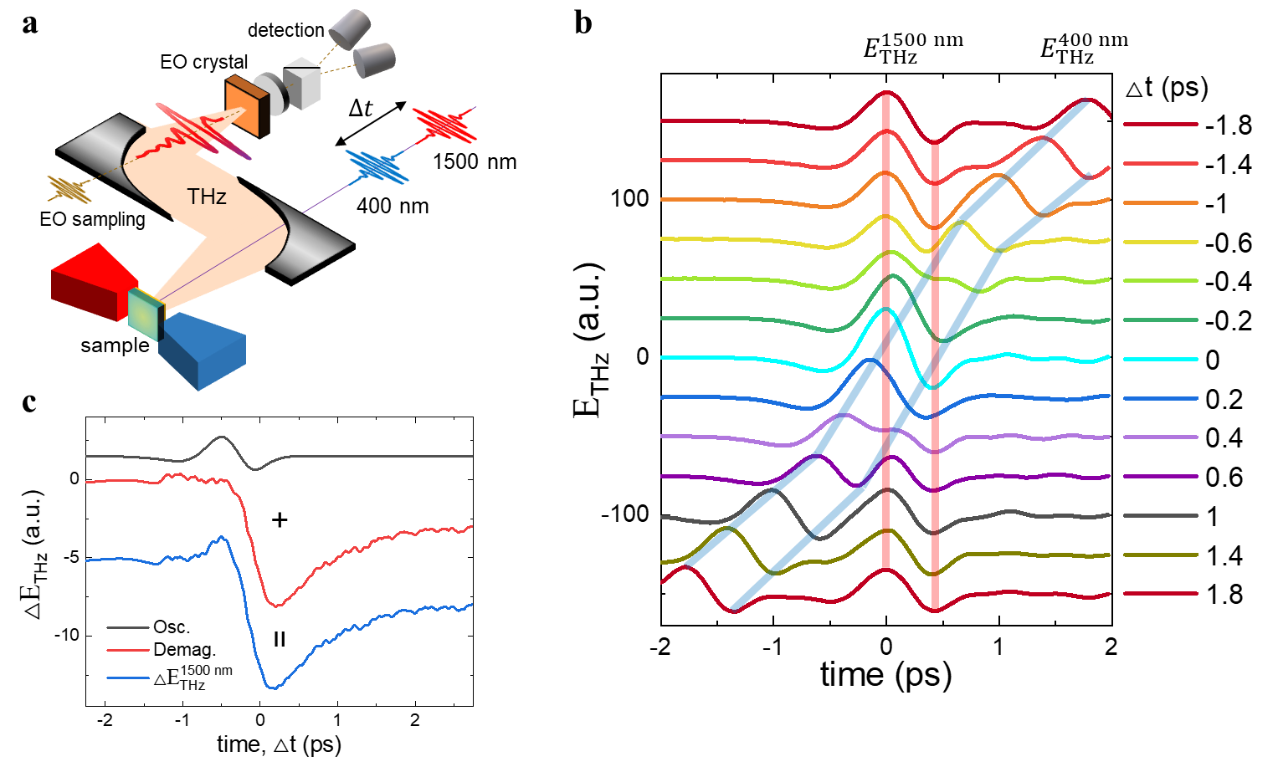Figure S2| a, Schematic diagram of double-pump THz emission spectroscopy. b, THz fields generated by 400-nm and 1500-nm laser pulses, measured as a function of the time delay between the two pulses. c, Transient amplitude change of the THz field induced by the 1500-nm laser $E_{THz}^{1500 nm}$ (blue). Following Ref. [3], oscillation (black) and demagnetization-related (red) components of $E_{THz}^{1500 nm}$ are distinguished.
In Figure S2b, the amplitude change of the THz field induced by the 1500-nm laser $E_{THz}^{1500 nm}$, highlighted by the red line, indicates the magnetization change caused by the preceding 400-nm laser pulse. The THz amplitude change $∆E_{THz}^{1500 nm}$ was obtained by subtracting the initial THz field $E_{0}^{1500 nm}$ from $E_{THz}^{1500 nm}$. As shown in Fig. S2c, $∆E_{THz}^{1500 nm}$ consists of a sub-picosecond oscillation during the overlap of the two laser pulses and a subsequent decrease in THz amplitude due to demagnetization. Following Ref. [3], we distinguish between the initial oscillatory component and the demagnetization signals.
Additionally, the THz spectrum change of $∆E_{THz}^{1500 nm}$ reveals significant changes throughout the laser-induced processes. During the initial oscillation of the THz amplitude, the spectrum undergoes modification, with part of the THz signal shifting to higher frequencies (Fig. S3a). Subsequently, the entire THz spectrum decreases in amplitude during demagnetization (Fig. S3b). Once the two laser pulses are separated (∆t > 0.2 ps), the THz spectrum regains its original shape, with only a reduction in magnitude due to demagnetization (Fig. S3c).
The origin of THz frequency shift during the initial oscillation (Fig. S3a) remains unclear. It could result from a spin current $j_{s}$ or from laser-induced changes in the spin Hall angle $γ$ within the NM layer. If it is a spin-related phenomenon, this would suggest the population of nonequilibrium angular momentum transfer during the initial laser excitation. Alternatively, if it is carrier-related, it would imply that laser-induced changes in the conductivity of the NM layer modify the charge current $j_{c}$ independently of spin effects.
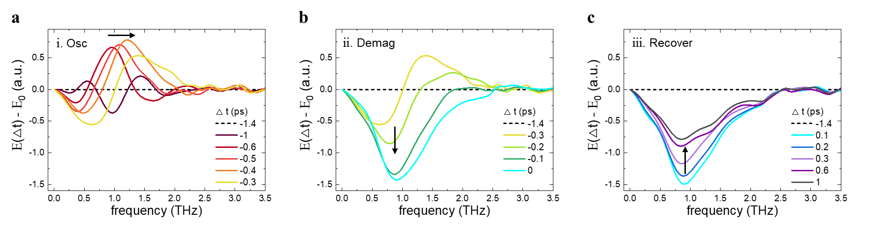Figure S3| THz spectral changes ($∆E_{THz}^{1500 nm}$) during a, sub-picosecond oscillation of the THz amplitude, b, demagnetization, and c, magnetization recovery.

Note 3. Probe wavelength-dependence in THz emission spectroscopy
It is important to note that the wavelength of the second laser pulse, used to probe the magnetization change ∆M, does not affect the $∆E_{THz}$ dynamics. By fixing the wavelength of the first pump pulse and varying that of the second laser pulse, we confirmed that the $∆E_{THz}$ dynamics, normalized by the original THz amplitude $E_{0}$, remain consistent (Fig. S4a). The THz field generated by the spin current is not expected to reflect variations in spin polarization at different binding energy levels and, consequently, at different probe wavelengths. Additionally, we verified that all signals obtained in the double-pulse pumped THz emission measurements depend on the initial magnetization $M_{\left(+,-\right)}$ of the FM layer (Fig. S4b), confirming that $∆E_{THz}$ originates from ∆M.
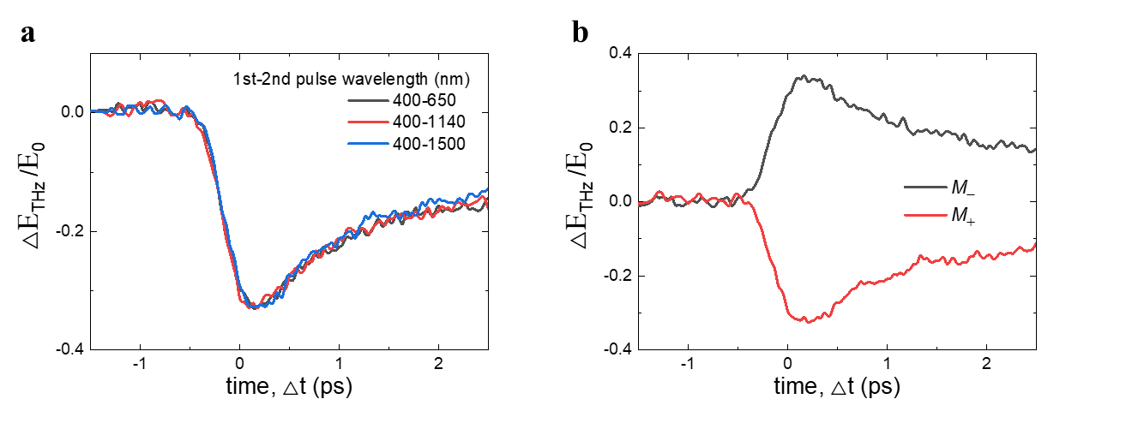
Figure S4| Effects of a, second laser wavelength and b, initial magnetization direction $M_{\left(+,-\right)}$ on $∆E_{THz}$ of TbCo/Pt.

Note 4. Magnetic resonance of TbCo/Pt and Co/Pt
The THz field generated via ISHE $E_{THz}^{y}$ ($∝j_{s}^{z}×M/{\left|M\right|}$) reflects magnetization parallel to the x-axis $M^{x}$. When the initial magnetization is aligned along the x-axis, the magnetic resonance, i.e., the spin component rotating around the x-axis, lies in the yz-plane $∆M^{yz}$ and therefore cannot be measured by $E_{THz}^{y}$. However, by applying an external magnetic field $B^{xz}$ at an angle $θ$ tilted from the x-axis, the initial magnetization is reoriented into the xz-plane. This reorientation allows the magnetic resonance to move out of the yz-plane and become measurable by $E_{THz}^{y}$ (Fig. S5a).
Figure S5b shows the magnetic resonance of TbCo/Pt measured using double-pump THz emission spectroscopy at different external magnetic field angles. A clear spin precession signal with a frequency of ~160 GHz was observed when the magnetic field was applied at an angle of $θ$ = 10° from the x-axis. A similar measurement on Co/Pt, shown in Fig. S5c, reveals a much slower spin precession with a frequency of ~18 GHz.
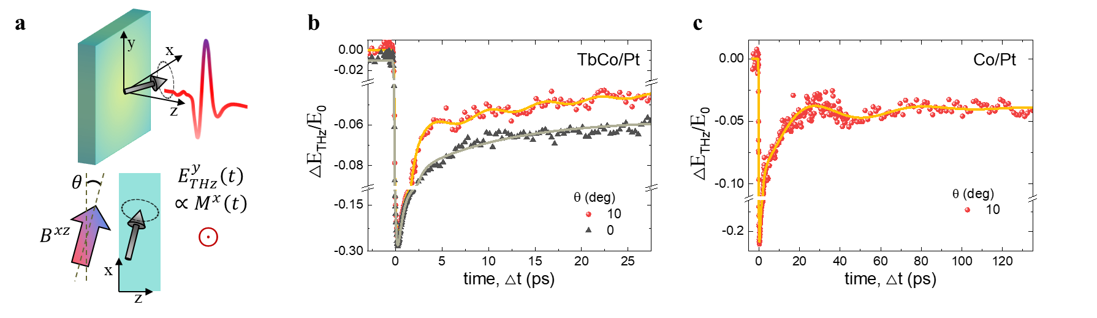
Figure S5| a, Schematic diagram of magnetic resonance analysis using THz emission spectroscopy with tilted initial magnetization. b, Spin precession of TbCo/Pt and c, Co/Pt excited by 400-nm pump and measured using 1500-nm laser-induced THz field at different magnetic field angles.

References
[1] E. Saitoh, M. Ueda, H. Miyajima, G. Tatara, Conversion of spin current into charge current at room temperature: Inverse spin-Hall effect, Appl Phys Lett, 88, 182509 (2006).
[2] S.O. Valenzuela, M. Tinkham, Direct electronic measurement of the spin Hall effect, Nature, 442, 176-179 (2006).
[3] B. Wang, S.Y. Shan, X.J. Wu, C. Wang, C. Pandey, T.X. Nie, W.S. Zhao, Y.T. Li, J.G. Miao, L. Wang, Picosecond nonlinear spintronic dynamics investigated by terahertz emission spectroscopy, Appl Phys Lett, 115, 121104 (2019).

