Supporting Information
Colored Polymer-reinforced Metal-organic Framework Microparticles with High Charge-to-mass Ratio for Electrophoretic Display
Jiamin Cheng^{1, 2}, Mian Qin^{1, 2}, Wenhao Wang^{1, 2}, Jingxing Zhang^{1, 2, 3}, Yao Wang^{1, 2}, Hao Li^{1, 2, *}, and Guofu Zhou^{1, 2, *}
¹Guangdong Provincial Key Laboratory of Optical Information Materials and Technology & Institute of Electronic Paper Displays, South China Academy of Advanced Optoelectronics, South China Normal University, Guangzhou 510006, China
²National Center for International Research on Green Optoelectronics, South China Normal University, Guangzhou 510006, China
³Faculty of Materials Science and Engineering/Institute of Technology for Carbon Neutrality, Shenzhen Institute of Advanced Technology, Chinese Academy of Sciences, Shenzhen, Guangdong, 518055, China

*Corresponding should be addressed to:
Associate Professor Hao Li; Tel: +86-20-39314813; Fax: +86-20-39314813
E-mail: haoli@m.scnu.edu.cn
Professor Guofu Zhou; Tel: +86-20-39314813; Fax: +86-20-39314813
E-mail: guofu.zhou@m.scnu.edu.cn

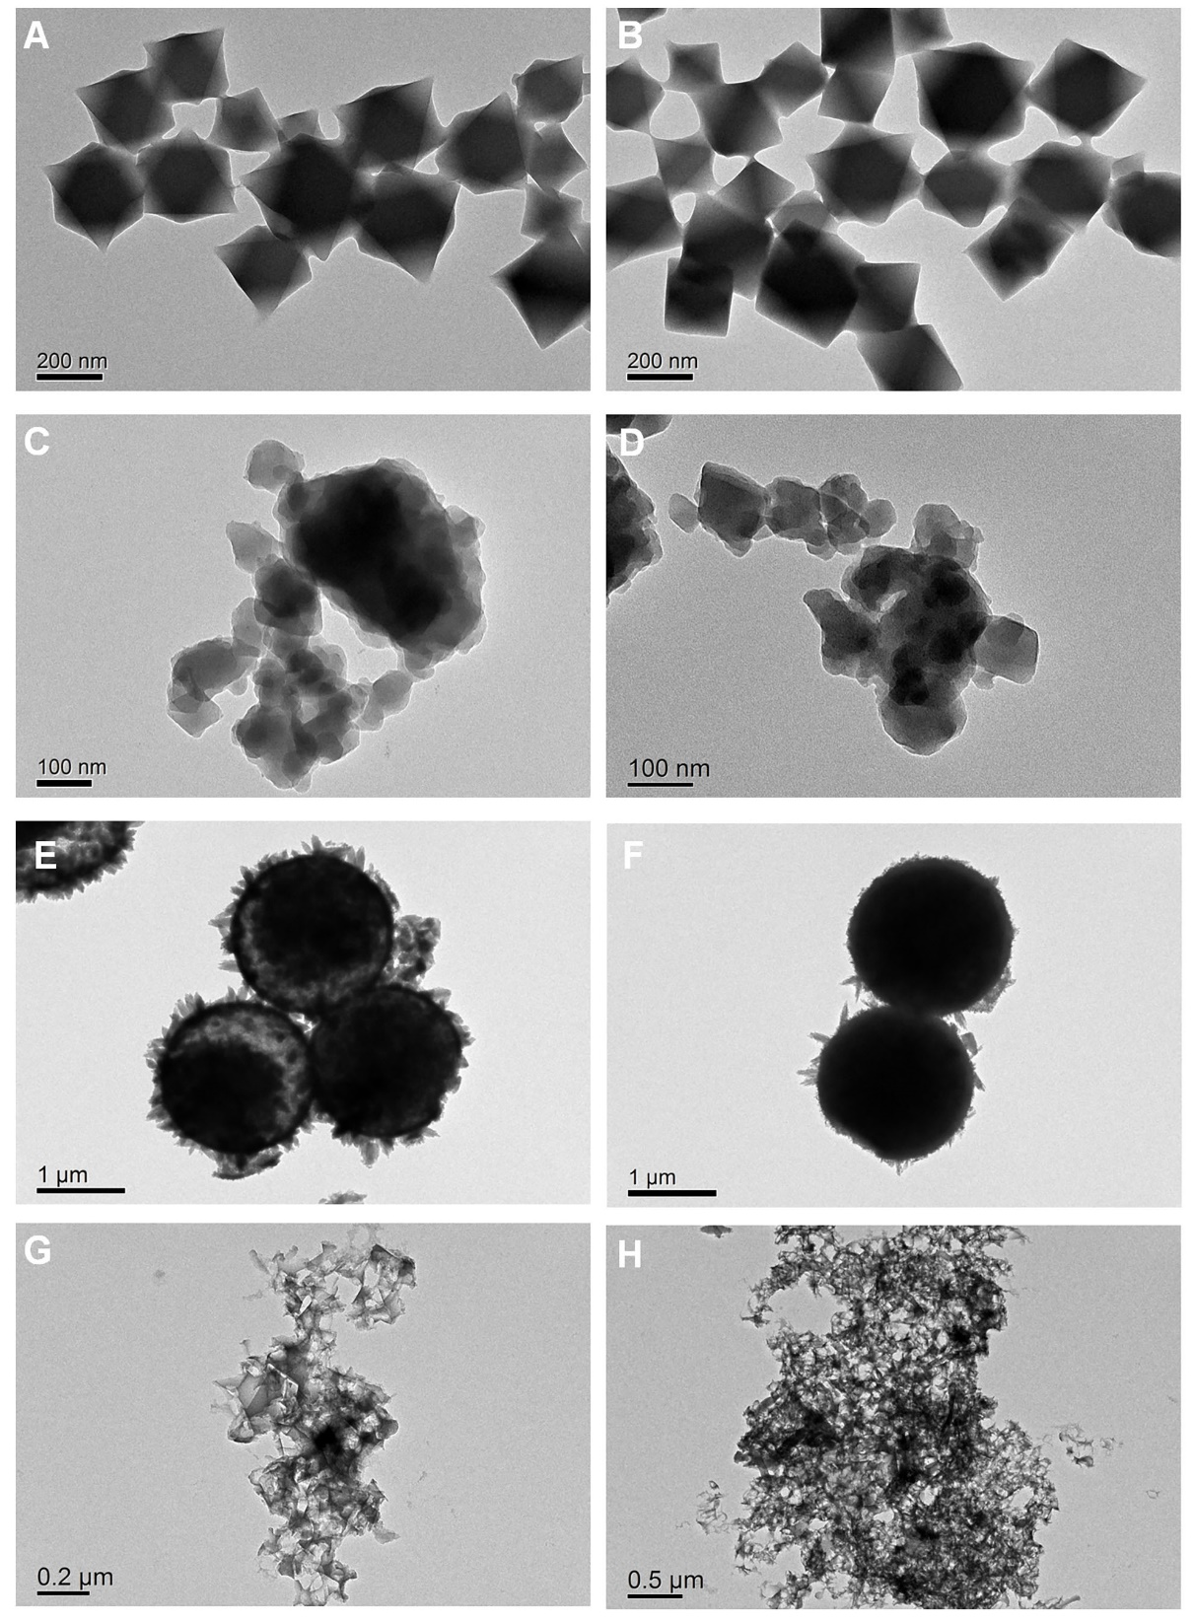
Figure S1. TEM images of the resulting Cu-BTC (A) & Cu-BTC-PEI (B), Fe-BTC (C) & Fe-BTC-PEI (D), Ni-BTC (E) & Ni-BTC-PEI (F), and Co-BTC (G) & Co-BTC-PEI microparticles (H).

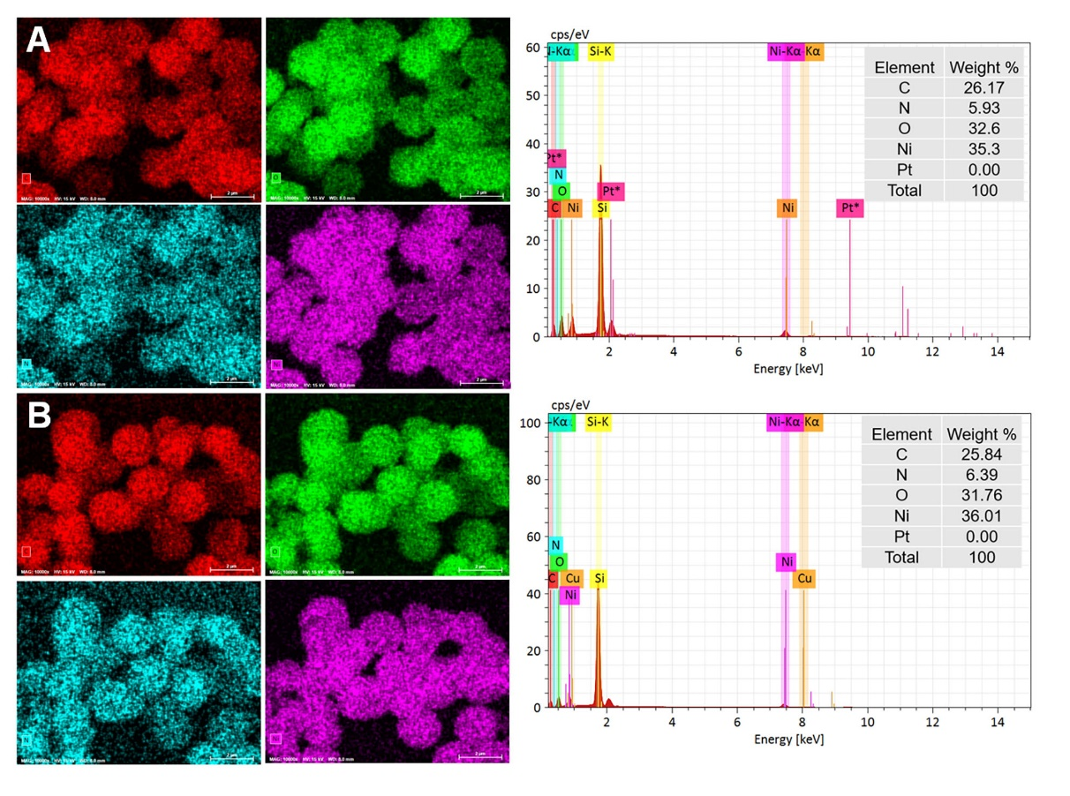
Figure S2. EDS elemental maps of the crude Ni-BTC (A) and the reinforced Ni-BTC-PEI microparticles (B).

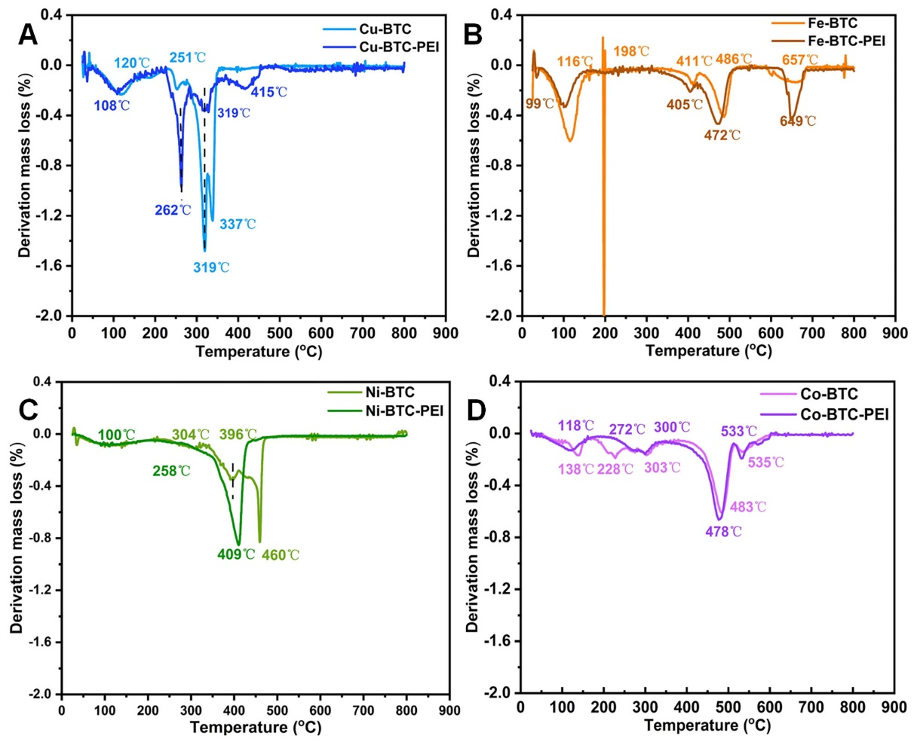
Figure S3. DTG curves for the resulting Cu-BTC & Cu-BTC-PEI (A), Fe-BTC & Fe-BTC-PEI (B), Ni-BTC & Ni-BTC-PEI (C), and Co-BTC & Co-BTC-PEI microparticles (D).

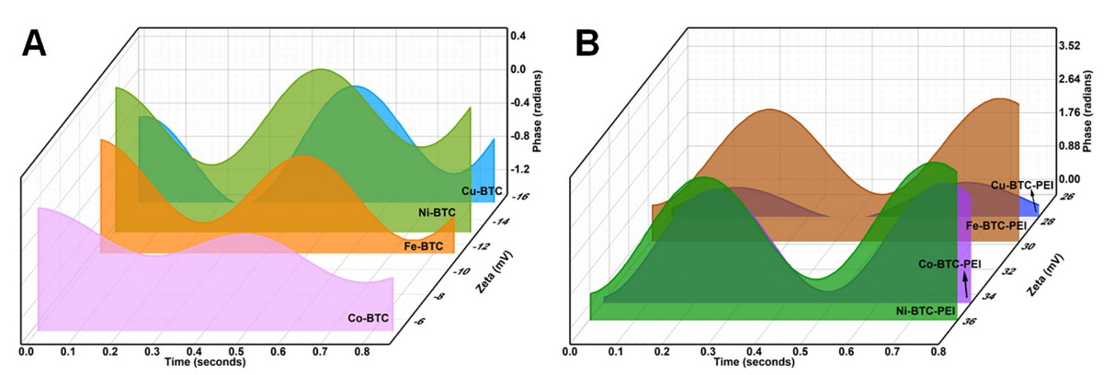
Figure S4. Zeta potential phase diagrams of the resulting M-BTC (A) and M-BTC-PEI microparticles (B)

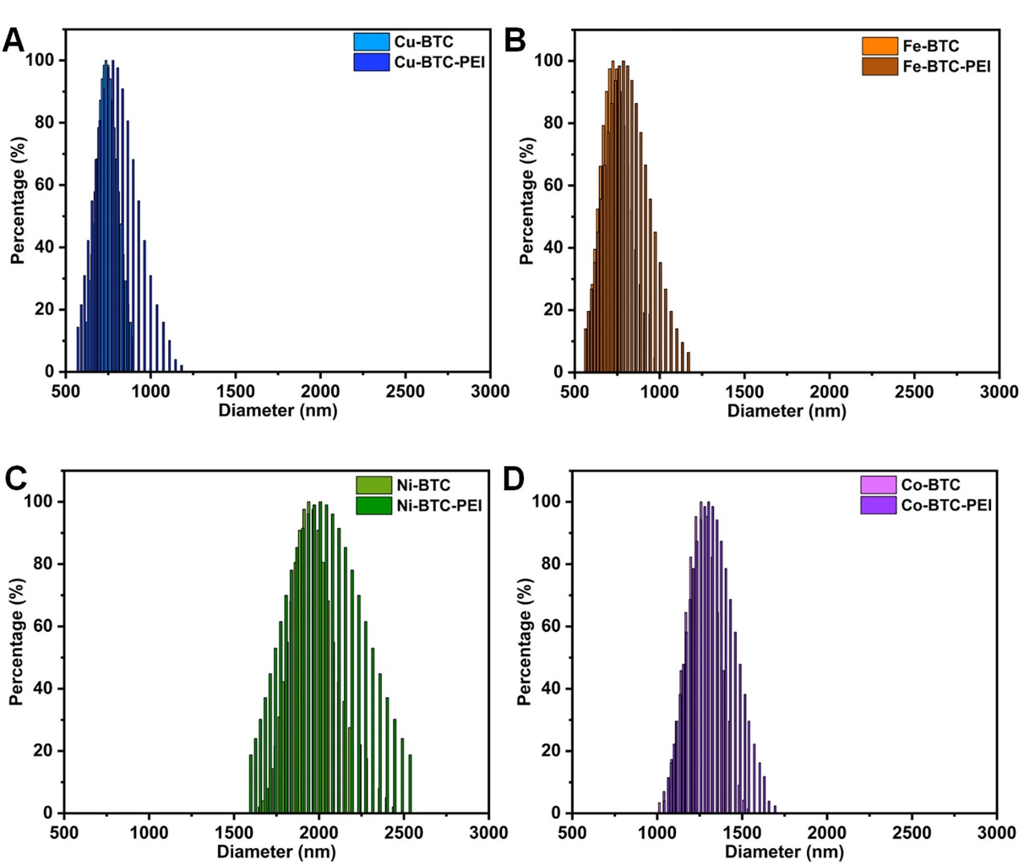
Figure S5. Particle size distributions of the resulting Cu-BTC & Cu-BTC-PEI (A), Fe-BTC & Fe-BTC-PEI (B), Ni-BTC & Ni-BTC-PEI (C), and Co-BTC & Co-BTC-PEI microparticles (D).

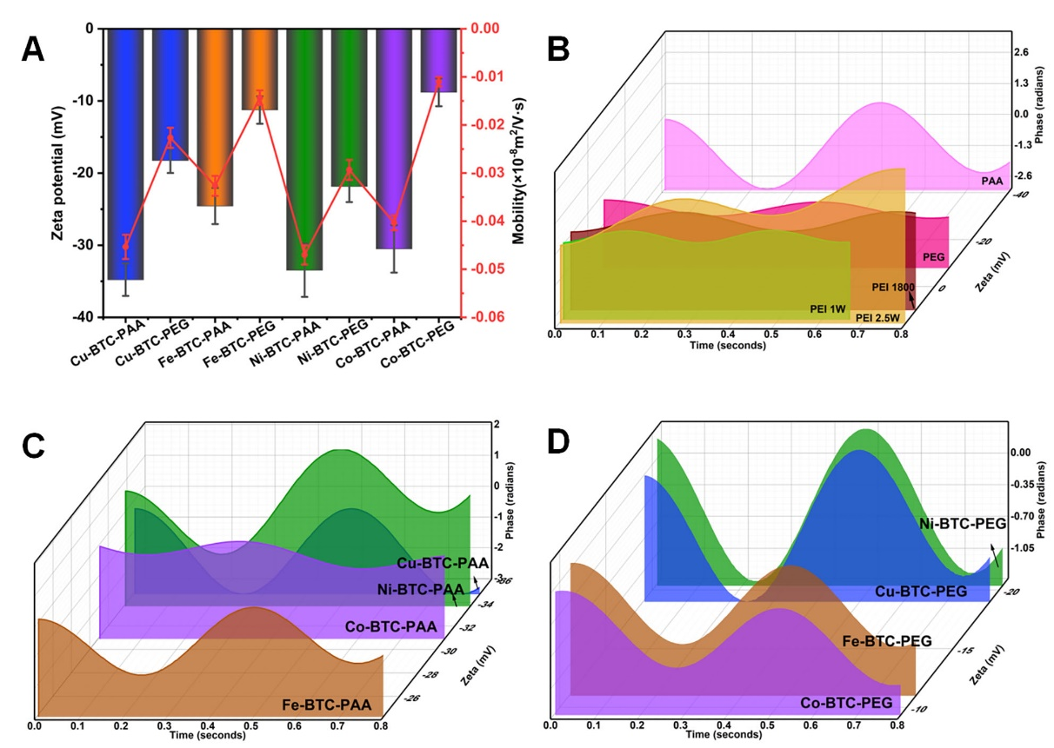
Figure S6. Zeta potentials and electrophoretic mobilities of the resulting M-BTC-PEG & M-BTC-PAA microparticles (A), and Zeta potential phase diagrams of the used polymers for reinforcing MOF microparticles (B), the resulting M-BTC-PAA (C) and M-BTC-PEG microparticles (D).

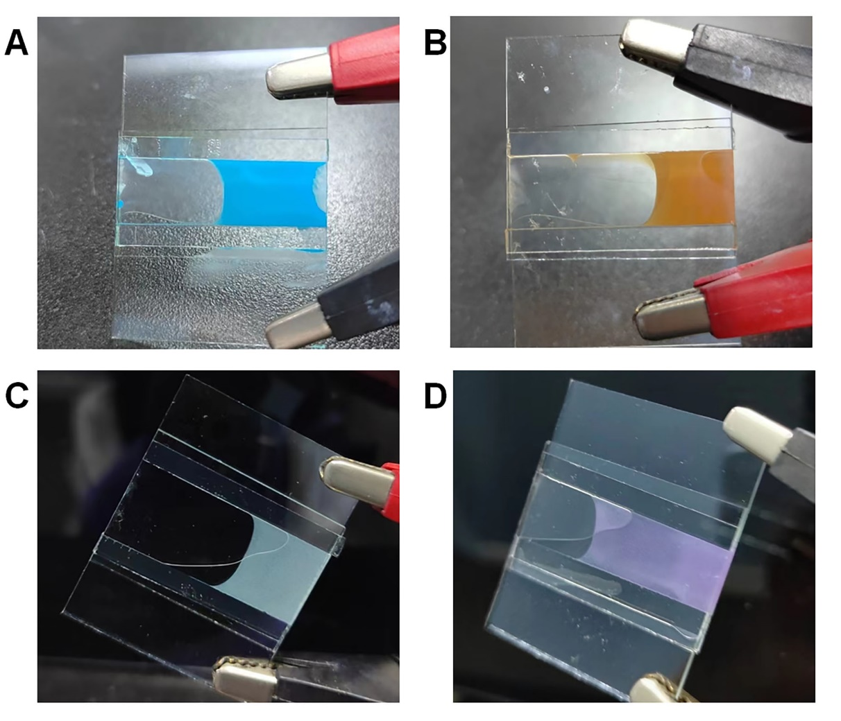
Figure S7. Single particle electrophoresis images of the resulting Cu-BTC-PEI (A), Fe-BTC-PEI (B), Ni-BTC-PEI (C), and Co-BTC-PEI microparticles (D) in the PIBSA-contained isododecane solution inside the predetermined electrophoresis tank with the settled spacing of 100 μm at a driving DC voltage of ±20 V.

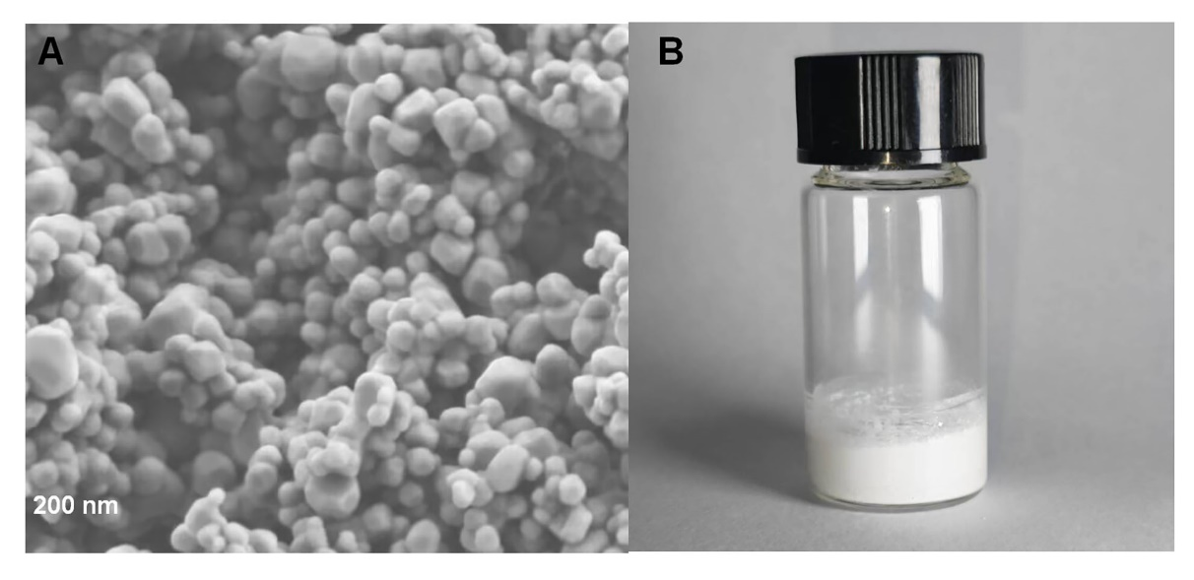
Figure S8. SEM (A) and real object image (B) of the modified white TiO₂ nanoparticles

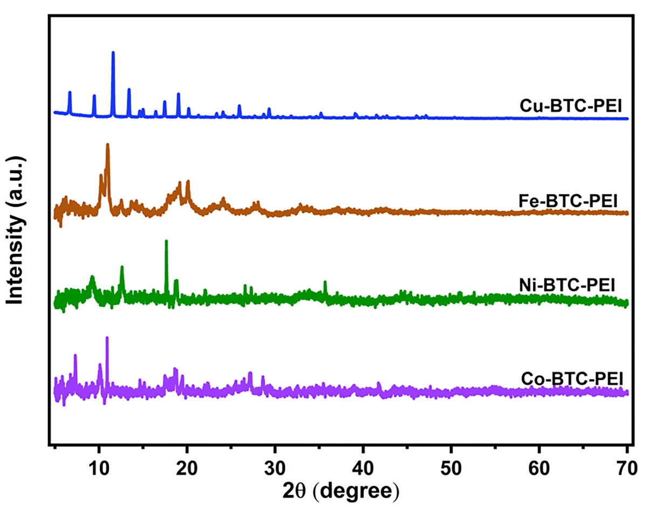
Figure S9. XRD patterns of the PEI-reinforced MOF microparticles inside the predetermined electrophoresis tank with the settled spacing of 100 μm at a driving DC voltage of ±20 V after continuous power (Time>1 hour).

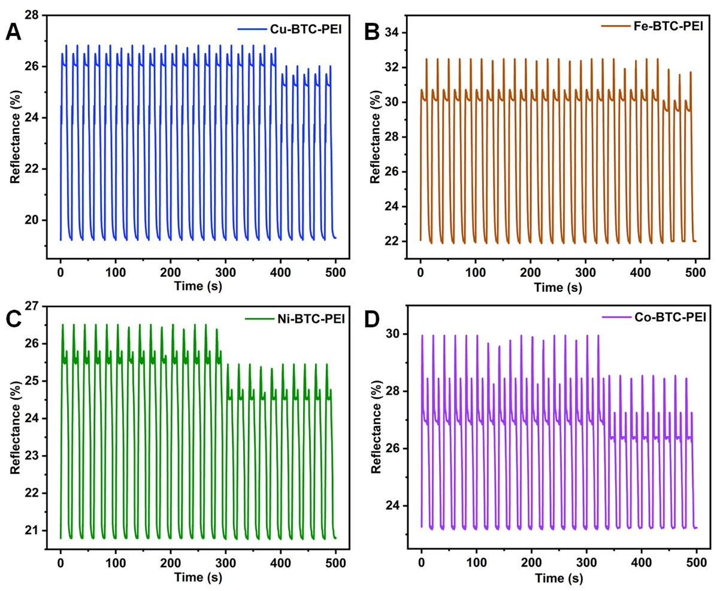
Figure S10. Cycling stabilities of the resulting Cu-BTC-PEI (A), Fe-BTC-PEI (B), Ni-BTC-PEI (C), and Co-BTC-PEI microparticles (D) in the PIBSA-contained isododecane solution inside the predetermined electrophoresis tank with the settled spacing of 100 μm at a driving DC voltage of ±20 V.

Table S1. Zeta potentials and DLS results of the crude and modified white TiO₂ nanoparticles.
Particle | Zeta potential  (mV) | Mobility  (*10⁻⁸ m²/(V·s)) | Diameter  (nm) | Polydispersity
Crude TiO₂ | 25.06±2.39 | 0.0183±0.0017 | 201.57±1.05 | 0.080±0.036
Modified TiO₂ | 60.83±5.15 | 0.0446±0.0037 | 214.41±3.05 | 0.156±0.052

Video S1. Two-color electrophoresis display video of the modified white TiO₂ nanoparticles and the reinforced Cu-BTC-PEI microparticles packaged in the predetermined electrophoresis tank with the settled spacing of 100 μm at a driving DC voltage of ±20 V (see the attached video file named “Video S1”).

Video S2. Two-color electrophoresis display video of the modified white TiO₂ nanoparticles and the reinforced Fe-BTC-PEI microparticles packaged in the predetermined electrophoresis tank with the settled spacing of 100 μm at a driving DC voltage of ±20 V (see the attached video file named “Video S2”).

Video S3. Two-color electrophoresis display video of the modified white TiO₂ nanoparticles and the reinforced Ni-BTC-PEI microparticles packaged in the predetermined electrophoresis tank with the settled spacing of 100 μm at a driving DC voltage of ±20 V (see the attached video file named “Video S3”).

Video S4. Two-color electrophoresis display video of the modified white TiO₂ nanoparticles and the reinforced Co-BTC-PEI microparticles packaged in the predetermined electrophoresis tank with the settled spacing of 100 μm at a driving DC voltage of ±20 V (see the attached video file named “Video S4”).

