Funding 1. The Jilin Province Science and Technology Development Plan Project (Grant No. 232662SF0103109942)
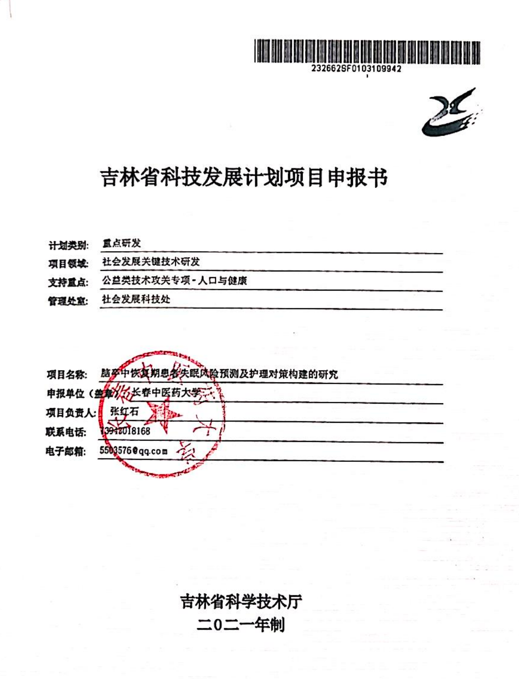

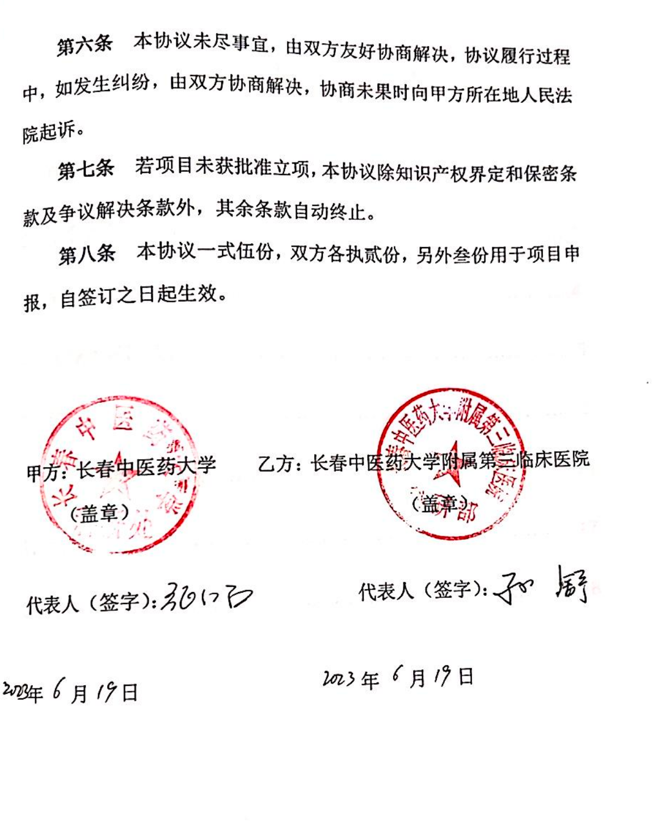

Funding 2. The National Natural Science Foundation of China (Grant No. 82074569)
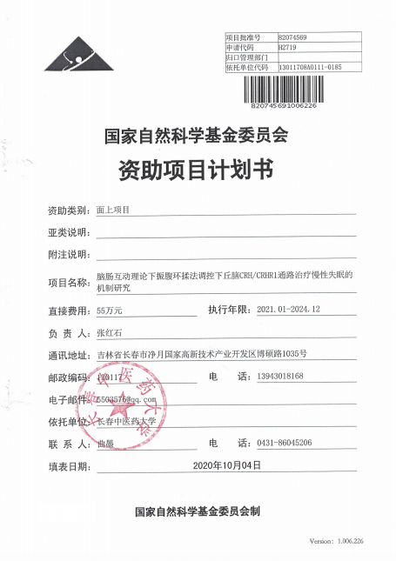

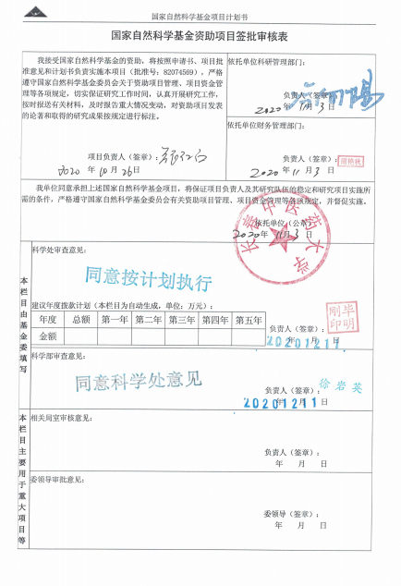

Funding 3. The National Key R & D Program of China (Grant No. 2018YFC1706002)
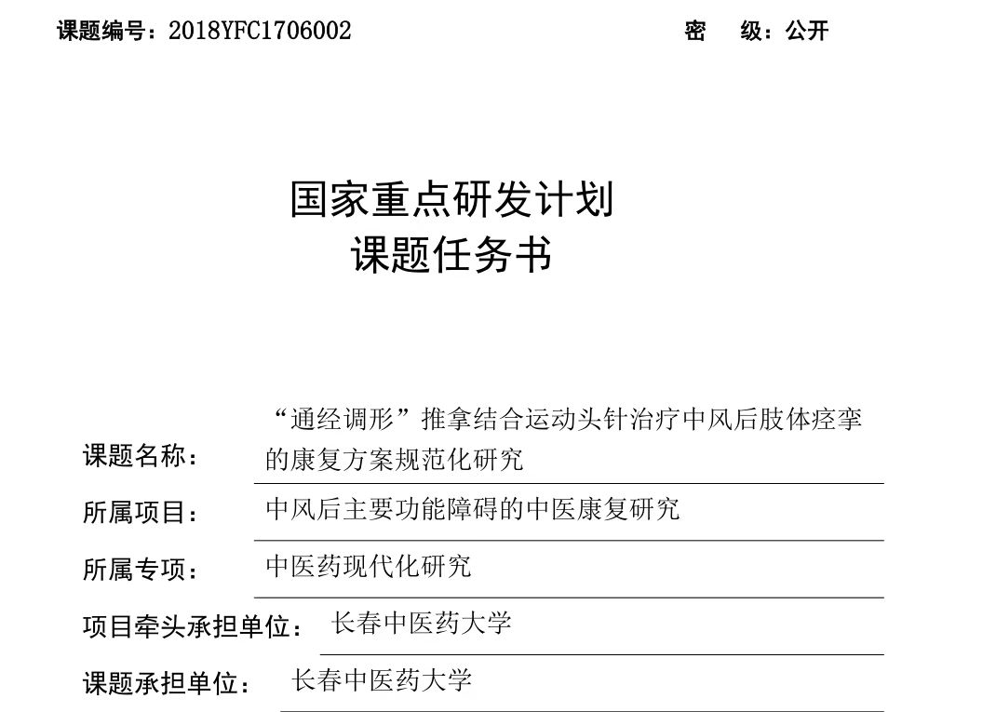

Ethical approval

