Table 1. Baseline characteristics of enrolled patients in the entire cohort.
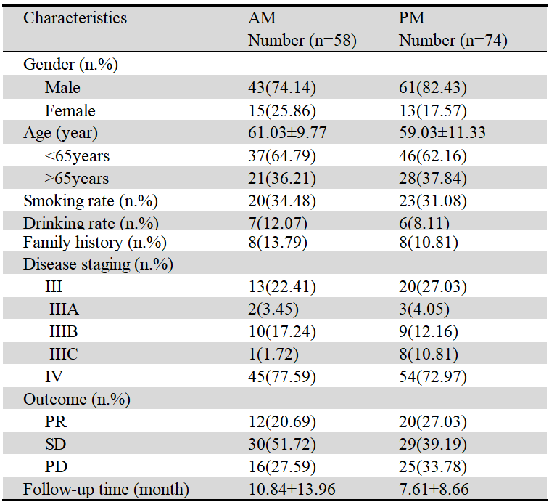

Table 2. Subgroup analysis of NSCLC patients between the AM group and PM groups.
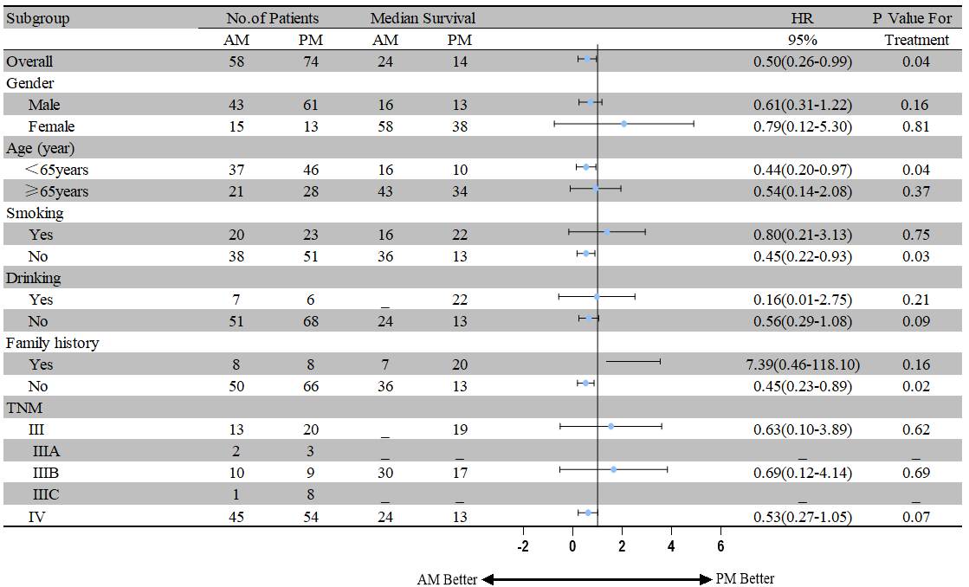
Table 3. Risk factors for progression-free survival based on univariate and multivariate analysis
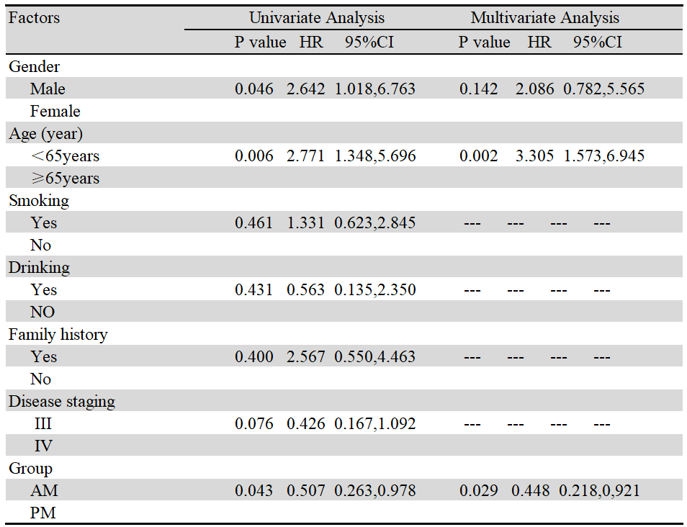

Table 4. Treatment-related adverse events
