Figure S1. Sensitivity analysis on BCVA as the outcome
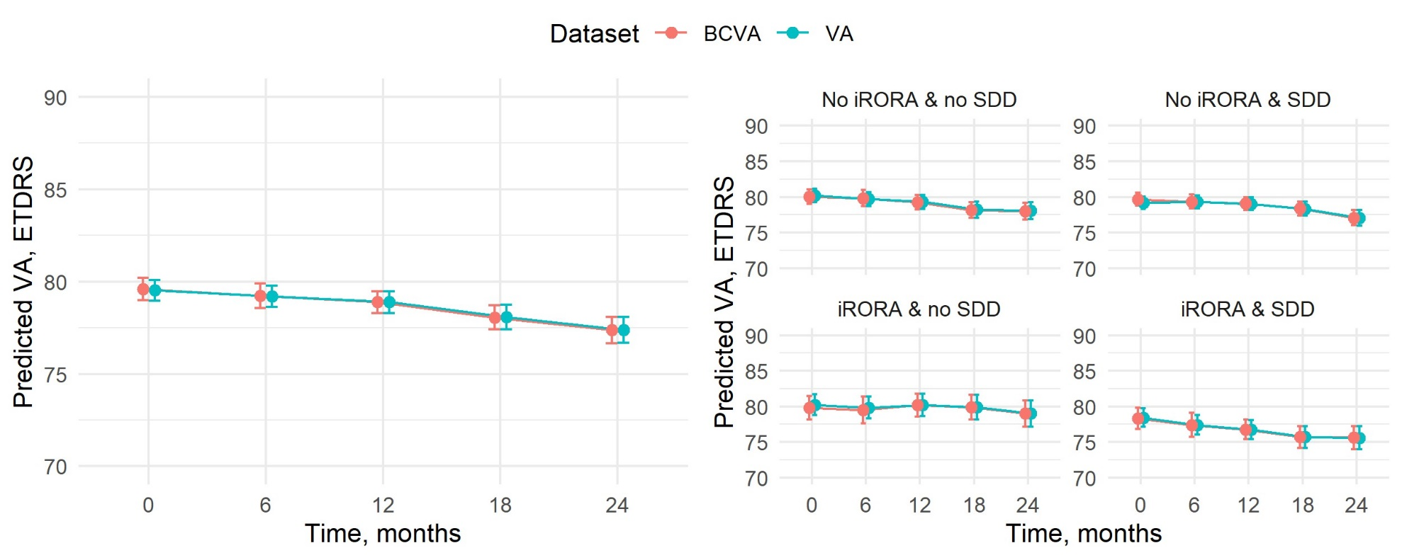
Abbreviations: Abbreviations: iAMD-intermediate age-related macular degeneration; iRORA- incomplete retinal and retinal pigment epithelial atrophy; SDD-subretinal drusenoid deposits; ETDRS-Early treatment Diabetic Retinopathy Study; BCVA-best corrected visual acuity; VA-visual acuity

