Supplementary materials S1. Water chemistry variability in space and time
Mean, range, and standard deviation of Dissolved Inorganic Nitrogen, Phosphate, N:P Ratio, and Total Suspended Solids in each watershed.

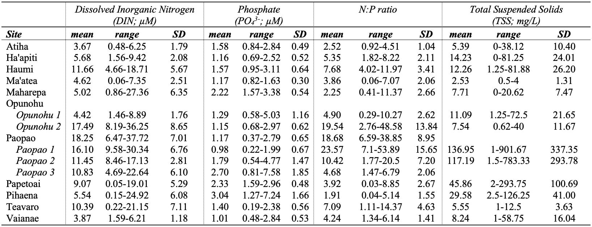

Supplementary materials S2. Results from ANOVA of river chemistry
ANOVA summaries for linear models of each major water chemistry parameter as a function of season, watershed (site), and their interaction. Water chemistry parameters as follows: Dissolved Inorganic Nitrogen (DIN), Nitrite (NO2⁻), Nitrate (NO3⁻), Ammonium (NH4⁺), Phosphate (PO₄³⁻), and Total Suspended Solids (TSS).

Response | Term | Df | Sum Sq | Mean Sq | F value | p
DIN | Season | 1 | 1.08 | 1.08 | 4.86 | 0.029 | *
 | Site | 13 | 55.25 | 4.25 | 19.14 | 0 | ***
 | Season:Site | 13 | 7.77 | 0.6 | 2.69 | 0.002 | **
 | Residuals | 157 | 34.86 | 0.22
NO₂⁻ | Season | 1 | 0 | 0 | 0.36 | 0.548
 | Site | 13 | 3.32 | 0.26 | 19.21 | 0 | ***
 | Season:Site | 13 | 0.43 | 0.03 | 2.51 | 0.004 | **
 | Residuals | 156 | 2.08 | 0.01
NO₃⁻ | Season | 1 | 0.84 | 0.84 | 3.88 | 0.051 | .
 | Site | 13 | 53.58 | 4.12 | 19.05 | 0 | ***
 | Season:Site | 13 | 8.56 | 0.66 | 3.04 | 0.001 | ***
 | Residuals | 156 | 33.74 | 0.22
NH₄⁺ | Season | 1 | 0.12 | 0.12 | 1.38 | 0.241
 | Site | 13 | 10.33 | 0.79 | 9.12 | 0 | ***
 | Season:Site | 13 | 1.91 | 0.15 | 1.69 | 0.068 | .
 | Residuals | 163 | 14.2 | 0.09
PO₄³⁻ | Season | 1 | 0.31 | 0.31 | 5.07 | 0.026 | *
 | Site | 13 | 5.98 | 0.46 | 7.44 | 0 | ***
 | Season:Site | 13 | 1.87 | 0.14 | 2.33 | 0.007 | **
 | Residuals | 156 | 9.65 | 0.06
TSS | Season | 1 | 12.53 | 12.53 | 10.49 | 0.002 | **
 | Site | 11 | 19.75 | 1.8 | 1.5 | 0.144
 | Season:Site | 11 | 17.18 | 1.56 | 1.31 | 0.233
 | Residuals | 93 | 111.1 | 1.19

