Additional file 1

COVID-19 vaccination program in China: a subnational descriptive analysis on target population size and current progress

Wen Zheng¹, Xuemei Yan¹, Zeyao Zhao¹, Juan Yang^{1,2*}, Hongjie Yu^{1,2,3*}

*These authors jointly supervised this work.
*Correspondence: Juan Yang, yangjuan@fudan.edu.cn; Hongjie Yu, yhj@fudan.edu.cn

Author details
1. Shanghai Institute of Infectious Disease and Biosecurity, School of Public Health, Fudan University, Shanghai, China
2. Fudan University, Key Laboratory of Public Health Safety, Ministry of Education, Shanghai, China
3. Department of Infectious Diseases, Huashan Hospital, Fudan University, Shanghai, China

Additional file 1
Table S1. Definitions of priority target groups for COVID-19 vaccination program 3
Table S2. The size of each target population for COVID-19 vaccination program in provinces 9
Table S3. The size of target population for COVID-19 vaccination program by vaccination goals 12
Figure S1. Three geographic regions of mainland China. 13
Figure S2. The size of ten priority groups for COVID-19 vaccination program in provinces, descending by the total population. 13
Figure S3. Scatter plots between the size of target population groups and the total population. A: Target population vs. total population. B: Target population for goal 1 vs. total population. C: Target population for goal 2 vs. total population. D: Target population for goal 3 vs. total population. 13
Figure S4. Based on the average capacity after mid-April 2021, service capacity gaps to vaccinate 70% of the target population by the end of 2021 or by mid-2022. A: The average capacity and service gaps by the end of 2021. B: The average capacity and service gaps by mid-2022. 14
References 15

Table S1. Definitions of priority target groups for the COVID-19 vaccination program
Goal | Tier | Subgroups | Target population | Definition | Data source
1 | 1 | 1 | Healthcare workers | Individuals working at hospitals, community medical institutions, and in the public health system. | The number comes from the China Economic Census Yearbook 2018[1];  The age structure comes from the tabulation of the 2010 Population Census of the People's Republic of China[2].
1 | 2 | 2 | Social security workers | Police officers and the People's Armed Police Force. Even though the People's Liberation Army plays an important role in responding to the epidemic in China, we excluded them here since they are under the direct leadership of the Central Military Commission, which does not involve the allocation of vaccines at the provincial level. | The number of police officers comes from a paper book and master’s thesis [3, 4]; the number of the People's Armed Police Force comes from the White Paper on China’s National Defense [5];  The age structure comes from the tabulation of the 2010 Population Census of the People's Republic of China[2].
1 | 2 | 2 | Personnel in social welfare institutions | Caregivers in aged organizations and social welfare hospitals. | The number comes from the China Civil Affairs Statistical Yearbook 2019;  The age structure comes from the tabulation of the 2010 Population Census of the People's Republic of China[2].
1 | 2 | 2 | Community network workers | Individuals working at urban and rural community services. | The number comes from the China Economic Census Yearbook 2018[1];  The age structure comes from the tabulation of the 2010 Population Census of the People's Republic of China[2].
1 | 2 | 2 | Personnel in sectors producing and supplying daily necessities like energy, water and transportation | Staff in the agricultural and sideline food processing industry, food manufacturing industry, retailers (i.e., grocery stores, convenience stores, supermarkets, large super markets); personnel in the production and supply of electricity, heat, gas and water industry; and staff in transportation, storage and postal services (i.e., road and water transportation, air transport industry, pipeline transportation, multimodal transport and transport agency industry, handling and warehousing industry, and express industry). | The number comes from the China Economic Census Yearbook 2018[1];  The age structure comes from the tabulation of the 2010 Population Census of the People's Republic of China[2].
1 | 2 | 2 | Those studying/working abroad | Individuals studying or working abroad. | The number comes from the Ministry of Education of the People's Republic of China [6] and the Ministry of Commerce of the People's Republic of China [7];  The proportion of individuals studying or working abroad by province comes from paper books [8];  The age structure of those studying abroad comes from a paper book [8]; the age structure of those working abroad comes from the Statistical Yearbook 2020 of provinces[2, 9-29].
2 | 3 | 3 | Older adults ≥ 60 years with underlying conditions | Individuals aged 60 or over with underlying conditions, which are on the basis of Clark’s report, and we added a body mass index ≥30. [30] | The number of the permanent population comes from the China Statistical Yearbook 2020 [31] and the Statistical Yearbook 2020 of provinces[2, 9-29];  The number of permanent populations comes from the China Statistical Yearbook 2020[31];  The age structure comes from the Statistical Yearbook 2020 of provinces[2, 9-29];  The prevalence of each underlying condition by age group comes from the Global Burden of Diseases, Risk Factors, and Injuries Study (GBD)[32];  The ratio of the probability of having ≥1 underlying chronic disease in persons among three geographic areas (east, central and west) in China comes from An Analysis Report of National Health Services Survey in China, 2013 [33].
2 | 3 | 4 | Older adults ≥ 80 years without underlying conditions | Individuals aged 80 or over without any underlying condition. | The number of the permanent population comes from the China Statistical Yearbook 2020 [31] and the Statistical Yearbook 2020 of provinces[2, 9-29];  The number of permanent populations comes from the China Statistical Yearbook 2020[31];  The age structure comes from the Statistical Yearbook 2020 of provinces[2, 9-29];  The prevalence of each underlying condition by age group comes from the Global Burden of Diseases, Risk Factors, and Injuries Study (GBD)[32];  The ratio of the probability of having ≥1 underlying chronic disease in persons among three geographic areas (east, central and west) in China comes from An Analysis Report of National Health Services Survey in China, 2013 [33]
2 | 4 | 5 | Older adults aged 60-79 years without underlying conditions | Individuals aged 60-79 without any underlying condition. | The number of the permanent population comes from the China Statistical Yearbook 2020 [31] and the Statistical Yearbook 2020 of provinces[2, 9-29];  The number of permanent populations comes from the China Statistical Yearbook 2020[31];  The age structure comes from the Statistical Yearbook 2020 of provinces[2, 9-29];  The prevalence of each underlying condition by age group comes from the Global Burden of Diseases, Risk Factors, and Injuries Study (GBD)[32];  The ratio of the probability of having ≥1 underlying chronic disease in persons among three geographic areas (east, central and west) in China comes from An Analysis Report of National Health Services Survey in China, 2013 [33]
2 | 4 | 6 | Individuals <60 years with underlying conditions | Individuals aged 0-59 with underlying conditions. | The number of the permanent population comes from the China Statistical Yearbook 2020 [31] and the Statistical Yearbook 2020 of provinces[2, 9-29];  The number of permanent populations comes from the China Statistical Yearbook 2020[31];  The age structure comes from the Statistical Yearbook 2020 of provinces[2, 9-29];  The prevalence of each underlying condition by age group comes from the Global Burden of Diseases, Risk Factors, and Injuries Study (GBD)[32];  The ratio of the probability of having ≥1 underlying chronic disease in persons among three geographic areas (east, central and west) in China comes from An Analysis Report of National Health Services Survey in China, 2013 [33]
2 | 4 | 7 | Pregnant women | The sum of live births, abortions, still births and fetus deaths in one year. | The number of live births, induced abortions and the rate of perinatal deaths by province comes from the China Health Statistical Yearbook in 2020;  The age structure of childbearing women giving birth by province comes from the China Population & Employment Statistics Yearbook 2020[34];  The proportion of induced abortion proportion, still births and fetus deaths comes from previous literature [35, 36].
3 | 5 | 8 | Adults aged 18-59 years without underlying conditions | Individuals aged 18-59 without any underlying condition. | The number of permanent populations comes from the China Statistical Yearbook 2020[31];  The age structure comes from the Statistical Yearbook 2020 of provinces and the China Population & Employment Statistics Yearbook 2020[34].
3 | 6 | 9 | School-aged children | School students aged 6-17. | The number of permanent populations comes from the China Statistical Yearbook 2020[31];  The age structure comes from the Statistical Yearbook 2020 of provinces and the China Population & Employment Statistics Yearbook 2020[34].
3 | 6 | 10 | Younger children | Individuals aged 0-5. | The number of permanent populations comes from the China Statistical Yearbook 2020[31];  The age structure comes from the Statistical Yearbook 2020 of provinces and the China Population & Employment Statistics Yearbook 2020[34].

Table S2. The size of each target population for the COVID-19 vaccination program in provinces
 |  | Target population (thousand persons, %)
 | All | Healthcare workers | Other critical workers | Older adults ≥ 60 years with underlying conditions | Older adults ≥ 80 years without underlying conditions | Older adults aged 60-79 years without underlying conditions | Individuals <60 years with underlying conditions | Pregnant women | Adults aged 18-59 years without underlying conditions | School-age children | Younger children ≤ 5 years
Subtotal | 1403850 (100.0) | 10714 (100.0) | 37625 (100.0) | 148176 (100.0) | 4103 (100.0) | 72339 (100.0) | 289271 (100.0) | 19375 (100.0) | 560696 (100.0) | 176965 (100.0) | 84586 (100.0)
Provinces
Beijing | 21540 (1.5) | 333 (3.1) | 1444 (3.8) | 2565 (1.7) | 62 (1.5) | 1057 (1.5) | 4861 (1.7) | 282 (1.4) | 8695 (1.6) | 1312 (0.7) | 930 (1.1)
Tianjin | 15620 (1.1) | 128 (1.2) | 509 (1.4) | 1742 (1.2) | 34 (0.8) | 696 (1.0) | 3560 (1.2) | 154 (0.8) | 6877 (1.2) | 1289 (0.7) | 631 (0.7)
Hebei | 75920 (5.4) | 481 (4.5) | 1751 (4.7) | 8288 (5.6) | 146 (3.5) | 3433 (4.7) | 16246 (5.6) | 879 (4.5) | 29278 (5.2) | 9327 (5.3) | 6092 (7.2)
Shanxi | 37290 (2.7) | 264 (2.5) | 995 (2.6) | 3619 (2.4) | 98 (2.4) | 1777 (2.5) | 7652 (2.6) | 417 (2.1) | 15410 (2.7) | 5142 (2.9) | 1914 (2.3)
Inner Mongolia | 25400 (1.8) | 197 (1.8) | 729 (1.9) | 2243 (1.5) | 83 (2) | 1416 (2.0) | 5034 (1.7) | 309 (1.6) | 11463 (2) | 2750 (1.6) | 1176 (1.4)
Liaoning | 43520 (3.1) | 365 (3.4) | 1180 (3.1) | 6481 (4.4) | 128 (3.1) | 2514 (3.5) | 9845 (3.4) | 405 (2.1) | 17411 (3.1) | 3707 (2.1) | 1484 (1.8)
Jilin | 26910 (1.9) | 208 (1.9) | 645 (1.7) | 2258 (1.5) | 55 (1.3) | 1221 (1.7) | 6181 (2.1) | 211 (1.1) | 12364 (2.2) | 2641 (1.5) | 1126 (1.3)
Heilongjiang | 37510 (2.7) | 254 (2.4) | 801 (2.1) | 5076 (3.4) | 115 (2.8) | 2744 (3.8) | 8236 (2.8) | 222 (1.1) | 15760 (2.8) | 3018 (1.7) | 1283 (1.5)
Shanghai | 24280 (1.7) | 249 (2.3) | 1113 (3) | 2564 (1.7) | 63 (1.5) | 1006 (1.4) | 5651 (2.0) | 275 (1.4) | 10878 (1.9) | 1595 (0.9) | 884 (1.0)
Jiangsu | 80700 (5.7) | 653 (6.1) | 2375 (6.3) | 13495 (9.1) | 264 (6.4) | 5603 (7.7) | 17313 (6.0) | 1121 (5.8) | 28092 (5.0) | 8168 (4.6) | 3616 (4.3)
Zhejiang | 58500 (4.2) | 544 (5.1) | 1541 (4.1) | 5650 (3.8) | 118 (2.9) | 2305 (3.2) | 13583 (4.7) | 1057 (5.4) | 24800 (4.4) | 6115 (3.5) | 2786 (3.3)
Anhui | 63660 (4.5) | 399 (3.7) | 1342 (3.6) | 7733 (5.2) | 247 (6.0) | 3696 (5.1) | 13468 (4.7) | 707 (3.6) | 23545 (4.2) | 8477 (4.8) | 4045 (4.8)
Fujian | 39730 (2.8) | 275 (2.6) | 1479 (3.9) | 3913 (2.6) | 65 (1.6) | 1792 (2.5) | 9143 (3.2) | 642 (3.3) | 15490 (2.8) | 4179 (2.4) | 2752 (3.3)
Jiangxi | 46660 (3.3) | 294 (2.7) | 1050 (2.8) | 4725 (3.2) | 156 (3.8) | 2337 (3.2) | 9345 (3.2) | 627 (3.2) | 17986 (3.2) | 6687 (3.8) | 3452 (4.1)
Shandong | 100700 (7.2) | 765 (7.1) | 3550 (9.4) | 14455 (9.8) | 315 (7.7) | 5424 (7.5) | 20428 (7.1) | 1421 (7.3) | 35496 (6.3) | 11908 (6.7) | 6939 (8.2)
Henan | 96400 (6.9) | 699 (6.5) | 2776 (7.4) | 10191 (6.9) | 266 (6.5) | 5569 (7.7) | 19194 (6.6) | 1305 (6.7) | 34699 (6.2) | 14919 (8.4) | 6782 (8.0)
Hubei | 59270 (4.2) | 471 (4.4) | 1748 (4.6) | 5269 (3.6) | 132 (3.2) | 2802 (3.9) | 12634 (4.4) | 706 (3.6) | 25458 (4.5) | 6798 (3.8) | 3251 (3.8)
Hunan | 69180 (4.9) | 482 (4.5) | 1579 (4.2) | 6505 (4.4) | 188 (4.6) | 3316 (4.6) | 14426 (5.0) | 782 (4.0) | 28611 (5.1) | 8505 (4.8) | 4786 (5.7)
Guangdong | 115210 (8.2) | 852 (7.9) | 3105 (8.3) | 9730 (6.6) | 227 (5.5) | 3644 (5.0) | 24704 (8.5) | 2302 (11.8) | 48271 (8.6) | 16000 (9) | 6377 (7.5)
Guangxi | 49600 (3.5) | 354 (3.3) | 840 (2.2) | 4119 (2.8) | 219 (5.3) | 2482 (3.4) | 8999 (3.1) | 913 (4.7) | 19811 (3.5) | 7618 (4.3) | 4246 (5.0)
Hainan | 9450 (0.7) | 76 (0.7) | 211 (0.6) | 853 (0.6) | 20 (0.5) | 318 (0.4) | 2005 (0.7) | 167 (0.9) | 3694 (0.7) | 1393 (0.8) | 713 (0.8)
Chongqing | 31240 (2.2) | 243 (2.3) | 977 (2.6) | 3808 (2.6) | 182 (4.4) | 2356 (3.3) | 5507 (1.9) | 455 (2.3) | 11688 (2.1) | 4211 (2.4) | 1812 (2.1)
Sichuan | 83750 (6) | 640 (6) | 1820 (4.8) | 8023 (5.4) | 363 (8.8) | 5199 (7.2) | 15759 (5.4) | 1251 (6.4) | 34358 (6.1) | 11541 (6.5) | 4796 (5.7)
Guizhou | 36230 (2.6) | 281 (2.6) | 603 (1.6) | 3211 (2.2) | 126 (3.1) | 2058 (2.8) | 6477 (2.2) | 589 (3.0) | 13943 (2.5) | 6398 (3.6) | 2544 (3.0)
Yunnan | 48580 (3.5) | 340 (3.2) | 834 (2.2) | 3177 (2.1) | 139 (3.4) | 2028 (2.8) | 9174 (3.2) | 854 (4.4) | 20828 (3.7) | 7792 (4.4) | 3414 (4.0)
Tibet | 3510 (0.3) | 18 (0.2) | 107 (0.3) | 155 (0.1) | 6 (0.2) | 103 (0.1) | 627 (0.2) | 43 (0.2) | 1505 (0.3) | 625 (0.4) | 320 (0.4)
Shaanxi | 38760 (2.8) | 343 (3.2) | 1065 (2.8) | 3677 (2.5) | 140 (3.4) | 2341 (3.2) | 7193 (2.5) | 564 (2.9) | 16521 (2.9) | 4877 (2.8) | 2038 (2.4)
Gansu | 26470 (1.9) | 180 (1.7) | 490 (1.3) | 2446 (1.7) | 73 (1.8) | 1609 (2.2) | 4847 (1.7) | 364 (1.9) | 10983 (2.0) | 3969 (2.2) | 1508 (1.8)
Qinghai | 6080 (0.4) | 53 (0.5) | 153 (0.4) | 407 (0.3) | 12 (0.3) | 270 (0.4) | 1128 (0.4) | 92 (0.5) | 2599 (0.5) | 949 (0.5) | 415 (0.5)
Ningxia | 6950 (0.5) | 57 (0.5) | 182 (0.5) | 389 (0.3) | 12 (0.3) | 266 (0.4) | 1302 (0.5) | 139 (0.7) | 2931 (0.5) | 1155 (0.7) | 517 (0.6)
Xinjiang | 25230 (1.8) | 218 (2.0) | 631 (1.7) | 1410 (1.0) | 47 (1.1) | 955 (1.3) | 4745 (1.6) | 230 (1.2) | 11222 (2.0) | 3815 (2.2) | 1957 (2.3)

Table S3. The size of the target population for the COVID-19 vaccination program by vaccination goals
 |  | Vaccination program goals (thousand persons, %)
 | All | Maintaining essential social functions | Reducing severe outcomes | Reducing illness/transmission
Subtotal | 1403850 (100) | 48339 (100.0) | 533263 (100.0) | 822247 (100.0)
Provinces
Beijing | 21540 (1.5) | 1776 (3.7) | 8827 (1.7) | 10937 (1.3)
Tianjin | 15620 (1.1) | 637 (1.3) | 6186 (1.2) | 8797 (1.1)
Hebei | 75920 (5.4) | 2232 (4.6) | 28991 (5.4) | 44697 (5.4)
Shanxi | 37290 (2.7) | 1259 (2.6) | 13564 (2.5) | 22467 (2.7)
Inner Mongolia | 25400 (1.8) | 926 (1.9) | 9086 (1.7) | 15389 (1.9)
Liaoning | 43520 (3.1) | 1545 (3.2) | 19373 (3.6) | 22602 (2.7)
Jilin | 26910 (1.9) | 852 (1.8) | 9926 (1.9) | 16131 (2)
Heilongjiang | 37510 (2.7) | 1055 (2.2) | 16394 (3.1) | 20061 (2.4)
Shanghai | 24280 (1.7) | 1363 (2.8) | 9560 (1.8) | 13357 (1.6)
Jiangsu | 80700 (5.7) | 3028 (6.3) | 37796 (7.1) | 39876 (4.9)
Zhejiang | 58500 (4.2) | 2086 (4.3) | 22714 (4.3) | 33701 (4.1)
Anhui | 63660 (4.5) | 1741 (3.6) | 25852 (4.8) | 36068 (4.4)
Fujian | 39730 (2.8) | 1754 (3.6) | 15555 (2.9) | 22421 (2.7)
Jiangxi | 46660 (3.3) | 1344 (2.8) | 17190 (3.2) | 28126 (3.4)
Shandong | 100700 (7.2) | 4315 (8.9) | 42042 (7.9) | 54343 (6.6)
Henan | 96400 (6.9) | 3475 (7.2) | 36525 (6.8) | 56400 (6.9)
Hubei | 59270 (4.2) | 2219 (4.6) | 21544 (4) | 35507 (4.3)
Hunan | 69180 (4.9) | 2061 (4.3) | 25217 (4.7) | 41902 (5.1)
Guangdong | 115210 (8.2) | 3957 (8.2) | 40606 (7.6) | 70647 (8.6)
Guangxi | 49600 (3.5) | 1194 (2.5) | 16732 (3.1) | 31674 (3.9)
Hainan | 9450 (0.7) | 287 (0.6) | 3362 (0.6) | 5801 (0.7)
Chongqing | 31240 (2.2) | 1220 (2.5) | 12309 (2.3) | 17711 (2.2)
Sichuan | 83750 (6) | 2460 (5.1) | 30595 (5.7) | 50695 (6.2)
Guizhou | 36230 (2.6) | 884 (1.8) | 12462 (2.3) | 22885 (2.8)
Yunnan | 48580 (3.5) | 1173 (2.4) | 15373 (2.9) | 32034 (3.9)
Tibet | 3510 (0.3) | 125 (0.3) | 935 (0.2) | 2450 (0.3)
Shaanxi | 38760 (2.8) | 1408 (2.9) | 13916 (2.6) | 23436 (2.9)
Gansu | 26470 (1.9) | 670 (1.4) | 9340 (1.8) | 16460 (2)
Qinghai | 6080 (0.4) | 206 (0.4) | 1910 (0.4) | 3964 (0.5)
Ningxia | 6950 (0.5) | 238 (0.5) | 2108 (0.4) | 4603 (0.6)
Xinjiang | 25230 (1.8) | 849 (1.8) | 7388 (1.4) | 16993 (2.1)

Figure S1. Three geographic regions of mainland China.
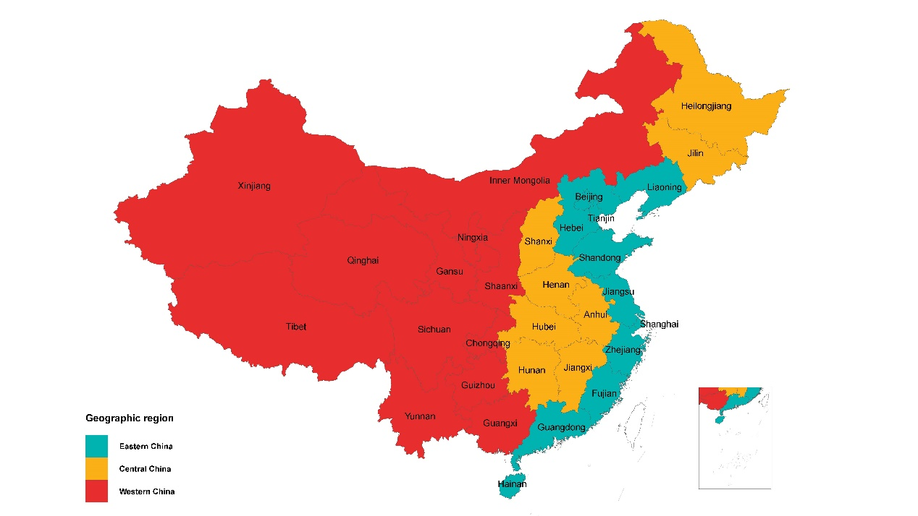

Figure S2. The size of ten priority groups for the COVID-19 vaccination program in provinces, decreased by the total population.
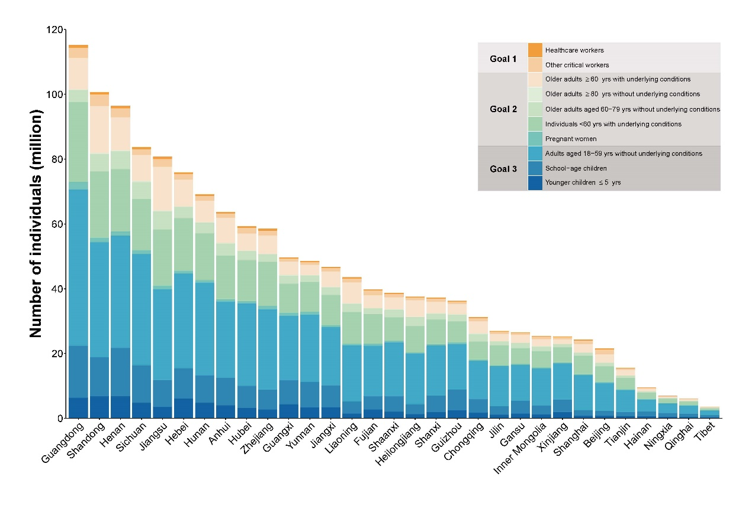

Figure S3. Scatter plots between the size of target population groups and the total population. A: Target population vs. total population. B: Target population for goal 1 vs. total population. C: Target population for goal 2 vs. total population. D: Target population for goal 3 vs. total population.
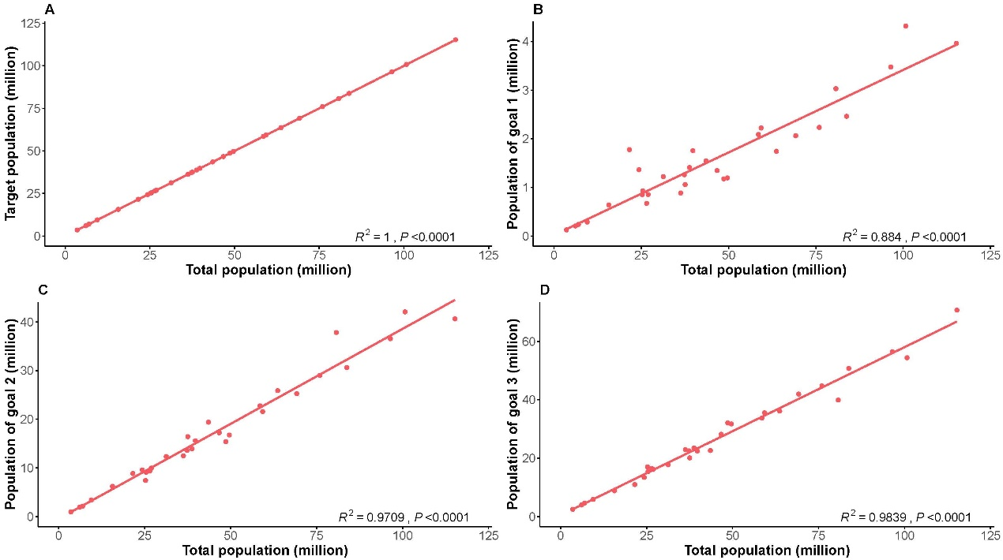

Figure S4. Based on the average capacity after mid-April 2021, service capacity gaps to vaccinate 70% of the target population by the end of 2021 or by mid-2022. A: The average capacity and service gaps by the end of 2021. B: The average capacity and service gaps by mid-2022.
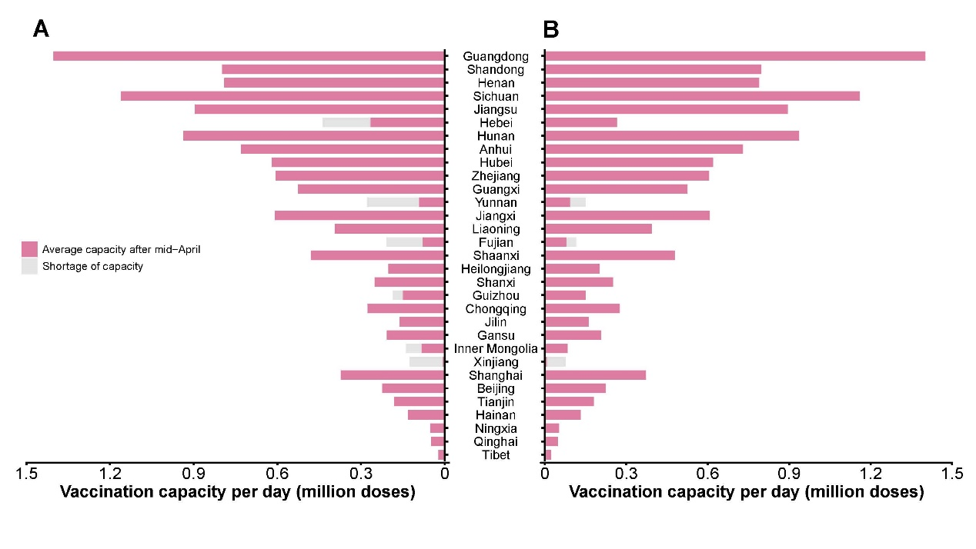

References
1. The Fourth National Economic Census. China Economic Census Yearbook 2018. http://www.stats.gov.cn/tjsj/pcsj/jjpc/4jp/zk/indexch.htm. Accessed 3 June 2021.
2. National Bureau of Statistics. Tabulation the 2010 Population Census of the People's Republic of China. http://www.stats.gov.cn/tjsj/pcsj/rkpc/6rp/indexch.htm. Accessed 30 Nov 2020.
3. Li Q. Research on the Optimal Allocation of Police Human Resources Based on Big Data. People’s Public Security University of China; 2020.
4. Fan P: Social transformation and state coercion. Beijing: China Social Sciences Press; 2017.
5. Ministry of National Defense of the People's Republic of China. White Paper on "China's National Defense In 2006". http://www.mod.gov.cn/regulatory/2011-01/06/content_4617808_4.htm. Accessed 30 Nov 2020.
6. Ministry of Education of the People's Republic of China. The considerations of college entrance examination delay; How to arrange the resumption of classes? http://www.moe.gov.cn/jyb_xwfb/s5147/202004/t20200401_437149.html. Accessed 30 Nov 2020.
7. Ministry of Commerce. PRC. Concise statistics on China's foreign labor service cooperation business from January to October 2020. http://hzs.mofcom.gov.cn/article/date/202011/20201103018497.shtml. Accessed 30 Nov 2020.
8. Service Center for Overseas Study, Ministry of Education. Blue book of return and employment of Chinese overseas students. Beijing: Yanshi Press in China; 2015.
9. Qinghai Bureau of Statistics. Qinghai statistical Yearbook 2020. http://tjj.qinghai.gov.cn/nj/2020/indexch.htm. Accessed 3 June 2021.
10. Gansu Bureau of Statistics. Gansu development Yearbook 2020. http://tjj.gansu.gov.cn/tjnj/2020/indexch.htm. Accessed 3 June 2021.
11. Shaanxi Bureau of Statistics. Shaanxi statistical Yearbook 2020. http://219.144.222.224:81/tjj/upload/n2020/indexch.htm. Accessed 3 June 2021.
12. Guizhou Bureau of Statistics. Guizhou statistical Yearbook 2020. http://202.98.195.171:81/tj/2020/zk/indexch.htm. Accessed 3 June 2021.
13. Chongqing Bureau of Statistics. Chongqing statistical Yearbook 2020. http://tjj.cq.gov.cn/zwgk_233/tjnj/2020/indexch.htm. Accessed 3 June 2021.
14. Hainan Bureau of Statistics. Hainan statistical Yearbook 2020. http://stats.hainan.gov.cn/tjj/tjsu/ndsj/2020/index.html. Accessed 3 June 2021.
15. Guangxi Bureau of Statistics. Guangxi statistical Yearbook 2020. http://tjj.gxzf.gov.cn//tjsj/tjnj/material/tjnj20200415/2020/zk/indexch.htm. Accessed 3 June 2021.
16. Guangdong Bureau of Statistics. Guangdong statistical Yearbook 2020. http://stats.gd.gov.cn/gdtjnj/content/post_3098041.html. Accessed 3 June 2021.
17. Shandong Bureau of Statistics. Shandong statistical Yearbook 2020. http://tjj.shandong.gov.cn/tjnj/nj2020/zk/indexch.htm. Accessed 3 June 2021.
18. Jiangxi Bureau of Statistics. Jiangxi statistical Yearbook 2020. http://tjj.jiangxi.gov.cn/resource/nj/2020CD/indexch.htm. Accessed 3 June 2021.
19. Fujian Bureau of Statistics. Fujian statistical Yearbook 2020. http://tjj.fujian.gov.cn/tongjinianjian/dz2020/index.htm. Accessed 3 June 2021.
20. Anhui Bureau of Statistics. Anhui statistical Yearbook 2020. http://tjj.ah.gov.cn/oldfiles/tjj/tjjweb/tjnj/2020/cn.html. Accessed 3 June 2021.
21. Jiangsu Bureau of Statistics. Jiangsu statistical Yearbook 2020. http://tj.jiangsu.gov.cn/2020/nj03/nj0307.htm. Accessed 3 June 2021.
22. Heilongjiang Bureau of Statistics. Heilongjiang statistical Yearbook 2020. http://tjj.hlj.gov.cn/app/tongjnj/2020/zk/indexch.htm. Accessed 3 June 2021.
23. Liaoning Bureau of Statistics. Liaoning statistical Yearbook 2020. http://tjj.ln.gov.cn/tjsj/sjcx/ndsj/otherpages/2020/2020/indexch.htm. Accessed 3 June 2021.
24. Inner Mongolia Bureau of Statistics. Inner Mongolia Statistical Yearbook 2020. http://tj.nmg.gov.cn/files_pub/content/PAGEPACK/b85658190a3644f8b192e45f5221f2fa/indexch.htm. Accessed 2 June 2021.
25. Tianjin Bureau of Statistics. Tianjin statistical Yearbook 2020. http://stats.tj.gov.cn/nianjian/2020nj/zk/indexch.htm. Accessed 2 June 2021.
26. Beijing Bureau of Statistics. Beijing statistical Yearbook 2020. http://nj.tjj.beijing.gov.cn/nj/main/2020-tjnj/zk/indexch.htm. Accessed 2 June 2021.
27. Shanxi Bureau of Statistics. Shanxi Statistical Yearbook 2020. http://tjj.shanxi.gov.cn/tjsj/tjnj/nj2020/zk/indexch.htm. Accessed 3 June 2021.
28. Henan Bureau of Statistics. Henan statistical Yearbook 2019. http://oss.henan.gov.cn/sbgt-wztipt/attachment/hntjj/hntj/lib/tjnj/2019/zk/indexch.htm. Accessed 3 June 2021.
29. Hebei Bureau of Statistics. Hebei Economic Yearbook 2018. http://tjj.hebei.gov.cn/res/nj2018/zk/indexch.htm. Accessed 3 June 2021.
30. Yang J, Zheng W, Shi H, Yan X, Dong K, You Q, Zhong G, Gong H, Chen Z, Jit M et al. Who should be prioritized for COVID-19 vaccination in China? A descriptive study. BMC Med. 2021;19(1):45.
31. National Bureau of Statistics. China Statistical Yearbook 2020. http://www.stats.gov.cn/tjsj/ndsj/2020/indexch.htm. Accessed 7 April 2021.
32. Global Health Data Exchange. Global Burden of Diseases, Risk Factors, and Injuries Study (GBD). http://ghdx.healthdata.org/gbd-results-tool. Accessed 7 April 2021.
33. Center for Health Statistics and Information, NHFPC. An Analysis Report of National Health Services Survey in China, 2013. http://www.nhc.gov.cn/ewebeditor/uploadfile/2016/10/20161026163512679.pdf. Accessed 7 April 2021.
34. National Bureau of Statistics. China Population & Employment Statistics Yearbook 2020. https://navi.cnki.net/KNavi/YearbookDetail?pcode=CYFD&pykm=YZGRL&bh=. Accessed 3 June 2021.
35. Wang YP, iang J, Zhu J, Zhou GX, Miao L, L. D. Ananlysis of the perinatal death and related male/female ratio of hospital delivery in China during 1988–1992. J Pract Obstet Gynecol. 2001;17:173–4.
36. Liu B, Gao ES. Risk factors for spontaneous abortion of Chinese married women at reproductive age. China Public Health. 2002;18(7):890-2.

