Supplementary Materials
Enabling a Leidenfrost drop to perform Biellmann spin
Shuai Huang^{1#}, Minghao Li^{1#}, Enze Liu^{2#}, Kai Feng¹*, Zeming Wang¹, Cunjing Lv²*, Yao Lu³*

1 College of Mechanical and Vehicle Engineering, Hunan University, Changsha, 410082, P. R. China
2 Department of Engineering Mechanics and Centre for Nano and Micro Mechanics, AML, Tsinghua University, Beijing, 100084, P. R. China
3 Department of Chemistry, School of Physical and Chemical Sciences, Queen Mary University of London, London E1 4NS, UK
* Corresponding author: jkai.feng@gmail.com (Kai Feng), cunjinglv@tsinghua.edu.cn (Cunjing Lv), yao.lu@qmul.ac.uk (Yao Lu)
# These authors contribute equally

Content
Supplementary Note 1
The influence of the substrate on the Biellmann-Leidenfrost spin
Supplementary Note 2
The influence of the cover plate on the Biellmann-Leidenfrost spin
Supplementary Note 3
The relation between the acceleration stage of Biellmann-Leidenfrost spin and the Leidenfrost stars
Supplementary Note 4
Force analyses of spinning drops
4.1 Initial stage
4.2 Acceleration stage
4.3 Deceleration stage
Supplementary Note 5
Variation of the geometrical centre of the drop during spinning
Supplementary Note 6
Morphology evolution of the drop with a cover plate
6.1 Estimation of the height h for spinning drops
6.2 Time evolution of r/R for spinning drops
6.3 Time evolution of h for spinning drops
Supplementary Note 7
Extension of drop resonance theory and the universality of the resonance state
7.1 Subharmonic resonance condition
7.2 Subharmonic resonance condition of the drop with a puddle-like shape
7.3 Harmonic resonance condition of the drop with a puddle-like shape
Supplementary Note 8
Analysis of drop shapes
8.1 Shapes of free static drops under gravity
8.2 Shapes of free spinning drops under gravity
Supplementary Note 9
Theoretical estimation of free drop evaporation
Movie legend
Supplementary Note 1
The influence of the substrate on the Biellmann-Leidenfrost spin
The experiments depicted in Fig. 1f are designed to examine the contact state between the Biellmann-Leidenfrost drop and the bottom hole of the substrate. To facilitate observation, we fabricated a small plateau using the same machining process as that employed for the bottom hole. This was accomplished using a 1500 W water-cooled CNC engraving machine (YD3040, Shenzhen Yidiao Technology Co., Ltd, China). To restrict the position of the spinning Biellmann-Leidenfrost drop on the plateau, a cover plate with a small hole was prepared and a needle was inserted into it. From a side view, a stable air cushion with a thickness of ~100 μm was observed using a drop analyser (JC2000D4F, Zhongchen, China), and aligns well with the literature data^{1,2}.
The micro and nano morphology was observed in Fig. S1. The left panel shows super depth-of-field images captured at different locations on the bottom-hole surface, revealing a groove-monopoly structure in a single direction due to the tool path and milling method. The depth of the grooves is ~0.16 μm, which is much smaller than the vapour layer with a thickness of ~100 μm, so the driving effect of the grooves on the spinning motion of the drop can be ignored. In addition, the edge of the bottom hole exhibits a laminar structure in the depth direction, which is assumed to have no substantial effect on generating a driving moment for the Biellmann–Leidenfrost drop. The right panel shows the scanning electron microscopy (SEM) image of the bottom hole at different magnifications, revealing a random distribution of microstructures. We assume that these structures on the bottom hole do not significantly influence the spinning motion of the Biellmann–Leidenfrost drop due to the absence of direct contact between them.
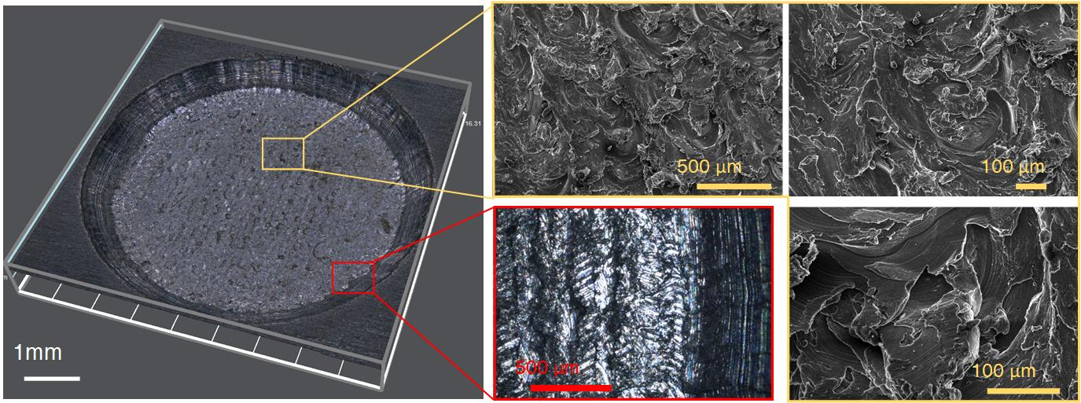
Fig. S1 Surface morphology of the bottom hole. Left panel: super depth-of-field image of the bottom hole. Right panel: SEM images of the bottom hole.

Figure S2 shows the statistics of the spin direction of the Biellmann-Leidenfrost drop. This experiment aims to evaluate the influence of the bottom hole on the direction of the drop spin. The results indicate that the spin direction is random across all three bottom holes, suggesting that the structure of the bottom hole has minimal effect on the spin direction of the Biellmann-Leidenfrost drop.

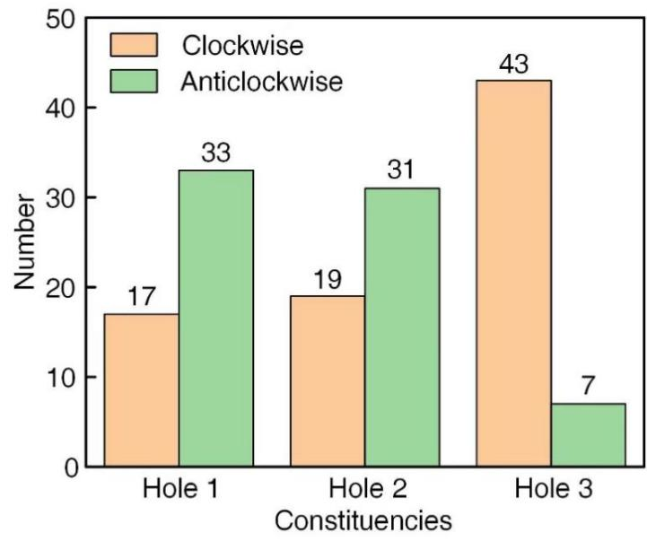
Fig. S2 Statistics of the spin direction of the Biellmann-Leidenfrost drop across 3 bottom holes. Each bottom hole underwent 50 trials.

To further study the spin direction of the Biellmann-Leidenfrost drop, we introduced an initial driving force by injecting bubbles into the drop as shown in Fig. S3a, b. Figure S3c shows the statistics of the spin direction of the Biellmann-Leidenfrost drop when subjected to this initial driving force. The results show that the spin direction of Biellmann-Leidenfrost drop is well guided by the initial driving force. This experiment also confirms that external forces significantly influence the spin direction of the Biellmann-Leidenfrost drop.

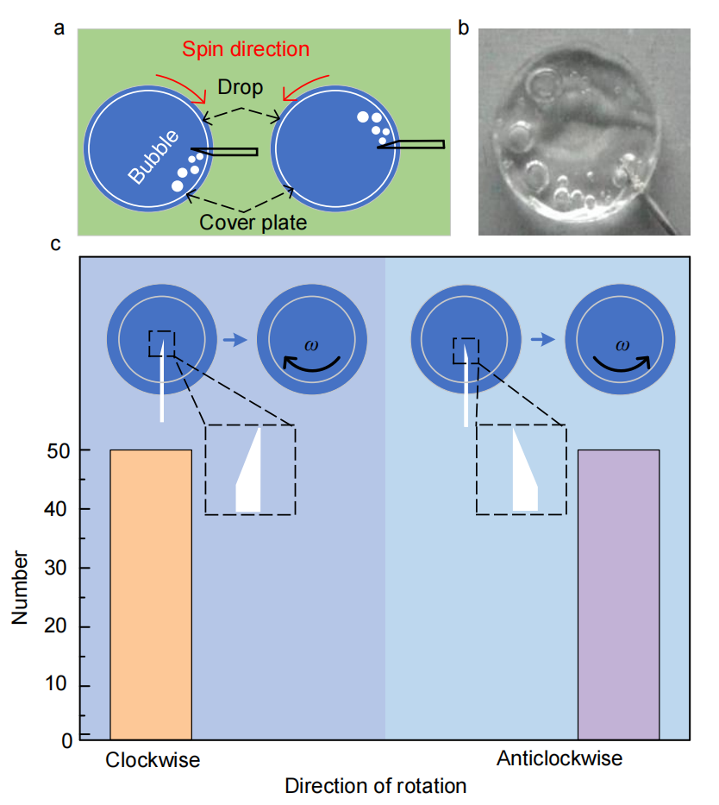
Fig. S3 Influence of injected bubbles on the Biellmann-Leidenfrost drops. (a) Schematic and (b) optical image of the experiment. (c) Statistics of the spinning direction of Biellmann-Leidenfrost drops in response to different directions of injected bubbles. Each direction of injected bubbles was tested in 50 trials.

Supplementary Note 2
The influence of the cover plate on the Biellmann-Leidenfrost spin
As shown in Fig. S4a, a polystyrene sphere was placed into the drop, and no relative movement was observed between the polystyrene sphere and the maker during drop spinning, indicating a non-slip condition between the drop and the cover plate.

The wettability of the cover plate is an important factor that influences the Biellmann-Leidenfrost spin. In Fig. S4b, both the upper paper layer and the lower aluminium foil of the cover plate were initially untreated, exhibiting hydrophilic properties with water contact angles of 51°±2° and 89°±2.6°, respectively. During the spinning process, the paper surface of the cover plate became wetted by the drop, leading to the cover plate eventually submerging into the drop and resulting in an unstable spin. As shown in Fig. S4c, when the lower surface (aluminium foil) was treated with a superhydrophobic coating (contact angle of 155°±1.8°), the cover plate was unable to stay on the top of the drop. In Fig. S4d, when the superhydrophobic treatment was exclusively applied to the upper paper surface (contact angle of 158°±1.2°), the cover plate retained a stable state on the spinning Biellmann-Leidenfrost drop.
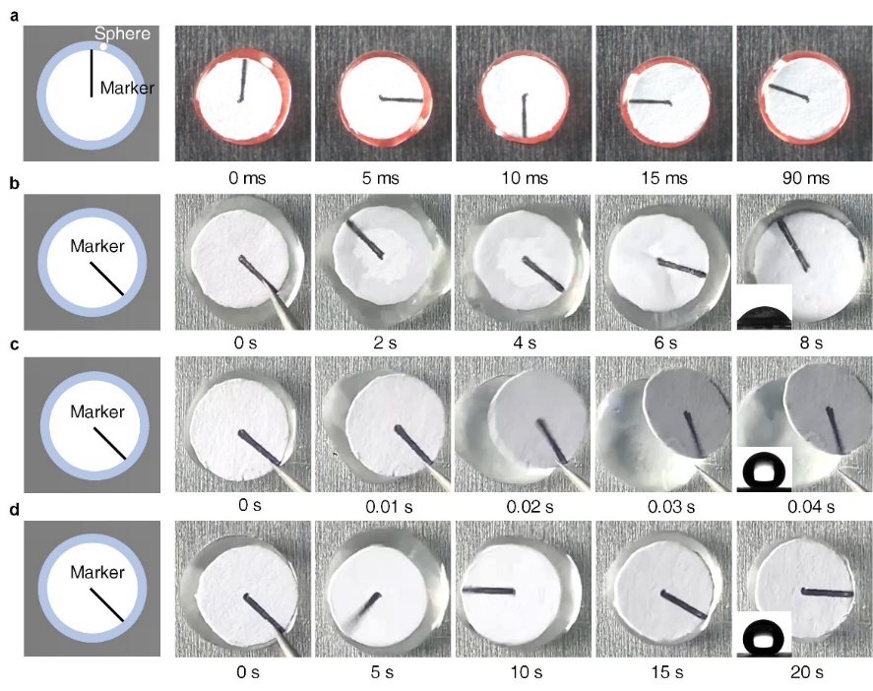
Fig. S4 (a) Slip condition between the drop and the cover plate. (b)-(d) Effect of cover plate wettability on the spinning behaviour of a Leidenfrost drop.

Figure S5 shows the influence of cover plate shape on the spinning behaviour of Leidenfrost drops. The Biellmann-Leidenfrost drop spin can also be achieved using various shapes of cover plates such as triangles, crosses, circles, rectangles and squares.
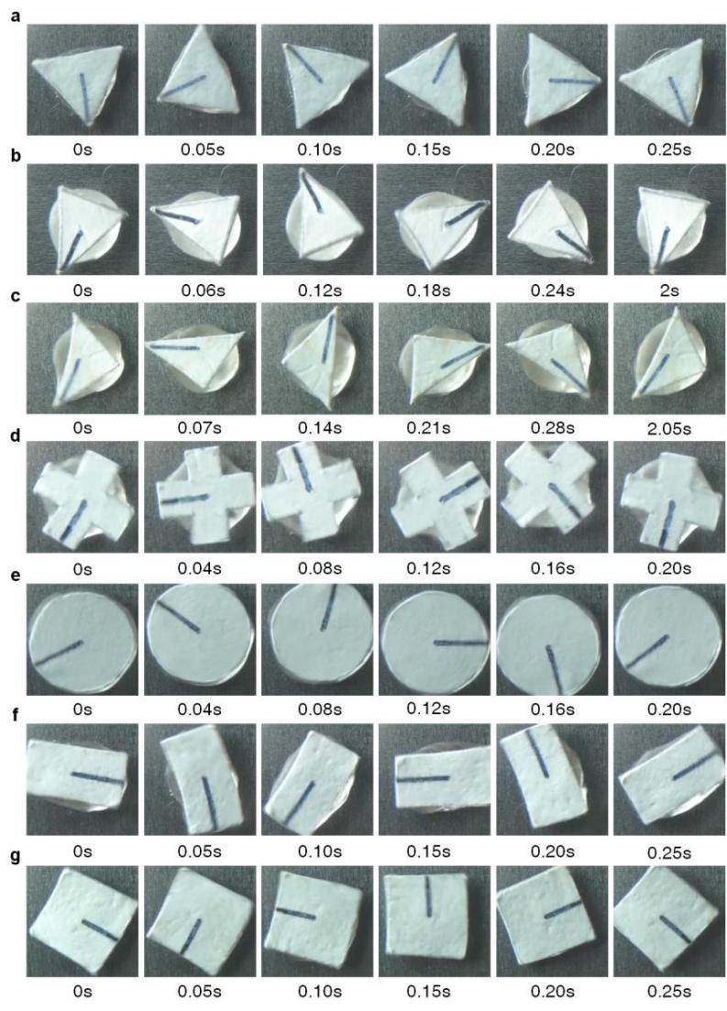
Fig. S5 Influence of cover plate shape on the spinning behaviour of Leidenfrost drops. Each cover plate has a circumference of 10.0 mm.

Supplementary Note 3
The relation between the acceleration stage of Biellmann-Leidenfrost spin and the Leidenfrost stars
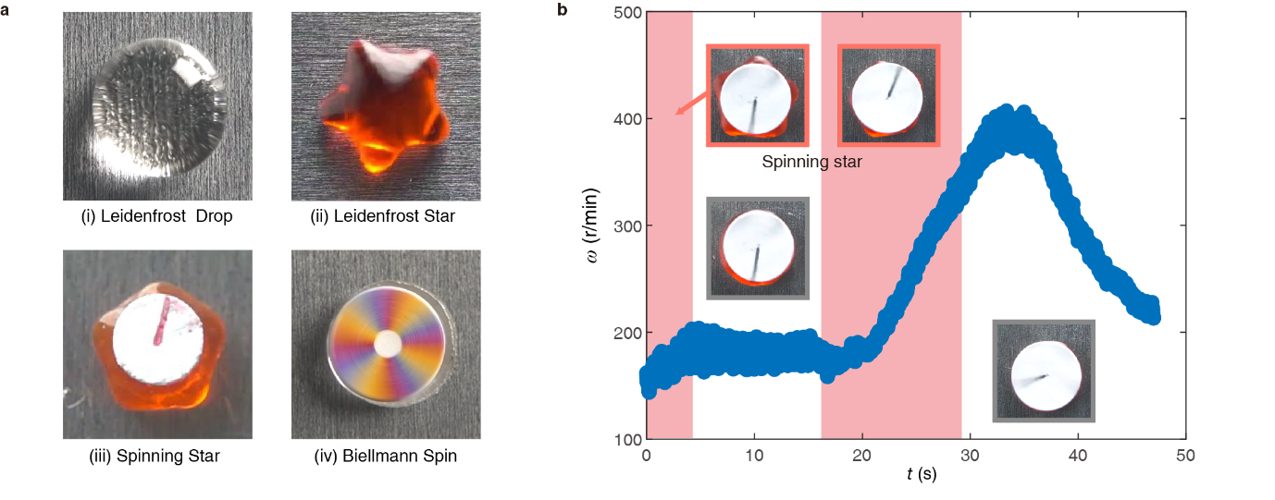
Fig. S6 Analysis of the relation between Biellmann-Leidenfrost spin and the Leidenfrost stars. (a) Illustration of typical states of Leidenfrost drops observed in our experiments. (i) Leidenfrost drop: a typical Leidenfrost drop. (ii) Leidenfrost star: a star-pattern formed on the surface of the drop due to horizontal stationary waves. (iii) Spinning star: a state similar to the Leidenfrost star, but with an added cover plate on the drop (R = 2.5 mm), causing the drop to oscillate in conjugation with spinning. (iv) Biellmann-Leidenfrost spin: a Leidenfrost drop spinning at high speed with a cover plate on the drop (R = 3 mm). The drops are located onto a bottom hole to restrict their horizontal movements. (b) Time evolution of the angular velocity throughout the entire spinning process of a drop (R = 5 mm). The highlighted red regions indicate the occurrence of spinning stars, satisfying double resonance conditions³. The insets depict the corresponding shapes of the Leidenfrost drops in the respective regimes.

Figure S6a illustrates the four typical states of Leidenforst drops observed during our experiments: Leidenfrost drop, Leidenfrost star, spinning star and Biellmann-Leidenforst spin. In the case of the Leidenfrost star³, the vapour film beneath the Leidenfrost drop consistently experiences vertical vibrations, triggering the Faraday instability within the drop⁴⁻⁶. When the drop size satisfies the double resonance condition (i.e., when the drop is treated as a resonant cavity, and both the polar hemiperimeter and equatorial hemiperimeter of the drop are multiples of the forcing wavelength), perturbations amplify, eventually leading to the formation of a Leidenfrost star. Under these conditions, energy from the vapour film vibrations is efficiently converted into the energy driving the oscillation of the star.
Moreover, we find that the theory proposed by Bouillant et al.³ is applicable in understanding the spinning star state with a cover plate, which we discovered in our experiments. Specifically, the presence of the cover plate only affects the double resonance condition by altering the shape of the Leidenfrost drops (i.e., their polar and equatorial hemiperimeters), but does not affect the vibrations of the vapour film beneath the drop, which are critical for managing the star oscillation.
Despite the seemingly disconnected relations between the Leidenfrost star and spinning, we have identified a significant correlation between the acceleration stage and the spinning star, as exemplified in Fig. S6b. The regime of the acceleration stage during spinning almost coincides with the regime where spinning stars form. Since star oscillation arises from resonance, it is reasonable to conclude that the acceleration stage only occurs when the resonance condition is satisfied. Consequently, the star oscillation serves as a useful indicator for determining whether the resonance condition is satisfied.
Next, we conducted a detailed analysis of the factors contributing to the acceleration stage from an energy perspective. First, the star oscillation under the resonance condition is more vigorous than that of the Faraday wave, which introduces additional energy and perturbations that augment the annular velocity of spinning. Second, due to the substantial horizontal deformation of the drop, the fixed solid-liquid-gas three-phase contact line on the top cover plate may impede the star oscillation to a greater extent. Comparatively, the spinning is associated with the vertical vibration of the vapour film, which, as discussed in the main text, can occur at any moment during the process. However, the acceleration of spinning is specifically connected to the resonance condition and appears only within a specific regime (i.e., the regime with the red color in Fig. S6).
However, in the regime where the spinning stars form, not all drops experience acceleration. This phenomenon is primarily influenced by drop size, wherein the influence of the cover plate diminishes if the drop radius r exceeds the cover plate radius R. As a result, the last stage (i.e., the second regime highlighted in red in Fig. S6b) that satisfies the resonance conditions (i.e., when the drop attains a minimum radius) frequently exhibits significant acceleration.
The unpredictability of the resonance state leads to significant fluctuations in the duration of drop acceleration, as reflected in the error bars in Fig. 3a, b and c. These analyses demonstrate a strong connection between the acceleration stage and the resonance condition. The inherent randomness associated with the resonance state results in an acceleration stage that ends at an unpredictable moment.

Supplementary Note 4
Force analyses of spinning drops
In the subsequent sections, we conduct theoretical analyses of spinning drops from the perspective of physical hydrodynamics⁷. As illustrated in Fig. 1 of the main text, three distinct features are observed during a specific spinning process of a drop, prompting us to divide the process into three stages.
In the initial stage (0 s < t < 20 s), a vigorous oscillation occurs, and the angular velocity ω(t) of the spinning drop approximately stabilizes, denoted as ω₀. Subsequently (t > 20 s), the rotation of the drop experiences significant acceleration, culminating in a maximum spinning velocity ω_{max} after approximately 20 s. As time progresses (t > 45 s), the drop undergoes a sudden deceleration and comes to a halt in its spinning motion. Next, we explore the underlying physics corresponding to each of these stages. Given the intricate morphology and dynamics of spinning drops, we conduct analyses from a scaling perspective.

4.1. Initial stage
In this stage, the drop undergoes a transition from a static state to a state with angular velocity. Despite the remarkable oscillation, the spinning drop approximately stabilizes and reach ω₀.
After the drop is deposited on the substrate, violent evaporation occurs, leading to the generation of water vapour between the drop and the substate. We denote the velocity of the water vapour at the edge of the drop along the radial direction as U||. Due to the rough nature of the substate, it is inevitable that the vapour flow causes a deviation from the radial direction. Here, we assume φ as the angle between the radial direction and the direction of the deviated flow, with a value of φ = 1°. As a consequence, this deviation of water vapour induces a tangential flow component U||* = U|| tanφ ≈ U||φ exerted on the edge of the drop. Consequently, a driving torque T_{dri} is exerted on the drop

$T_{dri}=\int_{0}^{r}{η_{v}}\left(U_{∥}^{*}\frac{\bar{r}}{r}\right)\frac{1}{δ}\left(2π\bar{r}\right)\bar{r}d\bar{r}=\frac{π}{2}\frac{η_{v}U_{∥}^{*}r^{3}}{δ}$, (S1)

where η_{v} and δ denotes the dynamic viscosity and the thickness of the water vapour, respectively. Additionally, r denotes the instantaneous radius of the drop, while $\bar{r}$ is an integral variable.

In the transition from a non-spinning to a spinning state, the drop must overcome the influence of its own viscosity. Consequently, we attribute the drag force to the viscous shear force of the water, resulting in a drag torque,

$T_{dr\text{ag}}=\int_{0}^{r}{η_{w}}\left(U\frac{\bar{r}}{r}\right)\frac{1}{h}\left(2π\bar{r}\right)\bar{r}d\bar{r}=\frac{π}{2}\frac{η_{w}r^{4}ω_{0}}{h}$, (S2)

where η_{w} and h denote the dynamic viscosity and the height of the drop, respectively. Here, we select h = 3.5 mm as a reasonable value, considering the range of drop sizes employed in our experiments (see Supplementary Note 8). Moreover, U = rω₀ represents the tangential linear velocity at the edge the drop (i.e., $\bar{r}=r$).

Balancing Eq. (S1) and Eq. (S2) with consideration of the values of δ and U|| (see Eq. (S31) and Eq. (36) in Supplementary Note 9, respectively) yields

$ω_{0}∼\frac{η_{v}}{η_{w}}\frac{h}{δ}\frac{U_{∥}^{*}}{r}≈c_{1}\frac{h}{r^{\frac{3}{2}}}\frac{1}{η_{w}}{\left(\frac{kΔTη_{v}}{ρ_{v}L}\right)}^{\frac{1}{4}}{\left(ρ_{w}gh\right)}^{\frac{3}{4}}$, (S3)

where c₁ ≈ 0.90 is a prefactor determined through the best fit to the experimental data. At this point, we consider the value of r when the first stage ends and denoted it as r₀, which is slightly larger than R.

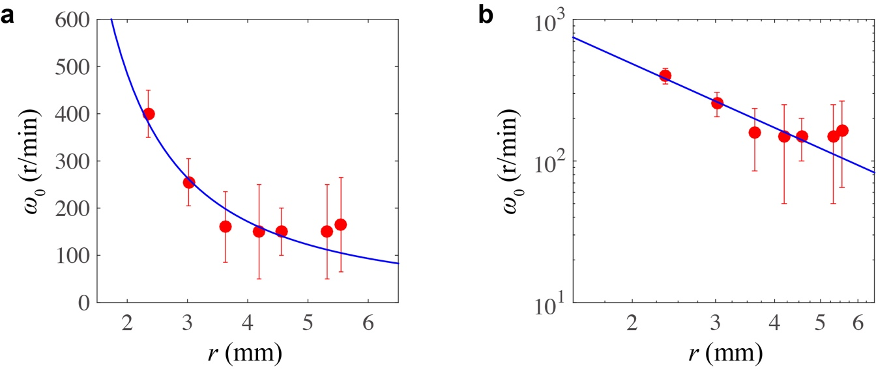
Fig. S7 Relation between ω₀ and the corresponding drop radius r in both (a) a linear plot and (b) a log-log plot. Here, r is selected as the instantaneous value (r₀) at the end of the initial stage, i.e., r = r₀.

As illustrated in Fig. S7, we extract the values of ω₀ (dots with errors) from experiments, and it is evident that our theoretical result (curve) finely follows the experimental data.

4.2. Acceleration stage
In this stage, we observe a noticeable acceleration of the spinning drop (Fig. 2a). Additionally, it is intriguing to note the emergence of a star oscillator (Fig. 2b-e) and observe that the drop spins much more smoothly, suggesting the presence of distinct underlying physics compared to the initial stage.

During this stage, the drop begins to accelerate with a smoother spin while evaporating more rapidly than a typical Leidenfrost drop, indicating a significantly stronger vapour release. We attribute the acceleration to the vapour flow from the petals of the stars. By applying the conservation of momentum, we obtain

$T_{dri}=\frac{dL_{m}}{dt}=\frac{ΔM}{Δt}r^{2}ω=2πρ_{v}δU_{∥}r^{3}ω$, (S4)

where L_{m} denotes angular momentum, ΔM denotes the decrease in drop mass over a time span Δt, and r and ω denote the outer radius and the angular velocity of the drop, respectively. The expressions for U|| and δ are obtained from the classical theory of evaporation of Leidenfrost drop (see Eq. (S31) and Eq. (S36) in Supplementary Note 9). On the other hand, in relation to the smooth spinning and the formation of an air boundary layer arises on the cover plate, we attribute the dominant drag torque to the viscous force of the air on the top of the drop, given by

$T_{dr\text{ag}}=\int_{0}^{r}{\frac{η_{a}}{Δ}}\left(ω\bar{r}\right)\left(2π\bar{r}\right)\bar{r}d\bar{r}=\frac{π}{2}\frac{η_{a}r^{4}ω}{Δ}=\frac{π}{2}{\left(η_{a}ρ_{a}\right)}^{\frac{1}{2}}r^{4}ω^{\frac{3}{2}}$, (S5)

where Δ ~ [η_{a}/(ρ_{a}ω)]^{1/2} denotes the thickness of the air boundary layer, with η_{a} and ρ_{a} being the dynamic viscosity and mass density of the surrounding air, respectively⁷.

Based on the driving torque and the drag torque described above, we formulate the kinetic equation for the spin of the drop in the following

$Iα=T_{dri}-T_{drag}$, (S6)

where I (t) = M(t)r(t)²/2 denotes the moment of inertia of the spinning drop, with M(t) being its instantaneous mass. Moreover, α(t) denotes the angular acceleration. The combination of Eqs. (S4) - (S6) leads to

$\frac{1}{2}Mr^{2}α=c_{2}\left(2πρ_{v}δU_{∥}r^{3}ω\right)-c_{3}\left[\frac{π}{2}{\left(η_{a}ρ_{a}\right)}^{\frac{1}{2}}r^{4}ω^{\frac{3}{2}}\right]$, (S7)

where c₂ and c₃ denotes two prefactors determined through fitting our theory to the experimental data. Assuming an average drop height of h = 3.5 mm (see Supplementary Note 8), our results show that, based on the best fits to the experimental data, c₂ ≈ 3.66 and c₃ ≈ 5.09 in Fig. S10; c₂ ≈ 3.66 and c₃ ≈ 6.05 in Fig. S16 and Fig. 3a; and c₂ ≈ 3.66 and c₃ ≈ 9.55 in Fig. 3b. Despite some deviations, our theories are generally self-consistent.
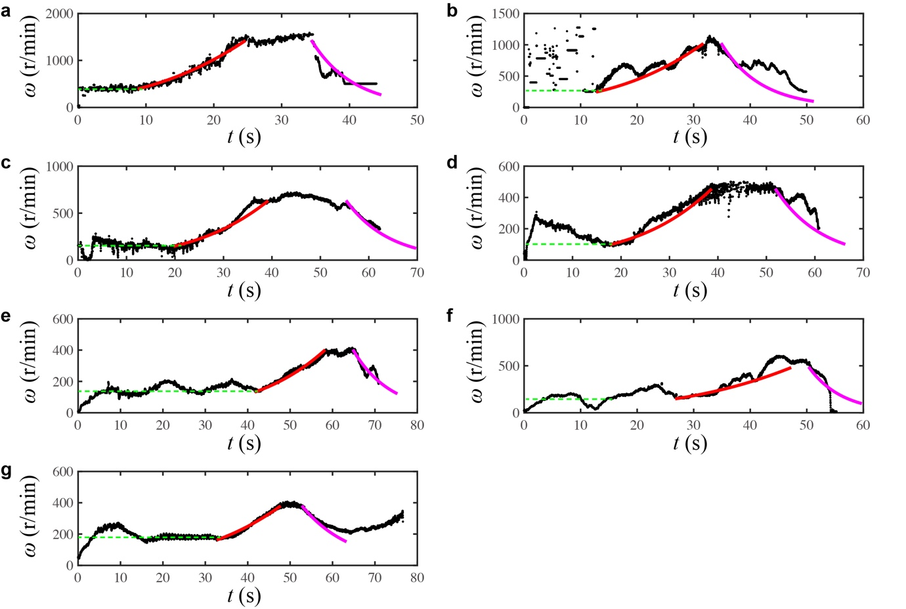
Fig. S8 Comparisons of experimental and theoretical results during the acceleration stage of the drop for various values of R. Panels (a)-(g) correspond to cover plate radii of R = 2.0, 2.5, 3.0, 3.5, 4.0, 4.5, 5.0 mm. The green dashed lines indicate the values of ω₀, the red curves represent the theoretical results of the acceleration stage (according to Eq. (S7)), and the blue curves represent the theoretical results of the deceleration stage (according to Eq. (S10)).

As illustrated in Fig. S8, for cover plates of varying radius R, our theory (Eq. S7) finely follows the experimental data. Moreover, we observe that the acceleration stage typically lasts around 20 s (see Fig. S8 and Fig. 2 in the main text). When the radius of the spinning drop r(t) reaches the radius of the cover plate R, the angular velocity peaks at a maximum value ω_{max}. By employing Eq. (S7), we can determine ω_{max} numerically and present a comparison between experimental data (dots) and theoretical results (curves) in Fig. 3a in the main text, suggesting good agreement between our theoretical predictions and the experimental data. In addition, as illustrated in Fig. 3c, d in the main text, we also investigate the influence of substrate temperature T_{s} and cover plate mass m_{p} on ω_{max}, and these outcomes are derived numerically based on the dynamic equation of the drop by taking consideration of relevant parameters.

Furthermore, leveraging this framework (see Eq. S7), we establish a relation between the maximum angular velocity ω_{max} and the substrate temperature T_{s} for cover plates of varying radii R, as depicted in Fig. 3b of the main text. Notably, when the radius of the cover plate is R = 4 mm and R = 5 mm, our theoretical predictions closely match the experimental observations. However, when R = 3 mm, remarkable deviations arise. One potential explanation is that our theoretical model is tailored for large drops, assuming a puddle-like shape, which may not fully capture the behaviour of smaller drops.

4.3. Deceleration stage
During the third stage, when the drop radius r exceeds the radius of the cover plate R, the drop experiences a sudden deceleration, coming to a halt in its spinning motion. While direct observation of the morphology of the drop from a top view is not feasible due to the covering top plate, we hypothesize that the pronounced star-like oscillation is significantly dampened by the pinning of the plate-water-air three-phase contact line. A side view image suggests that the drop takes on the shape of a spherical cap. These facts imply a distinct underlying physics governing this third stage compared to the previous two stages.

In this stage, the drop contracts into a spherical shape with a minimal plate-water contact region. Unlike the first stage, which features a larger liquid-vapour contact area, or the second stage characteristic by star-like oscillations, that generates driving toque, the driving torque is significantly reduced in this third stage. This reduction in driving torque suggests that drag torque has become the primary factor at play. On the other hand, a noticeable oscillation of the entire drop re-emerges (see Supplementary Movie S6), which is distinct from the behaviour observed in the first and the second stages. We attribute this drag torque to the viscous force within the vapour layer between the drop and the substrate

$T_{dr\text{ag}}=\int_{0}^{r}{η_{v}\left(U\frac{\bar{r}}{r}\right)\frac{1}{δ}}\left(2π\bar{r}\right)\bar{r}d\bar{r}=\frac{π}{2}\frac{η_{v}r^{4}ω}{δ}$. (S8)

As a consequence, the kinetic equation governing the spin of the drop degrades into

$Iα=-T_{drag}$, (S9)

Specifically, by combining Eqs. (S8) and (S9), we obtain

$\frac{1}{2}Mr^{2}α=-c_{4}\left(\frac{π}{2}\frac{η_{v}r^{4}ω}{δ}\right)$, (S10)

where the prefactor c₄ ≈ 2.23 is determined through the best fit to the experimental data (see Fig. S8).

Numerical calculations are carried out based on Eq. (S10), with the initial boundary conditions set by Eq. (S7) (i.e., the drop radius r(t) and the angular velocity ω(t)) at the end of the second stage. The theoretical results are plotted in Fig. S8 (magenta curves), demonstrating a fine agreement with the experimental data.

Furthermore, Eq. (S10) leads to a characteristic angular acceleration given by α ~ T_{drag}/I ~ η_{v}ω/(hρ_{w}δ). This leads to a characteristic timescale for the drop to halt its rotation, denoted as Δt ~ ω/α ~ δhρ_{w}/η_{w} ~ 10 s, which is consistent with our experimental findings (see Fig. S8).

Supplementary Note 5
Variation of the geometrical centre of the drop during spinning

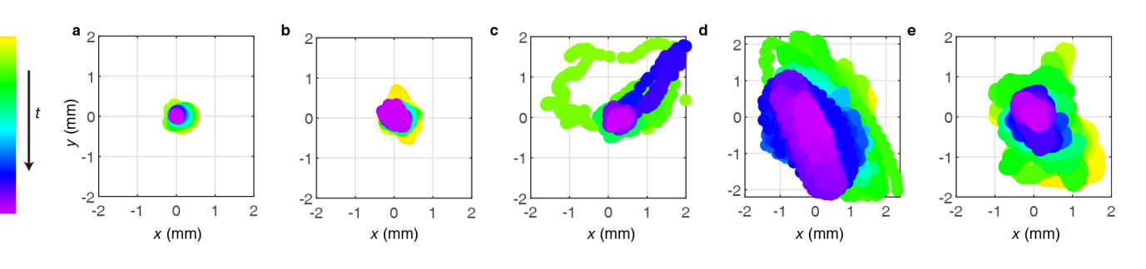
Fig. S9 Evolution of the geometrical centre of a drop from the initiation of spin to the moment of maximum angular velocity. The colour map illustrates the progression of time, with yellow colour indicating the initial state (ω = 0) and the purple colour indicating the spin at maximum velocity (ω = ω_{max}). The panels display cover plates with radii of R = (a) 3.0 mm, (b) 3.5 mm, (c) 4.0 mm, (d) 4.5 mm and (e) 5.0 mm, respectively.

We identify the contour of the dyed red drop using a custom-made MATLAB code (see Methods). Following this, we determine the geometrical centre of the drop. Fig. S9 illustrates the evolution of the drop centre from the initial spin (ω = 0) to the moment when the drop achieves its maximum angular velocity (ω = ω_{max}). The colour map represents the progression of time. As the angular velocity increases, the horizontal oscillation of the drop gradually diminishes.

Supplementary Note 6
Morphology evolution of the drop with a cover plate
6.1. Estimation of the height h for spinning drops
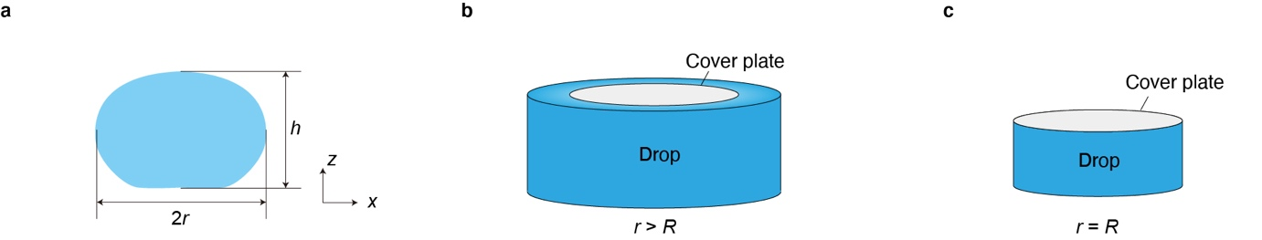
Fig. S10 Model of the spinning drop. (a) Schematic illustrating a side view of a spinning water drop. (b) The drop is modelled as a cylinder, with a radius larger than that of the cover plate, i.e., r > R. (c) The radii of the drop and the cover plate are equal to each other, i.e., r = R.

As depicted in Fig. S10a, we define the maximum width of the drop as its diameter (2r), and the drop height h is also defined in this figure. While the values of h and r defined in each frame may not accurately reflect the true height and radius due to the violent shaking of the drops, the overall trend observed across a substantial amount of experimental data can still effectively reflect the time evolution of h and r.

When considering the gravitational acceleration acting on the drop, the relation between the height h and radius r of a static drop can be analytically derived in the two-dimensional case by solving the Young-Laplace equation (i.e., the red dotted curve in Fig. 3d)^{8,9}. In our experiment, we observed that adding a cover plate on the top of the drop or increasing the spinning angular velocity results in a decrease in the drop height h. Therefore, all the data points in Fig. 3d should fall below the red dashed curve, which represents the theoretical solution for h vs. r of a two-dimensional static drop. It can be predicted that when the cover plate radius R is significantly smaller than the drop radius r or when the angular velocity ω is low, the relation between h and r is consistent with the red dashed curve. However, when r is slightly larger than R, the relation between h and r enters a transition status (r > R in Fig. 3e). As time progresses and more water evaporates, the condition r = R is satisfied due to the pinning of the solid-liquid-vapour three-phase contact line, resulting in a gradual decrease in h. In our experiment, the initial radius of the drop is not significantly larger than that of the cover plate, resulting in the majority of data points in Fig. 3d falling within the transition (r > R in Fig. 3e) and restriction status (r < R in Fig. 3e).

Next, we focus on identifying the boundary between the transition and restriction status through the following analyses. As demonstrated in Fig. S10b, we model the drop as a standard cylinder. To account for the shrinking process of the drop, we assume that the radius r is larger than the radius R of the cover plate in the energy analysis of the model, as shown in Fig. S10b. In this regard, the total energy of the drop is given by^{10,11}

$E=E_{surf}+E_{g}+E_{k}$, (S11)

where E_{surf}, E_{g} and E_{k} denote the surface energy, gravitational potential energy and kinetic energy, respectively. Here, the influence of the mass of the cover plate mass is negligible, it is significantly less than that of the drop. Specifically, the surface energy is expressed as follows

, (S12)

where A_{LV}, A_{SV}, A_{SL} denote the contact areas of the liquid-vapour, solid-vapour and solid-liquid interfaces, respectively. Here, σ_{LV} = 0.055 N/m is liquid-vapour interfacial tension for boiling water, while σ_{SV1} and σ_{SV2} denote the solid-vapour interfacial tensions of the bottom aluminum substrate and the aluminum foil on the top of the drop, respectively. σ_{SL1} denotes the solid-liquid interfacial tension between the drop and the bottom aluminum substrate, while σ_{SL2} denotes the solid-liquid interfacial tension between the drop and the top aluminum foil. A₀ is the area of the entire bottom aluminum. Here, Young equations cosθ_{bottom} = (σ_{SV1} − σ_{SL1})/σ_{LV} and cosθ_{foil} = (σ_{SV2} − σ_{SL2})/σ_{LV} are employed for the subsequent calculations, with θ_{bottom} and θ_{foil} being the contact angles of water on the bottom aluminum substrate and the top aluminum foil, respectively. Moreover, the gravitational potential energy and the kinetic energy are respectively given by

, (S13)
. (S14)

To obtain the equilibrium profile of the liquid, we calculate the derivative of the energy with respect to r, and set it to zero, i.e.,

. (S15)

In addition, considering volume conservation

, (S16)

we have ∂V/∂r = 0, leading to the following relation

. (S17)

Substituting Eqs. (S12)-(S14) and Eq. (S17) into Eq. (S15), we obtain the height h of the drop as follows

$-\frac{1}{πρ_{w}g}\frac{∂E}{∂r}=rh^{2}+\left(2l_{c}^{2}+\frac{ω^{2}r^{3}}{2g}\right)h-4rl_{c}^{2}=0$. (S18)

Equation (S18) can be further rewritten as follows

$h=-\left(\frac{l_{c}^{2}}{r}+\frac{r^{2}ω^{2}}{4g}\right)+\sqrt{{\left(\frac{l_{c}^{2}}{r}+\frac{r^{2}ω^{2}}{4g}\right)}^{2}+4l_{c}^{2}}$, (S19)

where l_{c} = [σ_{LV}/(ρ_{w}g)]^{1/2} denotes the capillary length (2.5 mm for water close to its boiling point). When ω = 0 and r → ∞, we obtain h = 2l_{c} through Eq. (S19), which is consistent with the classical theory¹⁰.

As illustrated in Fig. 3d, the black dashed curve represents the solution of Eq. (S19) when ω = ω_{max} (see the theoretical result of ω_{max} as a function of R in Fig. 3a). This curve reflects the value of h at which the drop reaches the end of the transition status (r = R). The theoretical result of Eq. (S19), depicted by the black dashed curve, agrees very well with the experimental results.

6.2. Time evolution of r/R for spinning drops

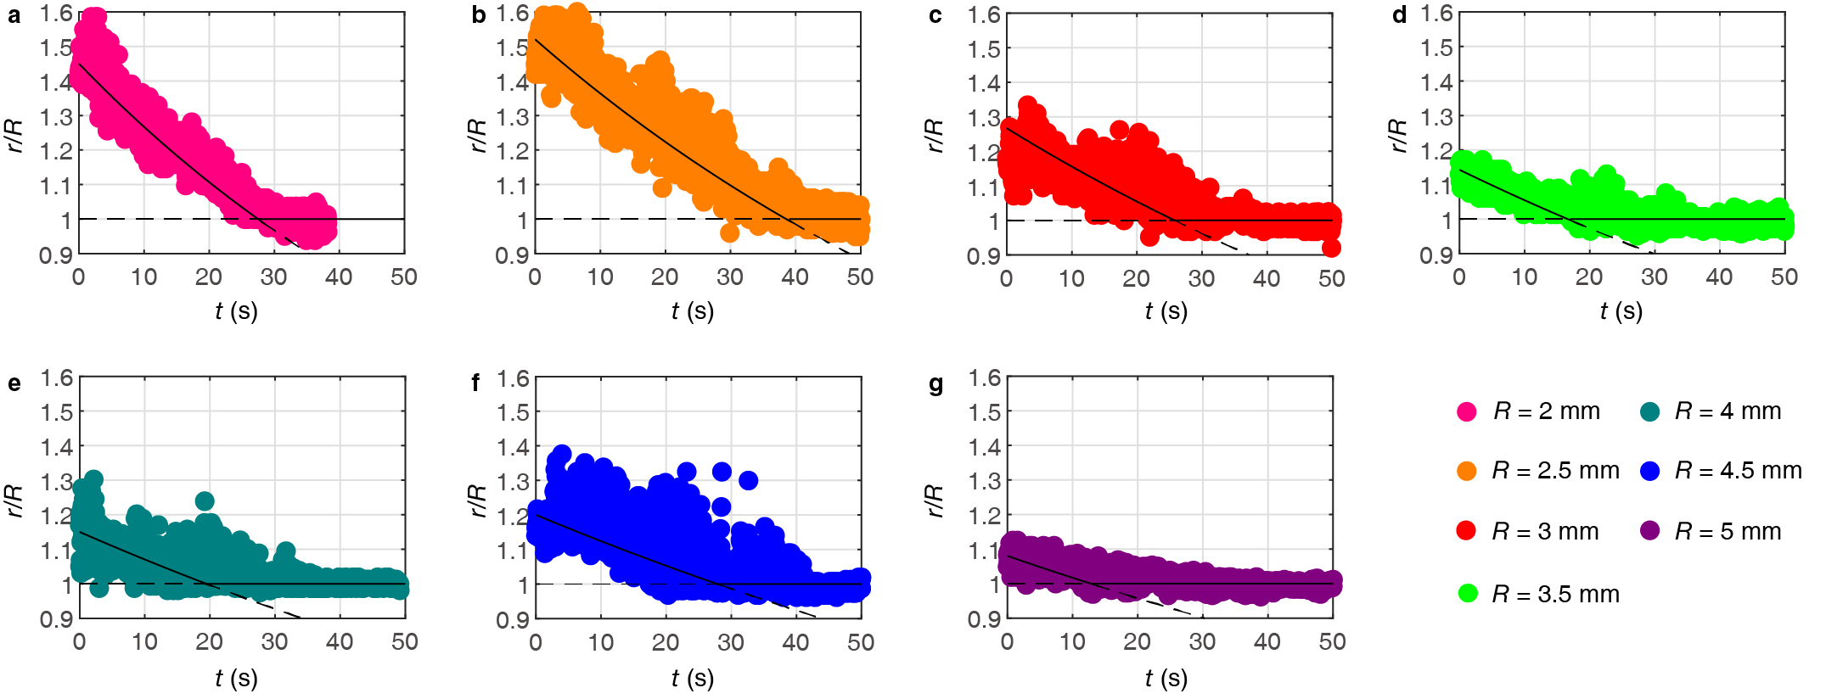
Fig. S11 Time evolution of r/R for spinning drops throughout the entire process. Each color represents a specific cover plate radii R, as illustrated in Fig. 3a in the main text. The non-horizontal black solid curves represent the theoretical solutions for r/R, as given by Eq. (S33) (see Supplementary Note 9). The dashed lines represent extensions of the corresponding solid lines.

By employing the heat transfer formula, we can estimate the evaporation rate during the transition status (r > R in Fig. 3e in the main text). The time evolution of r/R is then plotted in Fig. S13 for 7 different cover plates. The data can be divided into two distinct statuses, i.e., the transition and restriction statuses.

During the transition status, the height h of the liquid remains nearly constant and is independent of t (see Fig. S24 in Supplementary Note 8 for a reference). Assuming an average drop height of h = 3.5 mm and by employing the theory of evaporation derived in Eq. (S33) (see Supplementary Note 9), we can derive the theoretical results for r/R (represented by the non-horizontal black solid curves in Fig. S11). The theoretical results (without any adjustable parameters) agree very well with the experimental results. Moreover, as the geometry relation at the end of the transition status always satisfies the condition r = R, the value of r/R eventually converges to unity.

6.3. Time evolution of h for spinning drops
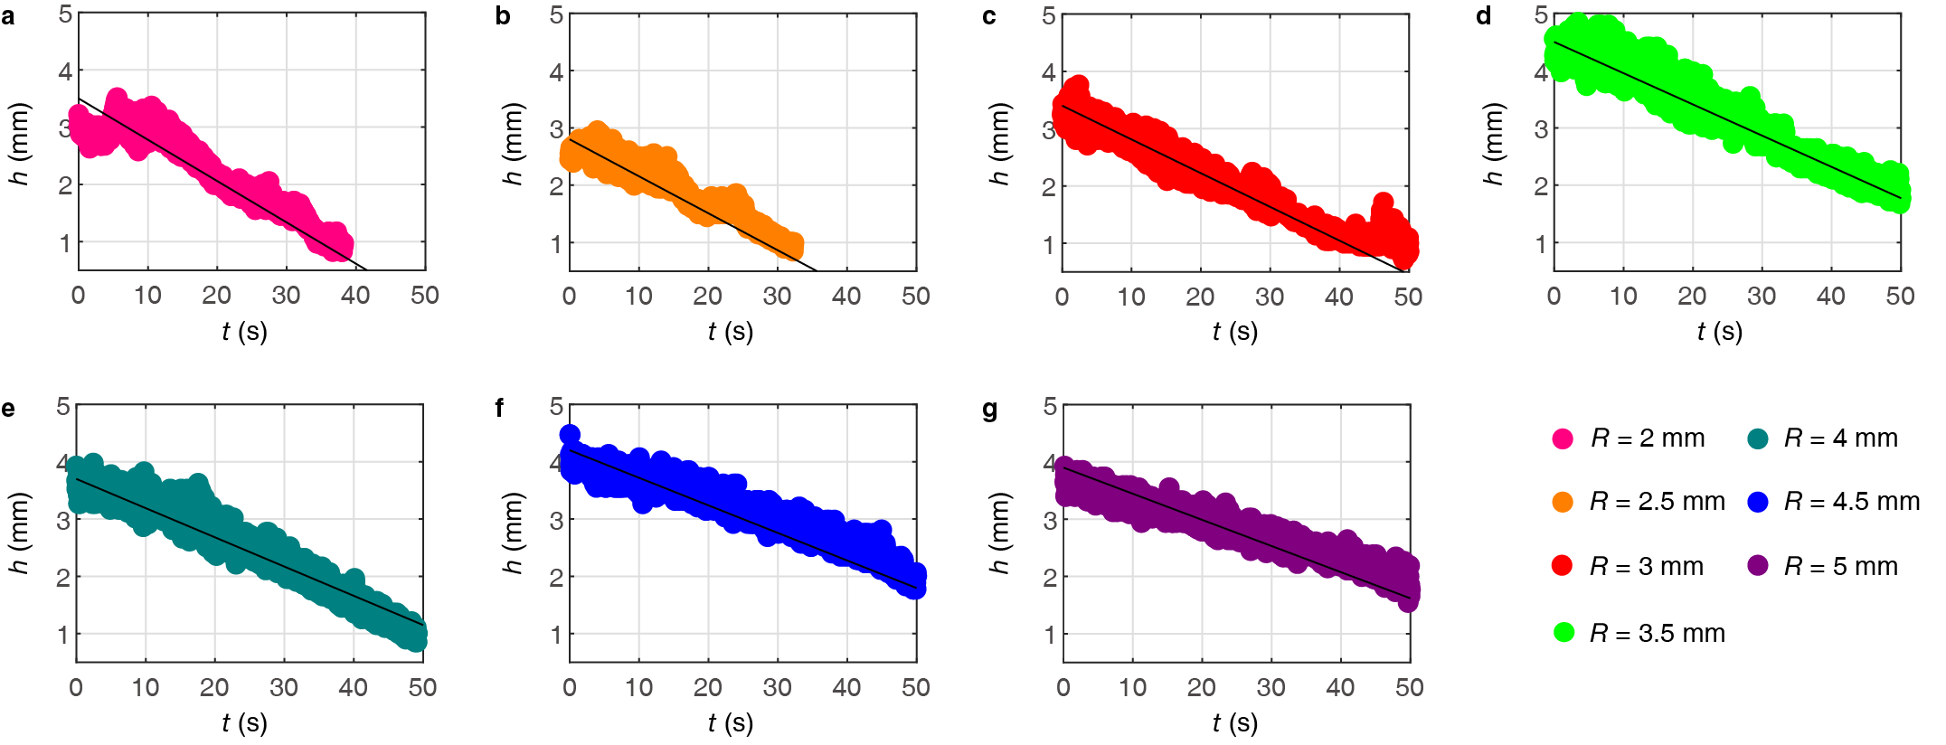
Fig. S12 Time evolution of the height h of the spinning drop throughout the entire process. Each line corresponds to a cover plate with a different radius, as illustrated in Fig. 3a of the main text. The black solid lines represent the theoretical solutions for h (see Eq. (S21)).

In Fig. S12, the dots of varying colours represent the time evolution of the drop height h for seven different cover plates. These results demonstrate an approximately linear relation between the drop height h and time t. As time progresses, the solid-liquid-gas three-phase contact line becomes fixed on the top of the drop when r approaches R (see Fig. S10c). Consequently, the variation in r becomes minimal over time, allowing us to assume that r is approximately constant. Moreover, considering the absence of an analytical solution for the morphology of the drop, studying the variations in the radius and the height of the drop separately would facilitate a better underlying of the dominant underlying mechanics. Base on that assumption and using the heat transfer formula ∂M/∂t = − kΔTA/(Lδ),^{1,12} we have

$\frac{∂h}{∂t}=-\frac{kΔT}{ρ_{w}Lδ}$. (S20)

In the above analyses, the drop mass and the contact area between the drop and the hot plate are expressed as M = πρ_{w}r²h and A = πr², respectively. By assuming a constant value for δ (considering the time-dependence of δ would yield slightly different results), we derive

$h=h_{0}-\left(\frac{kΔT}{ρ_{w}Lδ}\right)t$, (S21)

where h₀ denotes the initial height of the drop. As depicted in Fig. S12, the solid lines represent the theoretical results derived from Eq. (S21), which exhibit excellent agreement with the experimental data.

Supplementary Note 7

Extension of drop resonance theory and the universality of the resonance state
7.1. Subharmonic resonance condition
In this section, we observe a notable occurrence of spinning star-like formations in our experiments, with these star patterns manifesting in nearly every experimental trial. As depicted in Fig. S13, the drops exhibit rapid spinning accompanied by vigorous oscillations, leading to the formation of distinct petal-like structures.

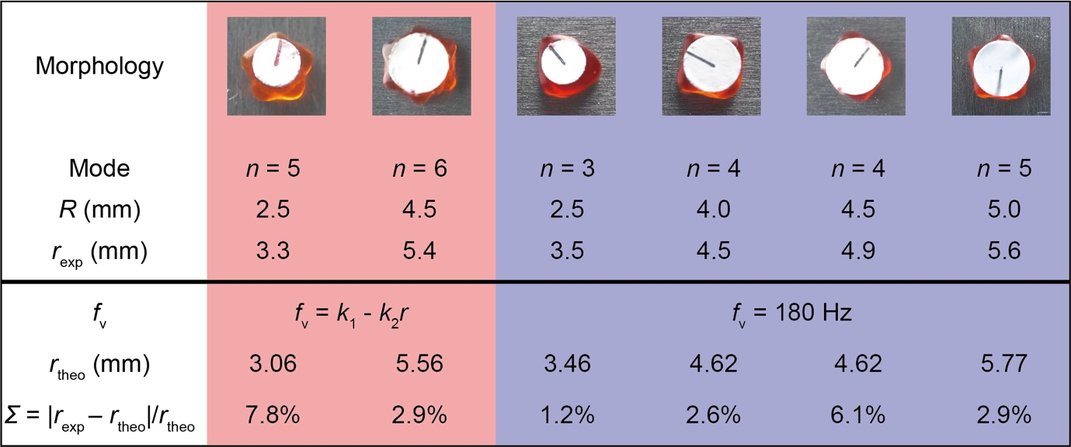
Fig. S13 Spinning stars observed in our experiments, each exhibiting distinct modes denoted by n, corresponding to the number of petals. The theoretical resonance radius r_{theo} for each mode is associated with an integer value of n. The deviation between the theoretical resonance radius r_{theo} and the experimental resonance radius r_{exp}, calculated as Σ = (r_{exp} – r_{theo})/r_{exp} = Δr/ r_{theo}, is generally within 10%.

In a previous study, Bouillant et al.³ treated the drop as a resonator cavity and predicted the region of star oscillation using the resonance condition. In this context, the number of petals corresponds to the equatorial resonance mode n, defined as n = πr/λ, with r and λ being the radius of the drop and the capillary wavelength, respectively. Additionally, the frequency f of the capillary wave is approximated as f ≈ [2πσ_{LV}/(ρ_{w}λ³)]^{1/2}. Consequently, we can derive λ ≈ [2πσ_{LV}/(ρ_{w}f²)]^{1/3}. Previous investigations have confirmed the relation between the vibration frequency of the vapour film f_{v} and the frequency of the capillary wave f, specifically, f = f_{v}/2. By substituting λ = πr/n and f = f_{v}/2 into λ ≈ [2πσ_{LV}/(ρ_{w}f²)]^{1/3}, we deduce

$n=\frac{π^{\frac{2}{3}}}{2}{\left(\frac{ρ_{w}f_{v}^{2}}{σ_{LV}}\right)}^{\frac{1}{3}}r$. (S22)

While the frequency f_{v} of the vapour film allows us to predict the number of petals n, observing the oscillation of the vapour film in our experimental setup is not feasible due to the existence of the bottom hole on the substrate. Therefore, we employ the value of f_{v} observed in Leidenfrost drop without a cover plate, as reported previously³.

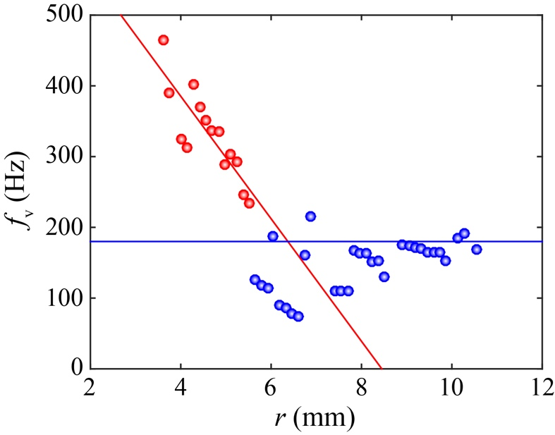
Fig. S14 Relation between the oscillation frequency f_{v} of the vapour film (at the bottom of the drop) and the drop radius r. The dots represent experimental data extracted from prior research³, with the boundary at r = 5.5 mm divided by red and blue colours.

As illustrated in Fig. S14, previous work has focused on the oscillation behaviour of Leidenfrost drops without a cover plate, utilizing f_{v} = 180 Hz when r > 5.5 mm. However, in our study, the drop sizes are generally smaller. For r < 5.5 mm, it appears that f_{v} decreases linearly with r. For the sake of simplicity, we establish the relation between f_{v} and r through a best fit, resulting in

$\left\{\begin{aligned}&f_{v}=k_{1}-k_{2}r, \left(r<5.5 mm\right) \\ &f_{v}=k_{3}, ​​\left(r>5.5 mm\right)\end{aligned}\right.$, (S23)(a)(b)

where k₁ = 731.6 Hz and k₁ = – 86585.6 Hz/m are coefficients obtained from the best fit to the experimental data (red dots in Fig. S16). Moreover, k₃ = 180 Hz was employed in the study of Bouillant et al., successfully explaining the physics of self-excitation in Leidenfrost drops and its implications for their stability³.

Next, as depicted in Fig. S15(a), we plot n as a function of r for r > 5.5 mm. The hollow circles represent theoretical predictions corresponding to the integer mode n and the theoretical drop radius r_{theo}. Furthermore, for a specific n, the width Δr of the highlighted region covers deviations of the theoretical prediction. Thus, we have (r_{theo} – Δr/2) ≤ r ≤ (r_{theo} + Δr/2) in the highlighted region, or equivalently, r_{theo}(1 – ε) ≤ r ≤ r_{theo}(1 + ε), where ε = (Δr/2)/r_{theo} represents the error.

To validate the theoretical predictions, we indicate the experimental results in Fig. S15(a) using solid dots, corresponding to the experimental values of the drop radius r_{exp} and the theoretical prediction n. To quantify the deviation between the experimental results and the theoretical predictions, we define the error as Σ = |r_{exp} – r_{theo}|/r_{theo}. As illustrated in Fig. S15 and Fig. S15, the values of Σ fall within a narrow range, which demonstrates the ability of the theory to predict experimental outcomes.

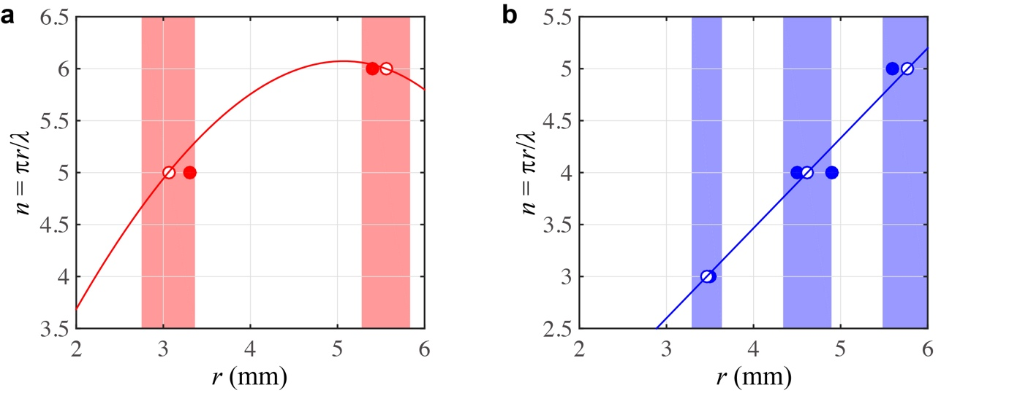
Fig. S15 Relation between n and r. The red curve and blue line in (a) and (b) are obtained using Eq. (S23)(a) and Eq. (S23)(b), respectively. The solid dots represent experimental data, while the hollow circles represent theoretical predictions. In panel (a), the highlighted regions correspond to ε = 10% for n = 5 and 5% for n = 6, respectively. In panel (b), the highlighted regions correspond to ε = 5% for n = 3, ε = 6% for n = 4, and ε = 5% for n = 5, respectively. The deviations between r_{exp} and r_{theo} are presented in Fig. S13.

While there is a good agreement between our theoretical predictions and the experimental outcomes shown in Fig. S15(a), it is important to note that these results represent only a small portion of our overall experimental data. In contrast, the major of the experimental data cannot be predicted using Eq. S(23)(a). We hypothesize that due to the presence of the cover plate, f_{v} may deviate from the predictions of Eq. S(23)(a). Therefore, we attempt to employ Eq. S(23)(b), and the resulting predictions are depicted in the blue line of Fig. S15(b), suggesting a notable agreement between the experimental results and the theoretical predications. These findings suggest that the behavior of f_{v} for large drops can also be applied to our smaller drops with cover plates.

Overall, the number of petals observed in the spinning stars depicted in Fig. S13 can be successfully predicted by the theoretical curves in Fig. S15. Interestingly, even when two drops have similar radii, the mode n may not necessarily be the same. Consequently, solely relying on the theory proposed by Bouillant et al.³ is insufficient to explain our experimental observations. While the co-prediction method of the two curves mentioned above can be consistent with the experimental results, the underlying reason for the different values of f_{v} at the same drop radius remains unclear.

Nevertheless, we discovered that drops with small radii (i.e., 2.0 mm ≤ r ≤ 5.5 mm) also exhibited a wide range of mode n. The resonance conditions are readily satisfied in these drops, similar to their larger counterparts. The cover plate plays a crucial role in satisfying the resonance conditions and enriching the mode n by constraining the solid-liquid-vapour three-phase contact line of the drop. The mass of the cover plate can be considered negligible, as it is much lighter than the drop (~10% of the mass of the drop) and only causes a 1% change in f_{v}.

7.2. Subharmonic resonance condition of the drop with a puddle-like shape
Considering that the drops exhibit a puddle-like shape, we establish the corresponding resonance condition for such drops in this subsection. To this end, we need to determine the secondary resonance mode m, which is defined as

$m=\frac{2r+h}{λ}$, (S24)

where λ represents the capillary wavelength along the amplitude direction of the drop, and r and h represent the instantaneous radius and height of the drop, respectively. To derive m, we must first determine h, which is governed by Eq. (S19). It is important to note that for a drop with a specific value of r, h changes with ω(t), resulting in a lower bound (blue curve) and an upper bound (red curve) of h; these bounds are determined by ω₀ and ω_{max}, as illustrate in Fig. S16(a). As a consequence, we calculate the lower bound (blue curve) and the upper bound (red curve) of h for a specific value of r of a spinning drop, as depicted in Fig. S16(b), which shows how h varies with r.

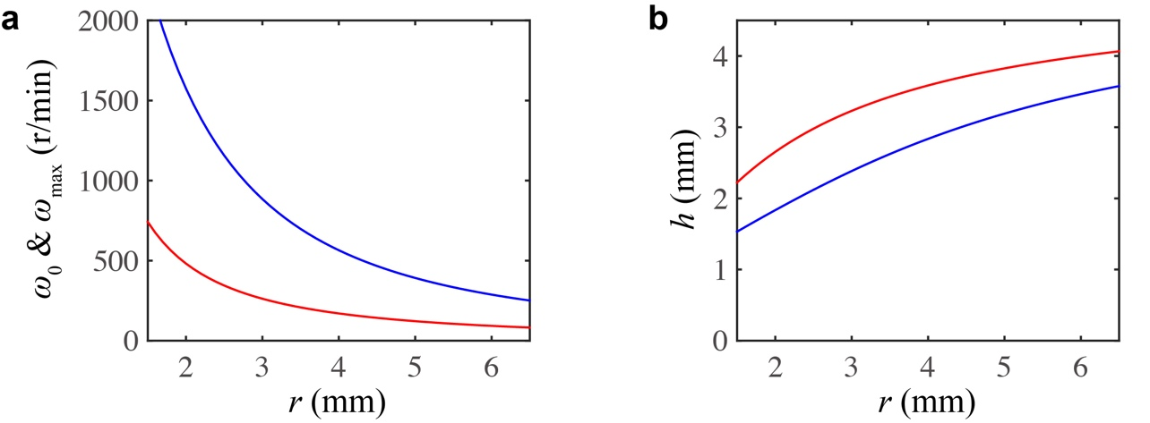
Fig. S16 Relations between ω₀ and r (red curve), and ω_{max} and r (blue curve) (a), along with the relation between h and r (b). The red curve in (b) is derived by substituting r and ω₀ into Eq. (S19), while the blue curve is derived by substituting r and ω_{max} into Eq. (S19).

Considering that h ranges between a lower bound and an upper bound (see Fig. S17(b)), the secondary resonance mode m also has a corresponding lower bound (blue dotted curve) and upper bound (blue dashed curve) as shown in Fig. S17. Given the richness of the phenomena in our problem, to give a clear description, we provide detailed descriptions from various perspectives in Fig. S17. In Fig. S17(a)-(d), the red curves represent the subharmonic mode n, determined by Eq. (S22) with f = f_{v}/2. In Fig. S17(a) and Fig. S17(c), the dotted blue curve represents the results of Eq. (S24) obtained by using ω₀ to derive h (see Eq. (S19)). In contrast, Fig. S17(b) and Fig. S17(d) feature the dashed blue curves, which represent the results of Eq. (S24) obtained by using ω_{max} to derive h (see Eq. (S19)). Additionally, the red and blue hollow dots represent the integer values of n and m, respectively. Here, we specifically discuss the case when n = m in Fig. S17(a) and Fig. S17(b), while n ≠ m is illustrated in Fig. S17(c) and Fig. S17(d). The highlighted regions in these figures represent the zones where double resonance is expected, with the width of each zone defined as Δr = |r_{n} – r_{m}|, where r_{n} and r_{m} correspond to the values of the drop radii corresponding to n and m, respectively.

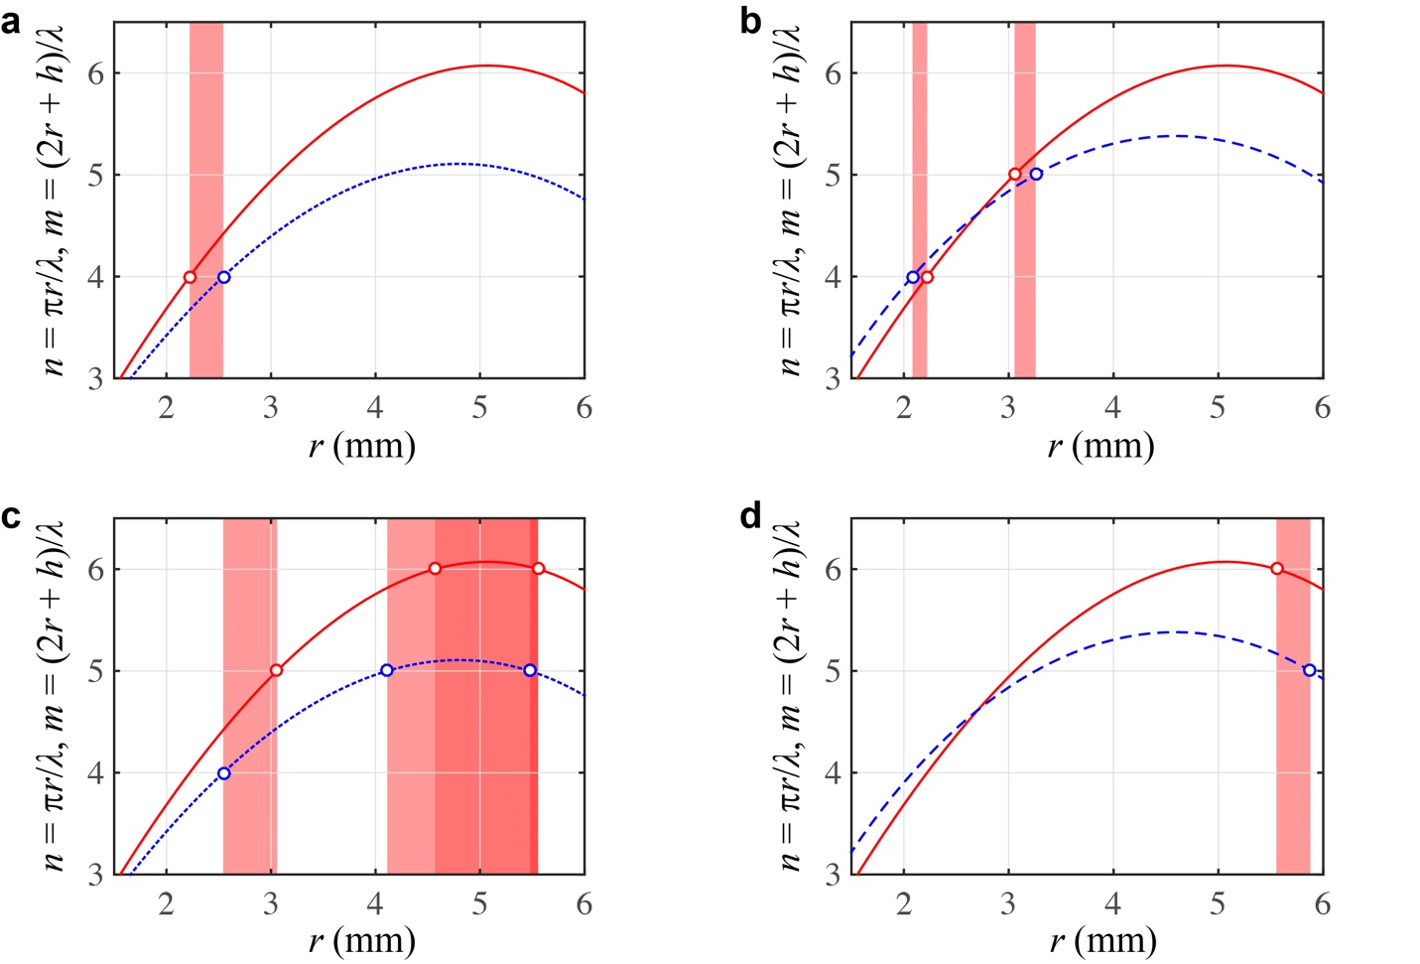
Fig. S17 Regions where the double resonance may occur. The red curves represent the subharmonic modes, determined by Eq. (S22) with f = f_{v}/2, while the dotted and the dashed blue curves represent the results of Eq. (S24) obtained by using ω₀ and ω_{max} to determine h, respectively. (a)(b) Possible scenarios for the double resonance when n = m. (c)(d) Possible cases for the double resonance when n ≠ m. In (c), varying shades of red are used to distinguish different zones (see Table S1).

As listed in Table S1, we present all instances of potential double resonance occurrences, as demonstrate in Fig. S17. To quantify our results, we defined the widths of the highlight regions in Fig. S17 as Δr = |r_{n} – r_{m}|, and their average values as r_{ave} = (r_{n} + r_{m})/2. Consequently, we calculate the corresponding errors as ε = (Δr/2)/r_{ave}. For the cases detailed in Table S1, the errors are below ε = 10% across all instances.

Table S1 Parameters for all instances of double resonance. The results presented in this table correspond to those illustrated in Fig. S17, where n = m in Fig. S17(a)(b) and n ≠ m in Fig. S17(c)(d).
No. | n | r_{n} (mm) | m | r_{m} (mm) | r_{ave} (mm) | ε | Figure
1 | 4 | 2.222 | 4 | 2.544 | 2.383 | 6.76% | Fig. S19(a)
2 | 4 | 2.222 | 4 | 2.083 | 2.153 | 3.22% | Fig. S19(b)
3 | 5 | 3.058 | 5 | 3.257 | 3.158 | 3.15% | Fig. S19(b)
4 | 5 | 3.058 | 4 | 2.544 | 2.801 | 9.17% | Fig. S19(c)
5 | 6 | 4.568 | 5 | 4.113 | 4.341 | 5.24% | Fig. S19(c)
6 | 6 | 4.568 | 5 | 5.474 | 5.021 | 9.02% | Fig. S19(c)
7 | 6 | 5.555 | 5 | 5.474 | 5.515 | 0.73% | Fig. S19(c)
8 | 6 | 5.555 | 5 | 5.878 | 5.717 | 2.83% | Fig. S19(d)

Additionally, based on Fig. S17, we extend the highlighted regions to include new areas with an error of ε = 10%, as depicted in Fig. S18 and Fig. S19. Of course, all the red and blue hollow dots are included within these new highlighted regions.

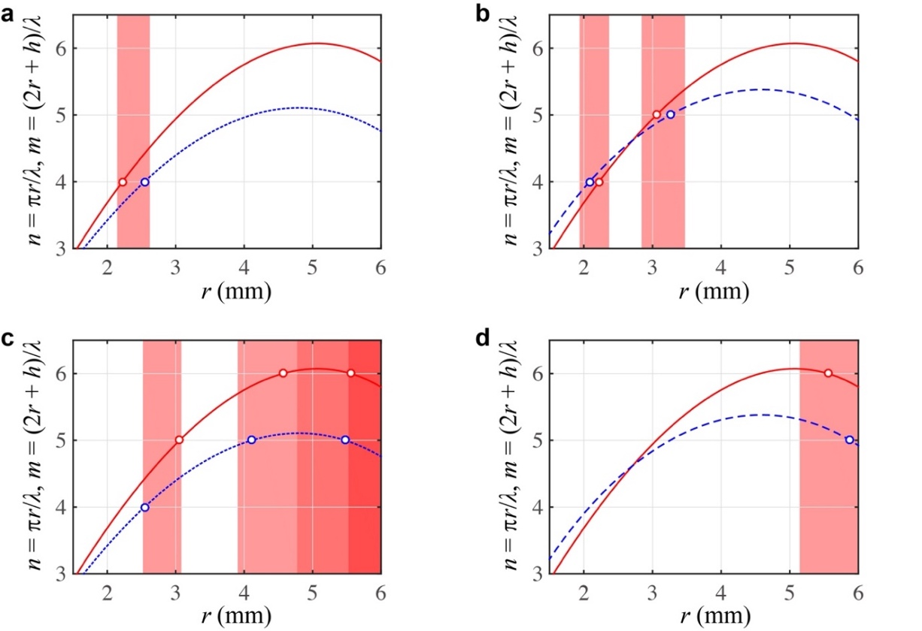
Fig. S18 Regions where double resonance may occur, replotting Fig. S17 with ε extended to ε = 10 %. In (c), varying shades of red are used to distinguish different zones (see Table S1).

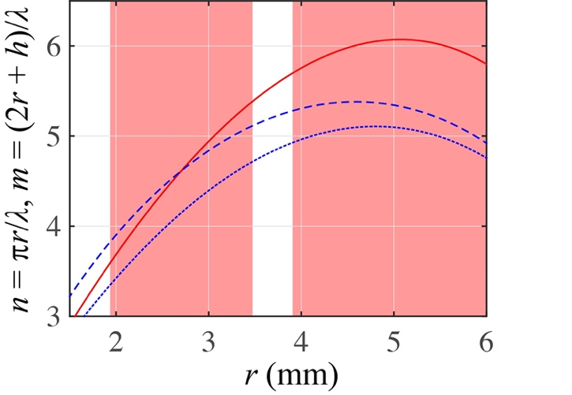
Fig. S19 Regions where double resonance may occur, represented as a superposition of the four sub-figures in Fig. S18 with ε = 10 %.

7.3. Harmonic resonance condition of the drop with a puddle-like shape
Moreover, we also analyze the condition for harmonic resonance. The procedures follow those outlined in subsection 7.2, with the only difference being that when calculating the wave length λ (i.e., λ ≈ [2πσ_{LV}/(ρ_{w}f³)]^{1/3}), we employ f = f_{v} instead of f = f_{v}/2 as in subsection 7.2.

Specifically, with respect to the condition for harmonic resonance, the combination of f = f_{v}, λ = πr/n and λ ≈ [2πσ_{LV}/(ρ_{w}f²)]^{1/3} yields the updated values of n as follows

$n=\frac{π^{\frac{2}{3}}}{2^{\frac{1}{3}}}{\left(\frac{ρ_{w}f_{v}^{2}}{σ_{LV}}\right)}^{\frac{1}{3}}r$, (S25)

where f_{v} is obtained from Eq. (S23)(a) (for r < 5.5 mm). Moreover, when calculating m, we will continue to employ the formula from Eq. (S24) but with the value of λ ≈ [2πσ_{LV}/(ρ_{w}f²)]^{1/3} = [2πσ_{LV}/(ρ_{w}f_{v}²)]^{1/3}.

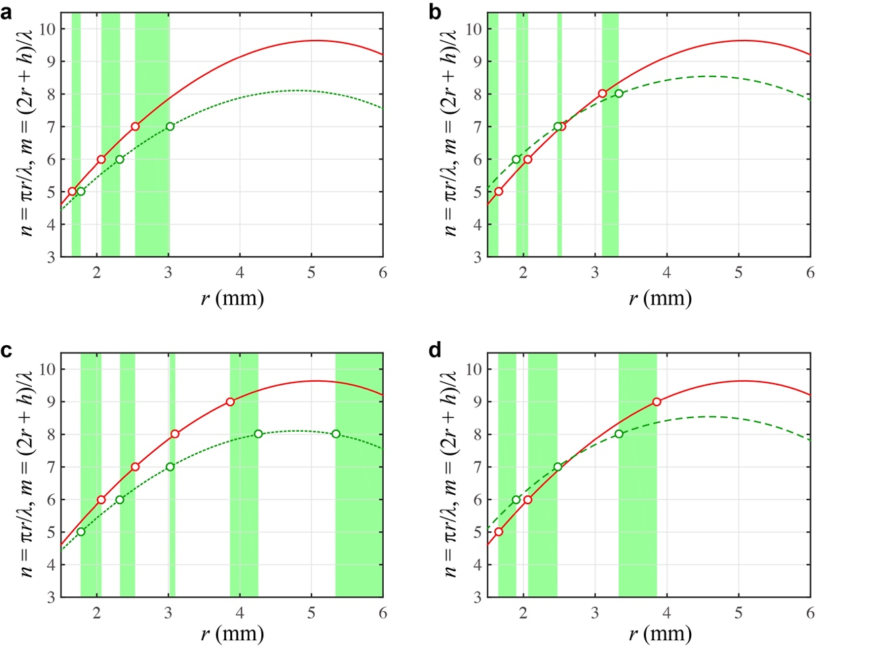
Fig. S20 Regions where the double resonance may occur. The red curves represent the harmonic modes n determined by Eq. (S25), while the dotted and the dashed green curves represents the results of Eq. (S24) (where λ ≈ [2πσ_{LV}/(ρ_{w}f_{v}²)]^{1/3}) obtained by using ω₀ and ω_{max} to determine h, respectively. The red and green hollow dots represent the integer values of n and m, respectively. (a)(b) Possible scenarios for the double resonance when n = m. (c)(d) Possible cases for the double resonance when n ≠ m.

As listed in Table S2, we present all instances of potential double resonance occurrences, as demonstrate in Fig. S20. To quantify our results, we defined the widths of the highlight regions in Fig. S20 as Δr = |r_{n} – r_{m}|, and their average values as r_{ave} = (r_{n} + r_{m})/2. Consequently, we calculate the corresponding errors as ε = (Δr/2)/r_{ave}. For the cases detailed in Table S2, the errors are below ε = 10% across all instances.

Table S2 Parameters for all instances of double resonance. The results presented in this table correspond to those illustrated in Fig. S20, where n = m in Fig. S20(a)(b) and n ≠ m in Fig. S20(c)(d).
No. | n | r_{n} (mm) | m | r_{m} (mm) | r_{ave} (mm) | ε | Figure
1 | 5 | 1.650 | 5 | 1.774 | 1.712 | 3.62% | Fig. S20(a)
2 | 6 | 2.065 | 6 | 2.324 | 2.195 | 5.90% | Fig. S20(a)
3 | 7 | 2.536 | 7 | 3.019 | 2.778 | 8.69% | Fig. S20(a)
4 | 5 | 1.650 | 5 | 1.455 | 1.553 | 6.28% | Fig. S20(b)
5 | 6 | 2.065 | 6 | 1.901 | 1.983 | 4.14% | Fig. S20(b)
6 | 7 | 2.536 | 7 | 2.474 | 2.505 | 1.24% | Fig. S20(b)
7 | 8 | 3.097 | 8 | 3.328 | 3.213 | 3.60% | Fig. S20(b)
8 | 6 | 2.065 | 5 | 1.774 | 1.920 | 7.58% | Fig. S20(c)
9 | 7 | 2.536 | 6 | 2.324 | 2.430 | 4.36% | Fig. S20(c)
10 | 8 | 3.097 | 7 | 3.019 | 3.058 | 1.28% | Fig. S20(c)
11 | 9 | 6.189 | 8 | 5.336 | 5.763 | 7.40% | Fig. S20(c)
12 | 9 | 3.861 | 8 | 4.258 | 4.060 | 4.89% | Fig. S20(c)
13 | 5 | 1.650 | 6 | 1.901 | 1.776 | 7.07% | Fig. S20(d)
14 | 6 | 2.065 | 7 | 2.474 | 2.270 | 9.01% | Fig. S20(d)
15 | 9 | 3.861 | 8 | 3.328 | 3.328 | 7.41% | Fig. S20(d)

Additionally, based on Fig. S20, we extend the highlighted regions to include new areas with an error of ε = 10%, as depicted in Fig. S21 and Fig. S22. Of course, all the red and green hollow dots are included within these new highlighted regions.

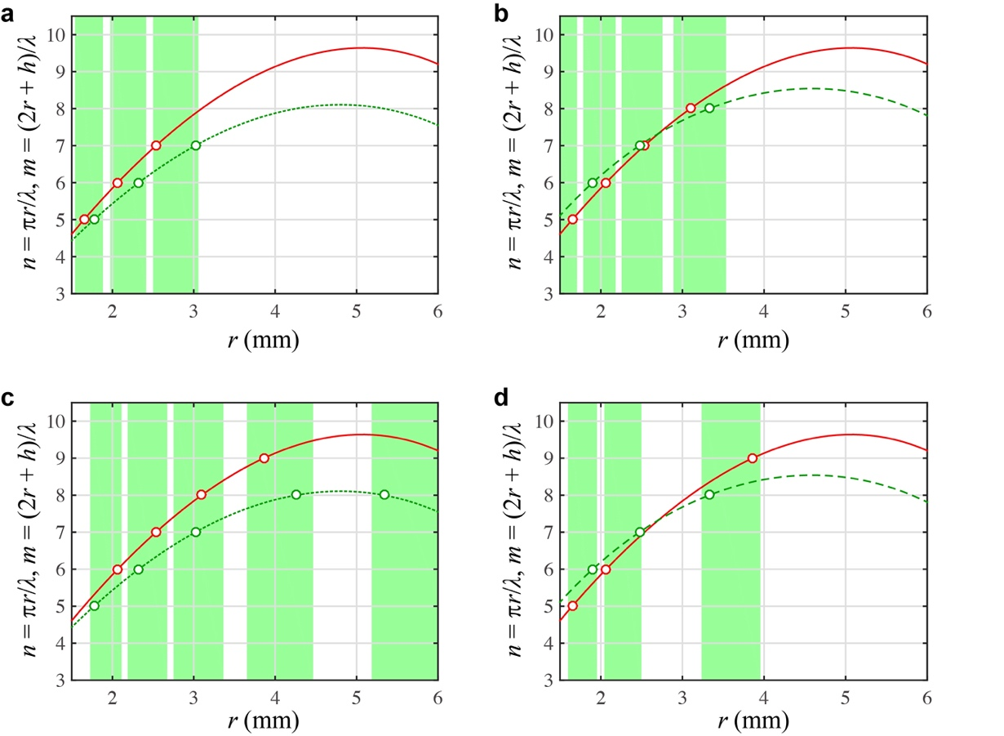
Fig. S21 Regions where the double resonance may occur, replotting of Fig. S20 with ε extended to ε = 10 %.

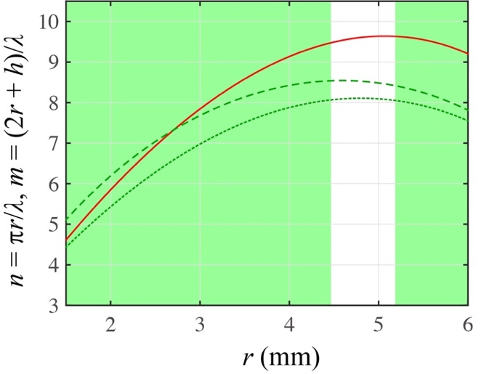
Fig. S22 Regions where double resonance may occur, represented as a superposition of the four sub-figures in Fig. S21 with ε = 10 %.

Figures S19 and S22 comprise Fig. 4b in the main paper.

Supplementary Note 8
Analysis of drop shapes
8.1. Shapes of free static drops under gravity
In this section, we investigate the shape of a static drop under the influence of gravity, considering the necessity of utilizing the height of the drop for our analysis of its rotational behaviour in section 4.

The drop shape is governed by the well-known Young-Laplace equation^{10,11},

$ΔP=2Hγ_{LV}=\left(κ_{1}+κ_{2}\right)γ_{LV}$, (S26)

where ΔP represents the pressure difference between the inside and outside of the drop, H represents the mean curvature at a specific point on the liquid-vapour interface, and κ₁ and κ₁ denote the two corresponding principal curvatures. When gravity is involved in our scenario, Eq. (S26) is reformulated as^{10,11}

$ΔP=P_{0}-ρ_{w}gz$. (S27)

Here, P₀ represents the pressure at a reference point within the drop, and the choice of this reference point does not alter the outcome of the drop shape. Additionally, z represents the vertical coordinate at a specific point on the liquid-vapour interface, defined as positive in the upward direction.

Since there is no analytical solution available for Eq. (S27), we employ a numerical method to resolve it. The outcomes of Eq. (S27) for different equatorial radii are illustrated in Fig. S23. In our scenario, we consider the drop as Leidenfrost drops, setting the contact angle θ between the drop and the substrate to θ = 180°. In Fig. S23, r_{max} = x_{max} and h = z_{max} represent the equatorial radius and height of the drop, respectively.
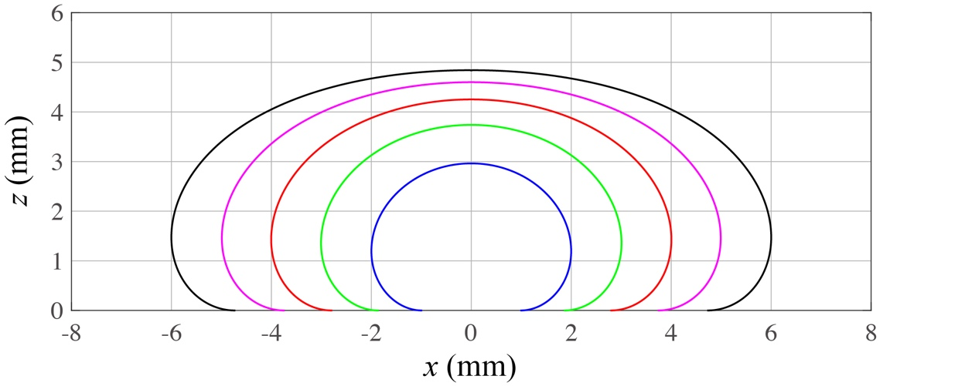
Fig. S23 Shapes of static drops under gravity. The blue, green, red, magenta and black curves correspond to (r_{max}, h) = (2.0 mm, 2.96 mm), (3.0 mm, 3.74 mm), (4.0 mm, 4.25 mm), (5.0 mm, 4.60 mm) and (6.0 mm, 4.84 mm), respectively. The cylindrical coordinate system is employed, with x and z designated as the radial and vertical directions, respectively.

The findings depicted in Fig. S23 suggest that, despite the equatorial diameters (for instance, r_{max} = 5 mm, magenta curve) of the drops being remarkably larger than the capillary length l_{c} (l_{c} = 2.5 mm), the drop heights remain noticeably smaller than 2l_{c}.

8.2. Shapes of free spinning drops under gravity
In this section, we explore the shape of a spinning drop under the combined influence of gravity and rotational velocity. When considering these factors, the centrifugal force becomes a critical component, necessitating a reformulation of the Young-Laplace equation as follows¹¹

$ΔP=2Hγ_{LV}=\left(κ_{1}+κ_{2}\right)γ_{LV}=P_{0}-ρ_{w}gz+\frac{1}{2}ρx^{2}ω^{2}$, (S28)

where ω represents the angular velocity of the drop. Here, we adopt a cylindrical coordinate system, with x and z retaining the same definitions as provided in the last section.

Since an analytical solution for Eq. (S28) is unavailable, we employ a numerical method to address it. The results of Eq. (S28) for varying equatorial radii are illustrated in Fig. S24. Treating the drop as a Leidenfrost drops, we set the contact angle θ between the drop and the substrate to θ = 180°. For illustration, we consider a typical angular velocity of ω = 200 r/min (see our experimental result in the main paper).
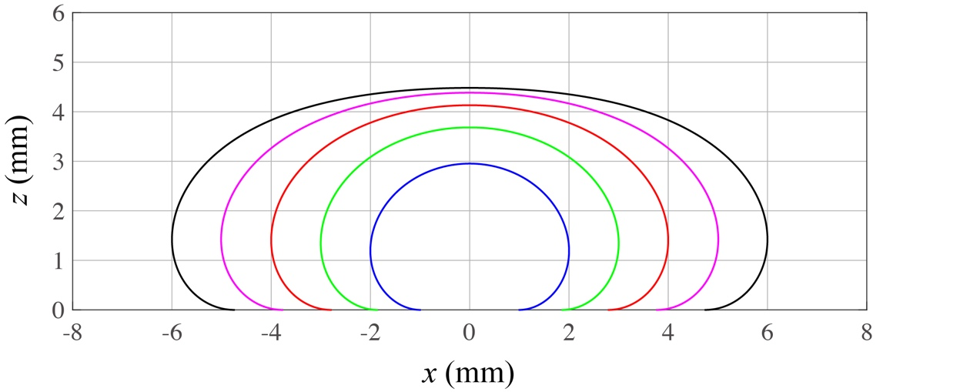
Fig. S24 Shapes of spinning drops under gravity at ω = 200 rmp. The blue, green, red, magenta and black curves correspond to (r_{max}, h) = (2.0 mm, 2.95 mm), (3.0 mm, 3.68 mm), (4.0 mm, 4.13 mm), (5.0 mm, 4.38 mm) and (6.0 mm, 4.48 mm), respectively.

A comparison between Fig. S23 and Fig. S24 reveals a noticeable decrease in drop height for the same value of r_{max} when rotational velocity is considered. In our experiments, where the radius R of the cover plate ranges from 2.0 mm to 5.0 mm, we select an average value of h = 3.5 mm for simplicity (see Supplementary Note 4). This height corresponds to approximately 70% of 2l_{c} (2l_{c} = 5.0 mm).

Supplementary Note 9
Theoretical estimation of free drop evaporation
In this section, we provide a theoretical estimation of drop evaporation, focusing on determining the evaporation rate of the drop over time. Drawing from thermal dynamics, we derive the evaporation rate (absolute value) as^{1,12}

$\frac{dM}{dt}=\frac{k}{L}\frac{ΔT}{δ}A=\frac{k}{L}\frac{ΔT}{δ}πr^{2}$, (S29)

where k represents the thermal conductivity of water vapour, L represents the latent of evaporation of water, ΔT represents the temperature difference between the substrate and the drop, δ represents the thickness of the vapour film, and A represents the contact zone between the substrate and the drop. In our experiments, since the drop size is sufficiently larger than the capillary length l_{c}, we approximate the drop mass and the contact zone as M = ρ_{w}πr²h and A = πr², with ρ_{w}, r and h being the mass density, radius of the contact zone and drop height, respectively.

On the other hand, the weight of the drop induces a radial Poiseuille flow of vapour between the drop and the substrate^{1,12}. By employing the lubrication approximation, we obtain

$\frac{dM}{dt}=ρ_{v}\frac{2πδ^{3}}{3η_{v}}Δp$, (S30)

where ρ_{v} and η_{v} represents the mass density and dynamic viscosity of the vapour, respectively. Moreover, Δp = ρ_{w}gh represents the pressure exerted by the drop, with g being the gravitational acceleration. The combination of Eq. (S29) and Eq. (S30) leads to a theoretical estimate of the thickness of the vapour film given by

$δ={\left(\frac{3kΔTη_{v}}{2Lρ_{v}ρ_{w}gh}\right)}^{\frac{1}{4}}r^{\frac{1}{2}}=k_{1}r^{\frac{1}{2}}$, (S31)

where, for simplicity, we introduce a coefficient k₁, and k₁ = [(3kΔTη_{v})/(2Lρ_{v}ρ_{w}gh)]^{1/4}. When substituting Eq. (S31) into Eq. (S29), we obtain

$\frac{dM}{dt}=\frac{k}{L}\frac{ΔT}{δ}A=\frac{k}{L}\frac{ΔT}{δ}πr^{2}=\frac{π}{k_{1}}\frac{kΔT}{L}r^{\frac{3}{2}}$. (S32)

Furthermore, by substituting M = ρ_{w}πr²h into Eq. (S32), we arrive at

$r\left(t\right)=\frac{1}{4}{\left(k_{2}t+2r_{0}^{\frac{1}{2}}\right)}^{2}$, (S33)

where r₀ = r|_{t = 0} represents the initial radius of the drop. The expression for the coefficient k₂ is defined as follows

$k_{2}=-\frac{1}{2^{\frac{3}{4}}}\frac{1}{3^{\frac{1}{4}}}{\left(\frac{kΔT}{L}\right)}^{\frac{3}{4}}{\left(\frac{ρ_{v}g}{η_{v}}\right)}^{\frac{1}{4}}{\left(\frac{1}{hρ_{w}}\right)}^{\frac{3}{4}}$. (S34)

Based on this theoretical framework, we can estimate the evolution of the drop radius r over time t, and we also present the change of the vapour film thickness δ with r, as illustrated in Fig. S25. In our analysis, we consider a drop with an initial radius of r₀ = 5 mm. Based on the range of temperature in our experiments, we select ΔT = 275 °C. If the drop size is significantly larger than l_{c} (i.e., 2r >> l_{c}), the drop height would remain constant at 2l_{c} during evaporation. However, in our specific scenario with r₀ = 5 mm, the drop height would gradually vary over time during evaporation. Consequently, we adopt an “average height” for the drop throughout evaporation process, setting h = 3.5 mm in our calculations (see Fig. S24 for drops with different radii as a reference).

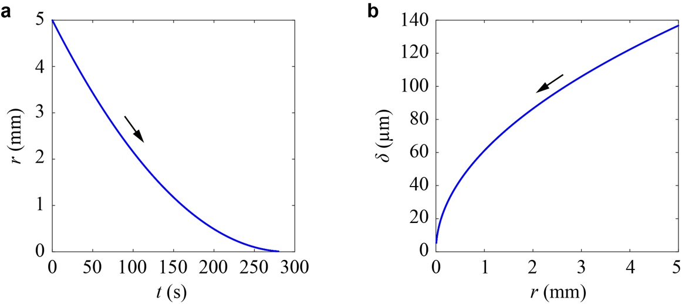
Fig. S25 Estimation of the evaporation rate of a Leidenfrost drop. (a) Time dependence of the drop radius. (b) Relation between the thickness δ of the vapour film and the drop radius r. The arrows indicate the progress direction of time.

Based on Fig. S25, we can draw the following conclusions:
(1) It is evident that for drop radii in the range of 2.5 mm < r < 5.0 mm, the relation between r and t demonstrates an almost linear trend. Based on this fact, the evaporation rate of the drop radius, defined as v = |dr/dt|, can be estimated by employing the theoretical data (Fig. S25a) within the range 2.5 mm < r < 5.0 mm. As a consequence, we obtain v ≈ 29.2 μm/s.
(2) As illustrated in Fig. S8 in the above analyses (see Supplementary Note 4), our experimental data and theoretical analysis indicate that when the accelerated spinning begins, the drop radius is approximately 0.5 mm larger than the drop radius at its maximum spinning velocity, i.e., Δr = 0.5 mm. Given that v ≈ 29.2 μm/s, we can calculate that a time duration of Δt = Δr/v ≈ 17.1 s is required for the drop to reach its maximum spinning velocity, which is quite close to the experimental value of 20 s (see Fig. S8). These analyses suggest that different aspects of our work are consistent with one another.

Moreover, based on volume conservation, we can express the evaporation rate of the drop with the following formula

$\frac{dM}{dt}=2πRδρ_{v}U_{∥}$, (S35)

where U|| denotes the velocity of the water vapour along the radial direction between the drop and the substrate. The combination of Eq. (S29) and Eq. (S35) leads to

$U_{∥}=\frac{kΔTR}{2ρ_{v}Lδ^{2}}={\left(\frac{kΔTρ_{w}gh}{6ρ_{v}Lη_{v}}\right)}^{\frac{1}{2}}$. (S36)

It is important to note that the results presented above are based on the case of large drops. For small drops that do not exhibit a puddle shape, necessary modifications to the theory must be implemented¹.

Movie legend
Supplementary Movie S1
A copper plate (~0.21 g) was placed onto a water drop (initial volume of ~350 µL, dyed red to aid visualisation), which is on a hot substrate (500 ℃). The water drop shows a high-speed spin by adding water of room temperature.
Supplementary Movie S2
Comparison of a conventional Leidenfrost drop and a Biellmann-Leidenfrost spinning drop.
Supplementary Movie S3
Side view observation of a conventional Leidenfrost drop and a Biellmann-Leidenfrost spinning drop.
Supplementary Movie S4
Spin direction is controlled using an asymmetric needle.
Supplementary Movie S5
A polystyrene sphere was placed in the drop to observe if there is any slip between the drop and the cover plate. Under the condition of the best spin stability, there is no displacement observed between the sphere and the marker on the cover plate during drop spinning, indicating a non-slip condition between the drop and the cover plate.
Supplementary Movie S6
Time dependence of the angular velocity ω throughout the lifespan of a spinning Biellmann-Leidenfrost drop.
Supplementary Movie S7
Persistence of vision effect of a spinning Biellmann-Leidenfrost drop showing a series of actions of Biellmann’s spin in figure skating on the cover plate at an angular velocity of 225 r/min.
Supplementary Movie S8
Continuous Biellmann-Leidenfrost spinning behaviour that was sustained by replenishing the evaporating drop.

References
1 Biance, A.-L., Clanet, C. & Quéré, D. Leidenfrost drops. Physics of Fluids 15, 1632-1637 (2003).
2 Quéré, D. Leidenfrost dynamics. Annual Review of Fluid Mechanics 45, 197-215 (2013).
3 Bouillant, A., Cohen, C., Clanet, C. & Quéré, D. Self-excitation of Leidenfrost drops and consequences on their stability. Proceedings of the National Academy of Sciences 118, e2021691118 (2021).
4 Faraday, M. On a peculiar class of acoustical figures; and on certain forms assumed by groups of particles upon vibrating elastic surfaces. Proceedings of the Royal Society of London Series I 3, 49-51 (1831).
5 Douady, S. Experimental study of the Faraday instability. Journal of Fluid Mechanics 221, 383-409 (1990).
6 Kumar, K. & Tuckerman, L. S. Parametric instability of the interface between two fluids. Journal of Fluid Mechanics 279, 49-68 (1994).
7 Guyon, E., Hulin, J. P., Petit, L. & Mitescu, C. D. Physical hydrodynamics. (Oxford university press, 2015).
8 Lv, C. & Shi, S. Wetting states of two-dimensional drops under gravity. Physical Review E 98, 042802 (2018).
9 Landau, L. D. & Lifshitz, E. M. Fluid Mechanics, 2nd ed., 242–243 (Pergamon Press, Oxford, 1987).
10 Gennes, P.-G., Brochard-Wyart, F. & Quéré, D. Capillarity and wetting phenomena: drops, bubbles, pearls, waves. (Springer, 2004).
11 Langbein, D. W. Capillary surfaces: shape—stability—dynamics, in particular under weightlessness. Vol. 178 (Springer, 2003).
12 Bird, R. B., Stewart, W. E. & Lightfoot, E. N. Transport Phenomena, 2nd Editon. (John Wiley & Sons, Inc., 2007).

