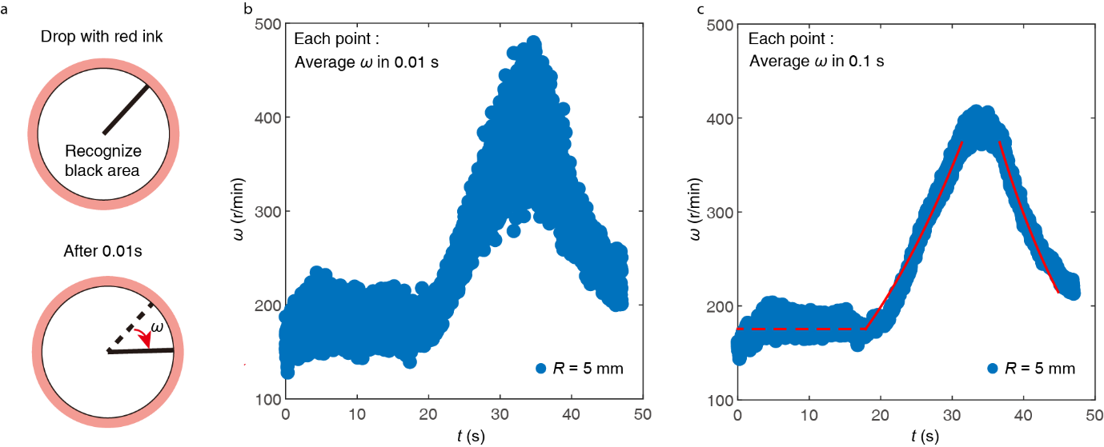
Extended Data Fig. 1 Angular velocity measurement. (a) Schematic illustrating a top view of a spinning drop, where water is dyed with red ink. The white part with a black boundary represents the cover plate, while the solid black line represents the pointer used to measure the angular velocity of the spinning drop. By determining the turning angle of the pointer at a specific time, we can calculate the angular velocity of the spinning drop. (b) Angular velocity ω as a function of time t throughout the entire spinning process, calculated using the frame-by-frame difference method. Each point on the plot represents the average value of the angular velocity over 0.01 s. The radius of the cover plate is R = 5 mm. (c) This is the same experiment as (b), but each point on the plot represents the average value of the angular velocity over 0.1 s. The dashed line and solid curves represent theoretical predictions (see details presented in Supplementary Note 4).

