Supplementary Information

Mitigating Stainless Steel Dissolution in LiFSI-based Electrolytes: Insights into Dissolution Mechanisms and Enhancing Cycle Life in Lithium-ion Batteries

  - Peng Yan¹, Marian Cristian Stan¹, Kazem Zhour², Diddo Diddens¹, Christian Wölke¹, Rayan Guerdelli¹, Martin Winter^{1,3} and Isidora Cekic-Laskovic^{1*}

¹Helmholtz-Institute Münster (HI MS), IMD-4, Forschungszentrum Jülich GmbH, Corrensstraße 48, 48149 Münster, Germany
²Institute of Physical Chemistry, University of Münster, Corrensstraße 28, 48149 Münster, Germany
³MEET Battery Research Center, University of Münster, Corrensstraße 46, 48149 Münster, Germany

Supplementary Figures
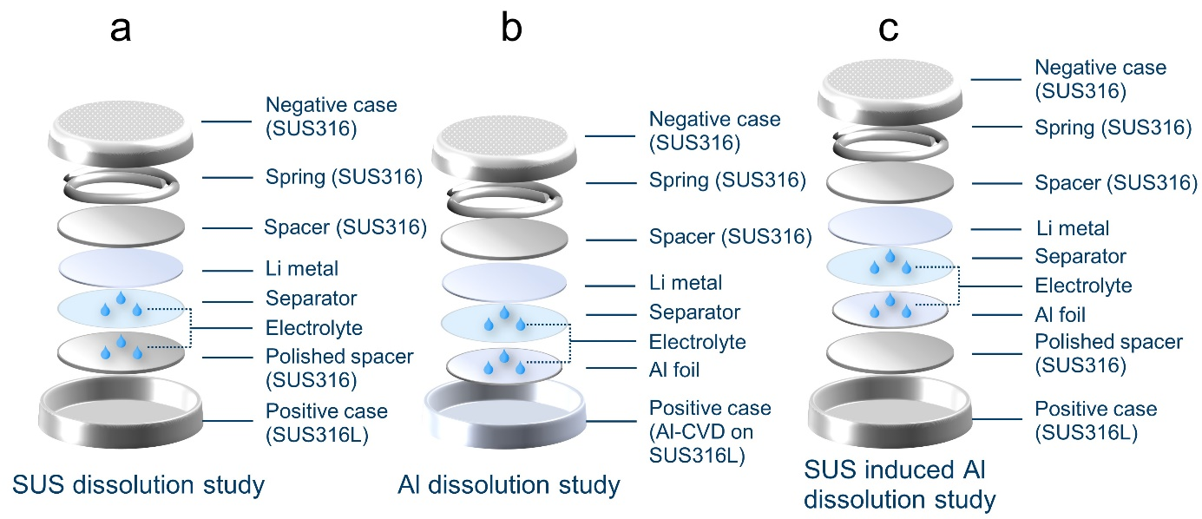
Figure S 1. Illustration of the coin cell setup for (a) SUS dissolution, (b) Al dissolution and (c) SUS induced Al dissolution studies.

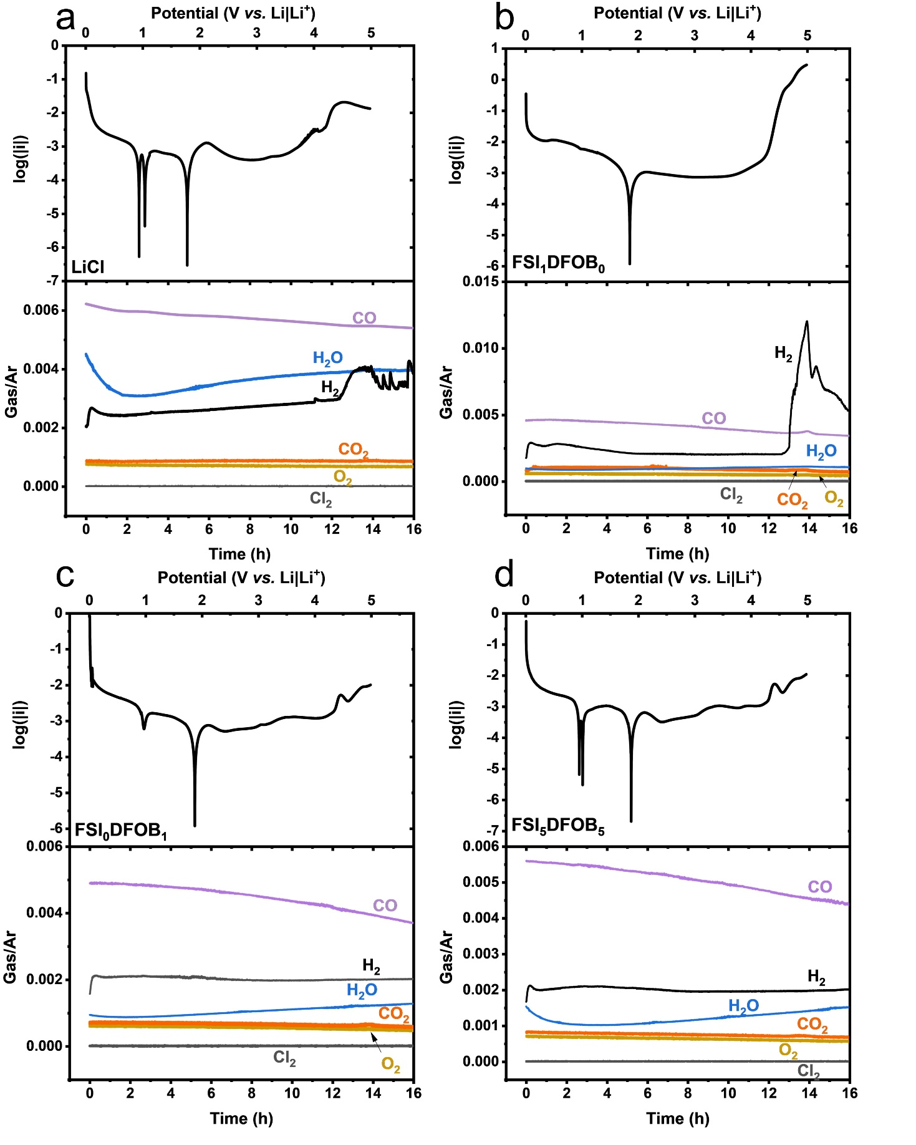
Figure S 2. Linear sweep voltammograms of 3-electrode DEMS cells scanned at 0.1 mV s⁻¹ using SUS316 as a working electrode and corresponding gas evolution. The following gases were measured: H₂ (m/z=2), CO₂ (m/z=44), CO (m/z=28), O₂ (m/z=32), H₂O (m/z=18), Cl₂ (m/z=70, 72, 74) and all gases were normalized to the Ar signal to eliminate the fluctuation of the carrier gas.

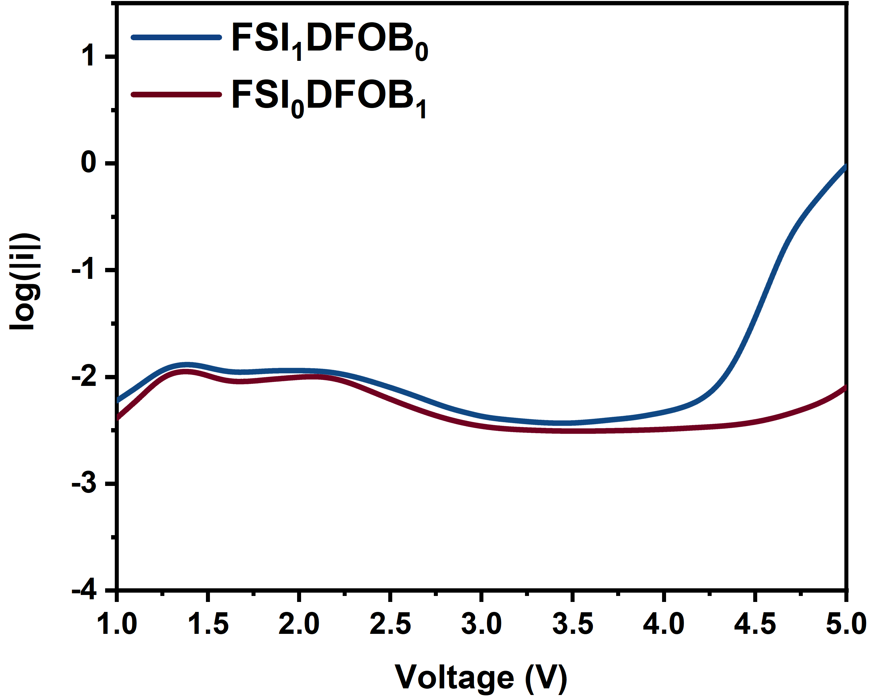
Figure S 3. Linear sweep voltammogram of cells containing SUS316 as working electrode with FSI₁DFOB₀ or FSI₀DFOB₁ electrolyte.

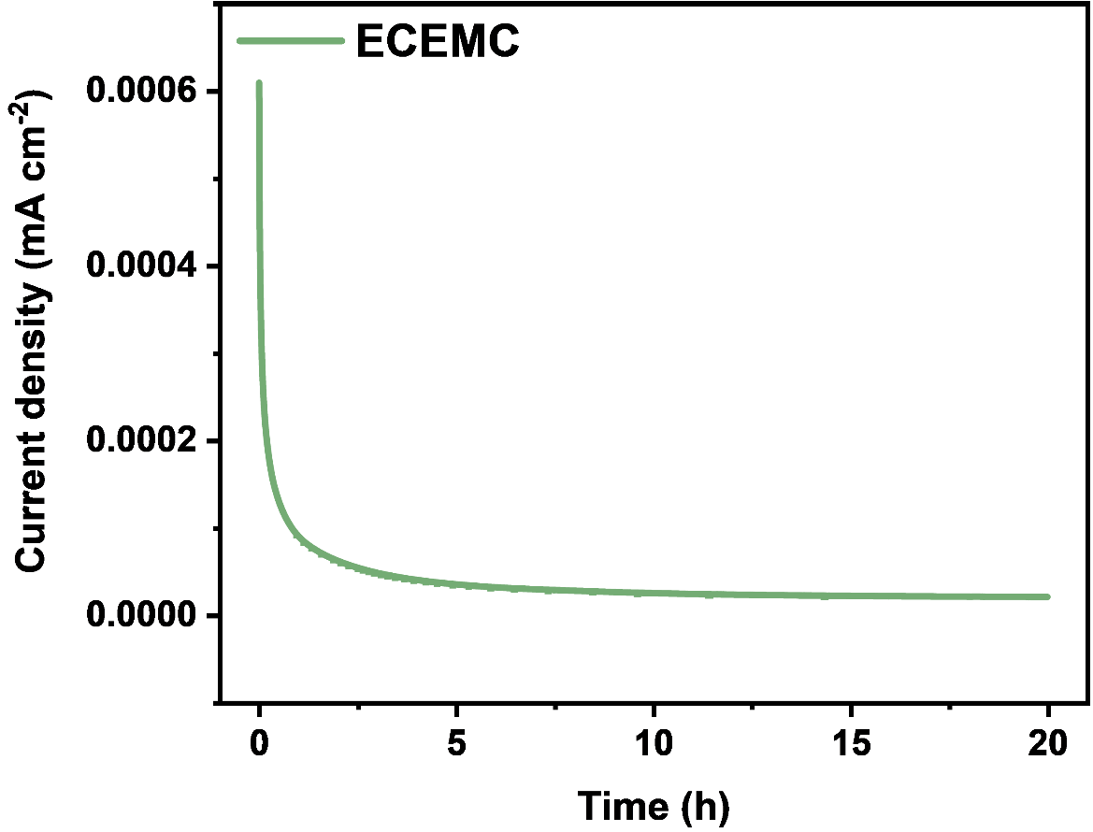
Figure S 4. Chronoamperogram of the base EC:EMC solvent mixture recorded at a potential of 4.2 V vs. Li⎮Li⁺ for 20 h.

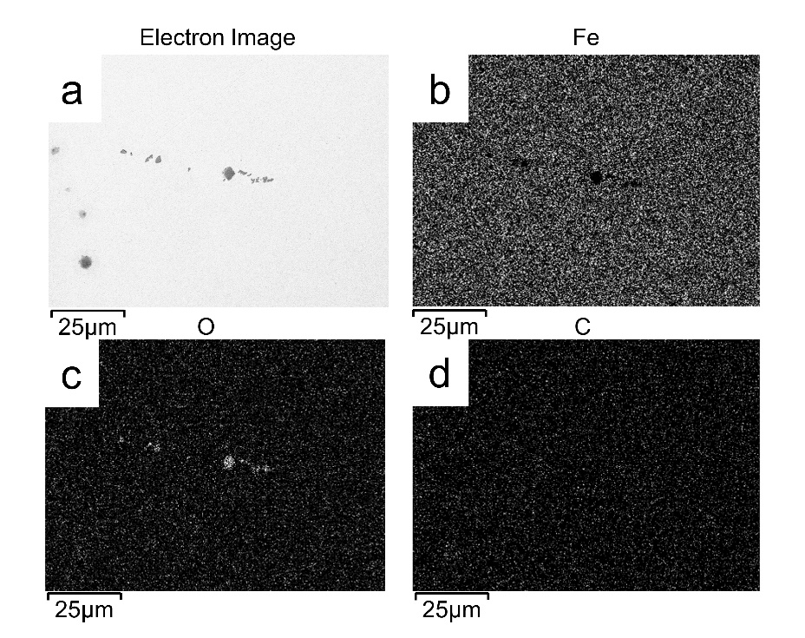
Figure S 5. EDX images of the polished SUS316 spacer harvested from cells after 20 h of chronoamperometry measurements with 5 ppm LiCl in the electrolytes. (a) Electron image. (b) EDX image of Fe element. (c) EDX image of O element. (d) EDX image of C element.

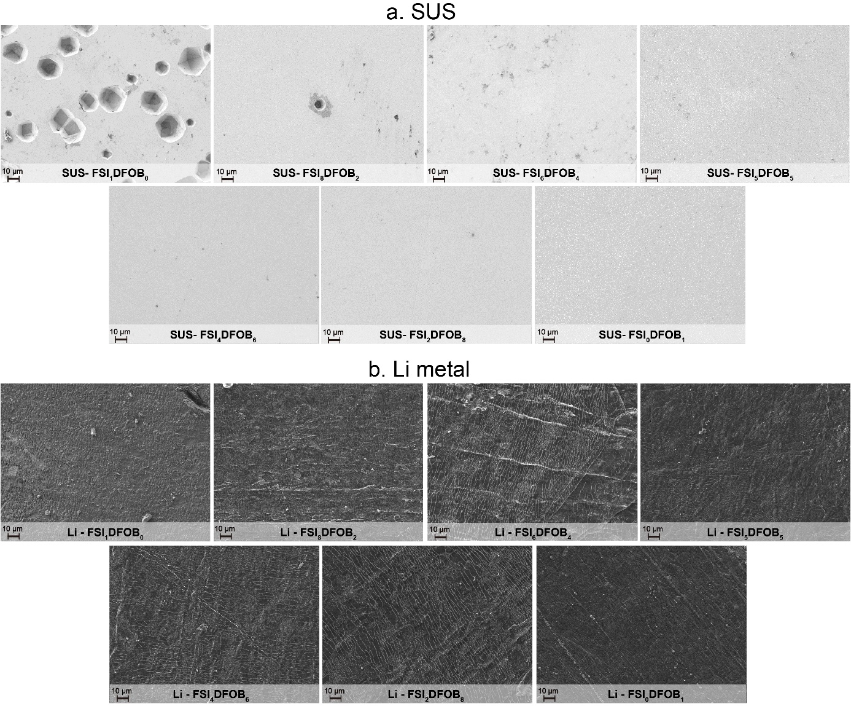
Figure S 6. SEM images of (a) SUS316 spacers and (b) Li metal recovered from cells containing LiDFOB-based electrolytes after 20 h of CA measurement at 4.2 V vs. Li⎮Li⁺.

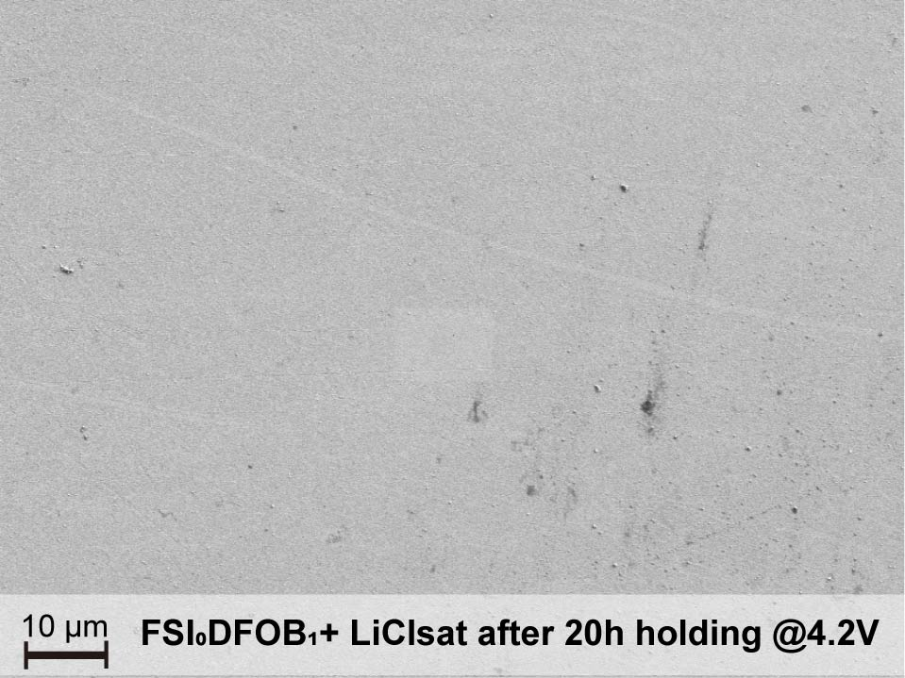
Figure S 7. SEM images of SUS316 spacers recovered from 20 h CA measurement with FSI₀DFOB₁+ LiCl_{sat} electrolyte.

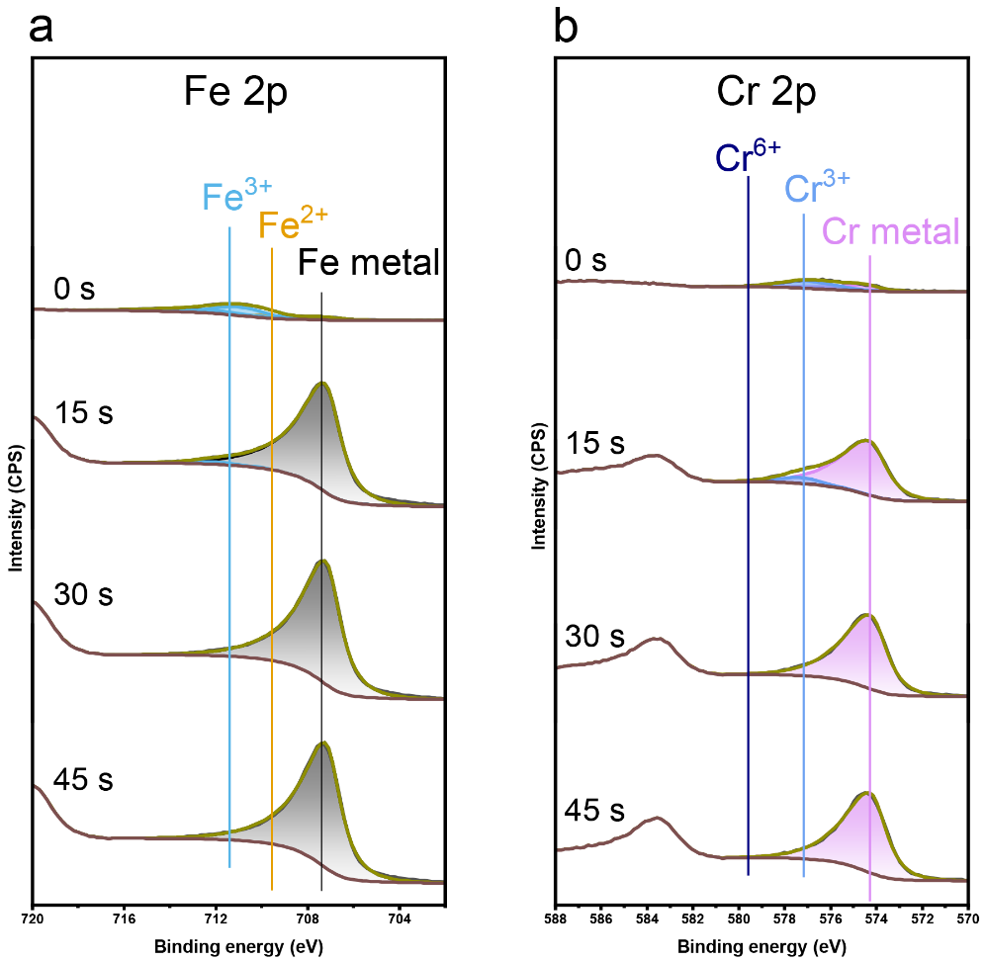
Figure S 8. Selected a) Fe 2p and b) Cr 2p XPS spectra of pristine SUS316 at 0 s, 15 s, 30 s and 45 s etching time.

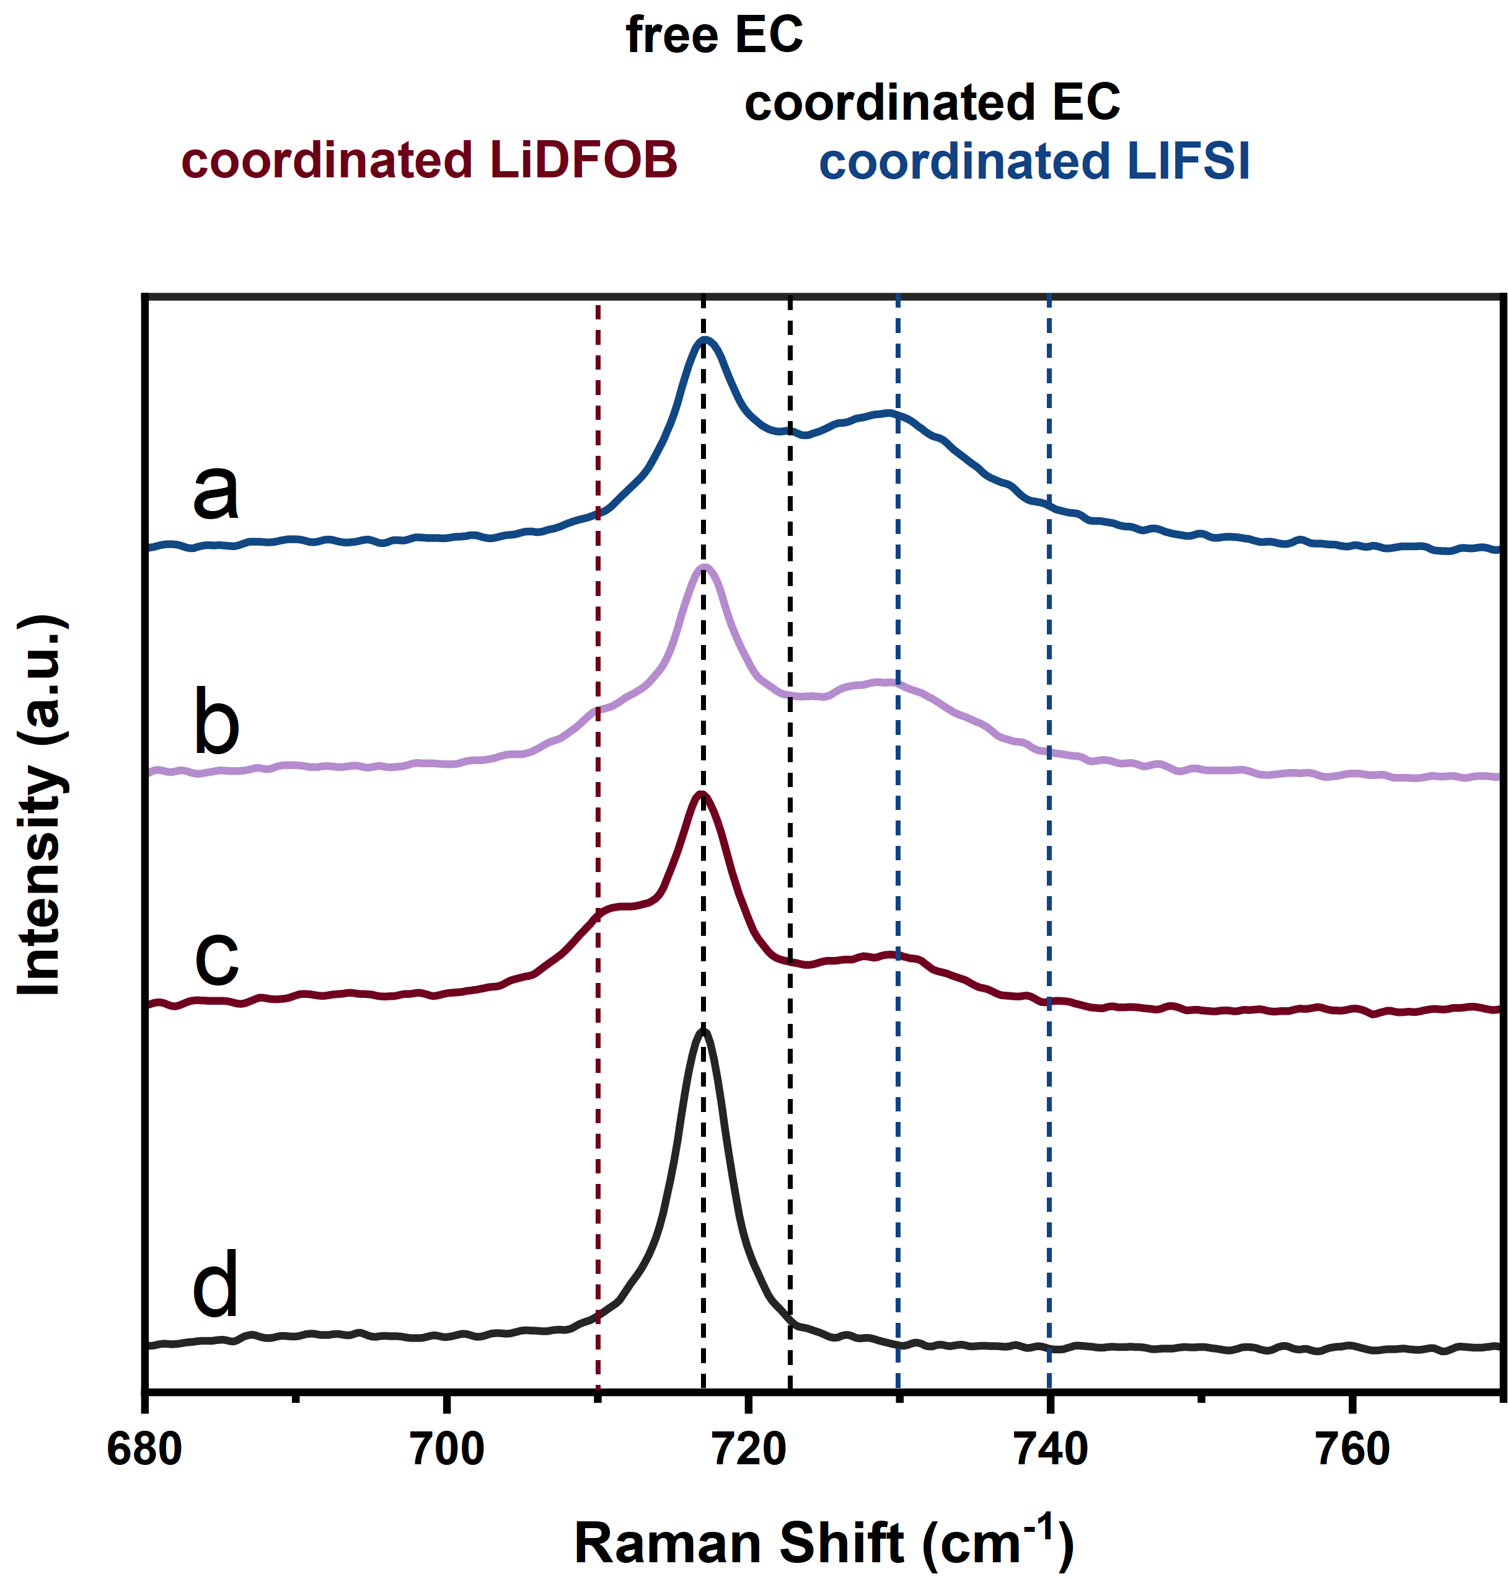
Figure S 9. Selected Raman spectra of different conducting salt containing electrolytes (a) FSI₁DFOB₀, (b) FSI₅DFOB₅, (c) FSI₀DFOB₁ and (d) 100ppm LiCl.
The band shown at ≈716 cm⁻¹ can be attributed to the C=O ring bending vibration in EC while the band at ≈723 cm⁻¹ can be explained by the coordination between free EC and Li⁺ ion upon the addition of lithium salts. In electrolytes containing LiDFOB, the bands attributed to the ring breathing of DFOB⁻ anion are fitted at ≈710 cm-1 and ≈725-734 cm⁻¹, corresponding to the coordinated LiDFOB^{[1]}. The first band of coordinated LiDFOB at ≈710 cm⁻¹ can be attributed to the solvent-separated ion pairs (SSIPs, an anion interacting with less than one Li⁺ ion) or contact-ion pairs (CIPs, an anion interacting with one Li⁺ ion) while another band at ≈725-734 cm⁻¹ is attributed to the aggregates (AGGs, an anion interacting with two or more Li⁺ ions)^{[1]}. In electrolytes containing LiFSI, additional peaks attributed to coordinated LiFSI are fitted at ≈724-734 and ≈740 cm⁻¹, corresponding to the CIP and AGG, respectively^{[1]}. With this understanding, the solvation structure of electrolytes upon the addition of different lithium salts can be characterized. The spectra of electrolytes containing 100 ppm LiCl have only a band fitted to free EC, suggesting that solvation structures are not enough to be detectable at the ppm level of LiCl (Figure S 9d). The spectra of FSI₁DFOB₀ electrolyte comprise large area peaks of free EC, solvated EC, and CIP while only a small area of AGG from FSI⁻ anions (Figure S 9a). As for the spectra of FSI₀DFOB₁ electrolyte, a large area of free EC, SSIPs/CIPs and AGGs can be observed, with only a small amount of solvated EC, suggesting the lower dissociation ability of LiDFOB in the organic carbonated solvents compared to LiFSI (Figure S 9c). In the blended salt electrolyte FSI₅DFOB₅, both DFOB⁻ and FSI⁻ anions and the EC solvent are involved in the coordination with Li⁺ ion, highlighting the contribution of both anions within the solvation structure (Figure S 9b).
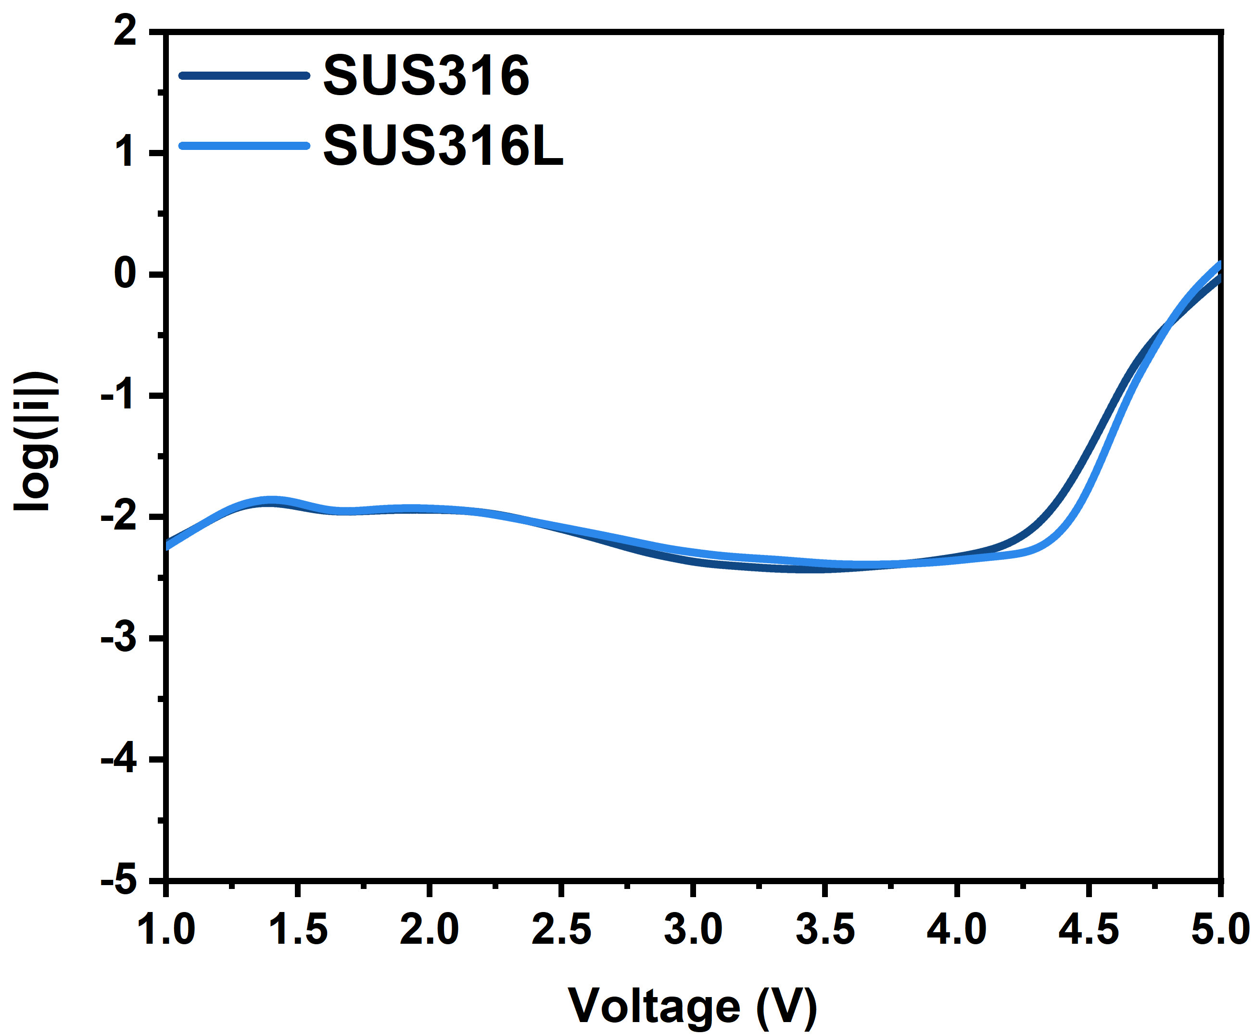
Figure S 10. LSV voltammogram of cells containing SUS316 and SUS316L as working electrodes in FSI₁DFOB₀ electrolyte.

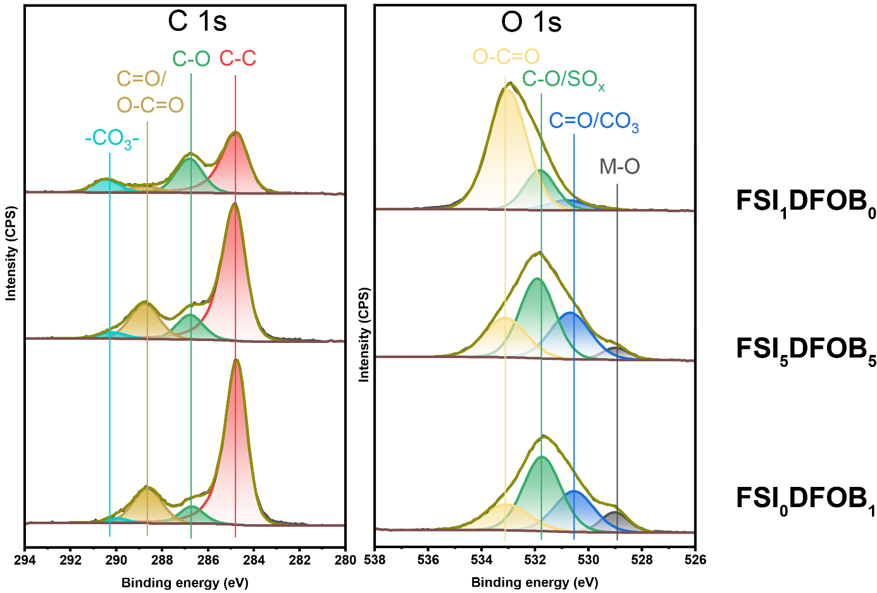
Figure S 11. Selected XPS spectra of the harvested SUS316 spacers from the cells containing FSI₁DFOB₀ (top), FSI₅DFOB₅ (middle) and FSI₀DFOB₁ (bottom) electrolytes after 20 h at 4.2 V.

Supplementary Tables
Table S 1. Elemental distribution weight percentage on the surface of SUS316 collected by EDX.
 | C (%) | O (%) | Fe (%) | Cr (%) | Ni (%) | F (%) | S (%)
Pristine | 2.55 | 1.12 | 68.00 | 17.04 | 11.29 | 0.00 | 0.00
LiCl_{sat} | 23.18 | 32.38 | 31.00 | 0.00 | 5.00 | 0.00 | 0.00
FSI₁DFOB₀ | 3.49 | 2.82 | 55.54 | 14.54 | 8.83 | 0.41 | 3.17
FSI₂DFOB₈ | 2.71 | 2.56 | 67.12 | 11.46 | 8.14 | 1.42 | 1.09
FSI₅DFOB₅ | 2.22 | 1.61 | 66.86 | 11.33 | 7.79 | 1.48 | 0.85
FSI₀DFOB₁ | 1.94 | 2.44 | 68.54 | 10.91 | 7.92 | 0.43 | 0.00

Table S 2. Elemental distribution on the surface of Li collected by EDX.
 | Li (%) | C (%) | O (%) | F (%) | N (%) | S (%) | Fe (%)
FSI₁DFOB₀ | 0.00 | 16.70 | 46.75 | 4.95 | 1.51 | 9.73 | 20.36
FSI₂DFOB₈ | 85.76 | 3.98 | 7.07 | 1.71 | 1.48 | 0.00 | 0.00
FSI₅DFOB₅ | 86.95 | 3.31 | 6.22 | 1.87 | 1.55 | 0.00 | 0.00
FSI₀DFOB₁ | 80.31 | 8.86 | 7.73 | 1.55 | 1.25 | 0.00 | 0.00

Investigation of SUS Inhibition Mechanism of LiDFOB
Extended CA measurements conducted for up to 1,000 h with samples containing FSI₆DFOB₄ and FSI₄DFOB₆ electrolytes reveal the important role of LiDFOB in suppressing the SUS dissolution. A slight increase in current is observed after 200 h for FSI₆DFOB₄ and 500 h for FSI₄DFOB₆ (Figure S 12a). The positive correlation between the hours for dissolution starting and LiDFOB amounts reveals that LiDFOB may act as a sacrificial salt additive to protect the SUS against “aggressive anions”. Considering the fact that the boron-containing film can be observed on the SUS316 surface with LiDFOB-containing electrolyte, it is assumed that this film can protect the SUS from the attack of aggressive Cl⁻ and FSI⁻ anions. To further confirm it, the SUS spacer was pretreated with FSI₀DFOB₁ electrolyte under LSV up to 5 V (referred to pre@SUS) (Figure S 12c). Subsequent XPS analysis of pre@SUS confirmed the presence of a boron-containing surface film, characterized by B-O and B-F, indicative of LiDFOB decomposition (Figure S 12b). However, when the pretreated pre@SUS spacer was reassembled into a cell using the FSI₁DFOB₀ electrolyte, an even higher current density compared to a cell with an untreated spacer during the CA measurements (Figure S 12d) was shown. Such an unexpected behavior indicates that the boron-containing surface film, while also protecting the SUS spacer against the aggressive anions, may also compromise the integrity of the native protective oxides of chromium on the SUS surface, resulting in a less effective surface film that is more prone to the attack of Cl⁻ and FSI⁻ anions.

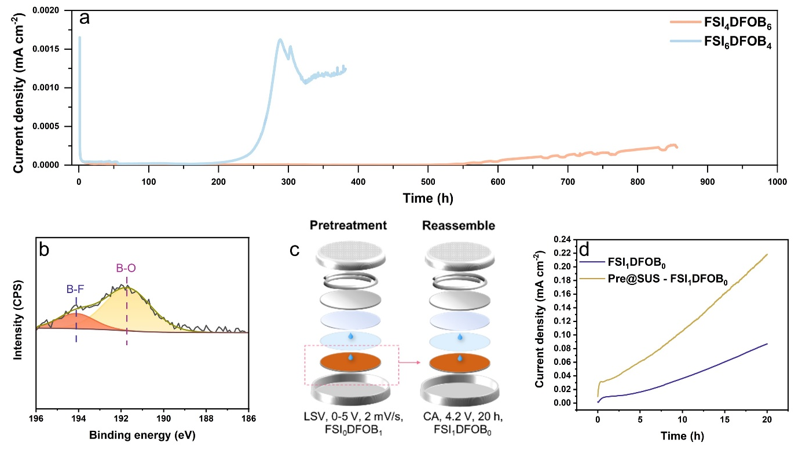
Figure S 12. (a) Chronoamperograms of cells using SUS316 spacer as working electrode with FSI₄DFOB₆ and FSI₆DFOB₄ electrolyte recorded at 4.2 V for 1,000 h. (b) B 1s spectra of the SUS316 spacer after pretreatment with FSI₀DFOB₁ electrolyte. (c) Illustration of the pretreatment of SUS316 spacer and reassemble process. The pretreated spacer is assembled in a new cell with a different electrolyte. (d) Comparison of linear sweep voltammograms using untreated SUS316 and pre@SUS as working electrodes and FSI₁DFOB₀ electrolyte.

Investigation of Al Dissolution
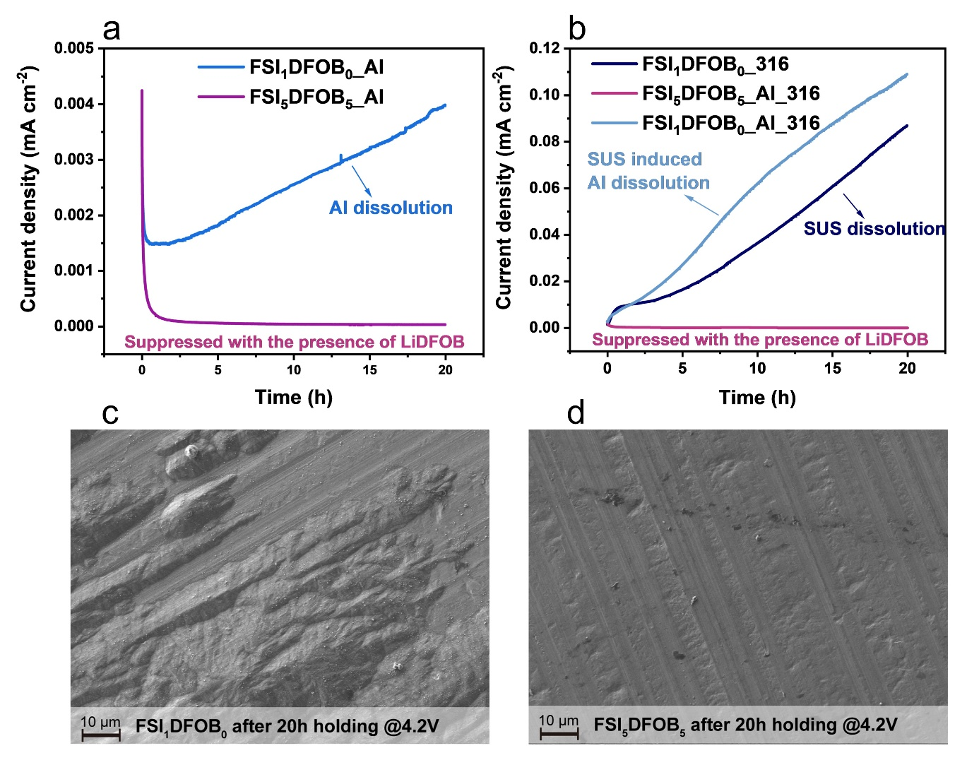
Figure S 13. (a) Chronoamperograms of cells with Al foil or Al foil on top of SUS316 space as a working electrode with FSI₁DFOB₀ and FSI₅DFOB₅ electrolyte recorded at 4.2 V. SEM image of Al foil recovered from sample (b) FSI₁DFOB₀_Al_316 and (c) FSI₅DFOB₅_Al_316
Modified coin cell setups using Al foil as the working electrode were used for these experiments, as shown in Figure S 1b, c. The variations of current density during the CA measurements are displayed for the FSI₁DFOB₀ and FSI₅DFOB₅ electrolytes, with and without SUS spacers (Figure S 13a,b). In cells using Al foil solely, the addition of LiDFOB notably inhibits the Al dissolution caused by the presence of LiFSI, consistent with findings reported in the literature^{[2–4]} (Figure S 13a). Notably, in the FSI₁DFOB₀ electrolyte, the SUS displays considerably higher dissolution behavior compared to Al, as evidenced by the 20 times higher current density after 20 h (≈0.09 mAh cm⁻² for SUS vs. ≈0.004 mAh cm⁻² for Al foil) (Figure S 13b). This effect can be attributed to the formation of galvanic cells between Al and SUS, which lowers the overpotential for the oxidation of Al and consequently enhances the dissolution of Al at high voltage^{[5]}. SEM images further support these findings, showing a rough surface on the Al electrode harvested from cells with FSI₁DFOB₀ electrolyte (Figure S 13c). However, when LiDFOB is included in the electrolyte (FSI₅DFOB₅), the coin cell containing both Al foil and SUS316 spacer shows a very stable current density till the end of measurements, resulting in a smooth Al surface as observed from the SEM images (Figure S 13d). This indicates that the inhibiting effects of LiDFOB on SUS dissolution also extend to suppressing Al dissolution in the presence of SUS spacers (or coin cell body).

Impact of Coin Cell Parts on Galvanostatic Cycling Performance
The use of SUS316L in coin cell components has a negligible impact on electrochemical performance for cells using the LP57 (1M LiPF₆ in EC:EMC, 3:7) electrolyte compared to those with SUS316 parts. Both NMC811||graphite and NMC811||Si-C cell chemistries exhibit similar capacity fading trends, indicating that the capacity fading observed in cells using LP57 is unrelated to SUS dissolution.
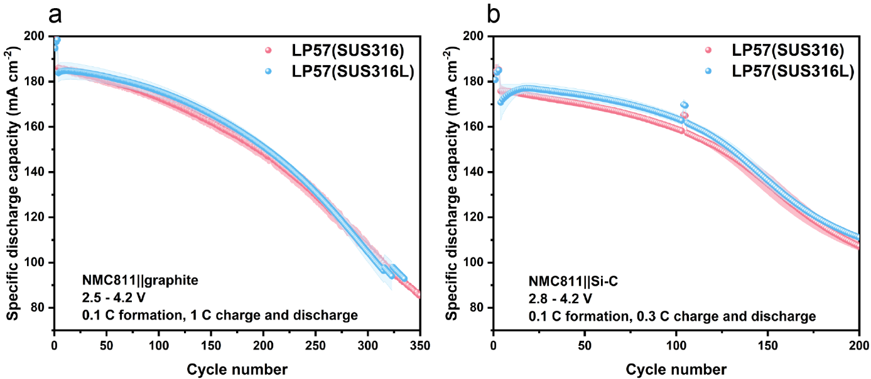
Figure S 14. Specific discharge capacity vs. cycle number of cells containing SUS316L parts with LP57 electrolyte in a) NMC811||graphite and b) NMC811||Si-C cell chemistries.

Investigation of the Impact of Polishing on Reproducibility
SUS316 and SUS316L spacers were polished to reach the mirror quality of the SUS surface, as confirmed by the SEM in Figure S 15. The impact of the surface roughness can be investigated by means of LSV measurements, as shown in Figure S 16. Compared to unpolished samples, the linear sweep voltammogram with polished samples shows improved reproducibility.
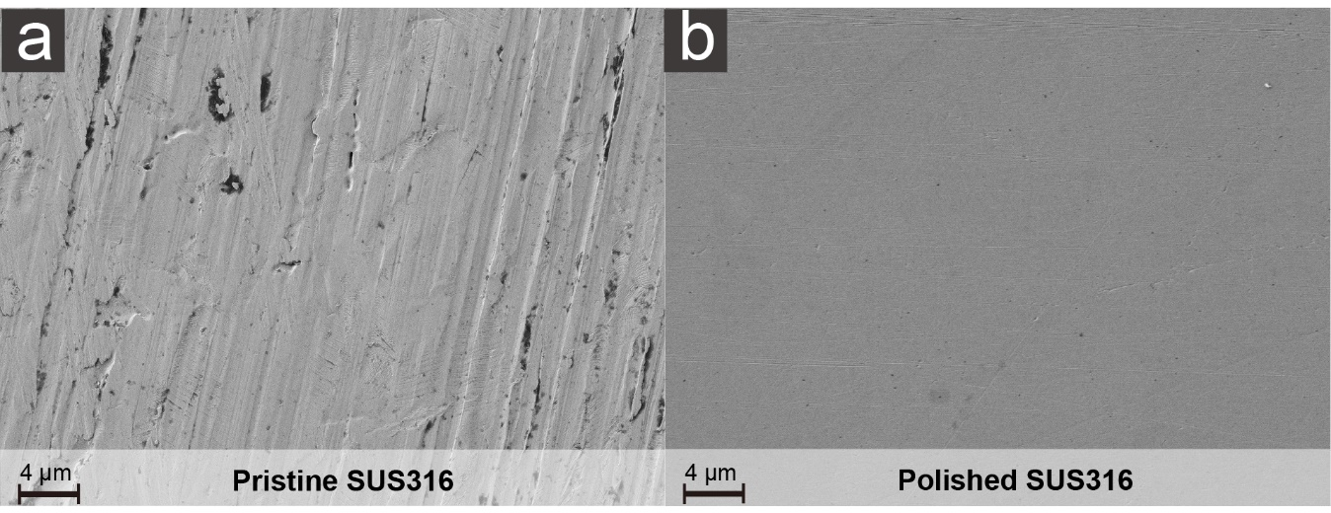
Figure S 15. SEM images of a) pristine and b) polished SUS316 spacers.
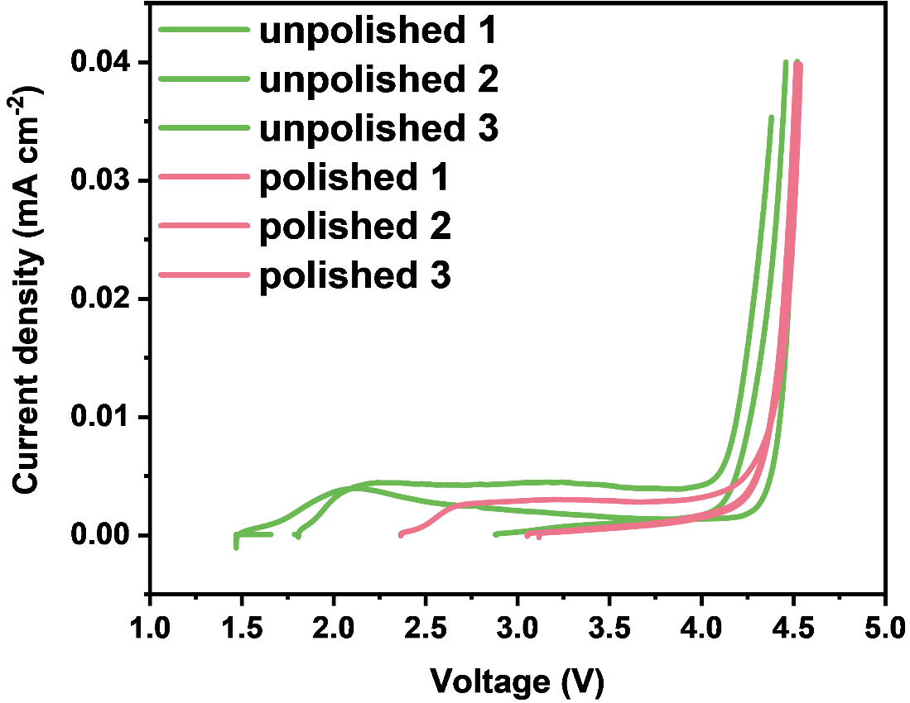
Figure S 16. Linear sweep voltammograms of cells containing pristine and polished SUS316 spacers with FSI₁DFOB₀ electrolyte.

References
[1] Z. Chang, X. Li, F. Yun, Z. Shao, Z. Wu, J. Wang, S. Lu, ChemElectroChem 2020, 7, 1135–1141.
[2] K. Park, S. Yu, C. Lee, H. Lee, J. Power Sources 2015, 296, 197–203.
[3] S. Shui Zhang, Electrochem. Commun. 2006, 8, 1423–1428.
[4] X. Liu, C. Shen, N. Gao, Q. Hou, F. Song, X. Tian, Y. He, J. Huang, Z. Fang, K. Xie, Electrochimica Acta 2018, 289, 422–427.
[5] S. S. Zhang, J. Electrochem. Soc. 2023, 170, 110527.

