Supplementary Information

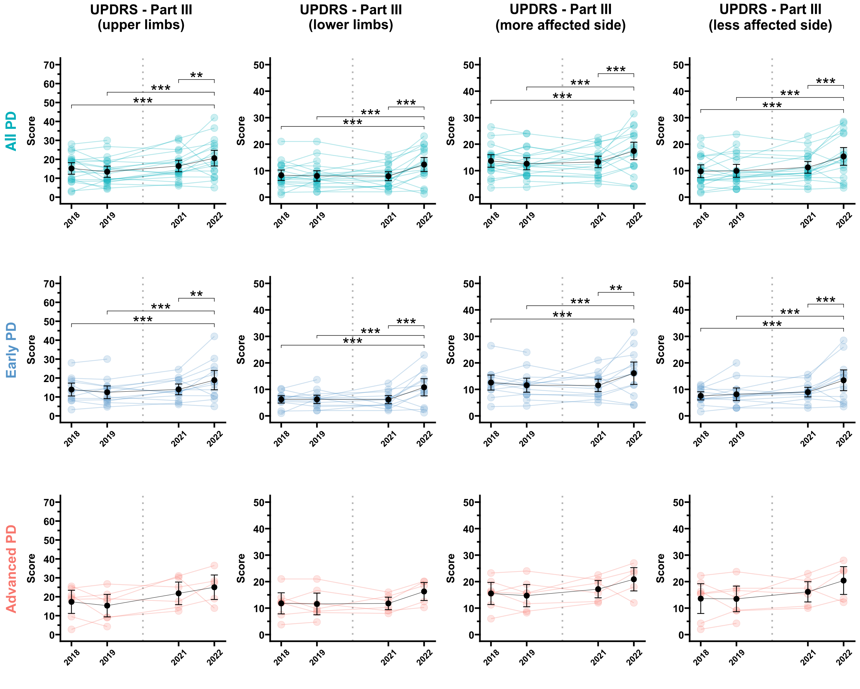
Supplementary Figure 1. Longitudinal changes in UPDRS Part III scores across evaluation periods, stratified by upper and lower limb assessments and the more affected and less affected sides. Data are shown for all Parkinson’s disease (PD) patients, as well as for early and advanced PD subgroups. Error bars indicate 95% confidence intervals, **p < 0.01, ***p < 0.001.

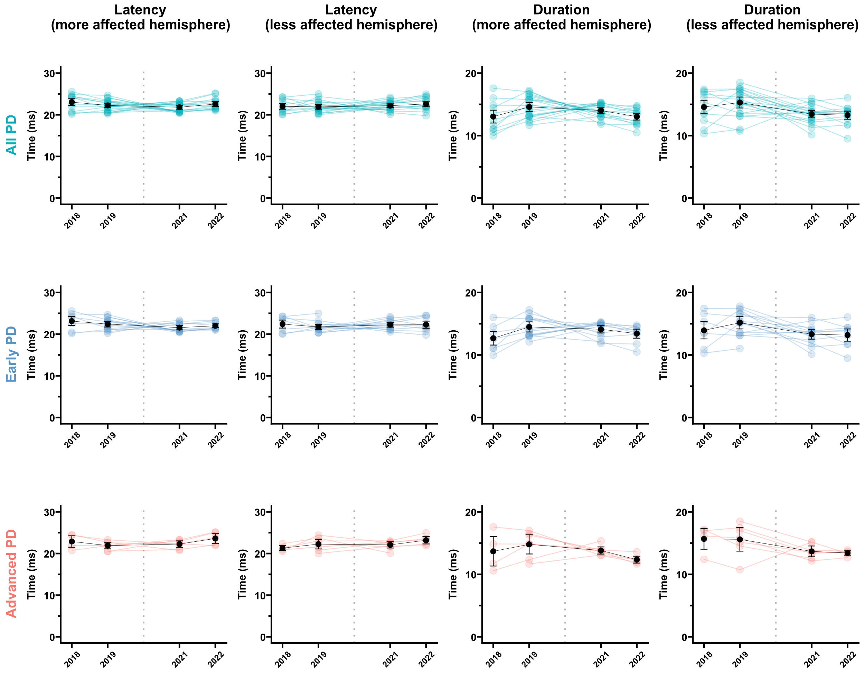
Supplementary Figure 2. Latency and duration of transcranial magnetic stimulation motor-evoked potentials across evaluation periods, stratified by all Parkinson’s disease (PD) patients, early PD, and advanced PD subgroups. Error bars indicate 95% confidence intervals.

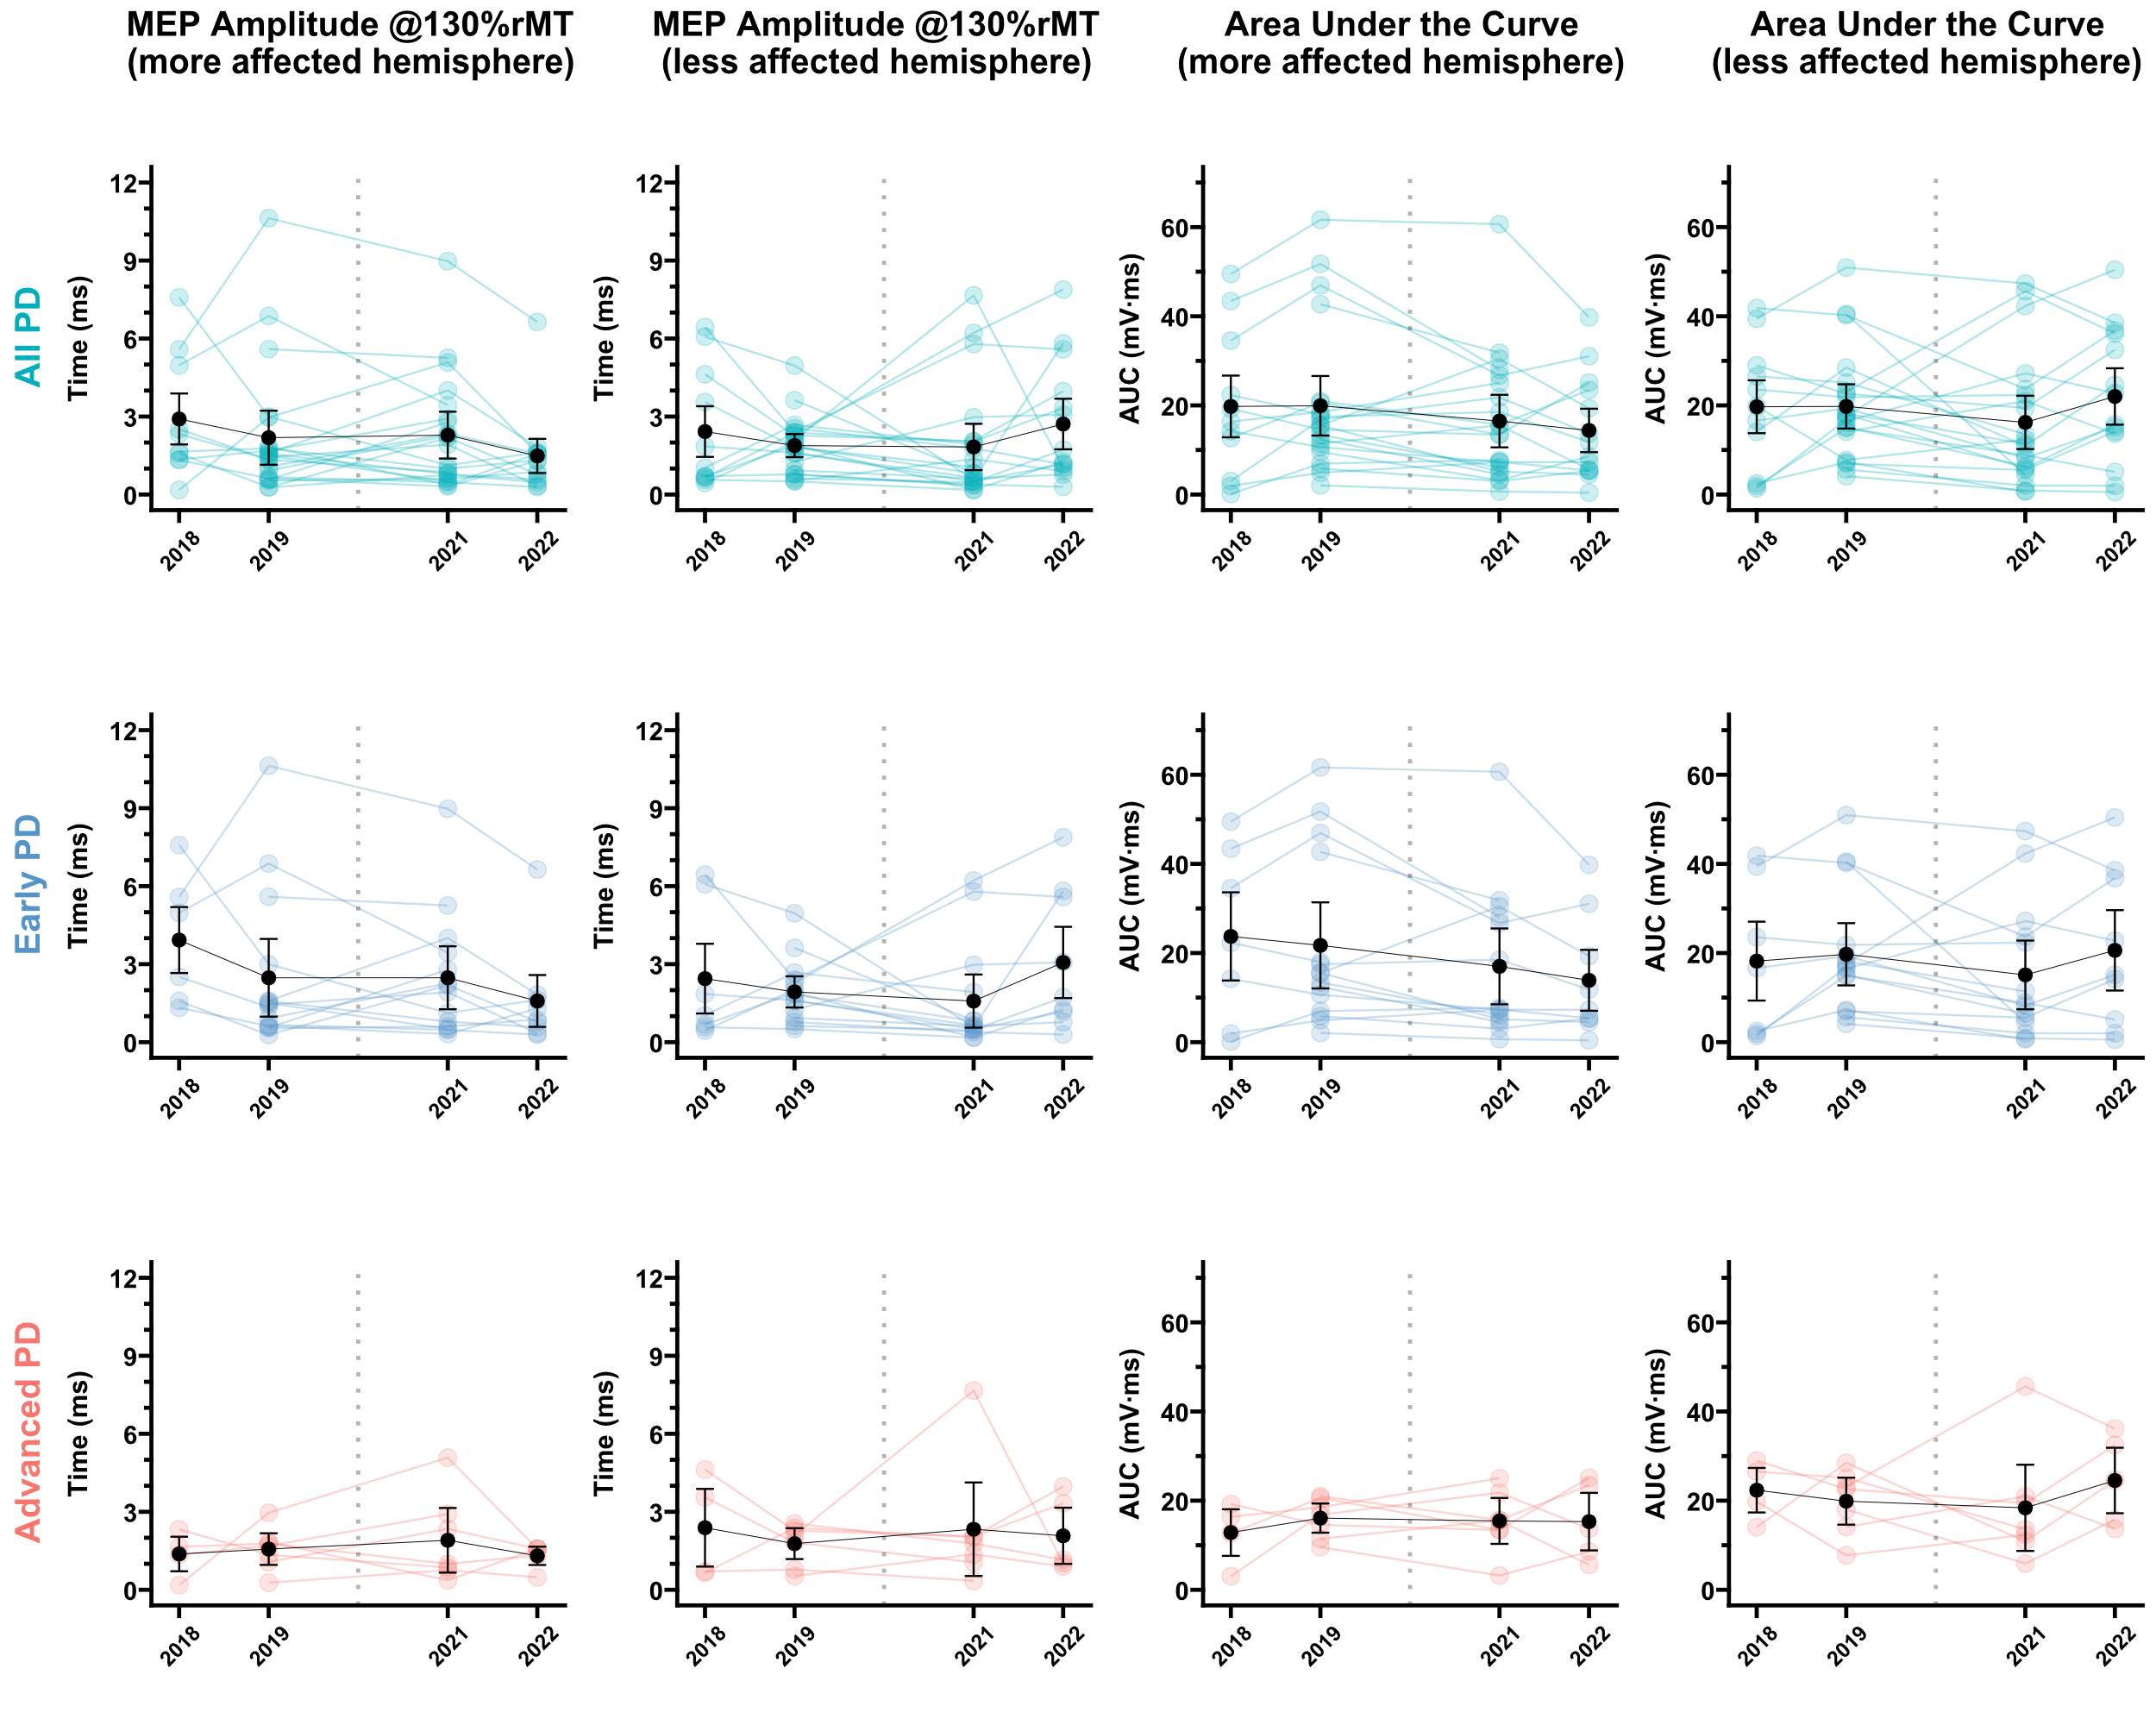
Supplementary Figure 3. The amplitude of transcranial magnetic stimulation motor-evoked potentials (MEPs) at S₅₀ intensity (130% of resting motor threshold, rMT) and the area under the recruitment curve across evaluation periods, stratified by all Parkinson’s disease (PD) patients, early PD, and advanced PD subgroups. Error bars indicate 95% confidence intervals.

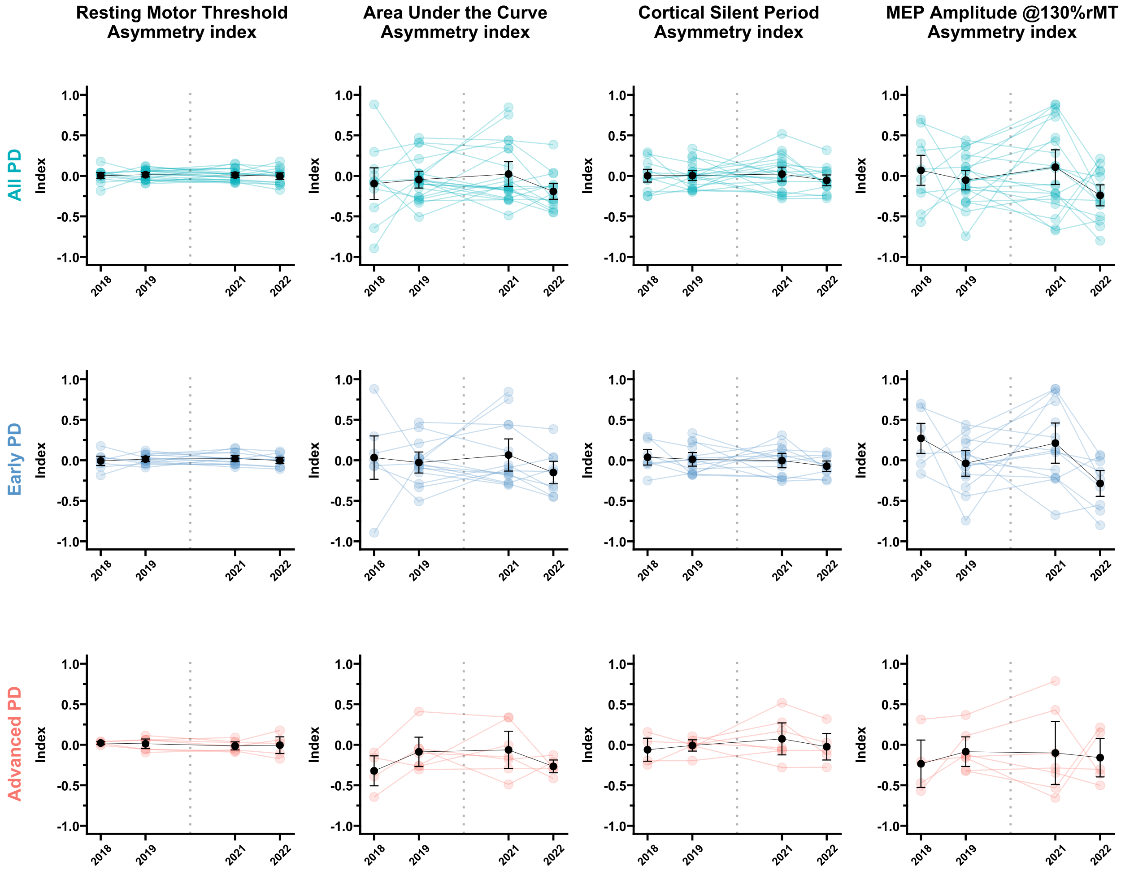
Supplementary Figure 4. Asymmetry indices for resting motor threshold (rMT), the area under the recruitment curve, cortical silent period, and motor-evoked potential (MEP) amplitude at S₅₀ intensity across evaluation periods, stratified by all Parkinson’s disease (PD) patients, early PD, and advanced PD subgroups. Error bars indicate 95% confidence intervals.

Supplementary Table 1. Results from the analysis of the effect of time on clinical outcomes (UPDRS).
Group | Clinical parameter | F | df_{num} | df_{den} | p-value | $$η_{p}^{2}$$
All PD | UPDRS-Part I | 7.55 | 3 | 51.41 | <0.001 | 0.31
All PD | UPDRS-Part II | 13.96 | 3 | 51.36 | <0.001 | 0.45
All PD | UPDRS-Part III | 15.24 | 3 | 52.54 | <0.001 | 0.47
All PD | UPDRS-Part III (UL) | 12.70 | 3 | 52.47 | <0.001 | 0.42
All PD | UPDRS-Part III (LL) | 11.20 | 3 | 53.19 | <0.001 | 0.39
All PD | UPDRS-Part III (MAS) | 9.68 | 3 | 52.41 | <0.001 | 0.36
All PD | UPDRS-Part III (LAS) | 14.74 | 3 | 52.81 | <0.001 | 0.46
All PD | UPDRS-Part III (AI) | 5.42 | 3 | 51.93 | 0.003 | 0.24
Early PD | UPDRS-Part I | 3.23 | 3 | 32.89 | 0.035 | 0.23
Early PD | UPDRS-Part II | 11.23 | 3 | 33.05 | <0.001 | 0.50
Early PD | UPDRS-Part III | 14.33 | 3 | 33.98 | <0.001 | 0.56
Early PD | UPDRS-Part III (UL) | 11.07 | 3 | 34.05 | <0.001 | 0.49
Early PD | UPDRS-Part III (LL) | 12.07 | 3 | 34.81 | <0.001 | 0.51
Early PD | UPDRS-Part III (MAS) | 8.14 | 3 | 33.95 | <0.001 | 0.42
Early PD | UPDRS-Part III (LAS) | 14.59 | 3 | 34.39 | <0.001 | 0.56
Early PD | UPDRS-Part III (AI) | 6.46 | 3 | 35.75 | 0.001 | 0.35
Advanced PD | UPDRS-Part I | 7.67 | 3 | 15.38 | 0.002 | 0.60
Advanced PD | UPDRS-Part II | 4.20 | 3 | 15.14 | 0.024 | 0.45
Advanced PD | UPDRS-Part III | 5.81 | 3 | 15.00 | 0.008 | 0.54
Advanced PD | UPDRS-Part III (UL) | 2.05 | 3 | 14.91 | 0.150 | 0.29
Advanced PD | UPDRS-Part III (LL) | 1.86 | 3 | 14.92 | 0.180 | 0.27
Advanced PD | UPDRS-Part III (MAS) | 1.97 | 3 | 15.02 | 0.162 | 0.28
Advanced PD | UPDRS-Part III (LAS) | 1.55 | 3 | 14.84 | 0.242 | 0.24
Advanced PD | UPDRS-Part III (AI) | 0.31 | 3 | 14.58 | 0.816 | 0.06

Supplementary Table 2. Results from the analysis of the effect of time on TMS outcomes.
Group | TMS parameter | F | df_{num} | df_{den} | p-value | $$η_{p}^{2}$$
All PD | rMT (MAH) | 6.50 | 3 | 43.75 | 0.001 | 0.31
All PD | rMT (LAH) | 6.82 | 3 | 43.89 | 0.001 | 0.32
All PD | Latency (MAH) | 2.31 | 3 | 64.00 | 0.085 | 0.10
All PD | Latency (LAH) | 0.94 | 3 | 64.00 | 0.429 | 0.04
All PD | Duration (MAH) | 3.87 | 3 | 52.13 | 0.014 | 0.18
All PD | Duration (LAH) | 5.48 | 3 | 45.20 | 0.003 | 0.27
All PD | CSP (MAH) | 7.87 | 3 | 45.16 | <0.001 | 0.34
All PD | CSP (LAH) | 15.92 | 3 | 45.11 | <0.001 | 0.51
All PD | Amplitude (MAH) | 0.89 | 3 | 44.49 | 0.452 | 0.06
All PD | Amplitude (LAH) | 1.17 | 3 | 47.09 | 0.330 | 0.07
All PD | AURC (MAH) | 1.73 | 3 | 44.18 | 0.174 | 0.11
All PD | AURC (LAH) | 1.55 | 3 | 47.08 | 0.213 | 0.09
All PD | rMT (AI) | 0.60 | 3 | 45.05 | 0.618 | 0.04
All PD | AURC (AI) | 1.77 | 3 | 44.36 | 0.167 | 0.11
All PD | CSP (AI) | 0.81 | 3 | 46.71 | 0.496 | 0.05
All PD | Amplitude (AI) | 2.00 | 3 | 46.72 | 0.128 | 0.11
Early PD | rMT (MAH) | 4.26 | 3 | 27.54 | 0.014 | 0.32
Early PD | rMT (LAH) | 7.27 | 3 | 27.59 | 0.001 | 0.44
Early PD | Latency (MAH) | 2.89 | 3 | 41.00 | 0.047 | 0.17
Early PD | Latency (LAH) | 0.73 | 3 | 27.72 | 0.542 | 0.07
Early PD | Duration (MAH) | 2.33 | 3 | 33.69 | 0.092 | 0.17
Early PD | Duration (LAH) | 2.58 | 3 | 28.83 | 0.073 | 0.21
Early PD | CSP (MAH) | 3.98 | 3 | 28.51 | 0.017 | 0.30
Early PD | CSP (LAH) | 12.72 | 3 | 28.38 | <0.001 | 0.57
Early PD | Amplitude (MAH) | 1.37 | 3 | 27.77 | 0.274 | 0.13
Early PD | Amplitude (LAH) | 1.31 | 3 | 29.47 | 0.289 | 0.12
Early PD | AURC (MAH) | 1.47 | 3 | 26.52 | 0.246 | 0.14
Early PD | AURC (LAH) | 1.00 | 3 | 31.02 | 0.407 | 0.09
Early PD | rMT (AI) | 0.40 | 3 | 28.97 | 0.757 | 0.04
Early PD | AURC (AI) | 0.98 | 3 | 29.02 | 0.414 | 0.09
Early PD | CSP (AI) | 0.71 | 3 | 30.18 | 0.556 | 0.07
Early PD | Amplitude (AI) | 3.44 | 3 | 30.92 | 0.029 | 0.25
Advanced PD | rMT (MAH) | 4.62 | 3 | 13.17 | 0.020 | 0.51
Advanced PD | rMT (LAH) | 2.40 | 3 | 13.18 | 0.114 | 0.35
Advanced PD | Latency (MAH) | 1.32 | 3 | 19.00 | 0.298 | 0.17
Advanced PD | Latency (LAH) | 1.50 | 3 | 13.79 | 0.259 | 0.25
Advanced PD | Duration (MAH) | 2.63 | 3 | 14.74 | 0.089 | 0.35
Advanced PD | Duration (LAH) | 5.45 | 3 | 13.37 | 0.011 | 0.55
Advanced PD | CSP (MAH) | 3.82 | 3 | 13.50 | 0.036 | 0.46
Advanced PD | CSP (LAH) | 2.46 | 3 | 13.94 | 0.106 | 0.35
Advanced PD | Amplitude (MAH) | 0.10 | 3 | 14.71 | 0.958 | 0.02
Advanced PD | Amplitude (LAH) | 0.24 | 3 | 14.13 | 0.865 | 0.05
Advanced PD | AURC (MAH) | 0.07 | 3 | 18.00 | 0.974 | 0.01
Advanced PD | AURC (LAH) | 1.23 | 3 | 14.03 | 0.336 | 0.21
Advanced PD | rMT (AI) | 0.87 | 3 | 13.31 | 0.482 | 0.16
Advanced PD | AURC (AI) | 1.21 | 3 | 12.81 | 0.346 | 0.22
Advanced PD | CSP (AI) | 0.52 | 3 | 13.47 | 0.678 | 0.10
Advanced PD | Amplitude (AI) | 0.14 | 3 | 13.18 | 0.931 | 0.03

Supplementary Table 3. Within-subjects correlations by group.
All PD
TMS parameter | Clinical parameter | Correlation coefficient and 95%CI | p-value | adjusted p-value¹
CSP-LAH | UPDRS-Part III (UL) | 0.3155 [0.0167, 0.5625] | 0.0393 | 0.9414
Early PD
TMS parameter | Clinical parameter | Correlation coefficient and 95%CI | p-value | adjusted p-value¹
CSP-LAH | UPDRS-Part III | 0.4074 [0.0481, 0.6734] | 0.0282 | 0.3273
CSP-LAH | UPDRS-Part III (UL) | 0.4354 [0.0820, 0.6915] | 0.0182 | 0.3273
CSP-LAH | UPDRS-Part III (LL) | 0.4095 [0.0506, 0.6747] | 0.0274 | 0.3273
CSP-LAH | UPDRS-Part III (MAS) | 0.4027 [0.0425, 0.6703] | 0.0303 | 0.3273
CSP-LAH | UPDRS-Part III (LAS) | 0.4058 [0.0462, 0.6723] | 0.0289 | 0.3273
¹Values adjusted by false discovery rate

Supplementary Table 4. Between-subjects correlations by group.
All PD
TMS parameter | Clinical parameter | Correlation coefficient and 95%CI | p-value | adjusted p-value¹
AURC-AI | UPDRS-Part III (LAS) | -0.4485 [-0.6254, -0.2278] | 0.0363 | 0.9320
AURC-AI | AI | 0.6851 [0.5283, 0.7968] | 0.0004 | 0.0234
Early PD
TMS parameter | Clinical parameter | Correlation coefficient and 95%CI | p-value | adjusted p-value¹
AURC-AI | AI | 0.6347 [0.4131, 0.7853] | 0.0110 | 0.5954
Advanced PD
TMS parameter | Clinical parameter | Correlation coefficient and 95%CI | p-value | adjusted p-value¹
AURC-AI | AI | 0.9561 [0.8930, 0.9823] | 0.0008 | 0.0409
¹Values adjusted by false discovery rate

