Supplementary materials
Venous catheterization
After the Tibet miniature pig was anesthetized, the Tibet miniature pig was placed on the operating table covered with a thermal insulation blanket. The skin preparation and disinfection were performed. The rapid internal jugular vein catheterization was performed under the condition of local anesthesia with lidocaine. The specific procedures are as follows: 1. Touch the pulse position of the carotid artery to facilitate the location of the puncture point; 2. Test puncture with a 10 ml syringe with heparin saline at 0.5 cm lateral to the pulse point of the carotid artery. The needle is at a 30-degree angle to the skin. The needle tip is directed towards the opposite nipple, and the needle is pulled back at the side of the puncture until the puncture shows blood; 3. Replace the needle with 7 ml syringe. F puncture needle, inhaling a small amount of heparin saline, inserting the needle at the puncture site. The needle is at a 30 degrees angle to the skin. The needle tip is directed towards the opposite nipple, and the needle is pulled back at the puncture side until the needle is fixed after blood is seen. 4. Slowly insert the guide wire along the Y-shaped mouth of the puncture needle. If the guide wire enters smoothly, the guide wire is in the blood vessel, if not smoothly. Puncture needle was moved slowly before and after puncture, and withdrawn at the same time until the blood flow was smooth, then the guide wire was re-placed. The puncture needle was slowly pulled out with gauze, and the skin was expanded with a skin expander. Then the 7 F central venous catheter was inserted into the jugular vein along the guide wire. The depth of the needle was about 15 cm, and the guide wire was pulled out with the liver. The syringe of saline water was drawn back to check whether there was blood and whether it was unobstructed. The central venous catheter was fixed by sealing the tube with heparin saline water, covering the heparin cap. The detail catheterization process in Group A, B, C were shown in Fig. S1. While in Group D were shown in Fig. S2
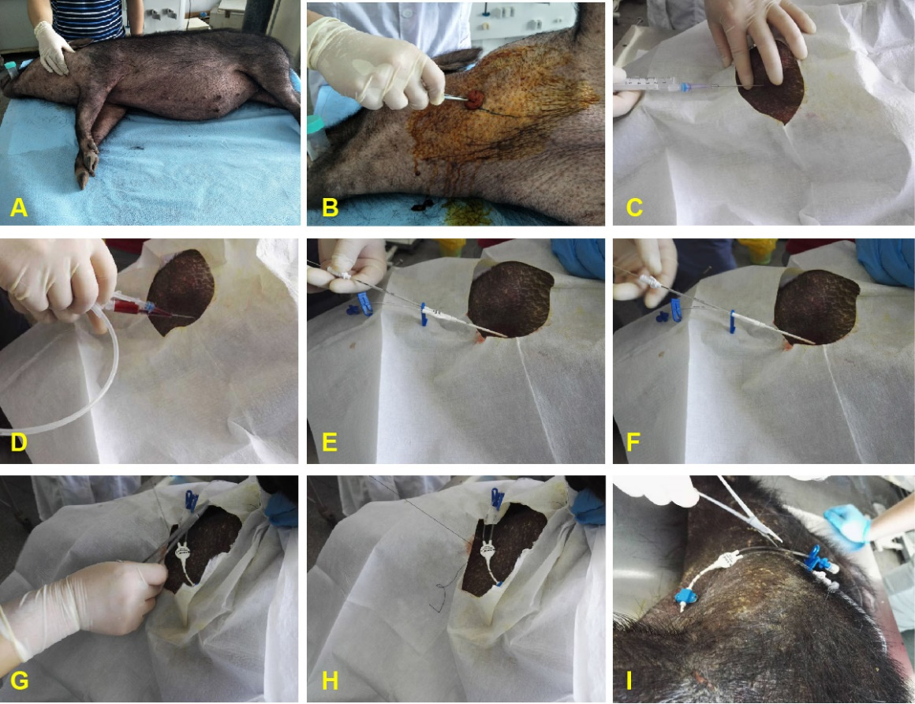
Fig S1: The detail catheterization process in Group A, B, C (Central venous catheter)
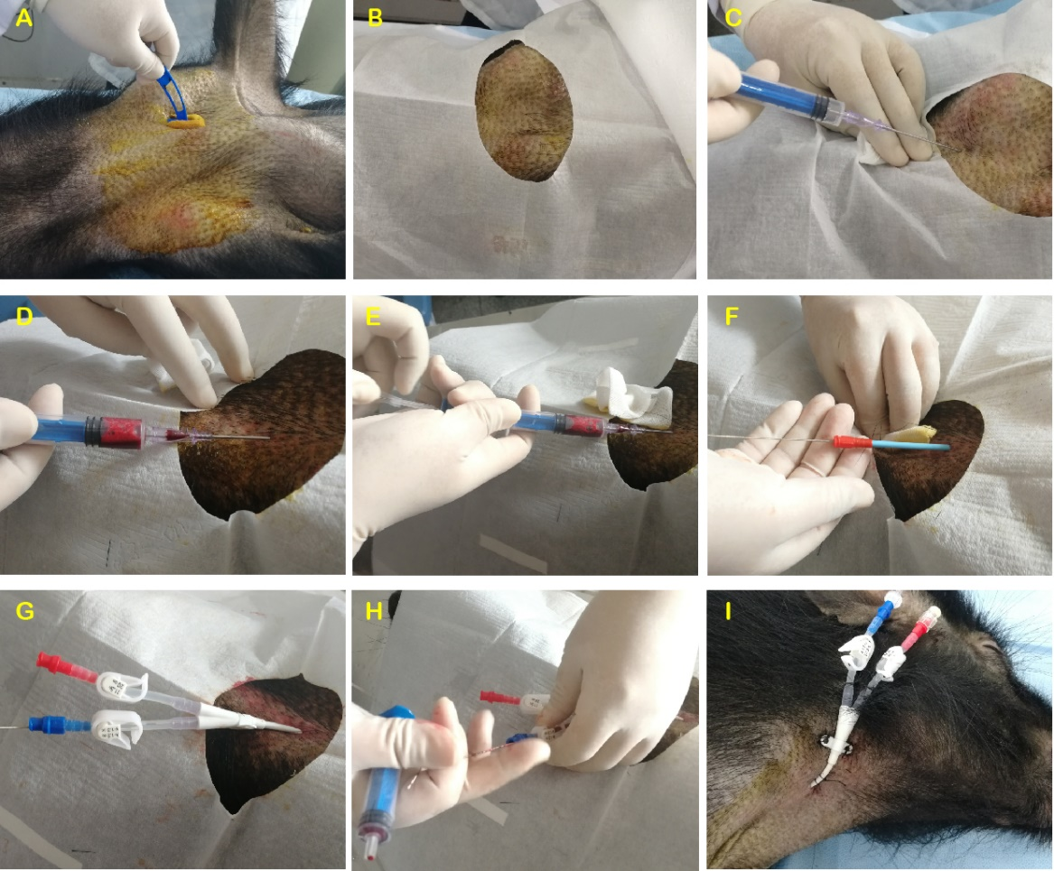
Fig S2: The detail catheterization process in Group D (Double chamber hemodialysis catheter)

