Supplementary Table S1 The sequence and parameter details in three cohorts.
Cohort | Scanner | Sequence | TR (ms) | TE (ms) | FOV (mm²) | Matrix | Slice thickness (mm) | Slice gap (mm)
Training and internal validation | GE Signa Pioneer 3.0 T | T2WI | 2200 | 85 | 380×380 | 480×256 | 6 | 1
Training and internal validation | GE Signa Pioneer 3.0 T | DWI | 3600 | 107.6 | 280×224 | 128×80 | 6 | 1
Training and internal validation | GE Signa Pioneer 3.0 T | CE-T1WI | 3.9 | 1.7 | 400×320 | 360×288 | 5 | 0
Training and internal validation | Philips Ingenia  3.0 T | T2WI | 4091 | 100 | 300×378 | 352×376 | 5 | 1
Training and internal validation | Philips Ingenia  3.0 T | DWI | 9000 | 55 | 300×242 | 120×97 | 5 | 1
Training and internal validation | Philips Ingenia  3.0 T | CE-T1WI | 3.7 | 1.31 | 400×353 | 208×253 | 5 | -2.5
Training and internal validation | Philips Ingenia  1.5 T | T2WI | 3351 | 90 | 300×373 | 352×272 | 5 | 1
Training and internal validation | Philips Ingenia  1.5 T | DWI | 6758 | 77 | 270×259 | 92×90 | 5 | 1
Training and internal validation | Philips Ingenia  1.5 T | CE-T1WI | 6.0 | 1.87 | 400×326 | 288×203 | 6 | -3
External test | GE Signa HDxt  3.0 T | T2WI | 3345 | 102 | 240×240 | 320×224 | 4 | 0.5
External test | GE Signa HDxt  3.0 T | DWI | 4050 | 65.6 | 380×380 | 130×96 | 4 | 1
External test | GE Signa HDxt  3.0 T | CE-T1WI | 4.2 | 1.1 | 400×320 | 320×224 | 4 | 0
External test | GE Signa HDxt  1.5 T | T2WI | 6680 | 130 | 240×240 | 320×224 | 4 | 0.5
External test | GE Signa HDxt  1.5 T | DWI | 7000 | 77.5 | 240×240 | 320×256 | 5 | 1
External test | GE Signa HDxt  1.5 T | CE-T1WI | 3.4 | 1.6 | 240×240 | 320×224 | 3 | 0
External test | Philips Ingenia  3.0 T | T2WI | 3276 | 100 | 220×220 | 292×220 | 4 | 1
External test | Philips Ingenia  3.0 T | DWI | 6000 | 56 | 220×220 | 88×106 | 4 | 1
External test | Philips Ingenia  3.0 T | CE-T1WI | 3.7 | 1.33 | 360×320 | 240×215 | 4 | -2
External test | Siemens Prisma  3.0 T | T2WI | 3200 | 89 | 200×200 | 320×240 | 3 | 0.3
External test | Siemens Prisma  3.0 T | DWI | 6300 | 75 | 250×134 | 134×72 | 3 | 0.3
External test | Siemens Prisma  3.0 T | CE-T1WI | 2.9 | 1.09 | 300×270 | 320×203 | 3 | 0
External test | Siemens Vida  3.0 T | T2WI | 3570 | 76 | 224×224 | 320×320 | 4 | 0.8
External test | Siemens Vida  3.0 T | DWI | 5600 | 46 | 380×306 | 271×219 | 6 | 1.5
External test | Siemens Vida  3.0 T | CE-T1WI | 3.5 | 1.66 | 347×347 | 386×386 | 0.9 | 0.18
External test | Siemens Skyra  3.0 T | T2WI | 3000 | 87 | 240×240 | 320×320 | 5 | 1
External test | Siemens Skyra  3.0 T | DWI | 5700 | 92 | 240×240 | 320×256 | 4 | 1
External test | Siemens Skyra  3.0 T | CE-T1WI | 3.3 | 1. 3 | 240×240 | 320×320 | 3 | 0
T2WI: T2-weighted imaging; DWI: diffusion-weighted imaging; CE-T1WI: contrast-enhanced T1-weighted imaging; TR: repetition time; TE: echo time; FOV: field of views.

Supplementary Table S2 The mean SI on different sequences, as well as the volume and proportion of each habitat.
Feature | Habitat 1 | Habitat 2 | Habitat 3 | Habitat 4
T2WI SI | 614.9 | 1001.3 | 1019 | 987.4
CE-T1WI SI | 621.3 | 1295.2 | 676.3 | 393.2
DWI SI | 1015 | 1232.9 | 545.7 | 2594.5
ADC SI | 389.5 | 471.9 | 1388.8 | 310.7
Volume (mm3) | 85740.6 | 18095.5 | 95659.7 | 88287.9
Proportion | 34.7% | 9.2% | 32.0% | 24.1%
SI: signal intensity; ADC: apparent diffusion coefficient.
* P < 0.05.

Supplementary Note 1: image preprocessing and segmentation.
Image preprocessing and segmentation were performed using 3D Slicer software (version 5.0.3, https://www.slicer.org/) and Python (version 3.7.12, https://www.python.org/). Preprocessing involved three key techniques: N4 bias field correction, resampling to isotropic voxels of 1 mm × 1 mm × 1 mm using B-spline interpolation, and spatial registration with the General Registration (Elastix) module. Two radiologists (Reader A with 9 years and Reader B with 12 years of experience in pelvic MRI) delineated the regions of interest for the lesions on T2WI after consensus with the other party, working slice by slice to create the volumes of interest. To achieve precise delineation, the association between primary tumors and metastases was meticulously scrutinized through the analysis of multiplanar and multisequence MRI images. Additionally, surgical records and gross pathological findings were utilized as references.

Supplementary Note 2: Details for K-means clustering and Calinski-Harabasz score.
First, each voxel in region of interest on T2WI, DWI, ADC and CE-T1WI was represented by a four-dimensional feature vector to form a dataset for clustering. Then, K-means algorithm classified tumors into 2 to 10 habitats by clustering these features. The algorithm functions by dividing the dataset into 2 to 10 unique clusters and progressively refining the centroids of these clusters in order to reduce the cumulative squared distances within each cluster. After clustering, sub-regions with the same features were merged into different habitats. According to the Calinski-Harabasz score, the clustering performance under each cluster number (2 to 10) was assessed. We chosed the cluster number with the highest scores to ensure that there were significant differences between different habitat sub-regions.

Supplementary Note 3: Feature extraction and selection.
The habitat radiomics features were extracted from each sub-region using Pyradiomics (https://pypi.org/project/pyradiomics/), and the majority complied with the Imaging Biomarker Standardization Initiative. The handcrafted features were categorized into geometry, intensity, and texture groups. As habitat characterization relied on unsupervised clustering algorithms, we employed the K-nearest neighbors approach to allocate labels to previously unclustered areas, thereby ensuring consistency within the defined habitat regions. Upon feature standardization using the Z-score, we used Pearson's correlation coefficient to identify redundant features. For features with a correlation coefficient exceeding 0.9, only one feature was retained.

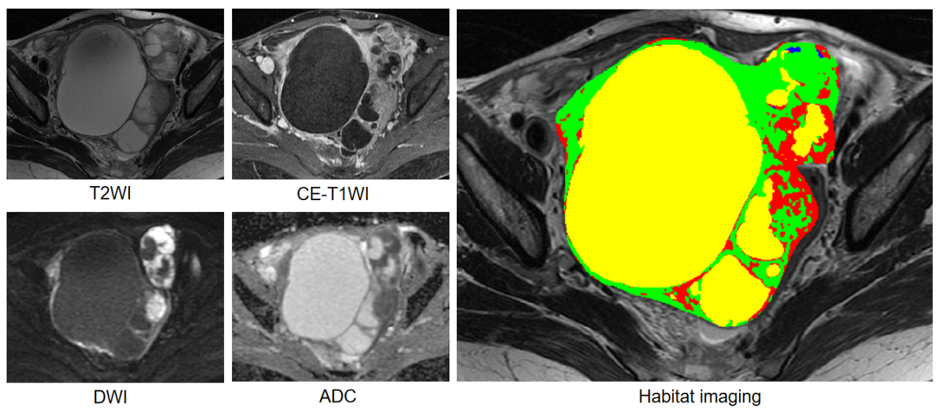
Supplementary Figure S1. Habitat imaging based on multiparametric MRI. Habitat 1, 2, 3, and 4 are represented by red, green, yellow, and blue areas, respectively. Habitat 1 and 2 are dominated by solid components, while Habitat 3 and 4 are dominated by cystic components.

Supplementary Figure S2. LASSO-Cox regression. The cross-validation plot (a and c) and coefficient profile plot (b and d). LASSO-Cox was used for feature reduction, which eliminated irrelevant features by zeroing coefficients based on λ (OS: 0.077; PFS: 0.086), and optimized by 10-fold cross-validation. LASSO: least absolute shrinkage and selection operator; OS: overall survival; PFS: progression-free survival.
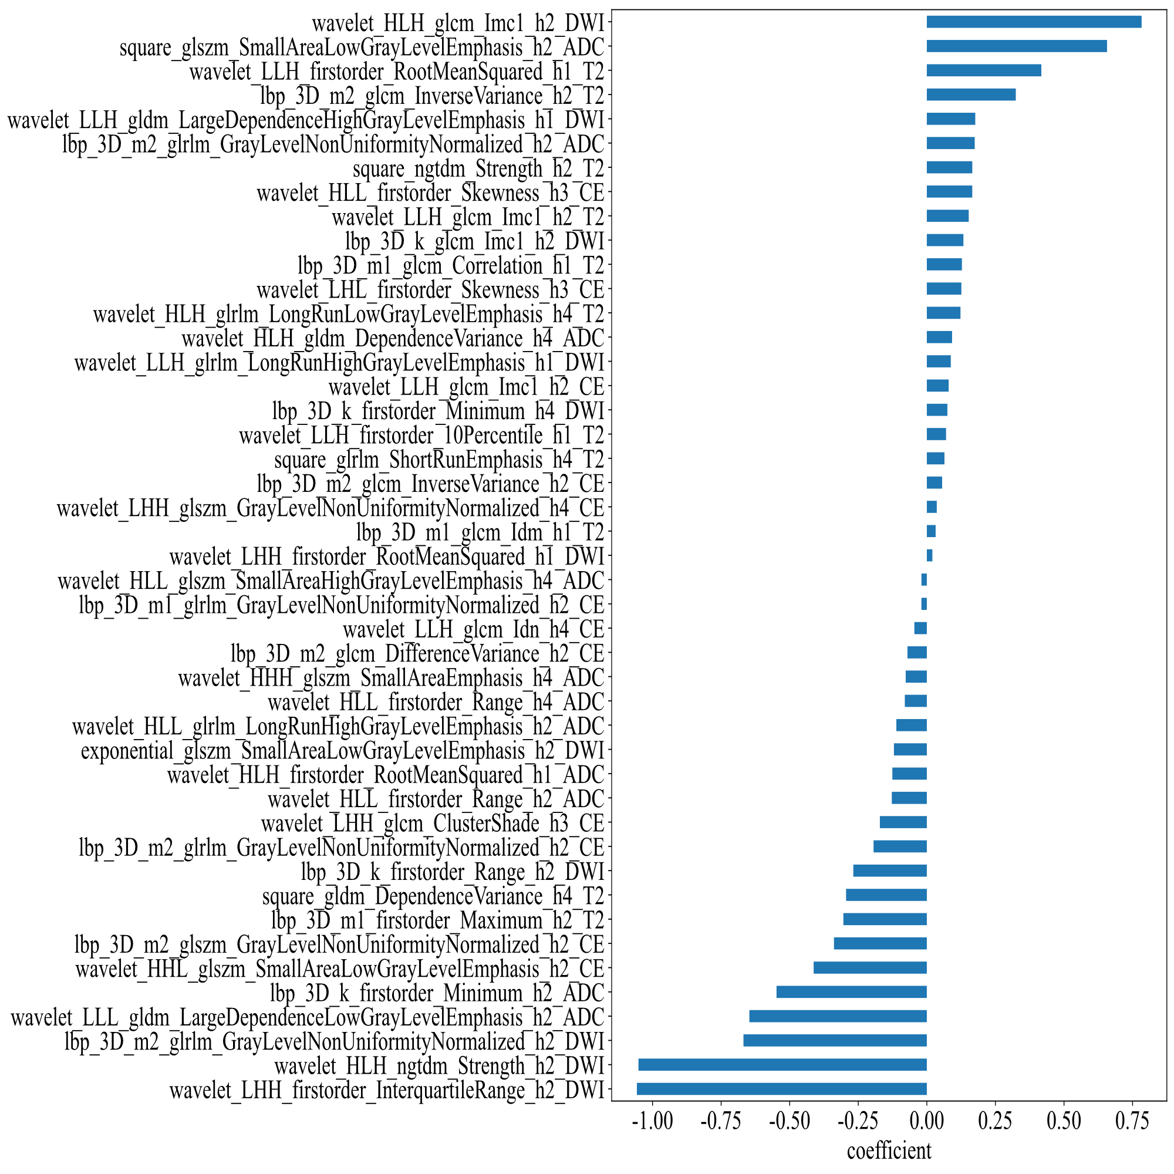
Supplementary Figure S3. Bar chart of feature weight for overall survival (OS). The top two features that contributed the most are both from Habitat 2 on DWI and ADC maps.
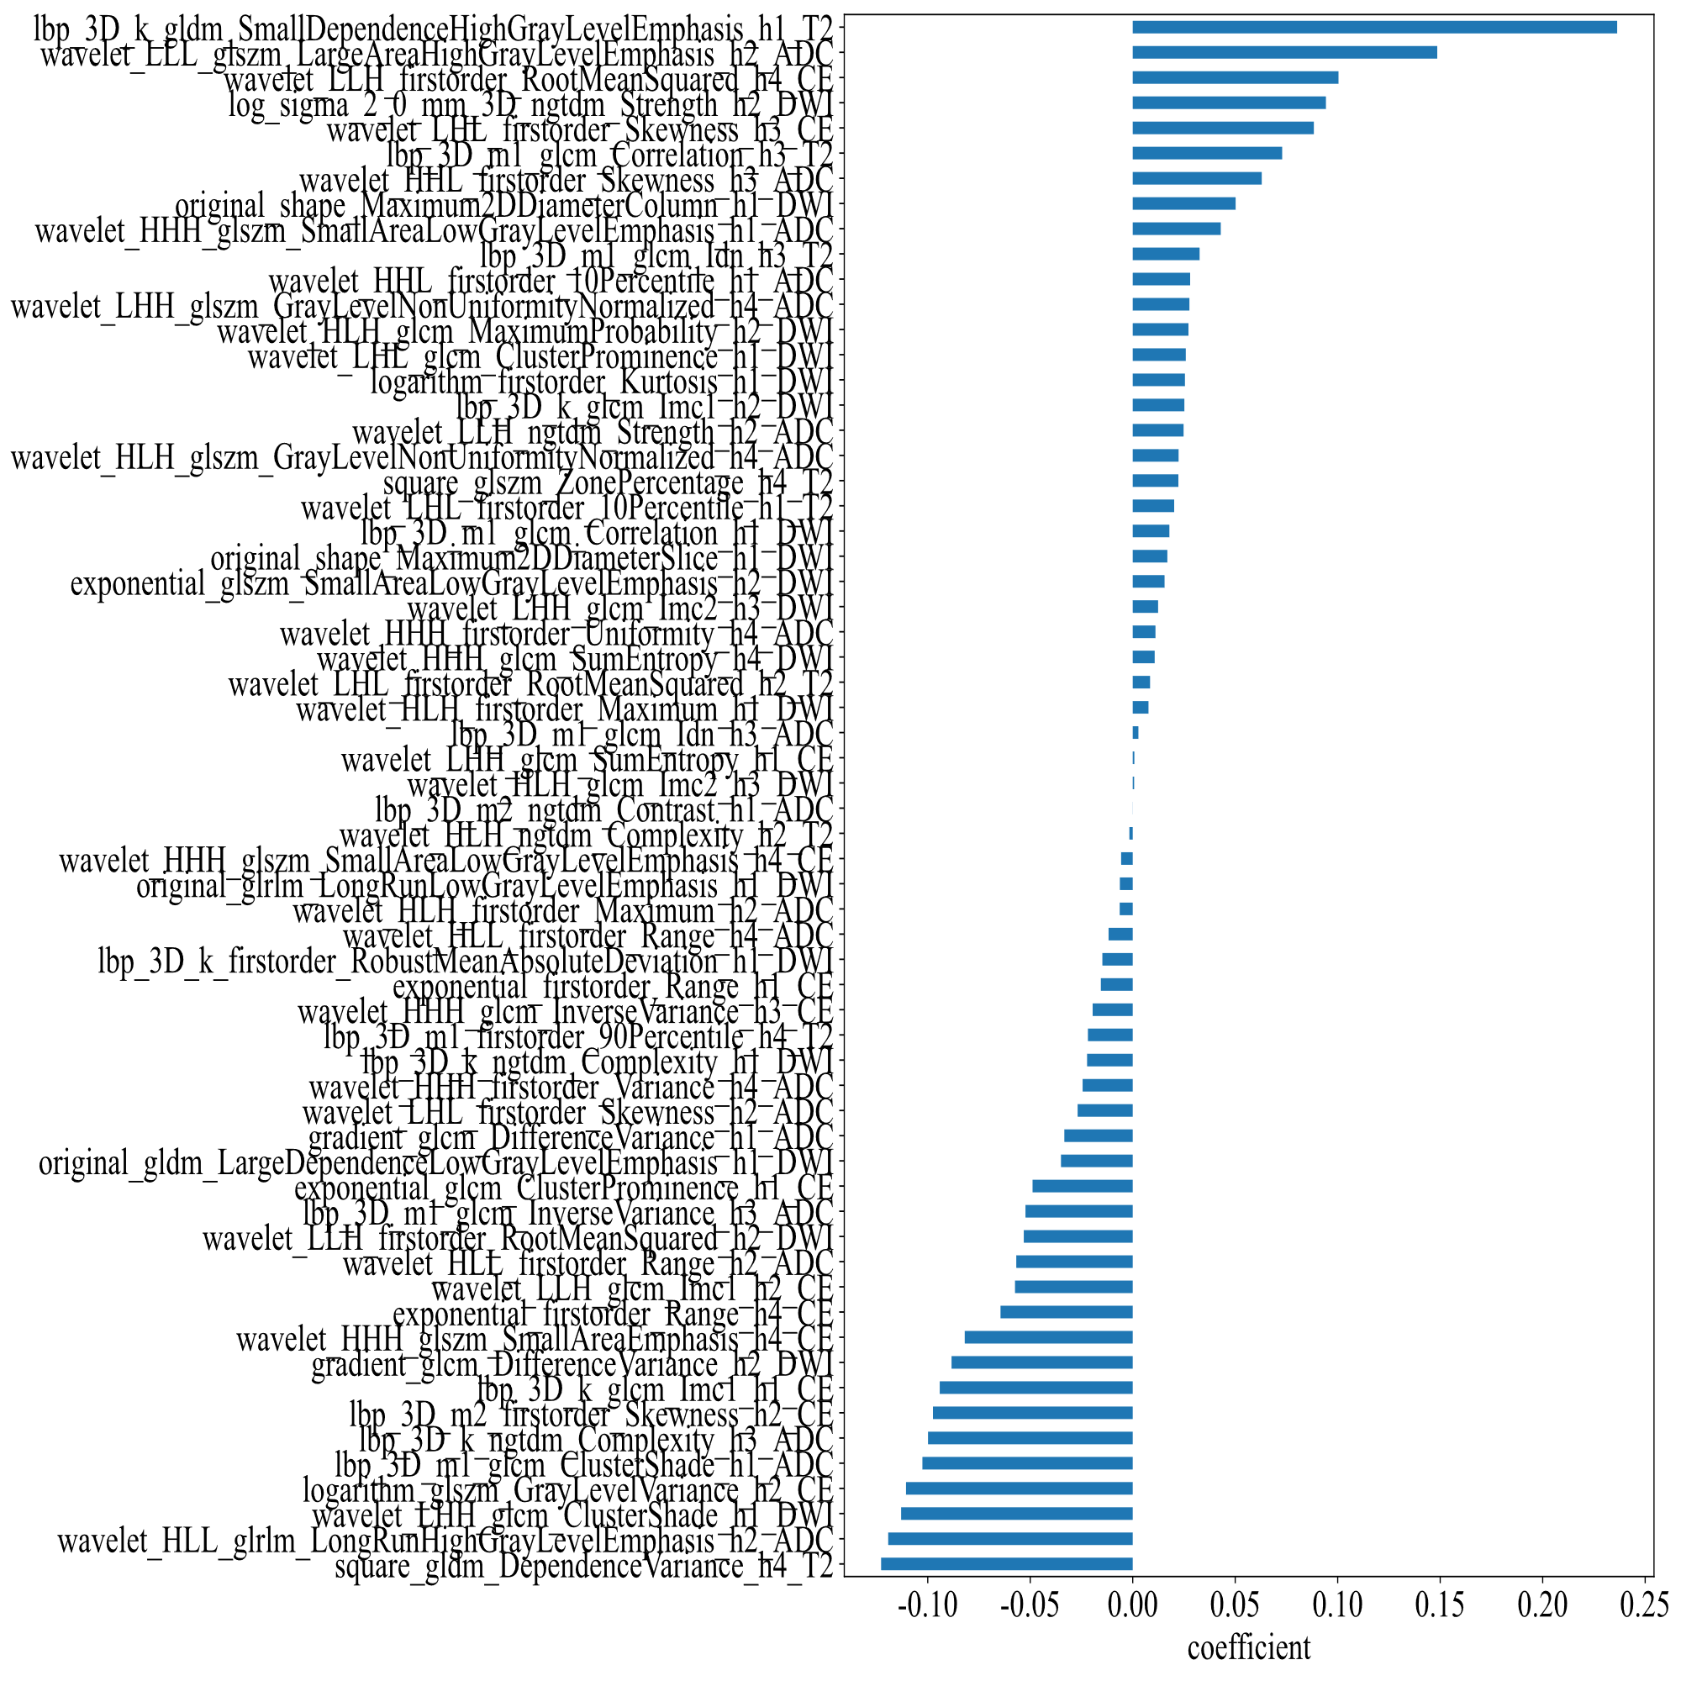
Supplementary Figure S4. Bar chart of feature weight for progression-free survival (PFS). The top two features that contributed the most are from Habitat 1 on T2WI and Habitat 2 on ADC maps.

