Supplementary Figures and Tables
Supervised Modelling of Longitudinal Human Milk and Infant Gut Microbiome Reveal Maternal Pre-Pregnancy BMI and Early Life Growth Interactions
R.R. Jakobsen, G.R. van der Ploeg, U.K. Sundekilde, J. Astono, K.O. Poulsen, J. Fuglsang, J.A. Westerhuis, A. Heintz-Buschart, A.K. Smilde, D.S. Nielsen

Supplementary figures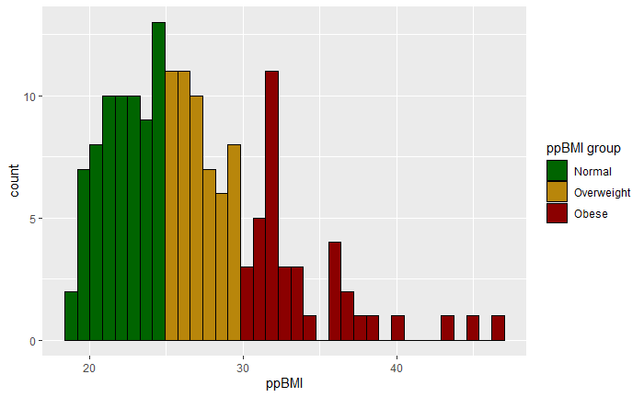
Supplementary Figure 1. Maternal pre-pregnancy BMI (ppBMI) was stratified into three groups: normal weight (BMI 25 or lower), overweight (BMI 25-30) and obese (BMI 30 or higher).

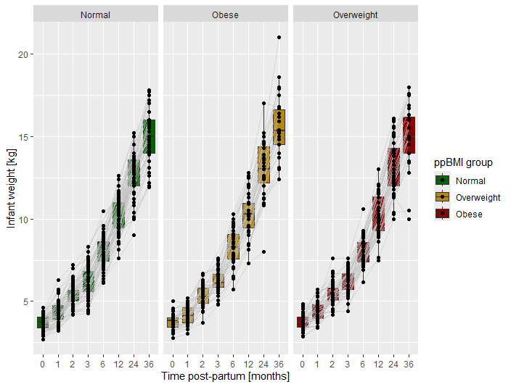
Supplementary Figure 2. Infant weights were recorded at birth and subsequently at 1, 2, 3, 6, 12, 24 and 36 months after birth. Plots were faceted by maternal ppBMI group.

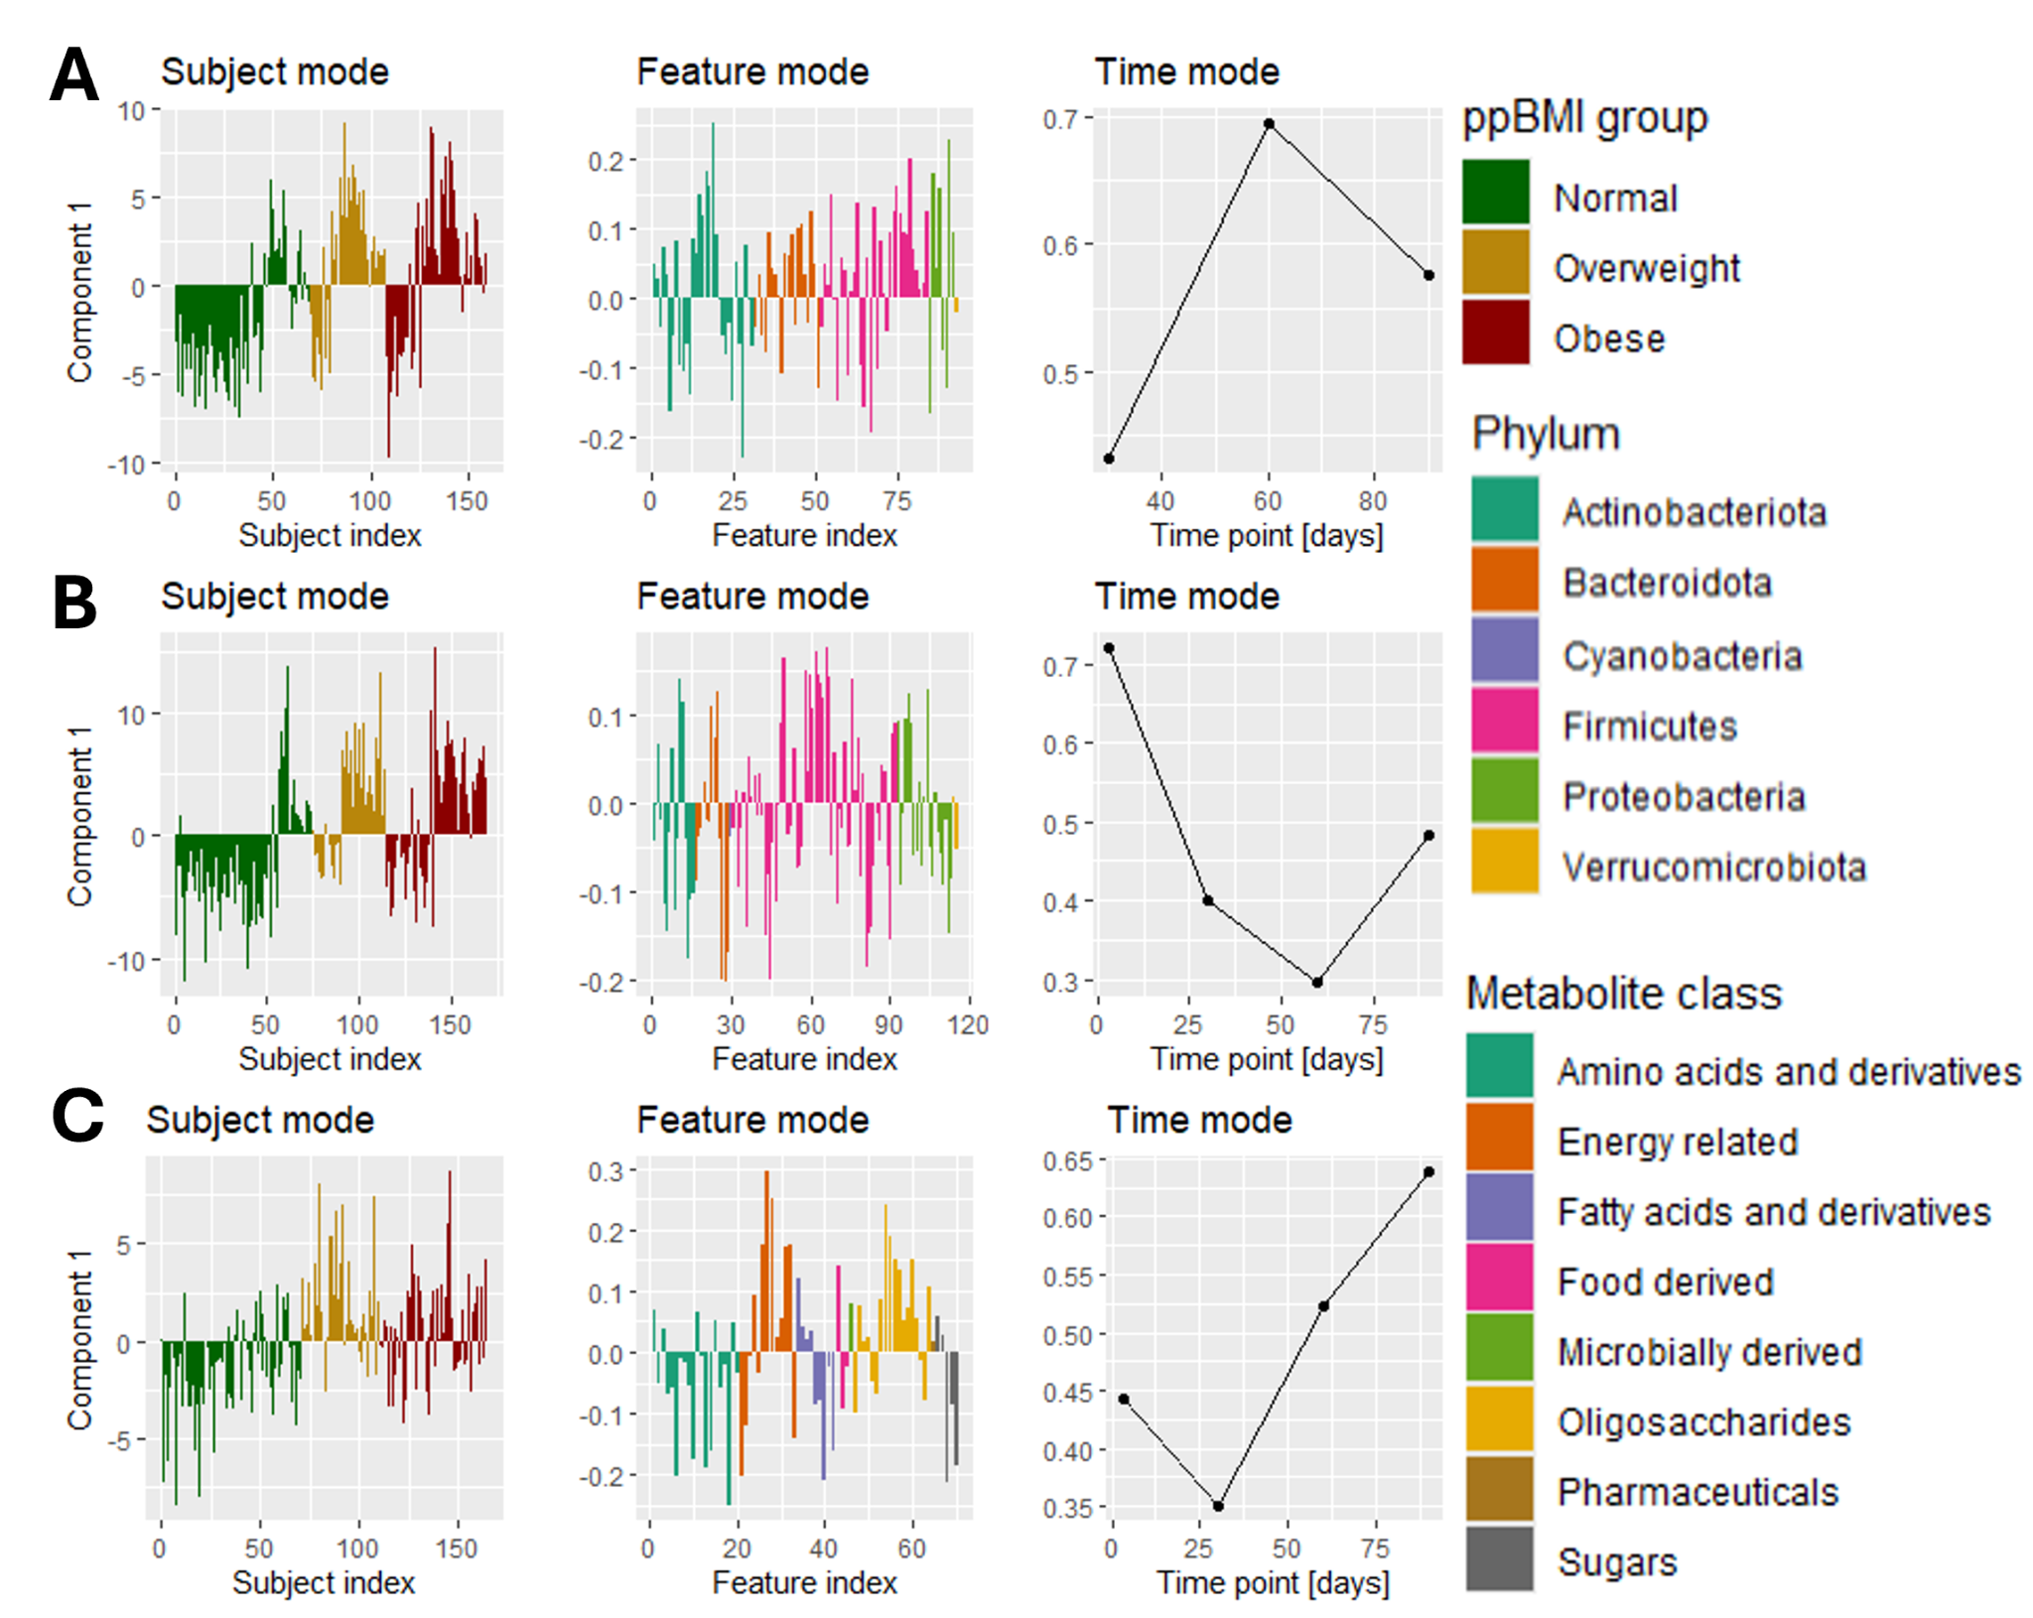
Supplementary Figure 3. Overview of all maternal ppBMI-regressed NPLS models. The left column shows the subject loadings. The middle column shows the feature loadings. The right column shows the time loadings. All NPLS models have one component. (A) NPLS model of the infant faecal microbiome. (B) NPLS model of the HM microbiome. (C) NPLS model of the HM metabolome.

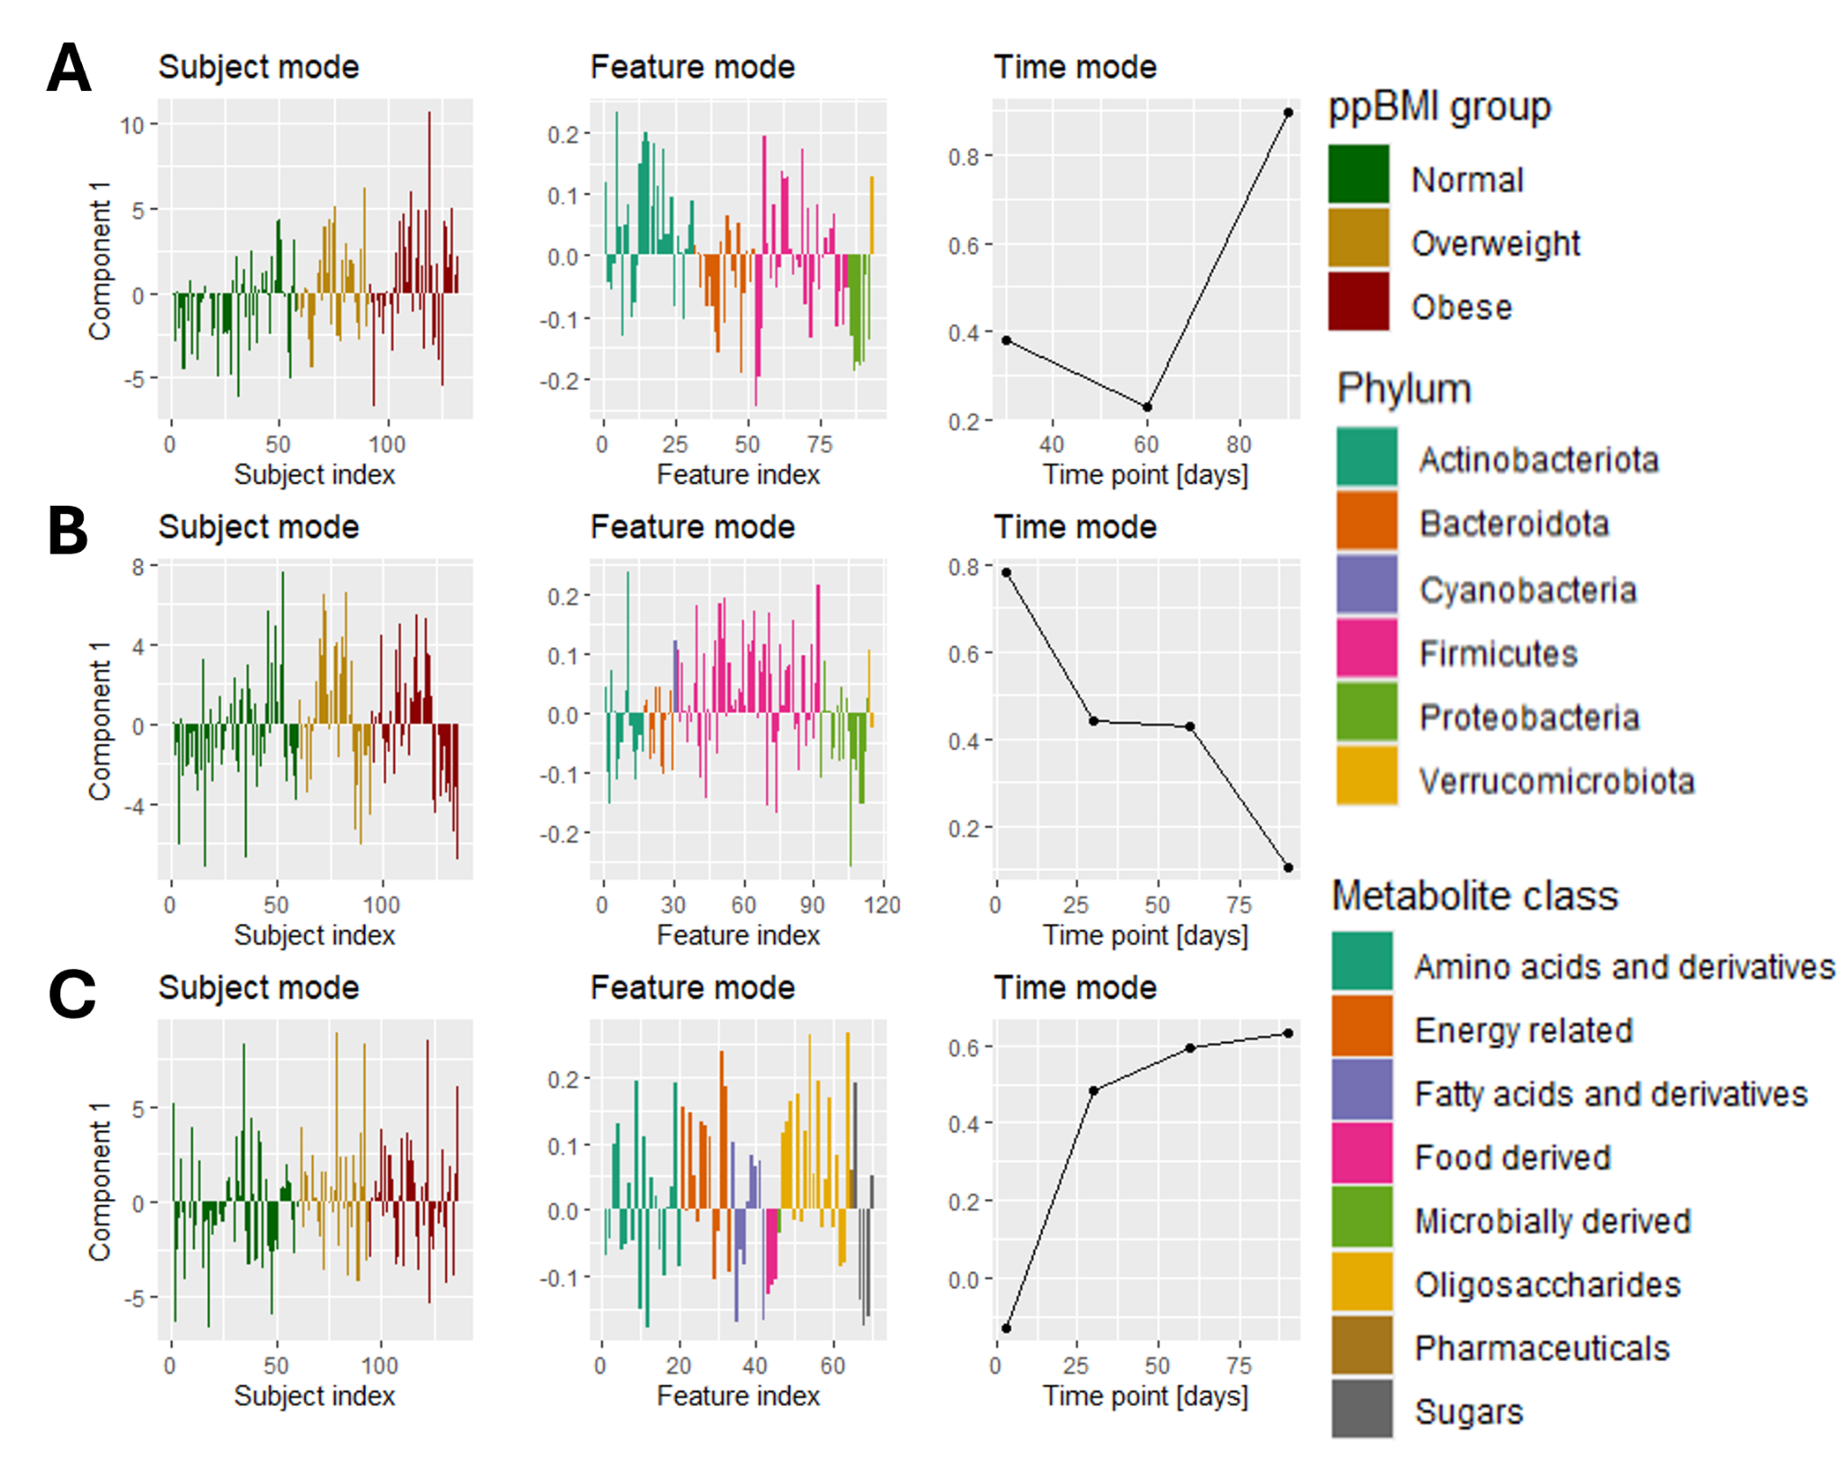
Supplementary Figure 4. Overview of all infant 6 month WHZ-regressed NPLS models. The left column shows the subject loadings. The middle column shows the feature loadings. The right column shows the time loadings. All NPLS models have one component. (A) NPLS model of the infant faecal microbiome.(B) NPLS model of the HM microbiome. (C) NPLS model of the HM metabolome.
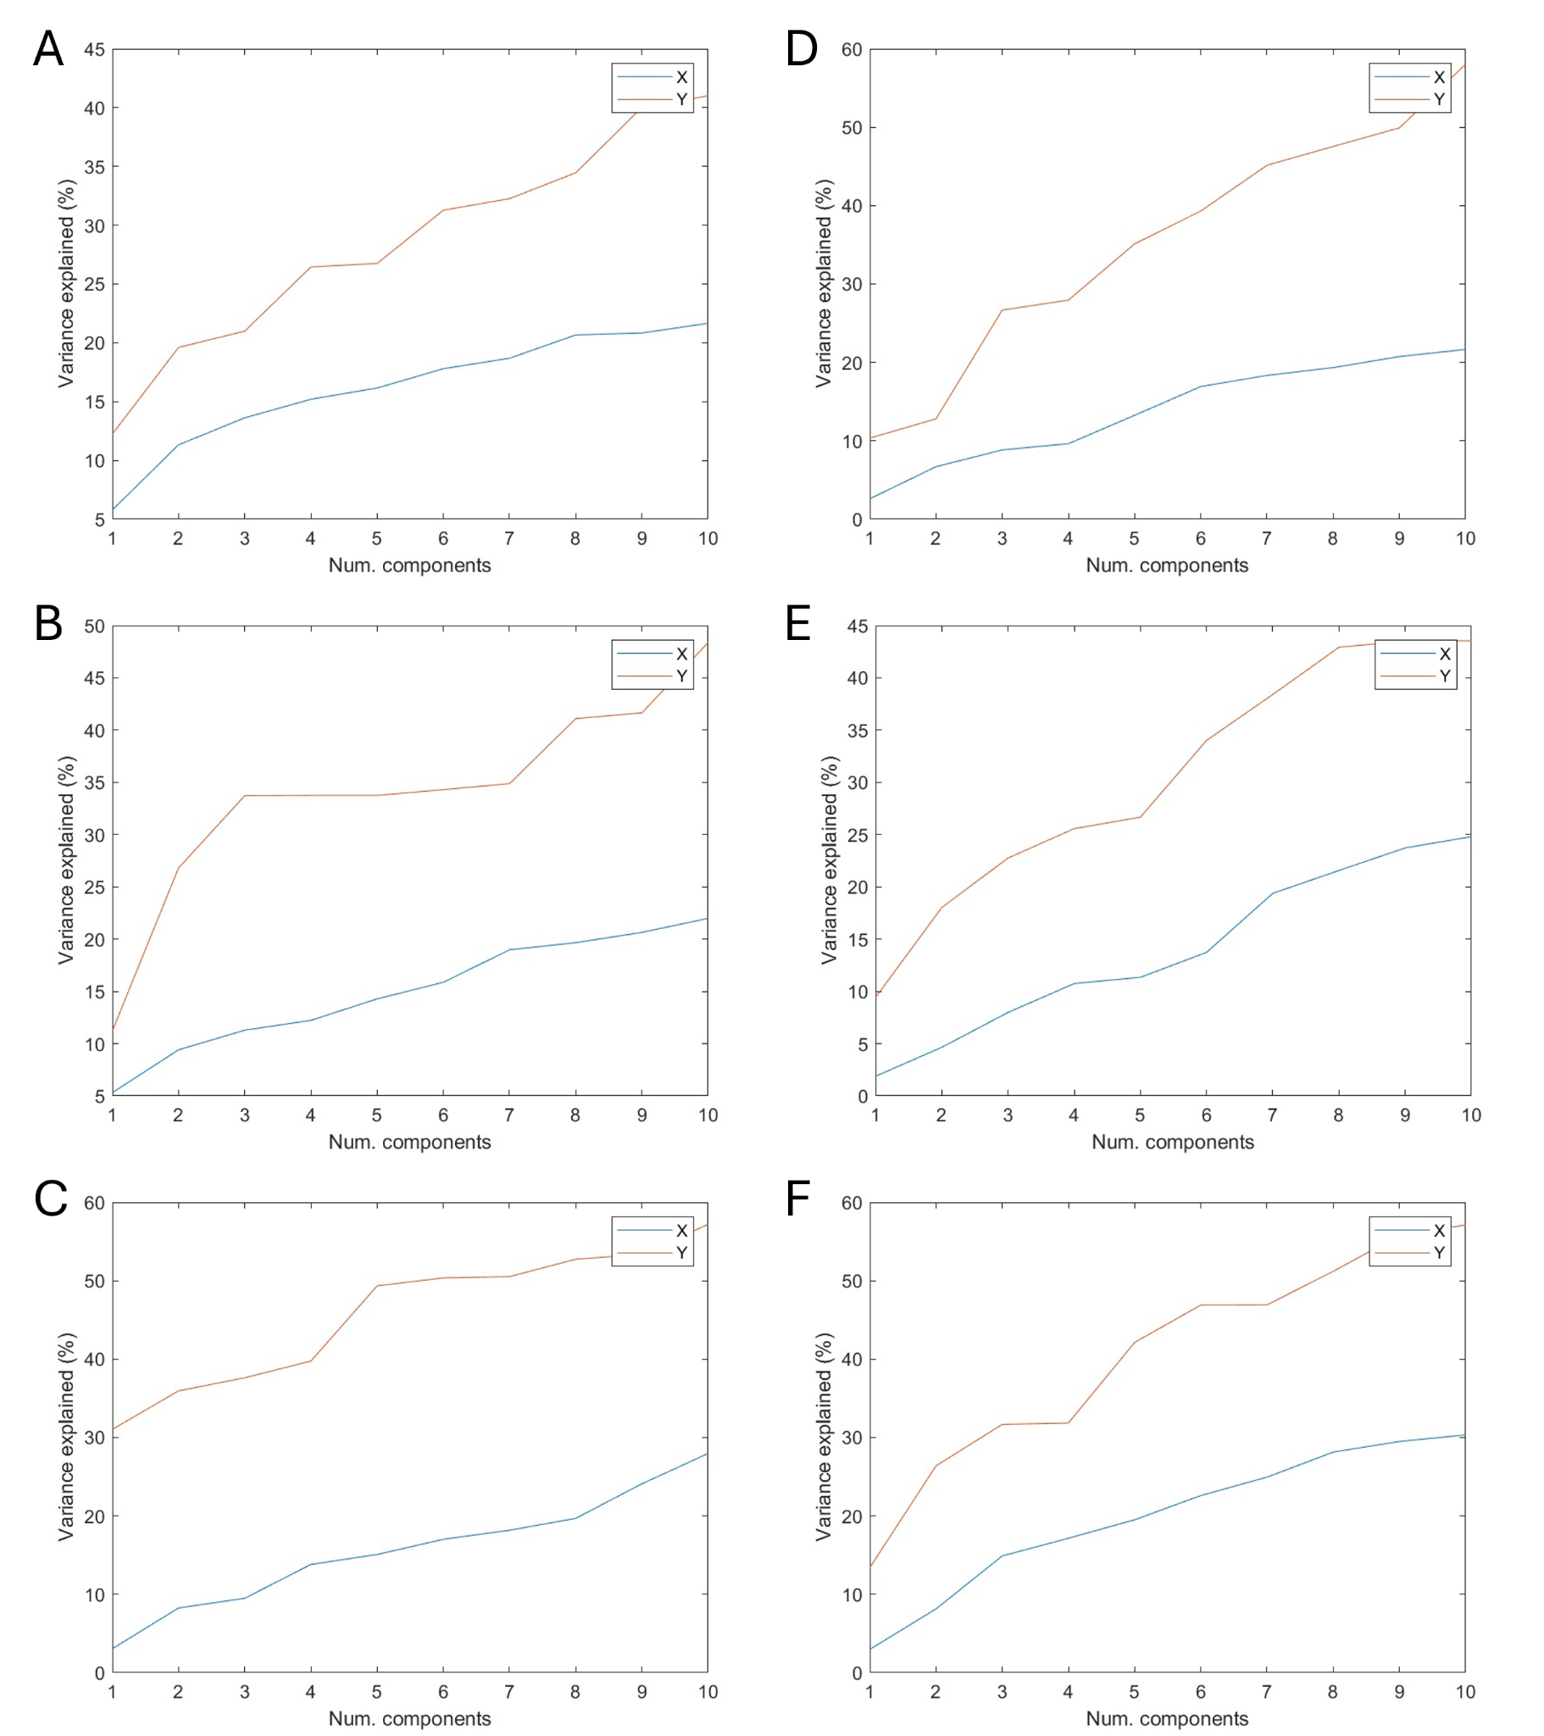
Supplementary Figure 5. Variation explained for the independent dataset (X) and the dependent variable (Y) for a given number of NPLS components. The NPLS models of (A) the infant faecal microbiome regressed onto maternal ppBMI (B) the HM microbiome regressed onto maternal ppBMI (C) the HM metabolome regressed onto maternal ppBMI (D) the infant faecal microbiome regressed onto infant 6-month WHZ (E) the HM microbiome regressed onto infant 6-month WHZ and (F) the HM metabolome regressed onto infant 6-month WHZ. For all models shown in this paper, a 1-component model was sufficient.

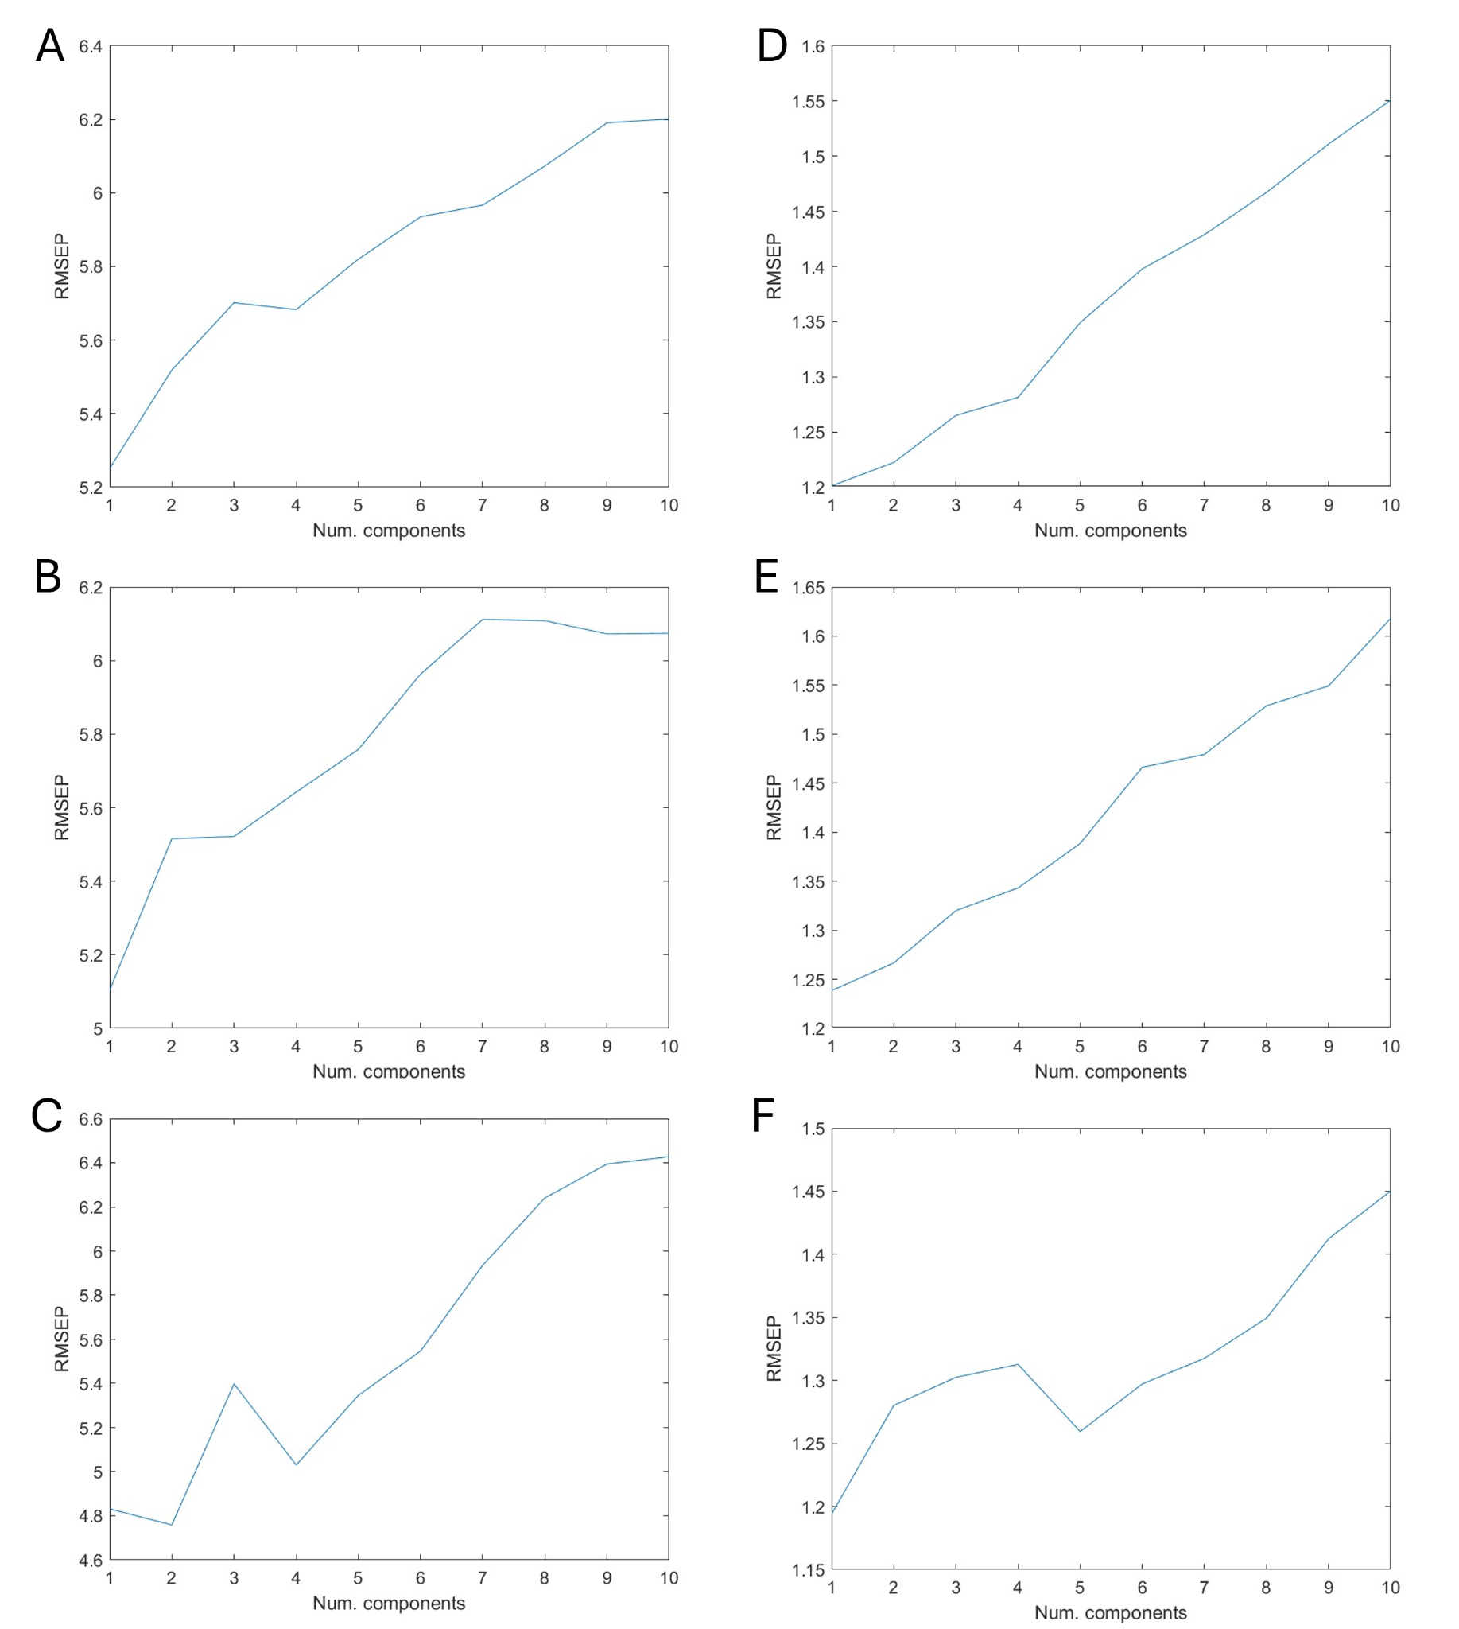
Supplementary Figure 6. Root mean squared error of prediction of the dependent variable for a given number of NPLS components. The NPLS models of (A) the infant faecal microbiome regressed onto maternal ppBMI (B) the HM microbiome regressed onto maternal ppBMI (C) the HM metabolome regressed onto maternal ppBMI (D) the infant faecal microbiome regressed onto infant 6-month WHZ (E) the HM microbiome regressed onto infant 6-month WHZ and (F) the HM metabolome regressed onto infant 6-month WHZ. For all models shown in this paper, a 1-component model was sufficient. While the RMSEP suggests a two-component model for the HM metabolome data regressed onto maternal ppBMI, we found that the extra component did not describe any relevant biological variation.

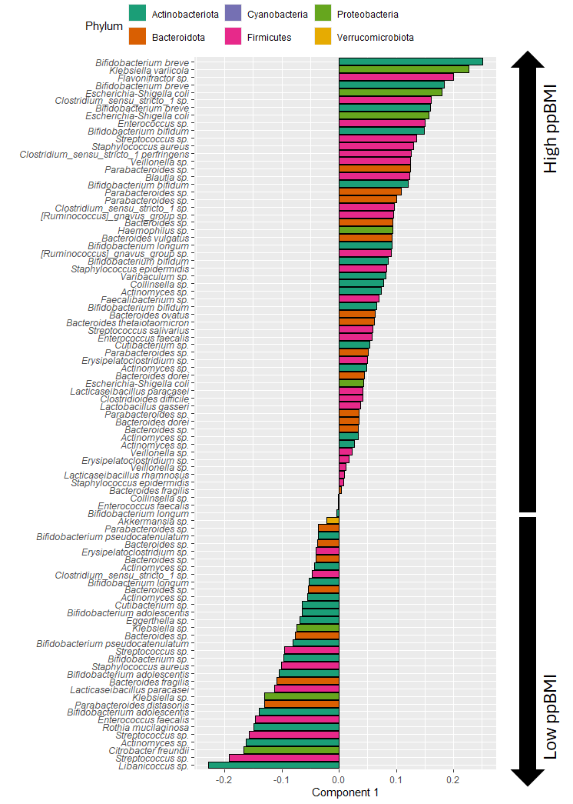
Supplementary Figure 7. Feature loadings in the NPLS model of the infant faecal microbiome regressed onto ppBMI. Positively loaded features are associated with high maternal ppBMI while negatively loaded features are associated with low maternal ppBMI.
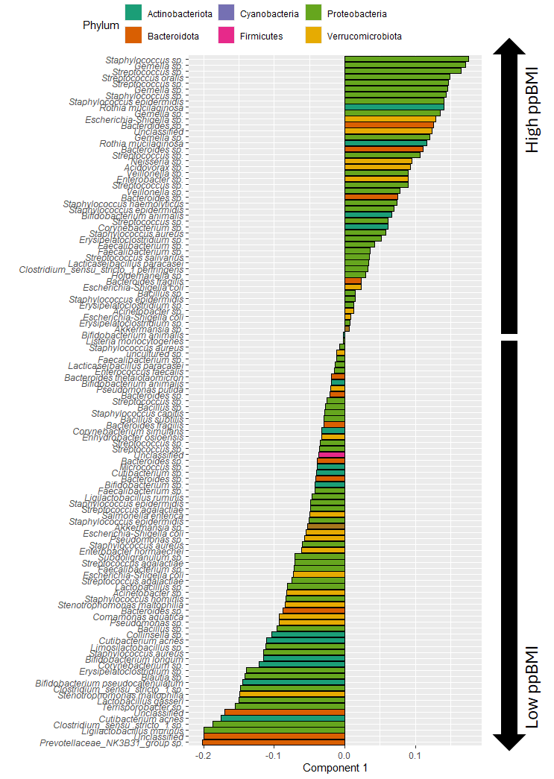
Supplementary Figure 8. Feature loadings in the NPLS model of the HM microbiome regressed onto ppBMI. Positively loaded features are associated with high maternal ppBMI while negatively loaded features are associated with low maternal ppBMI.
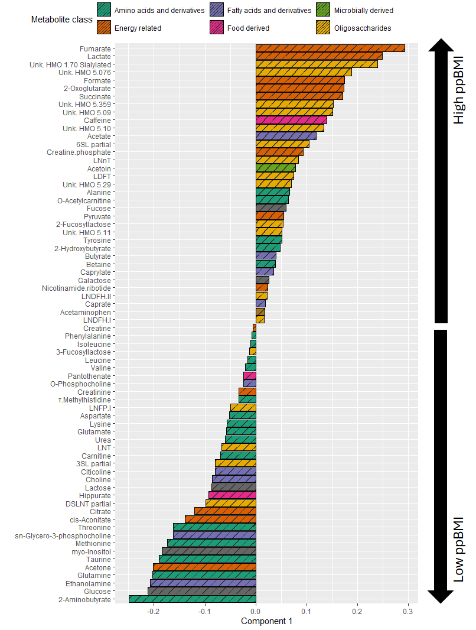
Supplementary Figure 9. Feature loadings in the NPLS model of the HM metabolome regressed onto ppBMI. Positively loaded features are associated with high maternal ppBMI while negatively loaded features are associated with low maternal ppBMI.
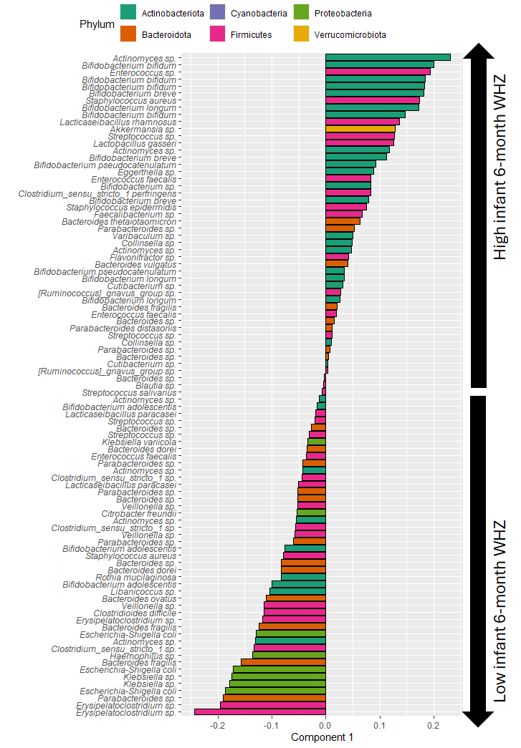
Supplementary Figure 10. Feature loadings in the NPLS model of the infant faecal microbiome regressed onto infant 6-month WHZ. Positively loaded features are associated with high infant 6-month WHZ while negatively loaded features are associated with low infant 6-month WHZ.
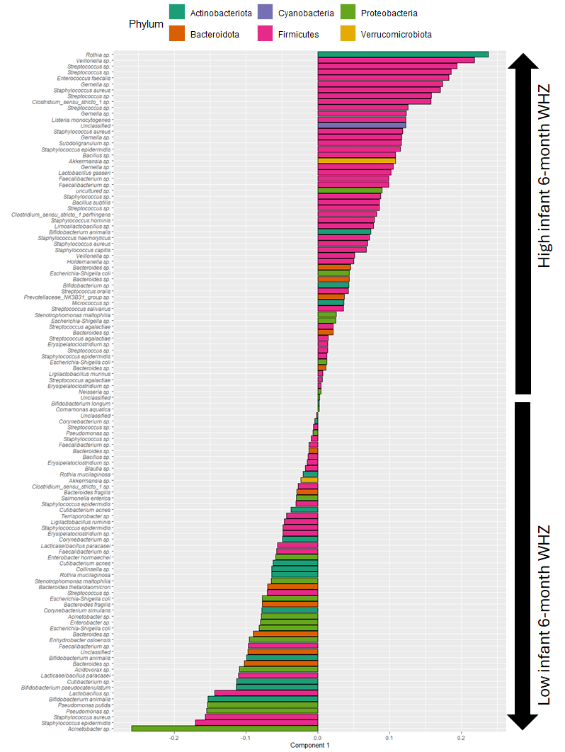
Supplementary Figure 11. Feature loadings in the NPLS model of the HM microbiome regressed onto infant 6-month WHZ. Positively loaded features are associated with high infant 6-month WHZ while negatively loaded features are associated with low infant 6-month WHZ.
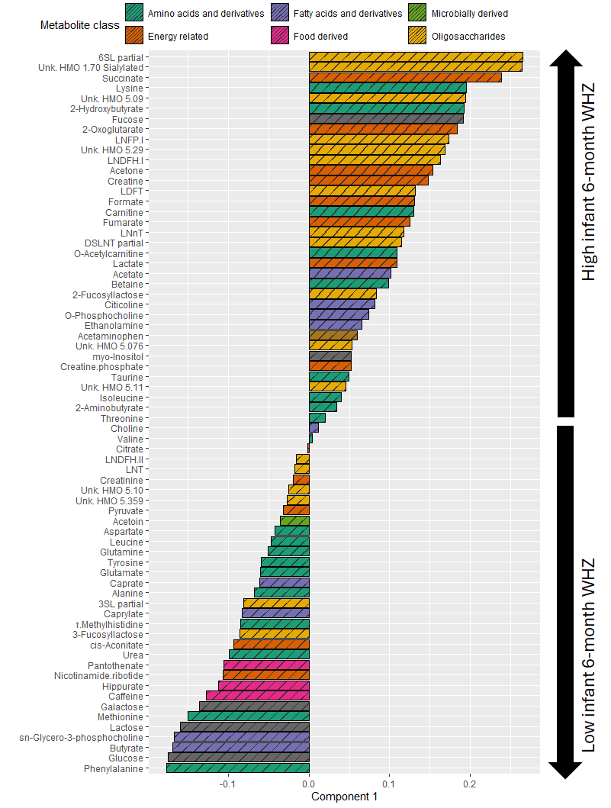
Supplementary Figure 12. Feature loadings in the NPLS model of the HM metabolome regressed onto infant 6-month WHZ. Positively loaded features are associated with high infant 6-month WHZ while negatively loaded features are associated with low infant 6-month WHZ.
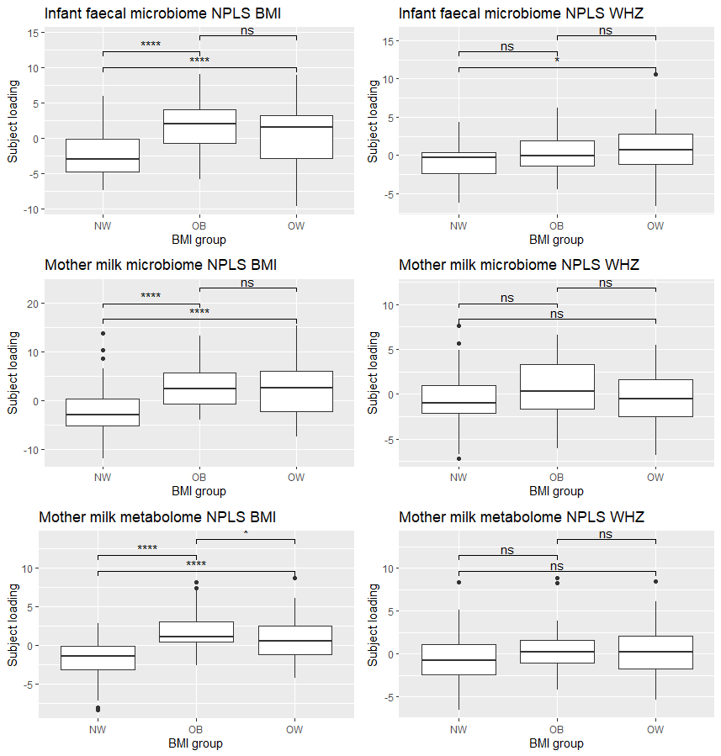Supplementary Figure 13. Comparison of subject loadings in the NPLS models highlighted in the main text. The rows correspond to the infant faecal microbiome, mother milk microbiome and mother milk metabolomics data, respectively. The left column shows the NPLS models of the maternal ppBMI and the right column shows the NPLS models of the 6 month WHZ of the infant. P-values of Wilcoxon tests between maternal ppBMI groups are indicated. *: p≤0.05, **: p≤0.01, ***: p≤0.001, **** p≤0.0001, ns: not significant.

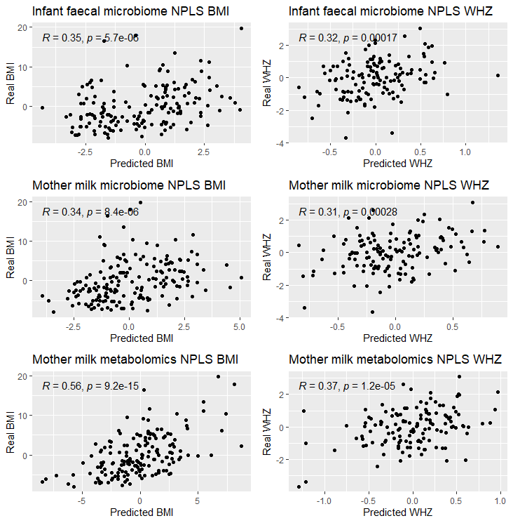
Supplementary Figure 14. Overview of real versus predicted maternal ppBMI (left) or infant 6-month WHZ (right) in (top) the infant faecal microbiome, (middle) the HM microbiome and (bottom) the HM metabolome. R and p-value correspond to a Pearson correlation test.

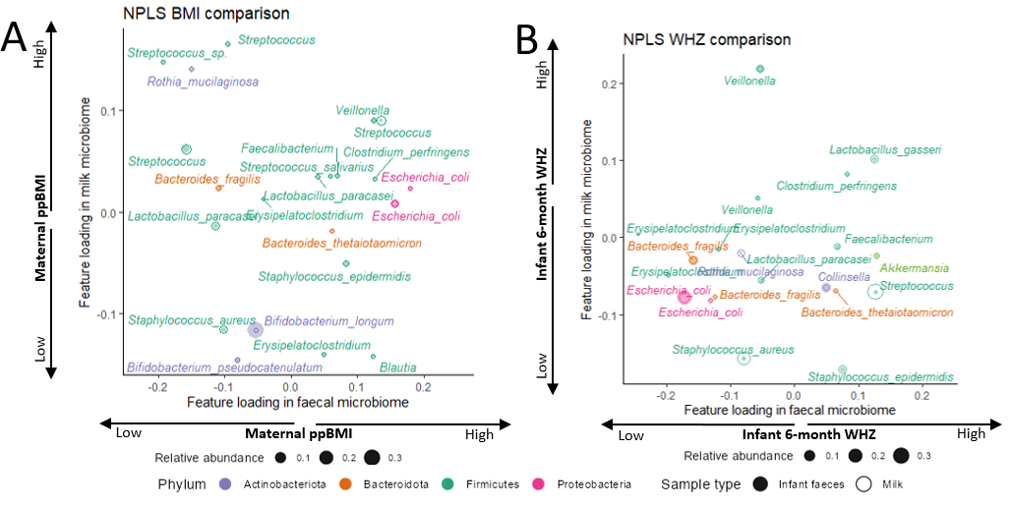
Supplementary Figure 15: Between-dataset comparisons of bacterial and metabolite loadings. Feature loading comparison for the NPLS models recessed onto (A) maternal ppBMI or (B) infant 6-month WHZ showing associations for faecal (x-axis) and milk-based (y-axis) models. A full overview of the loadings per metabolite and microbiota is given in Supplementary Figures 7-12. An overview of the associations per metabolite and microbiota is given in Supplementary Tables 5-7.

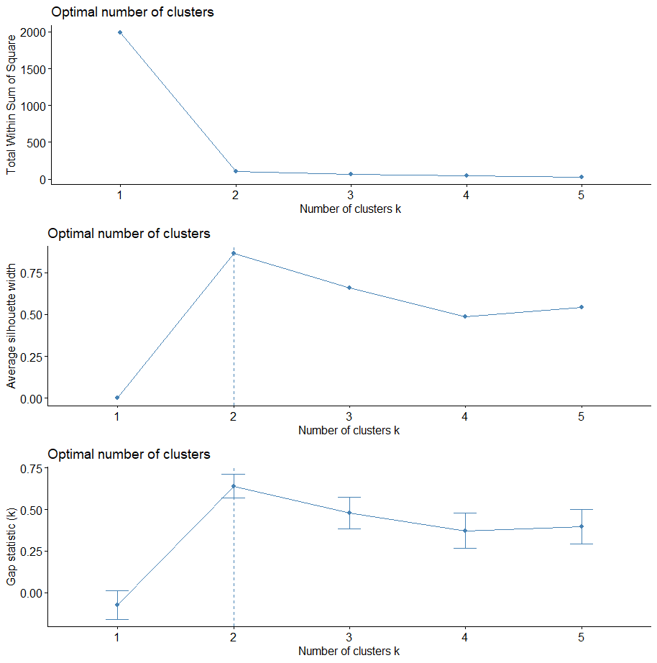
Supplementary Figure 16. Overview of ASV clustering diagnostics for the NPLS model of the infant faecal microbiome data using the maternal ppBMI. The top figure shows the total within-cluster sum of squares metric. The middle figure shows the average silhouette width metric. The bottom row shows the gap statistic. The optimal number of clusters is indicated with a dotted line and is generally followed if all metrics agree.
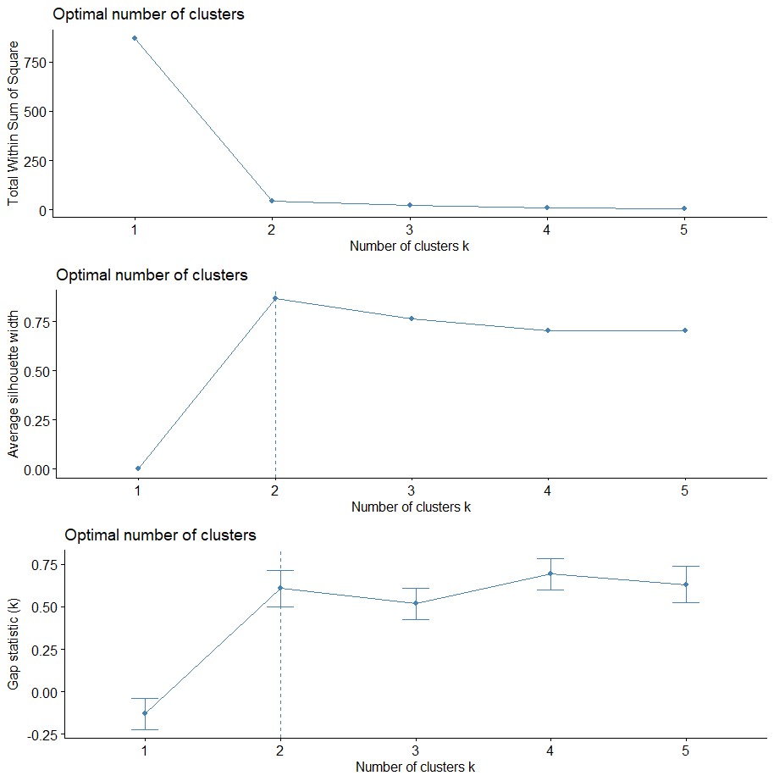
Supplementary Figure 17. Overview of ASV clustering diagnostics for the NPLS model of the infant faecal microbiome data using the infant 6-month WHZ. The top figure shows the total within-cluster sum of squares metric. The middle figure shows the average silhouette width metric. The bottom row shows the gap statistic. The optimal number of clusters is indicated with a dotted line and is generally followed if all metrics agree.
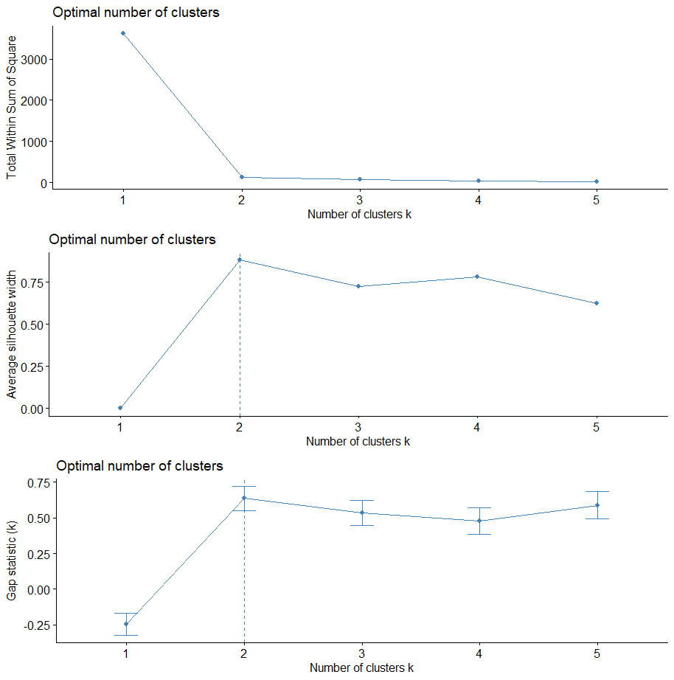
Supplementary Figure 18. Overview of ASV clustering diagnostics for the NPLS model of the mother milk microbiome data using the maternal ppBMI. The top figure shows the total within-cluster sum of squares metric. The middle figure shows the average silhouette width metric. The bottom row shows the gap statistic. The optimal number of clusters is indicated with a dotted line and is generally followed if all metrics agree.
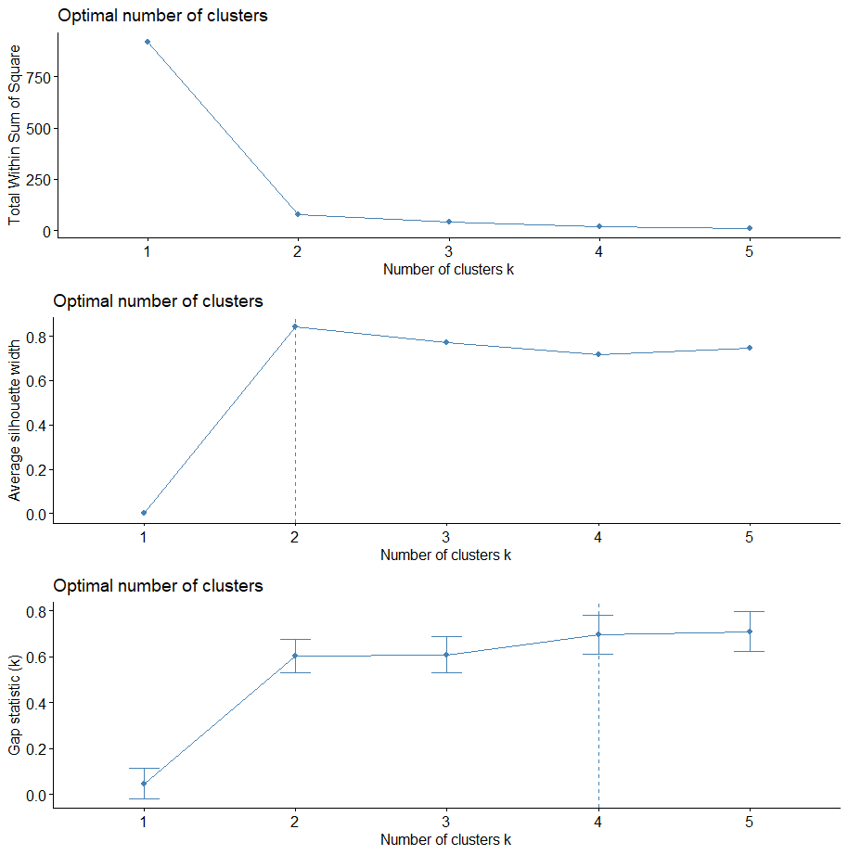
Supplementary Figure 19. Overview of ASV clustering diagnostics for the NPLS model of the mother milk microbiome data using the infant 6-month WHZ. The top figure shows the total within-cluster sum of squares metric. The middle figure shows the average silhouette width metric. The bottom row shows the gap statistic. The optimal number of clusters is indicated with a dotted line and is generally followed if all metrics agree.

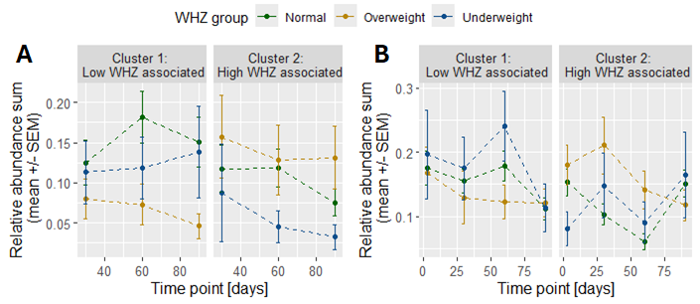
Supplementary Figure 20. Relative abundance sum (out of 1) of zOTUs for each WHZ group as described by theinfant 6-month WHZ regressed NPLS models of (A) infant faecal and (B) HM microbiota. Error bars correspond to the standard error of the mean (SEM) across all samples per WHZ group. See Supplementary Table 3 for the list of identified species per zOTU cluster. For the purposes of this plot, infant 6-month WHZ was stratified into three groups: normal weight (WHZ between -1 and 1), overweight (WHZ 1 or more) and underweight (WHZ -1 or less).

Supplementary Tables
Supplementary Table 1. Milk metabolites concentrations (mmol/ml), ordered within each category by mean values ± standard deviation. Group significance by BH-corrected Kruskal-Wallis test for ppBMI and Friedman test for time comparisons. Bold values are below the significance threshold p ≤ 0.05. Abbreviations: FL; fucosyllactose, HMOs; human milk oligosaccharides, LDFT; lactodifucotetraose, LNDFH; lacto-N-difucohexaose, LNT; lacto-N-tetraose, SD; standard deviation, SL; Sialyllactose

 | Concentration (mmol/ml) | Pre-pregnancy BMI | Days
Amino acids and derivatives
Glutamate | 1.5±0.56 | 5.8e-1 | 4.30e-21
Urea | 1.5±0.72 | 8.7e-1 | 2.01e-3
Glutamine | 0.56±0.41 | 6.2e-3 | 1.99e-40
Taurine | 0.36±0.17 | 9.2e-2 | 3.68e-20
Alanine | 0.26±0.099 | 1.9e-1 | 1.37e-8
Threonine | 0.11±0.045 | 1.4e-1 | 1.61e-7
Aspartate | 0.082±0.057 | 3.1e-2 | 1.37e-8
Valine | 0.059±0.045 | 8.4e-1 | 2.01e-19
Carnitine | 0.054±0.019 | 6.4e-1 | 4.47e-3
Betaine | 0.053±0.025 | 8.7e-1 | 2.55e-22
Leucine | 0.038±0.088 | 9.0e1 | 1.15e-12
Methionine | 0.032±0.018 | 1.3e-1 | 9.15e-19
τ-Methylhistidine | 0.031±0.019 | 6.9e-1 | 1.58e-3
O-Acetylcarnitine | 0.024±0.02 | 8.6e-1 | 7.94e-31
Lysine | 0.021±0.035 | 5.0e-1 | 4.31e-21
Tyrosine | 0.018±0.023 | 5.8e-1 | 5.67e-1
Phenylalanine | 0.017±0.013 | 8.6e-1 | 6.67e-4
2-Aminobutyrate | 0.015±0.018 | 2.6e-4 | 1.17e-20
Isoleucine | 0.014±0.0027 | 9.0e-1 | 1.64e-1
2-Hydroxybutyrate | 0.0083±0.021 | 7.8e-1 | 2.37e-10
Energy related
Citrate | 3.9±1.3 | 8.7e-1 | 3.85e-32
Lactate | 0.2±0.57 | 2.7e-4 | 3.78e-21
Creatine | 0.072±0.035 | 4.9e-4 | 1.17e-3
Nicotinamide ribotide | 0.063±0.041 | 7.0e-1 | 4.85e-32
Creatinine | 0.059±0.026 | 4.9e-1 | 1.17e-3
2-Oxoglutarate | 0.052±0.024 | 1.3e-2 | 1.16e-19
Creatine phosphate | 0.032±0.017 | 2.7e-1 | 1.90e-12
Formate | 0.026±0.3 | 2.6e-1 | 3.24e-11
Acetone | 0.016±0.0013 | 2.1e-3 | 6.32e-2
Pyruvate | 0.014±0.035 | 9.0e-1 | 2.16e22
Succinate | 0.0012±0.0062 | 1.5e-1 | 6.02e-10
cis-Aconitate | 0.01±0.0071 | 2.1e-1 | 1.43e-11
Fumarate | 0.0041±0.0029 | 5.9e-5 | 3.80e-28
Fatty acids and derivatives
O-Phosphocholine | 0.63±0.26 | 1.7e-1 | 9.63e-32
sn-Glycero-3-phosphocholine | 0.44±0.23 | 4.3e-3 | 8.49e-25
Citicoline | 0.24±0.14 | 6.1e-2 | 1.02e-16
Choline | 0.14±0.087 | 3.4e-1 | 4.28e-16
Caprylate | 0.097±0.12 | 5.3e-1 | 7.55e-10
Ethanolamine | 0.094±0.038 | 1.6e-3 | 8.12e-4
Caprate | 0.065±0.075 | 5.8e-1 | 5.28e-5
Butyrate | 0.059±0.092 | 6.3e-1 | 1.17e-11
Acetate | 0.041±0.38 | 1.4e-1 | 7.80e-17
Food derived
Pantothenate | 0.024±0.018 | 9.6e-1 | 3.95e-10
Hippurate | 0.015±0.013 | 6.3e-1 | 1.04e-13
Caffeine | 0.011±0.0096 | 1.8e-2 | 4.58e-1
Microbially derived
Acetoin | 0.0017±0.03 |  | 3.18e-1
Oligosaccharides
Unk. HMO 5.11 | 3.6±1.5 | 6.9e-1 | 8.88e-9
LNT | 3.2±1.8 | 8.8e-1 | 1.15e.39
2-Fucosyllactose | 2.6±2.1 | 6.3e-1 | 2.18e-33
3-Fucosyllactose | 2.5±2 | 6.6e-1 | 3.27e-50
Unk. HMO 5.10 | 2.1±2.2 | 1.4e-2 | 3.90e-30
Unk. HMO 5.09 | 1.9±0.93 | 3e-3 | 4.90e-39
Unk. HMO 5.076 | 1.7±0.25 | 8.1e-5 | 5.87e-30
Unk. HMO 5.359 | 1.5±0.34 | 2.1e-2 | 4.25e-1
LNDFH I | 0.76±0.65 | 1.9e-1 | 8.60e-29
Unk. HMO 5.29 | 0.62±0.59 | 2.3-1 | 8.46e-21
LDFT | 0.45±0.55 | 5-6e-1 | 5.74e-02
LNnT | 0.45±0.31 | 6.6e-1 | 4.65e-35
Unk. HMO 1.70 Sialylated | 0.44±0.51 | 1.3e-2 | 1.55e-55
LNDFH II | 0.43±0.49 | 5.8e-1 | 4.59e-1
LNFP I | 0.27±0.34 | 6.4e-1 | 1.50e-10
6SL | 0.25±0.18 | 8.6e-1 | 158e-59
DSLNT | 0.18±0.12 | 6.4e-1 | 5.43e-47
3SL | 0.12±0.055 | 9.4e-2 | 1.31e-22
Pharmaceuticals
Acetaminophen | 0.0048±0.016 |  | 1.95e-13
Sugars
Lactose | 214±9.4 | 4.8e-2 | 9.98e-40
myo-Inositol | 3.2±0.52 | 4.0e-3 | 3.13e-10
Glucose | 1.7±0.63 | 1.3e-2 | 5.55e-11
Galactose | 0.67±0.1 | 6.4e-2 | 6.81e-3
Fucose | 0.29±0.27 | 6.6e-1 | 4.91e-19

Supplementary Table 2. Model subject loading correlations with infant growth outcomes. BH-corrected Pearson correlation test results of subject loadings versus measured clinical parameters of interest. Bold values are below the significance threshold p ≤ 0.05. Dep. variable: dependent variable. ppBMI: pre-pregnancy BMI, BMIz: BMI-for-age, WHZ: weight-for-length/height z-score, varExpX: variation explained in the independent dataset. varExpY: variation explained in the dependent variable.

Independent dataset | Dependent variable | Number of components | maternal ppBMI | Infant 6-month WHZ | Infant 1-year WHZ | Infant 2-year BMIz score | Infant 3-year BMIz score
Infant  Faecal  Bacteria | maternal ppBMI | 1 | 1.1e-4 | 6.0e-1 | 6.0e-1 | 3.3e-1 | 4.4e-1
Infant  Faecal  Bacteria | Infant 6-month WHZ | 1 | 2.1e-1 | 7.4e-4 | 1.2e-1 | 1.0e-1 | 4.0e-1
Milk  Bacteria | maternal ppBMI | 1 | 1.3e-4 | 8.4e-1 | 4.2e-1 | 1.4e-1 | 2.1e-1
Milk  Bacteria | Infant 6-month WHZ | 1 | 8.8e-2 | 2.1e-3 | 7.0e-2 | 2.7e-1 | 6.1e-1
Milk  Metabolites | maternal ppBMI | 1 | 5.5e-13 | 4.2e-1 | 7.1e-1 | 8.6e-1 | 6.1e-1
Milk  Metabolites | Infant 6-month WHZ | 1 | 8.8e-2 | 1.4e-4 | 2.2e-4 | 4.1e-2 | 1.1e-1

Supplementary Table 3. Overview of all identified species per zOTU cluster per NPLS model. zOTUs within the same cluster have similar dynamics. Only clustered zOTUs with taxonomic annotations resolved to species level are shown. Indep. dataset: independent dataset. Dep. variable: dependent variable, N: number of cluster members
Indep.  dataset | Dep. variable | Cluster | N | Association | Microbiota
Infant faecal micro-  biome | Maternal ppBMI | 1 | 13 | High maternal ppBMI | Bifidobacterium bifidum, Bifidobacterium breve, Clostridium perfringens, Escherichia coli, Klebsiella variicola, Staphylococcus aureus
Infant faecal micro-  biome | Maternal ppBMI | 2 | 10 | Low maternal ppBMI | Bacteroides fragilis, Bifidobacterium adolescentis, Citrobacter freundii, Enterococcus faecalis, Lactobacillus paracasei, Parabacteroides distasonis, Rothia mucilaginosa
Infant faecal micro-  biome | Infant 6-month WHZ | 1 | 7 | Low infant 6-month WHZ | Bacteroides fragilis, Bacteroides ovatus, Clostridoides difficile, Escherichia coli
Infant faecal micro-  biome | Infant 6-month WHZ | 2 | 10 | High infant 6-month WHZ | Bifidobacterium bifidum, Bifidobacterium breve, Bifidobacterium longum, Lactobacillus gasseri, Lactobacillus rhamnosus, Staphylococcus aureus
Mother milk micro-  biome | Maternal ppBMI | 1 | 14 | Low maternal ppBMI | Bifidobacterium longum, Bifidobacterium pseudocatenulatum, Cutibacterium acnes, Lactobacillus gasseri, Lactobacillus murinus, Staphylococcus aureus, Stenotrophomonas maltophilia
Mother milk micro-  biome | Maternal ppBMI | 2 | 12 | High maternal ppBMI | Rothia mucilaginosa, Staphylococcus epidermidis, Streptococcus oralis
Mother milk micro-  biome | Infant 6-month WHZ | 1 | 10 | Low infant 6-month WHZ | Bifidobacterium animalis, Bifidobacterium pseudocatenulatum, Moraxella osloensis, Lactobacillus paracasei, Pseudomonas putida, Staphylococcus aureus, Staphylococcus epidermidis
Mother milk micro-  biome | Infant 6-month WHZ | 2 | 12 | High infant 6-month WHZ | Enterococcus faecalis, Lactobacillus gasseri, Listeria monocytogenes, Staphylococcus aureus, Staphylococcus epidermidis

Supplementary Table 4. BH-corrected p-values of a permutation test of mean difference between the summed relative abundance between normal-weight and overweight-or-obese groups (N=999). Dep. variable: dependent variable, ppBMI: pre-pregnancy body mass index, WHZ: weight-for-length/height z-score.

Independent dataset | Dep. variable | Cluster | Day 3 | Day 30 | Day 60 | Day 90
Infant faecal microbiome | Maternal ppBMI | 1 | - | 0.016 | <1e-3 | 0.0015
Infant faecal microbiome | Maternal ppBMI | 2 | - | 0.098 | 0.0015 | <1e-3
Infant faecal microbiome | Infant 6-monthWHZ | 1 | - | 0.11 | 0.083 | 0.083
Infant faecal microbiome | Infant 6-monthWHZ | 2 | - | <1e-3 | 0.083 | 0.021
Mother milk microbiome | Maternal ppBMI | 1 | 0.0032 | 0.48 | 0.48 | 0.0032
Mother milk microbiome | Maternal ppBMI | 2 | <1e-3 | 0.0053 | <1e-3 | <1e-3
Mother milk microbiome | Infant 6-monthWHZ | 1 | 0.35 | 0.35 | 0.21 | 0.067
Mother milk microbiome | Infant 6-monthWHZ | 2 | 0.0040 | 0.042 | <1e-3 | 0.011

Supplementary Table 5. Overview of maternal pre-pregnancy BMI (ppBMI) and infant 6-month growth (WHZ) per HM metabolite.
Mother milk metabolome | Low infant WHZ associated | High infant WHZ associated
Low ppBMI associated | 3-Fucosyllactose,  3SL partial,  Aspartate,  Citrate,  Creatinine,  Glucose,  Glutamate,  Glutamine,  Hippurate,  LNT,  Lactose,  Leucine,  Methionine,  Pantothenate,  Phenylalanine,  Urea,  cis-Aconitate,  sn-Glycero-3-phosphocholine,  tau-Methylhistidine | 2-Aminobutyrate,  Acetone,  Carnitine,  Choline,  Citicoline,  Creatine,  DSLNT partial,  Ethanolamine,  Isoleucine,  LNFP-I,  Lysine,  O-Phosphocholine,  Taurine,  Threonine,  Valine,  myo-Inositol
High ppBMI associated | Acetoin,  Alanine,  Butyrate,  Caffeine,  Caprate,  Caprylate,  Galactose,  LNDFH-II,  Nicotinamide ribotide,  Pyruvate,  Tyrosine,  Unk. HMO 5.10,  Unk. HMO 5.359 | 2-Fucosyllactose,  2-Hydroxybutyrate,  2-Oxoglutarate,  6SL partial,  Acetaminophen,  Acetate,  Betaine,  Creatine phosphate,  Formate,  Fucose,  Fumarate,  LDFT,  LNDFH-I,  LNnT,  Lactate,  O-Acetylcarnitine,  Succinate,  Unk. HMO 1.70 Sialylated,  Unk. HMO 5.076,  Unk. HMO 5.09,  Unk. HMO 5.11,  Unk. HMO 5.29

Supplementary Table 6. Overview of maternal pre-pregnancy BMI (ppBMI) and infant 6-month growth (WHZ) per HM microbiota.
Mother milk microbiome | Low infant WHZ associated | High infant WHZ associated
Low ppBMI associated | Acinetobacter sp.,  Akkermansia sp.,  Bacillus sp.,  Bacteroides sp.,  Bacteroides fragilis,  Bacteroides thetaiotaomicron,  Bifidobacterium animalis,  Bifidobacterium pseudocatenulatum,  Blautia sp.,  Clostridium sp.,  Collinsella sp.,  Corynebacterium sp.,  Corynebacterium simulans,  Cutibacterium sp.,  Cutobacterium acnes (2),  Moraxella osloensis,  Enterobacter hormaechei,  Erysipelatoclostridium sp.,  Faecalibacterium sp.,  Lactobacillus sp.,  Lactobacillus paracasei,  Lactobacillus ruminis,  Pseudomonas sp. (2),  Pseudomonas putida,  Salmonella enterica,  Staphylococcus aureus,  Staphylococcus epidermidis (2),  Stenotrophomonas maltophilia,  Streptococcus sp.,  Terrisporobacter sp.,  Unidentified (2) | Bacillus subtilis,  Bacteroides sp. (3),  Bifidobacterium sp.,  Bifidobacterium animalis,  Bifidobacterium longum,  Clostridium sp.,  Comamonas aquatica,  Enterococcus faecalis,  Escherichia coli (2),  Faecalibacterium sp. (2),  Lactobacillus gasseri,  Lactobacillus murinus,  Limosilactobacillus sp.,  Listeria monocytogenes,  Micrococcus sp.,  Prevotellaceae NK3B31 group sp.,  Staphylococcus aureus (2),  Staphylococcus capitis,  Staphylococcus hominis,  Stenotrophomonas maltophilia,  Streptococcus sp. (3),  Streptococcus agalactiae (3),  Unidentified (2)
High ppBMI associated | Acidovorax sp.,  Acinetobacter sp.,  Bacteroides sp. (2),  Bacteroides fragilis,  Bifidobacterium animalis,  Corynebacterium sp.,  Enterobacter sp.,  Erysipelatoclostridium sp.,  Escherichia coli (2),  Faecalibacterium sp. (2),  Lactobacillus paracasei,  Rothia mucilaginosa (2),  Staphylococcus sp. (2),  Staphylococcus epidermidis | Akkermansia sp.,  Bacillus sp.,  Bacteroides sp.,  Clostridium perfringens,  Erysipelatoclostridium sp. (2),  Escherichia-Shigella sp.,  Gemella sp. (4),  Holdemanella sp.,  Neisseria sp.,  Staphylococcus sp.,  Staphylococcus aureus,  Staphylococcus epidermidis (2),  Staphylococcus haemolyticus,  Streptococcus sp. (4),  Streptococcus oralis,  Streptococcus salivarius,  Veillonella sp. (2),  Unidentified (1)

Supplementary Table 7. Overview of maternal pre-pregnancy BMI (ppBMI) and infant 6-month growth (WHZ) per infant faecal microbiota.
Infant faecal microbiome | Low infant WHZ associated | High infant WHZ associated
Low ppBMI associated | Actinomyces sp. (2),  Bacteroides sp. (3),  Bacteroides fragilis,  Bifidobacterium adolescentis (3),  Citrobacter freundii,  Clostridium sp.,  Enterococcus faecalis,  Erysipelatoclostridium sp.,  Klebsiella sp. (2),  Lactobacillus paracasei,  Libanicoccus sp.,  Parabacteroides sp.,  Rothia mucilaginosa, Staphylococcus aureus,  Streptococcus sp. (2) | Actinomyces sp.,  Akkermansia sp.,  Bacteroides sp.,  Bifidobacterium sp.,  Bifidobacterium longum (2), Bifidobacterium pseudocatenulatum (2),  Collinsella sp.,  Cutibacterium sp.,  Eggerthella sp.,  Enterococcus faecalis,  Parabacteroides distasonis,  Streptococcus sp.
High ppBMI associated | Actinomyces sp. (2),  Bacteroides sp.,  Bacteroides dorei (2),  Bacteroides fragilis,  Bacteroides ovatus,  Blautia sp.,  Clostridioides difficile,  Clostridium sp. (2),  Erysipelatoclostridium sp. (2),  Escherichia coli (3),  Haemophilus sp.,  Klebsiella variicola,  Lactobacillus paracasei,  Parabacteroides sp. (3),  Streptococcus salivarius,  Veillonella sp. (3) | Actinomyces sp. (2),  Bacteroides sp.,  Bacteroides thetaiotaomicron, Bacteroides vulgatus,  Bifidobacterium bifidum (4), Bifidobacterium breve (3),  Bifidobacterium longum,  Clostridium perfringens,  Collinsella sp.,  Cutibacterium sp.,  Enterococcus sp.,  Enterococcus faecalis,  Faecalibacterium sp.,  Flavonifractor sp.,  Lactobacillus rhamnosus,  Lactobacillus gasseri,  Parabacteroides sp. (2),  Staphylococcus aureus,  Staphylococcus epidermidis,  Streptococcus sp.,  Varibaculum sp.,  Ruminococcus gnavus (2)

