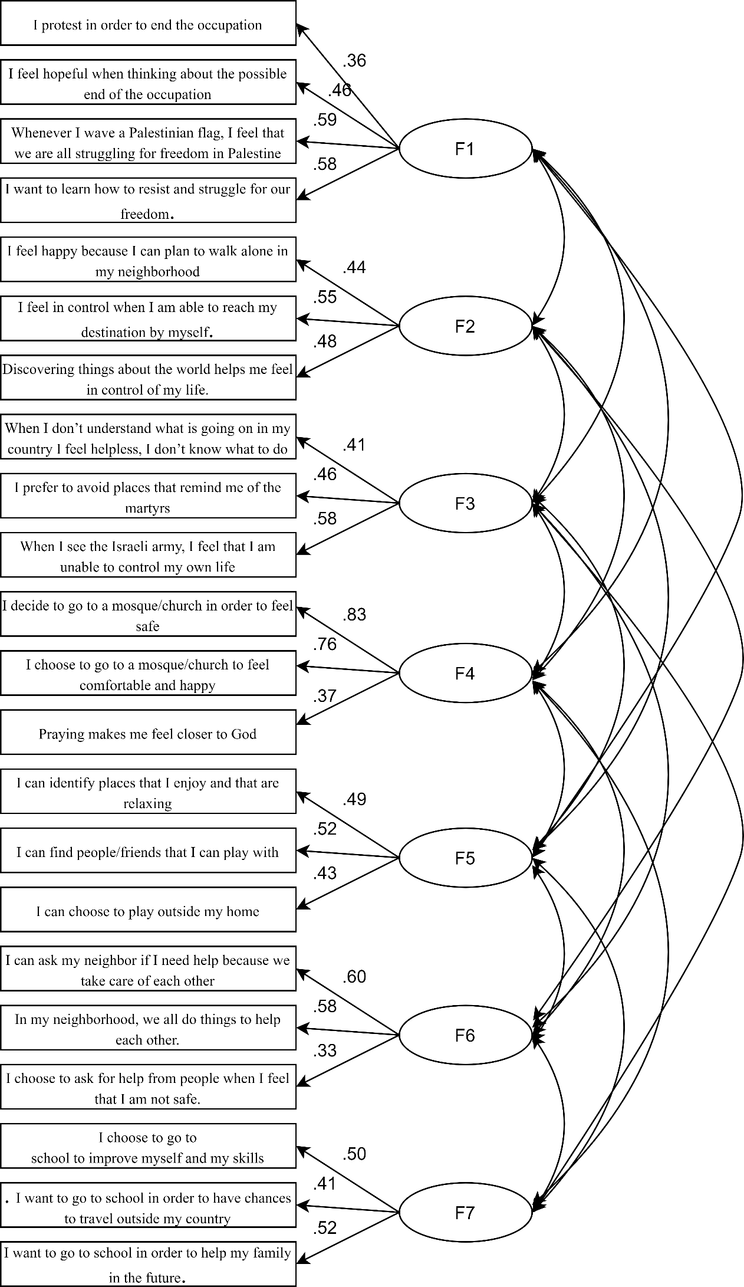
Figure 2. Confirmatory factor analysis: measurement model of War Child Agency Assessment Scale - Palestinian version (WCAAS-Pal). Standardized saturation values were reported.

