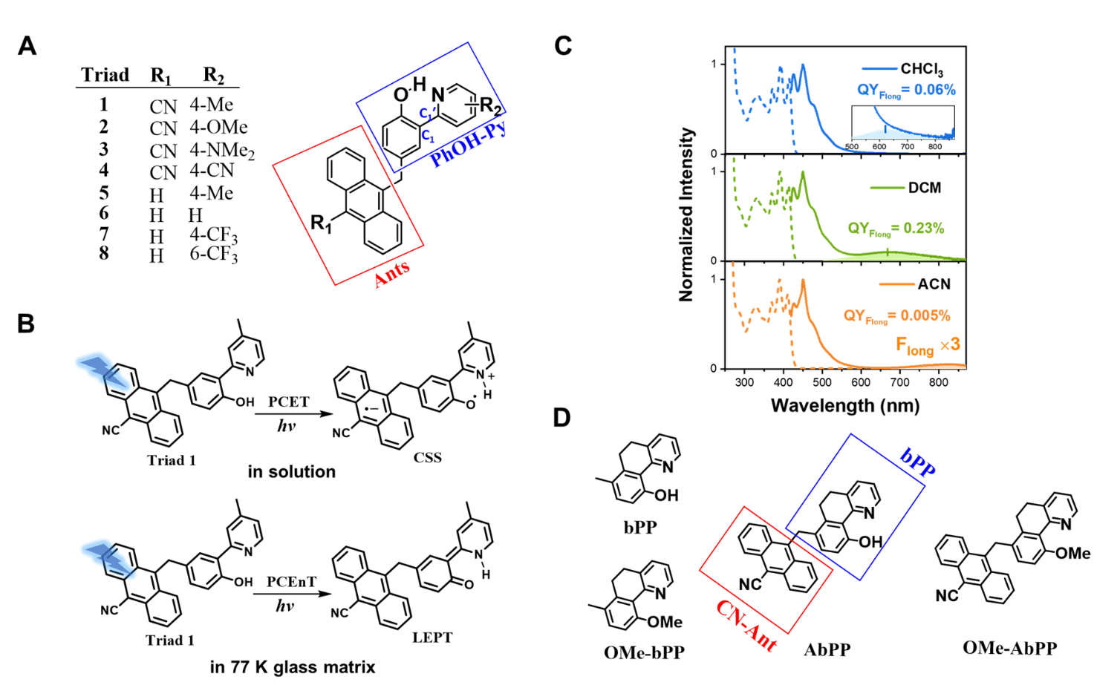
Scheme 1. (A) The chemical structures of triads 1-8 published in refs. 1, 2 and 3. (B) The PCET and PCEnT of triad 1 in different environments. (C) The previously unrecognized weak CSS emission of > 600 nm (shaded region) for triad 1 in different solvents, chloroform (CHCl₃), dichloromethane (DCM), and acetonitrile (ACN) (the concentration is ~1.0 × 10⁻⁵ M) (excited by 410 nm light) (D) The chemical structures of bPP, OMe-bPP, AbPP and OMe-AbPP in this study.

