Legends for Extended Data Figures

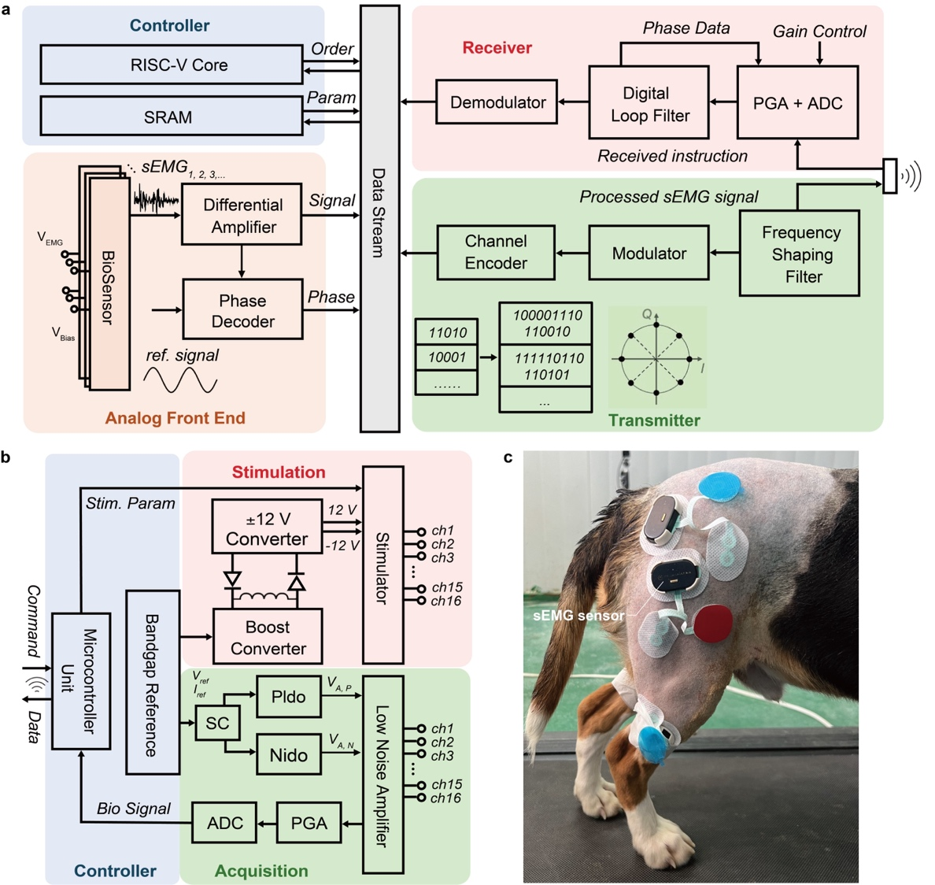
Extended Data Fig. 1 Detailed schematic of self-fine-tuning artificial neural pathway. a, Schematic of the surface electromyograph (sEMG) sensor. Controller receives commands from the server as well as acquires and sends sEMG signals; analog front-end collects the raw signals, performs differential amplification, and decodes phase; transmitter sends processed sEMG signals via Bluetooth; receiver demodulates instructions and stores parameters in the controller. b, Schematic of the neural interface. Controller part receives commands and sends neural signals from microcontroller unit and generates reference voltage and current from bandgap reference; stimulation part performes up to 16 channels of current stimulation; acquisition part recordes signals for up to 16 acquisition points and transmits the acquired signals to microcontroller unit after digital-to-analog conversion. c, Appearance of the sEMG sensor. Abbreviations: RISC-V, reduced instruction set computer V; Param, parameter; PGA, programmable gain amplifier; ADC, analog-to-digital converter; sEMG, surface electromyograph; Stim., stimulation; SC, switched capacitor; Pldo, positive low-dropout regulator; Nldo, negative low-dropout regulator.

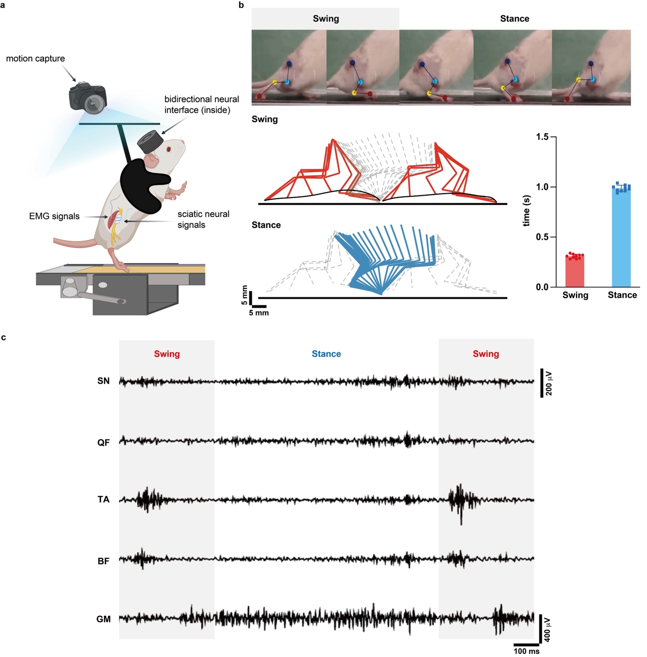
Extended Data Fig. 2 Decoding motor laws of rat’s hindleg in healthy gait cycles. a, Schematic diagram of the experimental platform, consisting of treadmill running at 0.144 km/h; camera capturing rat’s gait; chronic electromyograph (EMG) leads collecting hindleg EMG signals; and chronic cuff electrode recording sciatic neural signals. b, Motion capture and stick diagram. Red sticks indicate the swing phase; blue sticks indicate the stance phase; swing phase lasts 0.31 ± 0.02 s (n = 10 rats), and stance phase lasts 0.99 ± 0.03 s (n = 10 rats). c, Sciatic neural signals and EMG signals showing periodical changes consistent with gait cycles. Abbreviations: EMG, electromyography; SN, sciatic nerve; QF, quadriceps femoris; BF, biceps femoris; TA, tibialis anterior muscle; GM, gastrocnemius muscle. Illustration in a created using BioRender (https://biorender.com).

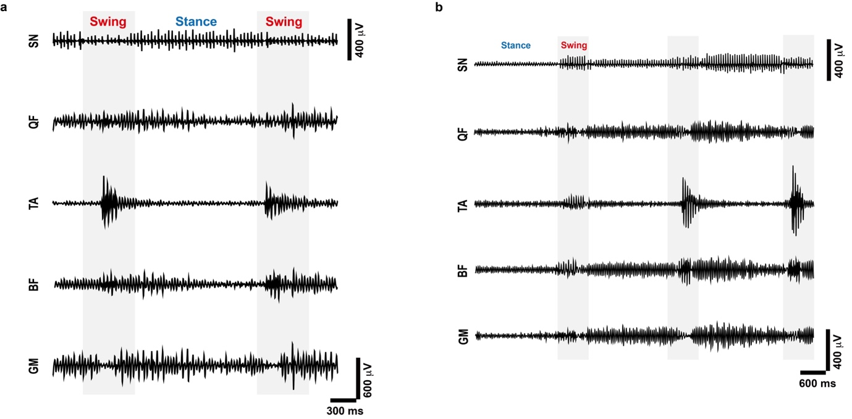
Extended Data Fig. 3 Motor recovery by EES with self fine tuning on rat. a, Meaningful surface electromyograph (sEMG) signals recorded immediately after EES is turned on. b, sEMG signals recorded with three-cycle self-fine-tuning feedback modulation. Abbreviations: SN, sciatic nerve; QF, quadriceps femoris; BF, biceps femoris; TA, tibialis anterior muscle; GM, gastrocnemius muscle.

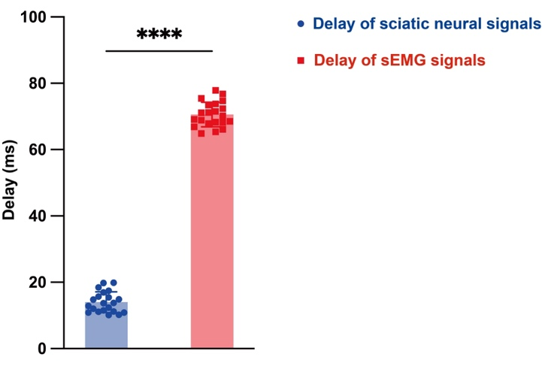
Extended Data Fig. 4 Comparison of the delay between sciatic neural signals and sEMG signals. Bar plot demonstrates a significantly shorter delay of sciatic neural signals in detecting the error than that of sEMG signals (n = 21 cycles: 3 cycles per beagle, 7 beagles totally). Abbreviation: sEMG, surface electromyograph. Two-tailed t-test; ****, P <0.001.

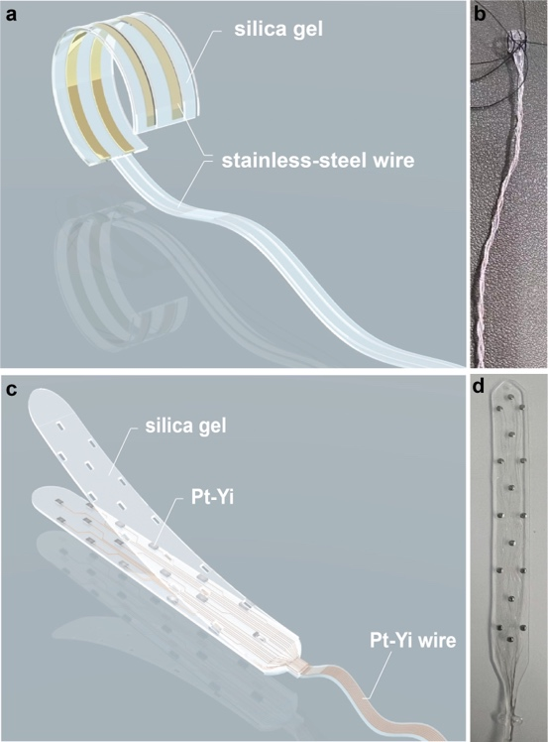
Extended Data Fig. 5 Sciatic nerve cuff electrode and epidural electrode. a, Diagram of a cuff electrode with a silica-gel base and stainless-steel wires. b, Image of the cuff electrode (for beagle) with a 4-mm diameter, 1 × 4 contacts, 500-mm wires, and prepared sutures. c, Diagram of an epidural electrode featuring a silica-gel base, Pt-Yi stimulating sites and wires, and a 16-electrode paddle array. d, Image of the epidural electrode measuring 8 mm in width and 104.7 mm in length.

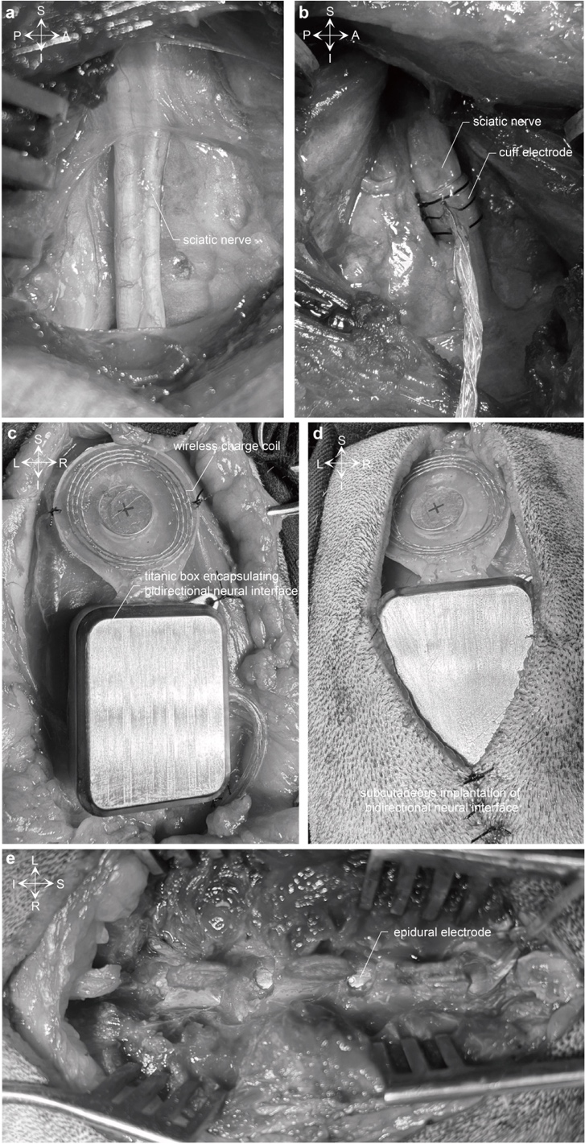
Extended Data Fig. 6 Implants in beagle. a, Anatomy of sciatic nerve. b, Chronic cuff electrode implanted to sciatic nerve. c, d, Bidirectional neural interface encapsulated in a titanic box implanted subcutaneously. e, Epidural electrode implanted in spinal canal.

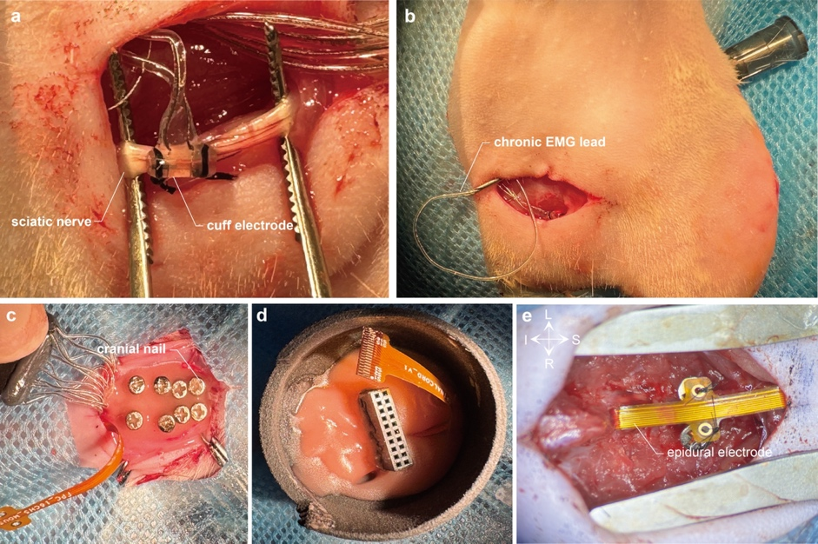
Extended Data Fig. 7 Implants in rat. a, Chronic cuff electrode implanted to sciatic nerve. b, Chronic electromyograph lead implanted into muscle. c, Cranial nails prepared on skull for fixing protective shell. d, Bidirectional neural interface fixed by dental cement in protective shell. e, Epidural electrode implanted in spinal canal. Abbreviation: EMG, electromyography.

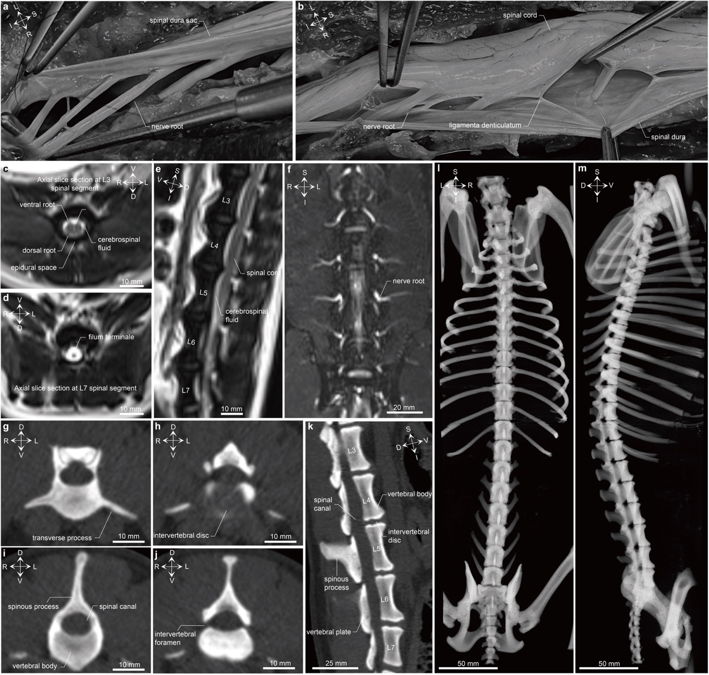
Extended Data Fig. 8 Anatomy of beagle’s spinal cords and spine. a, b, Autopsy of spinal cord and spinal nerves. c–e, Spinal T2-weighted sequencing of magnetic resonance imaging (c, d, axial view; e, sagittal view). f, Lumbosacral plexus nerve imaging, coronal view. g–k, Spinal computerized tomography (CT) scanning (g–j, axial view; k, sagittal view). l, m, Whole-spinal three-dimensional reconstruction of CT scanning (l, posterior view; m, lateral view).

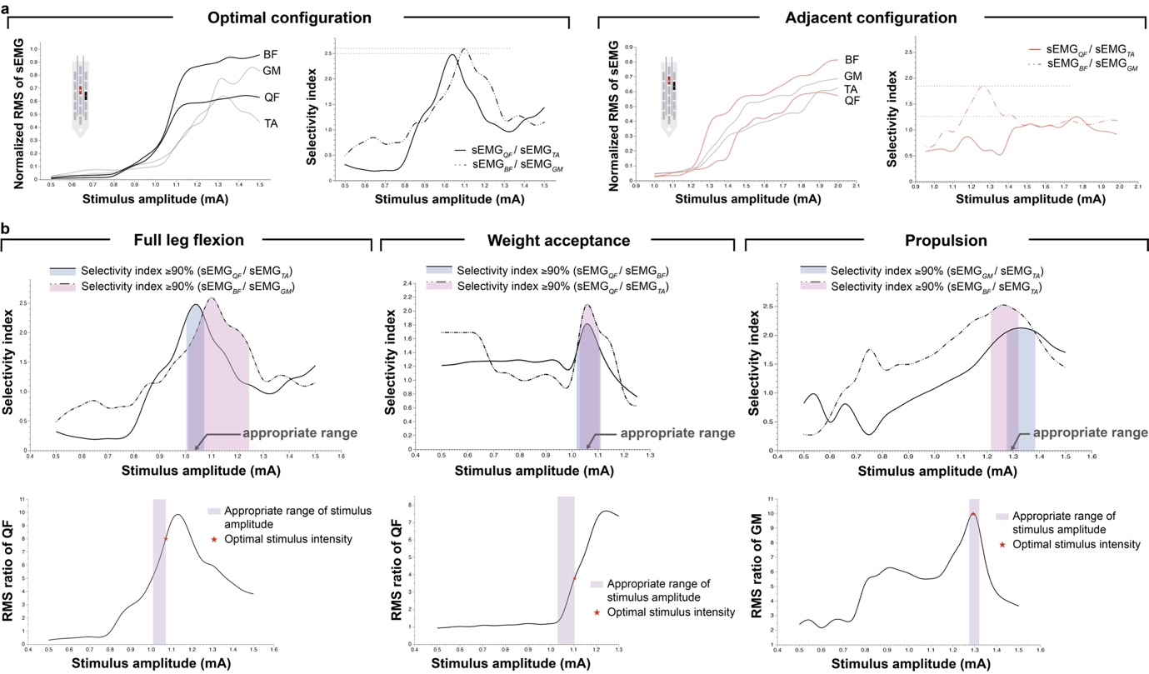
Extended Data Fig. 9 Selection of stimulus patterns. a, Selecting optimal configuration of cathode and anode (right full leg flexion). Selectivity index of adjacent configuration is remarkably lower than that of optimal one. b, Selecting optimal stimulus intensity (right hindleg). A current amplitude range with a selectivity index ≥90% is considered an appropriate stimulus intensity range. Within the appropriate range, the current amplitude that minimally activates contralateral muscles is regarded as the optimal stimulus intensity. Abbreviations: RMS, root mean square; sEMG, surface electromyography; QF, quadriceps femoris; BF, biceps femoris; TA, tibialis anterior muscle; GM, gastrocnemius muscle. Illustrations in a created using BioRender (https://biorender.com).

