Appendix 1
Model:
The ANFIS model is probably the Machine-Learning model which most closely resembles the human pattern-recognition process. First, from the raw sensory inputs (input data) clusters are formed (memberships) that produces a rough grouping of data based on its similarity to previous knowledge (memory or learned patterns). This can be considered as similar to the perception process in the brain. Then, a cognition process starts by passing the rough groups through logical rules to filter them further into the final decision. The ANFIS model achieves this by two layers of equations: the first one represents a neural network layer which learns its weights in a way that a group of neurons would start to favor one specific type of data group. The second group of neurons represent the Fuzzy rule-base which learns its parameters in such a way that further combinations of various neurons from the previous layer becomes possible. The resulting output of the second layer provides a score (0 to 1) which is similar to the probabilistic value obtained through Bayesian or other classifiers. A typical ANFIS structure is shown in Figure 2:
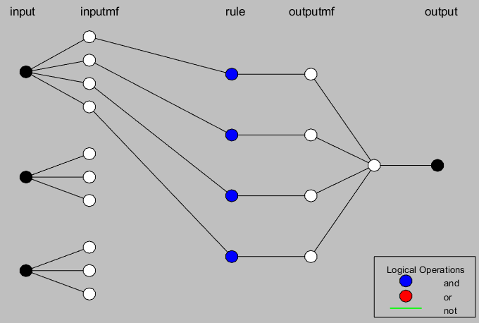  (a) | 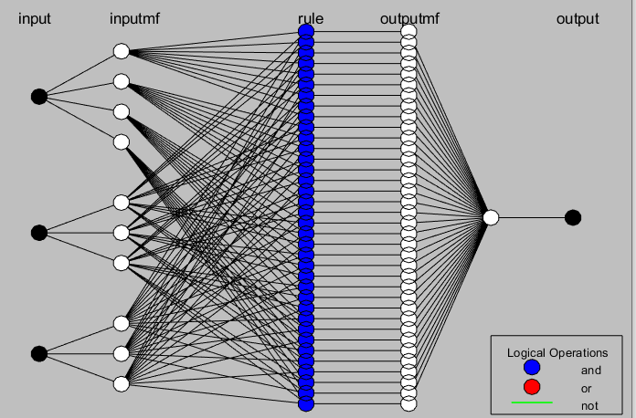  (b)

Common Parameters:
- Number of Epochs = 10.
- Type of ANFIS = Sugino type model
- Number of Inputs = 7 for VA, IOP, and Meds, and 6 for Ops.
- Number of Outputs = 1 for each model.
- And operation method: “prod” (Product)
- Or operation method: “probor” (Probabilistic Or)
- Implication Method: “prod” (Product)
- Aggregation Method: “sum”
- Defuzzification Method: “wtaver” (Weighted Average)
- Final predicted values are plotted in Figure 3 with the actual outputs to indicate near-perfect models for each of the outputs.

Final predicted values are plotted in Figure 3 with the actual outputs to indicate near-perfect models for each of the outputs.

