Supporting Information

Phytate and microbial suspension amendments increased soybean growth and shifted microbial community structure

Bulbul Ahmed¹, Jean-Baptiste Floc’h¹, Zakaria Lahrach^{1,2} and Mohamed Hijri^{1,2}*
¹Institut de Recherche en Biologie Végétale, Université de Montréal, 4101 Sherbrooke Est, Montréal (Québec), H1X 2B2, Canada
²African Genome Center, Mohammed VI Polytechnic University (UM6P), Lot 660, Hay Moulay Rachid, Ben Guerir 43150, Morocco

This article has the following supporting information:

Methods S1. Experimental design, treatments and sampling
The pots and turface were purchased from Hydro Dionne (Montreal, QC, Canada). The sandy loam soil was collected from the 15 cm top layer of an agriculture field under organic farming at the IRDA research station in St-Bruno in Quebec (45°32′59.6″N, 73°21′08.0″W) on May 9th, 2019. The substrate mixture was made to obtain a phosphate-poor medium. The seeds were surface sterilized with 3% hydrogen peroxide at room temperature for 5 minutes and rinsed five times with sterile distilled water. The seeds were pre-germinated in water socked paper towel for 48h, and then transplanted carefully in the pots. Microbial suspension was prepared from soil collected from n the Gault Nature Reserve at Mont Saint-Hilaire. Soil samples were taken in four distinct locations and then transported to the lab. Suspension was prepared by adding in deionized water, homogenized and kept for 3h at room temperature. Soil suspension was sieved to remove unwanted rock and plant material particles. The suspension was then transferred to a new bucket, homogenized and set for 2h. The supernatant was sieved through 63 µm and collected in an Erlenmeyer and 50 mL of microbial suspensions were applied in the substrate close of the plantlets after the emergence of the first two true leaves. Two treatments at four levels were performed as follows where M refers to microbial suspension and P refers to phytate: (i) M₀P₀ as control without microbial suspension nor phytate; (ii) M₁P₀ with microbial suspension without phytate; (iii) M₀P₁ without microbial suspension with phytate; and (iv) M₁P₁ with both phytate and microbial suspension. Plants were watered with tap water twice a week to keep the substrate humid. Each pot was fertilized once a week with 50 mL of full strength Long Ashton nutrient solution without phosphate [1]. Under these conditions, plants were maintained for the entire experiment until sampling.

Methods S2. Sampling and growth parameter measures
The harvest was performed at 90 days after the experiment setup. Shoots were cut at the plant collar with a clean and sterile scalpel and placed in a paper bag. Roots were separated from the soil substrate, washed with tap water and rinsed with sterile distilled water, and fragments of thin and young roots and about 5 g of rhizosphere soil (soil substrate that was attached to the roots) was collected per treatment by gently brushing the roots in a 15 mL falcon tube for DNA extraction. Shoot and root samples were placed in paper bags, kept on ice in a cooler box and immediately transported to the laboratory. The growth parameters determined were shoot fresh weight, root fresh weight and total nodule per plants. Both root and shoot samples were dried in a drying oven at 65°C, for 72h, and their dry weights were also measured. Samples for DNA extraction were kept at 4°C before being brought to the laboratory and preserved at - 80°C.

Methods S3. DNA extraction and amplicon sequencing
PCR amplifications of 16S rRNA was performed using forward primer CS1_341 (5’-ACACTGACGACATGGTTCTACACCTACGGGNGGCWGCAG-3’) and
reverse primer CS2_806 R (5′-TACGGTAGCAGAGACTTGGTCTGACTACHVGGGTATCTAATCC-3′) [2], while fungal ITS region was amplified with CS1_ITS3_KYO2 (5’-ACACTGACGACATGGTTCTACAGATGAAGAACGYAGYRAA-3’) and CS2_ITS4 (5’-TACGGTAGCAGAGACTTGGTCTTCCTCCGCTTATTGATATGC-3’) [3]. The PCR reaction was performed in a 25 μL reaction volume composed of 1.5X PlatinumTM Direct PCR Universal Master Mix (ThermoFisher, Montreal, QC), 0.25 μM of each primer, 1.5X PlatinumTM GC Enhancer and approximately 20 ng of template DNA. Thermal cycling was performed in a EppendorfTM MastercyclerTM Pro PCR system (Eppendorf, ON, Canada) with a cycling condition of activation at 94 °C for 2 min, followed by 35 cycles of denaturation at 94°C for 15 sec, annealing at 60°C for 15 sec, extension at 68°C for 20 sec, a final extension at 68°C for 1 min with a hold at 10°C. For each PCR run, negative PCR controls with only water were included and we did not observe any visible amplification while amplified products were quantified and visualized onto 1% agarose gel. Amplicons were submitted for sequencing using an Illumina (San Diego, CA, USA) MiSeq sequencer through a commercial service provided by the Genome Quebec Innovation Centre (Montreal, QC, Canada). The sequence was performed with 2 X 300 bp, pair-end and demultiplexed of reads on instrument by the service provider.

Methods S4. Bioinformatics pipeline and processing of data
MiSeq reads were processed, aligned and characterized using the microbiome pipeline, DADA2 to obtain unique sequence variants known as Amplicon Sequence Variants (ASV), unlike clustering groups of similar sequences known as Operational Taxonomic Units (OTU) inferred by another pipeline QIIME [4]. In short, reads were trimmed ensuing strict quality thresholds by removing primers and poor-quality sequences with filterAndTrim function (truncLen=c(245, 235), trimLeft=c(17, 21), maxEE=c(2,2) and truncQ=2) (details in the complementary R scripts), followed by filtering with DADA2’s error model process using learnErrors function. Afterward dereplicated, sample interference, merging pair-end reads and removal of chimera were performed to obtain the ASV table. The function assignTaxonomy was performed to assign taxonomy using the reference database SILVA [5] for 16S rRNA, and the UNITE database [6] for ITS. Non-fungal ASVs were removed from the fungal taxonomy dataset, reducing the number of fungal ASVs from 3230 to 2171. The identity of the ASVs of interest was manually tested using BLASTn on NCBI [7]. The bioinformatics pipeline ran remotely on multithread computer infrastructure on arcade (http://www.esi.umontreal.ca/connexion_ssh.html).
We used the function rarecurve of the vegan package [8] to standardize the dataset to the lowest number of reads assembled for a sample by selecting randomly subsampling of the read data from each sample. The relative abundance of taxa analysed per family by exploiting the package dplyr v2.0.0 [9] in R4.0.2 [10]. For both bacterial and fungal datasets, we removed ASVs taxonomically assigned to chloroplast and mitochondria assumed that they were expected to be part of plants genome. The Alpha (α)-diversity indices-Shannon and Simpson were computed using the vegan package v.2.5-6 in R. The significance of treatments on α-diversity indices was tested by analysis of variance (ANOVA) and Tukey’s post-hoc tests was used in comparing treatments and sample types (root or rhizosphere) using the R package agricolae v1.3-3 [11]. The structure of the bacterial and fungal communities (Beta diversity) was assessed with Principal Coordinates Analysis (PCoA) based on Bray-Curtis distances using the R package vegan v 2.5.6 [12]. To test the effect of treatments and sample types on community composition as a constant variable, we performed PERmutational Multivariate ANalysis Of VAriance (PERMANOVA) [13] with the function Adonis of the R package vegan v 2.5-6. ASVs abundance matrix was Hellinger-transformed and 999 permutations was used to test significance in vegan [8]. We visualized taxa abundance at order level community composition with the R package metacoder v 0.3.4 [14]. We performed indicator species analysis using the package indicspecies v 1.7.9 [15] in R4.0.2. using Šidák correction for multiple comparison in the R package ‘RVAideMemoire’ v 0.9-78 [16]. The ASVs observed across microbial assemblages in all plots considered as the core microbiota. We constructed co-occurrence network to evaluate the interactions between ASVs of both root and rhizosphere microbiome using the algorithm glasso of the package SPIEC-EASI v 1.0.6 [17] in R4.0.2. Subsequently, the networks were imported in Cytoscape v 3.8.0 for plotting and the layout “organic” used for drawing the network [18]. Betweenness centrality and degree of connectivity score of >95% of the taxa in the network were considered in multiparticle interactions and allowed to flag the highly connected taxa as hub taxa. We tested the effects of treatments on six plant productivity measures e.g., shoots fresh and dry weight, roots fresh and dry weight, number of nodules and total phosphorus (P) in shoots. We used two-way ANOVA with permutations to assess the statistical significance for the variables with treatments.

References
1. Davies, J., FT, et al., Alleviating phosphorus stress of chile ancho pepper (Capsicum annuum L.‘San Luis’) by arbuscular mycorrhizal inoculation. The Journal of Horticultural Science and Biotechnology, 2000. 75(6): p. 655-661.
2. Farnelid, H., et al., Diverse diazotrophs are present on sinking particles in the North Pacific Subtropical Gyre. ISME J, 2019. 13(1): p. 170-182.
3. Toju, H., et al., High-coverage ITS primers for the DNA-based identification of ascomycetes and basidiomycetes in environmental samples. PLoS One, 2012. 7(7): p. e40863.
4. Callahan, B.J., et al., DADA2: High-resolution sample inference from Illumina amplicon data. Nat Methods, 2016. 13(7): p. 581-3.
5. Quast, C., et al., The SILVA ribosomal RNA gene database project: improved data processing and web-based tools. Nucleic Acids Res, 2013. 41(Database issue): p. D590-6.
6. Nilsson, R.H., et al., The UNITE database for molecular identification of fungi: handling dark taxa and parallel taxonomic classifications. Nucleic Acids Research, 2018. 47(D1): p. D259-D264.
7. Johnson, M., et al., NCBI BLAST: a better web interface. Nucleic Acids Res, 2008. 36(Web Server issue): p. W5-9.
8. Oksanen, J., et al., vegan: Community Ecology Package. R package version 2.5-6. 2019. 2019.
9. Wickham, H. and M.H. Wickham, Package ‘plyr’. Obtenido de https://cran. rproject. org/web/packages/dplyr/dplyr. pdf, 2020.
10. Team, R.C., R: A Language and Environment for Statistical Computing. Vienna: R Project. 2020.
11. Peșteanu, A. and M. Bostan, Perfecţionarea unor elemente tehnologice la producerea materialului săditor pentru fondarea livezilor moderne de măr. Stiinta agricola, 2020(1): p. 52-59.
12. Oksanen, J., et al., Package—vegan: Community ecology package. R package version 2.5-6. 2020.
13. Anderson, M.J., A new method for non‐parametric multivariate analysis of variance. Austral ecology, 2001. 26(1): p. 32-46.
14. Poisot, T., et al., Metacoder: An R package for visualization and manipulation of community taxonomic diversity data. PLOS Computational Biology, 2017. 13(2).
15. De Cáceres, M. and F. Jansen, indicspecies-package: Studying the statistical relationship between species and. 2019.
16. Hervé, M. and M.M. Hervé, Package ‘RVAideMemoire’. See https://CRAN. R-project. org/package= RVAideMemoire, 2020.
17. Kurtz, Z.D., et al., Sparse and compositionally robust inference of microbial ecological networks. PLoS Comput Biol, 2015. 11(5): p. e1004226.
18. Shannon, P., et al., Cytoscape: a software environment for integrated models of biomolecular interaction networks. Genome Res, 2003. 13(11): p. 2498-504.

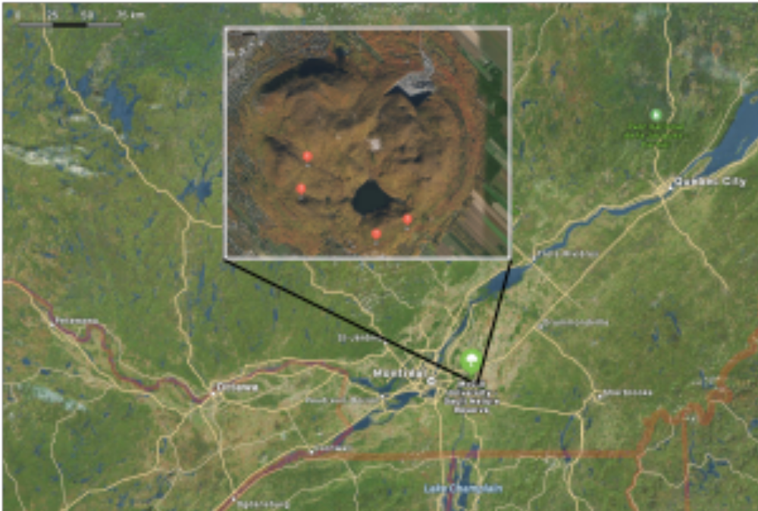
Figure S1. Map of Gault Nature Reserve. Sampling sites (S1-S4) for soil to prepare microbial inoculum used in the experiment.

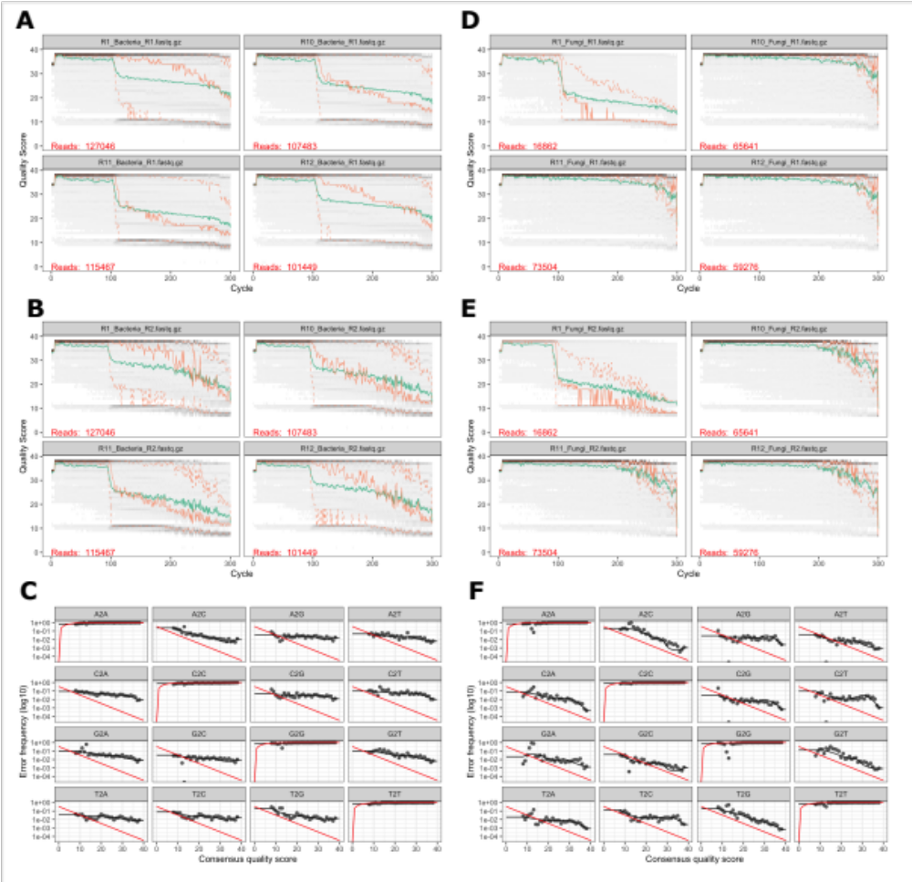
Figure S2. Quality profiles and error rates of raw reads. Quality profiles for 16sRNA forward reads (A), reverse reads (B), and ITS forward (D) and reverse reads (E). The green line denotes the mean quality score, the orange line denotes the quartiles, and the gray line denotes the frequency of each quality score at each base position. The error rates for each possible transposition are shown for 16s RNA (C) and ITS (F) reads.

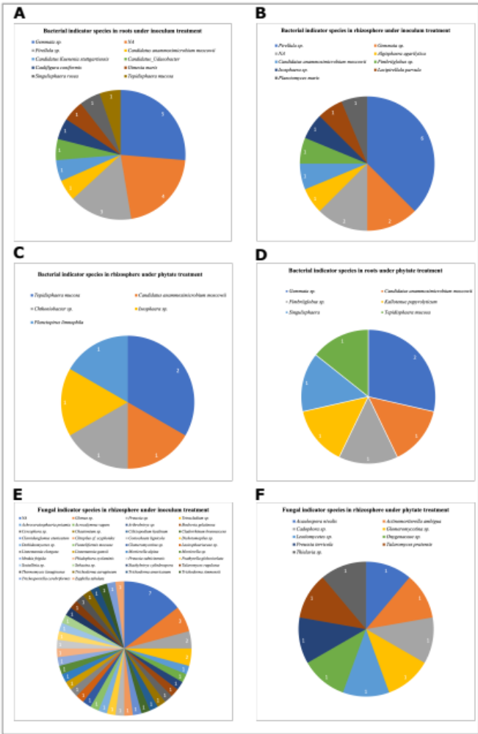
Figure S3. Indicator species of soybean microbiome at the genus level. The most representative species of soybean microbiome were identified through indicator species analysis. Bacterial indicator species under inoculum treatment in root (A) and in rhizosphere (B) biotopes; and under phytate treatment in rhizosphere (C) and in root (D). Fungal indicator species in rhizosphere biotope under inoculum treatment (E) and under phytate treatment (F).
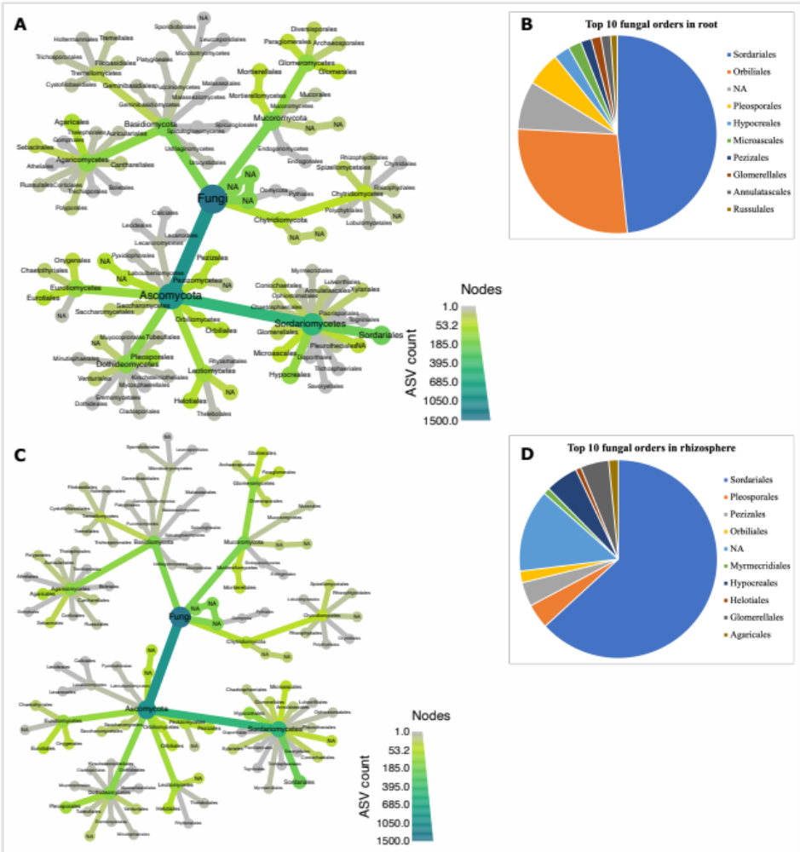
Figure S4. Taxonomic hierarchy (taxmap) and associated observations of ASVs (taxmap) for fungal communities. Taxmap at order level in root (A) and relative abundance of top 10 orders in root (B). Taxmap at order level in rhizosphere (C) and relative abundance of top 10 orders in rhizosphere biotope (D).

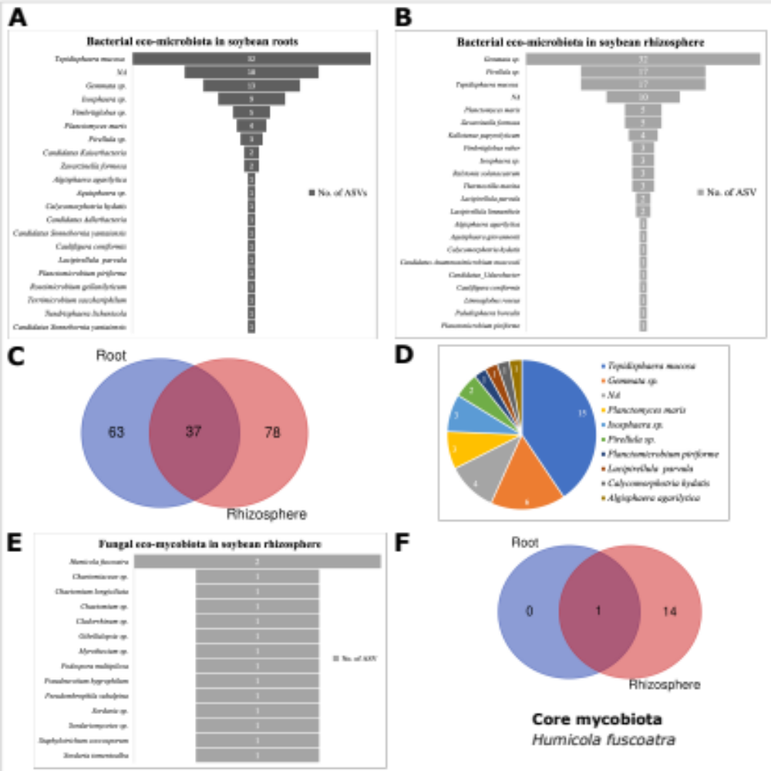
Figure S5. Eco and core microbiota in soybean microbiome. Bacterial eco-microbiota in root (A) and rhizosphere (B) biotopes. The Venn diagram shows the number of bacterial ASVs that were unique or shared in root and rhizosphere biotopes (C). The pie chart shows bacterial core microbiota (D). (E) Fungal eco-mycobiota in rhizosphere soil. (F) The Venn diagram shows the number of ASVs found unique or shared in root and rhizosphere biotopes. Humicola fuscoatra was the only core fungal microbe.
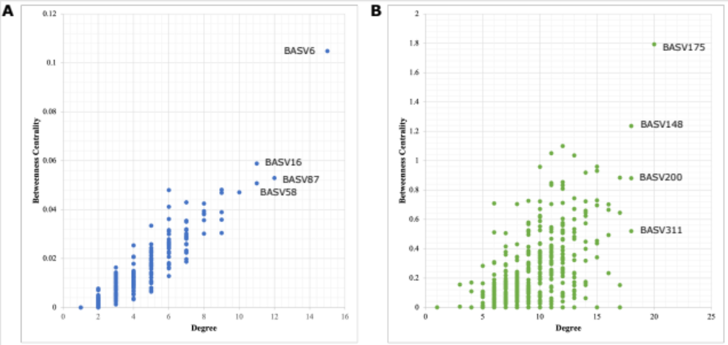
Figure S6. Scatter plot of the node degree versus betweenness centrality of ASVs in the root (A) and rhizosphere (B) microbiota.
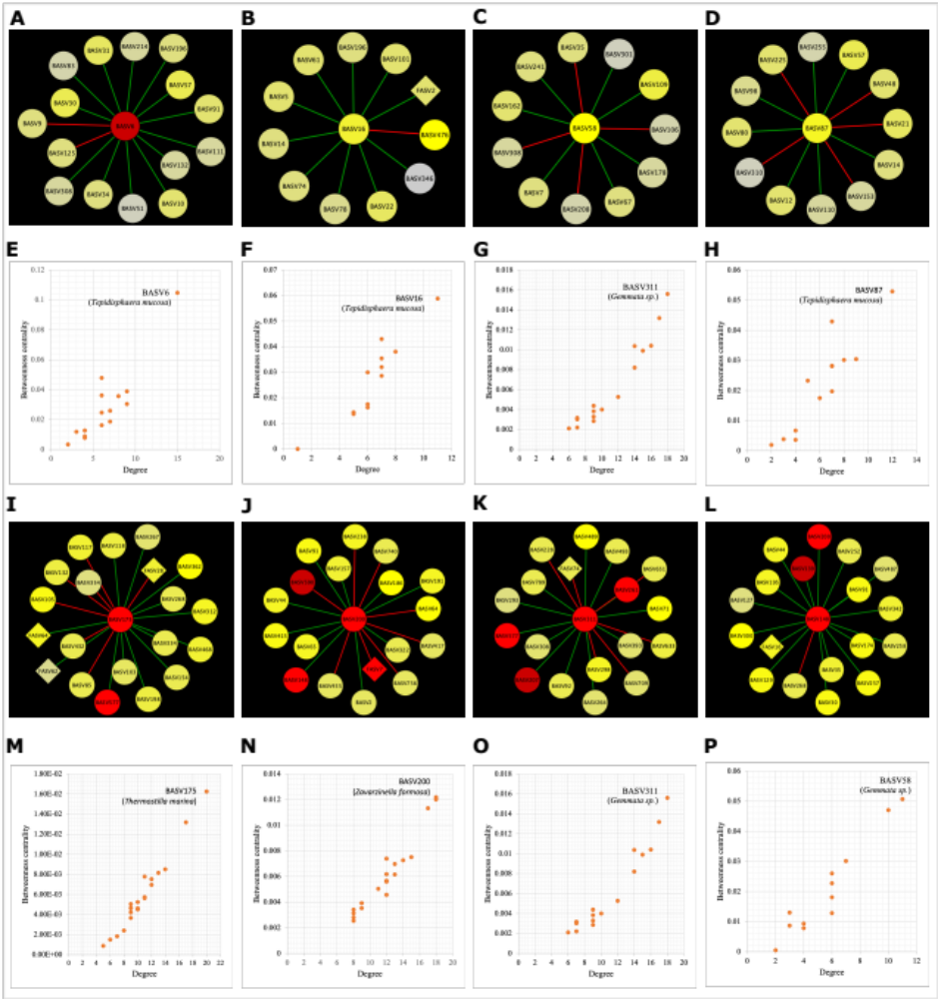
Figure S7. Subnetwork of the hub taxa. The co-occurrence of the hub taxa in root biotope (A-D), and scatter plot of the node degree versus betweenness centrality of ASVs in the corresponding subnetworks (E-H). The co-occurrence network of the hub taxa in rhizosphere biotope (I-L), and scatter plot representing the node degree versus betweenness centrality of ASVs in the corresponding subnetworks (M-P). Green link represents a positive interaction while red link represents a negative interaction. Nodes are coloured according to the relative abundance of the corresponding ASVs, and node shapes represent bacterial (circular) and fungal (rhombus) ASVs.

Supplementary Tables
Supplementary Tables S1-S2; S4-S11 are shown in an Excel File.

Table S3. List of bacterial and fungal ASVs selected under the inoculation and phytate addition treatments according to indicator species analysis. Significant selection at Sidak α = 0.0001, *** significant at α = 0.001, ** significant at α = 0.01, *significant at α = 0.05.
Bacteria
Inoculation |  |  |  |  |  | Phytate addition
Roots |  |  | Rhizosphere |  |  | Roots |  |  | Rhizosphere
Number of species = 19 |  |  | Number of species = 16 |  |  | Number of species = 7 |  |  | Number of species = 6
BASV5 | 0.0001 | *** | BASV590 | 0.0007 | *** | BASV1248 | 0.0073 | ** | BASV374 | 0.003 | **
BASV8 | 0.0001 | *** | BASV861 | 0.0021 | ** | BASV107 | 0.0045 | ** | BASV761 | 0.0083 | **
BASV114 | 0.0088 | ** | BASV569 | 0.0056 | ** | BASV1377 | 0.0418 | * | BASV1028 | 0.0203 | *
BASV713 | 0.004 | ** | BASV1092 | 0.0049 | ** | BASV738 | 0.0396 | * | BASV798 | 0.0232 | *
BASV36 | 0.0077 | ** | BASV571 | 0.0084 | ** | BASV185 | 0.0359 | * | BASV599 | 0.0252 | *
BASV1149 | 0.0163 | * | BASV585 | 0.0086 | ** | BASV1514 | 0.0465 | * | BASV619 | 0.0497 | *
BASV264 | 0.018 | * | BASV421 | 0.0183 | * | BASV27 | 0.0426 | *
BASV590 | 0.0206 | * | BASV537 | 0.0176 | *
BASV993 | 0.0205 | * | BASV20 | 0.0153 | *
BASV354 | 0.025 | * | BASV559 | 0.0265 | *
BASV669 | 0.0131 | * | BASV375 | 0.0333 | *
BASV605 | 0.0188 | * | BASV621 | 0.0357 | *
BASV250 | 0.0337 | * | BASV587 | 0.03 | *
BASV381 | 0.0285 | * | BASV882 | 0.0419 | *
BASV576 | 0.0168 | * | BASV21 | 0.0302 | *
BASV489 | 0.0231 | * | BASV1256 | 0.0359 | *
BASV1439 | 0.0495 | *
BASV904 | 0.0499 | *
BASV967 | 0.0247 | *
Fungi
Inoculation |  |  |  |  |  | Phytate addition
Roots |  |  | Rhizosphere |  |  | Roots |  |  | Rhizosphere
Number of species = 0 |  |  | Number of species = 48 |  |  | Number of species = 1 |  |  | Number of species = 9
 |  |  | FASV410 | 0.002 | ** | FASV113 | 0.045 | * | FASV1196 | 0.023 | *
 |  |  | FASV131 | 0.004 | ** |  |  |  | FASV338 | 0.020 | *
 |  |  | FASV479 | 0.001 | *** |  |  |  | FASV413 | 0.021 | *
 |  |  | FASV508 | 0.003 | ** |  |  |  | FASV798 | 0.034 | *
 |  |  | FASV400 | 0.009 | ** |  |  |  | FASV151 | 0.018 | *
 |  |  | FASV839 | 0.014 | * |  |  |  | FASV1227 | 0.020 | *
 |  |  | FASV513 | 0.004 | ** |  |  |  | FASV749 | 0.050 | *
 |  |  | FASV373 | 0.015 | * |  |  |  | FASV209 | 0.042 | *
 |  |  | FASV493 | 0.019 | * |  |  |  | FASV366 | 0.029 | *
 |  |  | FASV503 | 0.007 | **
 |  |  | FASV706 | 0.018 | *
 |  |  | FASV439 | 0.007 | **
 |  |  | FASV1286 | 0.015 | *
 |  |  | FASV944 | 0.011 | *
 |  |  | FASV502 | 0.023 | *
 |  |  | FASV512 | 0.012 | *
 |  |  | FASV551 | 0.027 | *
 |  |  | FASV530 | 0.022 | *
 |  |  | FASV193 | 0.003 | **
 |  |  | FASV471 | 0.021 | *
 |  |  | FASV885 | 0.016 | *
 |  |  | FASV248 | 0.034 | *
 |  |  | FASV207 | 0.045 | *
 |  |  | FASV606 | 0.046 | *
 |  |  | FASV328 | 0.038 | *
 |  |  | FASV1119 | 0.014 | *
 |  |  | FASV370 | 0.027 | *
 |  |  | FASV261 | 0.035 | *
 |  |  | FASV628 | 0.042 | *
 |  |  | FASV98 | 0.003 | **
 |  |  | FASV703 | 0.022 | *
 |  |  | FASV790 | 0.006 | **
 |  |  | FASV1169 | 0.050 | *
 |  |  | FASV662 | 0.040 | *
 |  |  | FASV1078 | 0.042 | *
 |  |  | FASV1855 | 0.040 | *
 |  |  | FASV702 | 0.045 | *
 |  |  | FASV945 | 0.037 | *
 |  |  | FASV324 | 0.024 | *
 |  |  | FASV552 | 0.024 | *
 |  |  | FASV465 | 0.041 | *
 |  |  | FASV183 | 0.008 | **
 |  |  | FASV1306 | 0.048 | *
 |  |  | FASV299 | 0.040 | *
 |  |  | FASV1097 | 0.017 | *
 |  |  | FASV569 | 0.004 | **
 |  |  | FASV108 | 0.029 | *
 |  |  | FASV87 | 0.046 | *

