Supplementary Information
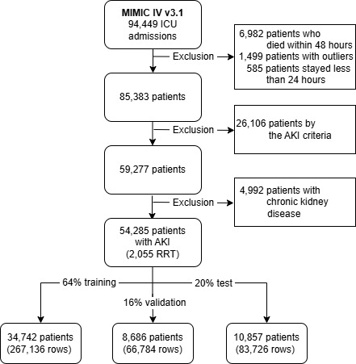
Supplemental Material 1. Patients with acute kidney injury from the MIMIC IV v3.1 database were identified using the AKI cohort.

Supplemental Material 2: Feature weight, feature distribution and number of missingness in both data sets.
Feature | Weight | MIMIC |  | MUW
 |  | Mean (SD) | Missingness (%) | Mean (SD) | Missingness (%)
12-hour total output, mL | 0.3944 | 765.77 ± 807.75 | 0 | 1274.57 ± 866.63 | 0
SOFA score | 0.2776 | 4.3 ± 2.7 | 0 | 8.87 ± 4.0 | 0
Cumulative balance, mL | 0.2434 | 15884.29 ± 30463.42 | 0 | 23672.98 ± 20214.82 | 0
Creatinine, mg/dL | 0.2399 | 1.34 ± 1.24 | 0 | 1.13 ± 0.92 | 48.5
Platelet count, ×10^3/µL | 0.2141 | 210.07 ± 113.65 | 0 | 202.12 ± 127.7 | 48.4
Chloride, mEq/L | 0.1887 | 103.52 ± 6.08 | 0 | 106.57 ± 5.27 | 4.9
BUN, mg/dL | 0.1836 | 28.06 ± 21.91 | 0 | 25.93 ± 17.44 | 48.4
Anion gap, mEq/L | 0.1802 | 13.16 ± 3.5 | 0 | 11.72 ± 3.81 | 99.8
Calcium, mg/dL | 0.171 | 8.46 ± 0.69 | 0 | 8.35 ± 0.62 | 48.7
Total input, mL | 0.1679 | 10466.24 ± 27521.2 | 0 | 13308.13 ± 11358.36 | 0
WBC count, ×10^3/µL | 0.1614 | 11.74 ± 7.83 | 0 | 11.41 ± 6.47 | 48.3
Total bilirubin, mg/dL | 0.1594 | 1.92 ± 4.18 | 0 | 1.4 ± 2.75 | 49
Phosphorus, mg/dL | 0.1537 | 3.49 ± 1.15 | 0 | 3.25 ± 1.18 | 48.7
O2 flow, L/min | 0.1529 | 11.6 ± 15.88 | 0 | 7.72 ± 12.2 | 52.6
Total output, mL | 0.1507 | 5418.05 ± 7215.22 | 0 | 10364.86 ± 9537.48 | 0
Weight, kg | 0.1478 | 83.21 ± 24.68 | 8,3 | 78.85 ± 20.03 | 0
RASS score | 0.1439 | -0.66 ± 1.33 | 0 | -1.51 ± 1.9 | 16.6
Sodium, mEq/L | 0.1434 | 138.97 ± 5.05 | 0 | 140.4 ± 5.04 | 4.9
Temperature, °C | 0.1417 | 36.9 ± 0.51 | 0 | 36.64 ± 0.69 | 40.1
Age, years | 0.1401 | 65.58 ± 16.25 | 0 | 59.23 ± 16.3 | 0
Maximum vasopressor dose, µg/kg/min | 0.1178 | 0.11 ± 1.21 | 0 | 0.16 ± 1.66 | 0
Mean airway pressure, cmH2O | 0.1151 | 9.07 ± 3.1 | 0 | 11.08 ± 3.48 | 48.8
GCS score | 0.1143 | 13.65 ± 2.66 | 0 | 8.94 ± 5.34 | 92.7
AST (SGOT), U/L | 0.1132 | 109.23 ± 386.12 | 0 | 139.07 ± 648.46 | 48.9
PT, s | 0.1112 | 15.49 ± 6.0 | 0 | 17.71 ± 8.87 | 99.8
PTT, s | 0.1109 | 38.66 ± 18.75 | 0 | 41.88 ± 11.06 | 48
RBC count, ×10^6/µL | 0.1085 | 3.35 ± 0.63 | 0 | 3.32 ± 0.57 | 48.2
LDH, U/L | 0.1066 | 357.1 ± 404.55 | 0 | 340.91 ± 601.05 | 49.2
Hematocrit, % | 0.106 | 30.98 ± 5.76 | 0 | 30.77 ± 4.91 | 5.8
Respiratory rate, breaths/min | 0.1057 | 19.71 ± 4.37 | 0 | 19.93 ± 7.29 | 16
Bicarbonate, mEq/L | 0.1028 | 24.58 ± 4.56 | 0 | 27.2 ± 3.52 | 16.6
SpO2, % | 0.1024 | 96.57 ± 2.26 | 0 | 97.52 ± 2.73 | 0.7
Ionized calcium, mmol/L | 0.1018 | 1.13 ± 0.08 | 0 | 1.17 ± 0.07 | 5.2
Hemoglobin, g/dL | 0.1011 | 10.1 ± 1.94 | 0 | 10.0 ± 1.64 | 4.9
FiO2, % | 0.0999 | 0.36 ± 0.15 | 0 | 0.44 ± 0.14 | 43.3
ALT (SGPT), U/L | 0.0978 | 115.29 ± 378.13 | 0 | 105.11 ± 338.9 | 49.2
Shock index | 0.0972 | 0.72 ± 0.23 | 0 | 0.66 ± 0.19 | 4.2
Glucose, mg/dL | 0.0971 | 141.27 ± 47.66 | 0 | 137.39 ± 33.57 | 5.1
Heart rate, beats/min | 0.0961 | 84.4 ± 16.19 | 0 | 80.61 ± 15.82 | 1.1
Minute ventilation, L/min | 0.0951 | 8.4 ± 2.31 | 0 | 7.72 ± 3.48 | 48.4
Mean blood pressure, mmHg | 0 | 80.77 ± 12.34 | 0 | 83.75 ± 12.89 | 3.6
INR | 0 | 1.42 ± 0.61 | 0 | 1.27 ± 0.36 | 49.1
Potassium, mEq/L | 0 | 4.07 ± 0.49 | 0 | 4.16 ± 0.43 | 5.1
Fibrinogen, mg/dL | 0 | 362.07 ± 175.11 | 3,1 | 488.9 ± 192.91 | 48.6
Arterial pH | 0 | 7.41 ± 0.05 | 0 | 7.43 ± 0.06 | 16.6
PaO2/FiO2 ratio | 0 | 331.81 ± 224.32 | 0 | 248.07 ± 98.65 | 26.1
Tidal volume, mL | 0 | 452.67 ± 112.05 | 0 | 496.04 ± 180.16 | 47.7
PaO2, mmHg | 0 | 106.66 ± 61.77 | 0 | 96.24 ± 23.81 | 16.6
Albumin, g/dL | 0 | 3.05 ± 0.57 | 0 | 2.85 ± 0.46 | 48.6
Diastolic blood pressure, mmHg | 0 | 60.61 ± 13.07 | 0 | 62.05 ± 11.1 | 3.6
12-hour total input, mL | 0 | 1352.12 ± 3401.3 | 0 | 1519.81 ± 1025.09 | 0
Magnesium, mg/dL | 0 | 2.11 ± 0.33 | 0 | 2.14 ± 0.36 | 48.7
Systolic blood pressure, mmHg | 0 | 120.54 ± 17.42 | 0 | 125.82 ± 18.96 | 3.6
Peak airway pressure, cmH2O | 0 | 17.8 ± 5.96 | 0 | 18.38 ± 6.08 | 48.4
Extubated (yes/no) | 0 | 0.13 ± 0.33 | 64 | 0.52 ± 0.5 | 0
Arterial base excess, mEq/L | 0 | 1.05 ± 4.33 | 0 | 0.4 ± 4.04 | 16.6
Plateau airway pressure, cmH2O | 0 | 18.0 ± 3.96 | 0 | 21.22 ± 4.83 | 90.4
Height, cm | 0 | 168.88 ± 12.79 | 41,7 | 171.46 ± 10.88 | 0
cCntral venous pressure, mmHg | 0 | 12.55 ± 18.56 | 0,9 | 12.73 ± 10.57 | 74.8
PaCO2, mmHg | 0 | 43.47 ± 10.63 | 0 | 42.02 ± 7.66 | 16.6
Arterial lactate, mmol/L | 0 | 1.8 ± 1.08 | 0 | 1.25 ± 1.21 | 5.2
PEEP, cmH2O | 0 | 5.94 ± 2.31 | 0 | 8.05 ± 2.51 | 47.2
CK-MB, ng/mL | 0 | 12.79 ± 33.32 | 4,4 | 6.86 ± 22.41 | 81
End-tidal CO2, mmHg | 0 | 36.96 ± 7.06 | 54 | 36.98 ± 0.0 | 0
Troponin, ng/mL | 0 | 0.35 ± 0.83 | 0 | 0.17 ± 0.28 | 97
Mechanical ventilation (yes/no) | 0 | 0.34 ± 0.47 | 0 | 0.64 ± 0.48 | 0
Absolute neutrophil count, ×10^3/µL | 0 | 11.14 ± 8.15 | 94,5 | 7.22 ± 2.66 | 81.2
SIRS criteria | 0 | 1.31 ± 0.96 | 0 | 0.73 ± 0.73 | 0
SaO2, % | 0 | 95.65 ± 3.91 | 91,9 | 96.51 ± 4.12 | 16.6
Triglycerides, mg/dL | 0 | 213.55 ± 224.51 | 93,2 | 215.5 ± 0.0 | 0
SvO2, % | 0 | 65.54 ± 10.64 | 95,3 | 68.04 ± 11.38 | 98.5
Pulmonary artery systolic pressure, mmHg | 0 | 39.99 ± 12.78 | 94,5 | 38.84 ± 22.05 | 96.7
Pulmonary artery diastolic pressure, mmHg | 0 | 19.82 ± 6.64 | 94,5 | 21.44 ± 17.98 | 96.7
re-admission (yes/no) | 0 | 0.31 ± 0.46 | 0 | 0.07 ± 0.26 | 0
Mean pulmonary artery pressure, mmHg | 0 | 28.47 ± 19.51 | 94,5 | 28.22 ± 18.69 | 96.7
Urine creatinine, mg/dL | 0 | 83.74 ± 59.71 | 96,7 | 61.21 ± 39.58 | 56.2
Gender (M/F) | 0 | 0.44 ± 0.5 | 0 | 0.39 ± 0.49 | 0
BNP, pg/mL | 0 | 7797.93 ± 11153.81 | 98,2 | 4444.9 ± 6366.23 | 97.1
CRP, mg/L | 0 | 101.46 ± 86.39 | 97,8 | 115.12 ± 94.43 | 48.5
Urine urea nitrogen, mg/dL | 0 | 491.05 ± 311.08 | 97,9 | 540.96 ± 336.14 | 56.2
Urine sodium, mEq/L | 0 | 65.29 ± 45.85 | 97,1 | 95.7 ± 46.47 | 57
Urine potassium, mEq/L | 0 | 39.77 ± 20.49 | 98 | 42.37 ± 21.65 | 96.3
Iron, µg/dL | 0 | 46.18 ± 40.87 | 99 | 39.48 ± 35.01 | 99.1
Ammonia, µg/dL | 0 | 48.78 ± 41.24 | 99,2 | 55.97 ± 41.29 | 99.1
TSH, mIU/L | 0 | 3.42 ± 5.44 | 98,7 | 3.37 ± 5.08 | 98
Total protein, g/dL | 0 | 5.47 ± 0.96 | 99,5 | 5.18 ± 0.85 | 94.4
Cardiac index, L/min/m² | 0 | 3.15 ± 0.95 | 99,4 | 3.32 ± 1.16 | 96.5
ACT, s | 0 | 157.45 ± 33.78 | 99 | 232.13 ± 151.92 | 99.8
T3, ng/dL | 0 | 72.17 ± 38.45 | 99,8 | 58.16 ± 26.64 | 100
GGT, U/L | 0 | 361.12 ± 438.95 | 99,9 | 283.31 ± 416.3 | 48.7
Low molecular weight heparin (yes/no) | 0 | 0.47 ± 0.36 | 99,9 | 0.47 ± 0.0 | 0
APACHE II renal failure score | 0 | 0.2 ± 0.39 | 100 | 0.0 ± 0.0 | 0
Urine osmolality, mOsm/kg | 0 | nan ± nan | 100 | 490.09 ± 154.73 | 55.5
SOFA: Sequential Organ Failure Assessment; RASS: Richmond Agitation-Sedation Scale; GCS: Glasgow Coma Scale; BUN: Blood Urea Nitrogen; WBC: White Blood Cells; AST (SGOT): Aspartate Aminotransferase (Serum Glutamic-Oxaloacetic Transaminase); PT: Prothrombin Time; PTT: Partial Thromboplastin Time; RBC: Red Blood Cells; LDH: Lactate Dehydrogenase; SpO₂: Peripheral Capillary Oxygen Saturation; FiO₂: Fraction of Inspired Oxygen; ALT (SGPT): Alanine Aminotransferase (Serum Glutamic-Pyruvic Transaminase); INR: International Normalized Ratio; PEEP: Positive End-Expiratory Pressure; Central Venous Pressure: Central Venous Pressure; PaCO₂: Arterial Partial Pressure of Carbon Dioxide; PaO₂: Arterial Partial Pressure of Oxygen; CK-MB: Creatine Kinase-MB Isoenzyme; BNP: B-type Natriuretic Peptide; CRP: C-Reactive Protein; TSH: Thyroid-Stimulating Hormone; APACHE II: Acute Physiology and Chronic Health Evaluation II; ACT: Activated Clotting Time; T3: Triiodothyronine; GGT: Gamma-Glutamyl Transferase; SIRS: Systemic Inflammatory Response Syndrome; SaO₂: Arterial Oxygen Saturation; SvO₂: Mixed Venous Oxygen Saturation

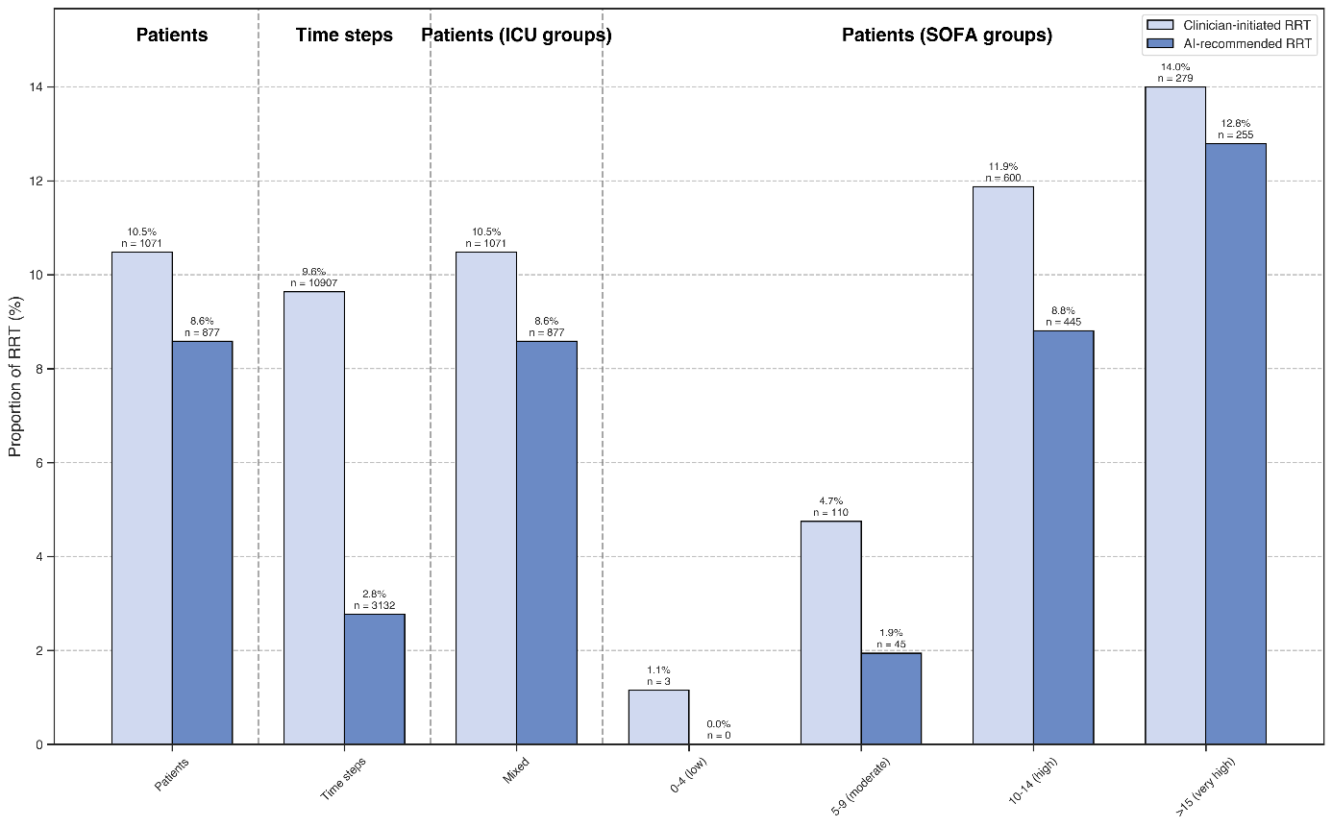
Supplemental Material 3. This figure demonstrates the proportion of AI-recommended renal replacement therapy (RRT) in the dataset of the Medical University of Vienna (MUW) compared to actual clinical practice, displayed across all time steps and for all patients, stratified by ICU groups and SOFA score categories. The term "time steps" is used to denote the proportion of 12-hour steps in which the model or clinician recommended RRT in the data set. While the overall treatment strategies appear similar, the AI tends to recommend RRT less frequently and demonstrates a more pronounced response to increasing SOFA scores. SOFA: Sequential Organ Failure Assessment

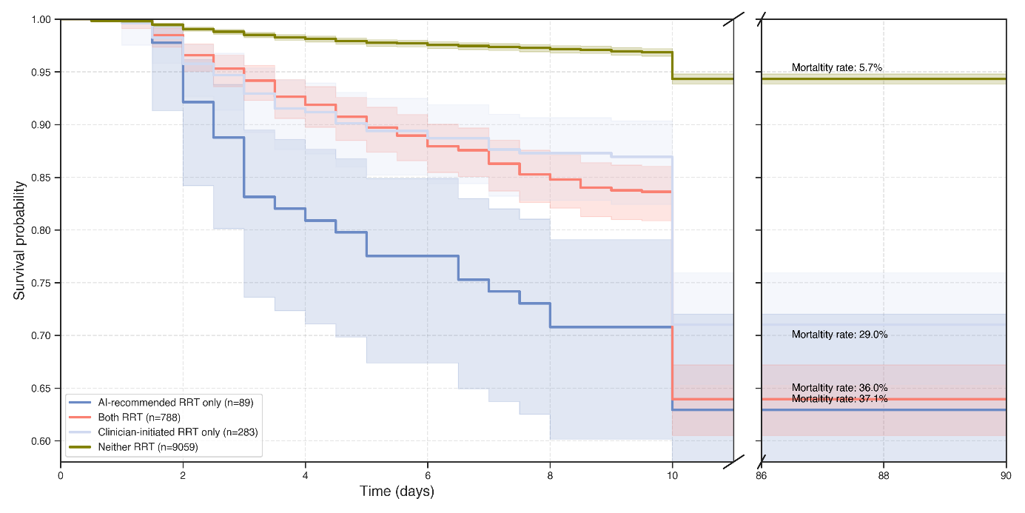
Supplemental Material 4. Survival probability in the Medical University of Vienna (MUW) data set. RRT: Renal Replacement Therapy
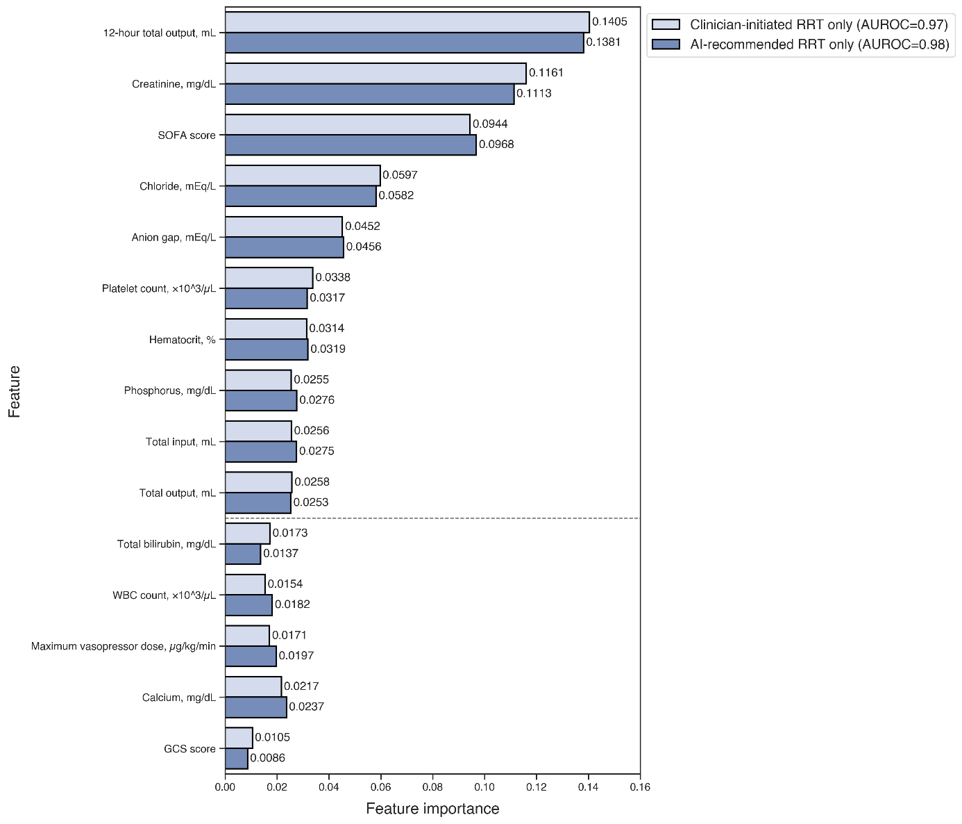
Supplemental Material 5. Comparison of feature importance for predicting renal replacement therapy (RRT) initiation by artificial intelligence (AI) and clinicians using the MIMIC dataset. The top 10 most important features are shown, with the five features exhibiting the greatest difference between AI and clinicians indicated below the dotted line.
SOFA: Sequential Organ Failure Assessment; BUN: Blood Urea Nitrogen; RBC: Red Blood Cells; RASS: Richmond Agitation-Sedation Scale; GCS: Glasgow Coma Scale

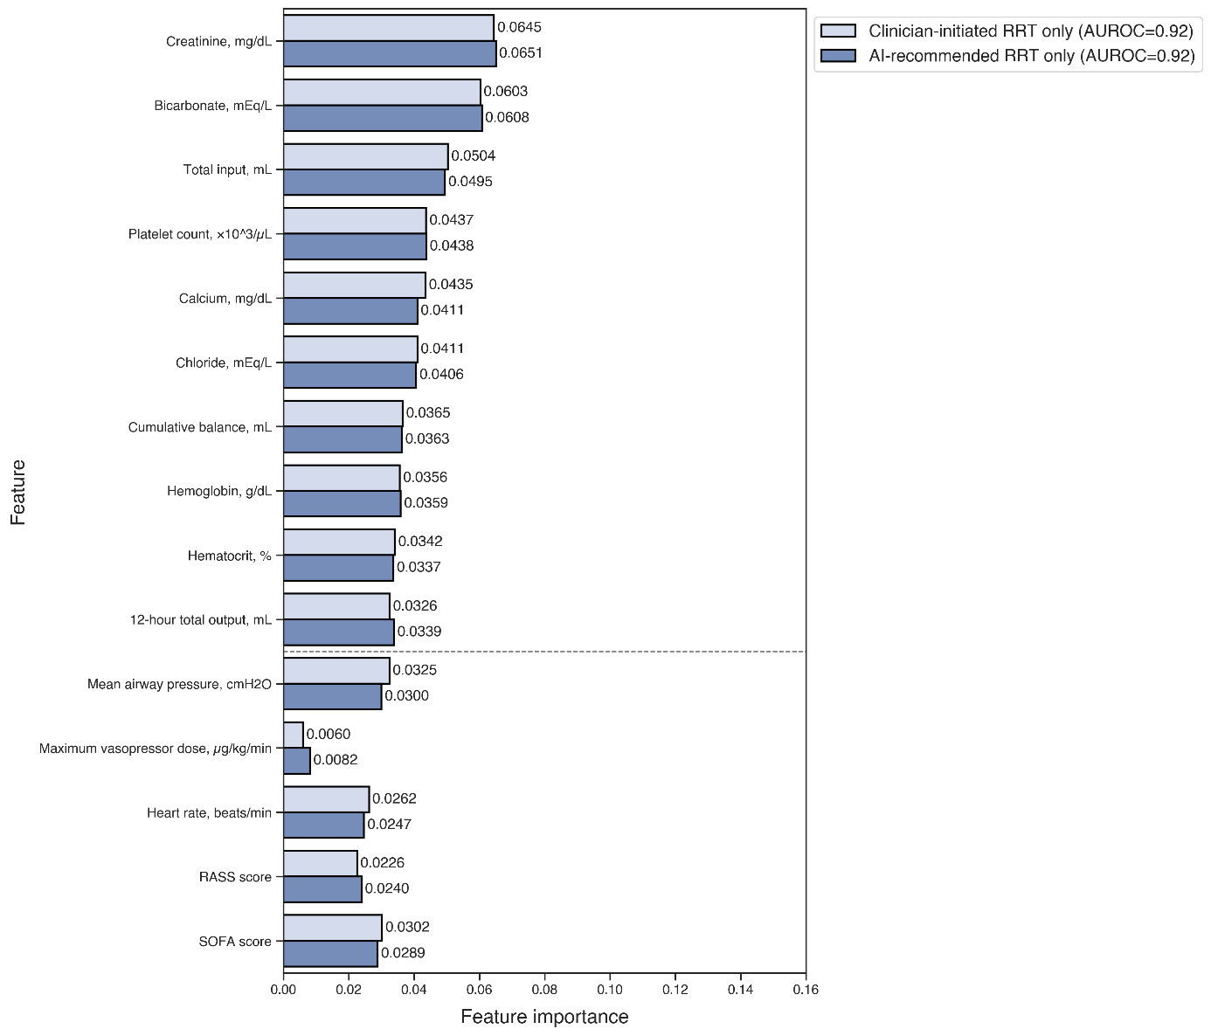
Supplemental Material 6: Comparison of feature importance for predicting renal replacement therapy (RRT) initiation by artificial intelligence (AI) and clinicians using the MIMIC dataset. The top 10 most important features are shown, with the five features exhibiting the greatest difference between AI and clinicians indicated below the dotted line.
SOFA: Sequential Organ Failure Assessment; BUN: Blood Urea Nitrogen; RBC: Red Blood Cells; RASS: Richmond Agitation-Sedation Scale; GCS: Glasgow Coma Scale

