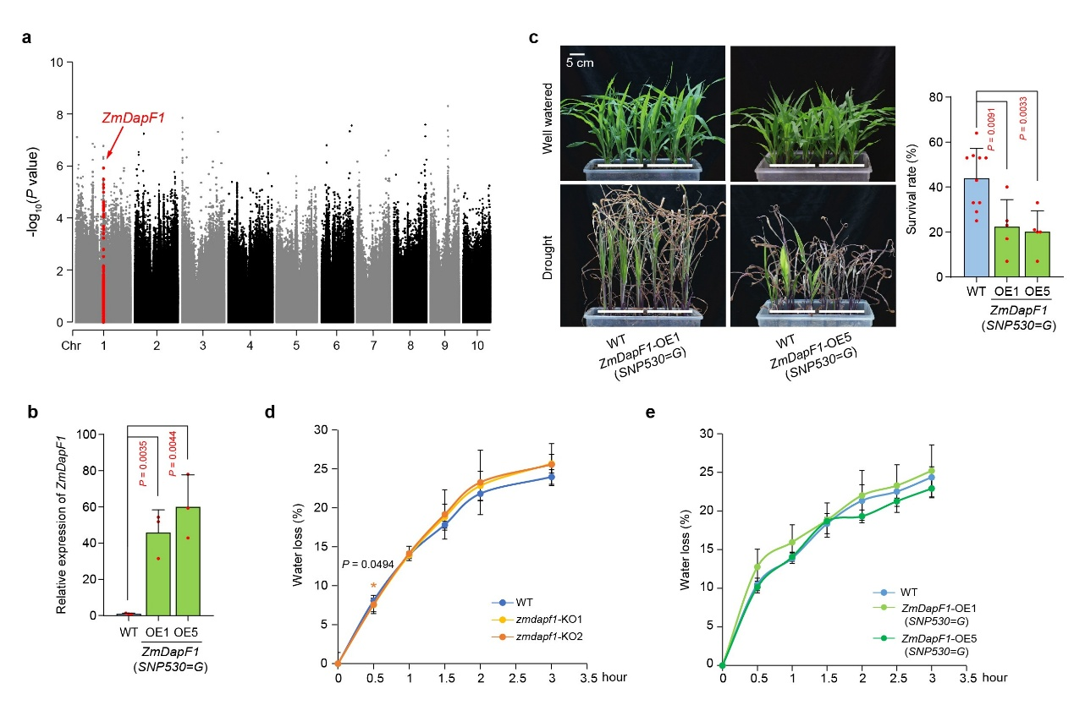
Extended Data Fig. 1 | Manhattan plot for the GWAS and drought resistance assays. a, Results of the GWAS for maize drought tolerance. The SNPs located within ZmDapF1 are highlighted as red dots. b, Relative expression levels of ZmDapF1 in ZmDapF1 (SNP530=G)-OE lines. Data were obtained from three independent replicates, and for each replicate three plants of each genotype were mixed and analyzed. c, Drought resistance assays of ZmDapF1 (SNP530=G)-OE lines. Left panel: the representative photos taken before and after the drought treatment. Right panel: survival rate of WT and ZmDapF1 (SNP530=G)-OE lines after drought stress. Fifteen plants of each genotype were tested in each experiment, and five replicates were conducted. d, e, Water loss rate of detached leaves at the indicated time points. Four leaves of each genotype of 18-day old seedlings were detached and dehydrated on a clean bench. The weights of leaves were measured over the course of 3 hours. Data are means ± s.d. from three biological replicates. Statistical significance was determined by a two-sided t-test in b-e.
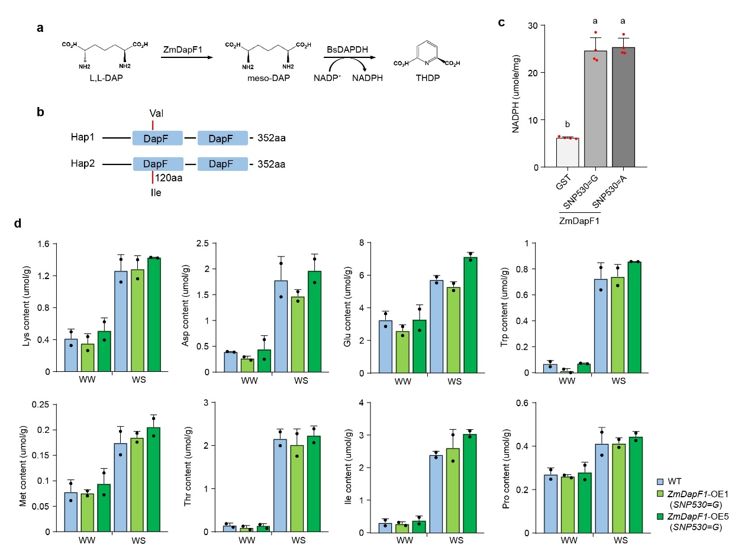
Extended Data Fig. 2 | ZmDapF1 exhibits diaminopimelate epimerase activity in vitro but does not affect lysine content in maize plants. a, Schematic illustration of the diaminopimelate epimerase activity assay for ZmDapF1. b, Schematic diagrams of the ZmDapF1 protein domain. The red line indicates the position of the non-synonymous variants caused by SNP530. c, In vitro diaminopimelate epimerase activity assay of two haplotypes of ZmDapF1. Data represent the mean ± s.d., based on four replicated experiments. Significance was determined by one-way ANOVA (Tukey’s test). d, Analysis of free amino acid contents in the leaves of 18-day old plants of WT and ZmDapF1 (SNP530=G)-OE lines under well-watered (WW) and water stressed (WS) conditions. Data are means ± s.d. from two biological replicates and the leave from four plants of each kind of plants were sampled in each biological replicate.
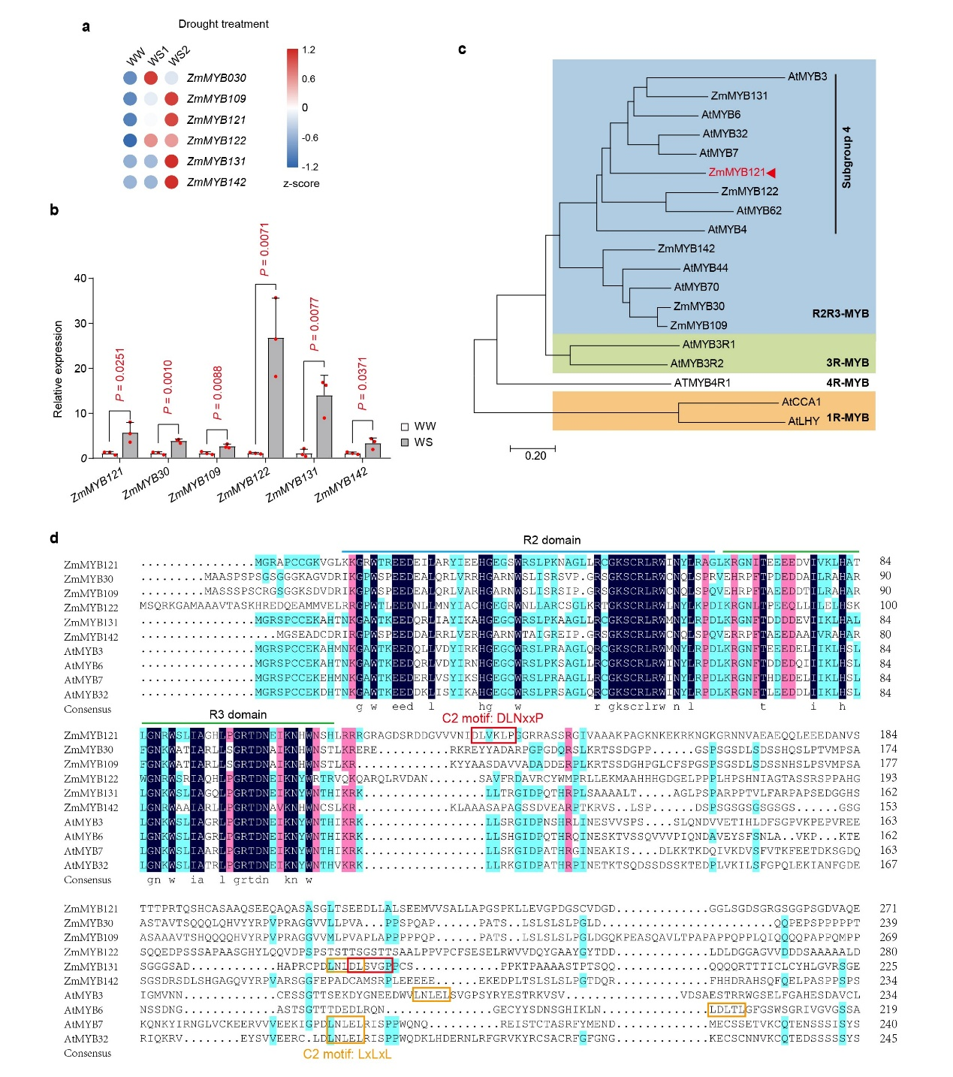
Extended Data Fig. 3 | Expression patterns of ZmMYB genes under drought and multiple sequence alignment of representative MYB proteins from different clades. a, Heat map of gene expression levels of ZmMYBs in B73 in response to drought treatment, based on RNA-sequencing analysis quantified by FPKM (fragments per kilobase million). Drought treatment was applied until relative leaf water content reached ~70% (WS1) and ~58% (WS2). b, Real-time quantitative PCR (RT-qPCR) analysis of expression levels of drought-induced ZmMYBs in B73 under well-watered and drought stress conditions. Data were obtained from three independent replicates, and for each replicate leaves from four plants of each genotype were mixed and analyzed. Data represent the mean ± s.d., and statistical significance was determined by a two-sided t-test. c, Phylogenetic relationships of the ZmMYB and AtMYB proteins. The phylogenetic tree was constructed using the Neighbor-Joining method with MEGA 7 software. d, ZmMYB121 and ZmMYB131 protein contain the C2 motifs, which are characteristic of most R2R3-MYB repressors. The conserved R2 and R3 MYB domains are indicated and the C2 motifs are framed.
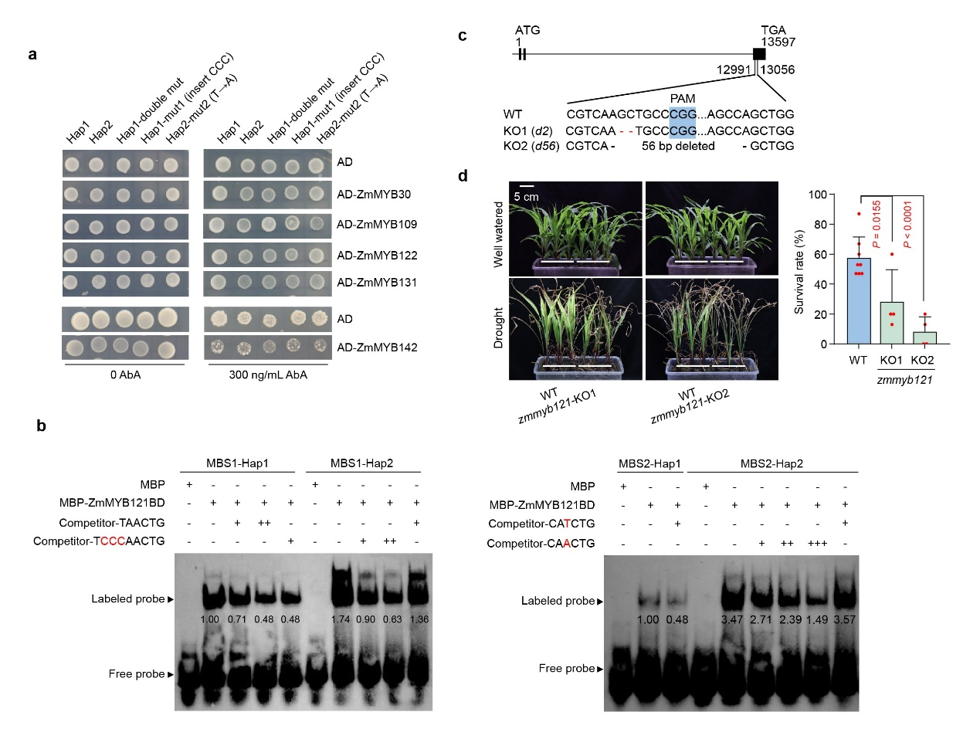
Extended Data Fig. 4 | ZmMYB121 preferentially binds to ZmDapF1-Hap2 promoter and zmmyb121-KO plants are drought susceptible. a, Five ZmMYB proteins did not show differently inhibition activity on the ZmDapF1-Hap1 and ZmDapF1-Hap2 promoters in yeast one-hybrid assays. b, Competition test in EMSA showing that the ZmDapF1-Hap2 sequence strongly competes with the ZmDapF1-Hap1 sequence for ZmMYB121 binding at both MBS1 (MYB binding site 1) (left) and MBS2 (right). The binding intensities were quantified using ImageJ software, and relative values are shown on the images. c, Schematic diagram illustrating the CRISPR-targeted mutations in zmmyb121-KO plants. d, Drought resistance test of zmmyb121-KO plants. Left panel: representative images taken before and after drought treatment; right panel: statistical analysis of survival rates. Fifteen plants of each genotype were tested in each experiment, and four replicates were conducted. Values represent means ± s.d., and statistical significance was determined by a two-sided t-test.
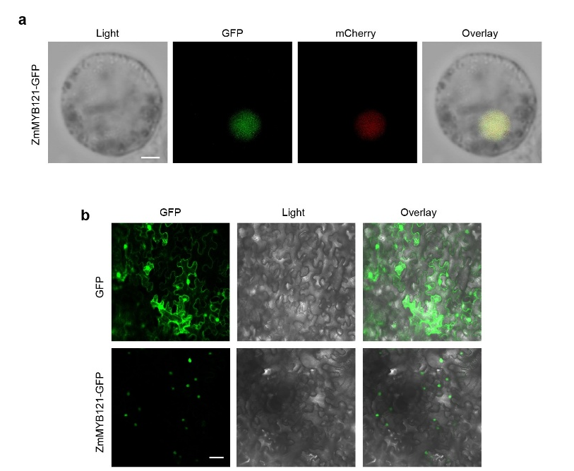
Extended Data Fig. 5 | ZmMYB121 is located in nucleus. a, Confocal microscopy images of the subcellular localization of ZmMYB121-GFP in maize mesophyll protoplasts. AtAHL22-RFP was used as a nucleus marker. Scale bar, 5 μm. b, Subcellular location of ZmMYB121-GFP in tobacco leaves. Scale bar, 50 μm. Images were taken by laser confocal scanning microscope ZEISS710.
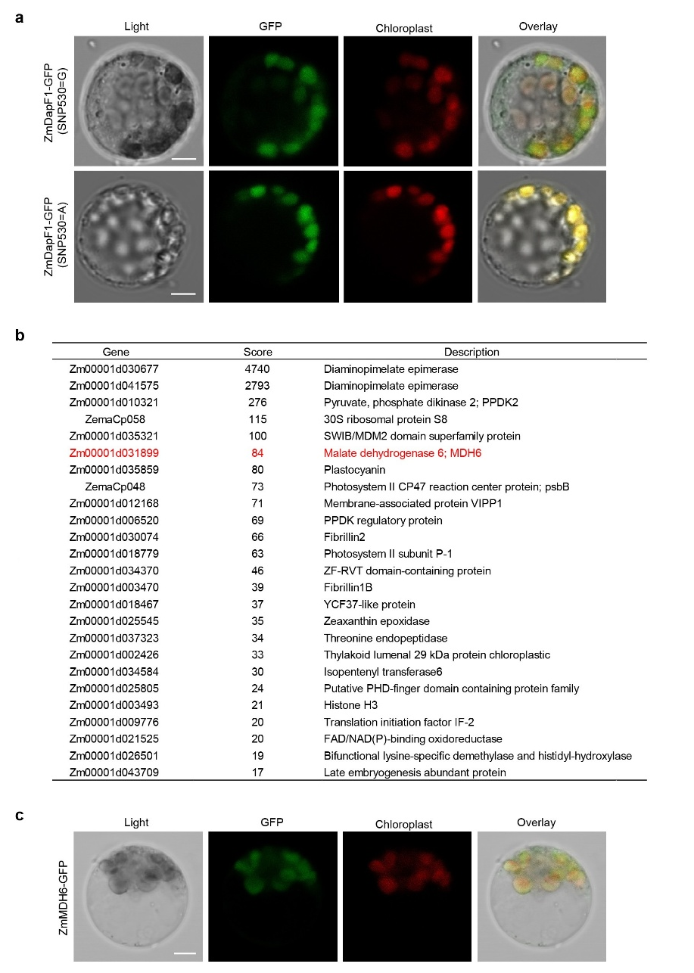
Extended Data Fig. 6 | Subcellular location of ZmDapF1-GFP and ZmMDH6-GFP in maize mesophyll protoplasts. a, Subcellular localization of ZmDapF1-GFP in maize protoplasts. Scale bar, 5 μm. b, List of proteins identified in the affinity-purified products of ZmDapF1-GFP but not GFP control by mass spectrometry analysis. The score reflected the degree of protein matching. A higher score indicated a greater possibility of the protein being correctly identified. c, Subcellular localization of ZmMDH6-GFP in maize protoplasts. Scale bar, 5 μm. In a, c, GFP signals and chloroplast autofluorescence were visualized by laser confocal scanning microscope ZEISS710.
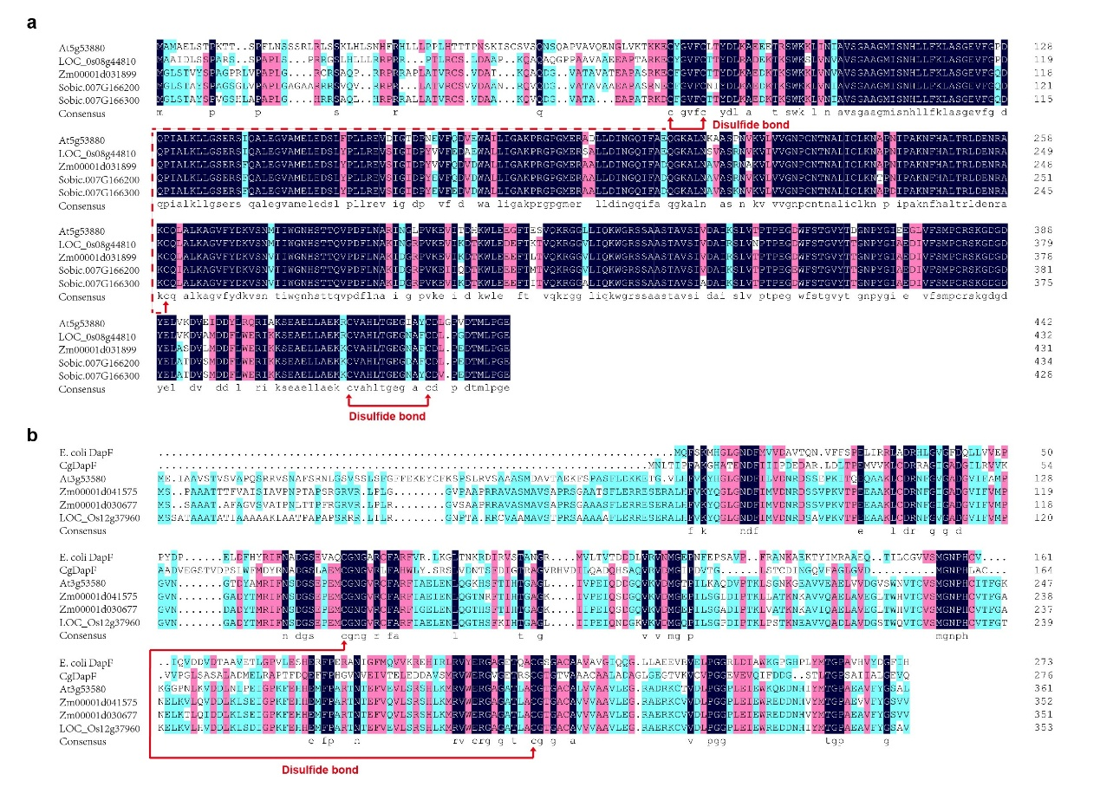
Extended Data Fig. 7 | Amino acid sequence alignments of NADP-MDH and DapF proteins from different species. a, Amino acid sequence alignments of NADP-MDH proteins from Arabidopsis thaliana (At), Oryza sativa (Os), Zea mays (Zm) and Sorghum bicolor (Sb). Identical and highly conserved residues are presented in red and blue, respectively. b, Amino acid sequence alignments of DapF proteins from Escherichia coli (E. coli), Corynebacterium glutamicum (Cg), Arabidopsis thaliana (At), Zea mays (Zm) and Oryza sativa (Os). Cysteine residues involved in the disulfide bond formation are marked with red arrows.
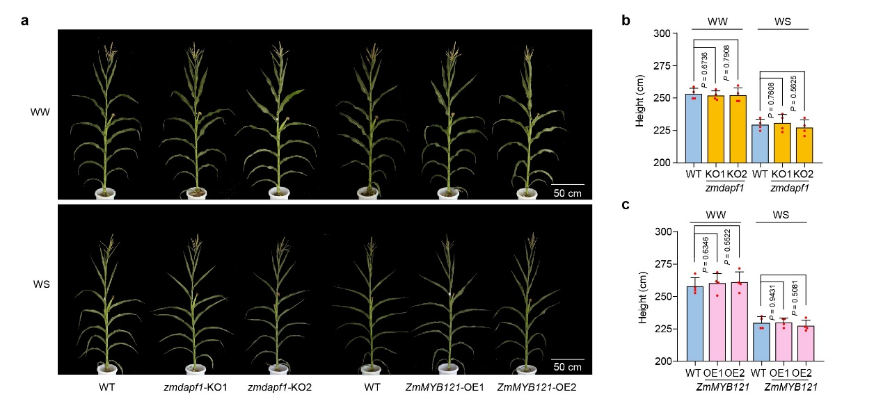
Extended Data Fig. 8 | Morphology of different transgenic maize in 2023. a, Representative photos of each genotype. b, c, Plant heights of WT, zmdapf1-KO plants (b) and ZmMYB121-OE lines (c) under WW and WS conditions. Data represent the mean ± s.d. from four plots, for each plot 18-24 plants were quantified. Statistical significance was determined by a two-sided t-test.
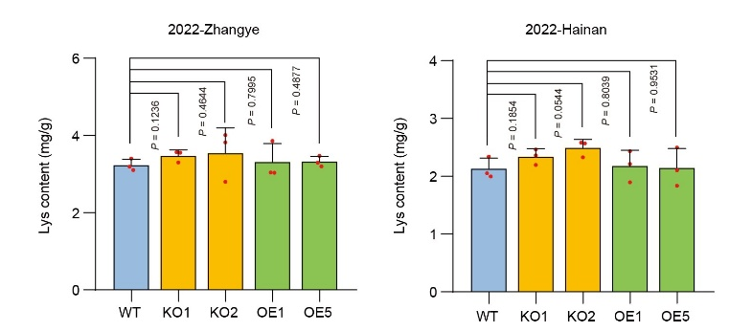
Extended Data Fig. 9 | Analysis of lysine content in the seeds of different transgenic maize harvested from Zhangye (left) and Hainan (right) in 2022. Data are means ± s.d. from three biological replicates, and six seeds of each kind of plants were sampled in each biological replicate. Statistical significance was determined by a two-sided t-test.

