Supplementary file

Search strategy (MEDLINE via Ovid)
MEDLINE Ovid (Ovid MEDLINE(R) Epub Ahead of Print, In‐Process & Other Non‐Indexed Citations, Ovid MEDLINE(R) Daily and Ovid MEDLINE(R) 1946 to Present)

Population: Trauma patients
1: exp "Wounds and Injuries"/OR trauma.ti,ab. OR injur*.ti,ab.

Index test: Physical examination
2: exp Physical examination/ OR ((physical or clinical) ADJ2 (diagnosis or sign* OR symptom* OR assessment or finding* OR evaluat* or examination*)).ti,ab,kw

Target condition: Pelvic fracture
3: ((fracture* or disrupt* or displac* or injur* or traum* or rupture*) adj2 (pelvi* or ilia* or pubi*)).ti,ab.

Exclusion: Review, case report, and animal studies
4: Review.pt OR case reports.pt OR (exp animals/ NOT exp humans/)

5: (1 AND 2 AND 3) NOT 4

Search strategy (EMBASE)

S1 EMB.EXACT.EXPLODE(Injury)
S2 ab(trauma) OR ti(trauma)
S3 ab(injur*) OR ti(injur*)
S4 S1 OR S2 OR S3
S5 EMB.EXACT.EXPLODE(physical examination)
S6 ab((physical or clinical) N/2 (diagnosis or sign* or symptom* or assessment or finding* or evaluat* or examination*)) OR ti((physical or clinical) N/2 (diagnosis or sign* or symptom* or assessment or finding* or evaluat* or examination*))
S7 ab((fracture* or disrupt* or displac* or injur* or traum* or rupture*) N/2 (pelvi* or ilia* or pubi*)) OR ti((fracture* or disrupt* or displac* or injur* or traum* or rupture*) N/2 (pelvi* or ilia* or pubi*))
S8 S6 OR S5
S9 S8 AND S7 AND S4

S-Table 1. Excluded literatures by full-text screening

Title | Year | Author | Reason
Predictive value of the hip flexion test for fractures of the pelvis | 1996 | Ham, S. J. | Wrong reference
The cost-effectiveness of routine pelvic radiography in the evaluation of blunt trauma patients | 1999 | Kaneriya, P. P. | Wrong index test
Does ethanol affect the reliability of pelvic bone examination in blunt trauma? | 2000 | Tien, I. Y. | Case-control design
Blunt trauma and the role of routine pelvic radiographs | 2001 | Duane, T. M. | Case-control design
The clinical presentation of pediatric pelvic fractures | 2001 | Junkins, E. P. | Case-control design
The screening pelvic radiograph in pediatric trauma | 2001 | Rees, M. J. | Wrong index test
Clinical examination in screening for pelvic fractures in blunt trauma 1 | 2002 | Krantz, Brent E. | Wrong purpose or type of study
Pelvic radiography in blunt trauma resuscitation: A diminishing role | 2002 | Guillamondegui, Oscar D. | Wrong index test
Physical examination and imaging of hip injuries | 2002 | Kallas, Kerry M. | Wrong reference
Clinical effectiveness of the physical examination in diagnosis of posterior pelvic ring injuries | 2003 | McCormick, Joseph P. | Wrong purpose or type of study
Validation of a decision instrument to limit pelvic radiography in blunt trauma | 2005 | Gross, Eric Alan | 2x2table unavailable
Is routine portable pelvic X-ray in stable multiple trauma patients always justified in a high technology era? | 2007 | Kessel, Boris | Wrong index test
Necessity of routine pelvic radiograph in the pediatric blunt trauma patient | 2008 | Ramirez, Dana W. E. | Case-control design
Physical Examination is a Poor Screening Test for Abdominal-Pelvic Injury in Adult Blunt Trauma Patients | 2010 | Michetti, Christopher P. | Wrong index test
Implementation of a cost-saving algorithm for pelvic radiographs in blunt trauma patients | 2011 | Barleben, Andrew | Wrong index test
Analysis of the necessity of routine tests in trauma patients in the emergency department | 2012 | Ozlem Koksal | Wrong index test
Indications and performance of pelvic radiography in patients with blunt trauma | 2012 | Holmes, James F. | Wrong index test
Role of routine pelvic radiography in initial evaluation of stable, high-energy, blunt trauma patients | 2013 | Paydar, Shahram | Wrong index test
Patterns of injury and management of children with pelvic fractures at a non-trauma center | 2014 | Ortega, Henry W. | Wrong index test
Clinical and economic effects of selective radiological evaluation of high-energy trauma patients: A prospective experience of a level 1 busy trauma centre | 2015 | Paydar, Shahram | Wrong purpose or type of study
Reducing unnecessary portable pelvic radiographs in trauma patients: A resident-driven quality improvement initiative | 2015 | Langer, Jessica M. | Wrong purpose or type of study
Significance of clinical examination, CT and MRI scan in the diagnosis of posterior pelvic ring fractures | 2015 | J.V. Nu ̈ chtern | Wrong purpose or type of study
Skip and save: Utility of pelvic x-rays in the initial evaluation of blunt trauma patients | 2015 | Soto, Jose Raul | Case-control design
Use of the initial trauma CT scan to aid in diagnosis of open pelvic fractures | 2015 | Scolaro, John A. | Wrong index test
Pre-hospital pelvic girdle injury: Improving diagnostic accuracy in a physician-led trauma service | 2016 | Yong, E. | Wrong index test
Prehospital assessment of injury type and severity in severely injured patients by emergency physicians: An analysis of the Trauma Register DGU | 2017 | Esmer, E. | Wrong index test
Negative Stress Examination Under Anesthesia Reliably Predicts Pelvic Ring Union Without Displacement | 2017 | Whiting, Paul S. | Wrong population
Straight leg elevation to rule out pelvic injury | 2018 | Bolt, Caroline | Wrong index test
The patellar pubic percussion test: a simple bedside tool for suspected occult hip fractures | 2018 | Smeets, Stef Jozef Marie | Wrong purpose or type of study
Is there any benefit in the pre-hospital application of pelvic binders in patients with suspected pelvic injuries? | 2019 | Schweigkofler, Uwe | Wrong purpose or type of study

S-Table 2. The detail of the assessment of QUDAS-2 tool
 |  | Patients selection |  |  |  | Index test |  |  | Ref |  |  |  | Patients flow
Author | Year | Bias | Reason | Applicability | Reason | Bias | Applicability | Reason | Bias | Applicability | Reason | Bias |  | Reason
Civil, et al | 1988 | Low |  | Low concern |  | Low | Low concern |  | High | High concern | Blind was unclear | Low
Grant | 1990 | High | Inappropriate Inclusion | High | Inappropriate Inclusion | Low | Low concern |  | Low | High concern |  | High |  | Inappropriate Exclusion in analysis
Salvino, et al | 1992 | Low |  | Low concern |  | Low | Low concern |  | Low | High concern |  | Low
Yugueros, et al | 1995 | Low |  | Low concern |  | Low | Low concern |  | Low | High concern |  | Low
SD. John, et al | 1996 | High | Inappropriate Inclusion | High concern | Inappropriate Inclusion | High | High concern | Index test Positive was unclar | High | High concern | Reader and Blindness | High |  | Inappropriate Exclusion in analysis
Heath, et al | 1997 | High | Inappropriate exclusion | High concern | Inappropriate exclusion | High | High concern | Index test Positive was unclar | High | High concern | Reader and Blindness | High |  | Inappropriate Exclusion in analysis
Junkins, et al | 2000 | Low |  | Low concern |  | Low | Low concern |  | Low | Low concern |  | Low
Duane, et al | 2002 | High | Inappropriate exclusion | High concern | Inappropriate exclusion | Low | Low concern |  | High | High concern | Reader and Blindness | High |  | Inappropriate Exclusion in analysis
Gonzalez, et al | 2002 | Low |  | Low concern |  | Low | Low concern |  | Low | Low concern |  | Low
Pehle, et al | 2003 | Low |  | Low concern |  | Low | Low concern |  | High | High concern | Blind was unclear | Low
Waydhas, et al | 2007 | Low |  | Low concern |  | Low | Low concern |  | Low | Low concern |  | Low
Duane, et al | 2008 | High | Inappropriate exclusion | High concern | Inappropriate exclusion | Low | Low concern |  | Low | Low concern |  | High |  | Inappropriate Exclusion in analysis
Duane, et al | 2009 | High | Inappropriate exclusion | High concern | Inappropriate exclusion | Low | Low concern |  | High | High concern | Reader and Blindness | High |  | Inappropriate Exclusion in analysis
Shlamovitz, et al | 2009 | High | Inappropriate exclusion | High concern | Inappropriate exclusion | High | High concern |  | Low | Low concern |  | High |  | Inappropriate Exclusion in analysis
Lagisetty, et al | 2012 | Low |  | Low concern |  | High | High concern |  | Low | High concern |  | High |  | Inappropriate Exclusion in analysis
Lustenberger, et al | 2016 | High | Inappropriate Inclusion | High concern | Inappropriate Inclusion | High | High concern | Index test Positive was unclar | High | High concern | Reader and Blindness | Low
Majidinejad, et al | 2018 | High | Unclear inclusion criteria | High concern | Unclear inclusion criteria | Low | Low concern |  | High | High concern | Reader and Blindness | Low
Schweigkofler, et al | 2017 | High | Unclear inclusion criteria | High concern | Unclear inclusion criteria | High | High concern | Index test Positive was unclar | High | High concern | Reader and Blindness | Low
Leent, et al | 2019 | High | Inappropriate Inclusion | High concern | Inappropriate Inclusion | Low | Low concern |  | High | High concern | Reader and Blindness | High |  | Inappropriate Exclusion in analysis
Moosa, et al | 2019 | Low |  | Low concern |  | Low | Low concern |  | Low | High concern |  | Low

S-Figure 1. The quality of the included studies in the sub-group of level of consciousness

GCS≥13 Only
Risk of bias
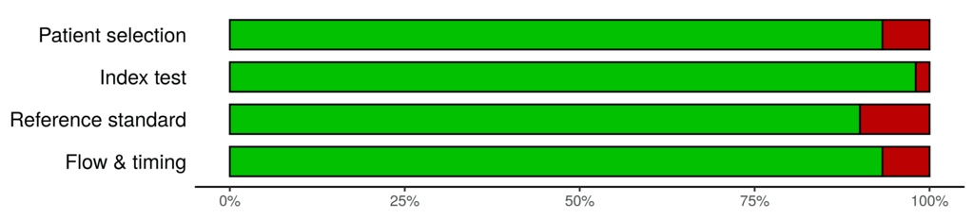
Applicability
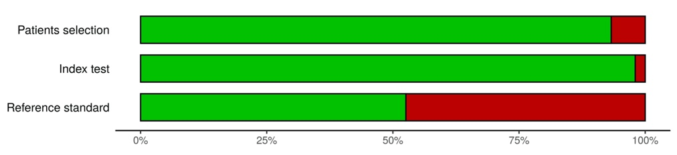

Including GCS≤13
Risk of Bias
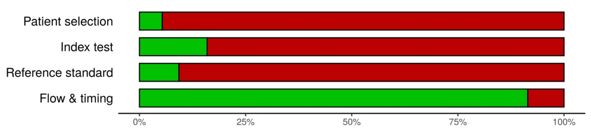
Applicability
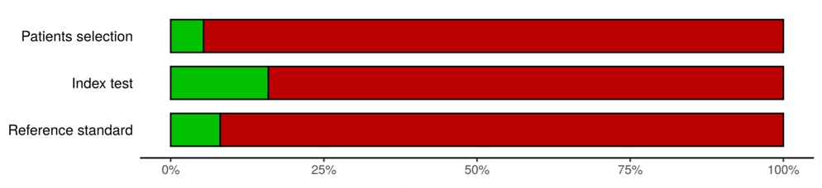

Green: Low risk of bias or low concern in applicability
Red: High risk of bias or high concern in applicability

S- Figure 2.
The results of sensitivity analysis excluding the studies using index test other than pre-defined in the review protocol
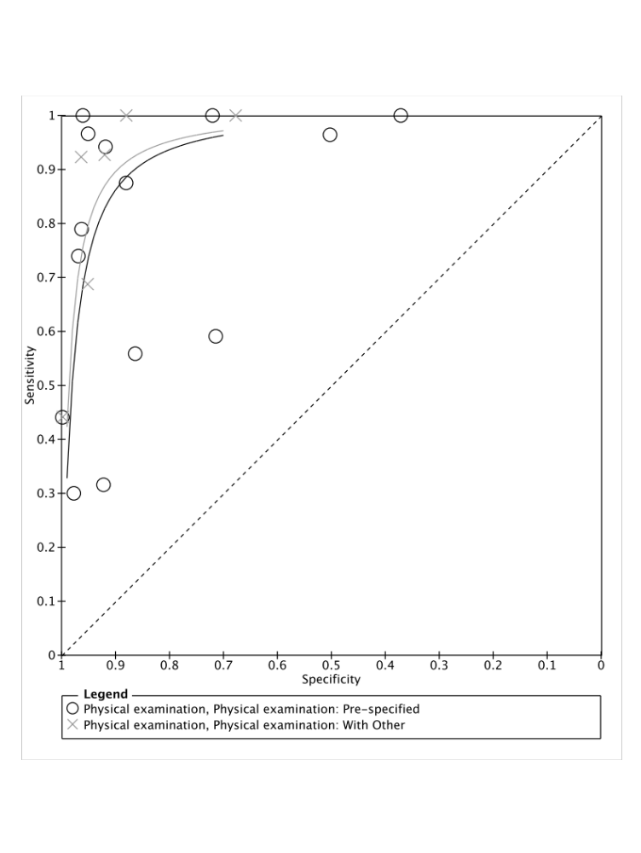
HSROC (Black): Sensitivity analysis only included studies using index test defined in review protocol
HSROC (Gray): Primary analysis included all studies
○: Studies using index test defined in protocol
×: Studies using index test other than pre-defined in review protocol such as neurological examination or rectal examination
DOR in sensitivity analysis: 55.6 [95%CI: 25.2-122.4]

S-Figure 3.
The results of sensitivity analysis excluding the studies using reference standard as only x-ray or unclear

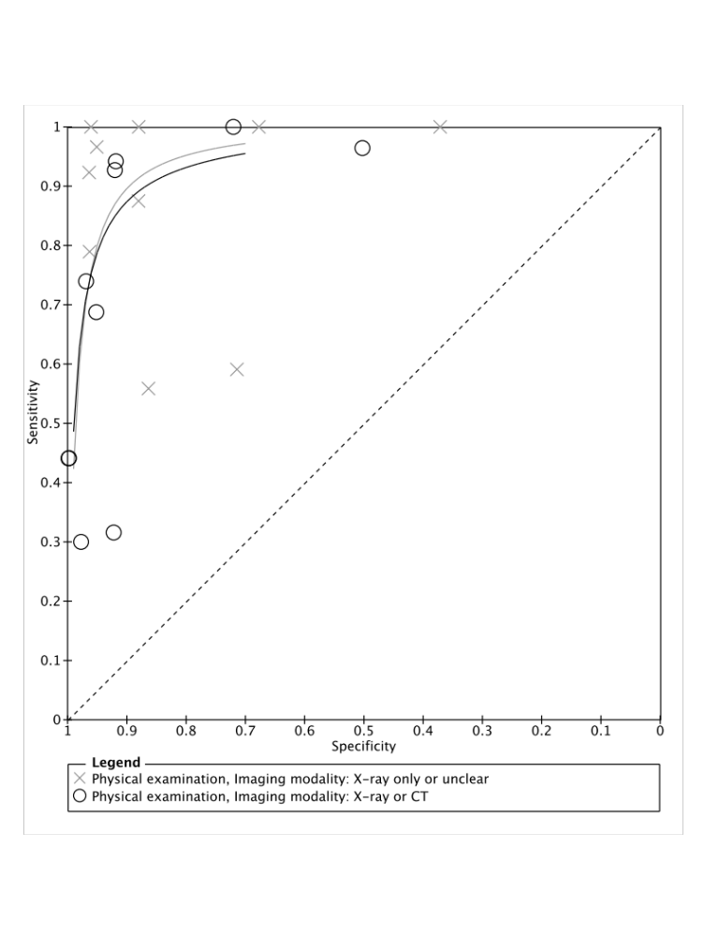

HSROC (Black): Sensitivity analysis only included studies using reference standard as X-ray or CT
HSROC (Gray): Primary analysis included all studies
○: Studies using reference standard as X-ray or CT
×: Studies using reference standard as X-ray only or unclear
DOR in sensitivity analysis: 72.9 [95%CI: 27.5-193.0]

S-Figure 3.
The results of post-hoc sensitivity analysis only excluding the studies evaluated as “High risk of bias” at least in one domain

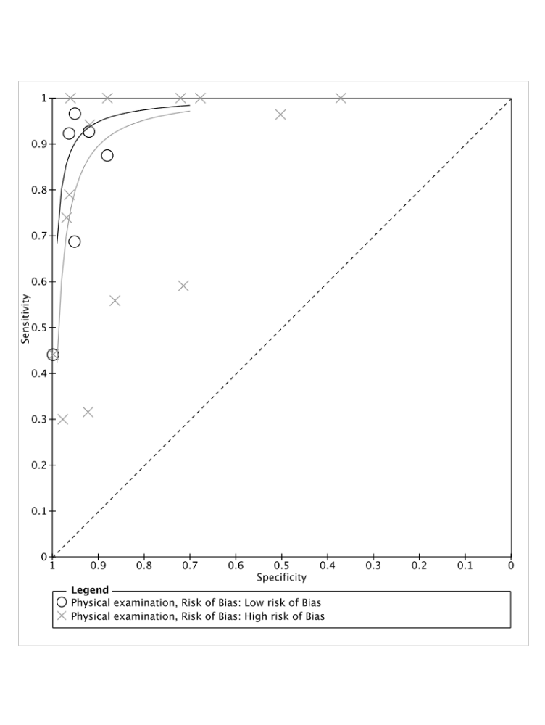

HSROC (Black): Sensitivity analysis only included studies evaluated as “Low risk of bias”
HSROC (Gray): Primary analysis included all studies
○: Studies evaluated as “Low risk of bias”
×: Studies evaluated as “High risk of bias” at least in one domain
DOR in sensitivity analysis: 187.0 [95%CI: 62.0-564.1]

