Supporting Information
Bimetallic Catalysts Based on Chiral Amplification, Inversion, and Assembly for an Asymmetric Cascade Process
Methods and Materials
Methods
Nuclear magnetic resonance (NMR) spectra were recorded using a Bruker 400 MHz spectrometer {H} operated in the Fourier Transform mode. Chemical shifts are reported in delta (δ) units and expressed in parts per million (ppm) downfield from tetramethylsilane (TMS) using the residual solvent proton as an internal standard. Size exclusion chromatography (SEC) was performed on Waters 1515 pump and 2414 differential refractive index (RI) detector (set at 25 °C) using a series of two linear TSK gel GMHHR-H columns. Molecular weight (Mn) and its dispersity (Mw/Mn) data are reported relative to polystyrene standards. The eluent was (DMF) at a flow rate of 0.8 mL/min. FT-IR spectra were recorded on Perkin-Elmer Spectrum BXFT-IR system using KBr pellets. Circular dichroism (CD) spectra were obtained in a 1.0 mm quartz cell at 25 °C using a JASCO J1500 spectropolarimeter. Absorptionspectra were recorded on UNIC 4802 UV/vis double beam spectrophotometer in a 1.0 cm quartz cell at 25 °C. Atomic forcemicroscope (AFM) was performed on a Cypher S microscope (Oxford Instruments, Asylum Research). Transmission electron microscopy (TEM) was performed on a JEM1400 FLASH operating at 120.0 kV accelerating voltage. High performance liquid chromatography (HPLC) was carried out on SHIMADZU LC-20AT equipment with UV-vis detector or on a JASCO Pu-418 pump with JASCO UV-4070and CD-4095 detectors, using n-hexane/i-PrOH as fluent on chiral column. UV-vis absorption spectra were carried on UNIC 4802 UV/vis double beam spectrophotometer
Materials
All solvents were obtained from Sinopharm. Co. Ltd., and were purified by the standard procedures before use. In experiments that required dry solvents, tetrahydrofuran (THF) and chloroform (CHCl₃) were dried using standard methods and distilled before use. All chemicals were purchased from Aladdin and Sigma-Aldrich Chemical Co. Ltd., and were used as received otherwise denoted.
Experimental
Monomers synthesis and characterization
- Synthesis of monomer S-B-Cu
Add 2-bromo-6-cyanopyridine (19.52 mmol) and bis(triphenylphosphine) palladium chloride (0.96 mmol) into a 250 mL round bottom flask, dissolve them in 150 mL anhydrous toluene, and stir at room temperature to add tributyltin (23.44 mmol). Reflux under argon atmosphere for 4 hours. After the reaction is complete, cool the solution to room temperature and filter through diatomaceous earth to remove insoluble impurities. Concentrate the filtrate and purify the product by column chromatography (PE: EA=4:1) to obtain 6-vinyl-2-cyanopyridine with a yield of 78%.
Add 6-vinyl-2-cyanopyridine (15.23 mmol) and zinc trifluoromethanesulfonate (16.43 mmol) into a 250 mL round bottom flask, dissolve them in 150 mL anhydrous toluene, then add L-valinol (15.23 mmol), sonicate for dissolution, and reflux under argon atmosphere for 48 hours. After the reaction is complete, cool the solution to room temperature, then dilute the reaction solution with 150 mL ethyl acetate, wash the diluted reaction solution with saturated saline water (3×240 mL) and 5% Na₂CO₃ (3×240 mL), dry the organic phase with anhydrous magnesium sulfate, filter and concentrate the organic phase, and purify the product by column chromatography (PE: EA=8:1) to obtain pyridoxazole. Pyrox (iPr) monomer with a yield of 83%. The synthesis route is shown in Fig. S1.
Fig. S1 The synthetic route of pyridoxazoline monomer (pyox (iPr)).
Add copper trifluoromethanesulfonate (2.5 mmol) and pyridine oxazoline pyrox (iPr) (2.5 mmol) into a 250 mL round bottom flask, then dissolve them in 100 mL anhydrous methanol and reflux under argon atmosphere for 4 h. After the reaction is complete, cool the solution to room temperature and concentrate to 4 mL, remove uncomplexed metals and monomers with toluene, and dry under vacuum overnight to obtain S-B-Cu. The synthesis route is shown in Fig. S2.
Fig. S2 The synthetic route of S-B-Cu.
- Synthesis of monomer (1R, 2R)A-Ru
Add (1R, 2R) - (+) -1,2-diphenyl-1,2-ethylenediamine (9.8 mmol) to a 150 mL round bottom flask, dissolve it in 50 mL of anhydrous dichloromethane, then add 2 mL of triethylamine, dissolve styrene sulfonyl chloride (10.22 mmol) in 10 mL of anhydrous dichloromethane, and add styrene sulfonyl chloride dropwise to the mixed solution under ice bath conditions. Stir at room temperature overnight after the reaction is complete, filter and remove insoluble substances, then dissolve and wash the organic phase with 5% NaOH, dry it with anhydrous magnesium sulfate, filter and concentrate the organic phase, and purify the product by column chromatography (PE: EA=1:1) to obtain V-TsDPEN chiral monomer. The synthesis route is shown in Fig. S3.
Fig. S3 The synthetic route of V-TsDPEN

Add V-TsDPEN (1.42 mmol) to a 100 mL round bottom flask, dissolve it in 30 mL of anhydrous dichloromethane, and dissolve bis (methyl isopropylbenzene dichloride) in 14 mL of anhydrous dichloromethane. Slowly drop it into the round bottom flask under an argon atmosphere, react at room temperature for 10 hours, remove the solvent, and add a CH₂Cl₂/Et₂O=1:1 mixed solvent to remove uncomplexed metal ruthenium. Concentrate the solvent again and precipitate it in a large amount of n-hexane. Dry the precipitate under vacuum overnight to obtain the small molecule catalyst (1R, 2R)A-Ru. The synthesis route is shown in Fig. S4.
Fig. S4 The synthetic route of (1R, 2R)A-Ru.
Polymers synthesis and characterization
(1) Homopolymer of Ρ-[Cu-pyox(^{i}Pr)] synthesized by RAFT polymerization
Add chiral ligand S-B-Cu (0.4 mmol) and 4-cyano-4- (phenylthioformylthio) valeric acid (CPADB) (0.0344 mmol) into a 25 mL Shrek flask, dissolve it in 3 mL anhydrous DMF by ultrasound, and add AIBN (0.0115 mmol). React at 70 ℃ for 24 hours. After the reaction is complete, wash it in a large amount of n-hexane/ether 2:1 mixed solvent to remove the unreacted monomers, and dry it under vacuum at 30 ℃ for 24 hours to obtain the homopolymer.
- Homopolymer of chiral ligand Ρ-[V-TsDPEN-Ru] synthesized by RAFT polymerization
Add the chiral ligand V-TsDPEN Ru (0.4 mmol) and 4-cyano-4- (phenylthioformylthio) pentanoic acid (CPADB) (0.0344 mmol) into a 25 mL Shrek flask, add 3 mL anhydrous DMF to sonicate and dissolve, then add AIBN (0.0115 mmol) and react at 70 ℃ for 24 hours. After the reaction is complete, wash it in a large amount of n-hexane/ether 1:1 mixed solvent to remove the unreacted monomers, and vacuum dry it at 30 ℃ for 24 hours to obtain the homopolymer of chiral ligand V-TsDPEN Ru.
(3) Synthesis of chiral Cu-Ru random copolymer by RAFT polymerization
The chiral ligand V-TsDPEN Ru, Cu-pyox(iPr), 4-cyano-4- (phenylthioformylthio) valeric acid (CPADB) was added to a 25 mL Shrek flask, and anhydrous DMF was added. After ultrasonic dissolution, AIBN was added and reacted at 70 ℃ for 24 hours. After the reaction is completed, the reaction solution is washed in a large amount of n-hexane/ether 1:1 mixed solvent to remove unreacted monomers. The mixture is then vacuum dried at 30 ℃ for 24 hours to obtain a random copolymer of chiral ligands V-TsDPEN Ru and Cu pyox (iPr).
(4) Synthesis of chiral Cu- Ru block copolymer by RAFT polymerization
Add chiral ligands Cu pyox (iPr) and 4-cyano-4- (phenylthioformylthio) valeric acid (CPADB) into a 25 mL Shrek flask, add anhydrous DMF, then add AIBN and react at 70 ℃ for 24 hours. After the reaction is complete, wash the reaction solution in a large amount of n-hexane/ether 2:1 mixed solvent to remove the unreacted monomers. Dry under vacuum at 30 ℃ for 24 hours to obtain the homopolymer of chiral ligand Cu pyox (iPr). Afterwards, Cu pyox (iPr) homopolymer was used as a macromolecular chain transfer agent, and V-TsDPEN-Ru was added to a 25 mL Shrek flask. Anhydrous DMF was added and sonicated to dissolve it. AIBN was then added and reacted at 70 ℃ for 24 hours. After the reaction is completed, the reaction solution is washed in a large amount of n-hexane/ether 1:1 mixed solvent to remove the unreacted chiral monomers. The block copolymer of chiral ligands Cu pyox (iPr) and V-TsDPEN Ru is obtained by vacuum drying at 30 ℃ for 24 hours.
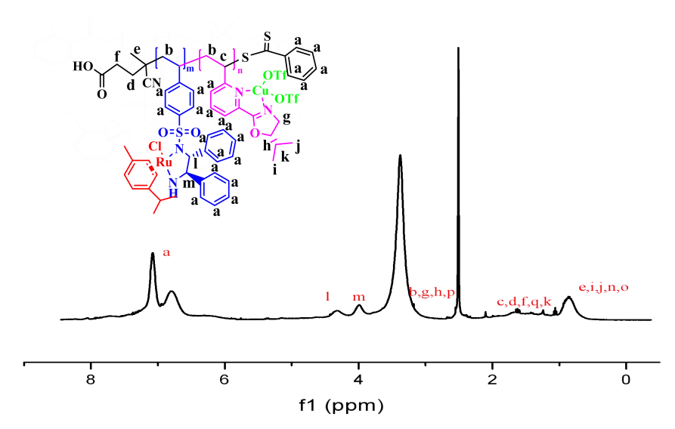
Fig. S5 ¹H NMR (400 MHz) spectrum of Poly(A-Ru₁)-r-(B-Cu₀) measured in DMSO-D₆ at 25 ℃.
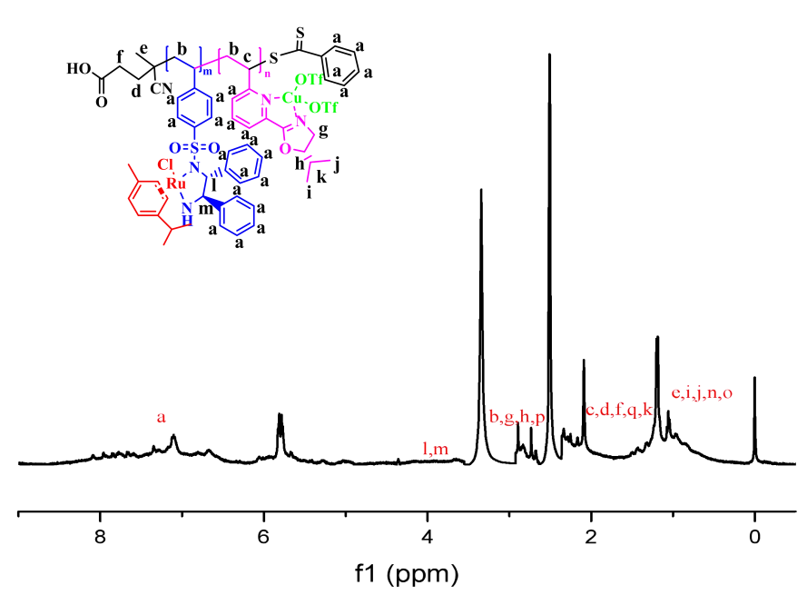
Fig. S6 ¹H NMR (400 MHz) spectrum of Poly(A-Ru₁)-r-(B-Cu₈) measured in DMSO-D₆ at 25 ℃.

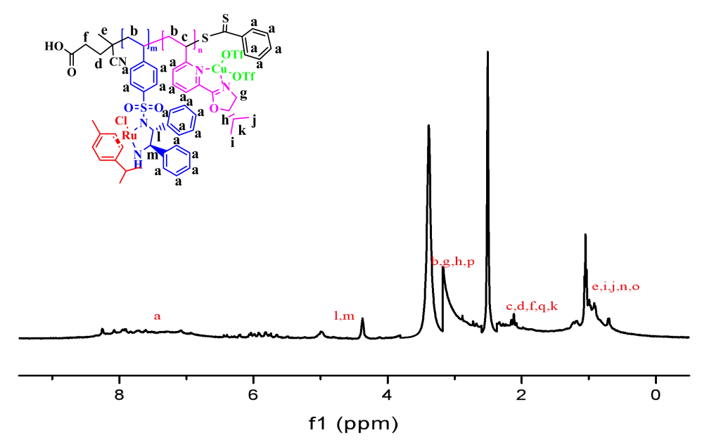
Fig. S7 ¹H NMR (400 MHz) spectrum of Poly(A-Ru₁)-b-(B-Cu₅) measured in DMSO-D₆ at 25 ℃.
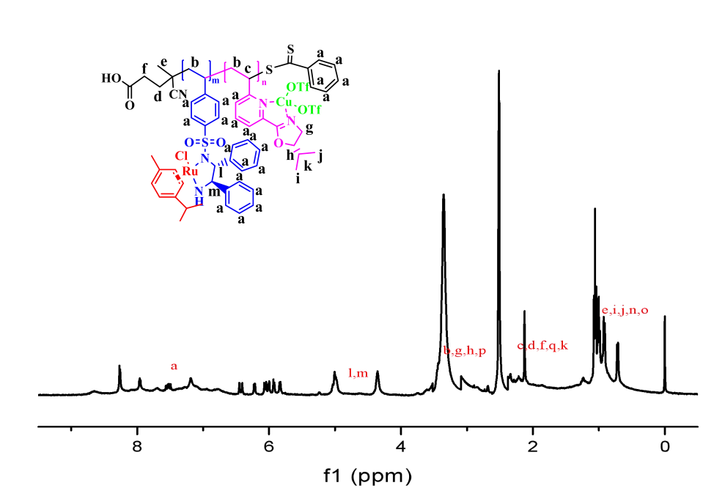
Fig. S8 ¹H NMR (400 MHz) spectrum of Poly(A-Ru₁)-b-(B-Cu₅) measured in DMSO-D₆ at 25 ℃.
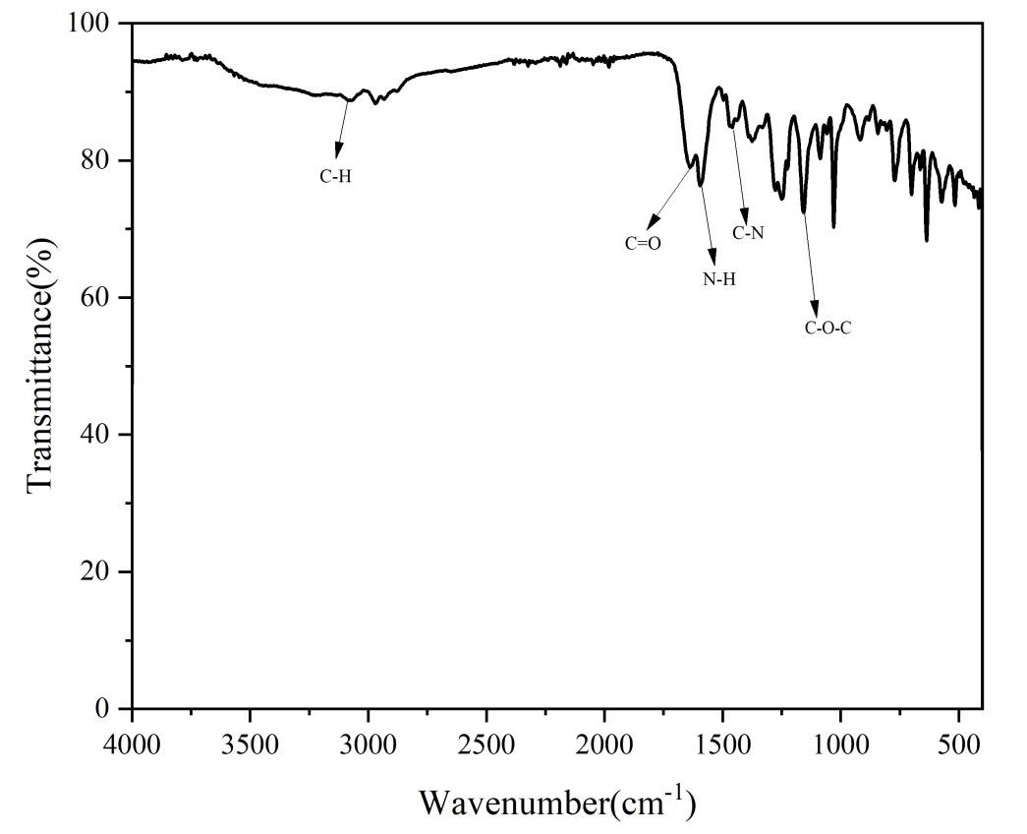
Fig. S9 FT-IR spectrum of poly(A-Ru₁)-(B-Cu_{5.6}) measured at 25 ℃ using KBr pellets.
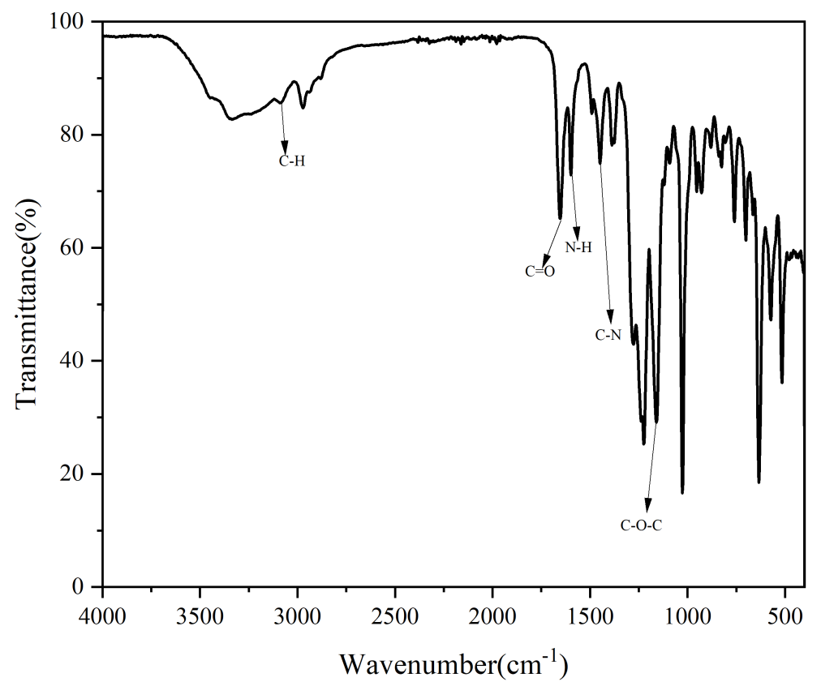
Fig. S10 FT-IR spectrum of poly(A-Ru₁)-r-(B-Cu_{1.5}) measured at 25 °C using KBr pellets.

Fig. S11 GPC of Poly(A-Ru₁)-b-(B-Cu_{2.6}) (a), Poly(A-Ru₁)-b-(B-Cu₅) (b), Poly(A-Ru₁)-r-(B_{1.3}) (c), Poly(A-Ru₁)-r-(B-Cu_{1.5}) (d), Poly(A-Ru₁)-b-(B-Cu_{2.2}) (e), Poly(A-Ru₁)-r-(B-Cu_{5.6}) (f), and Poly(A-Ru₁)-r-(B-Cu₈) (g) in DMF.
Catalytic reaction
- General procedure for the synthesis of racemic β-sulfonamido ketones
The cyclic aldimines 1 (0.12 mmol), catalyst (DBU, 5.0 mol%), and β-ketoacids 2 (0.18 mmol) in THF (0.96 mL) were added into a 5 mL round-bottomed flask equipped with a stirring bar under air atmosphere. The reaction was then stirred at 25 °C. After completion of the reaction (monitored by TLC), the residue was purified by column chromatography on silica gel (eluting with petroleum ether/ethyl acetate) to give the racemic 3.
- General procedure for the synthesis of racemic β-sulfonamido alcohols
The β-sulfonamido ketone 3 (0.06 mmol) in CH₃OH (1.7 mL) was added into a 5 mL round-bottomed flask equipped with a stirring bar under air atmosphere, then slowly add NaBH₄ (1.50 mmol) at 0 ℃. After completion of the reaction (monitored by TLC), the reaction was quenched with H₂O and extracted with CH₂Cl₂. The organic phase was concentrated and the residue was purified by column chromatography on silica gel (eluting with petroleum ether/ethyl acetate) to give the product 4′.
(3) General procedure for in the DMR/ATH cascade reaction
In a typical synthesis, copolymer (0.0004 mmol of Ru), 1 (0.18 g, 1.0 mmol), 2 (0.36 g, 1.5 mmol), HCOONH₄ (0.32 g, 5.0 mmol), and 2.0 mL solvent were added sequentially to a 10 mL round−bottom flask under the air atmosphere. The reaction was stirred at – 20 °C for the first 8 h. After the completion of the decarboxylative Mannich reaction monitored by TLC, the mixture was then heated to 60 °C and stirred for the second 8 h. After the complete transformation monitored by TLC, the most solvent was evaporated and quenched by the addition of water. The aqueous solution was extracted with ethyl ether (3×10.0 mL). The combined ethyl ether extracts were washed with brine twice and then dehydrated with Na₂SO₄. After evaporation of ethyl ether, the residue was purified by silica gel flash column chromatography (petroleum ether/ethyl acetate = 3:1) to give the final product.
CD results
Fig. S12 CD of B monomer and polymer in DMF before and after complexation with Cu (OTf)₂ (left) , CD of A monomer and polymer in DMF before and after complexation with [RuCl₂ (p-cylene)]₂ (CD spectra recorded at 25 ℃, polymer and monomer concentration c=1.54*10⁻³ mM).
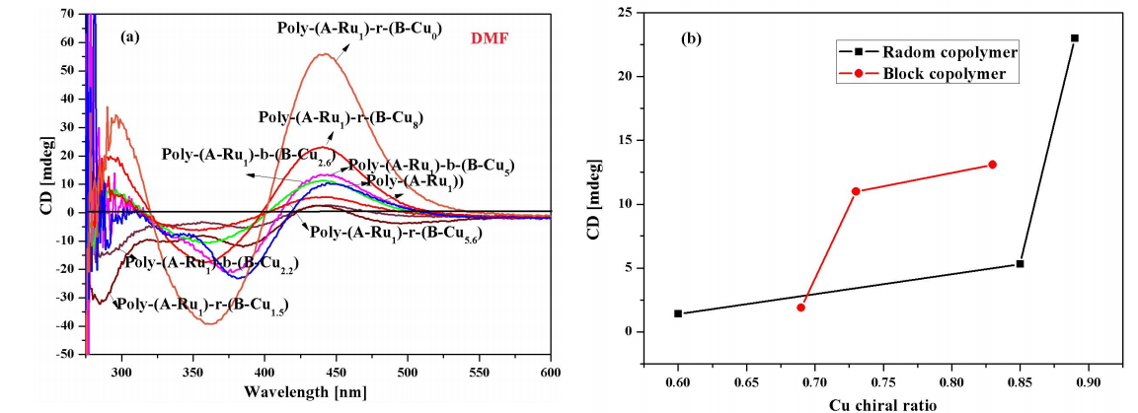
Fig. S13 CD spectra of various polymers in DMF (a) and the relationship between Cu chirality content and CD signal (b) (CD spectra recorded at 25 ℃, polymer concentration c=1.54*10⁻³ mM).
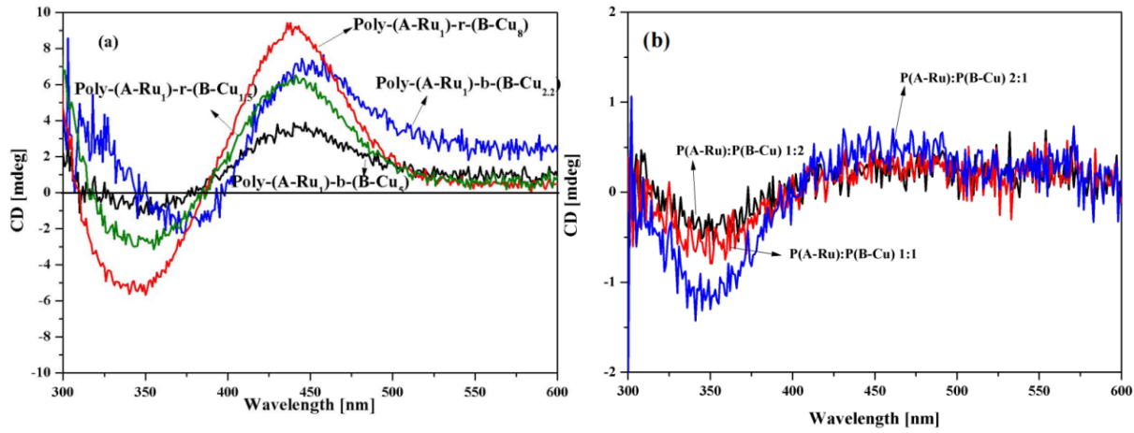
Fig. S14 CD spectra of different copolymer in THF (a) and CD spectra of blended homopolymers in THF/H₂O v/v 8/1 (b) (CD spectra recorded at 25 ℃, polymer concentration c=1.54*10⁻³ mM) .
TEM results
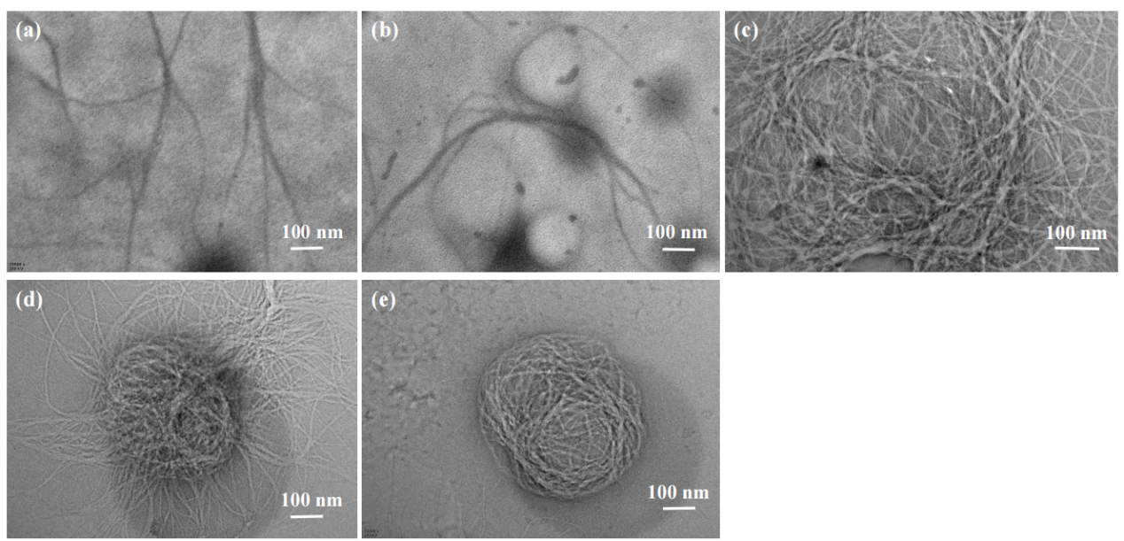
Fig. S15 TEM of Poly(A-Ru₁)-r-(B-Cu₈) in THF/H₂O v/v 8/1 c=1.54*10⁻³ mM (a), Poly(A-Ru₁)-r-(B-Cu_{1.5}) in THF/H₂Ov/v 4/1 c=1.54*10⁻³ mM (b), Poly(A-Ru₁)-r-(B-Cu_{1.5}) in THF/H₂Ov/v 4/1 c=3.0*10⁻³ mM (c), Poly(A-Ru₁)-r-(B-Cu_{1.5}) in THF/H₂Ov/v 4/1 c=9.0*10⁻³ mM (d), and Poly-(A-Ru₁)-r-(B-Cu_{1.5}) in THF/H₂Ov/v 4/1 c=1.54*10⁻² mM (e).
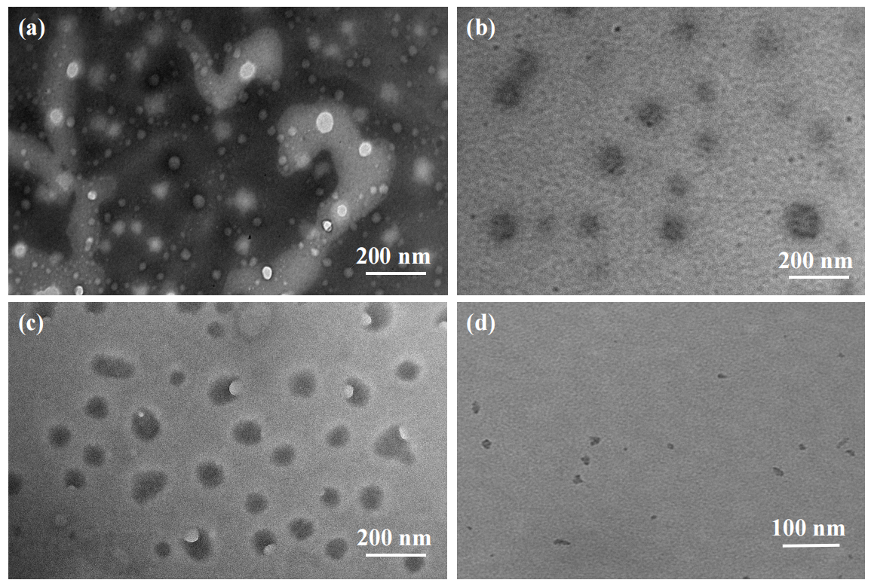
Fig. S16 TEM of Poly(A-Ru₁)-b-(B-Cu_{2.7}) (a), Poly(A-Ru₁)-b-(B-Cu_{2.6}) (b), Poly(A-Ru₁)-b-(B-Cu₅) (c), and Poly(A-Ru₁)-b-(B-Cu_{2.2}) (d) in THF/H₂O v/v 8/1.

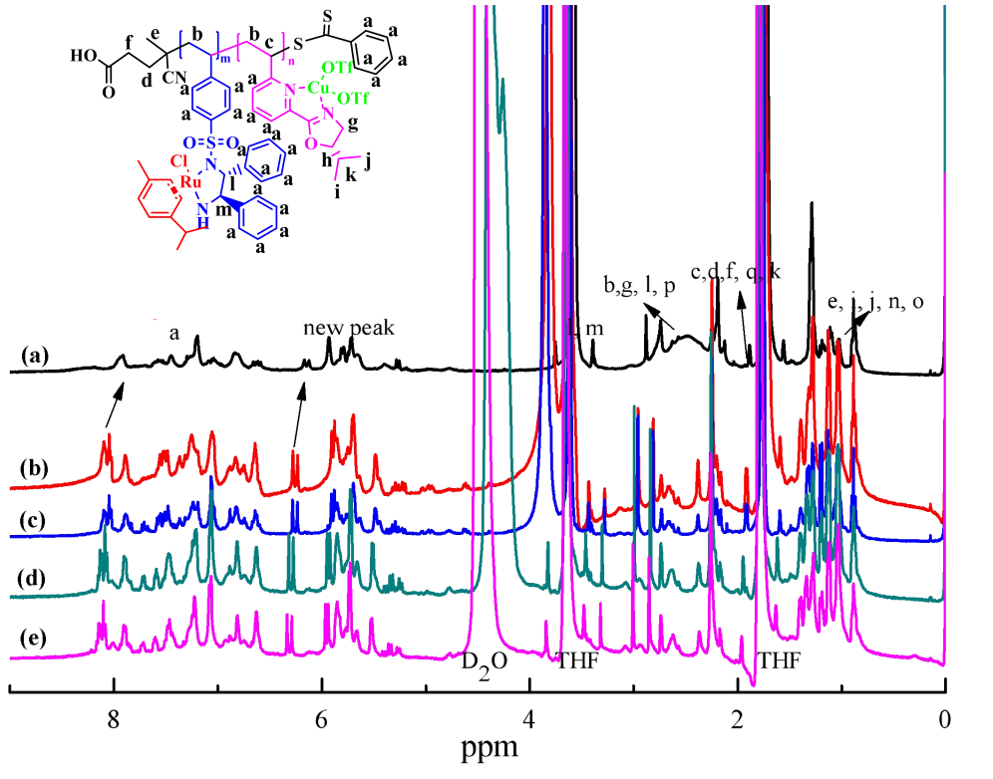
Fig. S17 ¹H NMR of Poly(A-Ru₁)-r-(B-Cu_{1.5}) in D₈-THF (a) , D₈-THF/D₂O v/v 8:1 (b), D₈-THF/D₂O v/v 4:1 (c), D₈-THF/D₂O v/v 2:1 (d), and D₈-THF/D₂O v/v 1:1 (e).
Table S2 Study on the catalytic performance of catalysts in different solvents
Catalysts | Solvent | Convesion %ª | % ee^{b} | dr/%^{b}
Poly-(A-Ru₁)-r-(B-Cu₈) | CH₃OH | 99 | 99 | 99:1
Poly-(A-Ru₁)-r-(B-Cu₈) | DMF | NR | --- | ---
Poly-(A-Ru₁)-r-(B-Cu₈) | THF | 99 | 99 | 99:1

a. Conversion rate; b. Determination by high-performance liquid chromatography, AD-H, n-hexane/isopropanol=90/10, 1.0 mL/min.
HPLC curves and ¹H NMR data of the products.
¹H NMR (400 MHz, CDCl₃) δ 7.44-7.33 (m, 6H), 7.29-7.24 (m, 2H), 7.12 (d, J = 8.2 Hz, 1H), 6.45 (d, J = 8.6 Hz, 1H), 5.19-5.15 (m, 1H), 4.93 (dd, J = 10.2, 2.7 Hz, 1H), 2.56-2.40 (m, 2H).
Compound was determined the enantiopurity by HPLC analysis: Chiralpak AD-H column, n-hexane/2-propanol=90:10, flow rate=1.0 mL/min, 254 nm UV detector, 20 ℃.

¹H NMR (400 MHz, CDCl₃): 7.31 (s, 2H), 7.27 – 7.24 (m, 4H), 7.14 (d, J = 8.0Hz, 1H), 6.95 (d, J = 16.0Hz, 1H), 6.33 (d, J = 4.0Hz, 1H), 5.03 (dd, J =3.6，2.8 Hz, 1H), 4.84 (dd, J = 9.5, 3.4 Hz, 1H), 2.46 – 2.43 (m, 2H), 2.19 (s, 1H).
Compound was determined the enantiopurity by HPLC analysis: The enantiomeric excess, ee=97% , dr=99:1, was determined by HPLC analysis: Chiralpak AD-H column, n-hexane/2-propanol = 90:10, flow rate = 1.0 mL/min, 254 nm UV detector, 20 ℃.

\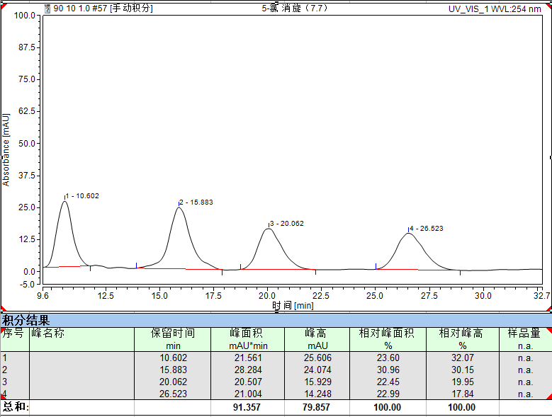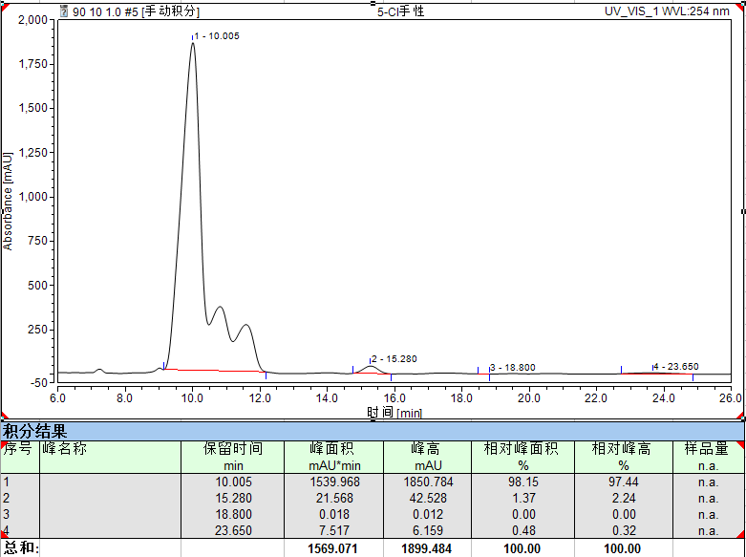
¹H NMR (400 MHz, CDCl₃): 7.45 – 7.38 (m, 2H), 7.36 – 7.10 (m, 5H), 6.96 (t, J = 8.8Hz, 1H), 5.01 (dd, J = 24, 8Hz, 1H), 4.85-4.76(m,1H)，2.27 (s,3H), 1.24-1.16 (m, 2H).
Compound was debenzylated to determine the enantiopurity by HPLC analysis: The enantiomeric excess, ee=96%, dr=95:5 was determined by HPLC analysis: Chiralpak AD-H column, n-hexane/2-propanol=90:10, flow rate=1.0 mL/min, 254nm UV detector, 20 ℃.
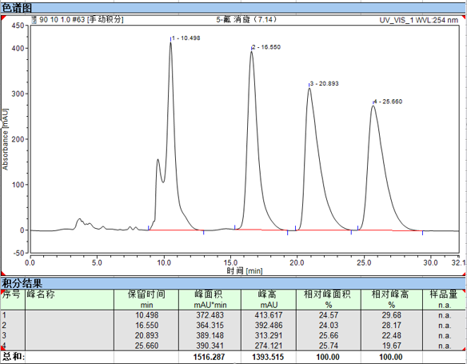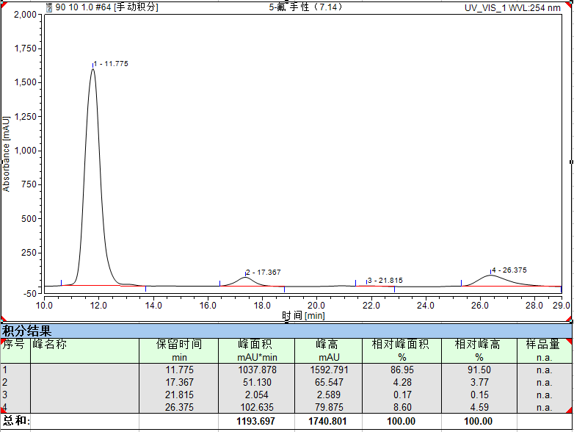

¹HNMR (400 MHz, CDCl3): δ 7.41–7.35 (m, 6H), 7.06 (d, J=2.4Hz, 1H), 6.94(d, J=8.8Hz, 1H), 5.07 (dd, J = 7.6, 5.2 Hz, 1H), 5.17–5.13 (m, 1H), 4.80 (dd, J = 6.0, 4.0 Hz, 1H), 2.5 – 2.51 (m, 1H), 2.45 – 2.41 (m,1H), 2.20 (s, 1H), 1.27 (s, 9H).
Compound was determined the enantiopurity by HPLC analysis: The enantiomeric excess, ee=99%, dr=4:96, was determined by HPLC analysis: Chiralpak AD-H column, n-hexane/2-propanol=90:10, flow rate=1.0 mL/min, 254 nm UV detector, 20 ℃.

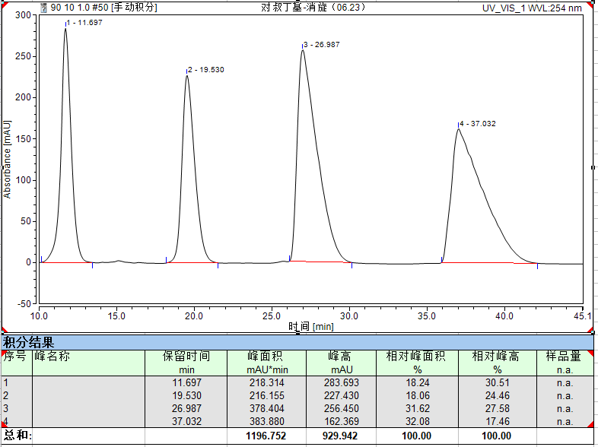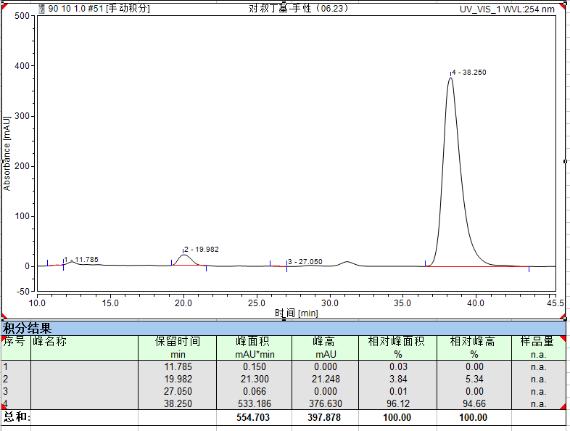
¹HNMR (400 MHz, CDCl3):7.39 – 7.58 (m, 5H), 7.01 (d, J = 8.8 Hz, 1H), 6.87 (dd, J = 9.2, 2.8 Hz, 1H), 6.70 (d, J = 2.8 Hz, 1H), 5.36-5.30 (s, 1H), 5.08 (dd, J = 6.4, 3.6 Hz, 1H), 4.93 (dd, J = 10.0, 2.8 Hz, 1H), 3.80 (s, 3H), 2.53 – 2.46 (m, 2H).
Compound was determined the enantiopurity by HPLC analysis: The enantiomeric excess, ee=99%, dr=99:1, was determined by HPLC analysis: Chiralpak IC column, n-hexane/2-propanol=90/10, flow rate =1.0 mL/min, 254 nm UV detector, 20 ℃.
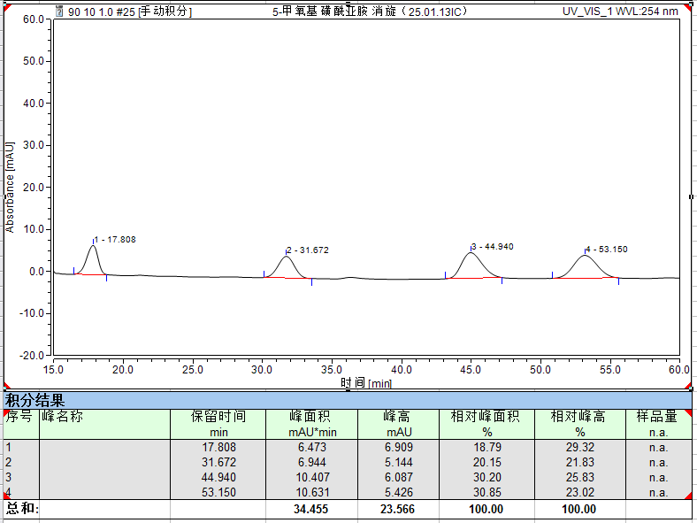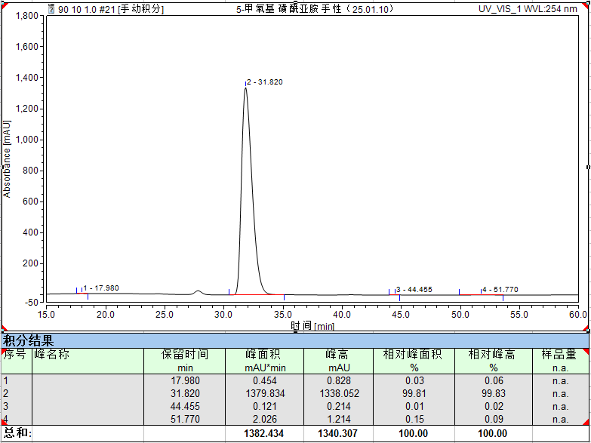
¹HNMR (400 MHz, CDCl3): 7.23 (td, J = 8.0, 1.6 Hz, 1H), 7.11 (td, J = 7.5, 1.3 Hz, 1H), 7.03(dt, J = 8.0, 1.2 Hz, 2H), 6.43 (s,1H), 4.99 (dd, J = 7.2,4.4 Hz, 1H), 2.95 (m, 1H), 2.53 (m, 1H), 2.29 (m, 1H), 0.98 – 0.90 (m, 1H), 0.57-0.52 (m, 2H), 0.15-0.13 (m, 1H), 0.09 – 0.07 (m, 1H).
Compound was determined the enantiopurity by HPLC analysis: The enantiomeric excess, ee=99%, dr=2:98, was determined by HPLC analysis: Chiralpak AD-H column, n-hexane/2-propanol = 94/6, flow rate = 1.0 mL/min, 254 nm UV detector, 20 ℃.
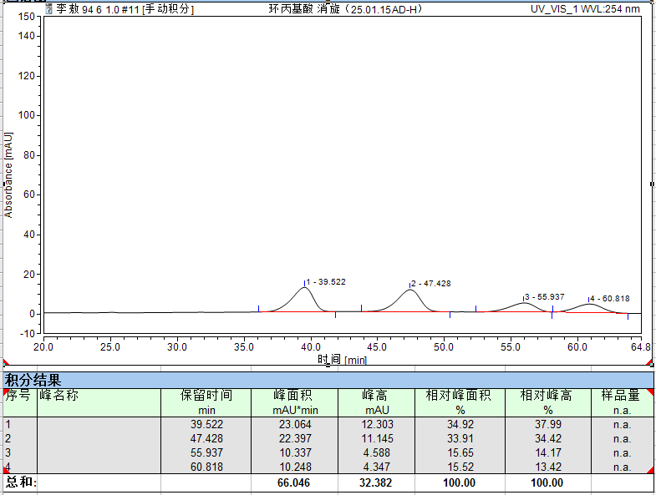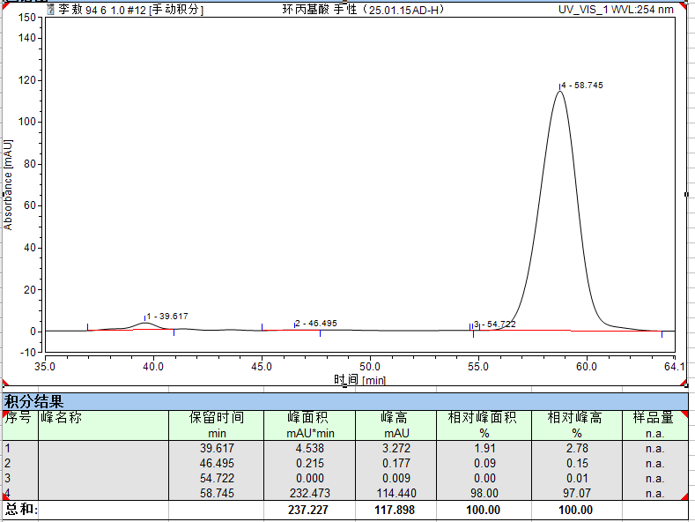

¹HNMR (400 MHz, CDCl3): 7.34 – 7.29 (m, 1H), 7.21 – 7.17 (m, 2H), 7.05 – 7.03 (m, 1H), 6.44 – 5.86 (m, 1H), 5.09 – 4.93 (m, 1H), 4.05 – 3.81 (m, 1H), 2.37 – 2.20 (m, 1H), 2.13 – 2.02 (m, 1H), 1.52– 1.36 (m, 4H), 0.98 – 0.86 (m, 3H).
Compound was determined the enantiopurity by HPLC analysis: The enantiomeric excess, ee=98%, dr=86:14, was determined by HPLC analysis: Chiralpak IC column, n-hexane/2-propanol=94/6, flow rate=1.0 mL/min, 254 nm UV detector, 20 ℃.
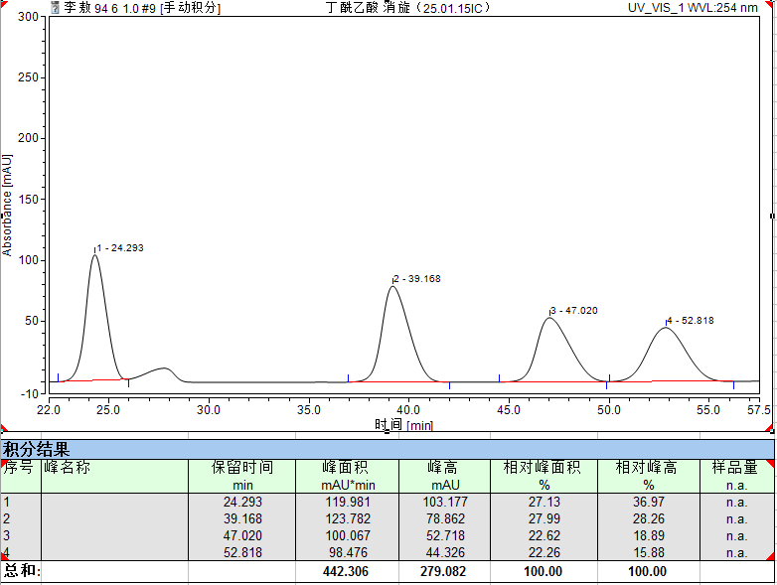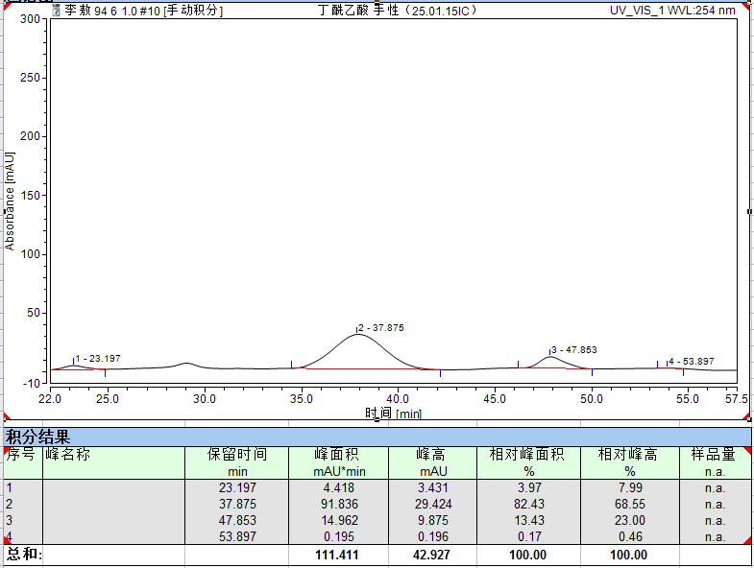

¹HNMR (400 MHz, CDCl3): 7.40-7.32 (m, 5H), 7.05 (dd, J=32.0, 8.0Hz, 1H), 6.82-6.68 (m, 1H), 6.57 (dd, J = 24.0, 4.0Hz, 1H), 5.35 (t, J = 4.0Hz, 1H), 5.10-5.03(m, 1H), 3.80(d, J = 16.0 Hz, 3H), 2.17 (s, 2H).
Compound was determined the enantiopurity by HPLC analysis: The enantiomeric excess, ee=99%, dr=99:1, was determined by HPLC analysis: Chiralpak IC column, n-hexane/2-propanol = 94:6, flow rate = 1.0 mL/min, 254 nm UV detector, 25 ℃.
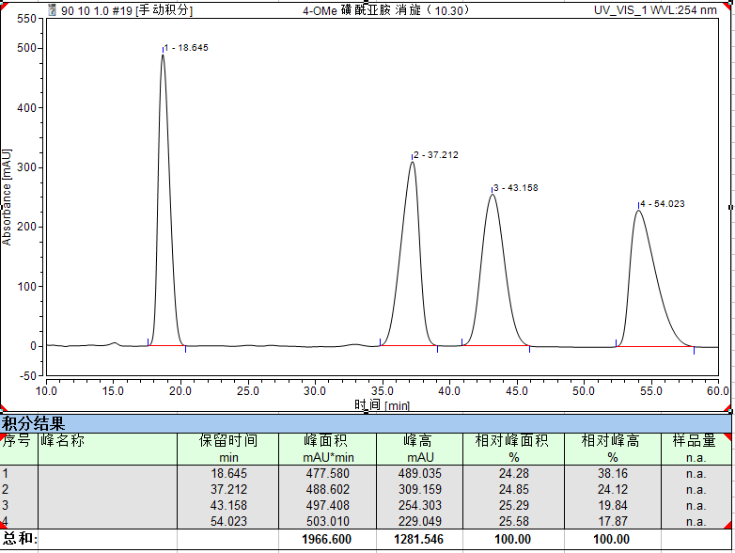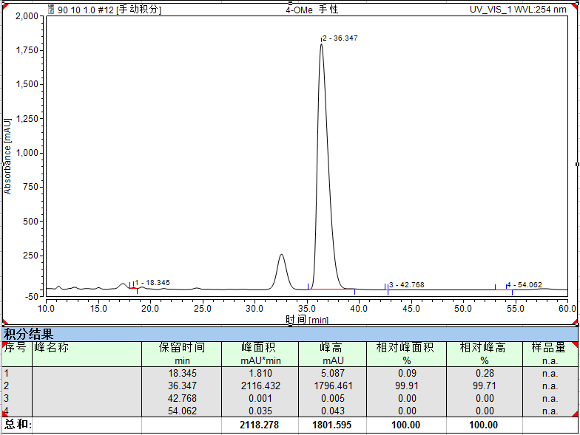
¹HNMR (400 MHz, CDCl3): 7.40 – 7.38 (m, 1H), 7.33-7.28 (m, 2H), 7.17 – 7.12 (m, 2H), 7.06 (t, J = 1.6 Hz, 1H), 6.30 (s, 1H), 5.07 (dd, J=8.0,5.6Hz, 1H), 4.81 (dd, J = 6.0,4.0 Hz, 1H), 2.55-2.47 (m, 1H), 2.41 (m, 1H), 2.15 (s, 1H).
Compound was debenzylated to determine the enantiopurity by HPLC analysis: The enantiomeric excess, ee=99%, dr=96:4, was determined by HPLC analysis: Chiralpak AD-H column, n-hexane/2-propanol = 94:6, flow rate = 0.8 mL/min, 254 nm UV detector, 25 ℃.

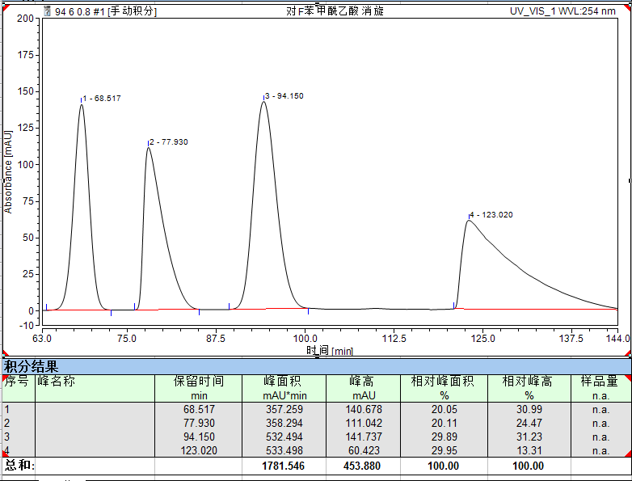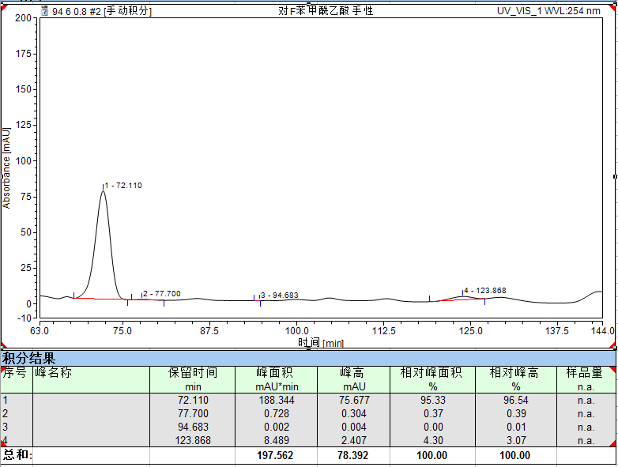
¹HNMR (400 MHz, CDCl3): 7.40 – 7.37 (m, 5H), 7.32 (d, J = 2.0 Hz, 2H), 6.57(d, J=4.4Hz, 1H), 5.06 (dd, J = 8.0,4.8 Hz, 1H), 4.12 (dd, J = 14.0,7.2 Hz, 1H), 2.47 (q, J = 2.0 Hz, 1H), 2.44 (d, J = 4.0 Hz, 1H).
Compound was debenzylated to determine the enantiopurity by HPLC analysis: The enantiomeric excess, ee=98%, dr=96:4, was determined by HPLC analysis: Chiralpak AD-H column, n-hexane/2-propanol=94/6, flow rate = 0.8 mL/min, 254 nm UV detector, 25 ℃.
