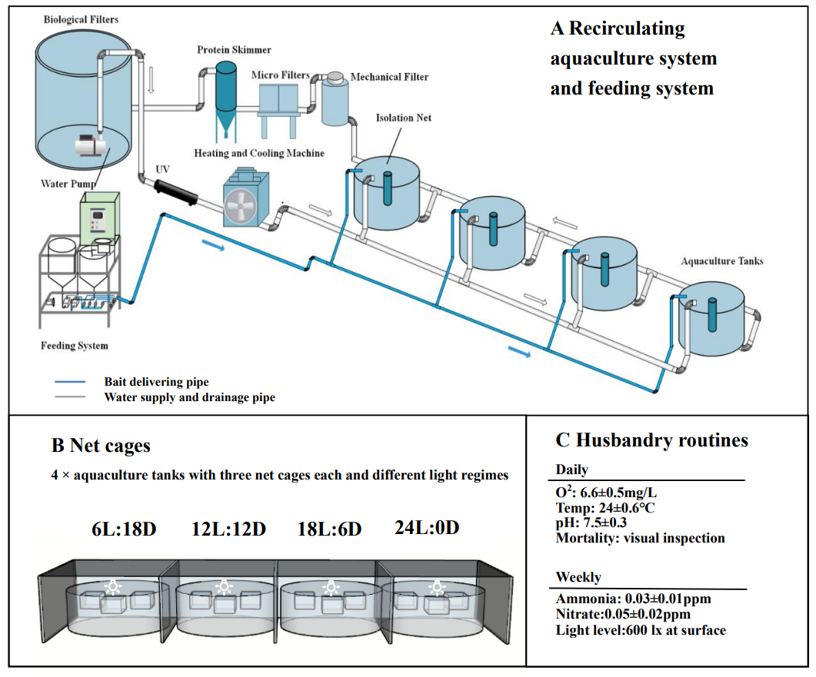
Supplementary Fig. 1 The aquaculture systems, design of experiment and relevant parameters.
A: Recirculating aquaculture system (RAS) and automatic feeding system. The aquaculture wastewater was respectively filtered by mechanical filter and micro-filters firstly, the protein in wastewater was separated by protein skimmer secondly, and then it was stored in biological filters for biological action; the aquaculture water was treated by UV lamp and heating and cooling machine for sterilization and temperature control, and then it was transported to each tank. The diets were distributed to different tanks by the automatic feeding system through plastic pipes.
B: Experimental design. The 4 photoperiod treatments of 6 light/18 dark, 12 light/12 dark, 18 light/6 dark and 24 light/0 dark were paired with the 4 tanks respectively. And there were 3 net cages (length × width × height = 40 cm × 40 cm × 40 cm) in each tank, representing 3 replicates in each treatment. Light regions were separated by light blocking shields.
C：Husbandry routines. The water quality index and light intensity were outlined daily and weekly over the duration of experiment in RAS, and the values were displayed with mean ± SD.
A
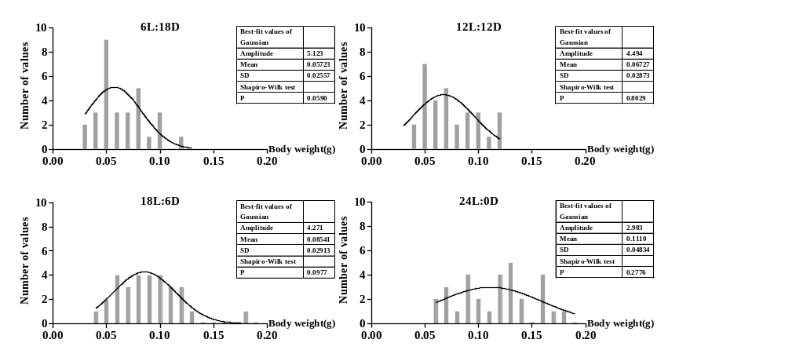
B
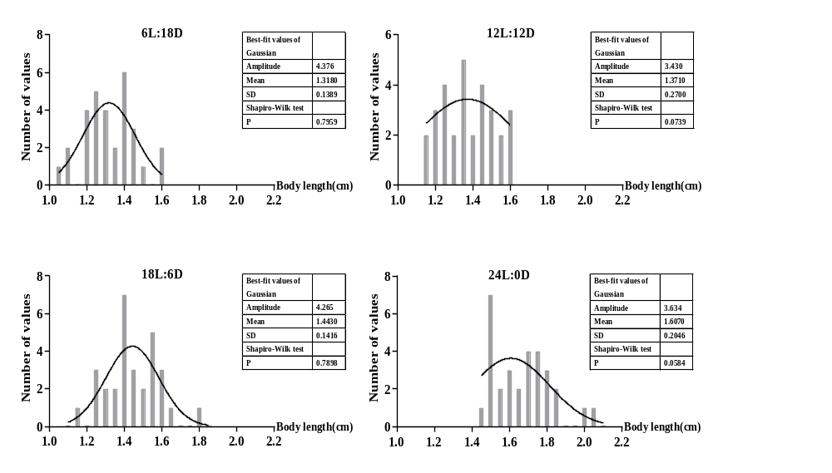

Supplementary Fig. 2 The shapiro-wilk normality tests of the final body weight (A) and final body length (B) for largemouth bass larvae (n = 30) The data was all normally distributed for the four treatments (P > 0.05).

