  - Supplementary materials

Table 1. The summary of the human-derived iPSC lines used in this study.
Represent symbol | Line | Donor’s sex | Donor’s  age at biopsy | APOE genotype | Health status | Reference
 | E3/3_1 | M | 67 | ε3/ ε3 | Healthy | [1]
 | E3/3_2 | M | 64 | ε3/ ε3 | Healthy | [2]
 | E3/3_3  E3/3_4  E3/3_5 | M  M  M | 63  66  80 | ε3/ ε3  ε3/ ε3  ε3/ ε3 | Healthy  Healthy  Isogenic of E4/4_5 | [2]  [1]  [3]
 | E3/3_6  E3/3_7 | M  F | 80  77 | ε3/ ε3  ε3/ ε3 | Isogenic of E4/4_5,  PLCG2 P522R  Healthy | [4]  [5]
 | E3/3_8 | F | 77 | ε3/ ε3 | Healthy | [5]
 | E4/4_1 | M | 58 | ε4/ ε4 | Healthy | [1]
 | E4/4_2  E4/4_3  E4/4_4 | M  M  M | 61  63  68 | ε4/ ε4  ε4/ ε4  ε4/ ε4 | Healthy  Healthy  NPH/AD* | Sup. Fig.1  Sup. Fig.1  Sup. Fig.1
 | E4/4_5  E4/4_6 | M  M | 80  80 | ε4/ ε4  ε4/ ε4 | AD*  Isogenic of E4/4_5,  PLCG2 P522R | [3, 4]  [4]
*NPH, Normal pressure hydrocephalus; AD, Alzheimer’s disease

  - Immunocytochemistry
The astrocytes used for immunocytochemistry were differentiated according to a protocol by Oksanen et al 2017 [5]. The cells were fixed with 4% paraformaldehyde in phosphate-buffered saline (PBS) at room temperature (RT) for 20 min. The cells were permeabilized with 0.2% Triton X-100 in PBS at RT for 10 min. The unspecific binding sites were blocked with 1% bovine serum albumin in 0.05 % Tween-20 in PBS at RT for 1h. For Ki67 staining, the iMGs were permeabilized and unspecific binding sites blocked with 0.3% Triton X-100 in 5% normal goat serum (NGS) in PBS at RT for 1h. For Tra1-81 and SSEA4 staining, the cells were not permeabilized. The primary and secondary antibodies and dilutions used are shown in Table 2. CD18 primary antibody was a generous gift from Prof. C. G. Gahmberg, University of Helsinki. Nuclei were visualized by DAPI staining (Sigma) at RT. The coverslips were mounted with Fluoromount, and images were acquired with a Zeiss AxioImager M1 epifluorescence microscope or EVOS M5000 (Invitrogen by Thermo Fisher Scientific) at 10x magnification. The percentage of Ki67 positive nuclei were quantified with ImageJ Software.

Table 2. Primary and secondary antibodies used in immunohistochemistry and immunocytochemistry.
Primary antibody | Host | Specificity | Supplier | Catalog # | Application | Dilution | RRID
Iba1 | goat | human | Novus | NB100-1028 | ICC | 1:200 | AB_521594
CX3CR1 | rabbit | human | Thermo Fisher | PA5-19910 | ICC | 1:100 | AB_11154568
TREM2 | goat | human | R&D Systems | AF1828 | ICC | 1:40 | AB_2208689
P2RY12 | rabbit | human | Sigma | HPA014518 | IHC | 1:2000 | AB_2669027
Iba1 | rabbit | human, mouse | Wako | 019-19741 | IHC | 1:300 | AB_839504
Ki67 | rat | mouse, non-human primate, rat, cynomolgus monkey, human, dog | eBioscience | 14-5698-82 | ICC | 1:200 | AB_10854564
LGALS1 | rabbit | human | Abcam | ab25138 | ICC, IHC | 1:1000 | AB_2136615
HuNu | mouse | human | Merck Millipore | MAB4383 | IHC | 1:500 | AB_827439
Phospho-NF-κB p65 (Ser536) | rabbit | human, mouse, rat, hamster, monkey, pig | Cell Signalling | 3033 | WB | 1:1000 | AB_331284
Total- NF-κB p65 (D14E12) XP | rabbit | human, mouse, rat, hamster, monkey, dog | Cell Signalling | 8242 | WB | 1:1000 | AB_10859369
Phospho-S6 Ribosomal protein (Ser235/236) | rabbit | human, mouse, rat | Cell Signalling | 4857 | WB | 1:1000 | AB_2181035
LC3 A/B | rabbit | human, mouse, rat | Cell Signalling | 4108 | WB | 1:1000 | AB_2137703
GLUL | rabbit | human, mouse | Abcam | ab197024 | WB | 1:5000
LAMP2 | rabbit | human, mouse, rat | Sigma-Aldrich | L0668 | WB | 1:1000 | AB_477154
SQSTM1/p62 | mouse | human | Abcam | ab56416 | WB | 1:1000 | AB_945626
OCT4 | mouse | human | Merck Millipore | MAB4401 | ICC | 1:400
NANOG | goat | human | R&D Systems | AF1997 | ICC | 1:100 | AB_355097
TRA1–81 | mouse | human | Merck Millipore | MAB4381 | ICC | 1:200 | AB_177638
SSEA4 | mouse | human | Merck Millipore | MAB4304 | ICC | 1:400 | AB_177629
β-actin | mouse | human, mouse, rat, pig, bovine, canine, feline, rabbit, carp, guinea pig, chicken, sheep | Sigma-Aldrich | A5441 | WB | 1:10000 | AB_476744
GAPDH | rabbit | human, mouse, rat | Cell Signalling | 2118 | WB | 1:1000 | AB_561053
Secondary antibodies
Alexa Fluor 488 | chicken | goat | Thermo  Fisher | A21467 | ICC | 1:300 | AB_2535870
Alexa Fluor 488 | goat | mouse | Thermo Fisher | A11001 | ICC | 1:300 | AB_2534069
Alexa Fluor 568 | goat | rabbit | Thermo Fisher | A11011 | ICC | 1:300 | AB_143157
Alexa Fluor 488 | goat | rabbit | Thermo Fisher | A11008 | IHC | 1:300  1:500 | AB_143165
Alexa Fluor 568 | goat | rat | Thermo Fisher | A11077 | ICC | 1:300 | AB_2534121
Alexa Fluor 568 | goat | mouse | Thermo Fisher | A11004 | IHC | 1:300 | AB_2534072
anti-mouse HRP | rabbit | mouse | Sigma-Aldrich | A9044 | WB | 1:20000 | AB_258431
anti-rabbit HRP | goat | rabbit | Invitrogen | A16096 | WB | 1:20000 | AB_2534770

  - Phagocytosis assays
For pHrodo zymosan phagocytosis assays, the cells were plated at a density of 20,000 cells per well into a black-walled 96-well imaging plate in 90 μl iMG medium containing the maturation factors CD200 and CX3CL1 three days before performing the assay. A day before the assay, 50 μl of fresh maturation iMG medium was added per well. On the day of the phagocytosis assay 40 μl of the medium was removed to keep the total volume at 100 μl. pHrodoTM zymosan BioParticlesTM were freshly dissolved in PBS, sonicated according to the manufacturer’s instructions, and added on top of cells at a final concentration of 83.3 μg/ml. The phagocytosis assay was performed using the IncuCyte S3 live cell imaging system (Sartorius) at the Biomedicum Stem Cell Center core facility, University of Helsinki. The cells were imaged every 30 minutes for 6.5 h and the integrated intensity of the fluorescence signal was normalized to cell confluence assessed by IncuCyte S3 before adding the pHrodo zymosan BioParticles.
To investigate fibrillar Aβ42 uptake by microglia, cells were re-plated at 222,000 cells per well in 1 ml iMG medium on a Matrigel-coated 12-well plate. Maturation factors were added to the medium at 4 days prior to the assay. Human beta-amyloid (1-42) HiLyteTM Fluor 488-labeled (AnaSpec) was reconstituted in PBS at 0.1 mg/ml and fibrillized for five days at + 37 °C in a glass vial. On the day of the assay, Aβ42 HiLyteTM Fluor 488-labeled fibrils were sonicated and incubated for 2 h on top of cells at the final concentration of 5 μg/ml at 37 °C. Then the cells were washed with ice-cold PBS and harvested by scraping and centrifuging at 300 G 5 min +4 °C. The cells were stained for 45 min with anti-CD11b APC-conjugated antibody (Biolegend) in 1% BSA. The unspecific binding was blocked by the human Fc receptor binding inhibitor (Thermo Fisher Scientific). The cells were analyzed using BD Accuri C6 flow cytometer with BD CSampler Plus software (BD Biosciences, Franklin Lakes, NJ, USA) at the Biomedicum Flow Cytometry Core Facility, University of Helsinki. Untreated cells served as the negative control.

Table 3. Primers used in RT-qPCR.
Primers | Producer | Catalog number
P2RY12 | Thermo Fisher Scientific | Hs00375457_m1
TREM2 | Thermo Fisher Scientific | Hs00219132_m1
APOE | Thermo Fisher Scientific | Hs00171168_m1
MSR1 | Thermo Fisher Scientific | Hs00234007_m1
TLR2 | Thermo Fisher Scientific | Hs00152932_m1
TLR4 | Thermo Fisher Scientific | Hs00152939_m1
CLEC7A | Thermo Fisher Scientific | Hs00224028_m1
MARCO | Thermo Fisher Scientific | Hs00198937_m1
CTSD | Thermo Fisher Scientific | Hs00157205_m1
CTSB | Thermo Fisher Scientific | Hs00947439_m1
MAP1LC3B | Thermo Fisher Scientific | Hs00917683_m1
FABP3 | Thermo Fisher Scientific | Hs07287863_m1
LPL | Thermo Fisher Scientific | Hs00173425_m1
AGPAT4 | Thermo Fisher Scientific | Hs0108853_m1
FAR1 | Thermo Fisher Scientific | Hs00386153_m1
PDK4 | Thermo Fisher Scientific | Hs01037712_m1
GCLC | Thermo Fisher Scientific | Hs00155249_m1
IL1B | Thermo Fisher Scientific | Hs01555410_m1
SLC1A5 | Thermo Fisher Scientific | Hs01056542_m1
SLC7A5 | Thermo Fisher Scientific | Hs01001189_m1
GAPDH | Thermo Fisher Scientific | Hs99999905_m1
ACTB | Applied Biosystems | 4326315E

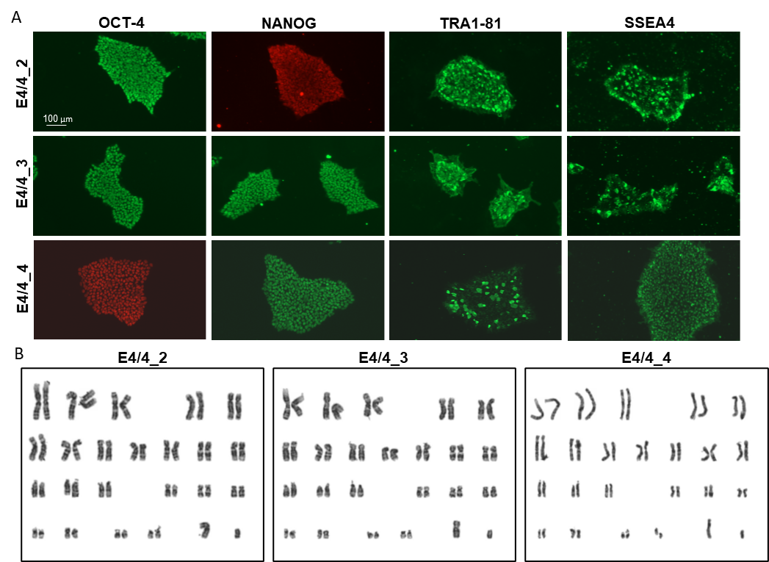
Supplementary Figure 1. Characterization of previously unpublished iPSC lines. Immunocytochemistry images of the expression of pluripotency markers octamer-binding transcription factor 46 (OCT4), NANOG, TRA1-81 and stage-specific embryonic antigen 4 (SSEA-4) in E4/4_2, E4/4_3 and E4/4_4 iPSC colonies. Scale bar 100 μm. B, karyograms of E4/4_2, E4/4_3, E4/4_4, E3/3_2_TdTomato and E4/4_4_TdTomato iPSC lines showing normal 46 XY karyotypes. The cells were karyotyped by Ambar Lab, Barcelona, Spain.
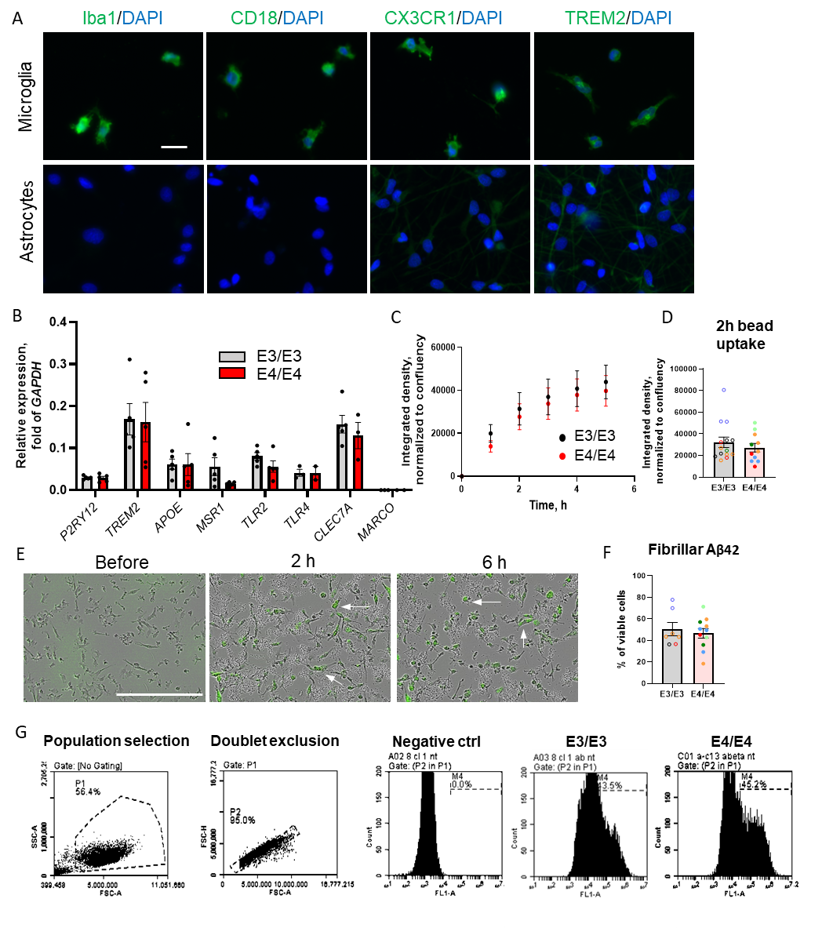Supplementary Figure 2. Characterization of E3/E3 and E4/E4 iMGs. A, iMGs are immunoreactive for Iba1, CD18, CX3CR1 and TREM2. iPSC-derived astrocytes are used as a negative control. Scale bar 50 μm. B, both E3/3 and E4/4 iMGs express microglia-associated genes and there are no significant differences between the genotypes. Dots represent the averages of individual iPSC lines. C, the uptake of pHrodo-conjugated zymosan-coated beads assessed using Incucyte S3. N = 5 iPSC lines per genotype. E, representative images of iMGs phagocytosing pHrodo-conjugated beads. The cells that have internalized beads look green (arrows). Scale bar 300 μm. D, F, the quantification of pHrodo-conjugated bead (F) and fibrillar Aβ42 (G) uptake at 2h. The data from different differentiation batches are shown as individual dots. Same color dots are derived from the same iPSC line (Table 1). G, the flow cytometry gating strategy for the quantification of fibrillar Aβ42 uptake, HiLyteTM Fluor 488-labeled Aβ42 fibrils taken up by iMGs emitted fluorescence in FL1-A channel. FSC-A, forward scatter area; SSC-A, side scatter area; FSC-H, forward scatter height.
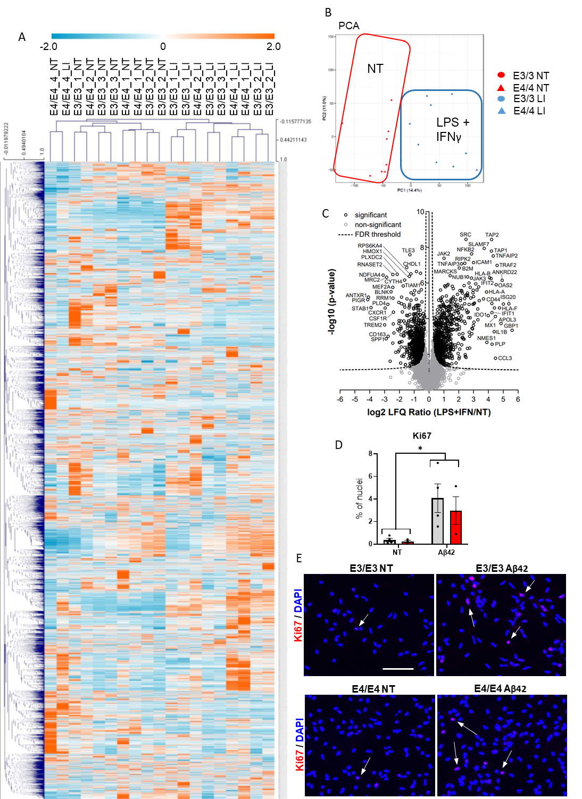Supplementary Figure 3. Metabolism and proliferation rate in iMGs. A, Heat map of the normalized signal abundances of the detected molecular features with signal-to-noise ratio > 5 (n = 16 318) in each studied sample. A hierarchical clustering was applied to arrange the metabolites, and the samples based on their similarity of the abundance between the samples. The color represents the z-score of the abundance, i.e. the number of standard deviations above (positive value, red color) or below (negative value, blue color) the mean abundance of that molecular feature in all samples. NT, no treatment (basal conditions); LI, LPS + IFNγ treatment. B, Principal component analysis (PCA) of the metabolite profiles of each sample based on all detected molecular features (n = 26 881). Component 1 (x axis) explains 14.4% of the variation between the samples and component 2 (y axis) explains 11.0% of the between-samples variation. C, Volcano plot of comparing LPS and IFN treated cells with non-treated cells (n=5). The minus log10 transformed p-values are plotted against the log2 transformed fold changes for each protein. The threshold of a permutation-based FDR correction for multiple hypotheses is indicated as dashed lines. Proteins with a significant change are indicated as black circles whereas non-significantly altered proteins are indicated as gray circles. Selected proteins are labeled with their UniProt gene names. D, percentages of Ki67+ nuclei in iMGs treated for 48h with Aβ42 or left untreated (NT). Dots represent individual iPSC lines. Data in the graphs are shown as mean ± SEM. P value is derived from two-way repeated measures ANOVA. *, p < 0.05. E, representative images of Ki67+ nuclei (arrows). Scale bar 100 μm.

References
1. Kettunen, P., et al., SARS-CoV-2 Infection of Human Neurons Is TMPRSS2 Independent, Requires Endosomal Cell Entry, and Can Be Blocked by Inhibitors of Host Phosphoinositol-5 Kinase. J Virol, 2023. 97(4): p. e0014423.
2. Jantti, H., et al., Microglial amyloid beta clearance is driven by PIEZO1 channels. J Neuroinflammation, 2022. 19(1): p. 147.
3. Schmid, B., et al., Generation of a set of isogenic iPSC lines carrying all APOE genetic variants (E2/E3/E4) and knock-out for the study of APOE biology in health and disease. Stem Cell Res, 2021. 52: p. 102180.
4. Takalo, M., et al., The protective PLCgamma2-P522R variant mitigates Alzheimer's disease-associated pathologies by enhancing beneficial microglial functions. J Neuroinflammation, 2025. 22(1): p. 64.
5. Wu, Y.C., et al., Human iPSC-derived pericyte-like cells carrying APP Swedish mutation overproduce beta-amyloid and induce cerebral amyloid angiopathy-like changes. Fluids Barriers CNS, 2024. 21(1): p. 78.

