Supplementary material for the paper: Liberal or restrictive transfusion for veno-arterial Extracorporeal Membrane Oxygenation patients: a target trial emulation using the OBLEX study data, Thao et. al, 2025

Definition of confounders
Variable | Type | Definition | Confounder type
Age | Continuous | Age (years) at hospital admission | Time-fixed
Gender | Binary | Gender (male/female) at hospital admission | Time-fixed
Diagnosis group | Categorical | Diagnosis at hospital admission. Underlying conditions include:  - Acute myocardial infarction (AMI)  - Chronic cardiomyopathy  - Pulmonary embolism  - Myocarditis  - Other acute cardiomyopathy such as: Acute decompensated heart failure not covered above, septic shock with myocardial depression, primary arrhythmia (Channelopathy) and toxic | Time-fixed
Renal replacement prior to ECMO | Binary | Renal replacement 24 hour prior to ECMO | Time-fixed
Extracorporeal cardiopulmonary resuscitation  (ECPR) | Binary | Extracorporeal cardiopulmonary resuscitation 24 hour prior to ECMO | Time-fixed
Surgery | Binary | Any surgery prior to ECMO | Time-fixed
Renal replacement during ECMO | Binary | Renal replacement during ECMO | Time-varying
Severe bleeding | Binary | Severe bleeding during ECMO. Severe bleeding is defined as Bleeding academic research consortium (BARC) score >3 | Time-varying
Any mechanical support | Binary | Mechanical support during ECMO. Types of mechanical support includes:  - intra-aortic balloon pump (IABP)  - right ventricular assist device (RVAD),  - left ventricular assist device (LVAD),  - total artificial heart,  - impella device,  - tandem heart, and  - other mechanical circulatory support | Time-varying

Calculation of weights(1)
For individual i, let $L_{b,i}$ denote the set of time-fixed confounders, and $L_{k,i}$denote the set of time-varying confounders recorded at time k with ${\overline{L}}_{k,i}$ denote the history of time-varying confounders prior to time k. From the assumed DAG (Figure S1), we have:
$$L_{b,i}= \{age_{i}, gender_{i}, diagnosis group_{i},$$
$$renal replacement prior to ECMO_{i}, ECPR_{i}, Surgery_{i}\}$$
$$L_{k,i}= \{severe bleeding_{k,i}, renal replacement_{k,i}, mechanical support_{k,i}\}$$
Denote ${\overline{A}}_{(k, j-1)}=\left\{A_{k}, A_{k+1},…, A_{j-1}\right\}$ the treatment status from time $k$to time $j-1$.
For individuals in the trial starting at time k, but do not initiate treatment at that time, the stabilized inverse probability of artificial-censoring weights (IPACW) at time t – k from the start of the trial is:
$$SW_{i,k}^{0}\left(t-k\right)=\prod_{j=k+1}^{k+t}{\frac{Pr⁡(A_{j}=0|{\overline{L}}_{k,i}, L_{b,i}, {\overline{A}}_{(k,j-1),i}=0, T≥k )}{Pr⁡(A_{j}=0|{\overline{L}}_{j,i} ,{\overline{A}}_{(k,j-1),i}=0, T≥k)}}$$
For individuals in the trial starting at time k, and initiate treatment at that time, the stabilized weights at time t – k from the start of the trial is:
$$SW_{i,k}^{1}\left(t-k\right)=\prod_{j=k+1}^{k+t}{\frac{Pr⁡(A_{j}=1|{\overline{L}}_{k,i}, L_{b,i}, {\overline{A}}_{k-1,i}=0, {\overline{A}}_{(k, j-1),i}=1, T≥k )}{Pr⁡(A_{j}=1|{\overline{L}}_{j,i} ,{\overline{A}}_{k-1,i}=0, {\overline{A}}_{(k, j-1),i}=1, T≥k)}}$$
We used logistic regression models to estimate the denominator and numerate of the weights, fitted to the combined data across 7 trials.
Reference:
1. Keogh RH, Gran JM, Seaman SR, Davies G, Vansteelandt S. Causal inference in survival analysis using longitudinal observational data: Sequential trials and marginal structural models. Stat Med. 2023 Jun 15;42(13):2191–225.

Supplementary tables and figures

Table S1: Number of patients received transfusion over 7 days of ECMO
Characteristic | Day 1, N = 534¹ | Day 2, N = 495¹ | Day 3, N = 475¹ | Day 4, N = 417¹ | Day 5, N = 342¹ | Day 6, N = 267¹ | Day 7, N = 215¹
Number of patients with at least 1 transfusion | 291 (54%) | 148 (30%) | 197 (41%) | 166 (40%) | 129 (38%) | 107 (40%) | 90 (42%)
Number of patients with
1 transfusion episode | 115 (22%) | 89 (18%) | 136 (29%) | 118 (28%) | 96 (28%) | 77 (29%) | 61 (28%)
2 transfusion episodes | 74 (14%) | 33 (6.7%) | 44 (9.3%) | 34 (8.2%) | 25 (7.4%) | 19 (7.1%) | 20 (9.3%)
3+ transfusion episodes | 105 (20%) | 27 (5.5%) | 19 (4.0%) | 15 (3.6%) | 9 (2.6%) | 11 (4.1%) | 9 (4.2%)
¹ n (%)

Table S2: Number of events by treatment arm in the 7 sequential trials
Characteristic | N | Overall¹ | Restrictive¹ | Liberal¹ | Intermediate¹ | No transfustions¹
Trial 1 | 534 | 117/534 (22%) | 16/48 (33%) | 10/51 (20%) | 69/192 (36%) | 22/243 (9.1%)
Trial 2 | 233 | 38/233 (16%) | 2/9 (22%) | 1/8 (13%) | 22/52 (42%) | 13/164 (7.9%)
Trial 3 | 160 | 32/160 (20%) | 2/8 (25%) | 2/7 (29%) | 15/46 (33%) | 13/99 (13%)
Trial 4 | 89 | 13/89 (15%) | 0/3 (0%) | 1/3 (33%) | 3/15 (20%) | 9/68 (13%)
Trial 5 | 54 | 8/54 (15%) | 0/2 (0%) | 0/2 (0%) | 2/10 (20%) | 6/40 (15%)
Trial 6 | 26 | 6/26 (23%) | 0/0 | 0/0 | 3/10 (30%) | 3/16 (19%)
Trial 7 | 13 | 3/13 (23%) | 0/0 | 0/0 | 2/4 (50%) | 1/9 (11%)
Total | 1,109 | 217/1,109 (20%) | 20/70 (29%) | 14/71 (20%) | 116/329 (35%) | 67/639 (10%)
¹ n/N (%)

Figure S1: Directed acyclic graph (DAG) depicting the assumed confounding path of treatment-outcome association. A simplified version for two time points.
Death
Age
gender
diagnostic group
prior renal replacement
ECPR
Surgical
Y2
X
A2
A1
L2
L1
Y1
Sever bleeding
any mechanical support
renal replacement
Transfusion

X: baseline confounders
{L1, L2}: time varying confounder at time 1 and 2, respectively,
{A1, A1}: Transfusion strategy at time 1 and 2,respectively
{Y1, Y2}: Outcome (in hospital death) at 1 and 2 respectively

Figure S2: Study design: illustration of 3 sequential trials

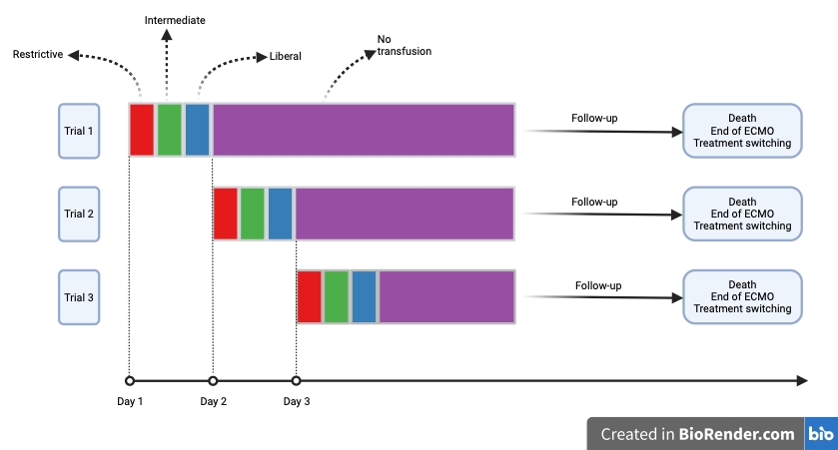

Figure S3: Transfusion pattern in the 7 sequential trials
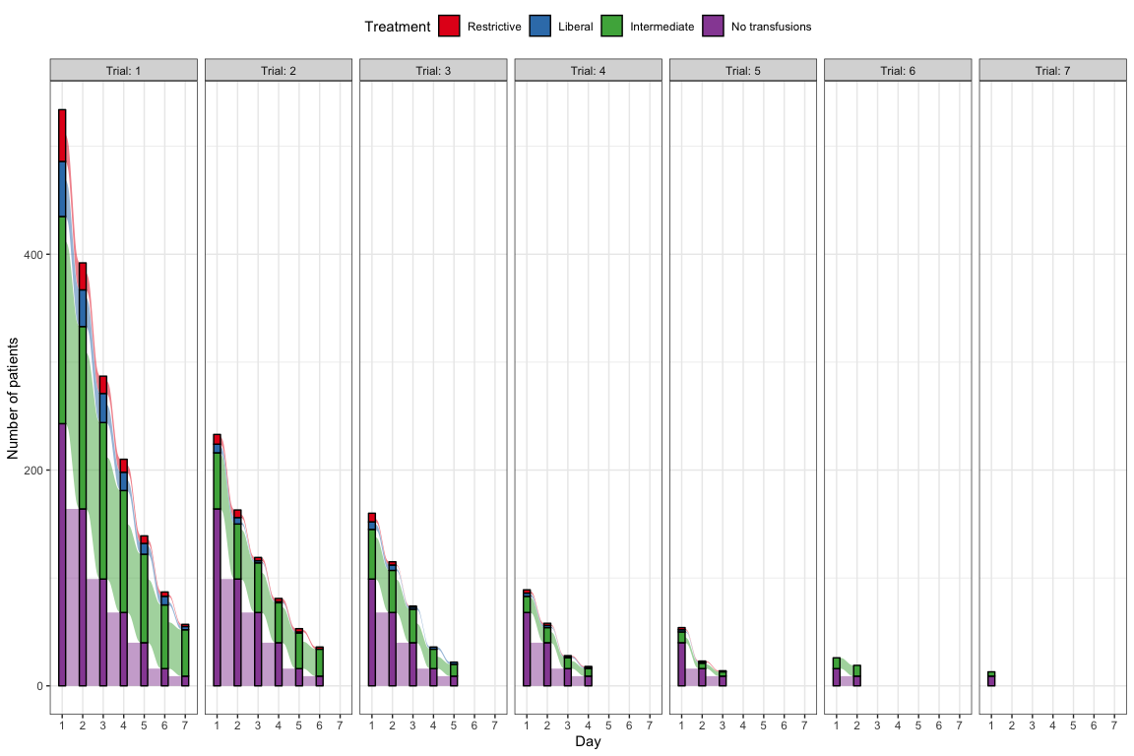

Figure S4: Distribution of the stabilised inverse probability weights for artificial censoring. A) original weights; B) truncated weights at 95th percentiles
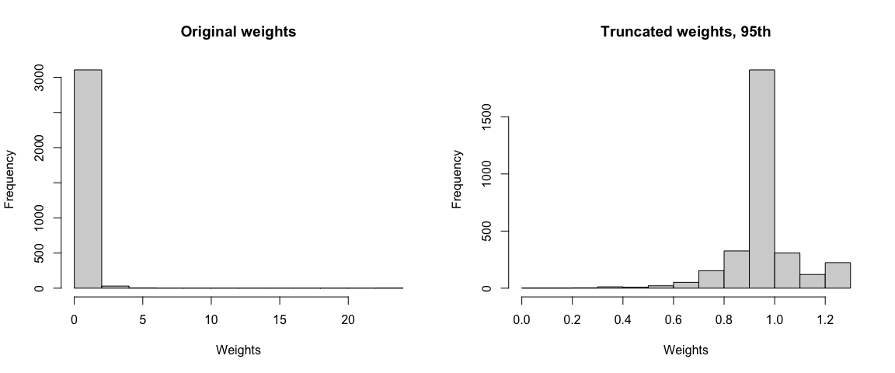
B)
A)

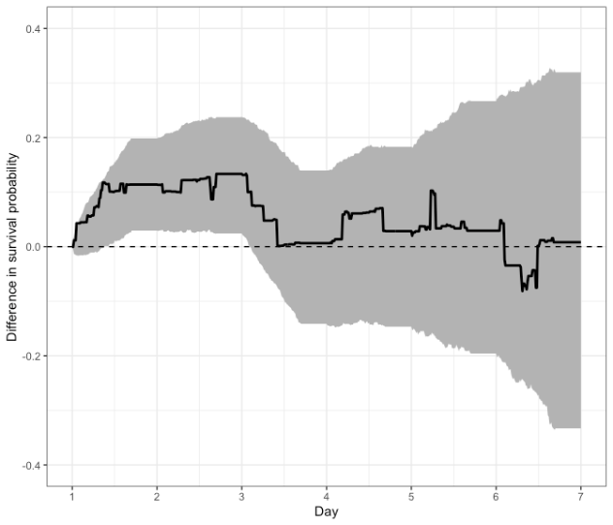
Figure S5: Estimated survival difference between the liberal and restrictive transfusion strategies A) with truncated weights; B) with massive transfusion prior to ECMO included as a confounder; C) restricted to patients with consistent treatment strategy. The shaded areas show the 95% confidence intervals.
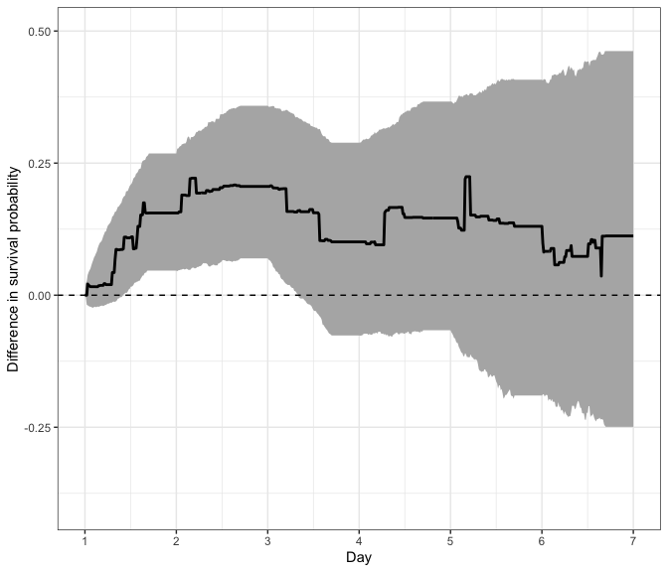
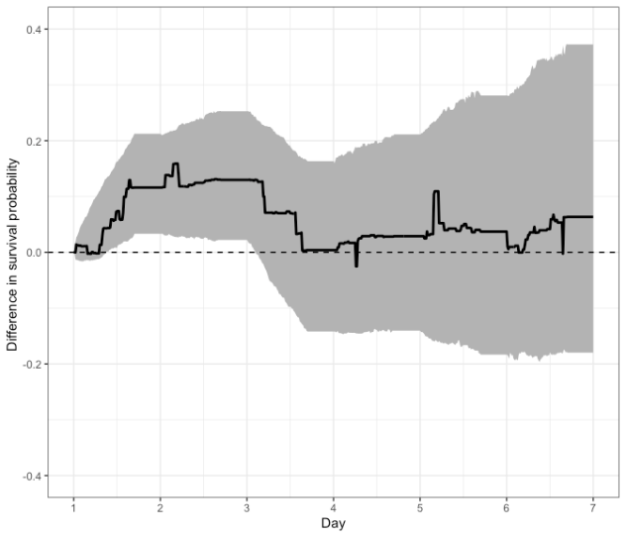
C)
B)
A)

