Assembly, annotation and analysis of the complete mitochondrial genome of Ligula intestinalis (Cestoda: Diphyllobothriidea): Insights into Evolution and Phylogenetics

Aarón Mondragón-Martínez^{1,2,*}, Rosa Martínez-Rojas¹, Inés Gárate³, Jaime R. Sanchez-Venegas⁴, Gerald Moreno-Morales⁵, Lidia Cruz-Neyra⁶, Celso Luis Cruces⁶, Enrique Garcia-Candela^{7,8}, Frank Guzman Escudero⁹, Jhon D. Chero¹⁰, Jefferson Yunis-Aguinaga¹¹

Figure S1. Predicted secondary structures of L. intestinalis tRNAs lacking DHU arms. The tRNAs are labeled with the standard amino acid abbreviations and their positions in the mitochondrial genome.

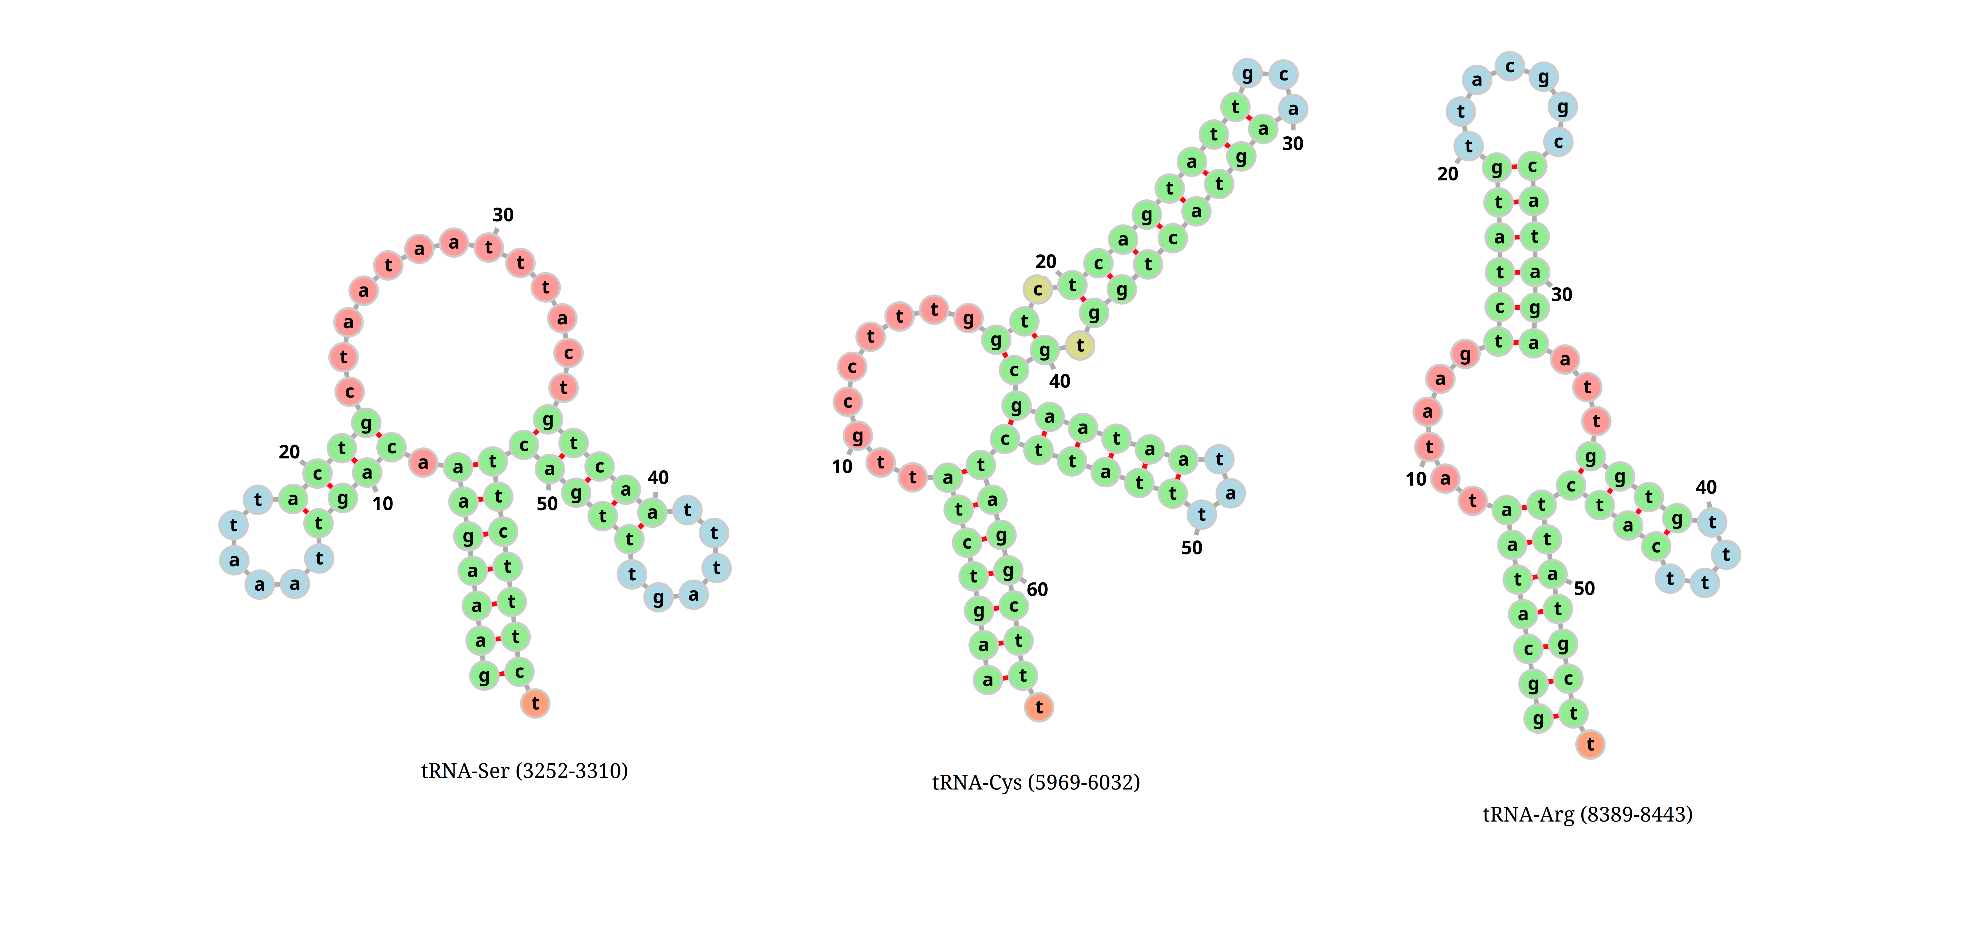

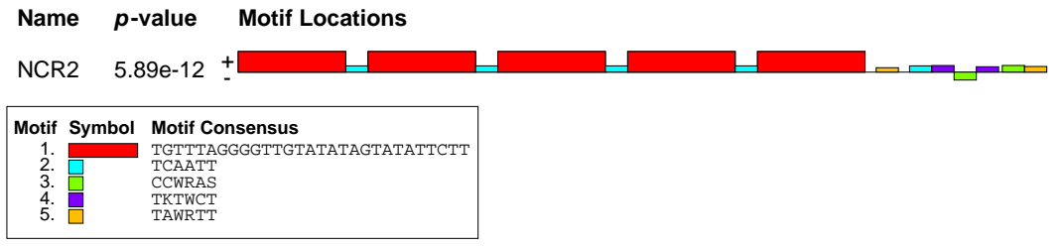
Figure S2. Motifs located in the non-coding region 2 (NCR2) of L. intestinalis. Tandem repeat motifs are represented by red and sky blue boxes, while other variable motifs are highlighted in different colors.

