Table 1 Characteristics of the sampling points
Sampling points | Photographs of the sampling points | Character analysis
S1 | 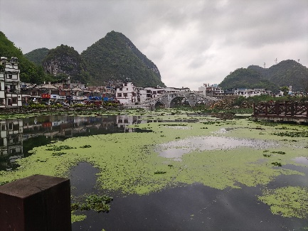 | Photographed in March 2024, located in a residential area of the town, where domestic sewage may be discharged into the river, and the water body is always turbid and emits an odour.
S2 | 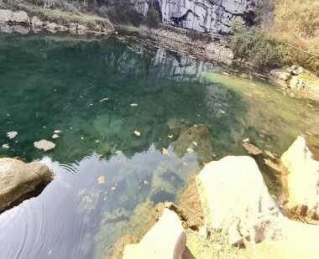 | Photographed in June 2024, located in the National Natural Water Resource Protection Zone, which is less exposed to human activities.
S3 | 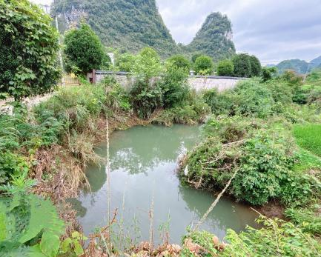 | Photographed in January 2024, located next to the town's wastewater treatment plant and is surrounded by cash crops such as rice.
S4 | 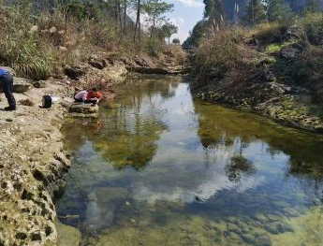 | Photographed in June 2024, located next to the road in Yaonan Village, surrounded by rice and other cash crops.
S5 | 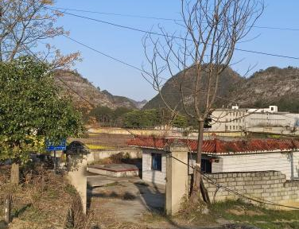 | Photographed in June 2024, this sampling points is a reservoir for groundwater extraction and storage in Huanghou Cave and is surrounded by agricultural activities.
X1 | 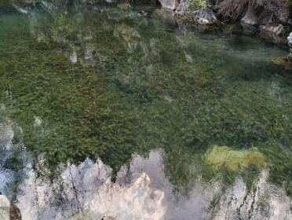 | Photographed in June 2024, located within the downstream World Heritage Site and is a groundwater outlet.
X2 | 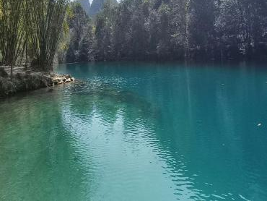 | Photographed in March 2024, located within the downstream in the World Heritage Site with better environment.
X3 | 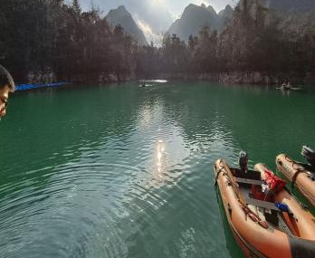 | Photographed in March 2024, located within the downstream in the World Heritage Site with better environment.
X4 | 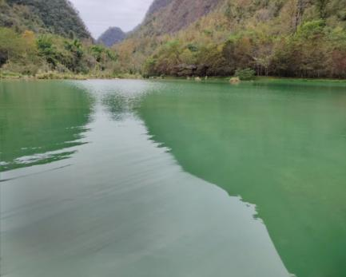 | Photographed in June 2024, located within the downstream in the World Heritage Site with better environment.
X5 | 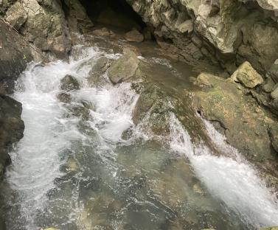 | Photographed in March 2024, located within the downstream World Heritage Site, which is a groundwater outlet and is less affected by tourists.
X6 | 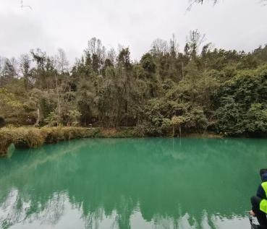 | Photographed in June 2024, located within the downstream in the World Heritage Site with better environment.

