Electronic Supplementary Information

Acidic site regulation of supported Pt-Cu alumina catalyst with bimetallic synergistic effect achieved high catalytic activity, selectivity, and stability in the dehydrogenation of perhydrodibenzyltoluene.

Qiuyue Ding,¹ Qing Li,² Huijie Wei,² Yanyan Xi,³ Songqing Hu,^{1*} Xufeng Lin^{2,4*}

¹College of Material Science and Engineering, China University of Petroleum (East China), Qingdao, P. R. China, 266580
²College of Chemistry and Chemical Engineering, China University of Petroleum (East China), Qingdao, P. R. China, 266580
³Advanced Chemical Engineering and Energy Materials Research Center, China University of Petroleum (East China), Qingdao, P. R. China, 266580
⁴State Key Laboratory of Heavy Oil Processing, China University of Petroleum (East China), Qingdao, P. R. China, 266580

*Authors to whom correspondence should be addressed.
Email: ccupc@163.com; hatrick2009@upc.edu.cn

1. Catalyst characterization for basic physiochemical properties
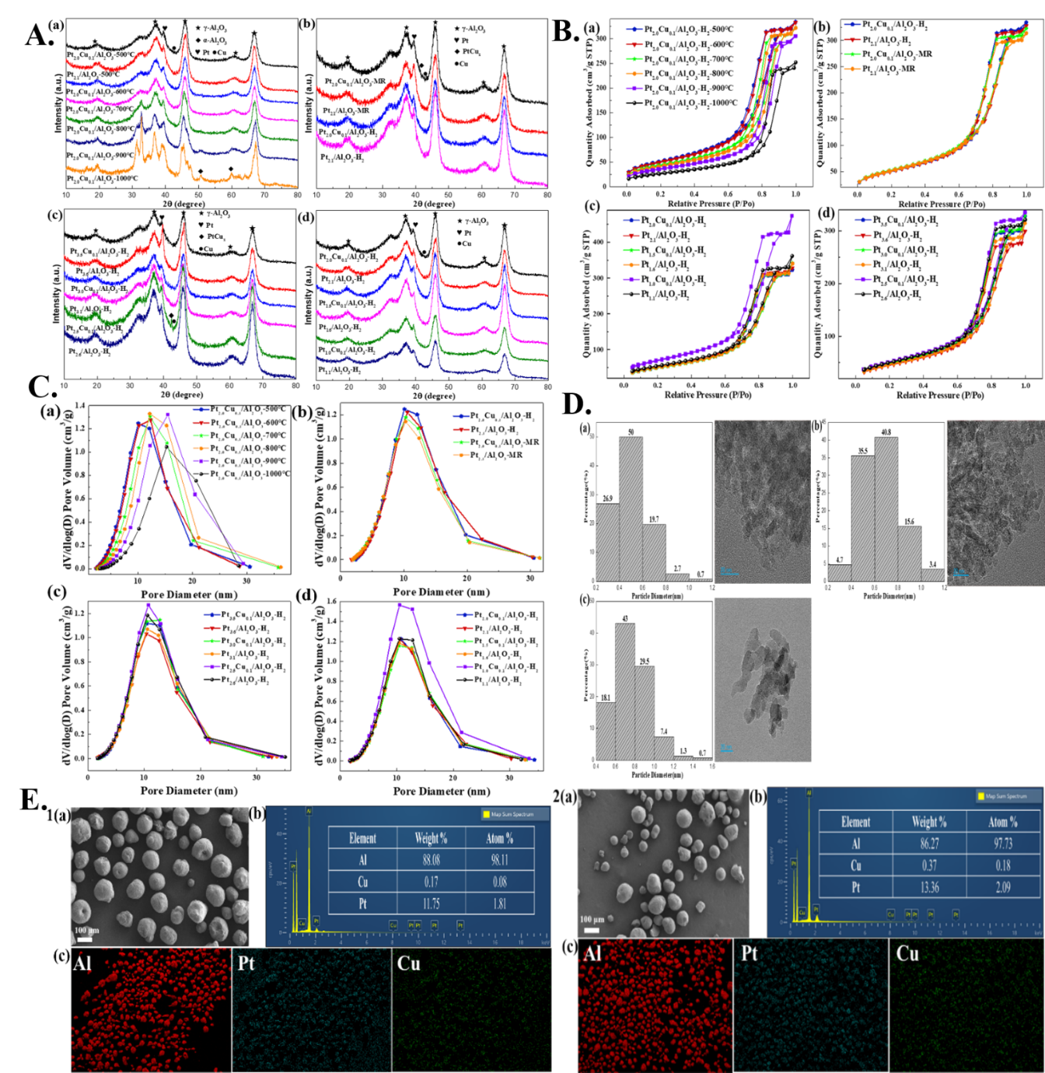
Figure S1. A) Powder XRD patterns of Pt_{2.0}Cu_{0.1}/Al₂O₃-H₂ catalysts with pre-calcination temperature of supports, other Pt-Cu and pure Cu catalysts pre-treated at 500 ℃ of supports; B) N₂ adsorption-desorption isotherms of the prepared Pt-Cu/Al₂O₃ and Pt/Al₂O₃ catalysts; C) Maximum Pore Size distribution of the prepared Pt-Cu/Al₂O₃ and Pt/Al₂O₃ catalysts; D) The particle size chart and TEM image of (a) Pt_{2.0}Cu_{0.1}/Al₂O₃-H₂-500℃, (b) Pt_{2.1}/Al₂O₃-H₂-500℃ and (c) Pt_{2.0}Cu_{0.1}/Al₂O₃-H₂-900℃; E) The SEM images and the EDX-mapping for Pt, Cu and Al elements of (1) Pt_{2.0}Cu_{0.1}/Al₂O₃-H₂-500℃ and (2) Pt_{2.0}Cu_{0.1}/Al₂O₃-H₂-900℃ catalysts.
As shown in Figure S1A, it could be perceived that under the same loading and preparation method, the XRD spectra of Pt and Pt-Cu alumina catalysts pre-calcined from 500 to 1000 ℃ on the support were similar in characteristic peaks. Especially the characteristic peak shapes of the support and Pt component were sharp, with typical characteristic peaks of γ-Al₂O₃ peaks at 2θ=18.8, 36.9, 45.9, 60.5, and 66.8° ^{[28] [1]}. As the pre-calcination temperature of the support increased, the characteristic peak signal of γ-Al₂O₃ decreased. The above phenomenon was particularly evident at 1000 ℃, with a characteristic peak of α-Al₂O₃ on the (024) plane at 2θ=52.68° ^{[29] [2]}. This indicated that pretreatment had a certain effect on the crystal phase of the support, and as the pretreatment temperature increased, the support underwent a transition from the gamma phase to the alpha phase. The characteristic diffraction peak at 2θ=39.5 °, which could be identified as the (111) plane of Pt ^{[30] [3]}, indicated good crystallinity and high dispersion in the Pt component. As the pre-calcination temperature increased, the diffraction peaks of Pt became more and more obvious, and the diffraction peak of Cu (111) surface ^{[31] [4]} at 2θ=43.3 °became less and less obvious. The above phenomenon was partly related to the low doping amount of Cu. On the other hand, as the pre-treatment temperature of the support increased, the dispersion of Pt decreased, making it easier to detect signals, while the signal of Cu component became weaker. This was also consistent with the BET plot, indicating that the modification of the support was crucial for the dispersion of the metal. And the dispersion of Pt and Cu components decreased with the increase of the pre-calcination temperature of the alumina support. Combined with Figure S1A(b)-(d), it could be seen that there was no significant formation of Pt-Cu alloy after modifying the support. This might be related to the extremely low doping amount of Cu, resulting in a very low content of Pt-Cu alloy. It also indicated that the formation of Pt-Cu alloy required harsh conditions, and a highly dispersed spatial environment was one of the important factors for its formation. Combined with XPS, it was shown that the doping of Cu had a significant impact on the electron transfer between the support and the metal, which could to some extent suppress SMSI. However, the modification of the support had little effect on the electron transfer between the support and the metal, but had a partial impact on the electron transfer between the metals. It further indicated that the important factor in the formation of Pt-Cu alloys was the electron transfer between metals.
The nitrogen adsorption desorption isotherms of Pt-Cu/Al₂O₃ and Pt/Al₂O₃ catalysts prepared at different pre-calcination temperatures were shown in Figure S1B. The nitrogen adsorption/desorption isotherms of all the catalysts mentioned above exhibit a type IV pattern. The catalysts with the calcination temperature from 500 ℃ to 900 ℃ exhibited an H2 (b) hysteresis loop in Figure S1B(a). As P/P0 increased, a saturated adsorption plateau appeared. This indicated that the catalyst was mainly a mesoporous material with uniform and relatively wide pore size distribution ^{[32-33] [5-6]}, and its pore size distribution was mostly between 10 and 16nm. The catalyst with a support calcination temperature of 1000 ℃ exhibited the hysteresis loop similar to H4, indicating the presence of a small number of micropores in the catalyst. The mesoporous characteristics of all the catalysts mentioned above were mainly due to the pore structure of the Al₂O₃ support. Besides, with the increase of support processing temperature, the specific surface area of the catalyst was gradually decreasing.
Table S1. Textural properties of the key Pt_{2.0}Cu_{0.1}/Al₂O₃ and Pt_{2.1}/Al₂O₃ catalysts prepared.
Sample | S_{BET} (m²/g) |  |  | V_{p} (cm³/g) | D_{mode} (nm)
Pt_{2.0}Cu_{0.1}/Al₂O₃-500℃ |  | 183.1 | 0.48 |  |  | 10.74
Pt_{2.1}/Al₂O₃-500℃ |  | 185.7 | 0.49 |  |  | 10.54
Pt_{2.0}Cu_{0.1}/Al₂O₃-600℃ |  | 181.1 | 0.50 |  |  | 12.33
Pt_{2.0}Cu_{0.1}/Al₂O₃-700℃ |  | 160.0 | 0.48 |  |  | 12.23
Pt_{2.0}Cu_{0.1}/Al₂O₃-800℃ |  | 149.7 | 0.48 |  |  | 12.16
Pt_{2.0}Cu_{0.1}/Al₂O₃-900℃ |  | 130.4 | 0.46 |  |  | 15.49
Pt_{2.0}Cu_{0.1}/Al₂O₃-1000℃ |  | 99.32 | 0.37 |  |  | 15.26

The pore structure datas of the prepared catalyst were listed in Table S1 and Figure S1C. Catalysts with the same loading amount prepared by pre calcination treatment of the same support at different temperatures are compared. Their specific surface area (S_{BET}) was as follows: Al₂O₃(500 ℃) > Al₂O₃(600 ℃) > Al₂O₃(700 ℃) > Al₂O₃(800 ℃) > Al₂O₃(900 ℃) > Al₂O₃(1000 ℃). The pore volume (V_{p}) was as follows: Al₂O₃(600 ℃) > Al₂O₃(500 ℃) = Al₂O₃(700 ℃) = Al₂O₃(800 ℃) > Al₂O₃(900 ℃) > Al₂O₃(1000 ℃). The most probable pore size (D_{mode}) was: Al₂O₃(900 ℃) > Al₂O₃(1000 ℃)> Al₂O₃(600 ℃) > Al₂O₃(700 ℃) > Al₂O₃(800 ℃) > Al₂O₃(500 ℃). The above trend of change roughly followed the following pattern. As the pre-calcination temperature of the support increased, especially for alumina supports from 500 ℃ to 800 ℃, some small pores collapsed, S_{BET} decreased and D_{mode} increased. And V_{p} showed a certain decreasing trend with a small or even negligible range of decrease. Generally speaking, when the temperature ranged from 600 to 800 ℃, the S_{BET} value was between 150 and 200, V_{p} value was around 0.5, and D_{mode} was around 10-13nm. When the temperature ranged from 900 ℃ to 1000 ℃, the crystal structure of the support began to transition from the γ phase to the α phase. S_{BET} value decreased to around 100 or even less than 100, D_{mode} increased to greater than 15nm, and V_{p} value slightly decreased to around 0.4. For Pt-Cu and pure Pt catalysts with the same total loading of the same support and preparation method, S_{BET} was Pt_{2.1}> Pt_{2.0}Cu_{0.1} and D_{mode} was Pt_{2.0}Cu_{0.1} > Pt_{2.1}. This might be due to the calcination fixation after Cu doping, which resulted in higher dispersion of the active component and easier occupation of some small pores. Therefore, S_{BET} decreased, D_{mode} increased, and V_{p} remained basically unchanged. Without considering the issue of catalyst deactivation, this further indicated that highly dispersed active components could enhance the catalytic activity of 18H-DBT. This was related to the fact that Cu used as a structural aid in the preparation of catalysts could alter the geometric structure and electronic properties of the active components, as evidenced by BET, TEM, and XPS analysis.
Compared with the Pt_{2.0}Cu_{0.1}/Al₂O₃-H₂-500 ℃ catalyst, the TEM image of the Pt_{2.0}Cu_{0.1}/Al₂O₃-H₂-900 ℃ catalyst clearly showed the phenomenon of partial aggregation of Pt grains on the support in Figure S1D. Therefore, its relatively larger average particle size was around 0.76nm. However, the average particle size of Pt_{2.0}Cu_{0.1}/Al₂O₃-500 ℃ was around 0.49nm, which was related to the structure of the support itself. And the specific surface area of the support under high-temperature calcination was greatly reduced (combined with BET). The average particle size of the Pt_{2.1}/Al₂O₃-H₂-500 ℃ catalyst was around 0.65nm, which was smaller than the average particle size of the Pt_{2.0}Cu_{0.1}/Al₂O₃-H₂-500 ℃ catalyst. The doping of Cu additive had a certain spatial dispersion effect on the high-temperature aggregation of Pt, and then the calcination and fixation of Pt and Cu components further formed spatial anchoring limitations. Therefore, Pt particles still had a relatively high dispersion and formed corresponding Pt NPs under high-temperature reduction. The spatial confinement structure also leaded to certain electron transfer between Pt and Cu, thus exhibiting excellent bimetallic synergistic dehydrogenation performance for 18H-DBT, as confirmed by XPS. In addition, the high-temperature pretreatment of the support reduced the dispersion of Pt-Cu and slightly increased the metal particle size. However, the change in acidic environment enhanced the interaction between Pt and Cu, which was beneficial for preventing excessive reaction.
Figure S1E showed that both Pt_{2.0}Cu_{0.1}/Al₂O₃-H₂-500 ℃ and Pt_{2.0}Cu_{0.1}/Al₂O₃-H₂-900 ℃ catalysts exhibited a typical spherical morphology of Al₂O₃. This indicated that the pre-calcination of the support and the introduction of Pt and Cu components did not significantly change the morphology and structure of the alumina during the reduction process of catalyst preparation. Compared with the Pt_{2.0}Cu_{0.1}/Al₂O₃-H₂-500℃ catalyst, the Pt_{2.0}Cu_{0.1}/Al₂O₃-H₂-900℃ catalyst had greater morphological differences and higher actual loading of Pt. This indicated that during the high-temperature calcination process of the support, some small pores partially collapsed and the pore structure was relatively unstable, with little reduction in specific surface area. Therefore, the dispersion of the active component was poor, making it easier to detect in some areas, consistent with the BET results. In addition, the distribution of Pt and Cu elements in both catalysts was basically consistent with the distribution of Al element in the same region, and the distribution of Al element depended on the support of Al₂O₃. This further proved that regardless of whether the support was modified or not, the doping of Cu component to a certain extent leaded to a relatively high dispersion of Pt component on the surface of support. And the distribution of Pt and Cu elements in the two catalysts also partially overlapped in the preparation process of low loading catalysts. As the pre-calcination temperature of the support increased, the overlap between Pt and Cu elements also increased. This further confirmed the existence of interaction forces between Pt and Cu in both catalysts mentioned above. Moreover, the increase in the calcination temperature of the support would also have an increased impact on the interaction force, which could be confirmed by both XPS and TEM.
Table S2. Acidic parameters of modified Pt_{2.0}Cu_{0.1}/Al₂O₃ and Pt_{2.1}/Al₂O₃ catalysts.
Catalyst | Total amount of L acid
Pt_{2.0}Cu_{0.1}/Al₂O₃-H₂-900℃ | 164.0
Pt_{2.0}Cu_{0.1}/Al₂O₃-H₂-500℃ | 103.7
Pt_{2.1}/Al₂O₃-H₂-500℃ | 99.0
According to the table, the ratio of L acid was: Pt_{2.0}Cu_{0.1}/Al₂O₃-H₂-900℃ > Pt_{2.0}Cu_{0.1}/Al₂O₃-H₂-500℃ > Pt_{2.1}/Al₂O₃-H₂-500℃. With the slight doping modification of Cu, the number of strong L acid sites increased and the modification of the support also increased the number of L acid sites. Based on the analysis of NH₃-TPD and Py-DRIFT, a series of modifications were carried out on Pt catalyst to increase the number of strongly acidic sites. This was beneficial for the capture of substrate electrons to form carbocations, which in turn facilitated internal hydrogen transfer and released hydrogen gas. The decrease in total acidity could reduce catalytic activity within a certain range. But it was worth mentioning that it could also reduce catalyst deactivation, decreased the possibility of secondary reactions, reduced carbon deposition and increased the lifespan of the catalyst.

2. Basic data of dehydrogenation reaction test
Table S3. Kinetic data analysis of dehydrogenation of 18H-DBT at different temperatures.
Temperature/℃ | k/mol∙s⁻¹ | T/K | /K⁻¹ | lnk/mol∙s⁻¹
270 | 0.0053 | 543.15 | 0.001841 | -9.3344
280 | 0.00886 | 553.15 | 0.001808 | -8.8206
290 | 0.0169 | 563.15 | 0.001776 | -8.1748
300 | 0.02468 | 573.15 | 0.001745 | -7.7961
310 | 0.02884 | 583.15 | 0.001715 | -7.6403

References
[1] Liu M, Li H, Xiao L, et al. XRD and Mössbauer spectroscopy investigation of Fe₂O₃–Al₂O₃ nano-composite. Journal of magnetism and magnetic materials, 2005, 294(3): 294-297.
[2] Djebaili K, Mekhalif Z, Boumaza A, et al. XPS, FTIR, EDX, and XRD analysis of Al₂O₃ scales grown on PM2000 alloy. Journal of spectroscopy, 2015, 2015(1): 868109.
[3] Dolev A, Shter G E, Grader G S. Synthesis and structural characterization of Pt/amorphous Al2O3 catalyst. Journal of Catalysis, 2003, 214(1): 146-152.
[4] Wen Y, Huang W, Wang B. A novel method for the preparation of Cu/Al₂O₃ nanocomposite[J]. Applied surface science, 2012, 258(7): 2935-2938.
[5] Y. S, Wu J, Ma F,et al. Synthesis and Characterization of Mesoporous Alumina via a Reverse Precipitation Method[J].Journal of Materials Science & Technology, 2012, 28(6):572-576.
[6] Hong U G, Hwang S, Seo J G, et al. Hydrogenation of succinic acid to γ-butyrolactone over palladium catalyst supported on mesoporous alumina xerogel[J]. Catalysis letters, 2010, 138: 28-33.

