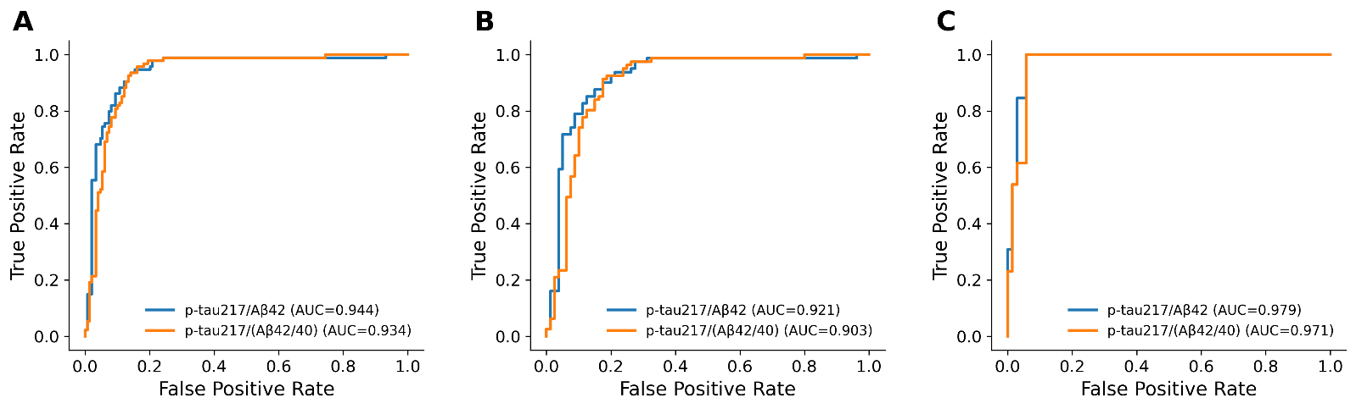
Fig. S1 ROC analysis of p-tau217/(Aβ42/ Aβ40) vs. tau217/Aβ42. The comparison groups are as follows: A: AD continuum (n=94) vs. HC + non-AD dementia (n=149); B: AD-MCI + AD-D (n=81) vs. non-AD dementia (n=80); C: preAD (n=13) vs. HC (n=69).

