Supplementary Table 1. Inclusion and exclusion criteria of the study
inclusion criteria | exclusion criteria
- Women or man, aged of 18 to 40 years  - Body mass index (BMI) between 18 and 25 kg/m²  - In good general health as evidenced by medical history and physical examination  - Non-smoker  - Caucasian  - For women: use of effective contraception  - H₂ – producer as evidenced by the screening test  - Provision of signed and dated informed consent form  - Stated willingness to comply with all study procedures and availability for the duration of the study | - Subjects presenting gastro-intestinal disorders such as ulcers, diverticulitis and inflammatory bowel diseases  - Subject presenting allergy or food intolerance (lactose, gluten)  - Subjects with psychiatric problems and/or using antipsychotics  - Current or recent (< 4 weeks) intake of antibiotics, probiotics, prebiotics, fiber complement, and/or any products modulation gut transit  - Feeding particular diet such as vegetarian diet or hyper protein diet  - Chronic intake of drug, excepted contraceptive drug  - Pregnant or lactating women or women who did not use effective contraception  - Subjects who drink more than 3 glasses of alcohol per day (> 30 g of alcohol per day)  - Subjects having participated to another clinical trial 1 month before the screening test visit  - Subjects presenting an allergy or intolerance to one component of the product tested

Supplementary Figure 2. Exhaled H₂ after lactulose intake

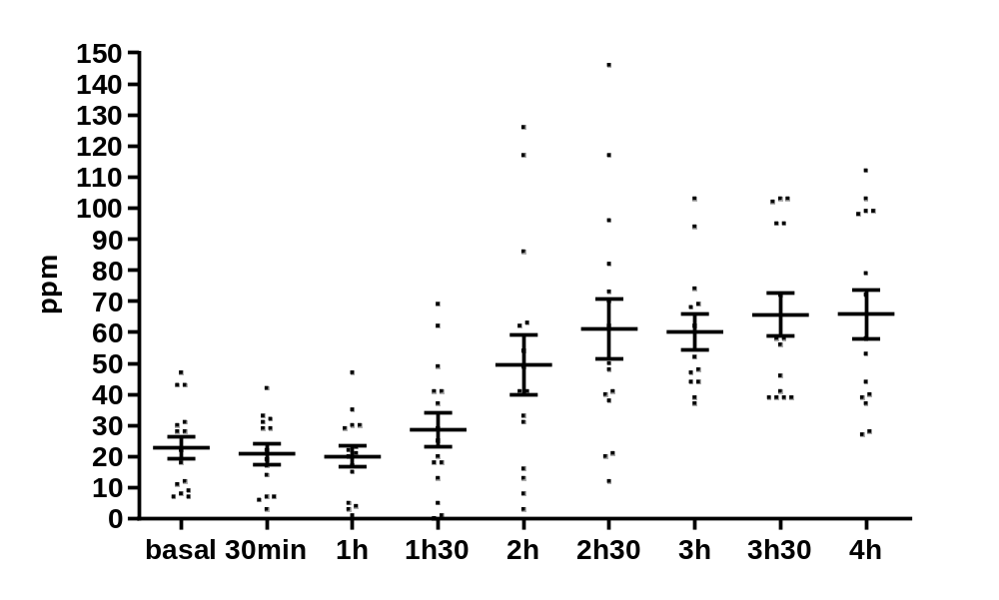

Supplementary Table 2. Baseline score of gastrointestinal symptoms of the participants at fasting state¹
 | Test day maltodextrin |  |  | Test day  chitin glucan |  |  | q-value
Nausea | 0.5 | ± | 0.5 | 0.0 | ± | 0.0 | 1.0
Flatulence | 3.5 | ± | 1.5 | 0.6 | ± | 0.6 | 0.8
Bloating | 3.3 | ± | 1.8 | 2.6 | ± | 1.2 | 1.0
Bramp | 0.6 | ± | 0.6 | 0.6 | ± | 0.6 | 1.0
Rumbling | 2.0 | ± | 1.1 | 2.8 | ± | 1.5 | 1.0
Reflux | 0.0 | ± | 0.0 | 0.7 | ± | 0.7 | 1.0
Discomfort | 2.3 | ± | 2.3 | 0.6 | ± | 0.6 | 1.0
Burp | 0.4 | ± | 0.4 | 0.0 | ± | 0.0 | 1.0
¹Values are means ± SEM (q > 0.05, matched-pairs Wilcoxon signed-rank test).

Supplementary Table 3. Baseline production of breath volatile metabolites (ppm) of the participants at fasting state¹
 | Test day  maltodextrin |  |  | Test day  chitin glucan |  |  | q-value
butanol | 0.112 | ± | 0.009 | 0.142 | ± | 0.018 | 0.542
1-propanol | 0.248 | ± | 0.058 | 0.271 | ± | 0.039 | 0.706
2.3-butanedione | 0.145 | ± | 0.014 | 0.116 | ± | 0.012 | 0.153
2-methylbutyric acid | 0.022 | ± | 0.002 | 0.021 | ± | 0.001 | 0.871
2-propanol | 0.292 | ± | 0.070 | 0.312 | ± | 0.044 | 0.706
3-methylbutyric acid | 0.005 | ± | 0.001 | 0.006 | ± | 0.000 | 0.871
acetaldehyde | 0.058 | ± | 0.008 | 0.046 | ± | 0.003 | 0.153
acetic acid | 0.126 | ± | 0.015 | 0.139 | ± | 0.012 | 0.706
3-hydroxybutanone | 0.033 | ± | 0.002 | 0.029 | ± | 0.002 | 0.313
acetone | 3.976 | ± | 1.192 | 2.916 | ± | 0.723 | 0.706
acetonitrile | 0.068 | ± | 0.024 | 0.045 | ± | 0.012 | 0.706
benzaldehyde | 0.011 | ± | 0.002 | 0.012 | ± | 0.001 | 0.871
benzene | 0.035 | ± | 0.005 | 0.042 | ± | 0.006 | 0.706
butyric acid | 0.049 | ± | 0.003 | 0.040 | ± | 0.002 | 0.184
ethane | 0.003 | ± | 0.001 | 0.002 | ± | 0.000 | 0.153
ethanol | 0.670 | ± | 0.158 | 0.697 | ± | 0.206 | 1.000
caproic acid | 0.008 | ± | 0.002 | 0.008 | ± | 0.001 | 0.718
hydrogen sulfide | 0.011 | ± | 0.001 | 0.011 | ± | 0.001 | 1.000
isoprene | 0.557 | ± | 0.075 | 0.450 | ± | 0.042 | 0.153
methane | 38.920 | ± | 6.703 | 32.103 | ± | 5.044 | 0.706
methanol | 0.315 | ± | 0.056 | 0.173 | ± | 0.023 | 0.153
pentane | 0.601 | ± | 0.029 | 0.442 | ± | 0.018 | 0.016*
valeric acid | 0.010 | ± | 0.001 | 0.010 | ± | 0.000 | 0.871
phenol | 0.134 | ± | 0.026 | 0.121 | ± | 0.011 | 0.830
propionic acid | 0.176 | ± | 0.040 | 0.295 | ± | 0.055 | 0.153
triethylamine | 0.008 | ± | 0.000 | 0.007 | ± | 0.001 | 0.156
¹Values are means ± SEM. (*q < 0.05, matched-pairs Wilcoxon signed-rank test).

Supplementary Figure 2. Targeted BVM concentrations of healthy subjects, corrected for baseline, after chitin glucan intake compared to maltodextrin intake¹
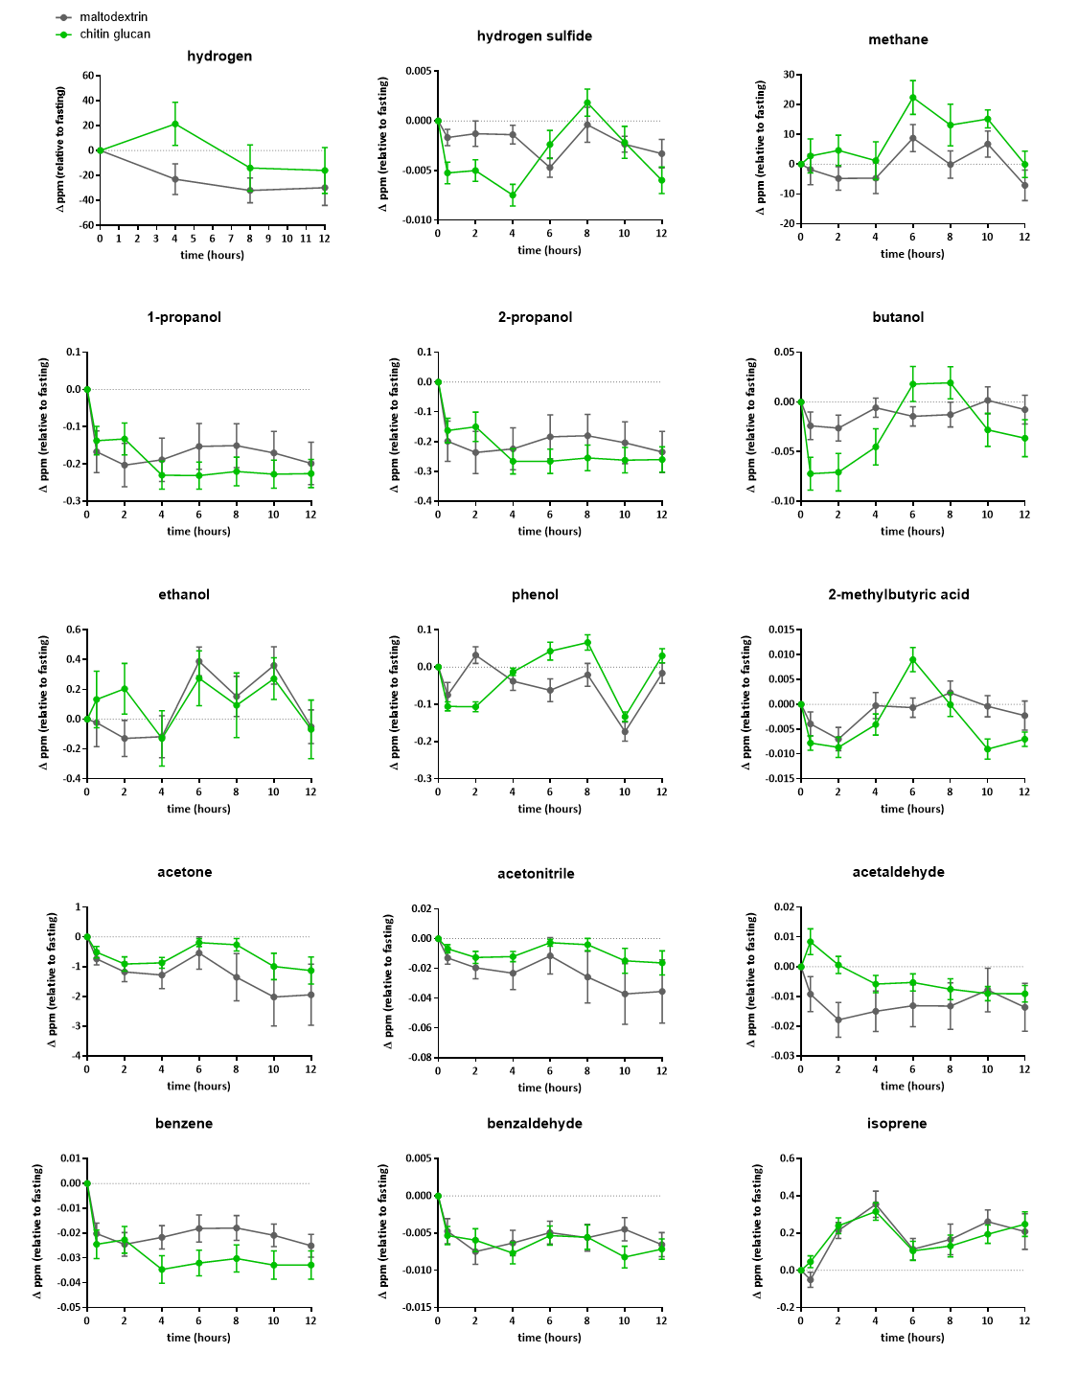
¹Data are means ± SEM (p>0.05; matched-pairs Wilcoxon signed-rank test on net AUC).

