Supporting information

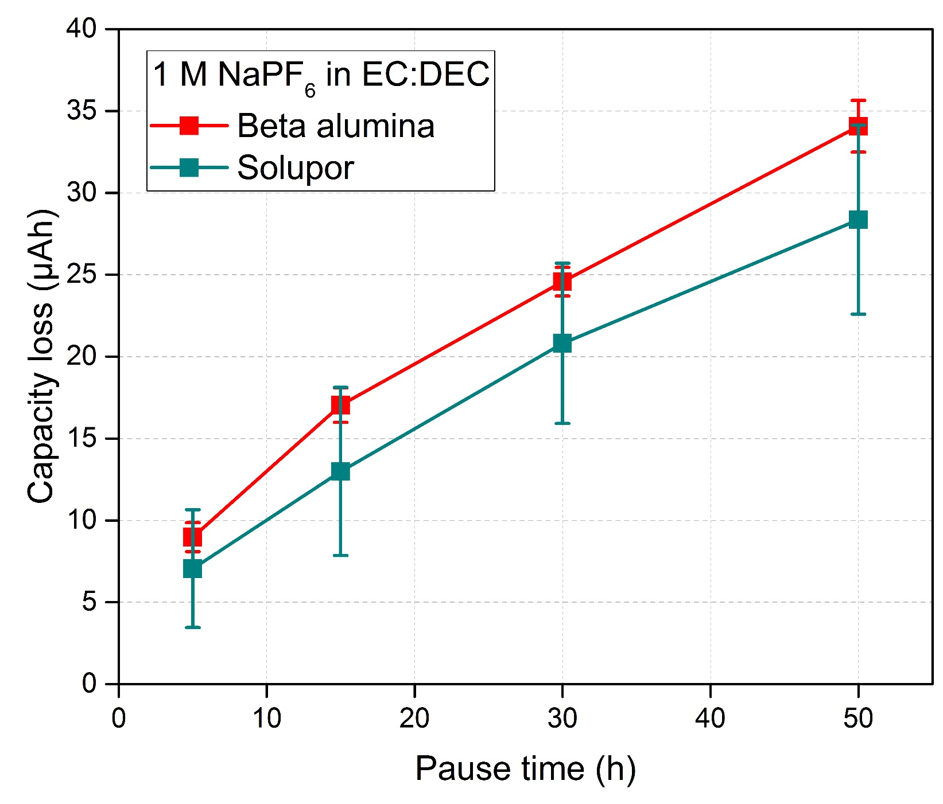
Figure S1. Absolute capacity loss with two different separators (red: β-alumina, green: Solupor®) as a function of the open circuit pause time. The cell with Solupor® separator resulted in smaller capacity losses which is due the higher concentration of species formed at the Na-metal electrode, saturating the electrolyte system, and hindering additional SEI dissolution. With Na-conductive β-alumina, the influence of species formed at the Na-metal on the carbon black working electrode can therefore be reduced and hence, the electrolyte systems can be studied without being affected by the species formed at Na-metal.

Figure S2. Galvanostatic cycling results. a) Presence of oxidation capacity between 1.0 – 2.0 V indicating Na-trapping during pause in previous sodiation steps, since it is a diffusion controlled process, which is time dependent. b) The potential of the CB electrode as a function of the open circuit pause time. The potential increase during pausing can be associated with the electrolyte system approaching an equilibrium state by diffusion of Na within the CB electrode. The potential is determined by the surface concentration of Na⁺ (in fact the concentration of reduced carbon) according to Nernst equation. As the Na (i.e., Na⁺ and e⁻) diffuses into the CB electrode, the potential of the electrode should increase (as the surface concentration of the reduced species, i.e., the reduced carbon) is decreasing with time.

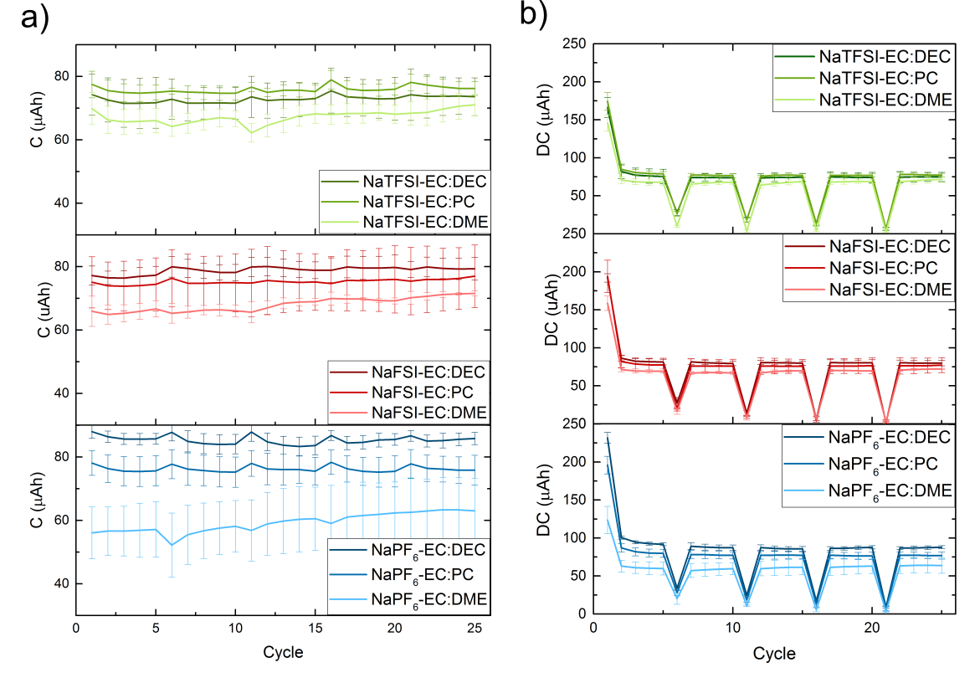
Figure S3. Galvanostatic cycling results. a) Obtained charge capacities in different electrolyte systems plotted over cycle numbers sorted after salt systems (green: NaTFSI, blue: NaPF₆). b) Obtained discharge capacities over cycle numbers sorted after salt systems as in a). Note that the drops in cycle 6, 11, 16 and 21, which are the self-discharge cycles and represent the capacity losses after a pause.

Compared to EC:DEC and EC:PC systems with charge capacities around 70 to 90 μAh, EC:DME systems exhibited the lowest charge capacities between 50 to 70 μAh. Therefore, in EC:DME less Na can be extracted from CB during charge which could be due to Na-trapping in the CB structure or less Na was stored in the CB electrode during sodiation which can be deducted from the discharge capacities. Disregarding the first cycle and the self-discharge cycles, the discharge capacities in all tested electrolyte systems range between 50 to 100 μAh which is similar to the charge capacity. The first cycle discharge capacity is significantly higher than in the subsequent cycles, indicating a charge consumption due to SEI formation. In EC:DEC and EC:PC solvent systems, the discharge capacities were generally higher than for EC:DME systems which is most significant when using NaPF₆. In general, charge and discharge capacities in NaPF₆-based electrolytes showed larger discrepancies for different solvents compared to NaTFSI.

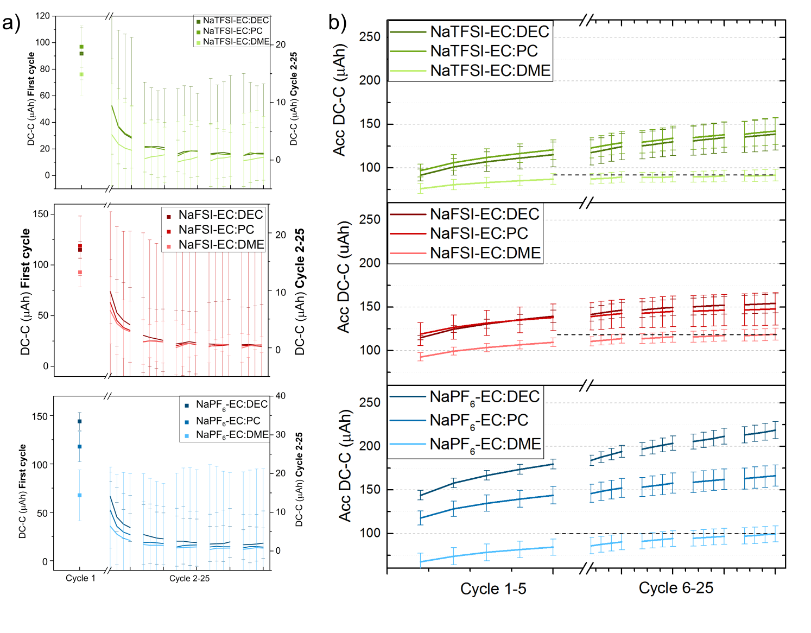
Figure S4. Galvanostatic cycling results. The error bars represent the standard deviation of three replicate cells. a) Difference in discharge and charge capacity plotted against the cycle number sorted after salt systems. Left y-axes represent the difference in discharge and charge capacity in the first cycle, whereas on the right y-axes for the subsequent cycles 2 – 25. b) Accumulated difference in discharge and charge capacity as a function of the number of cycles sorted after salt systems. The self-discharge cycles are disregarded in these plots in order to illustrate the baseline better.

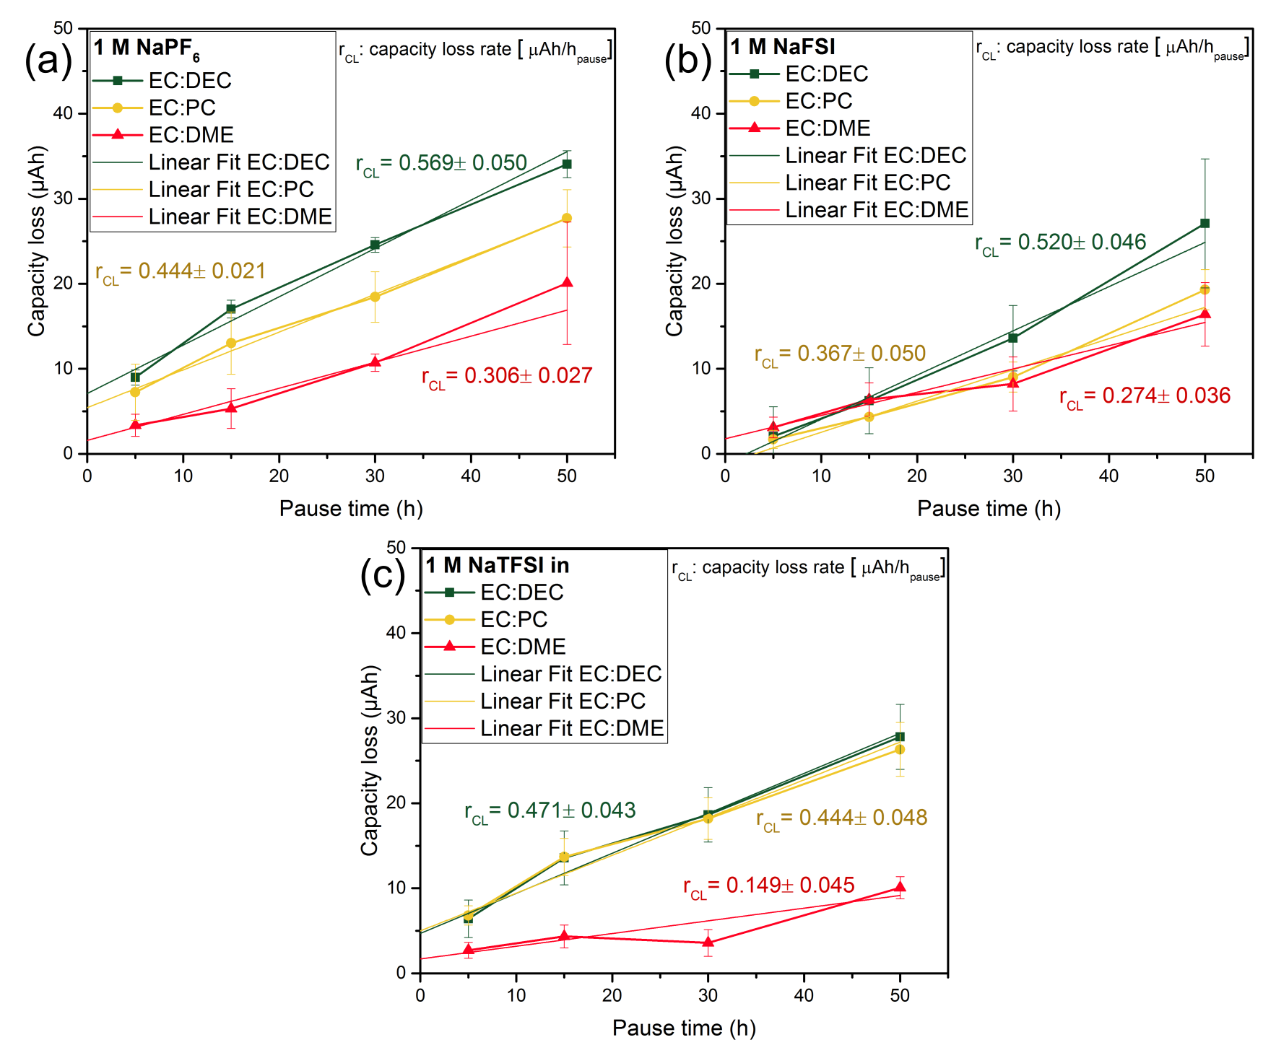
Figure S5. Absolute capacity losses plotted against the pause time using protocol 1 for a) NaPF₆, b) NaFSI and c) NaTFSI each in the solvent mixtures EC:DEC, EC:PC and EC:DME. The slope of each curves represents the capacity loss rate during pause. For all three electrolyte salt systems, the usage of solvent mixture EC:DME resulted in low-capacity loss rate.

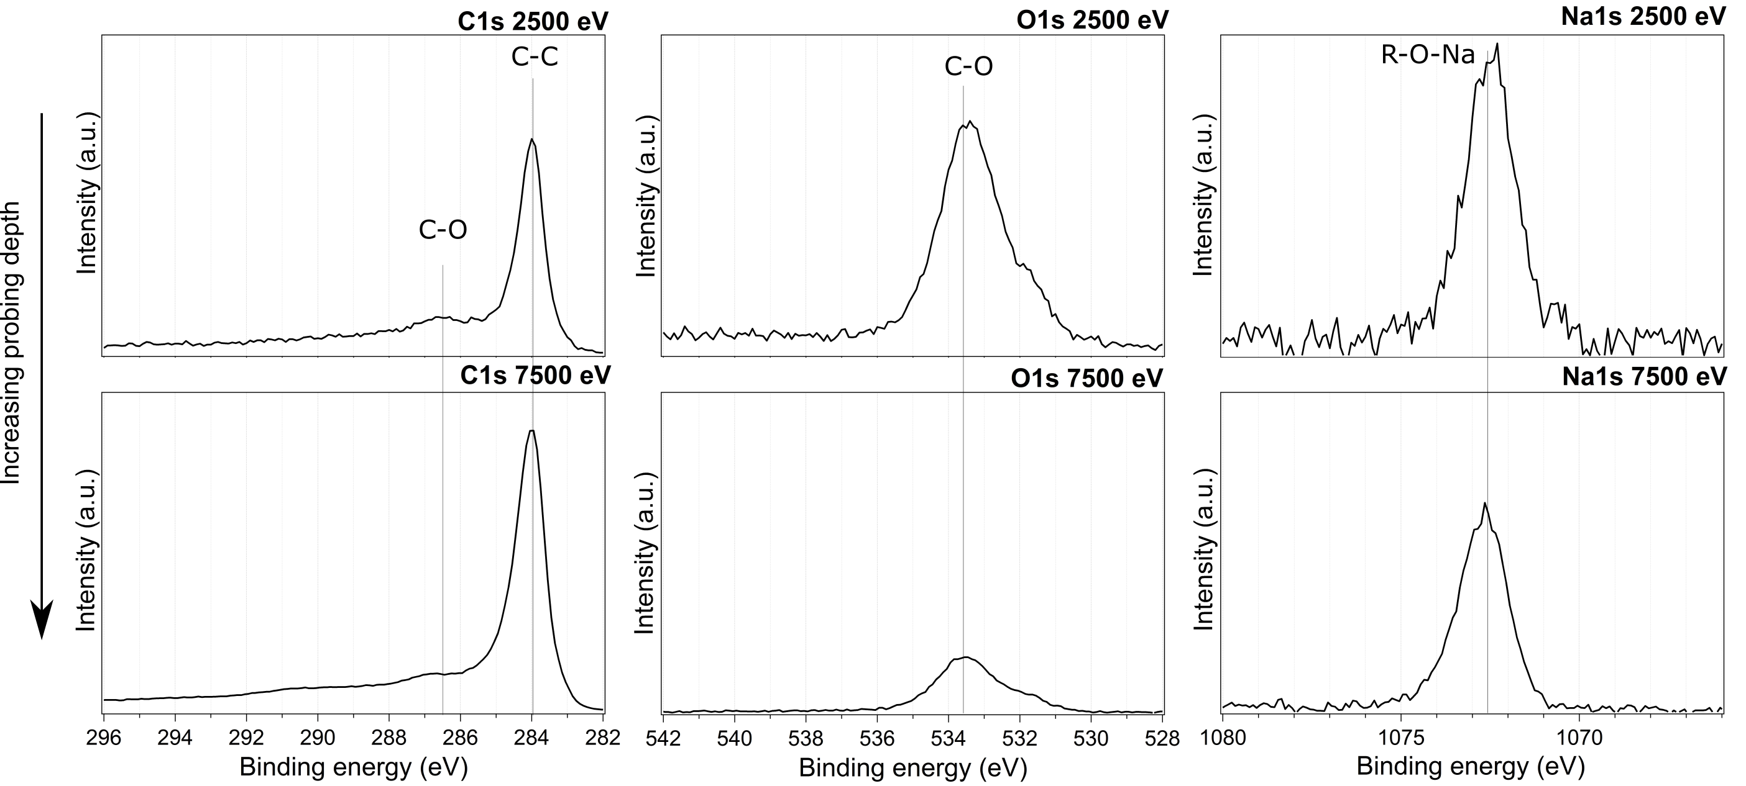
Figure S6. XPS spectra of C 1s, O 1s and Na 1s core levels measured on carbon black electrode with different photon energies of 2500 eV and 7500 eV. The peaks correspond to the expected components of active material carbon black and binder Na-carboxymethyl cellulose (Na-CMC).

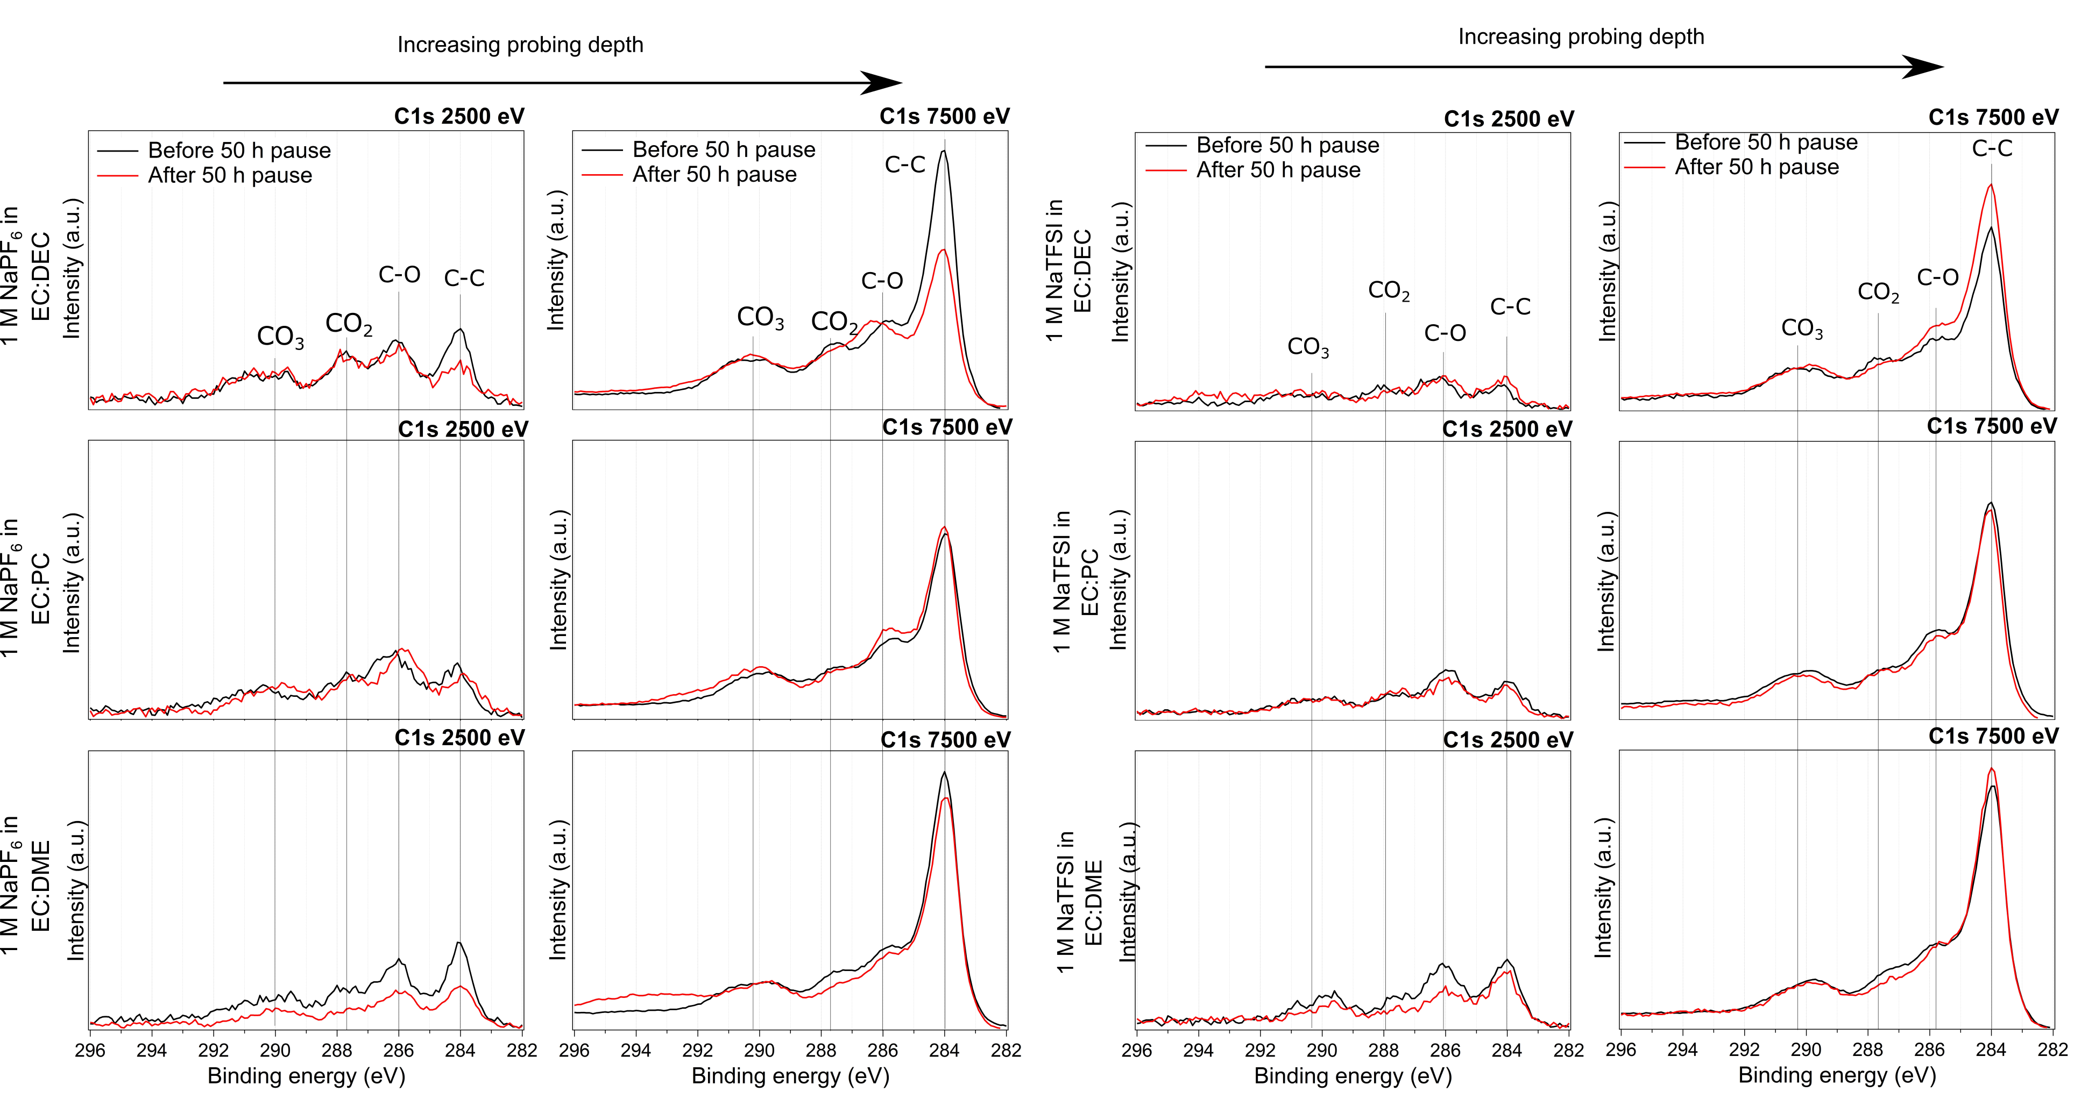
Figure S7. Surface and bulk sensitive XPS results with C 1s spectra of SEI formed in NaPF₆ (left images) in EC:DEC, EC:PC and EC:DME and in NaTFSI (right images) in EC:DEC, EC:PC and EC:DME.

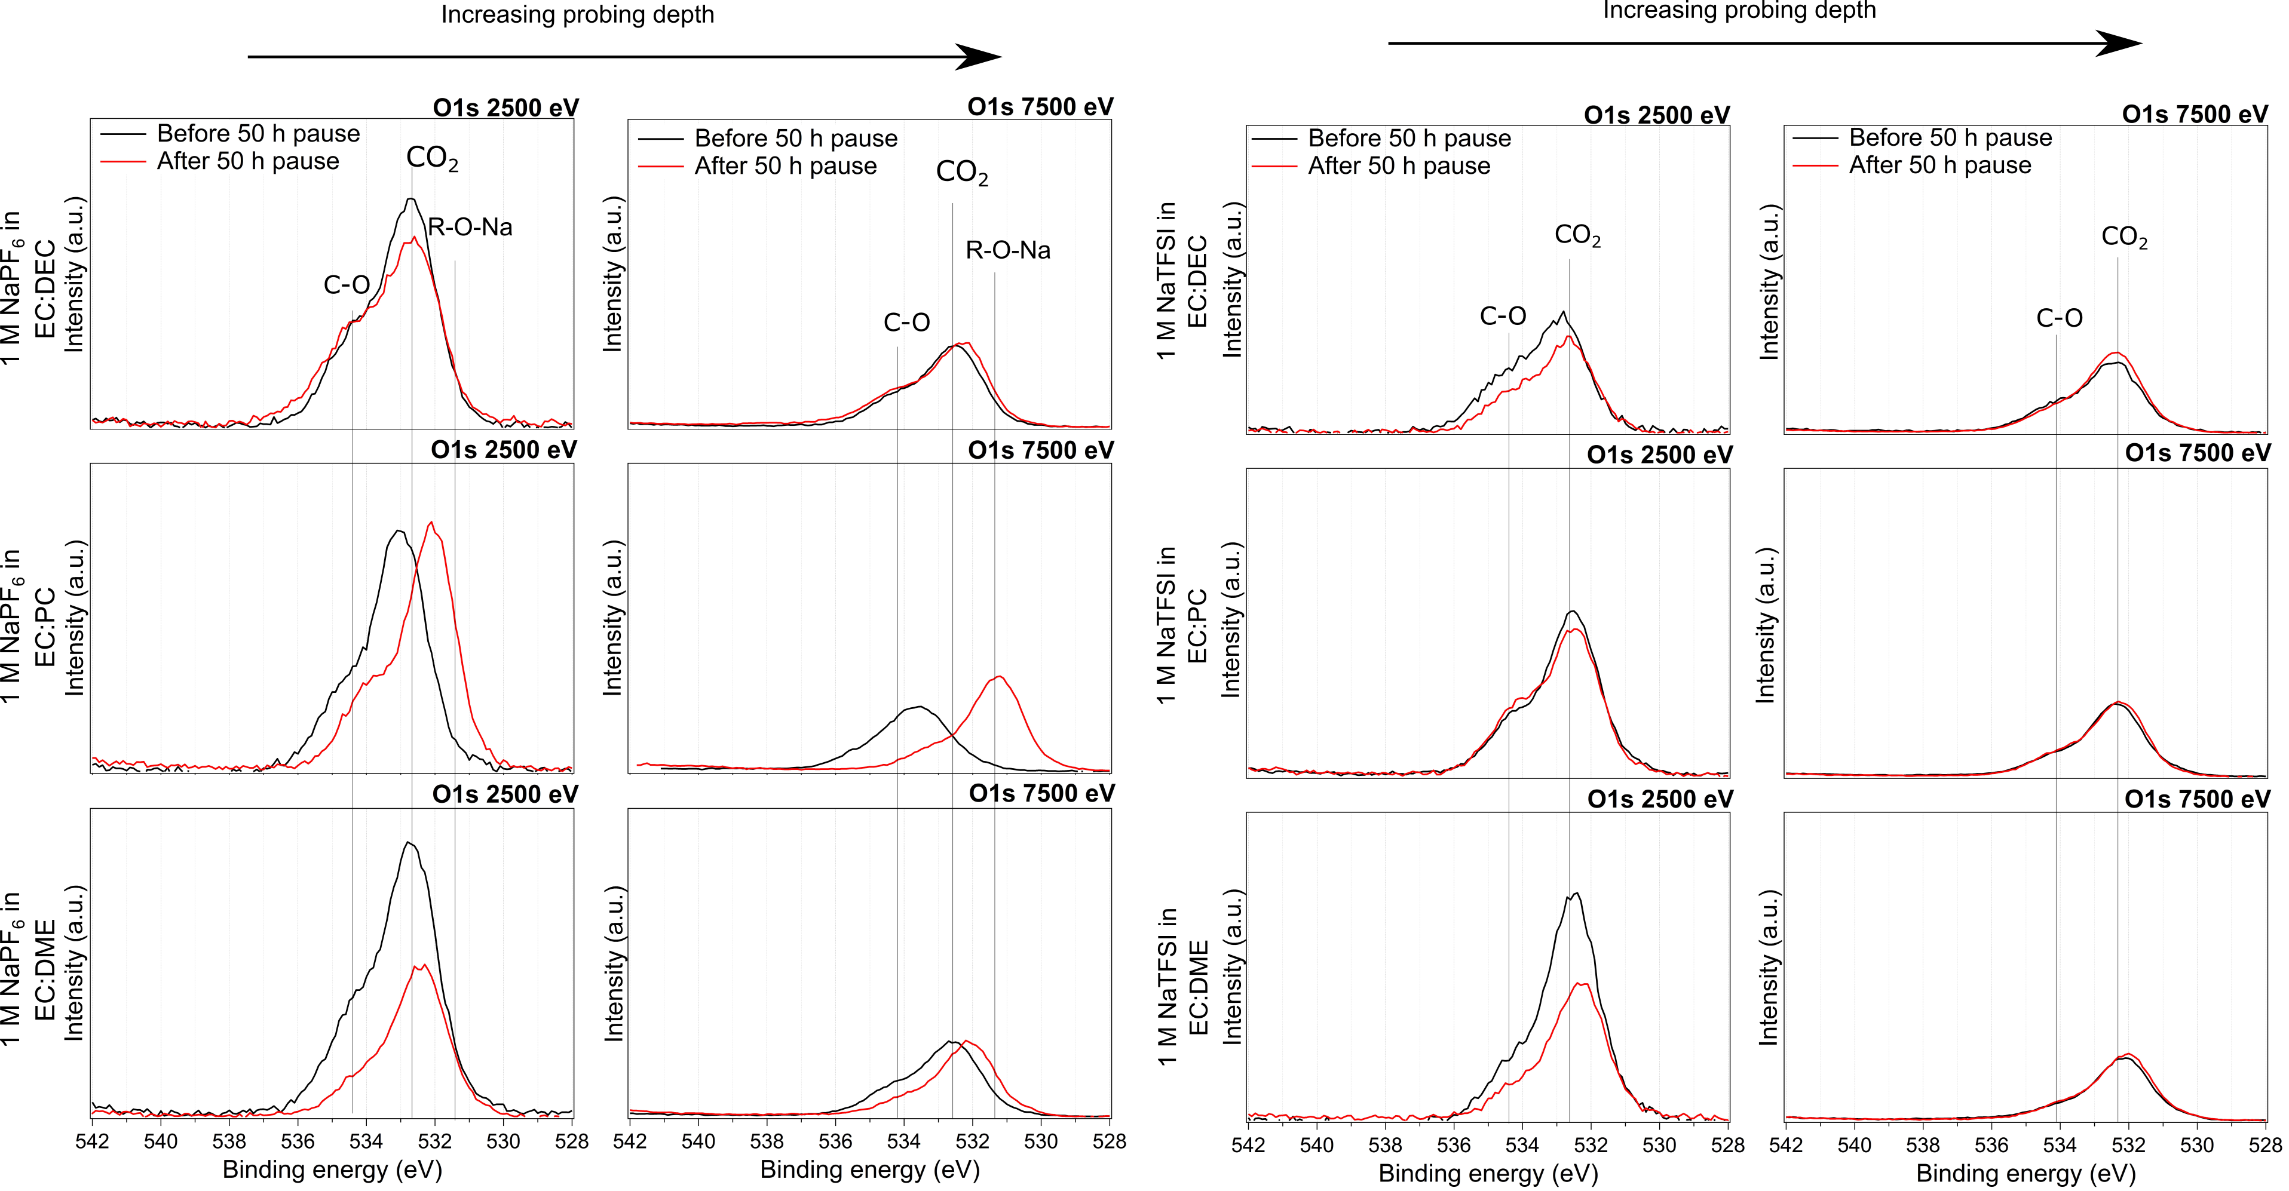
Figure S8. Surface and bulk sensitive XPS results with O 1s spectra of SEI formed in NaPF₆ (left images) in EC:DEC, EC:PC and EC:DME and in NaTFSI (right images) in EC:DEC, EC:PC and EC:DME

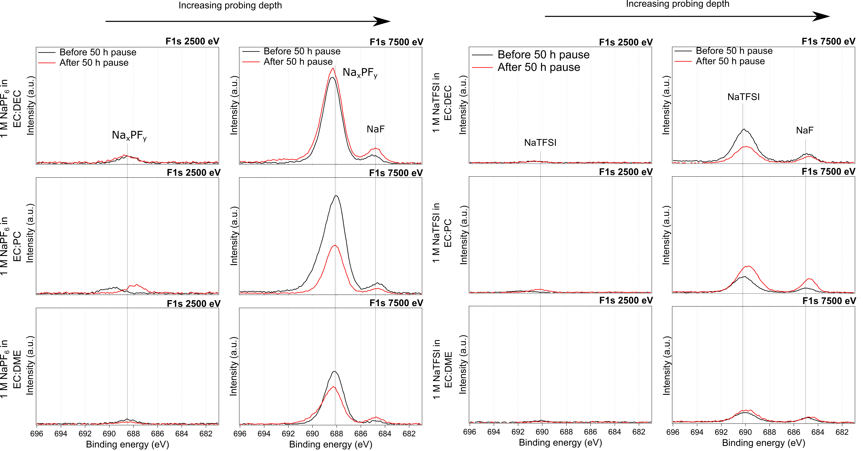
Figure S9. Surface and bulk sensitive XPS results with F 1s spectra of SEI formed in NaPF₆ (left images) in EC:DEC, EC:PC and EC:DME and in NaTFSI (right images) in EC:DEC, EC:PC and EC:DME

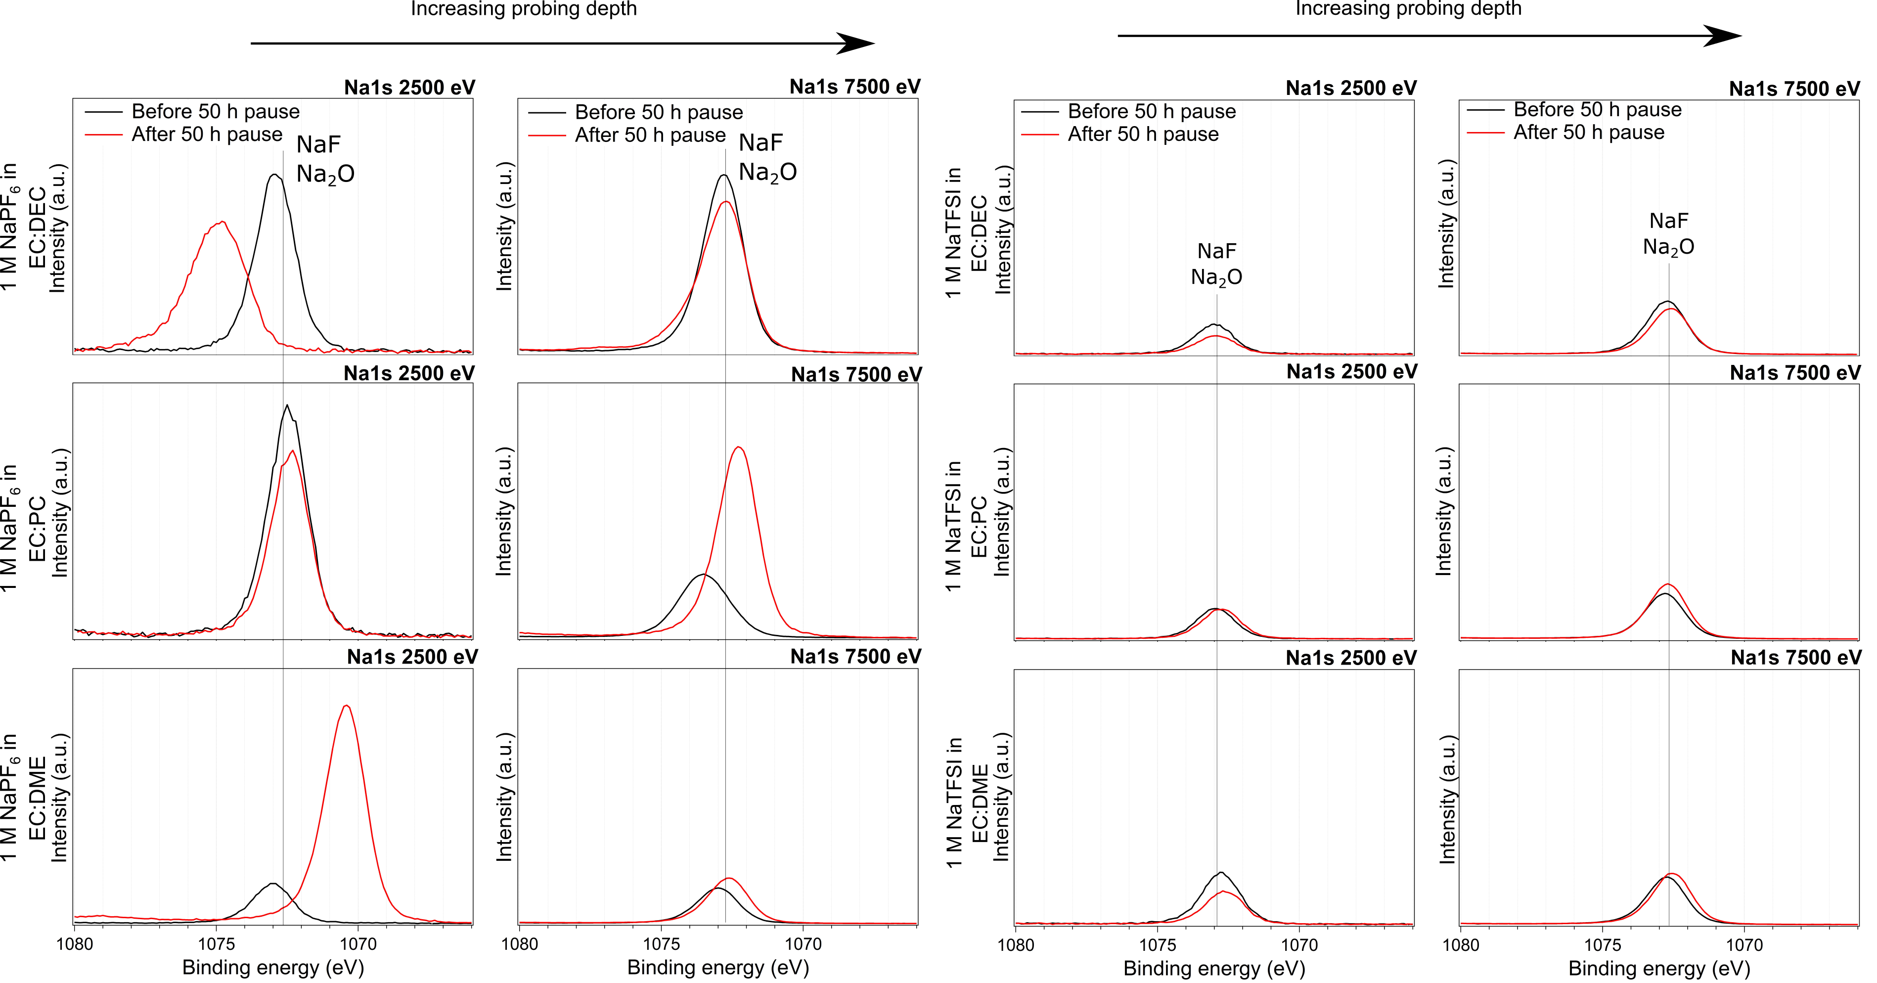
Figure S10. Surface and bulk sensitive XPS results with Na 1s spectra of SEI formed in NaPF₆ (left images) in EC:DEC, EC:PC and EC:DME and in NaTFSI (right images) in EC:DEC, EC:PC and EC:DME

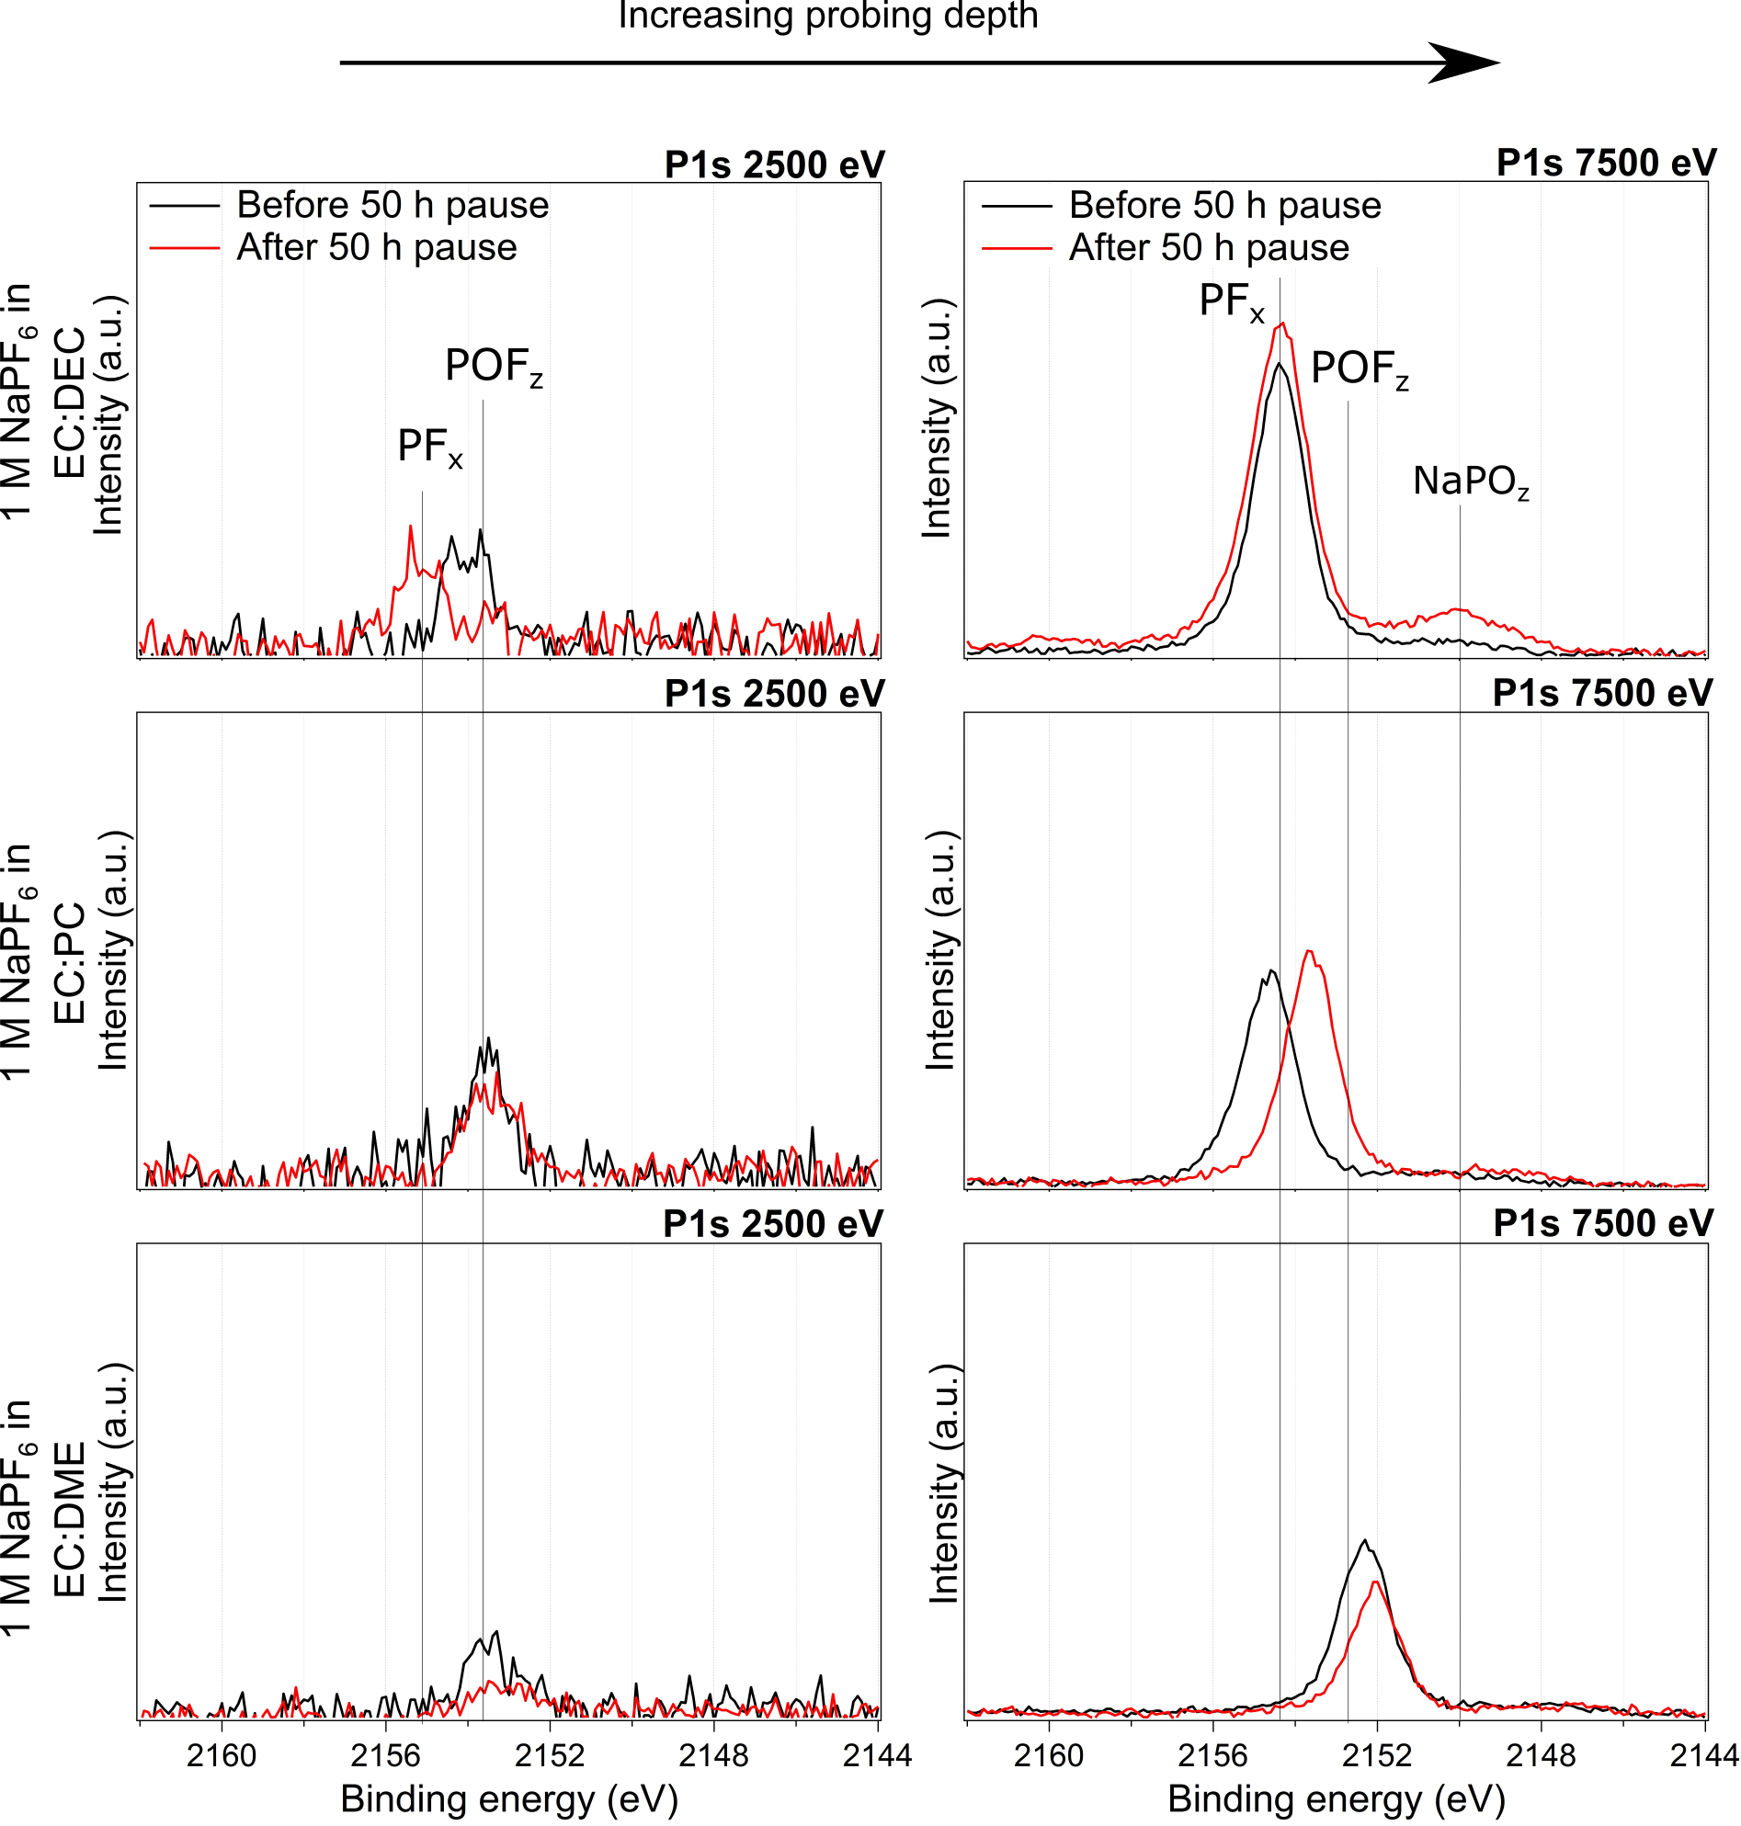
Figure S11. Surface and bulk sensitive XPS results with P 1s spectra of SEI formed in NaPF₆ in EC:DEC, EC:PC and EC:DME.

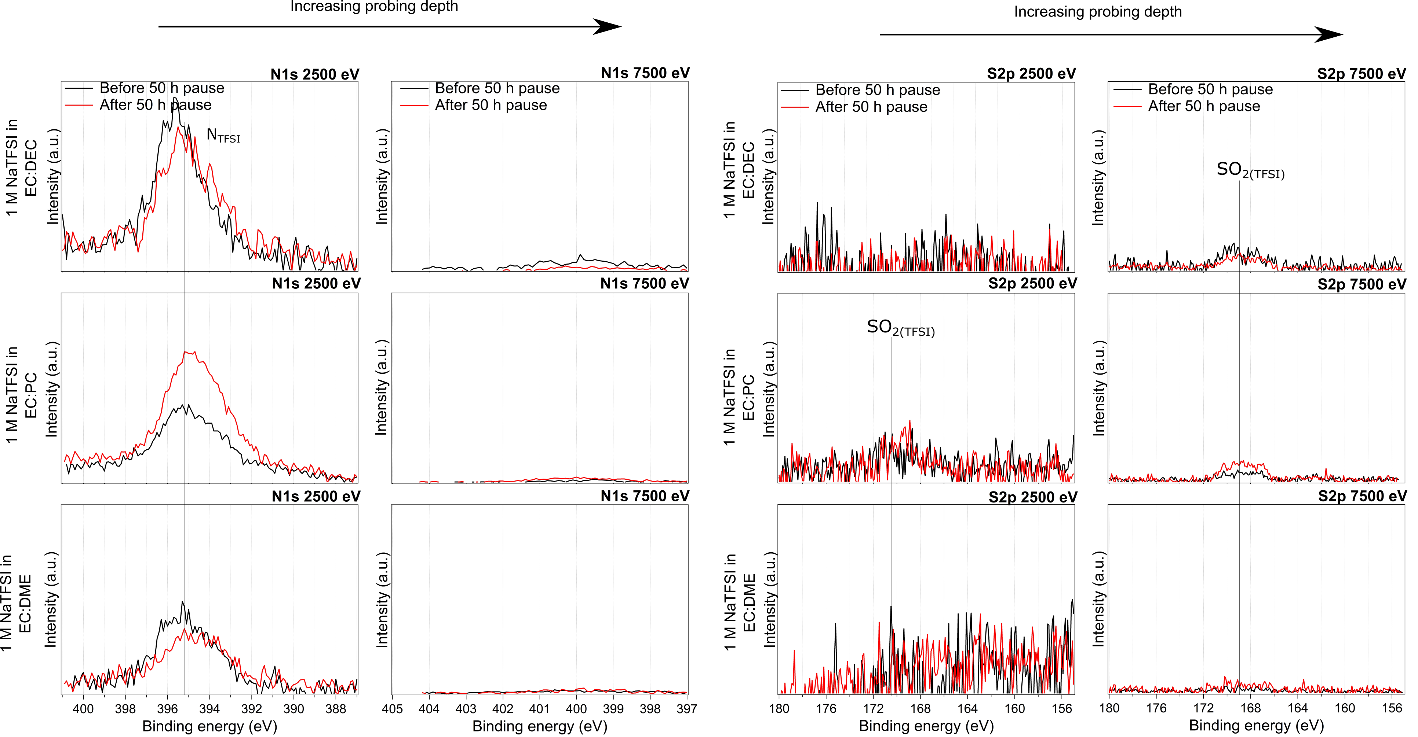
Figure S12. Surface and bulk sensitive XPS results with N 1s (left images) and S 2p spectra (right images) of SEI formed in NaTFSI in EC:DEC, EC:PC and EC:DME.

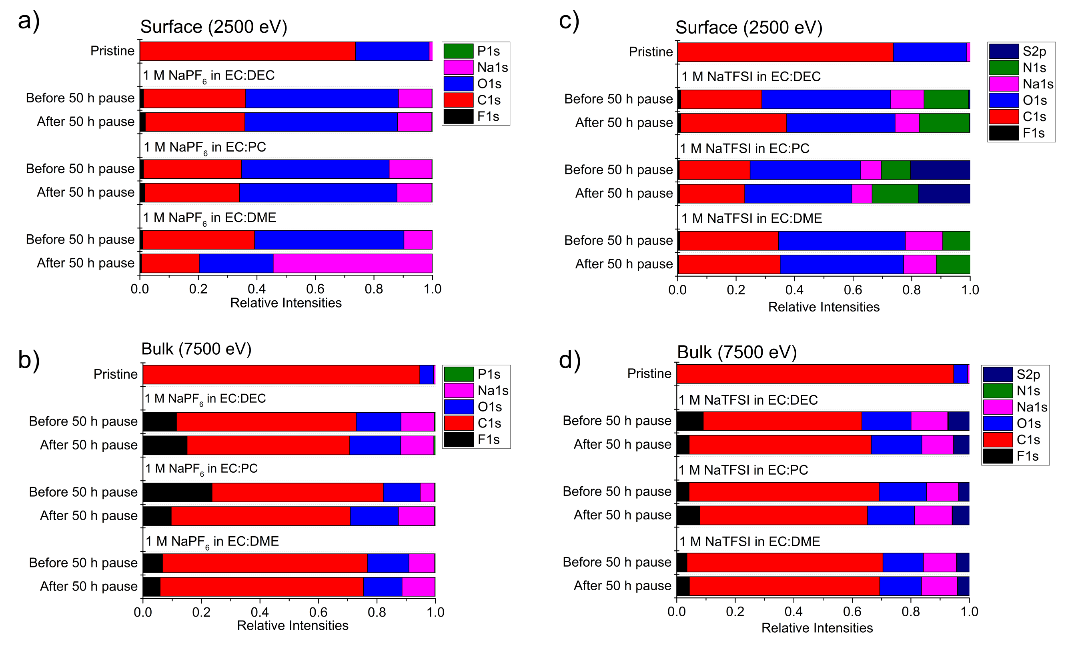
Figure S13. Elemental composition of SEI at the surface and in the bulk for all nine tested electrolyte systems concluded from the XPS spectra shown in Figure S6-12.

