Supplementary material for

Varroa destructor weakens the honey bee external immunity system by impairing melittin production

Michelina Pusceddu^{1,2*}, Simon Tragust^{3*}, Panagiotis Theodorou³, Irene Ciabattini Bolla¹, Jorge Sánchez Navarro¹, Francesco Corrias⁴, Alessandro Atzei⁴, Alberto Angioni⁴, Ignazio Floris^{1,2}, Alberto Satta^{1,2}
1 Department of Agricultural Sciences, Section of Plant Pathology and Entomology, University of Sassari, Sassari, Italy, 2 National Biodiversity Future Center (NBFC), Palermo, Italy, 3 General Zoology, Institute of Biology, Martin Luther University Halle-Wittenberg, Halle (Saale), Germany, 4 Department of Life and Environmental Sciences, University of Cagliari, Cagliari, Italy
*Corresponding authors: mpusceddu@uniss.it (MP); simon.tragust@zoologie.uni-halle.de (ST)

Table S1 Characteristic m/z ions during the ionization of melittin (MW 2646.75) operating in ESI mode.
Ion | m/z*
MH⁺² | 1423.88
MH⁺³ | 949.59
MH⁺⁴ | 712.44
MH⁺⁵ | 570.16
MH⁺⁶ | 475.30
*m/z: mass to charge ratio
ESI: electrospray ionization

Table S2 Optimized MS/MS conditions for the target analyte in positive ESI mode using the LC-MS/MS method in the MRM* setting.
Precursor ion (m/z) | Product ion (m/z) | Fragmentor (v) | Collision energy (v)
713 | 143 | 150 | 42
713 | 86 | 150 | 58
*MRM: multiple reaction monitoring

Table S3 Linear range, linear equation, correlation coefficient, LOQ, apparent recovery (%), precision (RSDr, and RSDwr; n=), uncertainty (U) of melittin using the LC-MS/MS method.
Analyte | Linearity  (µg mL⁻¹) | Linear regression equation | R² ± RSD% | LOQ  (µg mL⁻¹) | Apparent recovery (%) |  | RSDr% | RSDwr% | U
 |  |  |  |  | LOQ | 10 x LOQ | LOQ | LOQ
Melittin | 0.1 – 5.0 | y=66954.8x + 31352.9 | 0.997 ± 0.33 | 0.1 | 87.1±9.4 | 81.7±13.5 | 12.6 | 17.7 | 21.2
 |  |  |  |  | 93.7±2.4 | 90.3±3.3 | 10.5 | 15.3 | 14.7

Linearity: the calibration curve linearity was measured between 0.1 and 5.0 µg mL⁻¹
LOQ: limit of quantification.
RSDr%: relative standard deviation intraday repeatability
RSDwr: relative standard deviation interday repeatability
Apparent recovery (%): average percent of ‘measured concentration/spiked amount’.
U: expanded uncertainty, U = k x u′; u′ = 𝑢′(𝑏𝑖𝑎𝑠)² + 𝑢′(𝑝𝑟𝑒𝑐𝑖𝑠𝑖𝑜𝑛)², k = 2 (coverage factor), to accomplish a level of confidence of 95%.

Figure S1 Chromatograms of melittin in positive ESI mode using the LC-MS/MS method in the MRM setting.

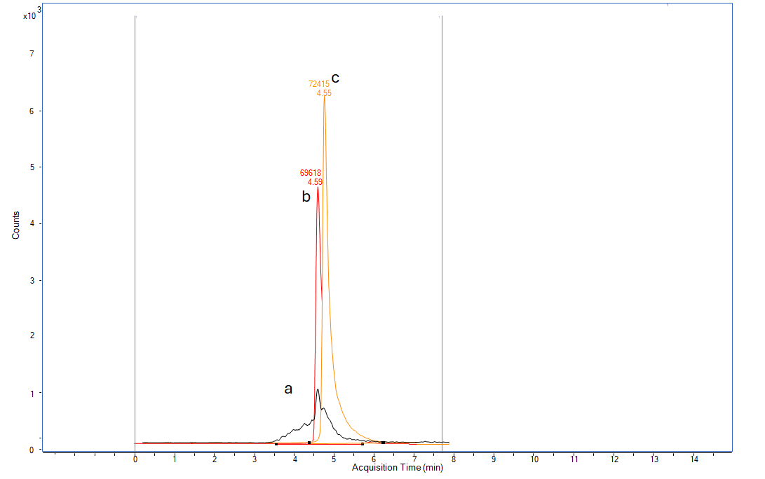

a) blank control, b) std at 250 µg L⁻¹, and c) melittin residue on worker bees.

Graphical abstract