Supplementary Information
Genetics of Major Depressive Disorder in a Homogeneous Population with Uniform Phenotyping

eMethods
BIONIC cohort descriptions
Supplementary Figure 1. Flowchart BIONIC GWAS of MDD sample.
Supplementary Table 1. Demographic characteristics of the BIONIC GWAS sample (N = 64,941).
Supplementary Figure 2. QQplot of genome-wide association mega-analysis of lifetime MDD.
Supplementary Figure 3. Regional association plot of the PALMD region.
Supplementary Figure 4. QQplot of genome-wide association mega-analysis of height.
Supplementary Figure 5. Number of twins by MDD PGS decile for discordant affected and concordant unaffected pairs.
Within-family Polygenic Score Sensitivity models
Twin concordance and PGS quartile in the Australian Genetics of Depression Study and NTR
Supplementary Figure 6. Number of twins by MDD PGS quartile and by twin pair MDD concordance in AGDS.
Supplementary Figure 7. Number of twins by MDD PGS quartile and by twin pair MDD concordance in NTR.
Supplementary Figure 8. MAGMA tissue enrichment analysis for MDD.
Genome-Wide Association Meta-Analysis of MDD
Supplementary Figure 9. GWAS meta-analysis of lifetime major depressive disorder case-control status.
Additional screening of lifetime MDD controls

eMethods

The BIONIC study
The BIONIC (BIObanks Netherlands Internet Collaboration) project includes sixteen cohort studies from across the Netherlands united in establishing a depression phenotype and genotype database to study the etiology and characteristics of depression in the Dutch population¹. When an major depressive disorder (MDD) definition based on the Diagnostic and Statistical Manual of Mental Disorders (DSM-5)² was not already available, uniform data collection was realized through an online diagnostic instrument, the Lifetime Depression Assessment Survey (LIDAS)³, developed to assess DSM-5 depression. These efforts resulted in a dataset of 132,402 Dutch individuals with information on lifetime MDD diagnosis, depression symptom status, episode characteristics, and a range of clinical and demographic indicators, including educational attainment, smoking, body-mass index and medication use. At the time of this study, 72,315 of these participants also had genome-wide single nucleotide polymorphism (SNP) data; of this group 64,941 had MDD case-control status, all covariates, good quality genotype data and were of European ancestry (Supplementary Figure 1).

Genotype data
The sixteen cohorts had collected genotype data with different arrays, resulting in 19 datasets where the same arrays could be available in different cohorts, or where the same cohort had performed genotyping on different arrays. For quality control (QC), samples were excluded in case of discrepancy between reported and biological sex (PLINK F_{chrX}-coefficient < 0.8 for males and F_{chrX} > 0.2 for females), excess heterozygosity (F_{autosomes} > 0.10 or < -0.10), insufficient sample call rate (< 0.90) and call rate by chromosome (< 0.80), or incorrect identity-by-descent sharing between relatives. SNPs were excluded based on Hardy Weinberg Equilibrium (p < 1x10-4) and SNP call rate (< 0.95), as well as Mendelian error rates above 1%. Palindromic SNPs were excluded with minor allele frequency (MAF) > 0.30. SNPs were aligned to the Haplotype Reference Consortium (HRC) reference panel (v1.1)⁴ and SNPs with an allele frequency difference > 0.10 with the reference data were excluded. Some of the datasets did not fit independent GWAS analysis criteria because they were too small or had an overrepresentation of cases. To include the largest number of individuals, SNP data genotyped on the same arrays were combined. This resulted in seven array groups with raw genotype data from Affymetrix 6, Axiom Finngen, Axiom-NL, Illumina CytoSNP, Global Screening Array, Human Core Exome, and Omnichip. These array groups were the units for further QC, including duplicate sample removal, a repeat of the SNP QC thresholds above, and a MAF threshold of 0.01. Genotype data were then imputed against the HRC reference panel (v1.1). Further details on the quality control procedure are provided elsewhere¹. After imputation, the seven array groups had identical genome coverage and were merged into a single set for mega-analysis. All arrays included genotype data on the 22 autosomes. The availability of X-chromosome data varied (Supplementary Figure 1), with the first pseudo-autosomal region (PAR), non-PAR, and second PAR available in 55,141, 55,863, and 41,441 individuals, respectively.
We conducted principal component analysis (PCA) in PLINK (v1.9)⁵ on the imputed data based on the three superpopulations (African, Asian, European) from the 1000 Genomes Project reference panel (phase 3v5)^{6,7}. The BIONIC genotype data were SNP and LD (linkage disequilibrium) pruned and projected onto the 1000 Genomes Project PCA space to compute principal components (PCs). Ancestry outliers in the BIONIC data were excluded based on a 4 SD distance from the mean of 0 for the first 6 standardized PCs. Additional ancestry outliers were removed based on visual inspection of PC clustering.

Phenotype data
Lifetime MDD cases were uniformly defined according to DSM-5 diagnostic criteria as ever having had a period of at least two weeks with five or more depression symptoms causing dysfunction in life, of which at least one a cardinal symptom². Lifetime MDD cases were primarily (47%) identified through the Lifetime Depression Assessment Survey (LIDAS)³. This online self-report questionnaire was developed to reliably and efficiently assess MDD diagnosis for large population studies and ongoing biobank studies based on the Diagnostic and Statistical Manual 5 diagnostic criteria². The LIDAS was validated against the composite international diagnostic interview (CIDI)⁸ and has been used in a number of epidemiological and genetic studies since^{9–13}. The remaining diagnoses were derived from the CIDI, mini international neuropsychiatric interview (v5; MINI)¹⁴, and diagnostic interview schedule (DIS)¹⁵.
The majority (87%) of lifetime MDD controls were defined in the absence of 5 symptoms, a core symptom, or dysfunction. Additional lifetime MDD controls (13%) were identified based on low scores on one or multiple depression symptom instruments, including the BDI, CES-D, HADS, and ASR-ASEBA¹⁶. As an additional screener, lifetime MDD controls were asked about diagnostic and treatment history for a range of psychopathologies when such information was available (56%). This included screening for a self-reported diagnostic or treatment history of depression, anxiety disorder, bipolar disorder, any eating disorder, schizophrenia, obsessive compulsive disorder, post-traumatic stress disorder, phobia, attention-deficit or hyperactivity disorder or attention deficit disorder, any personality disorder, alcohol or drug addiction, and use of antidepressant medication.
Age was defined as years at MDD assessment. If multiple measures for the same person were available, the timepoint was chosen where diagnostic criteria for MDD were first met (for cases), or the latest measurement at which diagnostic criteria had not been met (for controls). Individuals with missing age information or ages outside the range of 16 to 105 were excluded. Sex was defined based on self-report and confirmed through genotyping.
Height in centimeters was obtained via self-report. Outlying values (< 140 and > 210) were excluded. 52,893 individuals had information on height, non-missing covariates, good quality phenotyping and European ancestry (Supplementary Figure 1).

Genome-Wide Association Study Mega-analysis
We conducted a genome-wide association (GWAS) analysis of lifetime MDD and height for SNPs on the merged seven array HRC-imputed dataset. Analyses were conducted in fastGWA¹⁷ from the Genome-wide Complex Trait Analysis (GCTA) software (v1.94.1)¹⁸, with a generalized linear mixed model for lifetime MDD and a mixed linear model for height. We computed a genetic relatedness matrix (GRM) in GCTA to address relatedness in the sample (sparse-GRM threshold 0.05). We did not apply the saddle-point approximation-correction as this applies to samples with extreme case-control imbalance (e.g., 1 case for every 100 controls)¹⁸. SNPs with an allele frequency below 0.01 were excluded from analysis. Analyses were corrected for sex, age, 10 ancestry-informative principal components and genotype array. GWAS results were filtered on imputation quality > 0.40 and Hardy Weinberg Equilibrium test p-value < 0.0001. Independent GWAS signals were identified by conditional and joint (COJO) analysis in GCTA¹⁹, where the BIONIC GWAS MDD sample served as the LD reference sample, restricted to one individual per related pair (relatedness > 0.125) as calculated by the KING software (v2.2.6)²⁰.

SNP heritability and genetic correlations
The SNP-based heritability (SNP-h²) and genetic correlation with the largest major depression GWAS to date (PGC-MD)²¹ were estimated by Linkage Disequilibrium score regression (v1.0.1; LDSC)²². LD score regressions were conducted for lifetime MDD and height, using the GWA mega-analysis summary statistics as input. Effective sample size was calculated following previous literature²³. For lifetime MDD, SNP-h² was estimated on the liability scale. Analyses on the liability scale require population and sample prevalences. For this we specified 18% as population prevalence for lifetime MDD in the Netherlands⁹ and sample prevalence as observed in our data (27% for the lifetime MDD GWAS model).

GWAS-by-subtraction
To explore if there was evidence for specific Dutch MDD genetic signal, we carried out GWAS-by-subtraction as implemented in the genomic structural equation modeling (Genomic SEM)²⁴ software with the GWAS summary statistics from PGC-MD and the BIONIC MDD GWAS as input. See Figure 2A for model specification. When applied to two traits, GSEM obtains a GWAS of the unique genetic variation, i.e. the variance not shared, between the two traits²⁵. We defined unique Dutch MDD as the genetic variation in the BIONIC MDD GWAS that was not explained by the PGC-MD European GWAS (excluding the Netherlands), running a GWAS on the residual unique Dutch MDD genetic variation in the BIONIC MDD GWAS after the PGC-MD European GWAS was regressed out.

Polygenic scores
Predicting lifetime MDD status in BIONIC with polygenic scores
We generated major depression polygenic scores (PGSs) in BIONIC based on the PGC-MD GWAS summary statistics (European samples), excluding all datasets from the Netherlands²⁶. PGSs reflect the genetic propensity for a trait based on the weighted sum of risk increasing and decreasing alleles across the genome, with allelic weights derived from GWAS. PGSs were generated in the LDpred software (v0.9.1)²⁷, a Bayesian method that derives posterior mean causal effect sizes from GWAS summary statistics by assuming a prior for the genetic architecture and linkage disequilibrium (LD) information. For the prior, an infinitesimal model was assumed. LD block information for West-European ancestry was derived from the UKBiobank²⁸. The association between the MD PGS and lifetime MDD case-control status in BIONIC was estimated by logistic regression in unrelated individuals with age at assessment, sex, and 10 ancestry informative PCs as covariates. The proportion of variance explained by the PGS on the liability scale for MDD case-control status was estimated according to Lee et al.²⁹.
Out-of-sample prediction
We explored out-of-sample MDD PGS prediction based on the BIONIC MDD GWAS summary statistics in the UKBiobank. Genetic and clinical data from the UKBiobank were accessed under application number 16406²⁸. The UKBiobank initiative has been approved by the National Research Ethics Service Committee (reference 11/NW/0382). The imputation and quality control performed by the UKBiobank team together with additional in-house genomic control are described extensively elsewhere^{28,30}. After QC, a total of 9,380,668 high-quality SNPs were hard-called under a certainty threshold of 0.9³¹. Analyses were performed on common (MAF > 0.01) genotyped SNPs or common SNPs with very high imputation quality (INFO>0.9). Principal components from the 1000 Genomes reference populations³² were projected onto the called genotypes available using FLASHPCA2³³. Subjects with inferred European ancestry were kept for downstream analyses. Ancestry outliers (6 standard deviations to the average score of Europeans) were excluded. Subjects with sex aneuploidy, discordant reported and chromosomal sex, and relatives were excluded from the analysis. The final sample size resulted in 387,553 unrelated individuals of European ancestry.
Two depression phenotypes were defined based on the clinical data available for the UKBiobank cohort. First, a strict phenotype definition was constructed based on diagnosis of single or recursive depressive episodes (ICD10 codes: F32, F33) present in the hospital records. Next, a broad definition of depression based on Howard et al.³⁴ was adopted. A case was defined by answering yes to one of two questions in at least 1 assessment time point: ‘Have you ever seen a general practitioner for nerves, anxiety, tension or depression?’ (data field: 2090) or ‘Have you ever seen a psychiatrist for nerves, anxiety, tension or depression?’ (data field: 2100) or meets criteria for strict definition. Subjects diagnosed with schizophrenia, schizoaffective or delusional disorders (F20-F29) or bipolar disorder (F31) were excluded from the analysis. A total of 23,755 and 132,122 individuals met the criteria for strict and broad phenotype definitions, respectively.
PGSs were calculated using BIONIC MDD GWAS summary statistics similarly to above. PGSs were subset for alleles present in both datasets and reference alleles were aligned. HAPMAP3 SNPs were kept for downstream analyses. Scores were calculated using LDpred (v1.0.10)²⁷. First, data were synchronized using a subsample of 10,000 unrelated European individuals from the UKBiobank. Then, the SNP weights were calculated for the target sample using a LD radius of 100. The weights from the infinitesimal model were then used to perform allele scoring on the target sample with PLINK (v1.9). To examine the predictive power of the BIONIC MDD PGS in the UKBiobank, a logistic regression model was fitted. The primary independent variable was the standardized PGS. Sex, age, genotyping array, and the first 10 principal components were added as covariates.
Within-family prediction
PGS prediction of a trait can be subject to confounding, including bias from population stratification and assortative mating, as well as passive gene-environment correlation, where genes do not only directly affect our phenotype but also our (rearing) environment through the genotypes of our parents^{35–37}. Within-family designs are able to account for many sources of passive genotype-environment correlation, with dizygotic (DZ) twins having the additional benefit that all shared environmental factors are time-invariant among twins³⁸.
We sought to evaluate MD PGS prediction in a within-family design, following the approach of Selzam et al.³⁸ with DZ twins from the Netherlands Twin Register (NTR; a collaborating cohort in BIONIC). We identified 1141 dizygotic twin pairs with non-missing lifetime MDD case-control status and MDD polygenic scores. First, PGS prediction of MDD was assessed in the entire DZ twin sample through a logistic generalized linear mixed-effects model, correcting for sex and genotype array. Next, between-family PGS effects were defined as the change in lifetime MDD risk with a change in average family PGS values, and within-family PGS effects as the change in lifetime MDD risk with a change in the difference between individual PGS and the family average PGS. The two were fit as predictors of MDD in the same model, together with a random effect for family, so that individual estimates are adjusted for and independent of the effect of the other estimate. The statistical difference between the between- and within-family PGS effects was then empirically tested through a chi-square test of the difference between their coefficients divided by the standard deviations of the sampling distribution of the estimate differences^{39,40}. A statistical difference here would indicate that the PGS association with a trait may be partly explained by confounding. We conducted sensitivity analyses where data were restricted to sex-concordant DZ twin pairs (N = 1408; 704 pairs), sex-discordant DZ twin pairs (N = 874; 437 pairs), and DZ twin pairs in which twins were genotyped on the same array (N = 2084; 1042 pairs).
Polygenic scores and twin concordance
We computed MD PGS deciles based on the PGC-MD summary statistics in N = 2963 complete twin pairs from the NTR cohort who took part in BIONIC. We then distinguished 3 groups: concordantly affected (N = 133 pairs), concordantly unaffected (N = 2257), and discordantly affected (N = 573). We hypothesized that concordantly affected twins would be overrepresented in high MDD PGS deciles. We repeated this approach in an independent sample for replication, the Australian Genetics of Depression Study⁴¹. We formally tested the association between the mean MD PGS in NTR twin pairs and MDD concordance in an ordinal logistic regression model, correcting for two ancestry-informative PCs⁴².

Genetic correlations
We computed genetic correlations between the BIONIC lifetime MDD GWA mega-analysis and 1461 disease, personality and lifestyle traits using bivariate LDSC in the Complex-Traits Genetics Virtual Lab (CTG-VL) analysis pipeline (https://vl.genoma.io/). CTG-VL is a virtual web-tool that houses a collection of 1,461 GWAS summary statistics for free public access and post-GWAS analyses⁴³. The GWAS results were derived from GWAS consortia and the second wave of GWAS results by the Neale Lab (www.nealelab.is/uk-biobank/). The CTG-VL platform incorporates GWAS results predominantly from European ancestry samples. The inclusion criteria for GWAS in CTG-VL includes having a nominally significant LDSC SNP-heritability (P-value < 0.05 before multiple testing correction). These GWAS were adjusted for age, age-squared, inferred chromosomal sex, age * inferred sex, age-squared * inferred sex, and 20 genetic ancestry-informative principal components⁴³.

Latent Causal Variable analysis
We applied the bivariate latent causal variable (LCV) model to the 388 traits from the CTG-VL pipeline that had a significant genetic correlation with the BIONIC MDD GWAS. The LCV method is a statistical approach to identify potentially causal relationships among heritable traits⁴⁴. Specifically, it quantifies the degree to which a genetic correlation between two traits may be explained by (partial) genetic causality as opposed to full horizontal pleiotropy. In the LCV model, a genetic correlation between trait A and B is mediated by a latent variable (L) that represents the causal component between the two traits. The core metric used in this method is the genetic causal proportion (GCP), which is derived from correlations between trait A and L, and trait B and L, and quantifies the proportion to which a genetic correlation can be explained by potential causal effects. Assuming no bi-directional causality, a GCP value of 0 suggests the genetic correlation is purely due to horizontal pleiotropic effects, whereas a |GCP| of 1 indicates complete genetic causality. Intermediate GCP values denote partial genetic causality, where some, but not all, of the genetic correlation can be explained by causal effects. A |GCP| > 0.60 is considered to be robust^{45–47}. A negative GCP would suggest that a given trait is likely to be a risk or protective factor for MDD, whereas a positive GCP would suggest that MDD causes the trait. Benjamini-Hochberg’s False Discovery Rate < 5% was applied to correct for multiple testing at both the genetic correlation and LCV steps.

Gene analysis & tissue enrichment
We performed a gene-based test and gene-set analysis of MDD in the MAGMA (Multi-marker Analysis of GenoMic Annotation; v1.08)⁴⁸ tool. MAGMA employs a multiple linear principal components regression and F test to obtain P values for genes⁴⁸. In the gene-based test, input SNPs from the BIONIC MDD GWAS were mapped to 19,210 protein coding genes (gene window 10kb), and tested for association with MDD in a SNP-wise top model. Analyses were adjusted for possible confounders such as gene size, gene density, linkage disequilibrium and minor allele count. Genome-wide significance was set at the Bonferroni-corrected threshold of P = 0.05 / 19,210 = 2.6 x 10⁻⁶. Pathway-specific enrichment of genetic signal for MDD was explored in competitive gene-set analysis with the gene-based analysis of MDD as input. Association between gene-set membership and gene Z-scores was computed using MAGMA. Gene sets were derived from categories C2 and C5 from the publicly-accessible MsigDB v7.0. Significance was set at the Bonferroni-corrected threshold of P = 0.05 / 15,488 = 3.23 x 10⁻⁶. We performed tissue expression analysis in MAGMA with the gene-based test results as input and gene expression datasets obtained from GTEx v8 RNAseq. The MAGMA gene-property test compares average gene-expression for 53 tissue categories conditioning on average expression across all categories (one-side) to test for tissue-specific enrichment. Significance was defined at P = 0.05 / 18,062 = 2.77 x 10⁻⁶.

FLAMES gene prioritization
We fine-mapped the BIONIC MDD GWAS results in the Fine-mapped Locus Assessment Model of Effector geneS (FLAMES)⁴⁹ software. FLAMES integrates machine learning predictions linking SNPs to genes with GWAS-wide convergence of gene interactions, to predict the most likely effector gene (i.e., the gene through which a SNP enacts its effect on the phenotype) in a locus. Significant loci in the BIONIC MDD GWAS were subjected to FLAMES to determine the effector genes. Gene Z-scores and tissue enrichment estimates were derived from the MAGMA gene-based test and tissue expression analyses, respectively, and served as input for the Polygenic Priority Score (PoPS)(v0.2)⁵⁰ tool. An LD matrix was generated based on the BIONIC MDD GWAS sample in LDstore2 (v2)⁵¹ and posterior probabilities for 95% credible sets of causal SNPs were derived from the MDD GWAS summary statistics using FINEMAP (v1.4)⁵². Information from the MAGMA, PoPS and FINEMAP analyses were combined in FLAMES to generate the FLAMES score, an estimate between 0 and 1 assigned to genes near the associated locus where the highest estimate indicates the most likely effector gene.

BIONIC cohort descriptions
Doetinchem Cohort Study
The Doetinchem Cohort Study (DCS) is a prospective population-based cohort study that started in 1987 and has been following over 12,000 participants in Doetinchem, the Netherlands, with follow-up of 8,000 participants for over 30 years. The study aims to investigate the lifestyle and environmental determinants of chronic diseases and ageing in a life course perspective. Depression information was obtained using the LIDAS. For a detailed description of DCS, see Picavet, Blokstra, Spijkerman, & Verschuren (2017)⁵³.
The Hoorn Studies
The Hoorn Studies comprise two population-based cohort studies (The Hoorn Study and The New Hoorn Study) initiated in 1989 and 2006 in Hoorn, the Netherlands. The studies aim to investigate the effects and interplay of genetic and environmental factors on a wide range of health outcomes, including cardiovascular disease, cancer, diabetes, and respiratory diseases. Participants have been followed prospectively and have been assessed at regular intervals on a range of clinical, lifestyle, and environmental factors. Biological samples have also been collected from participants at various time points. Depression information was obtained from the LIDAS. For a detailed description of the Hoorn Studies, see Rutters et al. (2018)⁵⁴.
The Hoorn Diabetes Care System cohort
The Hoorn Diabetes Care System cohort is a prospective cohort study focused on studying the development and course of type 2 diabetes. Since its initiation in 1996 nearly 13,000 individuals have been included in the study with over 70,000 follow-up visits as of 2015. Participants with type 2 diabetes are followed over time with repeated measures on a range of demographic, physiological, lifestyle, clinical, mental health, and genetic outcomes. Depression information was obtained from the LIDAS. For a detailed description of the Hoorn Diabetes Care System cohort, see Heijden et al. (2017)⁵⁵.
Longitudinal Aging Study Amsterdam
The Longitudinal Aging Study Amsterdam (LASA) is a prospective cohort study of older adults in the Netherlands. The study began in 1992 and includes over 5,000 participants. Participants are assessed every 3 years on a range of physical, cognitive, emotional, and social functioning measures. The data also include genotype and mental health data. Depression information was obtained using the DIS across multiple measurement waves, the CIDI, and the CES-D. For a detailed description of LASA, see Hoogendijk et al. (2020)⁵⁶.
Lifelines
Lifelines is a multi-disciplinary prospective population-based cohort study examining in a unique three-generation design the health and health-related behaviors of 167,729 persons living in the north of the Netherlands. It employs a broad range of investigative procedures in assessing the biomedical, socio-demographic, behavioral, physical and psychological factors which contribute to the health and disease of the general population, with a special focus on multi-morbidity and complex genetics. Depression information was obtained through the LIDAS instrument and the MINI v5.0. These data were either collected or prepared in van Loo, Aggen, & Kendler (2022); van Loo et al. (2023)^{12,57}. Lifelines genotype data were collected as part of Francioli et al. (2014)⁵⁸. For a detailed description of Lifelines, see Sijtsma et al. (2022)⁵⁹.
MOod Treatment with Antidepressants or Running
The MOod Treatment with Antidepressants or Running (MOTAR) study is a randomized controlled trial where depression and anxiety patients were assigned one of two treatments, antidepressant medication or running therapy, to investigate their impact on symptoms, biological aging and metabolic stress. Depression information was assessed using the CIDI across two measurement waves. For a detailed description of MOTAR, see Lever-van Milligen et al. (2019)⁶⁰.
MooDFOOD
MooDFOOD is a 'Multi-country cOllaborative project on the rOle of Diet, Food-related behavior, and Obesity in the prevention of Depression'. It is a multidisciplinary consortium involving 13 organizations across 9 European countries, aimed at targeting food-related behaviors and nutritional status of people prone to overweight and obesity with the goal of preventing depression. The MoodFOOD sample is subclinical consisting of people with mild depressive symptomatology (PHQ-9 >= 5) but no current depressive episode, and BMI >= 25. For BIONIC, only the Dutch samples were included. Depression information was obtained at a baseline measurement with the MINI v5.0 and updated across three follow-up measurements, including one with where the LIDAS was administered. For a detailed description of the MooDFOOD project and its findings, see Bot et al. (2019); Cabout et al. (2017)^{61,62}.
Nijmegen Biomedische Studie
The Nijmegen Biomedische Studie (NBS) is a population-based study established in 2000 and expanded throughout several data collection waves. Set in the eastern part of the Netherlands, the study aims to investigate a wide range of demographic, clinical, biochemical, and genetic characteristics in the general Dutch population. Depression information was obtained through the LIDAS instrument. For a detailed description of NBS, see (Galesloot et al. (2017)⁶³.
Netherlands Study of Depression and Anxiety
The Netherlands Study of Depression and Anxiety (NESDA) is a longitudinal cohort study that aims to investigate the etiology, course, and consequences of depressive and anxiety disorders. The study began in 2004 and includes over 3,300 participants with a current or remitted depressive or anxiety disorder, as well as their siblings and healthy controls. Participants are assessed every 2 years on a range of clinical, psychosocial, and biological measures. Depression information was obtained through the CIDI across several measurements. For a detailed project description, see Penninx et al. (2021)⁶⁴.
Netherlands Study of Depression and Anxiety sibling cohort
The Netherlands Study of Depression and Anxiety sibling cohort (NESDAsib) is a side branch of the NESDA project comprising 367 full siblings of the NESDA cohort. Depression information was obtained through the CIDI. For a detailed description of NESDAsib, see Penninx et al. (2021)⁶⁴.
Netherlands Study of Depression in Older Persons
The Netherlands Study of Depression in Older Persons (NESDO) is a prospective cohort study that aims to investigate the determinants, course, and consequences of depression in older persons. The study began in 2007 and includes over 500 participants aged 60 years and older with a current or recent diagnosis of depression. Participants are assessed every 2 years on a range of clinical, psychosocial, and biological measures. The study has been used to study the impact of depression on physical health, cognitive function, and quality of life. NESDO findings have been used to develop and evaluate interventions to improve the lives of older adults with depression. Depression information was obtained using the CIDI across three measurement waves. For a detailed description of NESDO, see Comijs et al. (2011)⁶⁵.
Nutrition Questionnaires plus
The Nutrition Questionnaires plus (NQplus) study is a prospective cohort study that aims to investigate the dietary determinants of cardiometabolic health in Dutch adults. The study began in 2011 and includes over 2,000 participants aged 20–70 years. Participants are assessed every 2 years on a range of dietary and health measures, including mental health. Depression information was obtained using the LIDAS. For a detailed description of NQplus, see Brouwer-Brolsma et al. (2018)⁶⁶.
Netherlands Twin Register
The Netherlands Twin Register (NTR) is a population-based cohort of over 200,000 twins and twin-families from across the Netherlands. NTR respondents are periodically invited to participate in lab and questionnaire measurements, resulting in a vast array of biological and behavioral data. NTR-Biobank^{67,68} includes around 10,000 participants with genotyping and biomaterials. Additional genotype either in blood or buccal DNA is available in an extra 15,000 samples. Depression information was obtained from the LIDAS, the CIDI, and the ASR-ASEBA, BDI, and HADS. For a detailed description of the NTR, see Ligthart et al. (2019)⁶⁹.
Tracking Adolescents’ Individual Lives Survey
The Tracking Adolescents’ Individual Lives Survey (TRAILS) and TRAILS clinical cohort (TRAILS-CC) are a prospective population-based and clinical cohort study of adolescents in the Netherlands. The studies aims to investigate the development of adolescents into young adults, with a focus on mental health, social-emotional development, and health behaviors. The population cohort consists of N = 2,230 and TRAILS-CC of N = 543 participants who were born in 1996 or 1997; participants have been followed prospectively since they were 11 years old. Depression information was obtained using the LIDAS. For a detailed description of the TRAILS and TRAILS-CC studies, see Oldenhinkel et al. (2015)⁷⁰.

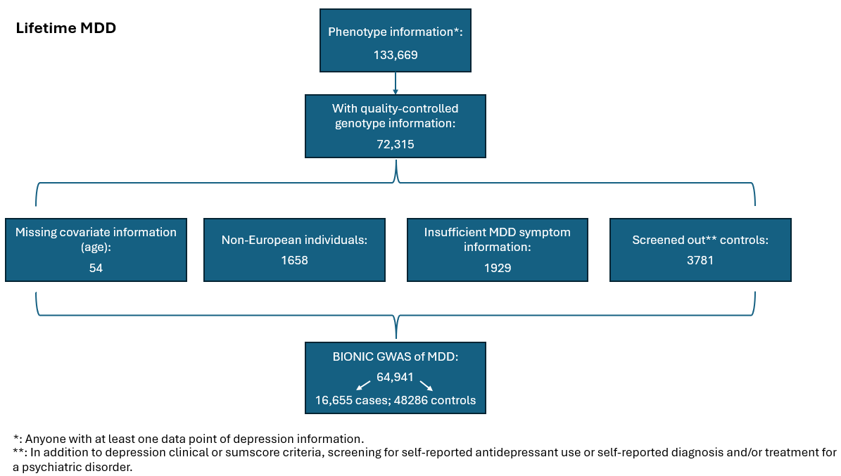
Supplementary Figure 1. Flowchart BIONIC GWAS of MDD sample.

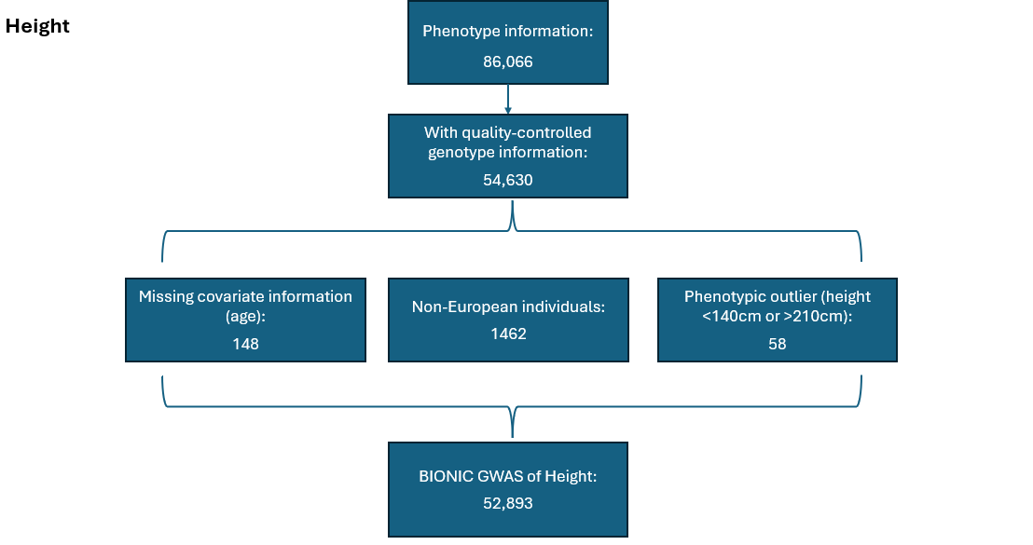
Supplementary Table 1. Demographic characteristics of the BIONIC GWAS sample (N = 64,941).
 | Full sample  N = 64,941 | MDD cases  N = 16,655 | MDD controls  N = 48,286
Age (mean years, SD) | 50.7 (16.0) | 48.7 (14.3) | 51.4 (16.5)
Sex, % female | 60.8% | 70.4% | 57.4%

Supplementary Figure 2. QQplot of genome-wide association mega-analysis of lifetime MDD.
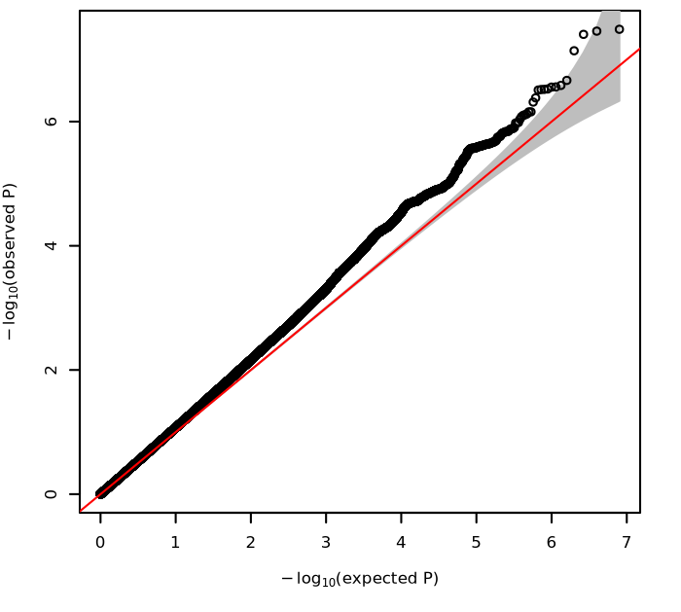
QQplot showing expected versus observed -log10 P-values from the genome-wide association mega-analysis of lifetime major depressive disorder (MDD) (N = 64,941).

Supplementary Figure 3. Regional association plot of the PALMD region.
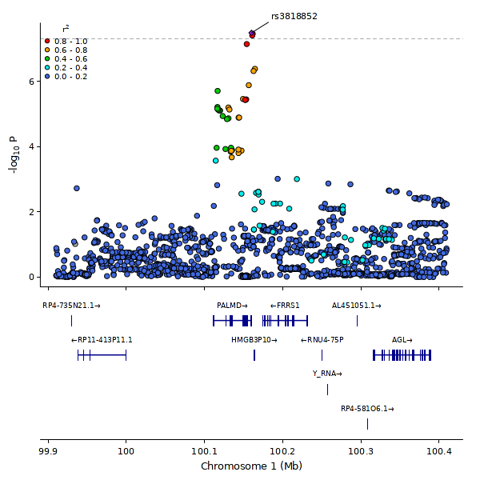
Regional association plot of the PALMD region, identified in the GWAS mega-analysis of lifetime MDD. The y-axis shows the -log10 p-values of the SNPs. The x-axis represents their chromosomal positions. Arrows mark the genomic locations of genes within the regions of interest based on the NCBI Build 37 human assembly. SNP colors indicate linkage disequilibrium with the top associated SNP. The figure was generated using LocusZoom (http://csg.sph.umich.edu/locuszoom/).

Supplementary Figure 4. QQplot of genome-wide association mega-analysis of height.
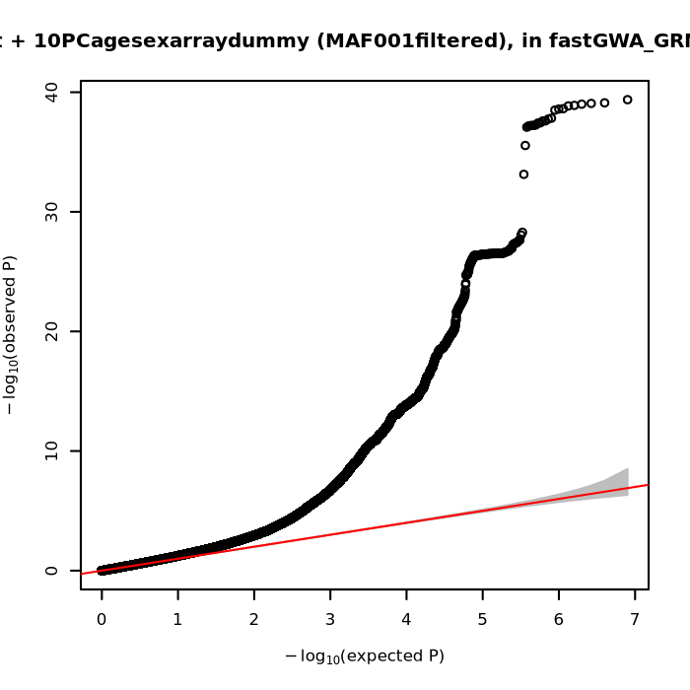
QQplot showing expected versus observed -log10 P-values from the genome-wide association mega-analysis of height (N = 52,893).

Supplementary Figure 5. Number of twins by MD PGS decile for discordantly affected and concordantly unaffected pairs.
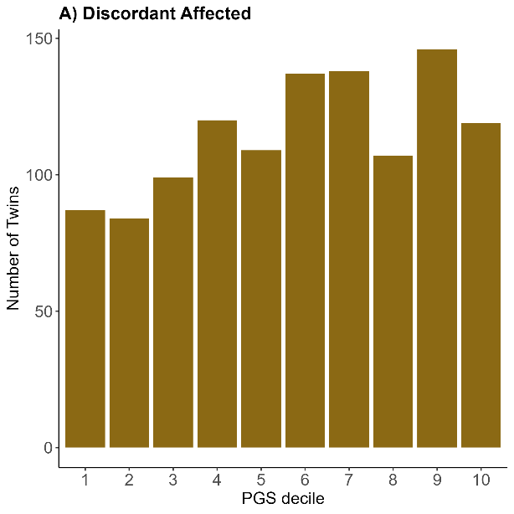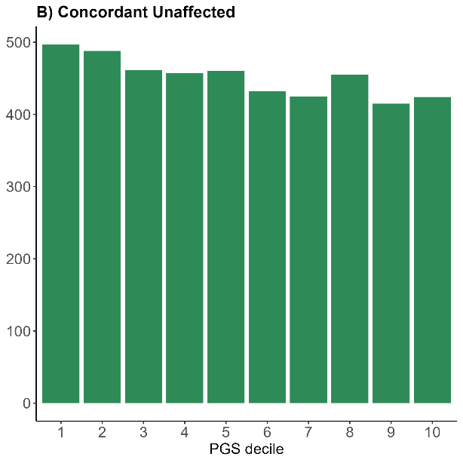
Number of twins per major depression (MD) polygenic score (PGS) decile by monozygotic and dizygotic twin major depressive disorder (MDD) concordance. A) Discordant affected twins (N = 1146). B) Concordant unaffected twins (N = 4514).

Within-Family Polygenic Score sensitivity models
The within-family major depression (MD) polygenic score (PGS) prediction of lifetime MDD described in the main text was repeated in a series of sensitivity analyses. First, data were restricted to sex-concordant dizygotic (DZ) twin pairs (N = 1408; 704 pairs) to evaluate a potentially confounding effect of sex in the main model. The MD PGS significantly predicted lifetime MDD in the global model (OR = 1.434, p = 9.52 x 10⁻⁹), and so did the between- and within-family MDD PGS predictors in the within-family model (OR = 1.409, p = 9.04 x 10⁻⁵; OR = 1.948, p = 1.09 x 10⁻⁶). Unlike the main model, the difference between the between- and within-family MD PGS effects was no longer significant (Χ² (1, N = 1408) = 0.609, p = 0.435), suggesting sex might be the main confounder in this analysis. Next, data were instead restricted to sex-discordant DZ twin pairs (N = 874; 437 pairs). Here, the MD PGS significantly predicted lifetime MDD in the global model (OR = 1.420, p = 3.73 x 10⁻⁴), and the between- and within-family MD PGS significantly predicted lifetime MDD in the within-family model (OR = 1.291, p = 0.039; OR = 2.254, p = 1.61 x 10⁻⁴). Similar to the main model, the difference in the between- and within-family MD PGS effects remained significant (Χ² (1, N = 874) = 5.033, p = 0.025). Finally, data were restricted to DZ twin pairs genotyped on the same array (N = 2084; 1042 pairs), to evaluate a potential confounding effect of genotype array in the main model. The MD PGS significantly predicted lifetime MDD in the global model (OR = 1.467, p = 5.62 x 10⁻⁹), and so did the between- and within-family MD PGS predictors in the within-family model (OR = 1.447, p = 3.43 x 10⁻⁵; OR = 1.880, p = 6.88 x 10⁻⁶). Unlike the main model, the difference in the between- and within-family MD PGS effects was not significant (Χ² (1, N = 2084) = 2.48, p = 0.116). The sensitivity analyses suggest that sex differences might be a potential source of confounding of the association between the MD PGS and lifetime MDD.

Twin concordance and PGS quartile in the Australian Genetics of Depression Study and NTR
The comparison of twin concordance and MD PGS was assessed in an independent twin sample, the Australian Genetics of Depression Study (AGDS). AGDS is an ongoing study on the genetic determinants of depression in Australia, spanning over 20,000 individuals of which over 15,000 also provided genotype information. PGSs were created using SBayesR software⁷¹ with weights derived from Adams et al.²¹. We computed MD PGS quartiles in the AGDS genotype sample (sample size did not allow for deciles) and restricted the sample to complete monozygotic (MZ) twin pairs with information on genotype and lifetime MDD status. We then plotted MD PGS quartiles against MZ twin concordance status: concordantly affected (N = 152 pairs), concordantly unaffected (853 pairs), and discordantly affected twins (426 pairs). We repeated the Netherlands Twin Register (NTR) analyses following this approach. Results in AGDS mirrored those from the main analyses, in that the fraction of concordant unaffected twins decreases in higher MD PGS quartiles, and the fraction of concordant affected twins increases in higher MD PGS quartiles (Supplementary Figure 6). This same pattern was observed for the alternative NTR definition (Supplementary Figure 7).

Supplementary Figure 6. Number of twins by MDD PGS quartile and by twin pair MDD concordance in AGDS.
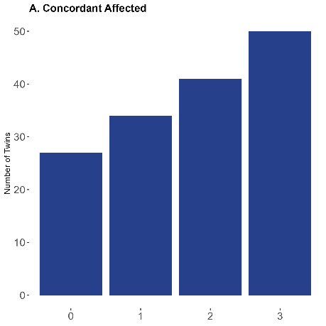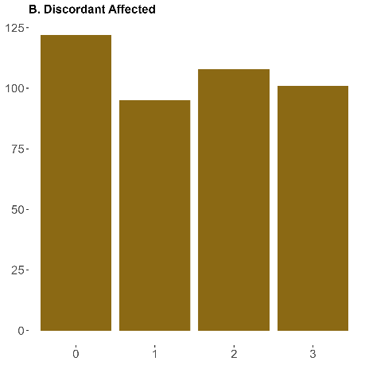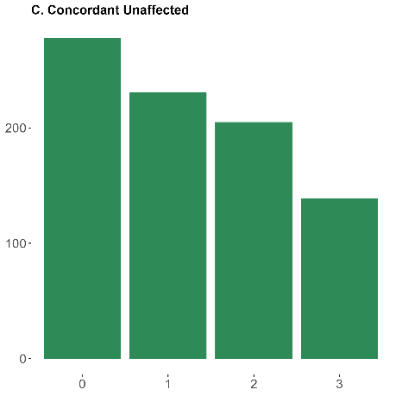
Number of twins per major depression (MD) polygenic score (PGS) decile by monozygotic twin major depressive disorder (MDD) concordance status in the Australian Genetics of Depression Study (AGDS).

Supplementary Figure 7. Number of twins by MDD PGS quartile and by twin pair MDD concordance in NTR.
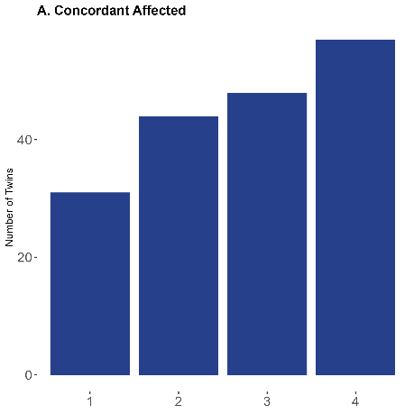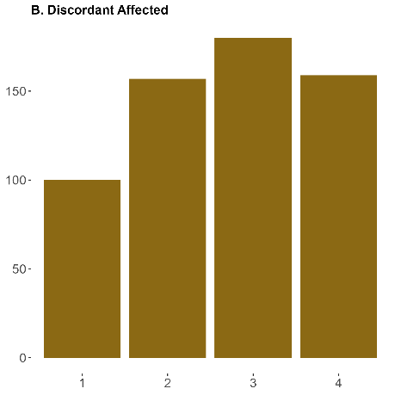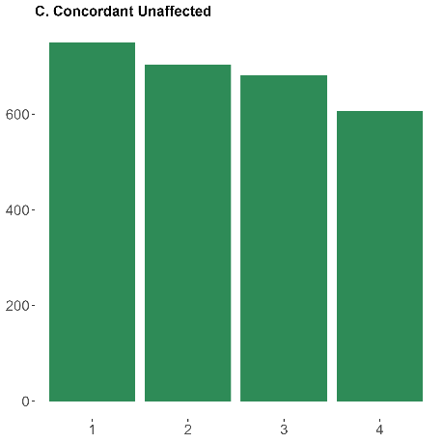
Number of twins per major depression (MD) polygenic score (PGS) decile by monozygotic twin major depressive disorder (MDD) concordance status in the Netherlands Twin Register (NTR).

Supplemental Figure 8. MAGMA tissue enrichment analysis of MDD.
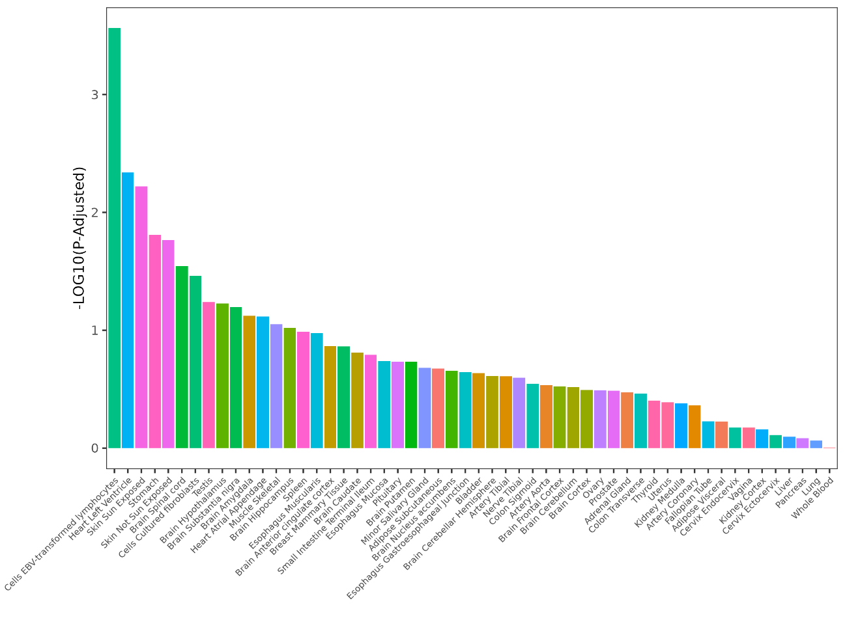
MAGMA tissue enrichment analysis of major depressive disorder (MDD). The x-axis shows 53 tissue types from the GTEx v8 database. The y-axis shows nominal -log10 P-values.

Genome-Wide Association Meta-Analysis of MDD
We conducted a fixed-effect genome-wide association meta-analysis of lifetime MDD in N = 64,941 Dutch individuals (16,655 cases) from the BIONIC study. First, genome-wide association analyses of lifetime MDD were conducted in in the seven array groups (specified in eMethods) in fastGWA¹⁷ from the Genome-wide Complex Trait Analysis (GCTA) software¹⁸, using a generalized linear mixed model. Except for genotype array, the same covariates as in the main analysis were applied: sex, age, and 10 ancestry-informative principal components. We computed a genetic relatedness matrix (GRM) in GCTA to address any relatedness in the sample. For computational efficiency, GRM values below 0.05 were set to 0 in a sparse GRM, which was included in the association analyses. SNPs with an allele frequency below 0.01 were excluded from analysis. GWAS results were filtered on imputation quality > 0.40 and Hardy Weinberg Equilibrium test p-value < 0.0001 and were meta-analyzed with the Genome-Wide Association Meta-Analysis (GWAMA) software⁷².
Results from the meta-analysis of MDD are presented in Supplementary Figure 9. The significant finding on chromosome 1 that was found in the GWAS mega-analysis did not reach significance in the meta-analysis, although it remained the top SNP and very close to the significance threshold. LDSC SNP-based heritability (SNP-h²) on the liability scale (N_{eff} = 63,742.64) was SNP-h² = 0.134 (0.016). The LDSC genetic correlation (r_{G}) with the GWAS mega-analysis (same sample, different method) was rG = 1.0853 (0.0131). The LDSC genetic correlation with the PGC-MD sumstats was rG = 0.866 (0.0484). Altogether, these results indicate the two methodologies yield highly similar results and are in line with minimal confounding due to genotype array.

Supplementary Figure 9. GWAS meta-analysis of lifetime major depressive disorder case-control status.
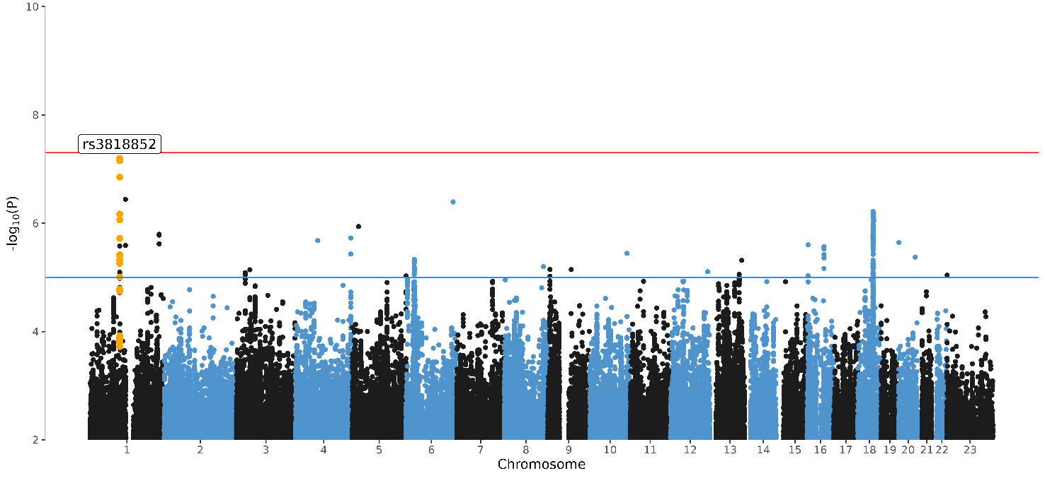
Manhattan Plot of the genome-wide association (GWAS) meta-analysis of lifetime major depressive disorder (MDD) in BIONIC. The x-axis indicates chromosomal position. Y-axis denotes -log10 P-value and indicates the strength of association between the single-nucleotide polymorphism and the outcome phenotype. The red line indicates Bonferroni-corrected genome-wide significance; P < 5x10⁻⁸. The blue line indicates suggestive singificance; P < 5x10⁻⁵.

Additional screening of lifetime MDD controls
In the main GWAS model, lifetime MDD controls (as defined through DSM-5 criteria or low scores on depression questionnaires) were screened for a history of diagnosis or treatment for a range of psychopathology and antidepressant use. Lifetime MDD controls who reported ‘yes’ to any of these measures were excluded from analyses. Although common for MDD, screening controls for any psychiatric disorder can lead to the selection of super-controls, i.e., individuals who are healthier than expected by chance⁷³. Such controls could be especially depleted for deleterious variants, violating the random effects assumption of GWAS. This would, in turn, lead to biased SNP-based heritability (SNP-h²) and genetic correlation (r_{G}) estimates.
Here we considered the effect of additional screening of lifetime MDD controls on SNP-h² and r_{G} with the main model and PGC-MD results. For this we defined an alternative phenotype definition where lifetime MDD controls were screened only for depression and not for additional psychopathology. We ran a GWAS mega-analysis of MDD in 67,440 individuals (16,655 lifetime MDD cases and 50,785 controls) in fastGWA¹⁸ using identical parameters and covariates as the main model (sex, age, genotype array, 10 ancestry-informative PCs, and relatedness). SNP-h² and r_{G} estimates were calculated in LDSC²².
In this model with no additional screening of lifetime MDD controls, we found a SNP-h² on the liability scale (Neff = 66,124.13) of 0.118 (0.015). Genetic correlation with the main model was r_{G} = 0.9991 (0.0008). Genetic correlation with the PGC-MD GWAS results was r_{G} = 0.869 (0.0497). These results suggest minimal bias due to the exclusion of individuals diagnosed with other psychiatric disorder from the control population.
References
1. Huider F, Milaneschi Y, Hottenga JJ, et al. Genomics Research of Lifetime Depression in the Netherlands: The BIObanks Netherlands Internet Collaboration (BIONIC) Project. Twin Res Hum Genet. Published online March 18, 2024:1-11. doi:10.1017/thg.2024.4
2. American Psychiatric Association. Diagnostic and Statistical Manual of Mental Disorders (DSM-5®). 5th ed. American Psychiatric Association; 2013.
3. Bot M, Middeldorp CM, de Geus EJC, et al. Validity of LIDAS (LIfetime Depression Assessment Self-report): a self-report online assessment of lifetime major depressive disorder. Psychol Med. 2017;47(2):279-289. doi:10.1017/S0033291716002312
4. McCarthy S, Das S, Kretzschmar W, et al. A reference panel of 64,976 haplotypes for genotype imputation. Nat Genet. 2016;48(10):1279-1283. doi:10.1038/ng.3643
5. Purcell S, Neale B, Todd-Brown K, et al. PLINK: A Tool Set for Whole-Genome Association and Population-Based Linkage Analyses. Am J Hum Genet. 2007;81(3):559-575.
6. Auton A, Abecasis GR, Altshuler DM, et al. A global reference for human genetic variation. Nature. 2015;526(7571):68-74. doi:10.1038/nature15393
7. Novembre J, Stephens M. Interpreting principal component analyses of spatial population genetic variation. Nat Genet. 2008;40(5):646-649. doi:10.1038/ng.139
8. Kessler RC, Andrews G, Mroczek D, Ustun B, Wittchen HU. The World Health Organization Composite International Diagnostic Interview short-form (CIDI-SF). Int J Methods Psychiatr Res. 1998;7(4):171-185. doi:https://doi.org/10.1002/mpr.47
9. Fedko IO, Hottenga JJ, Helmer Q, et al. Measurement and genetic architecture of lifetime depression in the Netherlands as assessed by LIDAS (Lifetime Depression Assessment Self-report). Psychol Med. Published online 2020:1-10. doi:10.1017/S0033291720000100
10. Huider F, Milaneschi Y, van der Zee MD, et al. Major Depressive Disorder and Lifestyle: Correlated Genetic Effects in Extended Twin Pedigrees. Genes. 2021;12(10):1509. doi:10.3390/genes12101509
11. van de Weijer MP, Pelt DHM, Baselmans BML, et al. Capturing the well-being exposome in poly-environmental scores. J Environ Psychol. 2024;93:102208. doi:10.1016/j.jenvp.2023.102208
12. van Loo HM, Aggen SH, Kendler KS. The structure of the symptoms of major depression: Factor analysis of a lifetime worst episode of depressive symptoms in a large general population sample. J Affect Disord. 2022;307:115-124. doi:10.1016/j.jad.2022.03.064
13. Vreijling SR, van Haeringen M, Milaneschi Y, et al. Sociodemographic, lifestyle and clinical characteristics of energy-related depression symptoms: A pooled analysis of 13,965 depressed cases in 8 Dutch cohorts. J Affect Disord. 2023;323:1-9. doi:10.1016/j.jad.2022.11.005
14. Sheehan DV, Lecrubier Y, Sheehan H, et al. The Mini-International Neuropsychiatric Interview (M.I.N.I.): The Development and Validation of a Structured Diagnostic Psychiatric Interview for DSM-IV and ICD-10. J Clin Psychiatry. 2018;(59):22-33.
15. Robins LN, Helzer JE, Croughan J, Ratcliff KS. National Institute of Mental Health Diagnostic Interview Schedule: Its History, Characteristics, and Validity. Arch Gen Psychiatry. 1981;38(4):381-389. doi:10.1001/archpsyc.1981.01780290015001
16. Boomsma DI, Beem AL, Berg M van den, et al. Netherlands twin family study of anxious depression (NETSAD). Twin Res Hum Genet. 2000;3(4):323-334. doi:10.1375/twin.3.4.323
17. Jiang L, Zheng Z, Qi T, et al. A resource-efficient tool for mixed model association analysis of large-scale data. Nat Genet. 2019;51(12):1749-1755. doi:10.1038/s41588-019-0530-8
18. Yang J, Lee SH, Goddard ME, Visscher PM. GCTA: A Tool for Genome-wide Complex Trait Analysis. Am J Hum Genet. 2011;88(1):76-82. doi:10.1016/j.ajhg.2010.11.011
19. Yang J, Ferreira T, Morris AP, et al. Conditional and joint multiple-SNP analysis of GWAS summary statistics identifies additional variants influencing complex traits. Nat Genet. 2012;44(4):369-S3. doi:10.1038/ng.2213
20. Manichaikul A, Mychaleckyj JC, Rich SS, Daly K, Sale M, Chen WM. Robust relationship inference in genome-wide association studies. Bioinformatics. 2010;26(22):2867-2873. doi:10.1093/bioinformatics/btq559
21. Adams MJ, Streit F, Meng X, et al. Trans-ancestry genome-wide study of depression identifies 697 associations implicating cell types and pharmacotherapies. Cell. 2025;0(0). doi:10.1016/j.cell.2024.12.002
22. Bulik-Sullivan BK, Loh PR, Finucane HK, et al. LD Score regression distinguishes confounding from polygenicity in genome-wide association studies. Nat Genet. 2015;47(3):291-295. doi:10.1038/ng.3211
23. Ip HF, van der Laan CM, Krapohl EML, et al. Genetic association study of childhood aggression across raters, instruments, and age. Transl Psychiatry. 2021;11(1):1-9. doi:10.1038/s41398-021-01480-x
24. Grotzinger AD, Rhemtulla M, de Vlaming R, et al. Genomic structural equation modelling provides insights into the multivariate genetic architecture of complex traits. Nat Hum Behav. 2019;3(5):513-525. doi:10.1038/s41562-019-0566-x
25. Demange PA, Malanchini M, Mallard TT, et al. Investigating the genetic architecture of noncognitive skills using GWAS-by-subtraction. Nat Genet. 2021;53(1):35-44. doi:10.1038/s41588-020-00754-2
26. Adams MJ, Lewis CM, Andrew M. McIntosh, for the Psychiatric Genomics Consortium Major Depressive Disorder Working Group. Genome-wide study of half a million individuals with major depression identifies 697 independent associations, infers causal neuronal subtypes and biological targets for novel pharmacotherapies. Published online June 24, 2024:2024.04.29.24306535. doi:10.1101/2024.04.29.24306535
27. Vilhjálmsson BJ, Yang J, Finucane HK, et al. Modeling Linkage Disequilibrium Increases Accuracy of Polygenic Risk Scores. Am J Hum Genet. 2015;97(4):576-592. doi:10.1016/j.ajhg.2015.09.001
28. Bycroft C, Freeman C, Petkova D, et al. The UK Biobank resource with deep phenotyping and genomic data. Nature. 2018;562(7726):203-209. doi:10.1038/s41586-018-0579-z
29. Lee SH, Goddard ME, Wray NR, Visscher PM. A Better Coefficient of Determination for Genetic Profile Analysis. Genet Epidemiol. 2012;36(3):214-224. doi:10.1002/gepi.21614
30. Savage JE, Barr PB, Phung T, et al. Genetic Heterogeneity Across Dimensions of Alcohol Use Behaviors. Am J Psychiatry. 2024;181(11):1006-1017. doi:10.1176/appi.ajp.20231055
31. Nielsen R, Paul JS, Albrechtsen A, Song YS. Genotype and SNP calling from next-generation sequencing data. Nat Rev Genet. 2011;12(6):443. doi:10.1038/nrg2986
32. Fairley S, Lowy-Gallego E, Perry E, Flicek P. The International Genome Sample Resource (IGSR) collection of open human genomic variation resources. Nucleic Acids Res. 2019;48(D1):D941. doi:10.1093/nar/gkz836
33. Abraham G, Qiu Y, Inouye M. FlashPCA2: principal component analysis of Biobank-scale genotype datasets. Bioinformatics. 2017;33(17):2776-2778. doi:10.1093/bioinformatics/btx299
34. Howard DM, Adams MJ, Shirali M, et al. Genome-wide association study of depression phenotypes in UK Biobank identifies variants in excitatory synaptic pathways. Nat Commun. 2018;9(1):1470. doi:10.1038/s41467-018-03819-3
35. Kong A, Thorleifsson G, Frigge ML, et al. The nature of nurture: Effects of parental genotypes. Science. 2018;359(6374):424-428. doi:10.1126/science.aan6877
36. Pingault JB, O’Reilly PF, Schoeler T, Ploubidis GB, Rijsdijk F, Dudbridge F. Using genetic data to strengthen causal inference in observational research. Nat Rev Genet. 2018;19(9):566-580. doi:10.1038/s41576-018-0020-3
37. Plomin R, DeFries JC, Loehlin JC. Genotype-environment interaction and correlation in the analysis of human behavior. Psychol Bull. 1977;84(2):309-322. doi:10.1037/0033-2909.84.2.309
38. Selzam S, Ritchie SJ, Pingault JB, Reynolds CA, O’Reilly PF, Plomin R. Comparing Within- and Between-Family Polygenic Score Prediction. Am J Hum Genet. 2019;105(2):351-363. doi:10.1016/j.ajhg.2019.06.006
39. Clogg CC, Petkova E, Haritou A. Statistical Methods for Comparing Regression Coefficients Between Models. Am J Sociol. 1995;100(5):1261-1293. doi:10.1086/230638
40. Paternoster R, Brame R, Mazerolle P, Piquero A. Using the Correct Statistical Test for the Equality of Regression Coefficients. Criminology. 1998;36(4):859-866. doi:10.1111/j.1745-9125.1998.tb01268.x
41. Byrne EM, Kirk KM, Medland SE, et al. Cohort profile: the Australian genetics of depression study. BMJ Open. 2020;10(5):e032580. doi:10.1136/bmjopen-2019-032580
42. Song J, Pasman JA, Johansson V, et al. Polygenic Risk Scores and Twin Concordance for Schizophrenia and Bipolar Disorder. JAMA Psychiatry. Published online August 28, 2024. doi:10.1001/jamapsychiatry.2024.2406
43. Cuéllar-Partida G, Lundberg M, Kho PF, et al. Complex-Traits Genetics Virtual Lab: A community-driven web platform for post-GWAS analyses. Published online May 9, 2019:518027. doi:10.1101/518027
44. O’Connor LJ, Price AL. Distinguishing genetic correlation from causation across 52 diseases and complex traits. Nat Genet. 2018;50(12):1728-1734. doi:10.1038/s41588-018-0255-0
45. García-Marín LM, Campos AI, Cuéllar-Partida G, Medland SE, Kollins SH, Rentería ME. Large-scale genetic investigation reveals genetic liability to multiple complex traits influencing a higher risk of ADHD. Sci Rep. 2021;11(1):22628. doi:10.1038/s41598-021-01517-7
46. García-Marín LM, Campos AI, Martin NG, Cuéllar-Partida G, Rentería ME. Inference of causal relationships between sleep-related traits and 1,527 phenotypes using genetic data. Sleep. 2021;44(1):zsaa154. doi:10.1093/sleep/zsaa154
47. Haworth S, Kho PF, Holgerson PL, et al. Assessment and visualization of phenome-wide causal relationships using genetic data: an application to dental caries and periodontitis. Eur J Hum Genet. 2021;29(2):300-308. doi:10.1038/s41431-020-00734-4
48. de Leeuw CA, Mooij JM, Heskes T, Posthuma D. MAGMA: Generalized Gene-Set Analysis of GWAS Data. PLoS Comput Biol. 2015;11(4):e1004219. doi:10.1371/journal.pcbi.1004219
49. Schipper M, de Leeuw CA, Maciel BAPC, et al. Prioritizing effector genes at trait-associated loci using multimodal evidence. Nat Genet. 2025;57(2):323-333. doi:10.1038/s41588-025-02084-7
50. Weeks EM, Ulirsch JC, Cheng NY, et al. Leveraging polygenic enrichments of gene features to predict genes underlying complex traits and diseases. Nat Genet. 2023;55(8):1267-1276. doi:10.1038/s41588-023-01443-6
51. Benner C, Havulinna AS, Järvelin MR, Salomaa V, Ripatti S, Pirinen M. Prospects of Fine-Mapping Trait-Associated Genomic Regions by Using Summary Statistics from Genome-wide Association Studies. Am J Hum Genet. 2017;101(4):539-551. doi:10.1016/j.ajhg.2017.08.012
52. Benner C, Spencer CCA, Havulinna AS, Salomaa V, Ripatti S, Pirinen M. FINEMAP: efficient variable selection using summary data from genome-wide association studies. Bioinformatics. 2016;32(10):1493-1501. doi:10.1093/bioinformatics/btw018
53. Picavet HSJ, Blokstra A, Spijkerman AM, Verschuren WM. Cohort Profile Update: The Doetinchem Cohort Study 1987–2017: lifestyle, health and chronic diseases in a life course and ageing perspective. Int J Epidemiol. 2017;46(6):1751. doi:10.1093/ije/dyx103
54. Rutters F, Nijpels G, Elders P, et al. Cohort Profile: The Hoorn Studies. Int J Epidemiol. 2018;47(2):396-396j. doi:10.1093/ije/dyx227
55. Heijden AA van der, Rauh SP, Dekker JM, et al. The Hoorn Diabetes Care System (DCS) cohort. A prospective cohort of persons with type 2 diabetes treated in primary care in the Netherlands. BMJ Open. 2017;7(5):e015599. doi:10.1136/bmjopen-2016-015599
56. Hoogendijk EO, Deeg DJH, Breij S de, et al. The Longitudinal Aging Study Amsterdam: cohort update 2019 and additional data collections. Eur J Epidemiol. 2020;35(1):61. doi:10.1007/s10654-019-00541-2
57. van Loo HM, Beijers L, Wieling M, de Jong TR, Schoevers RA, Kendler KS. Prevalence of internalizing disorders, symptoms, and traits across age using advanced nonlinear models. Psychol Med. 2023;53(1):78-87. doi:10.1017/S0033291721001148
58. Francioli LC, Menelaou A, Pulit SL, et al. Whole-genome sequence variation, population structure and demographic history of the Dutch population. Nat Genet. 2014;46(8):818-825. doi:10.1038/ng.3021
59. Sijtsma A, Rienks J, van der Harst P, Navis G, Rosmalen JGM, Dotinga A. Cohort Profile Update: Lifelines, a three-generation cohort study and biobank. Int J Epidemiol. 2022;51(5):e295-e302. doi:10.1093/ije/dyab257
60. Lever-van Milligen BA, Verhoeven JE, Schmaal L, et al. The impact of depression and anxiety treatment on biological aging and metabolic stress: study protocol of the Mood treatment with antidepressants or running (MOTAR) study. BMC Psychiatry. 2019;19(1):425. doi:10.1186/s12888-019-2404-0
61. Bot M, Brouwer IA, Roca M, et al. Effect of Multinutrient Supplementation and Food-Related Behavioral Activation Therapy on Prevention of Major Depressive Disorder Among Overweight or Obese Adults With Subsyndromal Depressive Symptoms: The MooDFOOD Randomized Clinical Trial. JAMA. 2019;321(9):858-868. doi:10.1001/jama.2019.0556
62. Cabout M, Brouwer IA, Visser M, the MooDFOOD Consortium. The MooDFOOD project: Prevention of depression through nutritional strategies. Nutr Bull. 2017;42(1):94-103. doi:10.1111/nbu.12254
63. Galesloot TE, Vermeulen SH, Swinkels DW, et al. Cohort Profile: The Nijmegen Biomedical Study (NBS). Int J Epidemiol. 2017;46(4):1099-1100j. doi:10.1093/ije/dyw268
64. Penninx BWJH, Eikelenboom M, Giltay EJ, et al. Cohort profile of the longitudinal Netherlands Study of Depression and Anxiety (NESDA) on etiology, course and consequences of depressive and anxiety disorders. J Affect Disord. 2021;287:69-77. doi:10.1016/j.jad.2021.03.026
65. Comijs HC, van Marwijk HW, van der Mast RC, et al. The Netherlands study of depression in older persons (NESDO); a prospective cohort study. BMC Res Notes. 2011;4(1):524. doi:10.1186/1756-0500-4-524
66. Brouwer-Brolsma EM, van Lee L, Streppel MT, et al. Nutrition Questionnaires plus (NQplus) study, a prospective study on dietary determinants and cardiometabolic health in Dutch adults. BMJ Open. 2018;8(7):e020228. doi:10.1136/bmjopen-2017-020228
67. Boomsma DI, Willemsen G, Vink JM, et al. Design and Implementation of a Twin-Family Database for Behavior Genetics and Genomics Studies. Twin Res Hum Genet. 2008;11(3):342-348. doi:10.1375/twin.11.3.342
68. Willemsen G, Geus EJC de, Bartels M, et al. The Netherlands Twin Register Biobank: A Resource for Genetic Epidemiological Studies. Twin Res Hum Genet. 2010;13(3):231-245. doi:10.1375/twin.13.3.231
69. Ligthart L, Beijsterveldt CEM van, Kevenaar ST, et al. The Netherlands Twin Register: Longitudinal Research Based on Twin and Twin-Family Designs. Twin Res Hum Genet. 2019;22(6):623-636. doi:10.1017/thg.2019.93
70. Oldehinkel AJ, Rosmalen JG, Buitelaar JK, et al. Cohort Profile Update: The TRacking Adolescents’ Individual Lives Survey (TRAILS). Int J Epidemiol. 2015;44(1):76-76n. doi:10.1093/ije/dyu225
71. Lloyd-Jones LR, Zeng J, Sidorenko J, et al. Improved polygenic prediction by Bayesian multiple regression on summary statistics. Nat Commun. 2019;10(1):5086. doi:10.1038/s41467-019-12653-0
72. Mägi R, Morris AP. GWAMA: software for genome-wide association meta-analysis. BMC Bioinformatics. 2010;11(1):288. doi:10.1186/1471-2105-11-288
73. Kendler KS, Chatzinakos C, Bacanu SA. The impact on estimations of genetic correlations by the use of super-normal, unscreened, and family-history screened controls in genome wide case–control studies. Genet Epidemiol. 2020;44(3):283-289. doi:10.1002/gepi.22281

