Table S1. Threshold effects analysis of the association of BW with BMI, WC, WHtR, and FLI among adolescents.
 | BW<=3 | BW >3 | P-interaction
 | Coeff. (95%CI) P-value | Coeff. (95%CI) P-value
BMI
BW | -0.069 (-0.876, 0.739) 0.8676 | 1.453 (0.885, 2.021) <0.0001 | 0.0011
WC
BW | -0.117 (-2.345, 2.110) 0.9180 | 4.088 (2.530, 5.647) <0.0001 | 0.0007
WHtR
BW | -0.001 (-0.014, 0.011) 0.8301 | 0.016 (0.007, 0.024) 0.0006 | 0.0168
FLI
BW | -0.847 (-4.478, 2.783) 0.6479 | 5.598 (2.902, 8.294) 0.0001 | 0.0024
Table S2. Threshold effects analysis of the association of BW with general obesity, central obesity, and hepatic steatosis among adolescents.
 | OR (95%CI) P-value | OR (95%CI) P-value | P-interaction
BMI | BW<=2.53 | BW>2.53
BW | 0.780 (0.251, 2.422) 0.6681 | 1.915 (1.470, 2.494) <0.0001 | 0.1288
WC | BW<=2.66 | BW>2.66
BW | 1.429 (0.827, 2.468) 0.2028 | 1.430 (1.174, 1.743) 0.0005 | 0.9968
WHtR | BW<=2.66 | BW>2.66
BW | 1.355 (0.832, 2.206) 0.2240 | 1.237 (1.027, 1.490) 0.0262 | 0.7339
FLI | BW<=2.66 | BW>2.66
BW | 1.076 (0.564, 2.052) 0.8239 | 1.719 (1.341, 2.202) <0.0001 | 0.1650
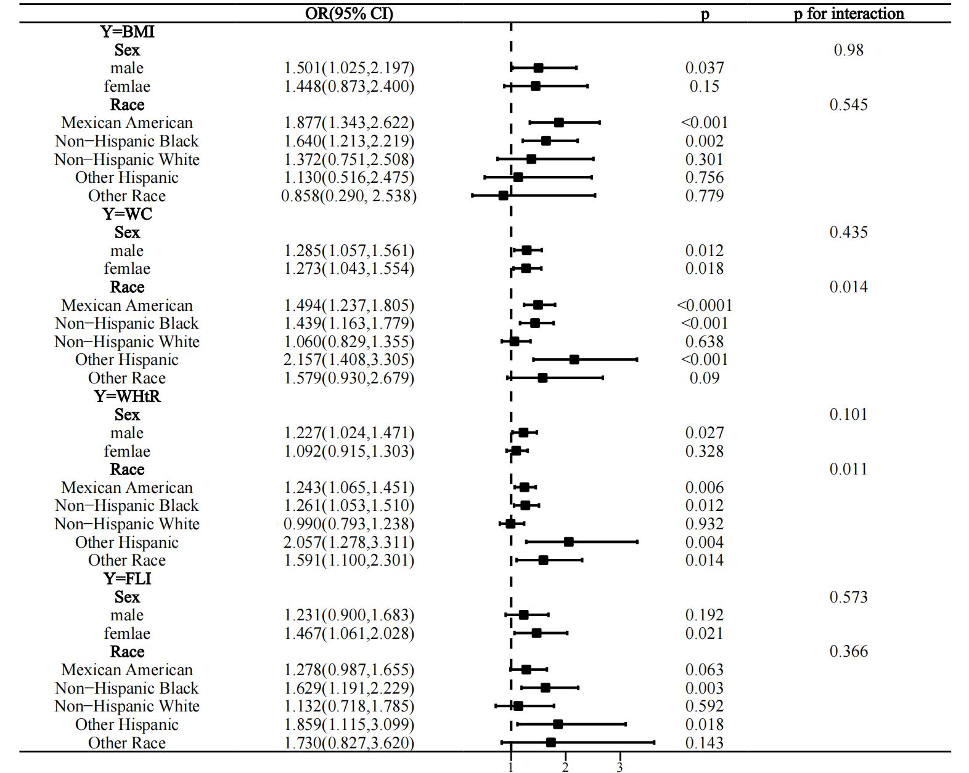
Figure S1. Stratified analysis of the association of BW with obesity and hepatic steatosis in adolescents.

