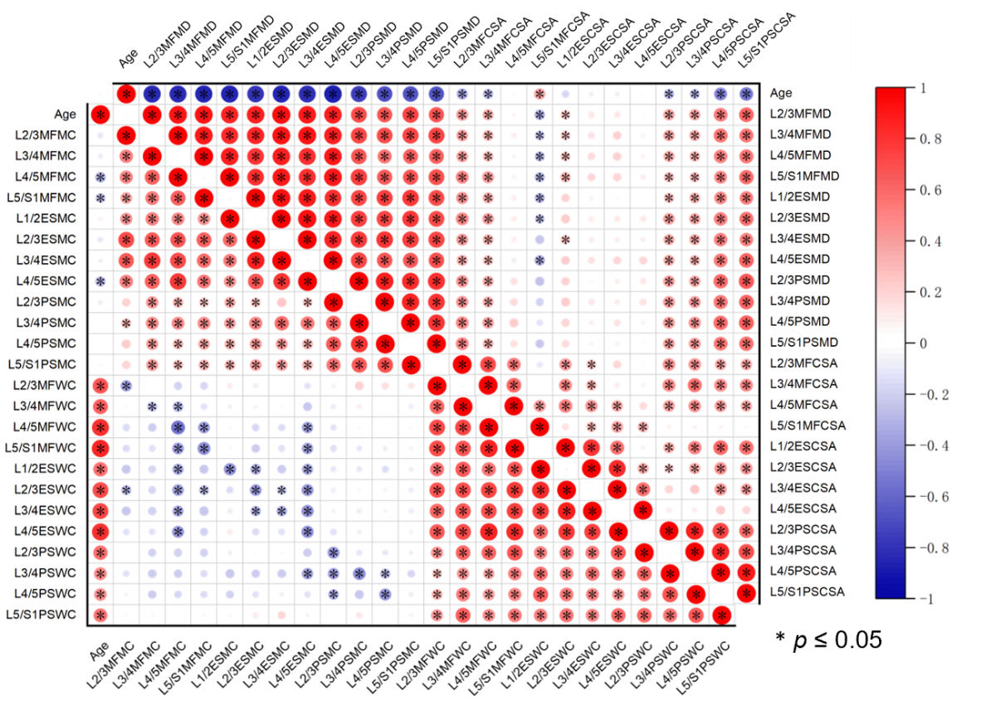
Figure S1 The correlation between paraspinal muscle parameters and age in males. Blue indicates a negative correlation, while red represents a positive correlation; the deeper the color and the larger the area of the block, the higher the correlation.

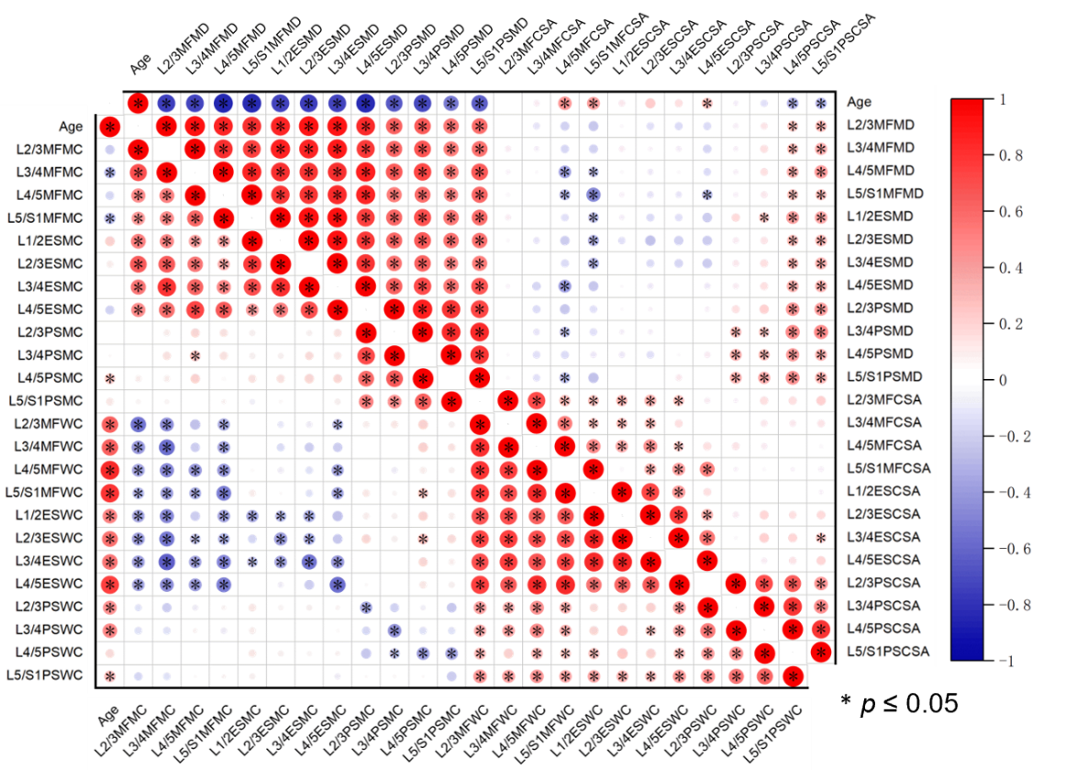
Figure S2 The correlation between paraspinal muscle parameters and age in females. Blue indicates a negative correlation, while red represents a positive correlation; the deeper the color and the larger the area of the block, the higher the correlation.

