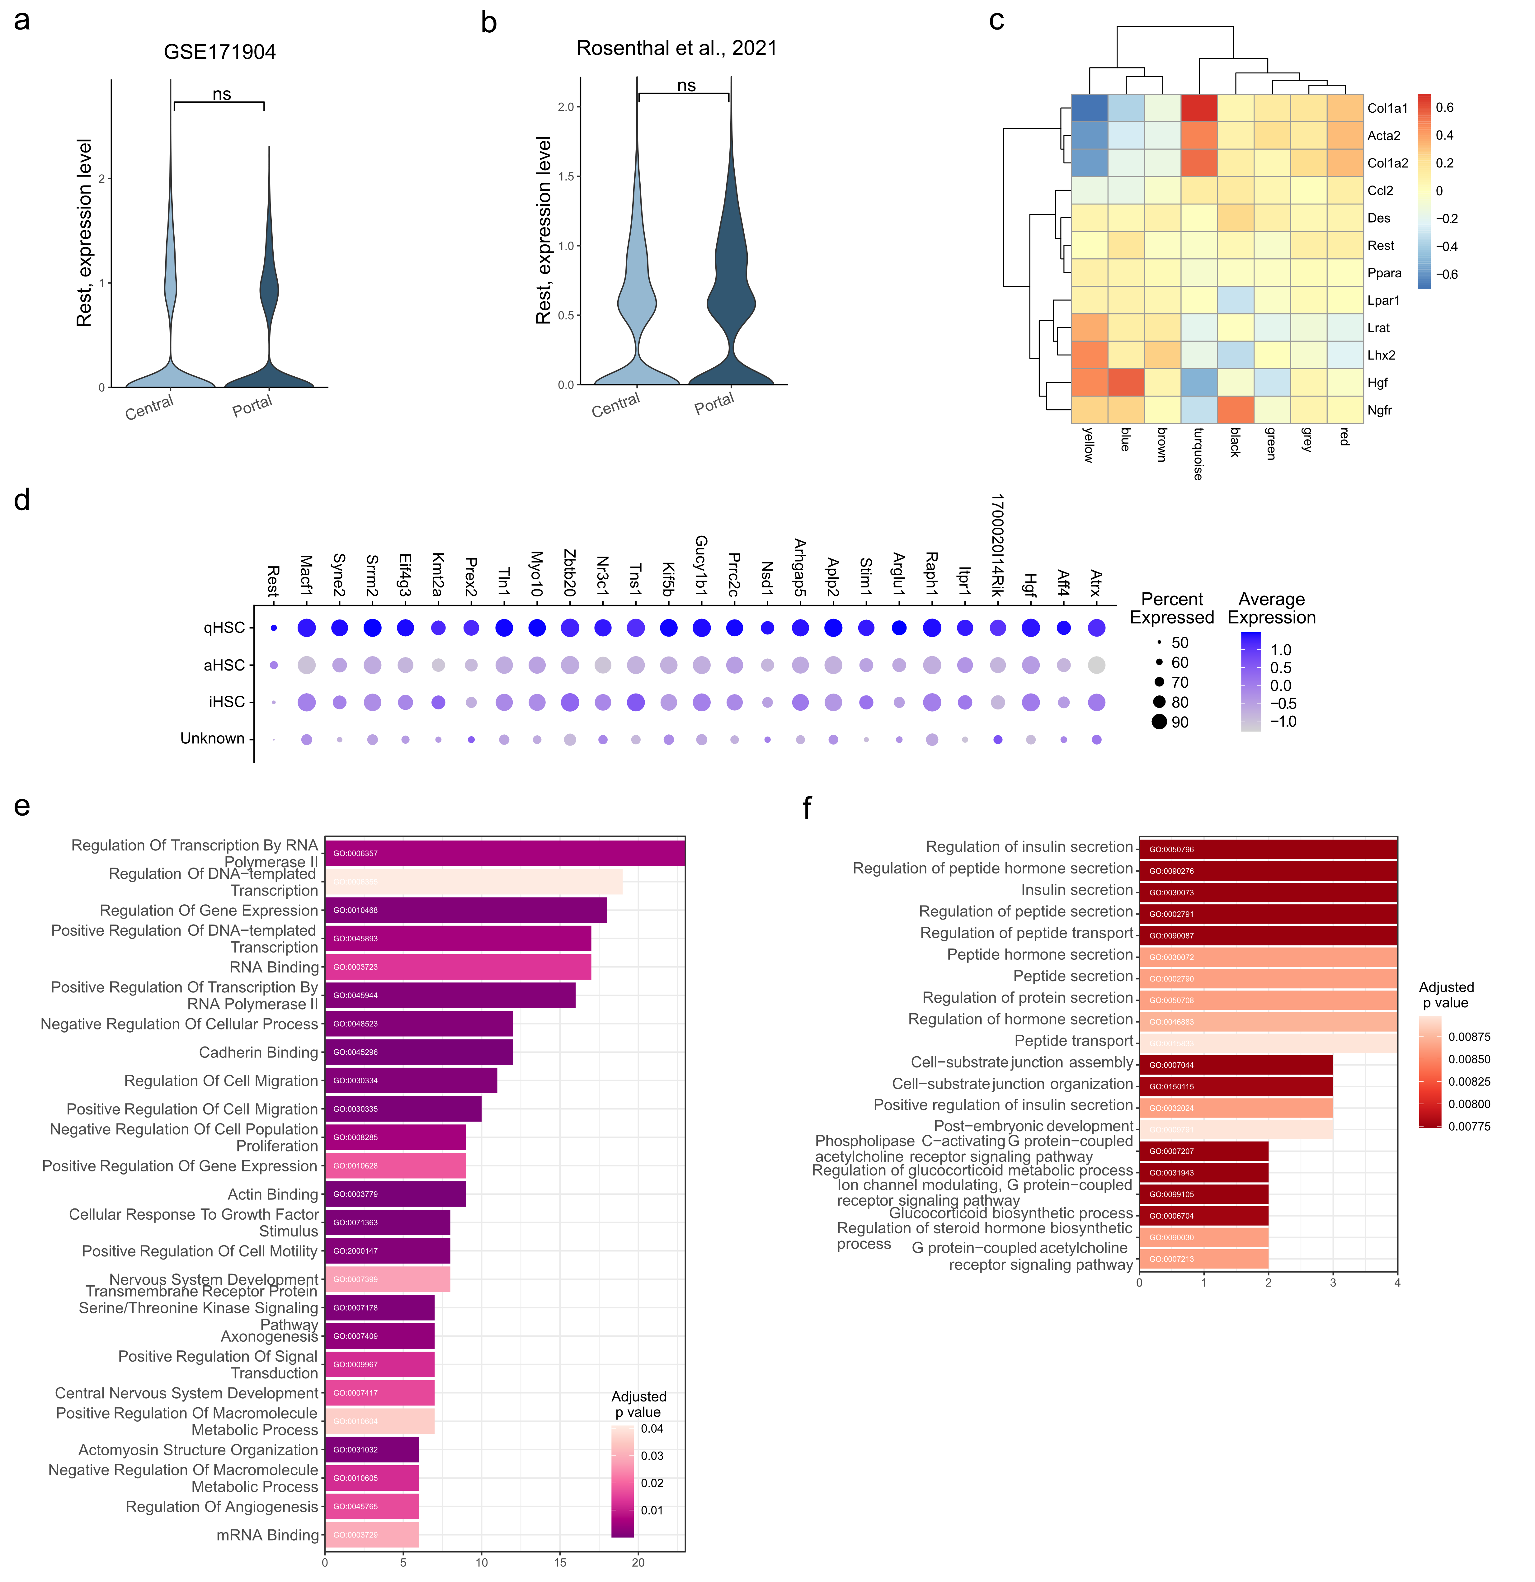
Figure S1: REST expression is associated with HSC activation in mouse models of MASH. (a-b) Violin plot of REST mRNA levels in central and portal vein-associated HSCs from GSE171904 (a) and Rosenthal et al., 2021 (b) dataset. (c) Heatmap of Eigengene-based connectivity (kME) for qHSC- and aHSC-associated genes per module. (d) Dot plot of top 25 genes correlated to Rest sorted by topological overlap between Rest and GOI. (e) Bar graph of enrichment for GO terms in the module designated “blue”. (f) Bar graph of enriched GO terms with adjusted p value < 0.01 from GO enrichment analysis of top 25 Rest-correlated genes.

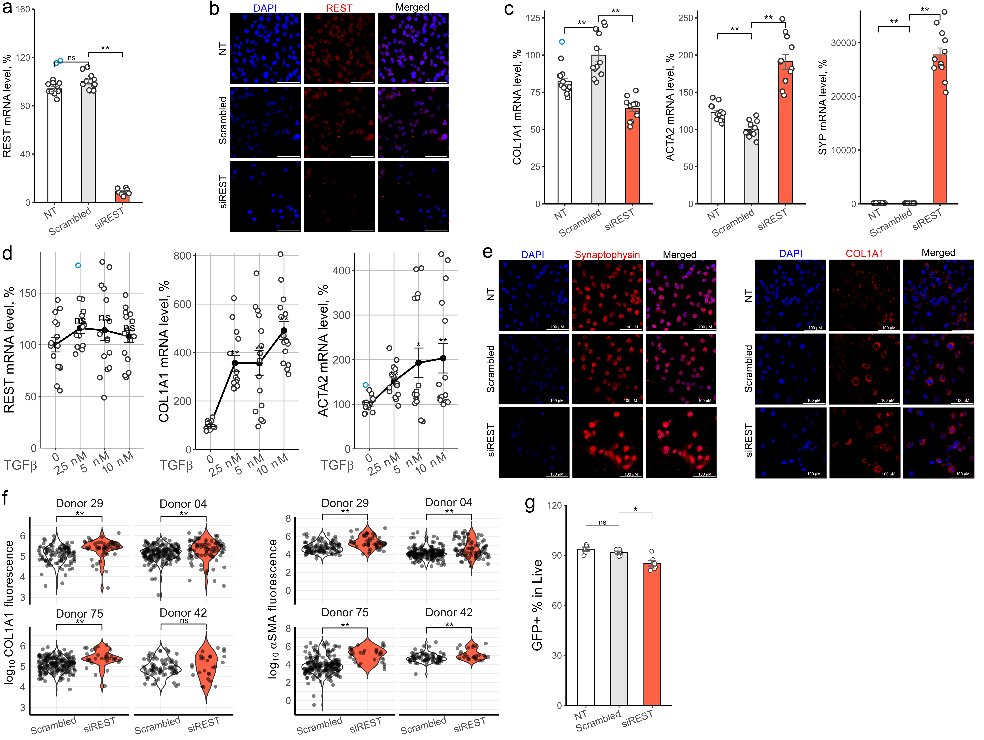
Figure S2: REST regulates activation of LX2 cells. (a-c,e) LX2 cells were transfected with scrambled or REST siRNA for 96h. (a, c) Gene expression following REST KD in LX2 cells (n=3). Bars show mean±SEM, normalized to PPIA, SDHA and RPLP0 and expressed relative to mean of scrambled siRNA-transfected cells (t test, Hommel test for multiple comparison correction). (b, e) Representative images of REST (b), SYP (e) and COL1A1 (e) protein level in LX2 cells following siRNA transfection (n=2). Confocal microscopy. (d) Gene expression following in LX2 cells following TGFβ exposure. Cells were serum-starved for 24h and exposed to TGFβ for 48h (n=4). The Y axis shows TGFβ concentration. Bars show mean±SEM, normalized to PPIA, SDHA and RPLP0 and expressed relative to mean of scrambled siRNA-transfected cells (t test, Hommel test for multiple comparison correction). (f) Violin plots showing COL1A1 (g) and αSMA (h) protein level in activated phHSCs. Confocal microscopy (Mann-Whitney U test). (g) Bar graph showing percentage of GFP⁺ LX2 cells following REST knock down (n=2). LX2 cells expressing EGFP under control of COL1A1 promoter were transfected with scrambled siRNA or siRNA targeting REST for 96h and GFP fluorescence was measured using flow cytometry (t test, Hommel test for multiple comparison correction). Outliers are indicated in blue. *p<0.05, **p<0.01.

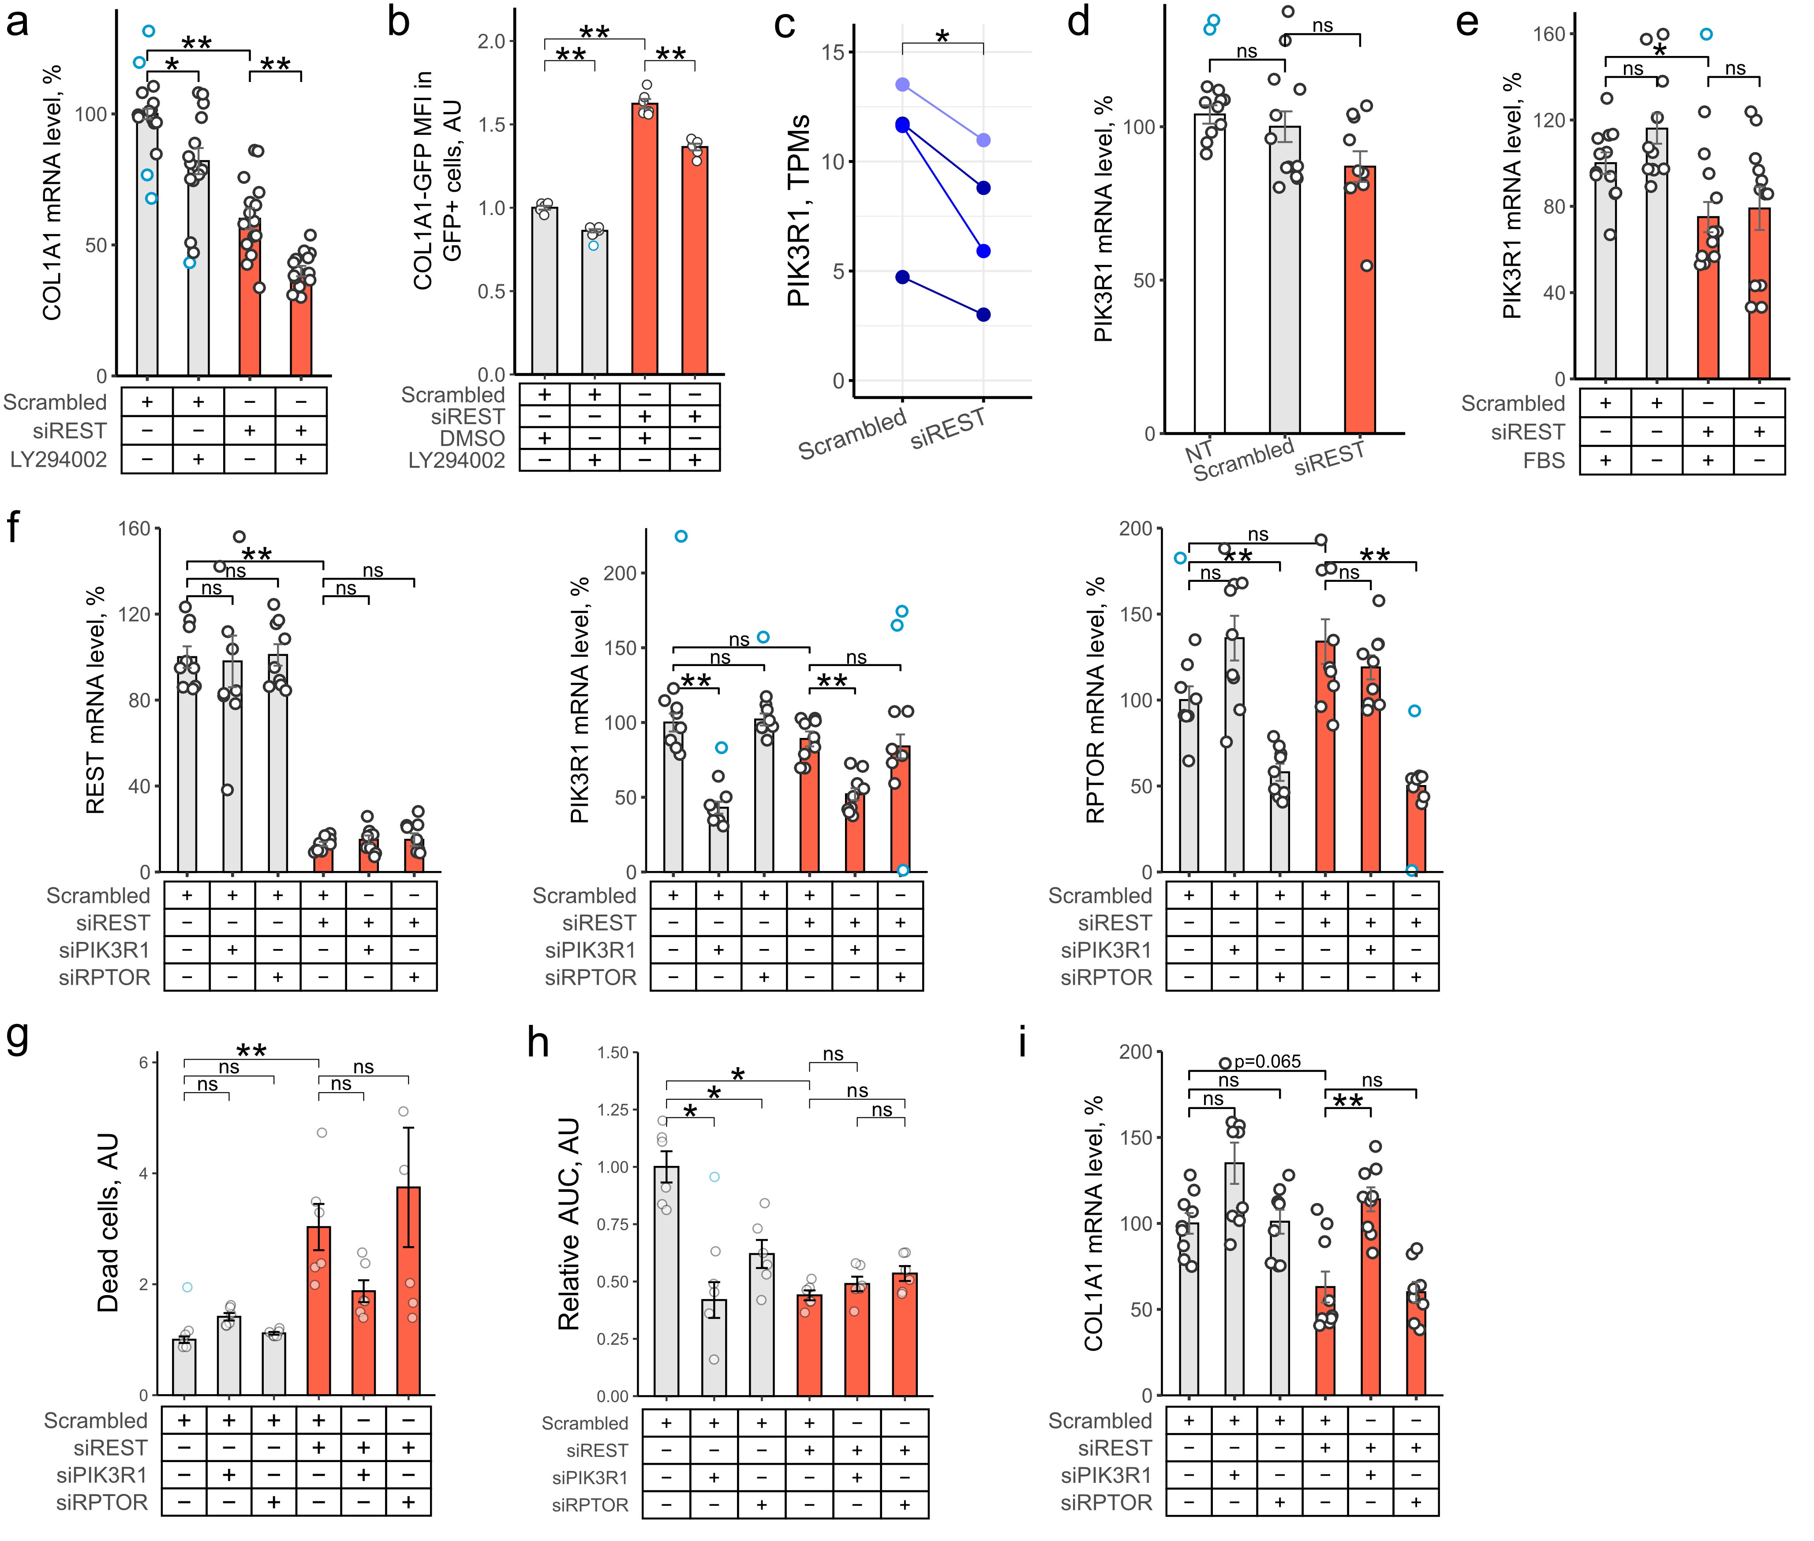
Figure S3: REST/PI3K pathway regulates survival independent of growth and fibrogenesis in LX2 cells. (a, b) LX2 cells (a) or LX2 cells expressing EGFP under control of COL1A1 promoter (b) were transfected with scrambled siRNA or siRNA targeting REST (a: n=4, b: n=2). After 24h, cells were exposed to fresh media with 10% FBS and DMSO (vehicle) or PI3K inhibitor LY294002 (10 μM) for 72h. (d, e) LX2 cells were transfected with scrambled siRNA or siRNA targeting REST for 24h and incubated in DMEM with (d, e) 10% or (c) 0% FBS for 72h (n=4). NT – non-transfected cells. (c) mRNA level of PIK3R1 following 12d of phHSC activation and transfection (n=4). Cells were exposed to fresh DMEM with 10% FBS 24h before harvesting. y axis shows transcripts per million (TPM). Colors indicate HSCs from individual donors (paired t test). (f-i) LX2 cells were co-transfected with combination of scrambled siRNA, siRNA targeting REST, PIK3R1 or RPTOR. 24h following transfection, cells incubated in DMEM with 10% FBS for 72h. qPCR. (a, c-f, i) qPCR (n=3). Bars show mean±SEM, normalized to PPIA, SDHA and RPLP0 and expressed relative to mean of scrambled siRNA-transfected cells (t test, Hommel test for multiple comparison correction ). (b) Flow cytometry. Y axis shows MFI (mean fluorescence intensity) of GFP under control of COL1A1 promoter normalized to non-transfected (NT) cells. (g) LX2 cells were incubated for 72h in DMEM following transfection (n=2). Cell death was measured using fluorimetry as described, normalized to total cell fluorescence and expressed relative to scrambled siRNA. Bars show mean±SEM of relative death expressed in arbitrary units, AU (Dunnett test). (h) LX2 cells were incubated in Incucyte for 72h in DMEM with 10% FBS and photographed every 4h (n=1). Y axis shows area under the curve (AUC) normalized to mean of scrambled siRNA exposed to vehicle. Bar show mean±SEM of relative growth expressed in arbitrary units, AU (Mann-Whitney U test, Hommel test for multiple comparisons correction). Outliers are indicated in blue. *p<0.05, **p<0.01.
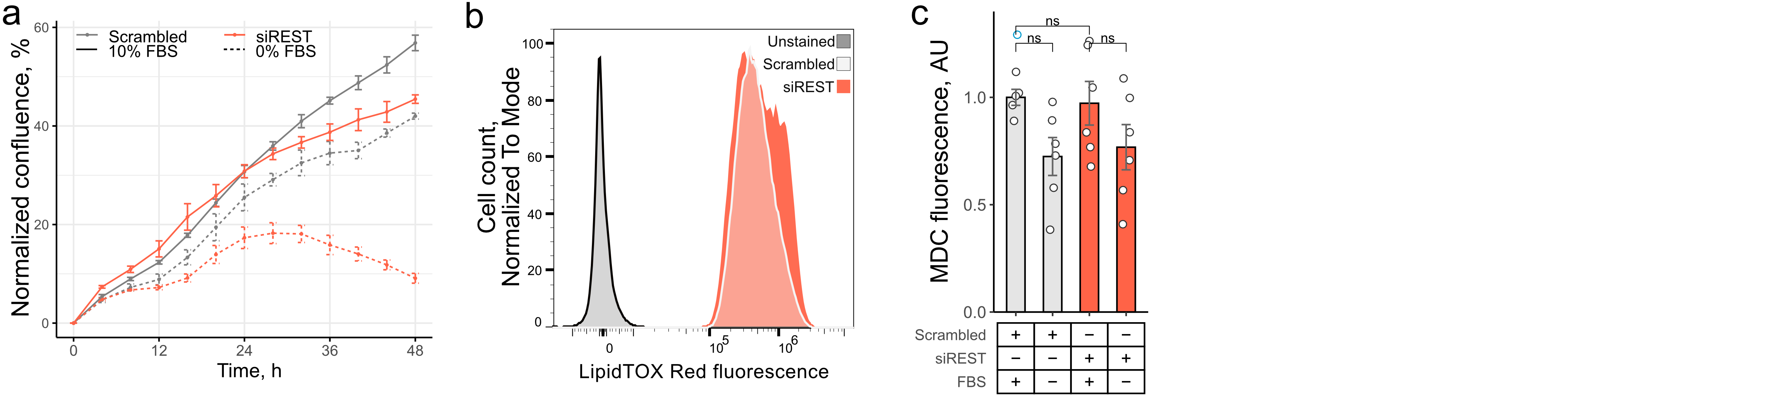
Figure S4: REST links metabolism and growth in activated HSCs. (a) Representative plot of change in LX2 confluence following REST KD. LX2 cells were transfected with scrambled siRNA or siRNA targeting REST and incubated in IncuCyte for 72h. in DMEM with 10% or 0% FBS. x axis shows time in hours, y axis shows normalized confluence in % of total area. Confluence was normalized to 0h per sample. (b) Histogram of LipidTOX Red fluorescence following REST KD in phHSCs. PhHSCs were activated and transfected with scrambled siRNA or siRNA targeting REST for 12 days. Histogram shows concatenated samples of 4 individual donors per condition. X axis shows LipidTOX Red fluorescence, y axis showed cell count normalized to mode. Flow cytometry. (c) Bar graph of monodansylcadaverine (MDC) fluorescence in LX2 cells. LX2 cells were transfected with scrambled siRNA or siRNA targeting REST and incubated in DMEM with 10% or 0% FBS for 72h. y axis shows MDC fluorescence normalized to scrambled siRNA-transfected cells exposed to DMEM with 10% FBS. (Mann-Whitney U test, Hommel test for multiple comparison correction). Outliers are indicated in blue.
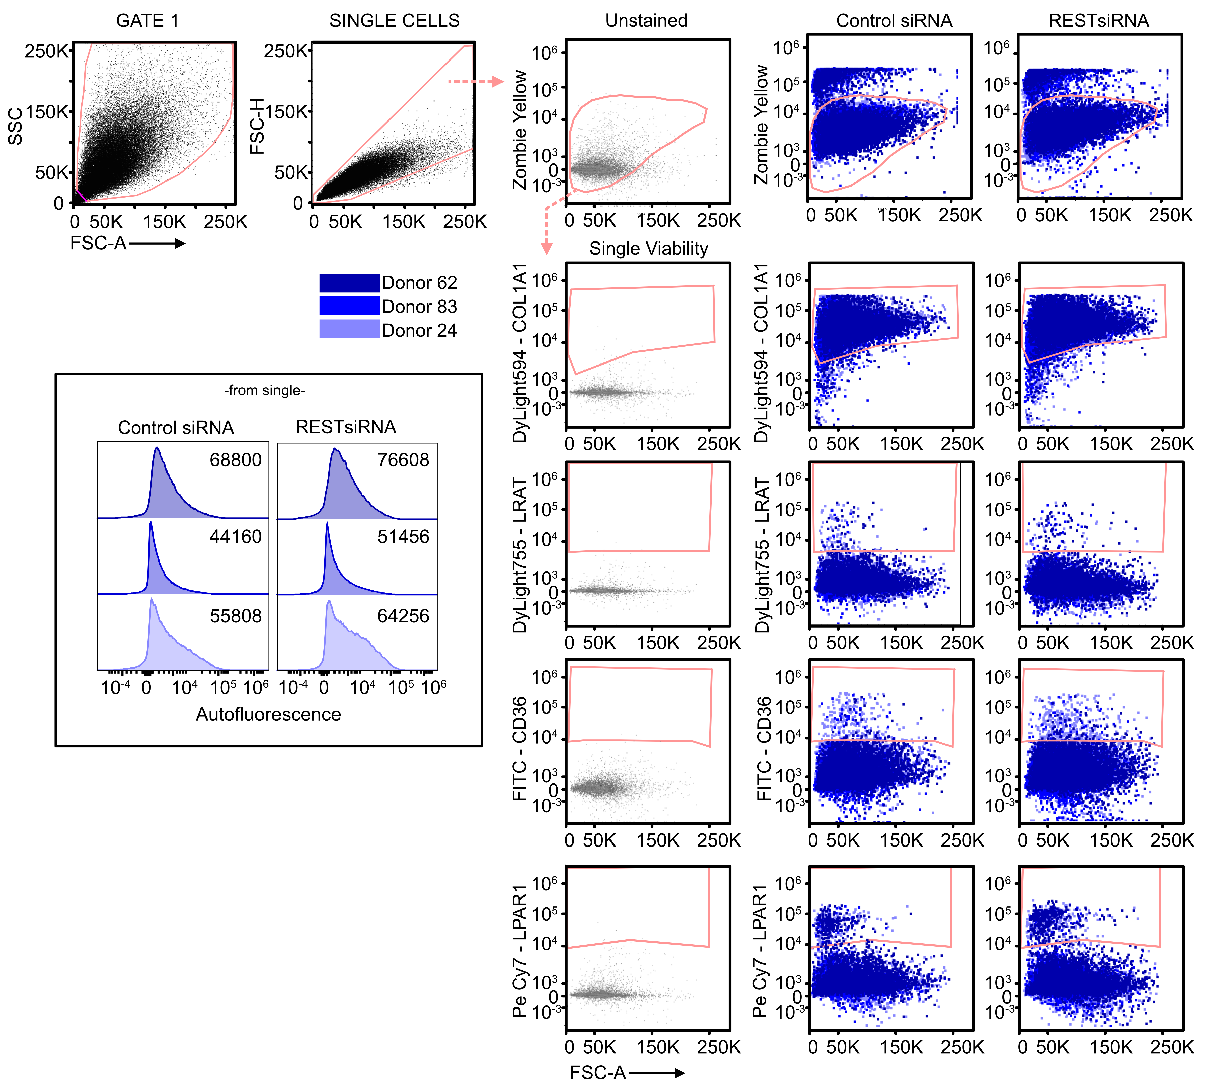
Figure S5: Representative plots of flow cytometry gating and analysis of primary human HSCs (n = 3). Primary human HSCs were activated by plating and transfected with scrambled siRNA or siRNA targeting REST for 12 days and exposed to fresh DMEM with 10% FBS 24 before harvesting. Cells were stained with viability dye zombie yellow and antibodies against marker of quiescent HSCs (LRAT), activated HSCs (COL1A1, LPAR1) and quiescent/inactivated HSCs (CD36).
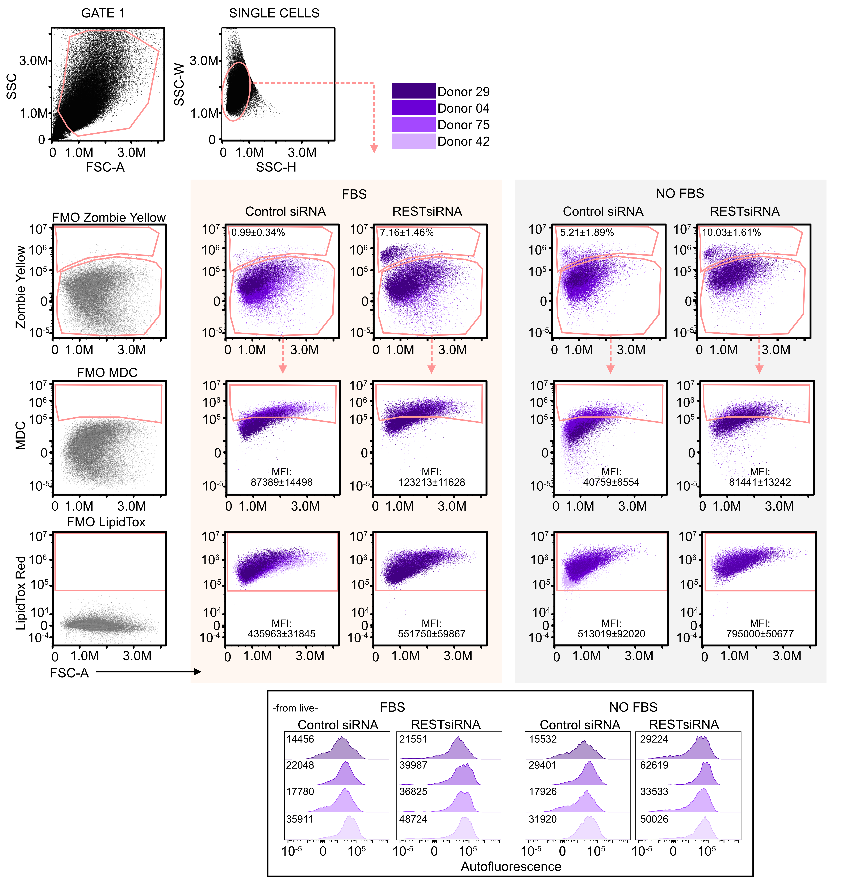
Figure S6: Representative plots of flow cytometry gating and analysis of primary human HSCs (n = 4). Primary human HSCs were activated by plating and transfected with scrambled siRNA or siRNA targeting REST for 12 days. Cells were stained with viability dye zombie yellow, dye for neutral lipids (LipidTOX Red) and monodansylcadaverine (MDC), a marker of autophagic vacuoles.
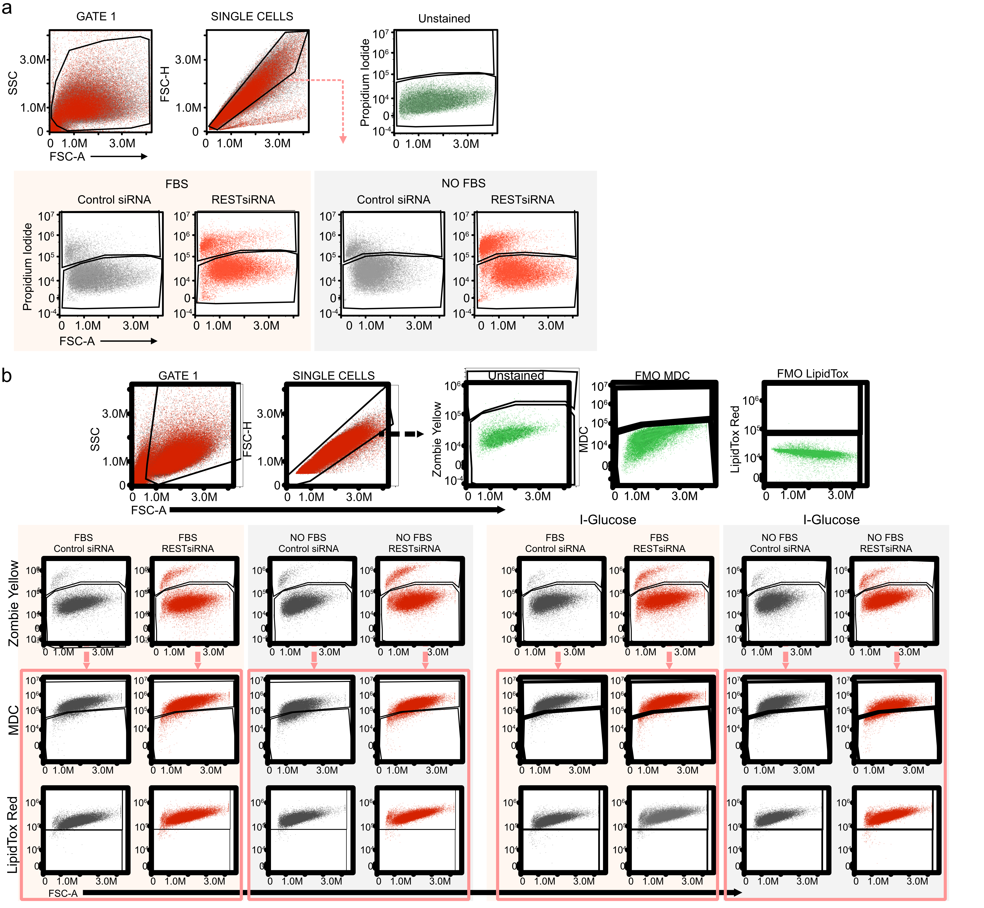
Figure S7: Representative plots of flow cytometry gating and analysis of LX2 cells. LX2 cells were transfected with scrambled siRNA or siRNA targeting REST and incubated in DMEM with 10% FBS or DMEM for 72h. (a) Gating strategy following staning of LX2 cells with propodium iodide. (b) Gating strategy following staining with viability dye zombie yellow, dye for neutral lipids (LipidTOX Red) and monodansylcadaverine (MDC), a marker of autophagic vacuoles.

Supplementary Table 1: Expression of Rest in mouse HSCs
Dataset | Group 1 | Group 2 | P value | Average log₂ FC | Adjusted p value
GSE171904 | Oil | BDL | 6*10⁻¹³⁵ | 0.51 | 2*10⁻¹³⁰
GSE171904 | Oil | CCl₄ | 5*10⁻²⁹² | 0.76 | 1*10⁻²⁸⁷
GSE171904 | qHSC | aHSC | ≈0 | 0.7 | ≈0
GSE171904 | pvHSC | cvHSC | 5*10⁻² | -0.12 | 1
Rosenthal et al. | Chow | HFD | 7*10⁻¹⁰⁰ | 0.4 | 1*10⁻⁹⁵
Rosenthal et al. | qHSC | aHSC | 4*10⁻¹⁰⁷ | 0.44 | 8*10⁻¹⁰³
Rosenthal et al. | pvHSC | cvHSC | 2*10⁻⁴ | -0.11 | 1
GSE206409 | cyHSC | myHSC | 3*10⁻⁸ | 0.13 | 0.0006

Supplementary Table 2: Primers
GOI | Forward (5'-3') | Reverse (5'-3') | Taqman probe (5'-3')
RPLP0 | GACCTCCTTTTTCCAGGCTTTA | TTGATCAGCTGCACATCACTC | TCCAGGGGCACCATTGAAATCC
SDHA | CAAGGCGAAAGGTTTATGGA | CAGGGCCACAGCCTCTT | CCCTGTCGCGAAGGACCTGG
ACTA2 | CAACTGGGACGACATGGAA | AGCAGGGTGGGATGCTCT | AATGAGCTTCGTGTTGCCCCTGA
COL1A1 | GTCGATGGCTGCACGAGT | TGGGATGGAGGGAGTTTACA | ATCGATGTGGCCCCCTTGGA
PIK3R1 | GCAATGAGAAAGAAATACAAAGGAT | ACTCAGCTGCCTGCTTCTTC
REST | AATTATGTTCAGCATGTTAGAACTCA | GAGGCCACATAACTGCACTG | TGCGTACTCATTCAGGTGAGAAGCCA
RPTOR | AAGGGCCCAGAGCAGACT | AGTCGCAGAACCCCGTCT
SYP | CAGACAGGGAACACATGCAA | AGAGCACCAGGTTCAGGAAG | CGGGACTCAACACCTCGGTGG

Supplementary Table 3: Antibodies for Western Blotting
Host | Target | Company | Cat. Num. | Flourophore
Rabbit | Caspase-3 | Cell Signaling | 9662 | Unconjugated
Rabbit | LC3A/B | Cell Signaling | 12741 | Unconjugated
Mouse | AKT | Cell Signaling | 9272 | Unconjugated
Rabbit | pAKT (Ser473) | Cell Signaling | 4051 | Unconjugated
Rabbit | ULK1 | Cell Signaling | 8054 | Unconjugated
Rabbit | pULK1 (Ser757) | Cell Signaling | 6888 | Unconjugated
Goat | β-actin | Abcam | ab8229 | Unconjugated

Supplementary Table 4: Antibodies
Host | Target | Company | Cat. Num. | Flourophore
Horse | Rabbit | Vector Labs | DI-1094 | DyLight 594
Horse | Mouse | Vector Labs | DI-2594 | DyLight 594
Goat | Rat | Abcam | ab98422 | DyLight 594
Donkey | Goat | Invitrogen | A-11058 | Alexa Fluor 594
Donkey | Goat | LI-COR | 926-68074 | IRDye 680RD
Donkey | Rabbit | LI-COR | 926-32213 | IRDye 800CW
Donkey | Mouse | LI-COR | 926-49012 | VRDye 490
CM – confocal microscopy, WB – western blot.

Supplementary Table 5: Antibodies for Flow Cytometry
Host | Target | Company | Cat. Num. | Flourophore
Mouse | NGFR | BioLegend | 345114 | Alexa Fluor 647
Mouse | aSMA | LifeSpan Bioscience | LS-C124868 | PE
Mouse | LRAT | Novus | NBP2-50444 | DyLight 755
Rabbit | COL1A1 | Novus | NB600-408AF700 | Alexa Fluor 700
Mouse | IL7Ra | BioLegend | 351364 | PE/Fire 640
Mouse | LPAR1 | Novus | NBP2-72519PECY7 | PE/Cy7
Rat | GFAP | Invitrogen | 51-9792-82 | Alexa Fluor 647

Supplementary Table 6: Antibodies for Confocal Microscopy
Host | Target | Company | Cat. Num. | Flourophore
Mouse | aSMA | Dako | M0851 | Unconjugated
Mouse | REST | Abcam | ab211537 | Unconjugated
Rabbit | Synaptophysin | Abcam | ab32127 | Unconjugated
Rabbit | COL1A1 | Cell Signaling | 72026 | Unconjugated

