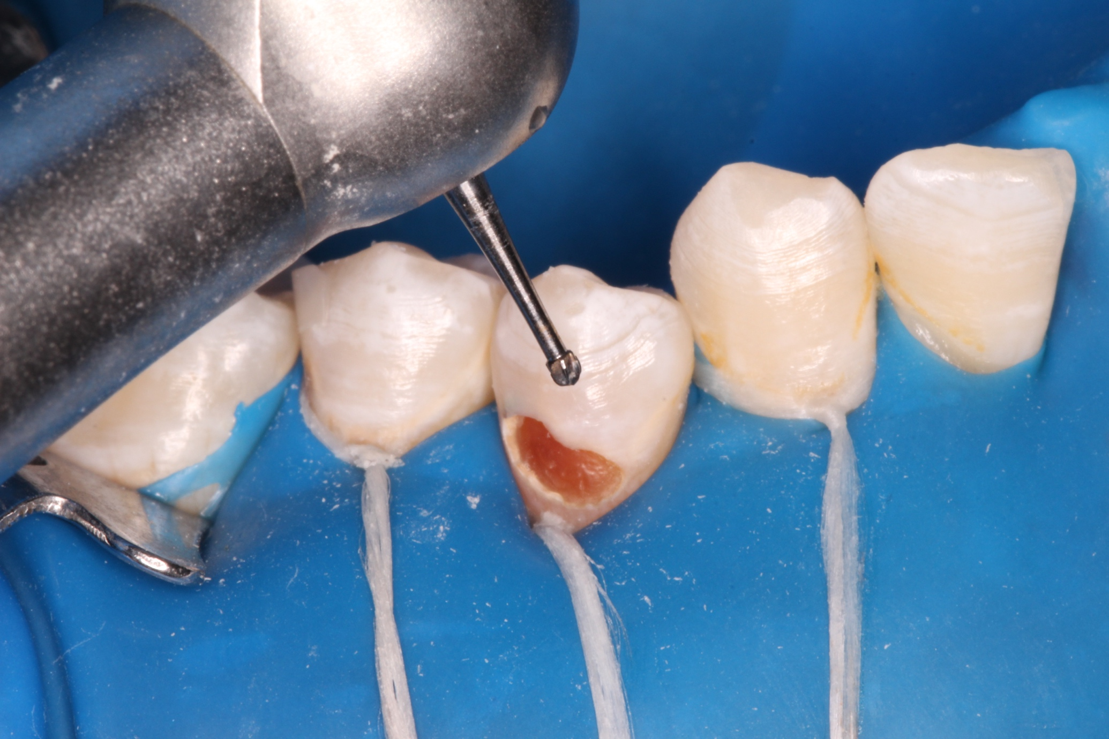
Figure (1): Tooth preparation. A: Cavity preparation using carbide round bur, B: Deep caries removal using spoon excavator, C: Bevel using yellow finishing stone
A

B

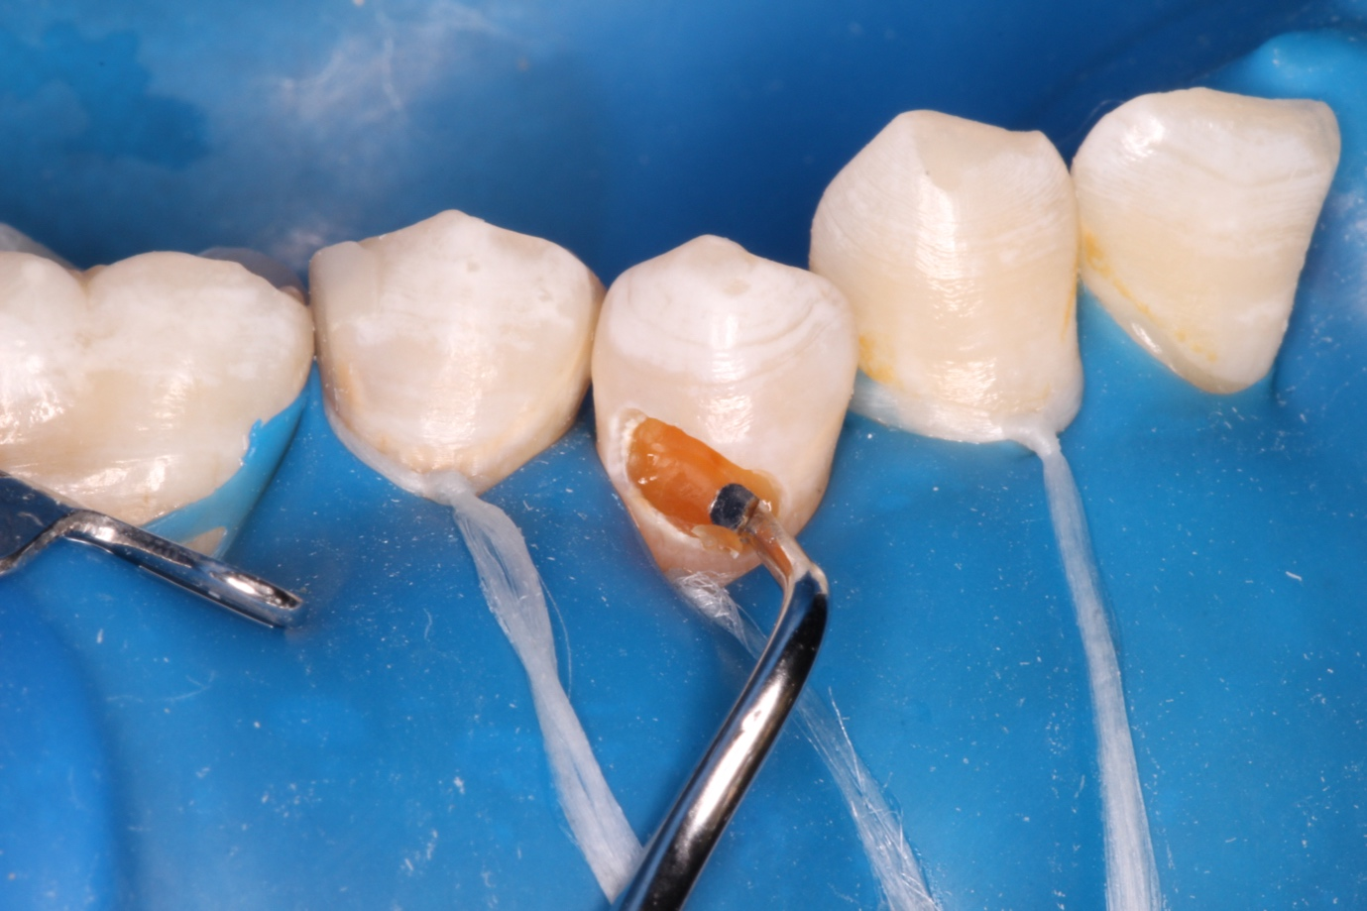
Figure (1): Tooth preparation. A: Cavity preparation using carbide round bur, B: Deep caries removal using spoon excavator, C: Bevel using yellow finishing stone

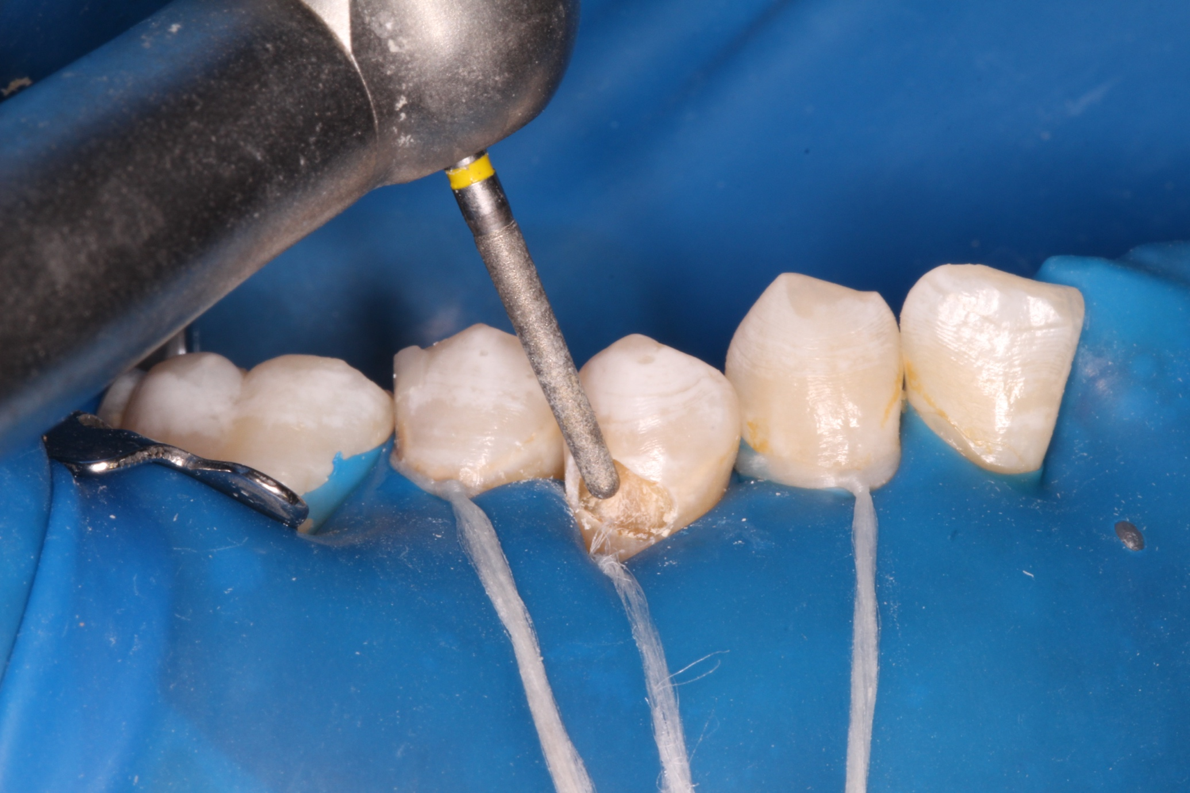
Figure (1): Tooth preparation. A: Cavity preparation using carbide round bur, B: Deep caries removal using spoon excavator, C: Bevel using yellow finishing stone
C

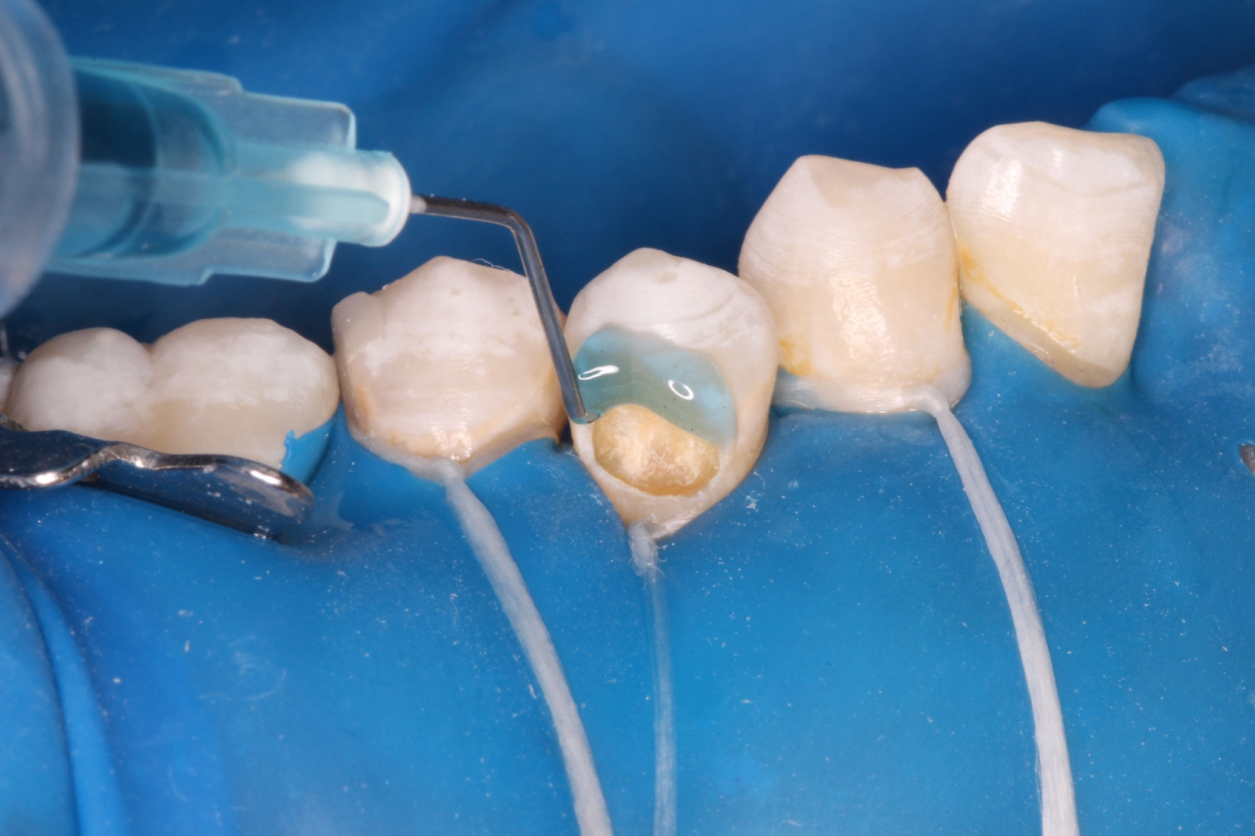
Figure (2): A: Selective etching , B: Single bond application
A
B
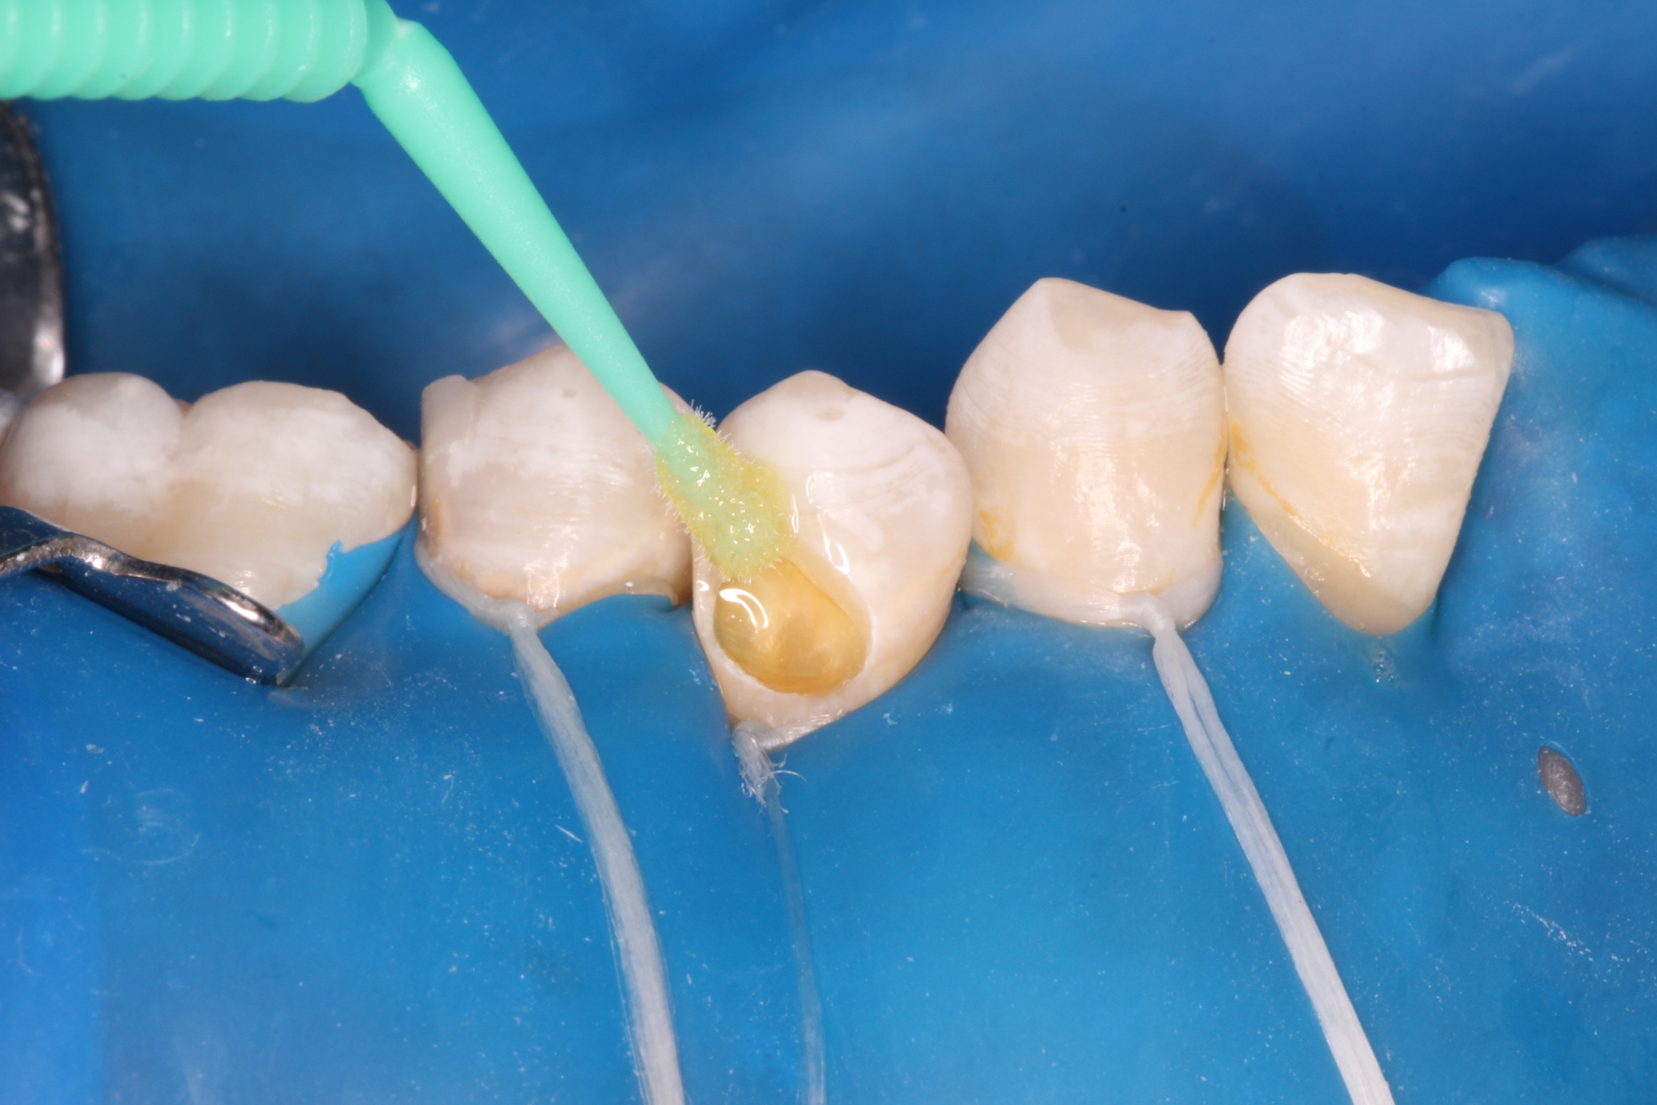
Figure (2): A: Selective etching , B: Single bond application

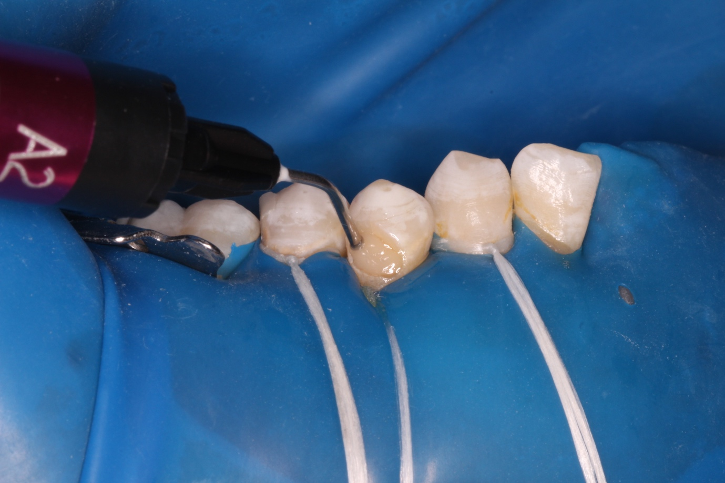

Figure (3): Beautifil flow x application
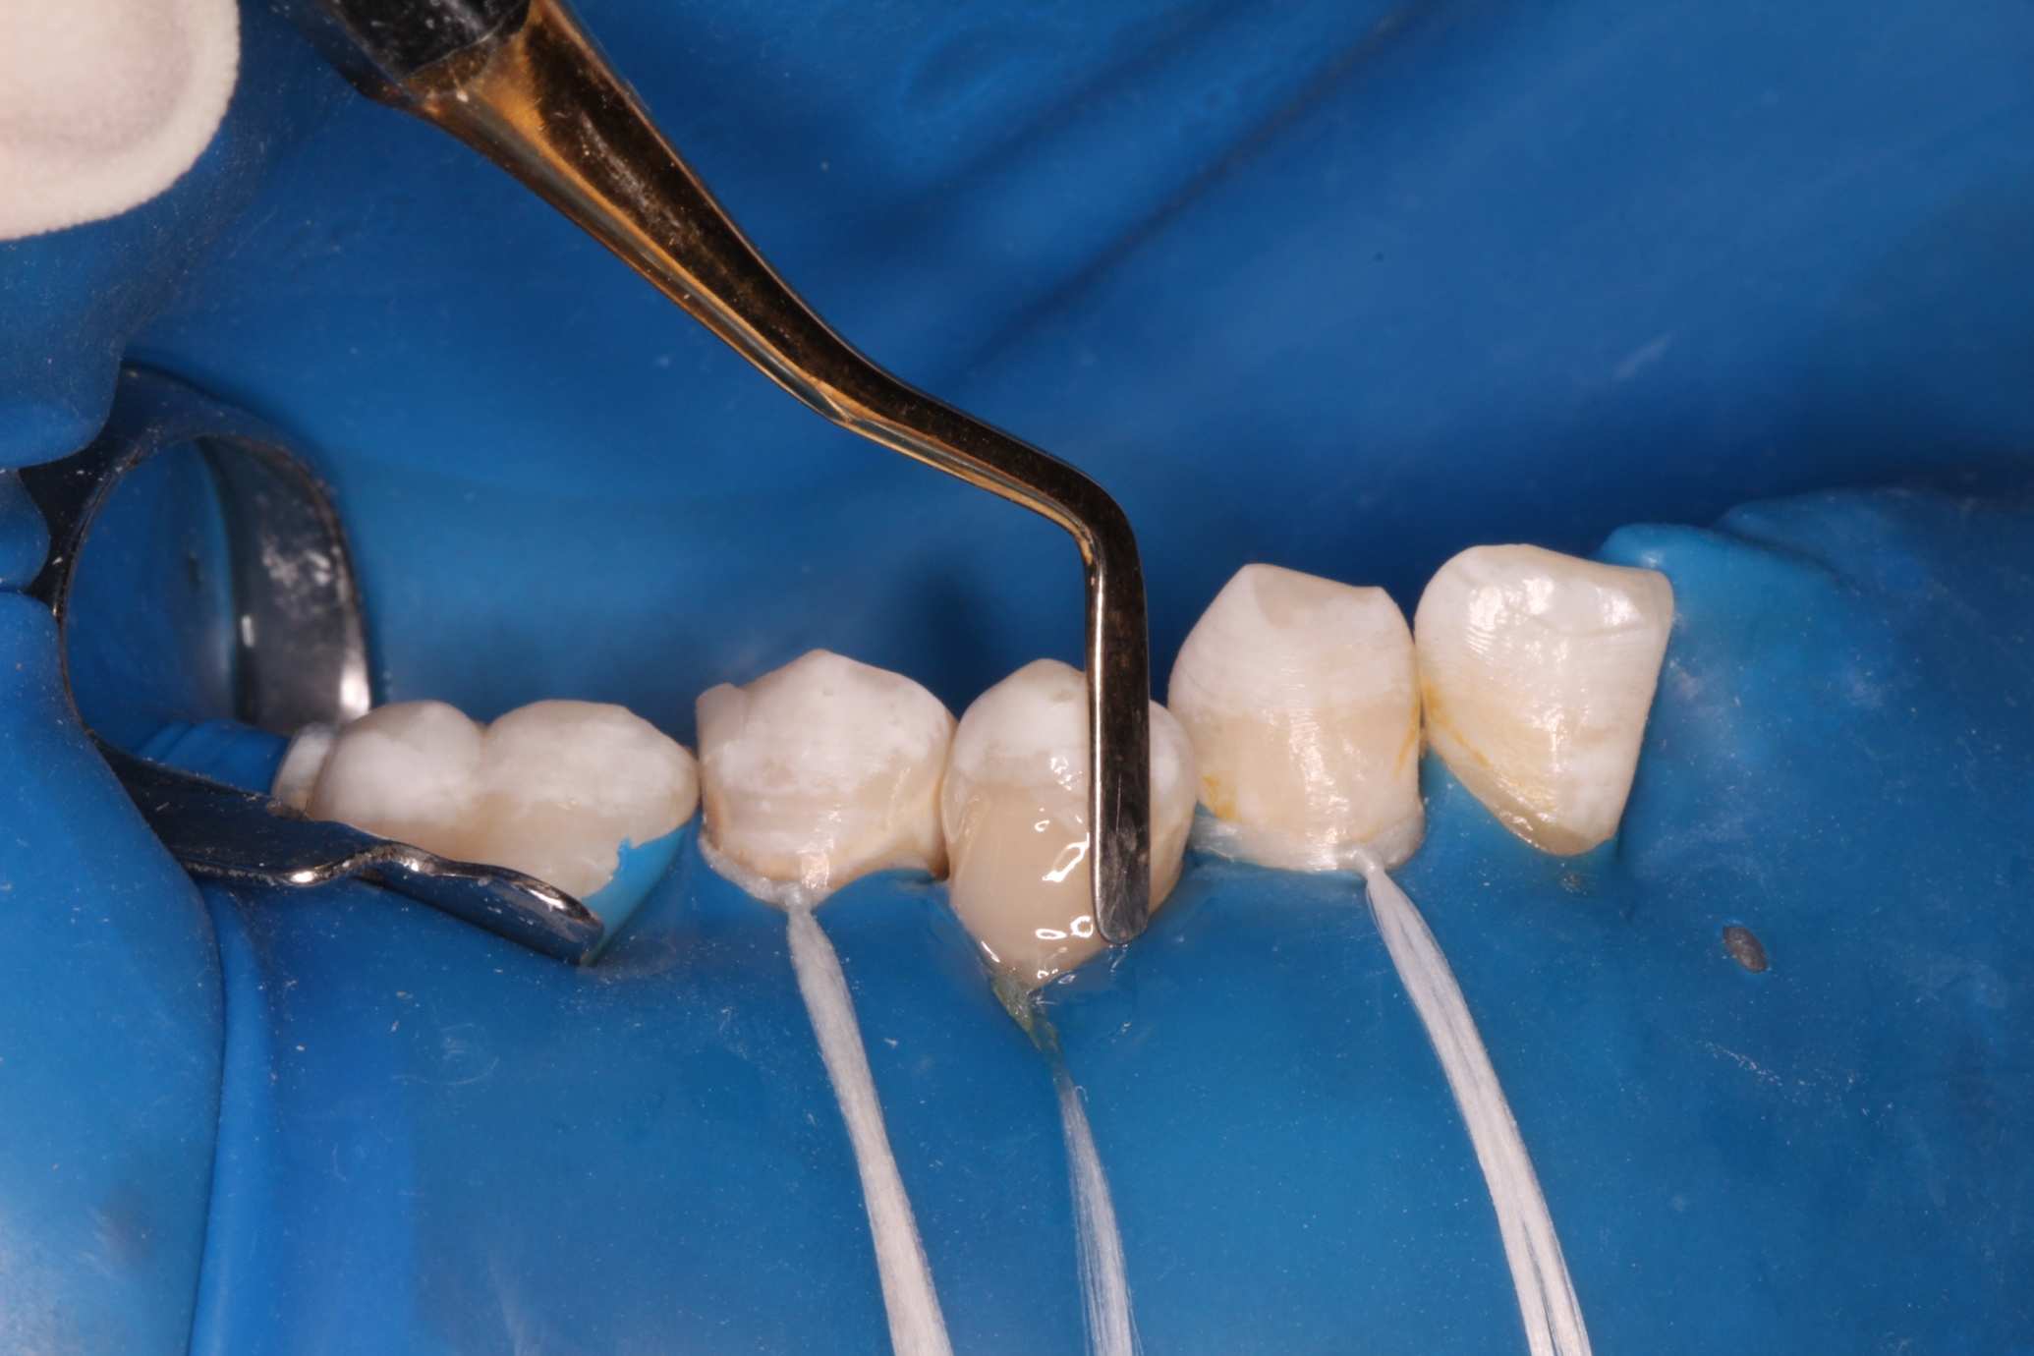
Figure (3): Beautifil flow x application
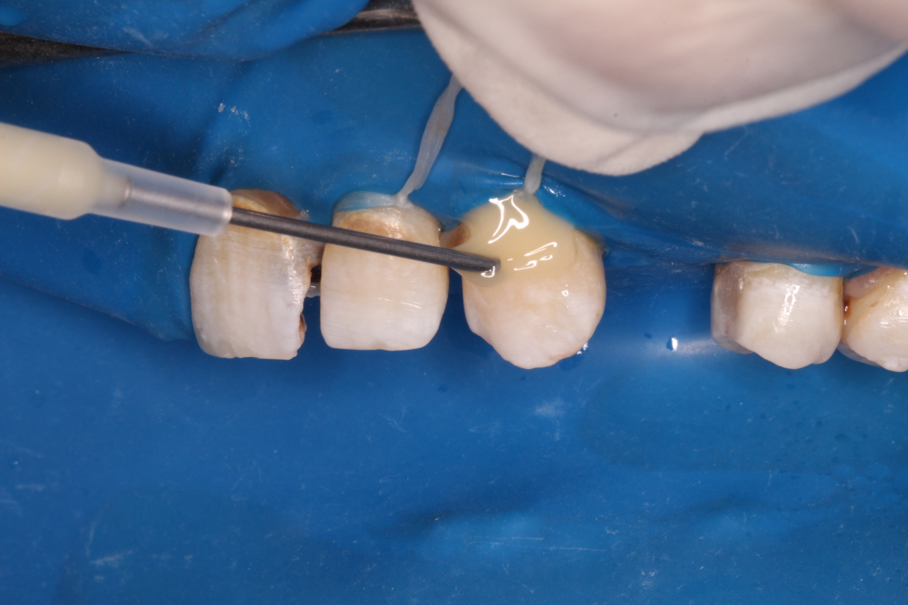
Figure (4): ACTIVA bioactive application

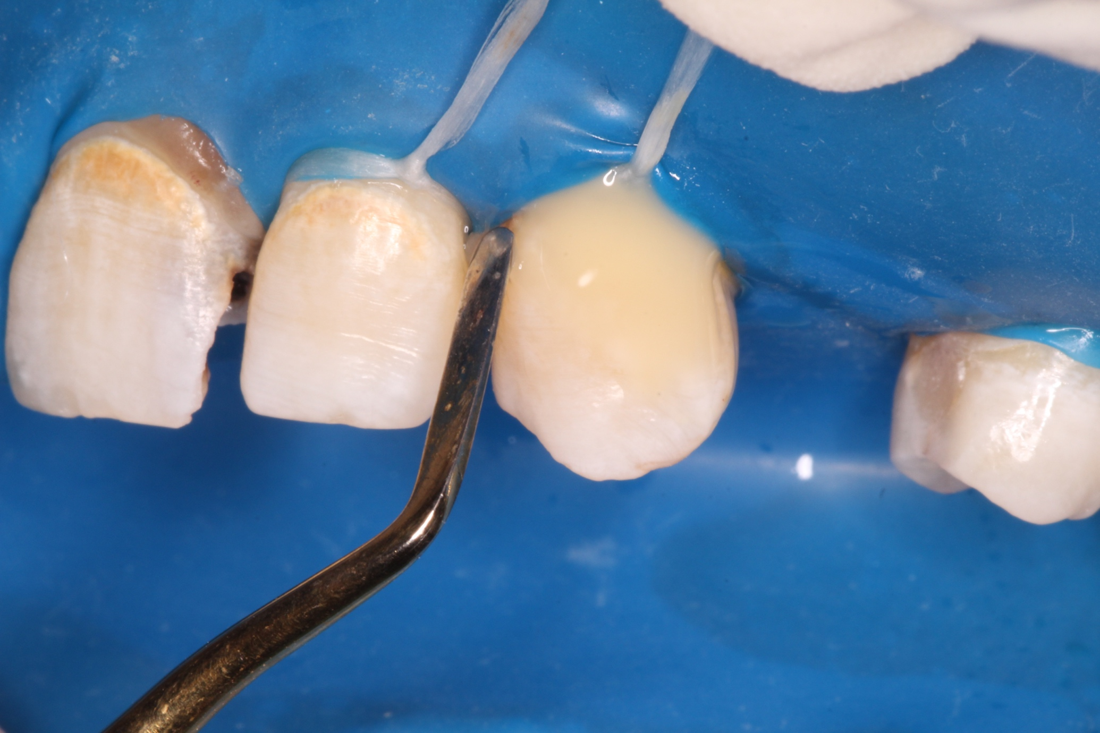
Figure (4): ACTIVA bioactive application
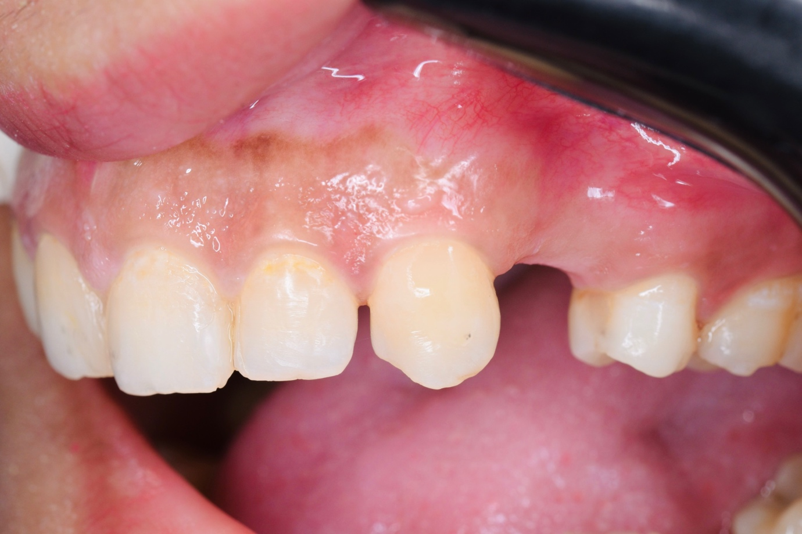
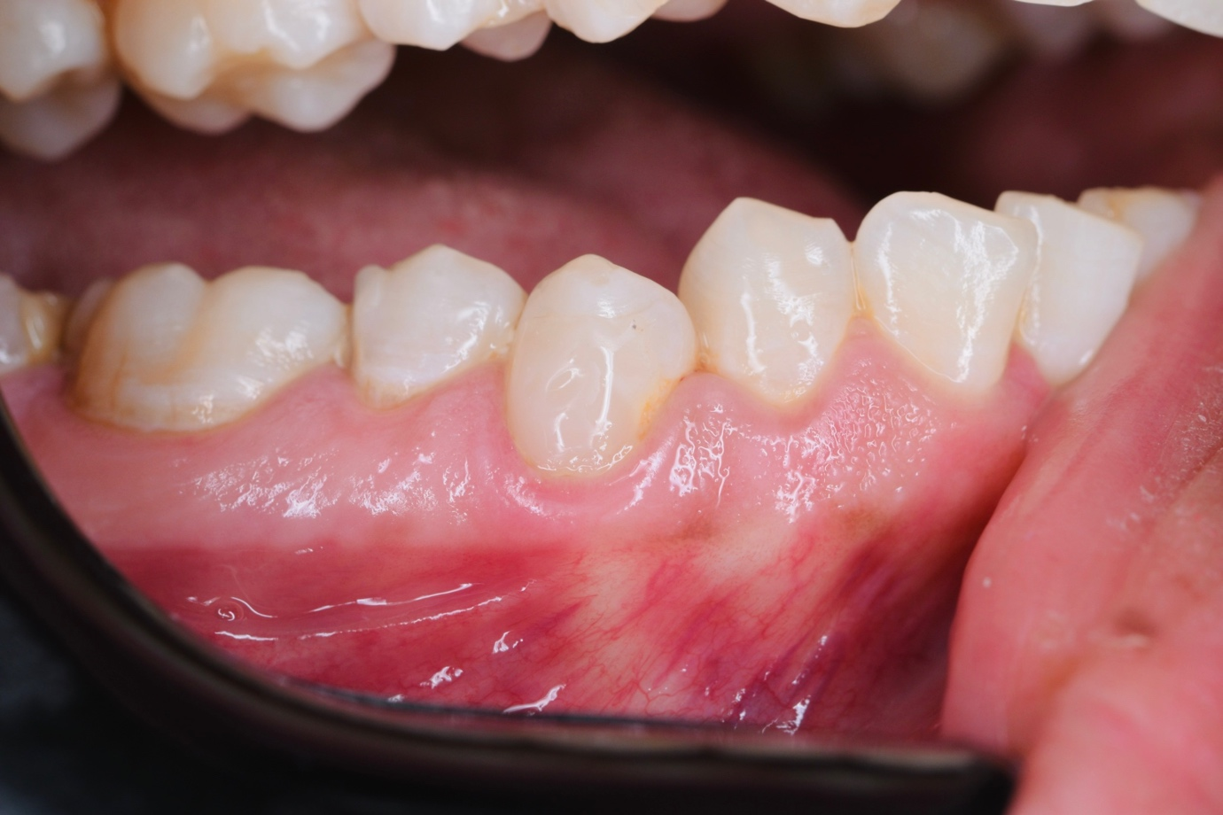
B
A
B
Figure (5): Follow up after 18 month. A: Beautifil flow plus X, B: ACTIVA bioactive.

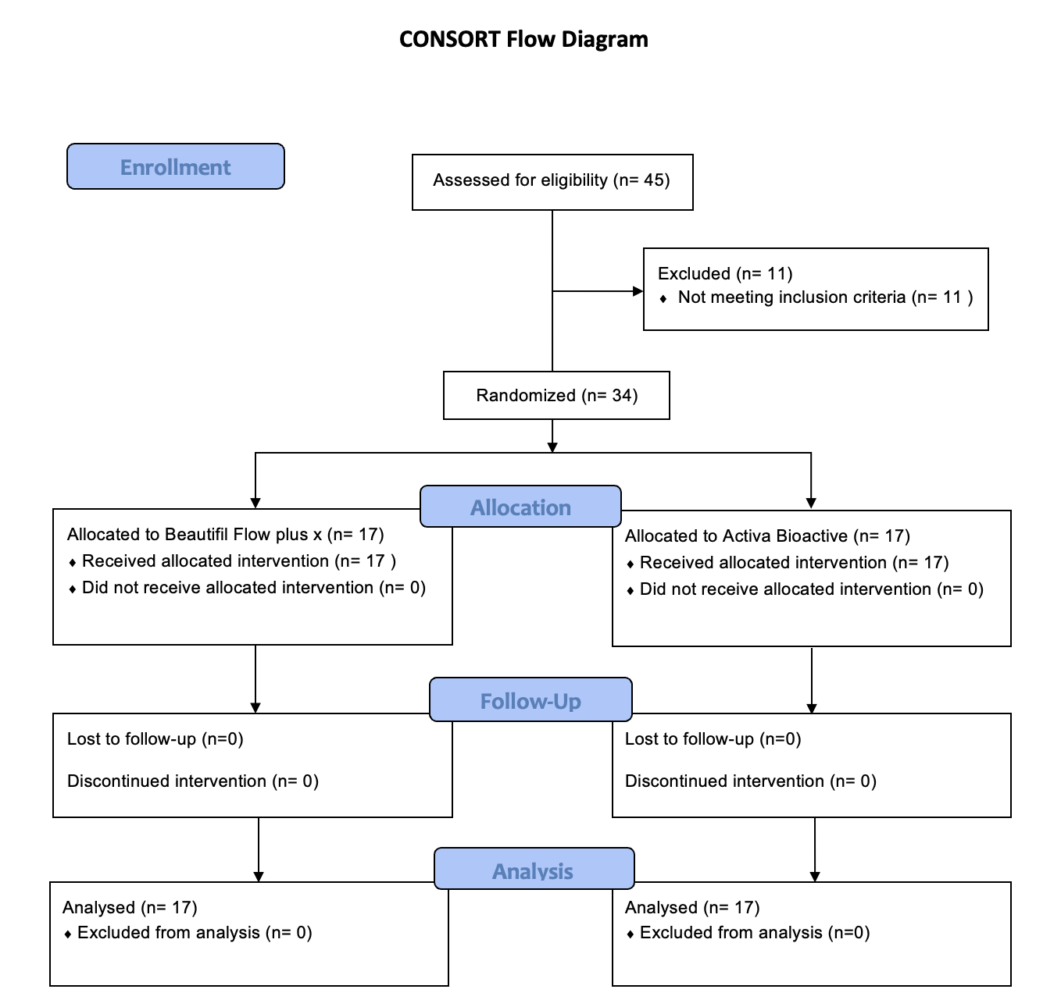

Figure (6): Participants Flow Diagram

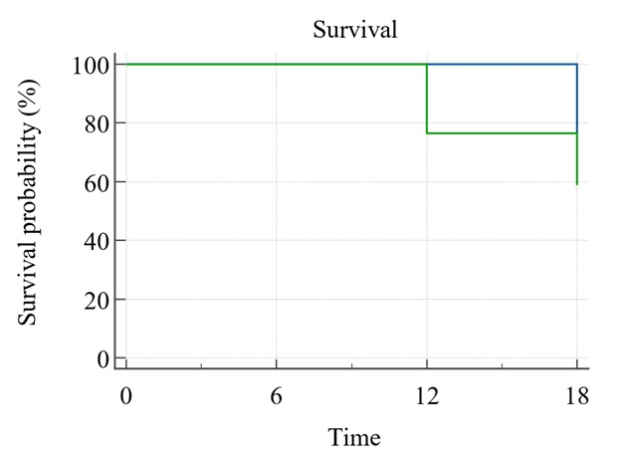

Figure (7): Survival analysis of Activa and Beautifil for cervical restorations after 18 months

