Journal name : European Polymer Journal

Manuscript Title : Synergistic Defence: Electron Beam Irradiated Chitosan and Bacillus subtilis sp. in Combating Chickpea Wilt for agricultural sustainability.
The name(s) of the author(s): Sravani Bana, T. K Narute, S. B. Latke, R.M. Naik, S.V. Kolse, D.A. Bhosale and S.G. Dalvi*
The affiliation(s) and address(es) of the author(s):
- Dr. Ms. Sravani Bana, Ph.D. scholar, Department of Plant Pathology and Agricultural Microbiology, Post Graduate Institute (PGI), Mahatma Phule Krishi Vidyapeeth, Rahuri, Ahmednagar, India. (https://orcid.org/0009-0008-9904-9870)
- Prof. Dr. T. K. Narute, Head, Department of plant pathology and agricultural microbiology, Post Graduate Institute (PGI), Mahatma Phule Krishi Vidyapeeth, Rahuri, Ahmednagar, India.
- Dr.R. M. Naik, Ex-Head and Professor, Department of Biochemistry, Post Graduate Institute (PGI), Mahatma Phule Krishi Vidyapeeth, Rahuri, Ahmednagar, India.
4. Dr. S. B. Latke, Asso. Professor (Plant Pathology), Pulse Improvement Project, Mahatma Phule Krishi Vidyapeeth, Rahuri, Ahmednagar, India
- Dr. S. V. Kolse, Asso. Professor (Plant Pathology), Pulse Improvement Project, Mahatma Phule Krishi Vidyapeeth, Rahuri, Ahmednagar, India.
- Ms. D. A. Bhosale, Research Assistant, Agri. Sci & Tech Div. Vasantdada Sugar Institute, Pune, India
- *Dr. S. G. Dalvi, Scientist, Agri. Sci & Tech Div., Vasantdata Sugar Institute (VSI), Pune, India-Corresponding author.

The e-mail address, telephone and fax numbers of the corresponding author:

sgdalvi@gmail.com, +91 020 26902100/ +919822834247, Fax +91 020 26902244

Fig. S1 Determination of Viscosity Average Molecular Weight Chitosan a) non-irradiated chitosan (Molecular weight- 269. 19 kDa) and b) Electron Beam Irradiated chitosan (Molecular weight- 75.09917 kDa )
ab
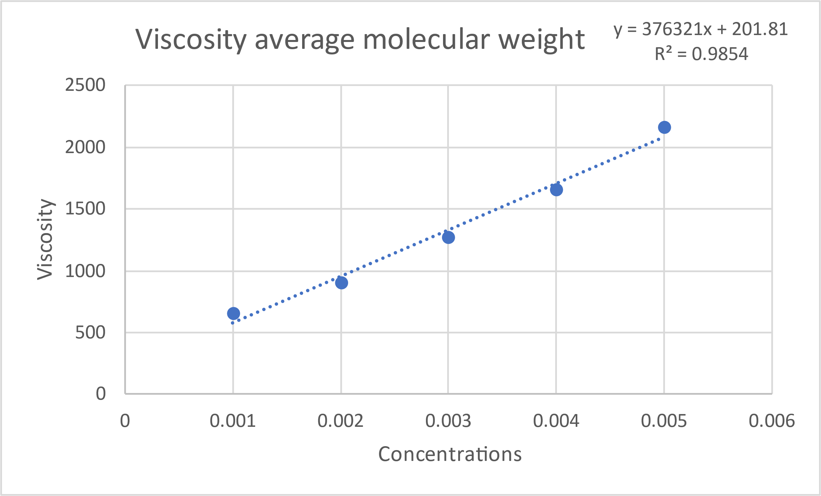
b

Fig. S2 Dynamic Light Scattering Images of Chitosan (a) Non Irradited chitosan and (b) Electron Beam Irradiated chitosan at 100 kGy
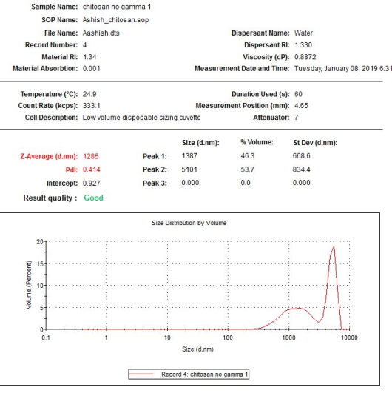

a

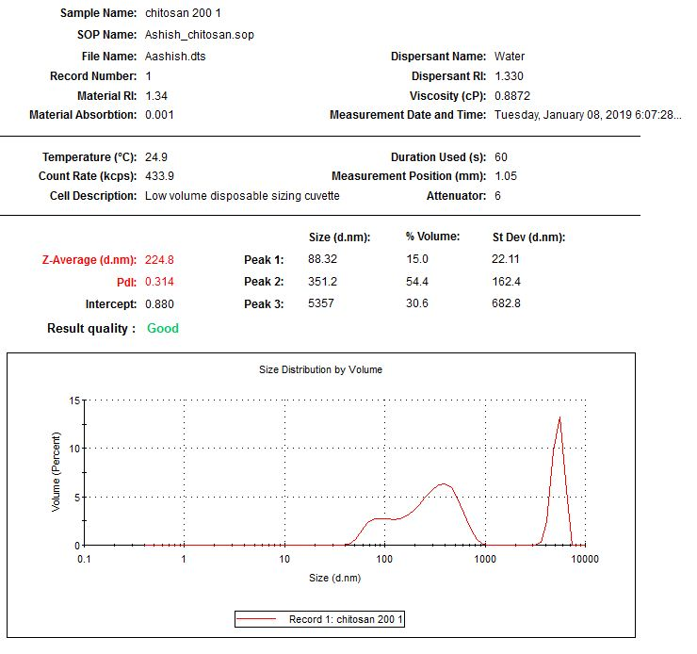

b

Fig. S3 Zeta Potential Report

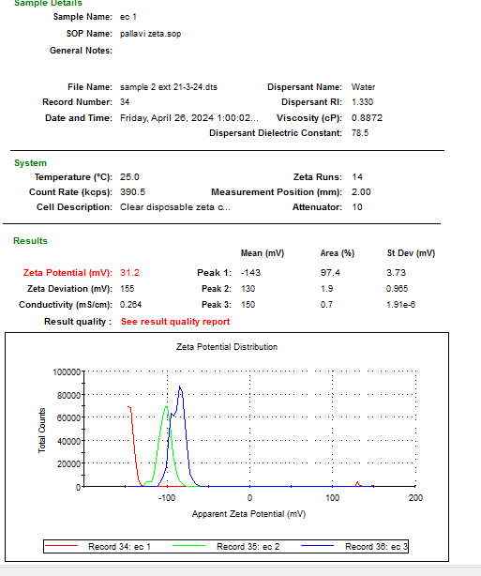

Table S1. Effect of CNP and B – CNP treatments on mean wilt incidence and average grain yield of chickpea under field condition
S. No. | Treatments | Pooled Mean (2020-21 and 2021-22)
S. No. | Treatments | Disease incidence (%) | Grain yield (q/ha) | Increase in yield (%)
1 | T1  Bacillus subtilis @ 5g/ kg seed | 24.38^{d}  (29.53) | 14.38^{c} | 23.15
2 | T2  Chitosan NPs @ 50ppm | 17.92^{d}  (24.95) | 15.64^{b} | 33.92
3 | T3  Chitosan NPs @ 100ppm | 14.17^{bc}  (22.05) | 16.26^{b} | 39.27
4 | T4  Chitosan NPs @ 150ppm | 11.46^{ab}  (19.7) | 16.89ª | 44.65
5 | T5  Bacillus subtilis + Chitosan NPs 50ppm | 13.34^{b}  (21.34) | 16.33^{ab} | 39.78
6 | T6  Bacillus subtilis + Chitosan NPs 100ppm | 10.42ª  (18.61) | 16.96ª | 45.34
7 | T7  Bacillus subtilis + Chitosan NPs 150ppm | 8.34ª  (16.65) | 17.55ª | 50.52
8 | T8  Control | 37.3e  (37.58) | 11.68^{d}
 | S.Em. + | 0.96 | 0.4
 | CD at 5 % | 2.91 | 1.24

