Supplementary: How objective and perceived exposures to nature impact people’s happiness in Tokyo

Supplementary - Table of Contents | Pages
Supplementary Figures | 2-4
- Supplementary Figure 1. Study area
- Supplementary Figure 2. Assessment of indirect exposure through window views
- Supplementary Figure 3. Assessment of incidental exposure through street views
- Supplementary Figure 4. Assessment of intentional exposure through park proximity
- Supplementary Figure 5. Assessment of the quantities of unplanned natural resources
Supplementary Tables | 5-9
- Supplementary Table 1. OLS regression results for three types of objective exposures to nature and happiness
- Supplementary Table 2. Collinearity analysis results of three types of nature exposure indicators and covariates for OLS regression
- Supplementary Table 3. Validity test of OLS regression
- Supplementary Table 4. SEM results for objective and perceived exposures to nature and happiness
- Supplementary Table 5. Model fit of SEM using five different buffer zone sizes
- Supplementary Table 6. Moran’s I test result for residuals of OLS regressions
- Supplementary Table 7. Moran’s I test result for residuals of linear regressions a) between happiness and perceived exposure (Equation 12), and b) between perceived and objective exposure (Equation 13) in SEM

i) Study area
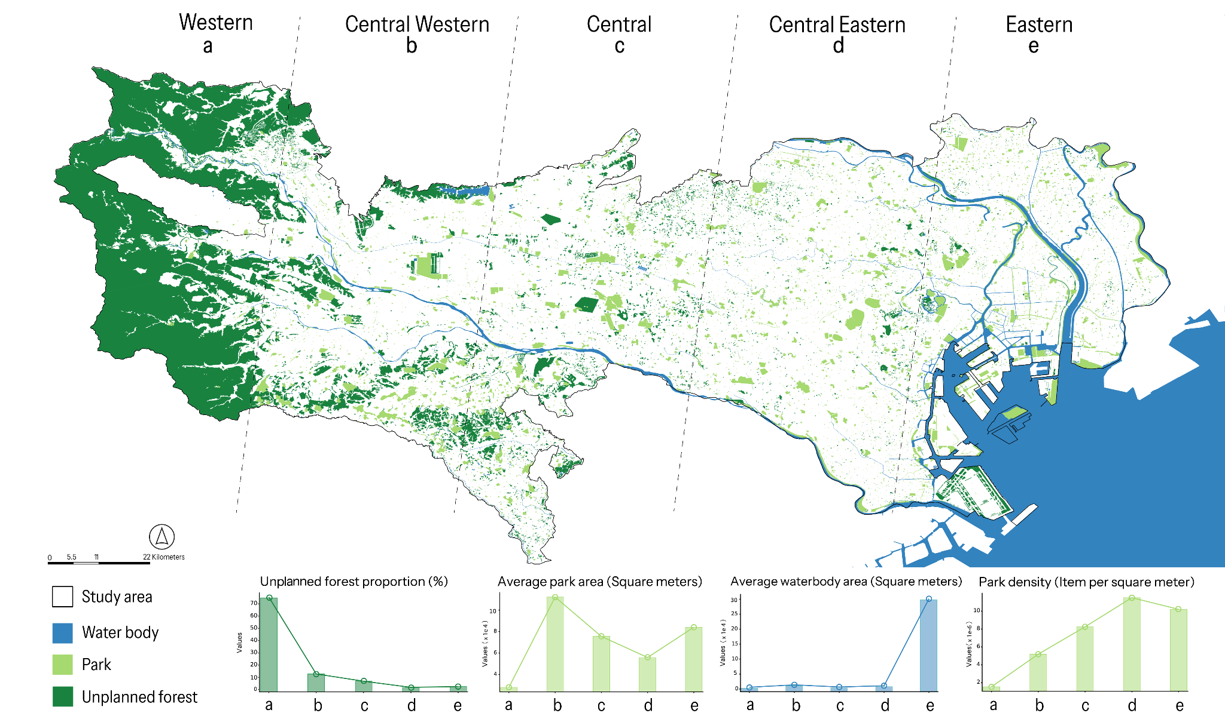
Supplementary Figure 1. Study area. (a) Western, (b) Central Western, (c) Central, (d) Central Eastern, and (e) Eastern regions of urban Tokyo.

ii) Assessment of indirect exposure through window views
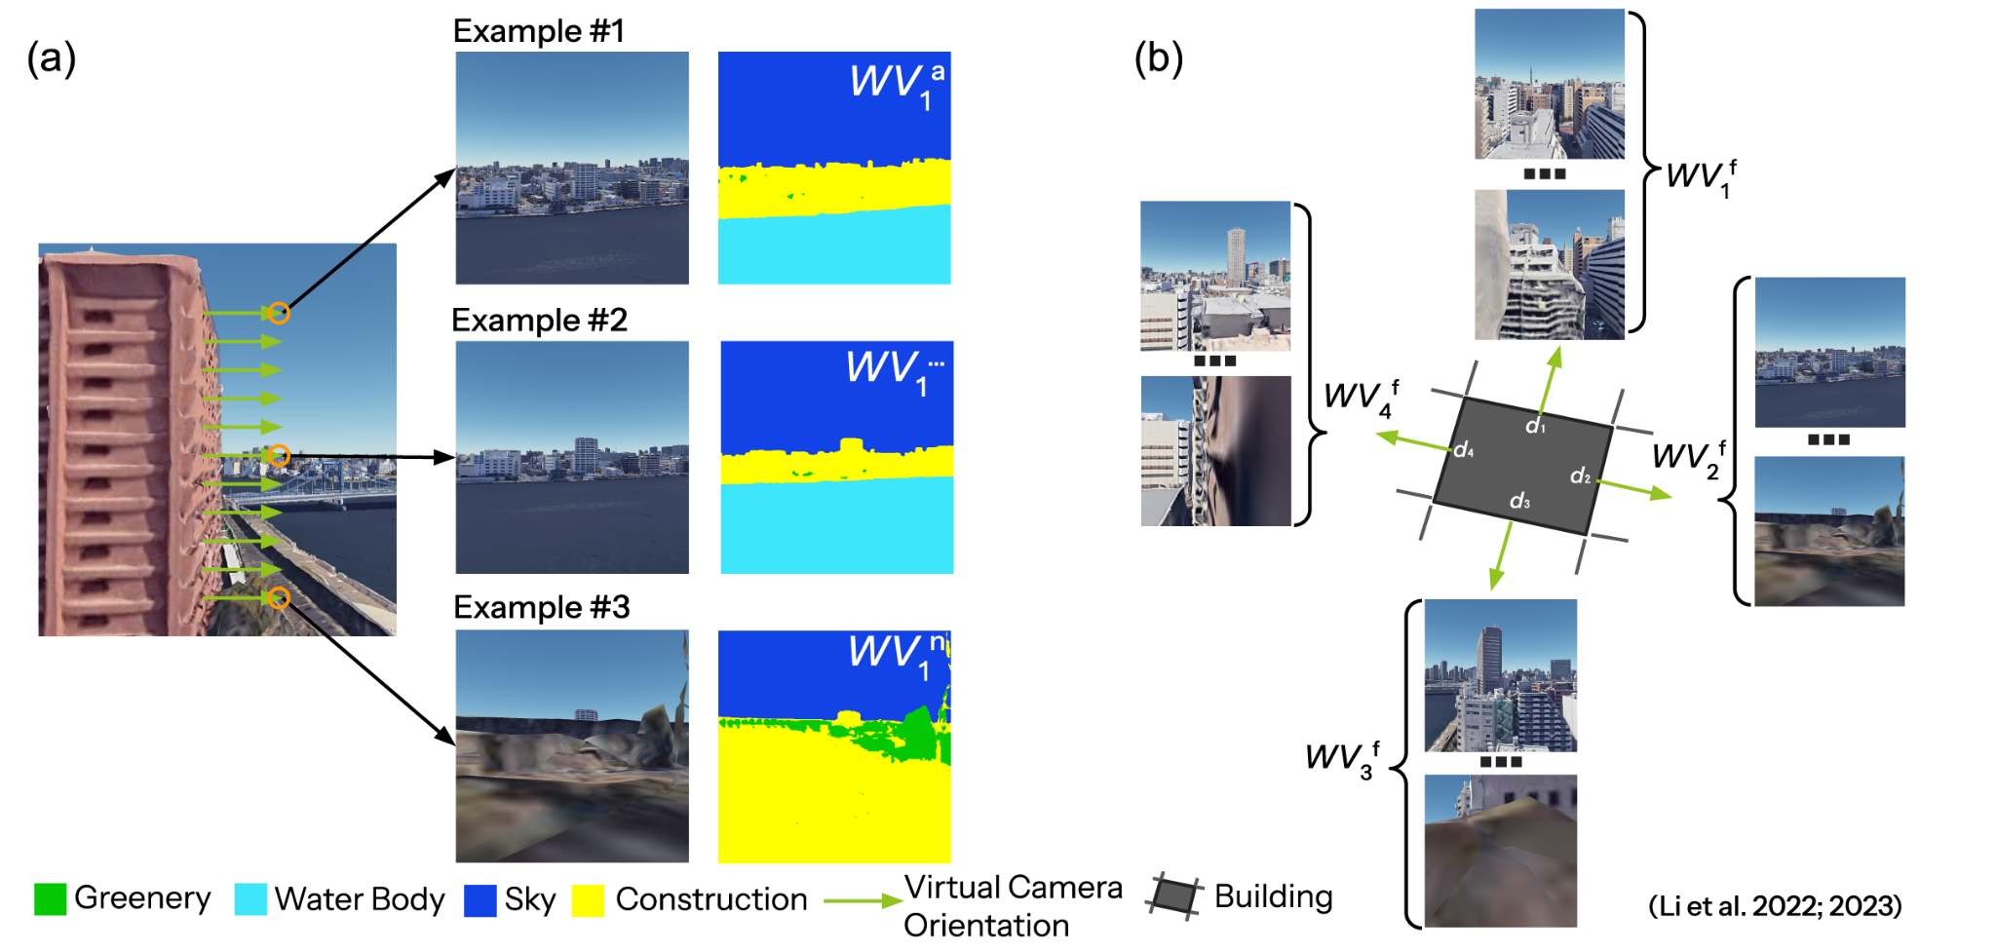
Supplementary Figure 2. Assessment of indirect exposure through window views. (a) WVs collected from photorealistic window view samples through semantic segmentation and (b) Collection of WVs from all building facades for WV^{bldg}.

iii) Assessment of incidental exposure through street views.
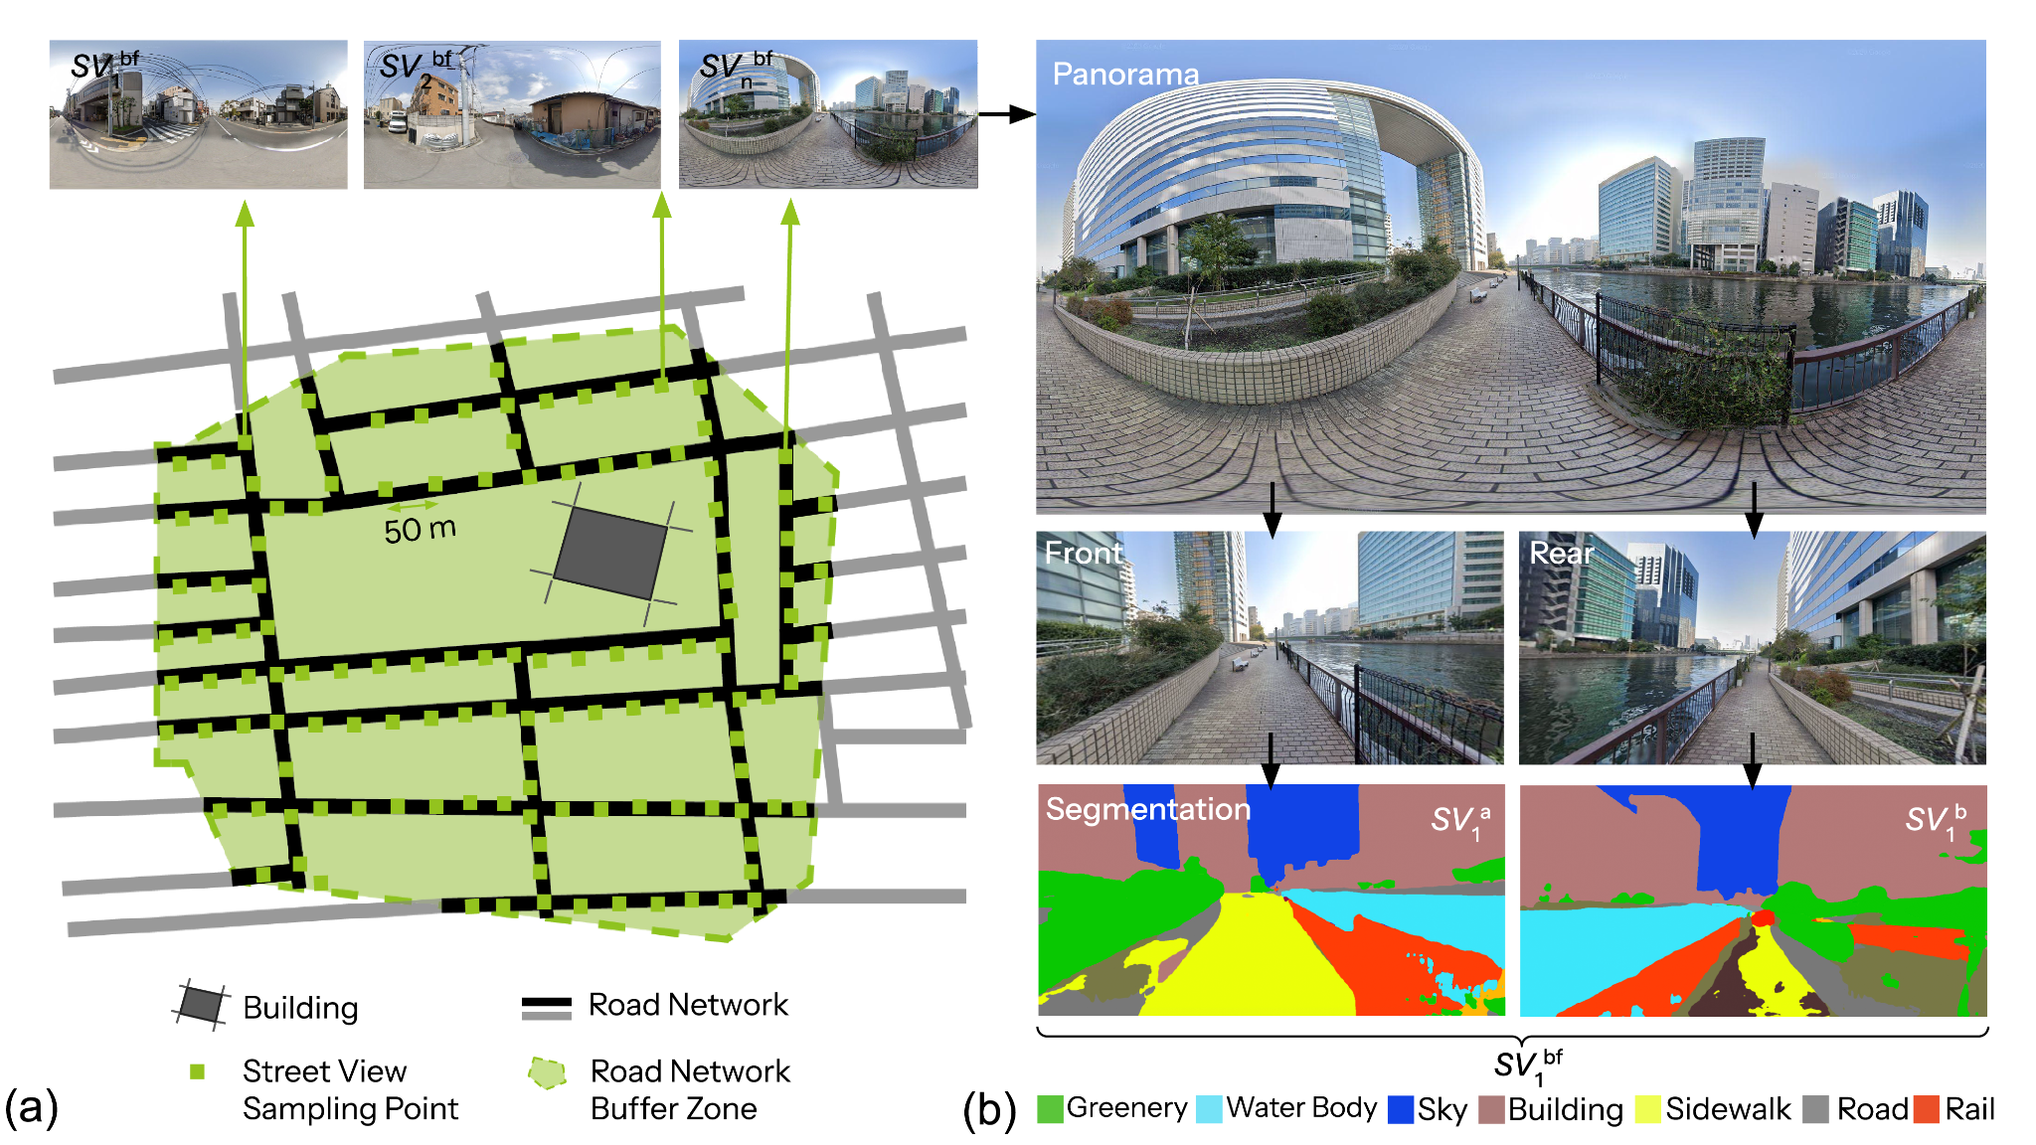
Supplementary Figure 3. Assessment of incidental exposure through street views. (a) Sampling of street views alongside the road networks and (b) semantic segmentation of front and rear views converted from street view panoramas for SVs.

iv) Assessment of intentional exposure through park proximity.
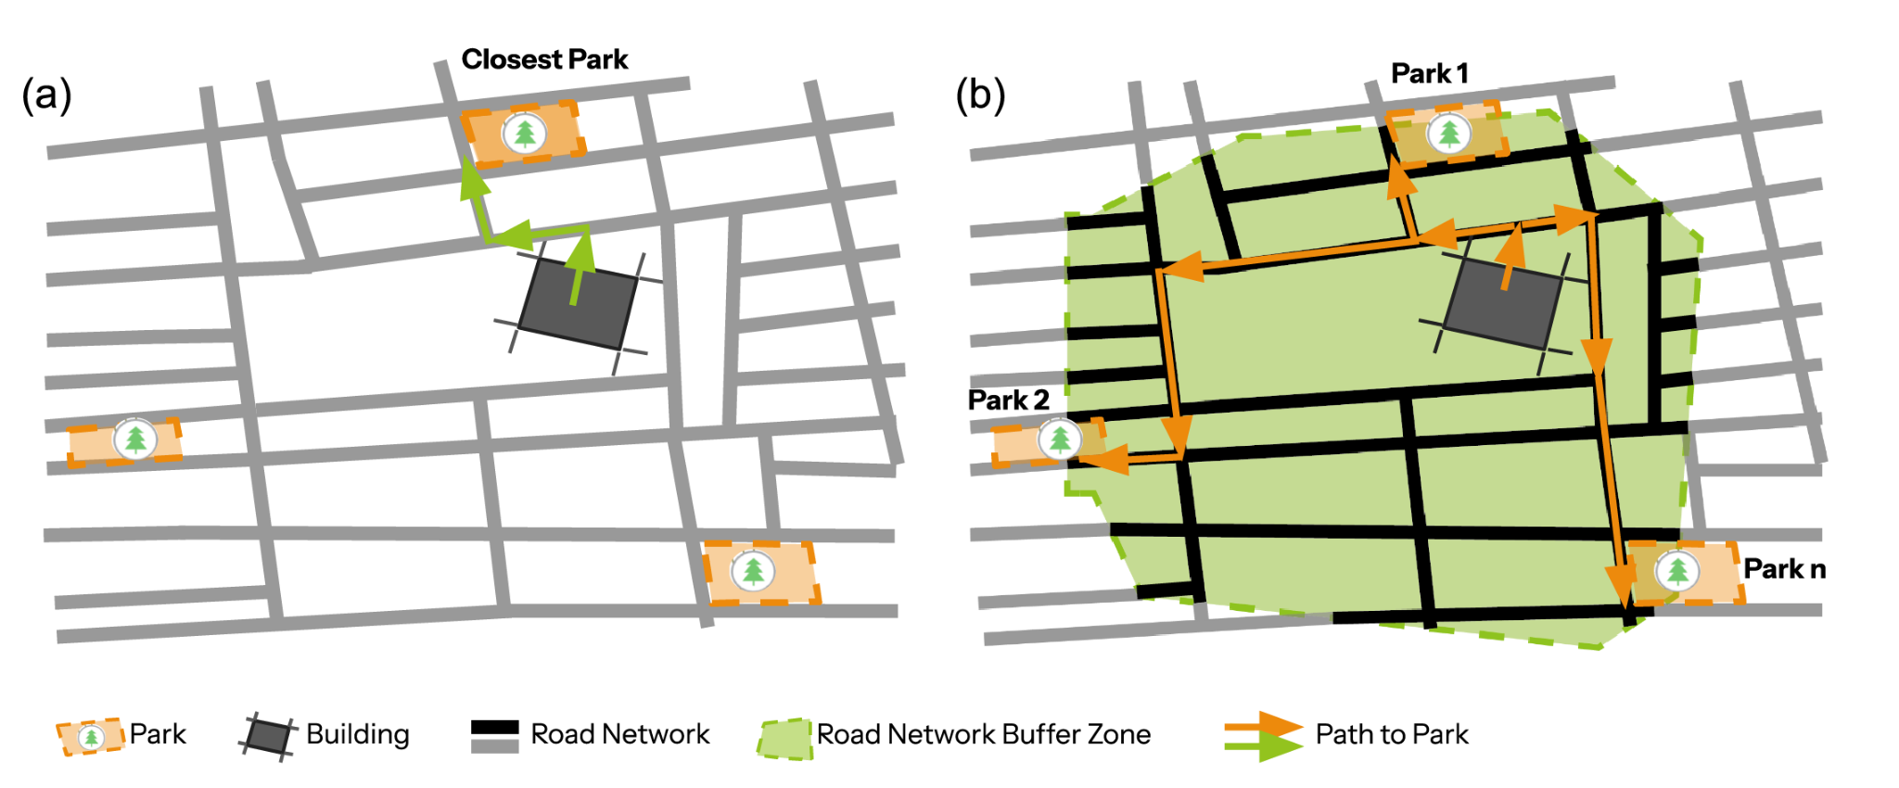
Supplementary Figure 4. Assessment of intentional exposure through park proximity. (a) Closest and (b) accessible parks in different sizes of buffer zones.

v) Assessment of the quantities of unplanned natural resources
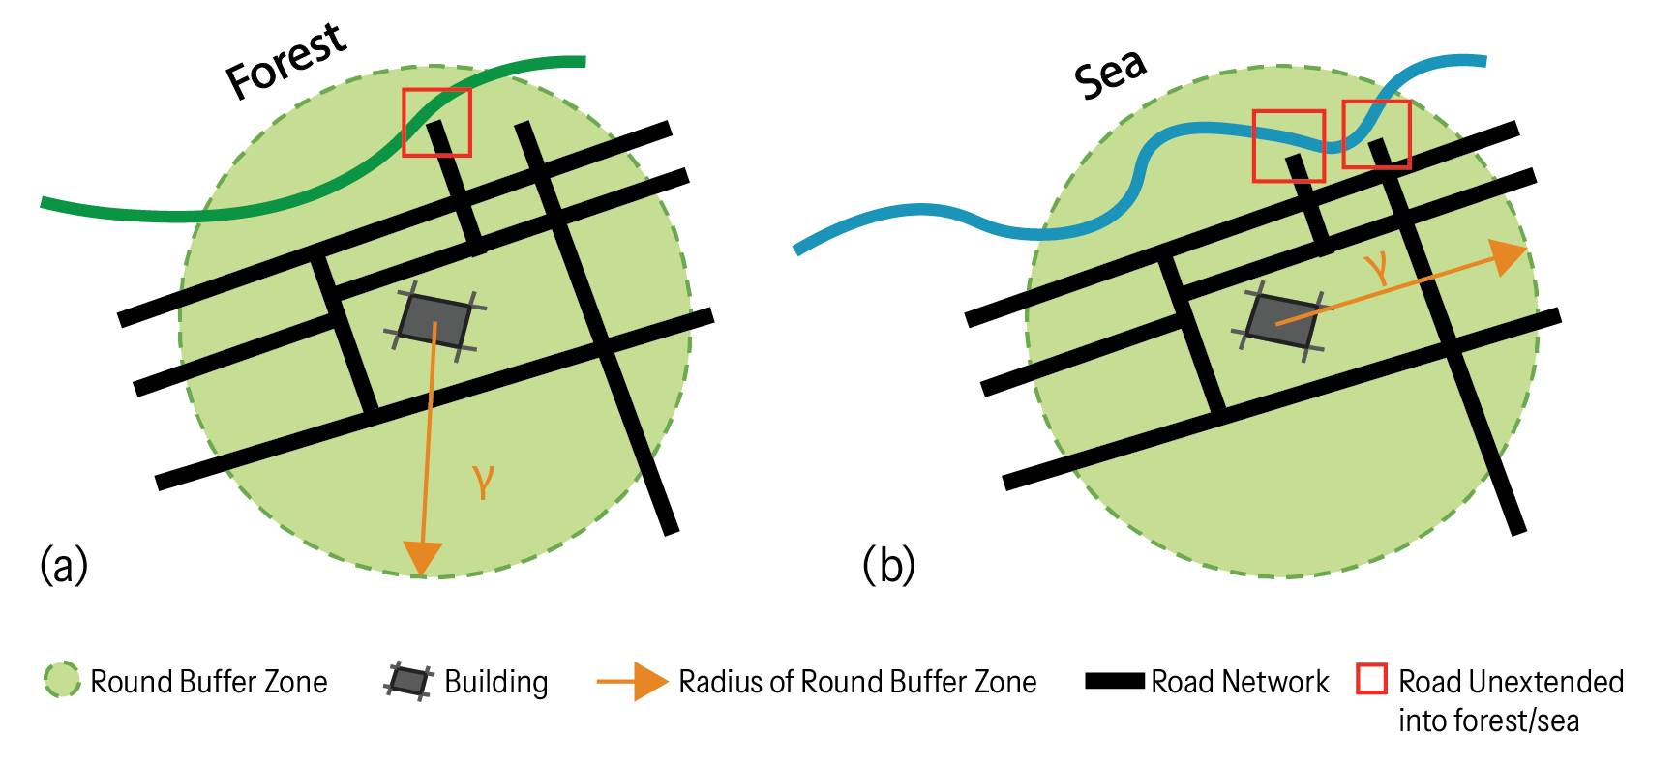
Supplementary Figure 5. Assessment of the quantities of unplanned natural resources. Inaccessible (a) forests and (b) sea and rivers within buffer zones.

vi) OLS regression results with the buffer zone sizes at 500 m, 750 m, 1,000 m, and 1,500 m.
Supplementary Table 1. OLS regression results for three types of objective exposures to nature and happiness
 | Standardized coefficients (β)
Descriptor | M_{CP}⁵⁰⁰ | M_{AP}⁵⁰⁰ | M_{CP}⁷⁵⁰ | M_{AP}⁷⁵⁰ | M_{CP}¹⁰⁰⁰ | M_{AP}¹⁰⁰⁰ | M_{CP}¹⁵⁰⁰ | M_{AP}¹⁵⁰⁰
Intercept | 0 | 0 | 0 | 0 | 0 | 0 | 0 | 0
ZMaleProp | 0.023 | 0.023 | 0.023 | 0.023 | 0.023 | 0.022 | 0.023 | 0.022
ZAvgAge | 0.077* | 0.076* | 0.079* | 0.076* | 0.081** | 0.077* | 0.080* | 0.079*
ZPhysicalSatus | 0.068 | 0.066 | 0.069 | 0.068 | 0.073 | 0.071 | 0.076 | 0.075
ZMentalStatus | 0.424*** | 0.425*** | 0.421*** | 0.423*** | 0.419*** | 0.420*** | 0.417*** | 0.416***
ZIncomeSatisfaction | 0.159*** | 0.158*** | 0.163*** | 0.165*** | 0.166*** | 0.169*** | 0.169*** | 0.171***
Zln(WV_{green}) | 0.068 | 0.069 | 0.057 | 0.060 | 0.069 | 0.062 | 0.066 | 0.054
Zln(WV_{water}) | -0.009 | -0.006 | -0.010 | -0.008 | -0.003 | 0.001 | 0.006 | 0.009
Zln(SV_{green}) | -0.030 | -0.020 | -0.041 | -0.021 | -0.063 | -0.053 | -0.066 | -0.068
Zln(SV_{water}) | 0.056 | 0.058 | 0.064 | 0.070 | 0.062 | 0.072 | 0.041 | 0.054
Zln(CP_{green}) | -0.025 |  | -0.020 |  | -0.016 |  | -0.022
Zln(CP_{water}) | 0.053 |  | 0.048 |  | 0.037 |  | 0.041
Zln(AP_{green}) |  | -0.042 |  | -0.065 |  | -0.046 |  | -0.022
Zln(AP_{water}) |  | 0.070 |  | 0.067 |  | 0.012 |  | -0.017
Zln(UF) | 0.012 | 0.013 | 0.047 | 0.051 | 0.052 | 0.052 | 0.060 | 0.054
Zln(UW) | -0.048 | -0.057 | -0.041 | -0.051 | -0.023 | -0.015 | -0.030 | -0.009
Adjusted R² | 0.315 | 0.316 | 0.316 | 0.318 | 0.316 | 0.317 | 0.316 | 0.315
AIC | 1985.585 | 1984.525 | 1984.762 | 1982.071 | 1984.483 | 1983.657 | 1985.076 | 1985.755
Note: Significance codes: *** : < 0.001; ** : < 0.01; * : < 0.05.

vii) Validity test of OLS regression
The values of Variance Inflation Factors (VIFs) less than 2.603 as shown in Supplementary Table 2 indicated that there was no severe multicollinearity among three types of objective exposure indicators and covariates. The Durbin-Watson values slightly less than 2 were acceptable. The p-value of F statistic less than 0.001 confirmed the validity of the regression model.
Supplementary Table 2. Collinearity analysis results of three types of nature exposure indicators and covariates for OLS regression
 | Variance Inflation Factor (VIF)
Descriptor | OLS_{CP}⁵⁰⁰ | OLS_{AP}⁵⁰⁰ | OLS_{CP}⁷⁵⁰ | OLS_{AP}⁷⁵⁰ | OLS_{CP}¹⁰⁰⁰ | OLS_{AP}¹⁰⁰⁰ | OLS_{CP}¹²⁵⁰ | OLS_{AP}¹²⁵⁰ | OLS_{CP}¹⁵⁰⁰ | OLS_{AP}¹⁵⁰⁰
Intercept
ZMaleProp | 1.056 | 1.056 | 1.057 | 1.057 | 1.056 | 1.055 | 1.055 | 1.054 | 1.055 | 1.054
ZAvgAge | 1.128 | 1.127 | 1.127 | 1.129 | 1.131 | 1.134 | 1.128 | 1.130 | 1.127 | 1.128
ZPhysicalSatus | 2.108 | 2.108 | 2.098 | 2.098 | 2.091 | 2.094 | 2.090 | 2.092 | 2.090 | 2.094
ZMentalStatus | 2.094 | 2.095 | 2.086 | 2.084 | 2.086 | 2.088 | 2.087 | 2.088 | 2.084 | 2.083
ZIncomeSatisfaction | 1.401 | 1.402 | 1.416 | 1.418 | 1.424 | 1.433 | 1.428 | 1.442 | 1.432 | 1.451
Zln(WV_{green}) | 2.550 | 2.474 | 2.539 | 2.471 | 2.564 | 2.456 | 2.587 | 2.468 | 2.603 | 2.460
Zln(WV_{water}) | 1.446 | 1.420 | 1.439 | 1.408 | 1.267 | 1.237 | 1.204 | 1.176 | 1.225 | 1.206
Zln(SV_{green}) | 2.404 | 2.419 | 2.449 | 2.496 | 2.437 | 2.499 | 2.411 | 2.477 | 2.409 | 2.476
Zln(SV_{water}) | 1.525 | 1.528 | 1.612 | 1.606 | 1.441 | 1.433 | 1.394 | 1.386 | 1.428 | 1.415
Zln(CP_{green}) | 1.487 |  | 1.490 |  | 1.477 |  | 1.457 |  | 1.440
Zln(CP_{water}) | 1.483 |  | 1.466 |  | 1.426 |  | 1.408 |  | 1.421
Zln(AP_{green}) |  | 1.400 |  | 1.382 |  | 1.278 |  | 1.232 |  | 1.212
Zln(AP_{water}) |  | 1.857 |  | 1.960 |  | 1.917 |  | 1.887 |  | 1.958
Zln(UF) | 1.304 | 1.302 | 1.432 | 1.435 | 1.536 | 1.541 | 1.582 | 1.581 | 1.628 | 1.619
Zln(UW) | 1.317 | 1.433 | 1.342 | 1.534 | 1.294 | 1.536 | 1.274 | 1.511 | 1.291 | 1.601

Supplementary Table 3. Validity test of OLS regression
Test | OLS_{CP}  ⁵⁰⁰ | OLS_{AP}  ⁵⁰⁰ | OLS_{CP}  ⁷⁵⁰ | OLS_{AP}  ⁷⁵⁰ | OLS_{CP}  ¹⁰⁰⁰ | OLS_{AP}  ¹⁰⁰⁰ | OLS_{CP}¹²⁵⁰ | OLS_{AP}¹²⁵⁰ | OLS_{CP}¹⁵⁰⁰ | OLS_{AP}¹⁵⁰⁰
Durbin-Watson | 1.980 | 1.985 | 1.982 | 1.985 | 1.987 | 1.986 | 1.987 | 1.984 | 1.986 | 1.982
ANOVA F-statistic | 29.34*** | 29.46*** | 29.43*** | 29.74*** | 29.47*** | 29.56*** | 29.49*** | 29.48*** | 29.40*** | 29.32***
Note: Significance codes: *** : < 0.001; ** : < 0.01; * : < 0.05.

viii) SEM results with the buffer zone sizes at 500 m, 750 m, 1,000 m, and 1,500 m.
Supplementary Table 4. SEM results for objective and perceived exposures to nature and happiness
 | Standardized coefficients (β)
Descriptor | M_{CP}⁵⁰⁰ | M_{AP}⁵⁰⁰ | M_{CP}⁷⁵⁰ | M_{AP}⁷⁵⁰ | M_{CP}¹⁰⁰⁰ | M_{AP}¹⁰⁰⁰ | M_{CP}¹⁵⁰⁰ | M_{AP}¹⁵⁰⁰
Direct effects on happiness
ZMaleProp | 0.028 | 0.028 | 0.028 | 0.028 | 0.028 | 0.028 | 0.028 | 0.028
ZAvgAge | 0.077* | 0.077* | 0.077* | 0.077* | 0.077* | 0.077* | 0.077* | 0.077*
ZPhysicalStatus | 0.074 | 0.074 | 0.074 | 0.074 | 0.074 | 0.074 | 0.074 | 0.074
ZMentalStatus | 0.411*** | 0.411*** | 0.411*** | 0.411*** | 0.411*** | 0.411*** | 0.411*** | 0.411***
ZIncomeSatisfaction | 0.157*** | 0.157*** | 0.157*** | 0.157*** | 0.157*** | 0.157*** | 0.157*** | 0.157***
ZPerceivedNatureExposure | 0.062* | 0.062* | 0.062* | 0.062* | 0.062* | 0.062* | 0.062* | 0.062*
Indirect effects mediated by perceived exposure
Zln(WV_{green}) | 0.016*** | 0.018*** | 0.017*** | 0.018*** | 0.016*** | 0.018*** | 0.014*** | 0.017***
Zln(WV_{water}) | -0.003 | -0.003 | -0.003 | -0.003 | -0.003 | -0.002 | -0.002 | -0.001
Zln(SV_{green}) | 0.010*** | 0.008** | 0.009*** | 0.006* | 0.007** | 0.005* | 0.007** | 0.006*
Zln(SV_{water}) | -0.000# | -0.001 | -0.000# | -0.002 | -0.001 | -0.002 | -0.004* | -0.005**
Zln(CP_{green}) | 0.003 |  | 0.003 |  | 0.003 |  | 0.003
Zln(CP_{water}) | 0.003 |  | 0.003 |  | 0.005* |  | 0.007***
Zln(AP_{green}) |  | 0.008*** |  | 0.010*** |  | 0.010*** |  | 0.008***
Zln(AP_{water}) |  | 0.006** |  | 0.004 |  | 0.004* |  | 0.005*
Zln(UF) | 0.007*** | 0.007*** | 0.009*** | 0.009*** | 0.014*** | 0.013*** | 0.018*** | 0.017***
Zln(UW) | 0.006** | 0.004* | 0.008*** | 0.006** | 0.006** | 0.005** | 0.003 | 0.004
ZMaleProp | -0.005** | -0.005** | -0.005** | -0.005** | -0.005** | -0.004** | -0.004** | -0.005**
ZAvgAge | -0.003 | -0.003 | -0.003 | -0.003 | -0.003 | -0.002 | -0.003 | -0.003
ZPhysicalStatus | 0.004* | 0.004 | 0.004 | 0.004 | 0.004 | 0.003 | 0.004 | 0.004
ZMentalStatus | 0.002 | 0.003 | 0.003 | 0.003 | 0.003 | 0.004 | 0.003 | 0.003
ZIncomeSatisfaction | 0.005** | 0.005* | 0.005** | 0.005** | 0.006** | 0.005** | 0.007*** | 0.006**
Note: #: > -0.0005; Significance codes: *** : < 0.001; ** : < 0.01; *: < 0.05.

ix) Validity test of SEM
Supplementary Table 5 lists the test results of constructed Structural Equation Models (SEM) using two types of intentional nature exposure metrics, i.e., CPs and AP, respectively. The analyses were conducted across buffer zones of 500 m, 750 m, 1,000 m, 1,250 m, and 1,500 m. All constructed models were valid according to the tests. Specifically, the p values of the Chi-squared test were larger than 0.05, reflecting an acceptable model fit. All models both passed four evaluation metrics, i.e., GFI (> 0.90), CFI (> 0.95), SRMR (< 0.08), and RMSEA (< 0.05).
Supplementary Table 5. Model fit of SEM using five different buffer zone sizes
Model | CHISQ | Siginfiance (p) | CHISQ/df | GFI | CFI | SRMR | RMSEA
M_{CP}⁵⁰⁰ | 8.038 | 0.530 | 0.893 | 0.999 | 1.000 | 0.007 | 0.000
M_{AP}⁵⁰⁰ | 9.430 | 0.399 | 1.048 | 0.999 | 0.999 | 0.007 | 0.008
M_{CP}⁷⁵⁰ | 8.051 | 0.529 | 0.895 | 0.999 | 1.000 | 0.007 | 0.000
M_{AP}⁷⁵⁰ | 11.958 | 0.216 | 1.329 | 0.998 | 0.993 | 0.007 | 0.020
M_{CP}¹⁰⁰⁰ | 7.882 | 0.546 | 0.876 | 0.999 | 1.000 | 0.007 | 0.000
M_{AP}¹⁰⁰⁰ | 10.023 | 0.349 | 1.114 | 0.998 | 0.998 | 0.007 | 0.012
M_{CP}¹²⁵⁰ | 8.215 | 0.513 | 0.913 | 0.999 | 1.000 | 0.006 | 0.000
M_{AP}¹²⁵⁰ | 9.297 | 0.410 | 1.033 | 0.999 | 0.999 | 0.007 | 0.006
M_{CP}¹⁵⁰⁰ | 7.281 | 0.608 | 0.809 | 0.999 | 1.000 | 0.006 | 0.000
M_{AP}¹⁵⁰⁰ | 7.568 | 0.578 | 0.841 | 0.999 | 1.000 | 0.006 | 0.000

x) Moran’s I test of residuals in OLS regression and SEM
Moran’s I test results in both Supplementary Tables 6 and 7 (Statistic close to 0, p > 0.05) suggest no spatial autocorrelation of residuals in both OLS regression and SEM.
Supplementary Table 6. Moran’s I test result for residuals of OLS regressions
Model | Statistic | Z-score | Siginfiance (p)
OLS_{CP}⁵⁰⁰ | 0.013 | 0.675 | 0.250
OLS_{AP}⁵⁰⁰ | 0.009 | 0.494 | 0.311
OLS_{CP}⁷⁵⁰ | 0.013 | 0.662 | 0.254
OLS_{AP}⁷⁵⁰ | 0.011 | 0.584 | 0.280
OLS_{CP}¹⁰⁰⁰ | 0.010 | 0.520 | 0.302
OLS_{AP}¹⁰⁰⁰ | 0.010 | 0.525 | 0.300
OLS_{CP}¹²⁵⁰ | 0.009 | 0.500 | 0.308
OLS_{AP}¹²⁵⁰ | 0.009 | 0.468 | 0.320
OLS_{CP}¹⁵⁰⁰ | 0.010 | 0.534 | 0.297
OLS_{AP}¹⁵⁰⁰ | 0.009 | 0.469 | 0.320

Supplementary Table 7. Moran’s I test result for residuals of linear regressions a) between happiness and perceived exposure (Equation 12), and b) between perceived and objective exposure (Equation 13) in SEM
Regression | Statistic | Z-score | Siginfiance (p)
a | 0.012 | 0.646 | 0.259
b_{CP}⁵⁰⁰ | -0.026 | -2.281 | 0.989
b_{AP}⁵⁰⁰ | -0.022 | -1.908 | 0.972
b_{CP}⁷⁵⁰ | -0.026 | -2.213 | 0.987
b_{AP}⁷⁵⁰ | -0.022 | -1.854 | 0.968
b_{CP}¹⁰⁰⁰ | -0.027 | -2.314 | 0.990
b_{AP}¹⁰⁰⁰ | -0.022 | -1.917 | 0.972
b_{CP}¹²⁵⁰ | -0.027 | -2.311 | 0.990
b_{AP}¹²⁵⁰ | -0.023 | -1.958 | 0.975
b_{CP}¹⁵⁰⁰ | -0.027 | -2.320 | 0.990
b_{AP}¹⁵⁰⁰ | -0.025 | -2.172 | 0.985

