Optimization of Graphene based biosensor designed with metal oxides and easy electrochemical test with various biomolecules

Latiful Kabir ¹, Young Jun Joo ², Kwang Youn Cho ², Won-Chun Oh ^{1∗}

¹ Department of Advanced Materials Science & Engineering, Hanseo University, Seosan-si, Chungnam, Korea, 356-706
² Korea Institutes of Ceramic Engineering and Technology, Soho-ro, Jinju-Si, Gyeongsangnam-do, South Korea

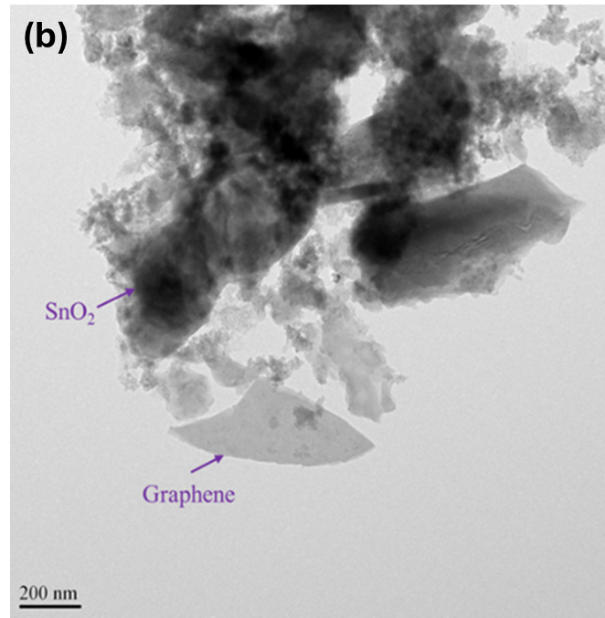
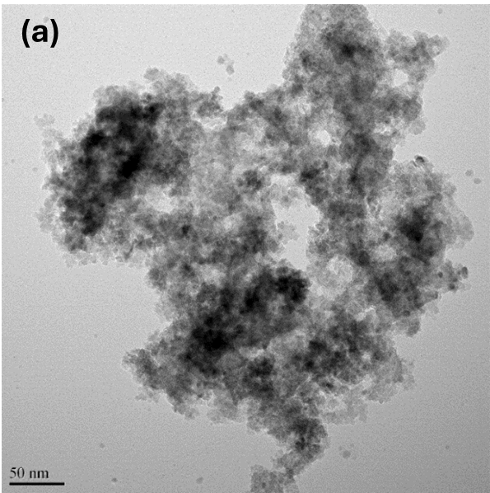

Fig S1 TEM image of (a) SnO₂ (b) SnO₂-G
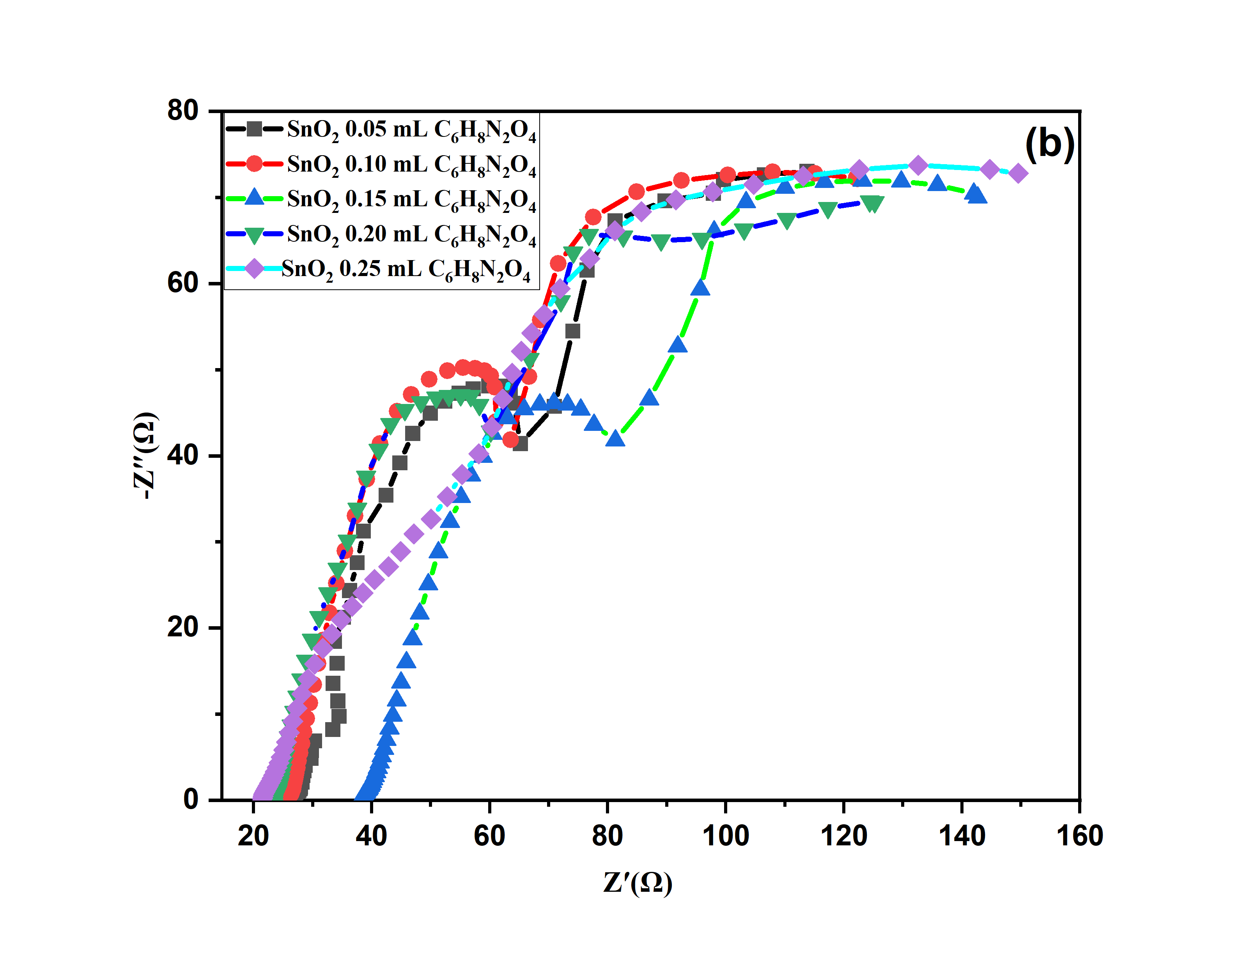
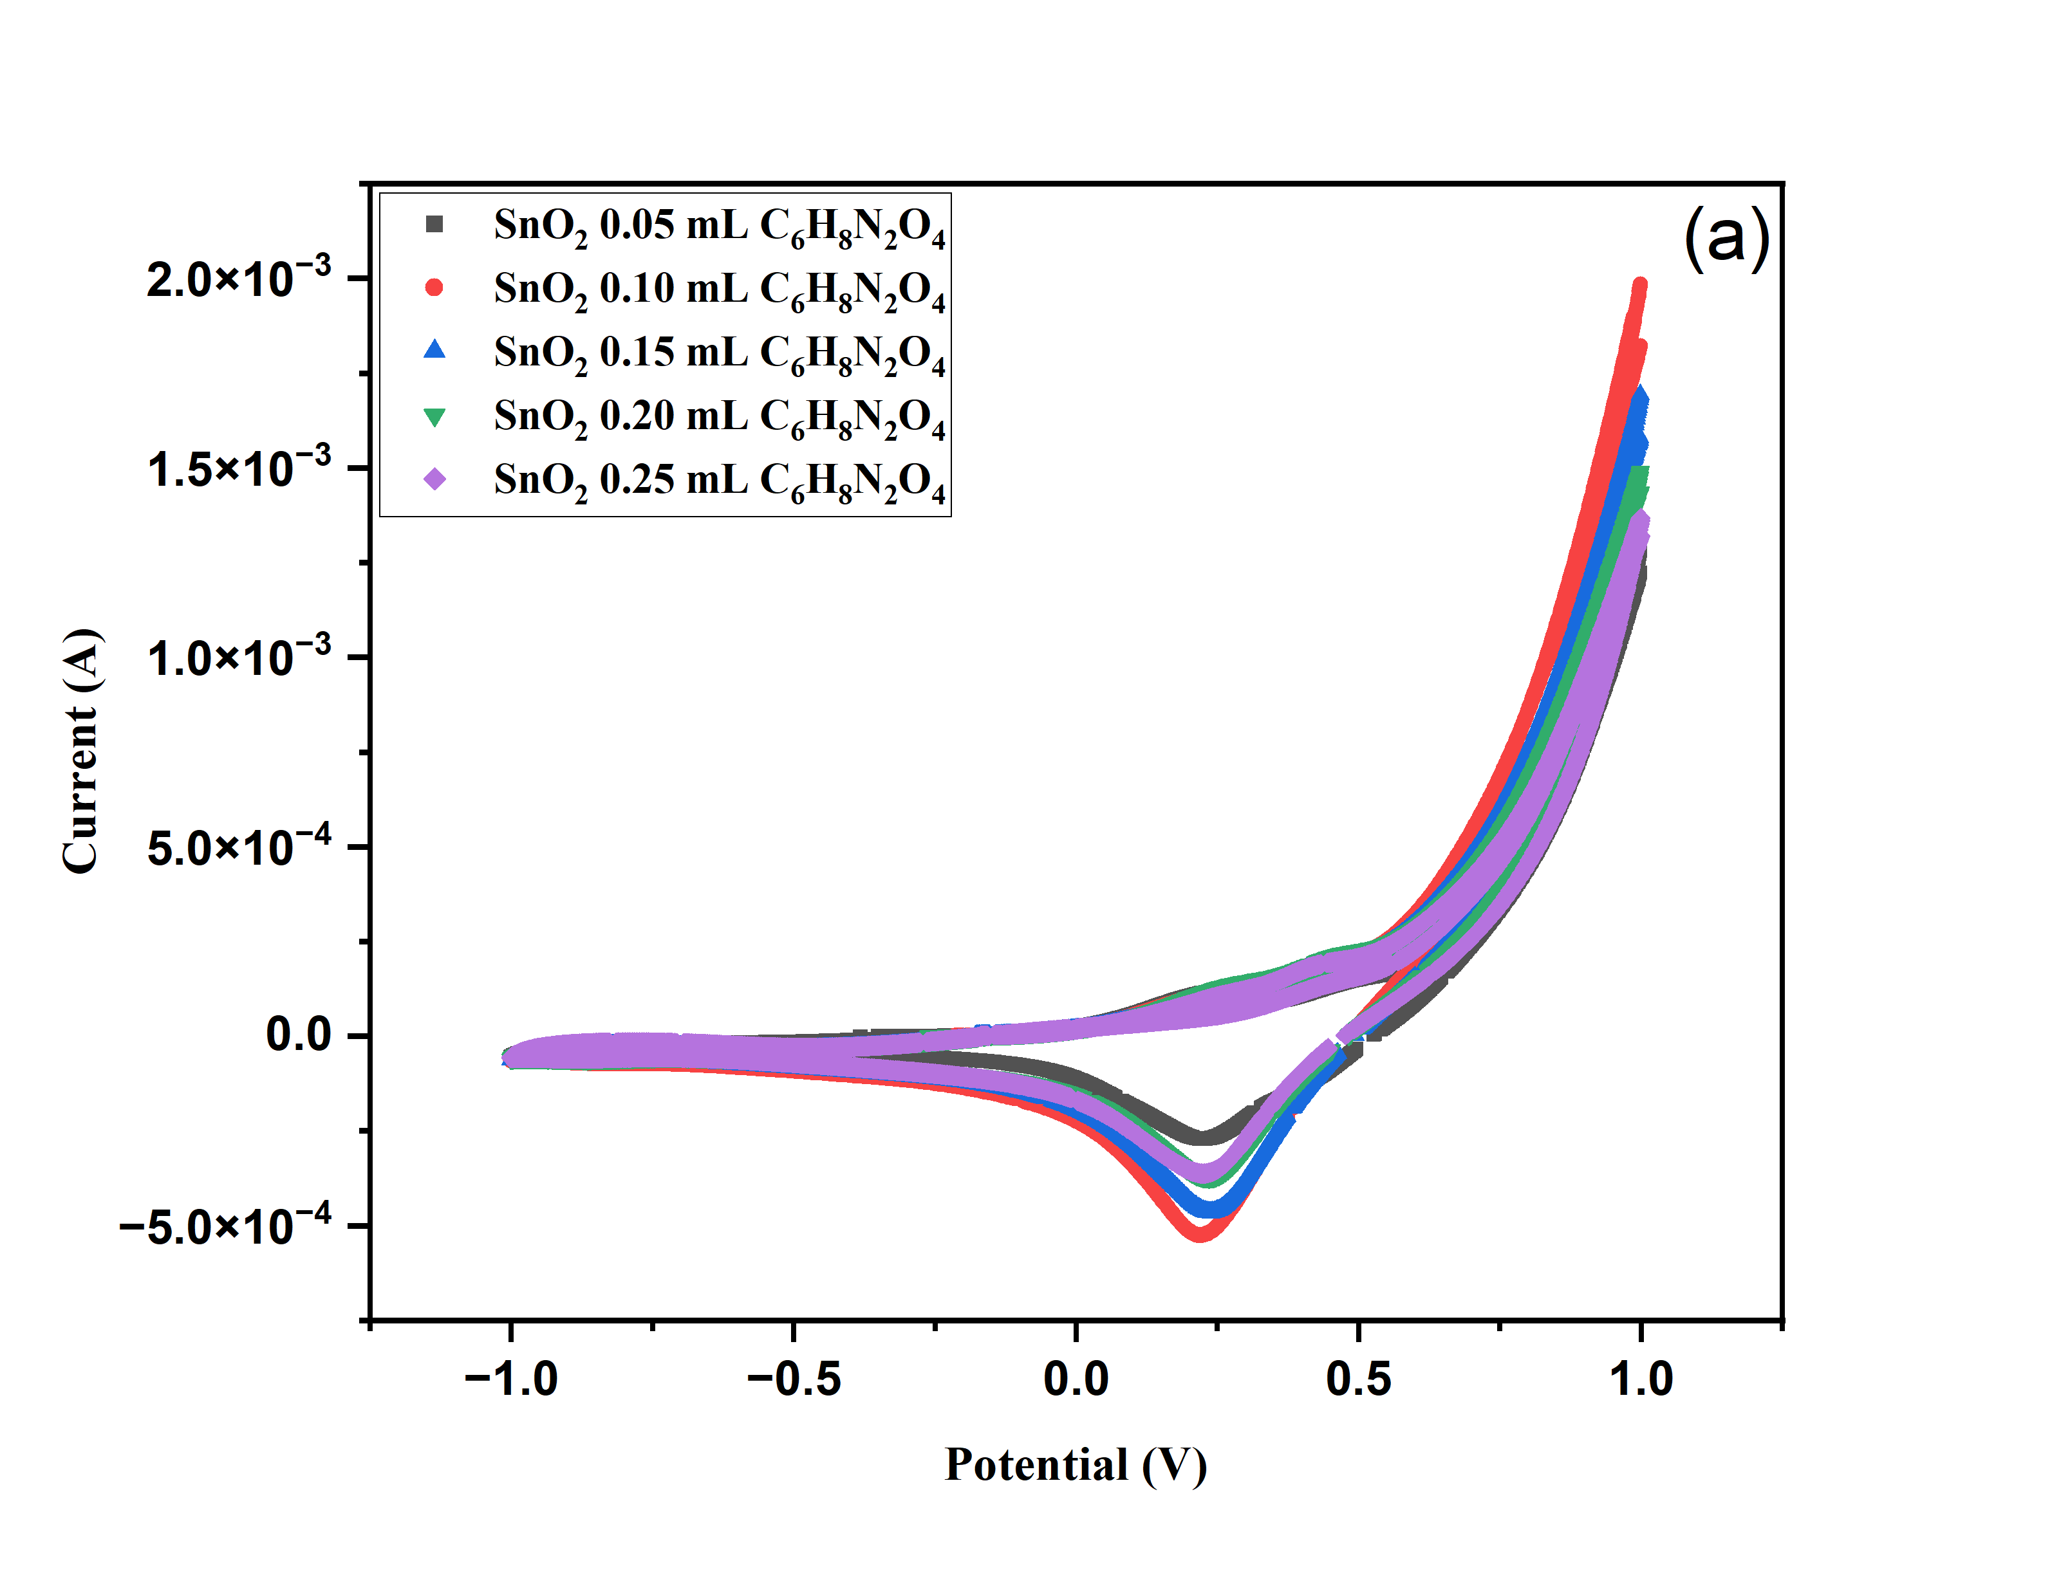

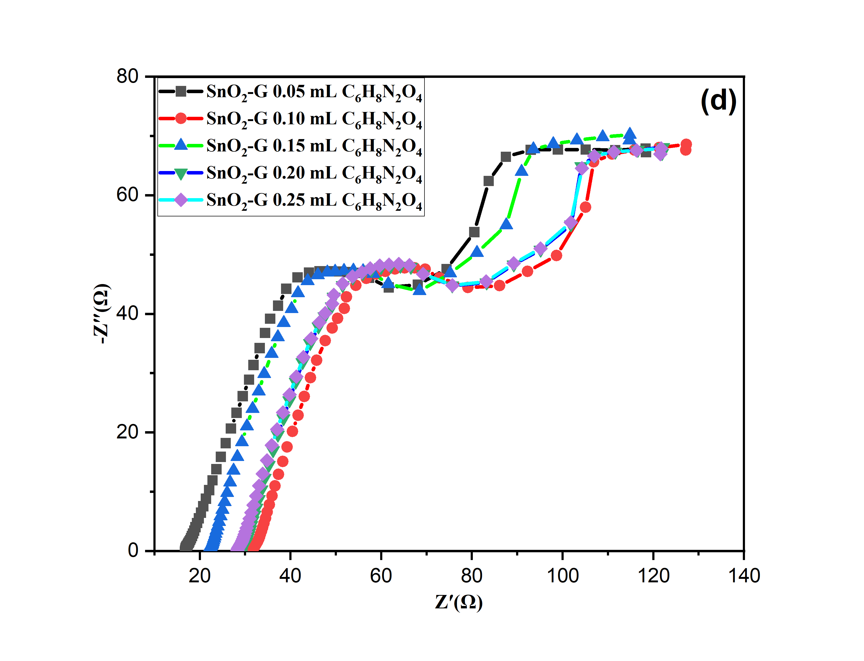
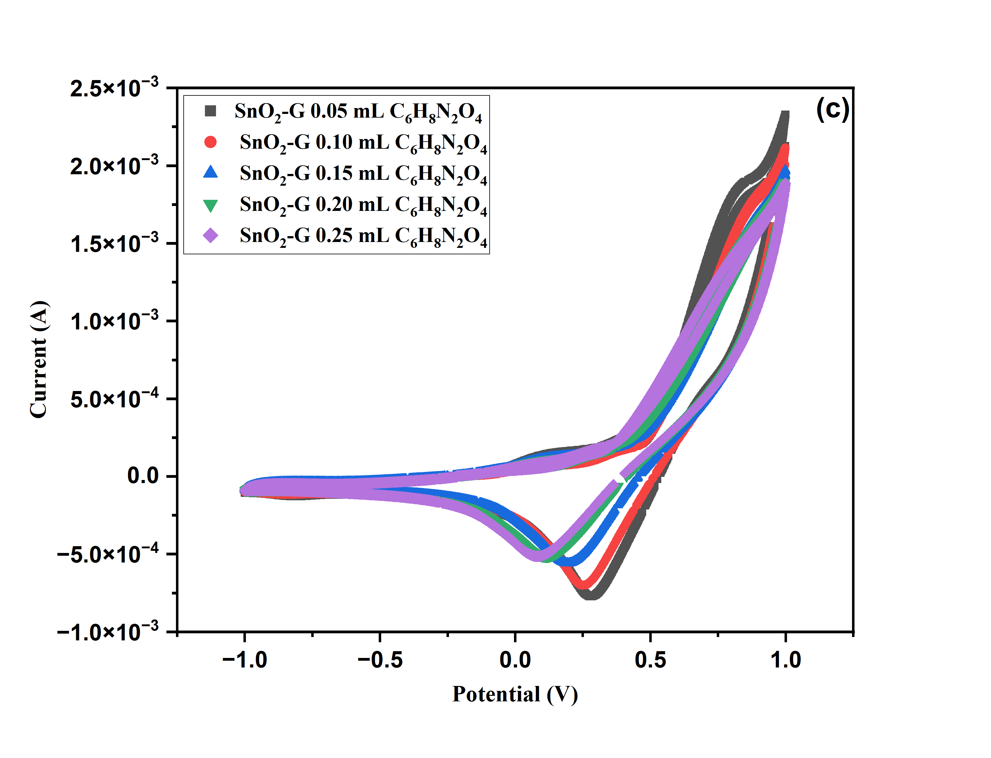

Fig. S2. CV test various concentrations of albumin SnO₂, SnO₂-G (a, c); EIS plot of SnO₂ and SnO₂-G (b, d).

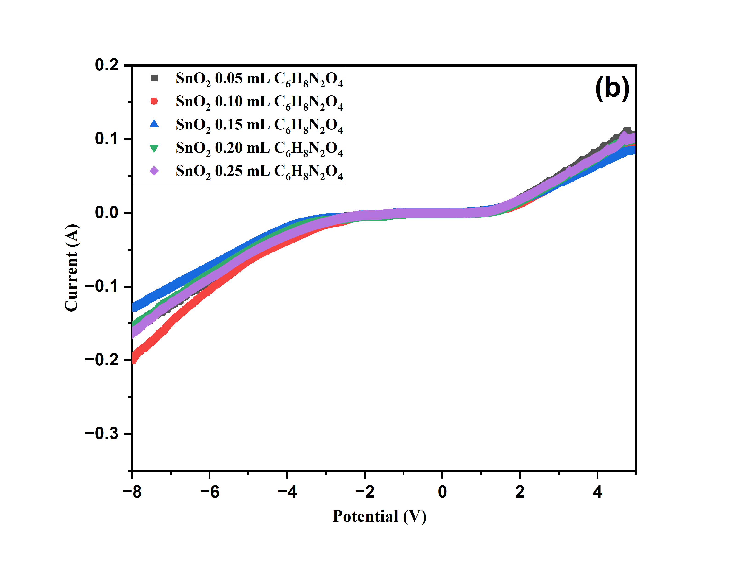
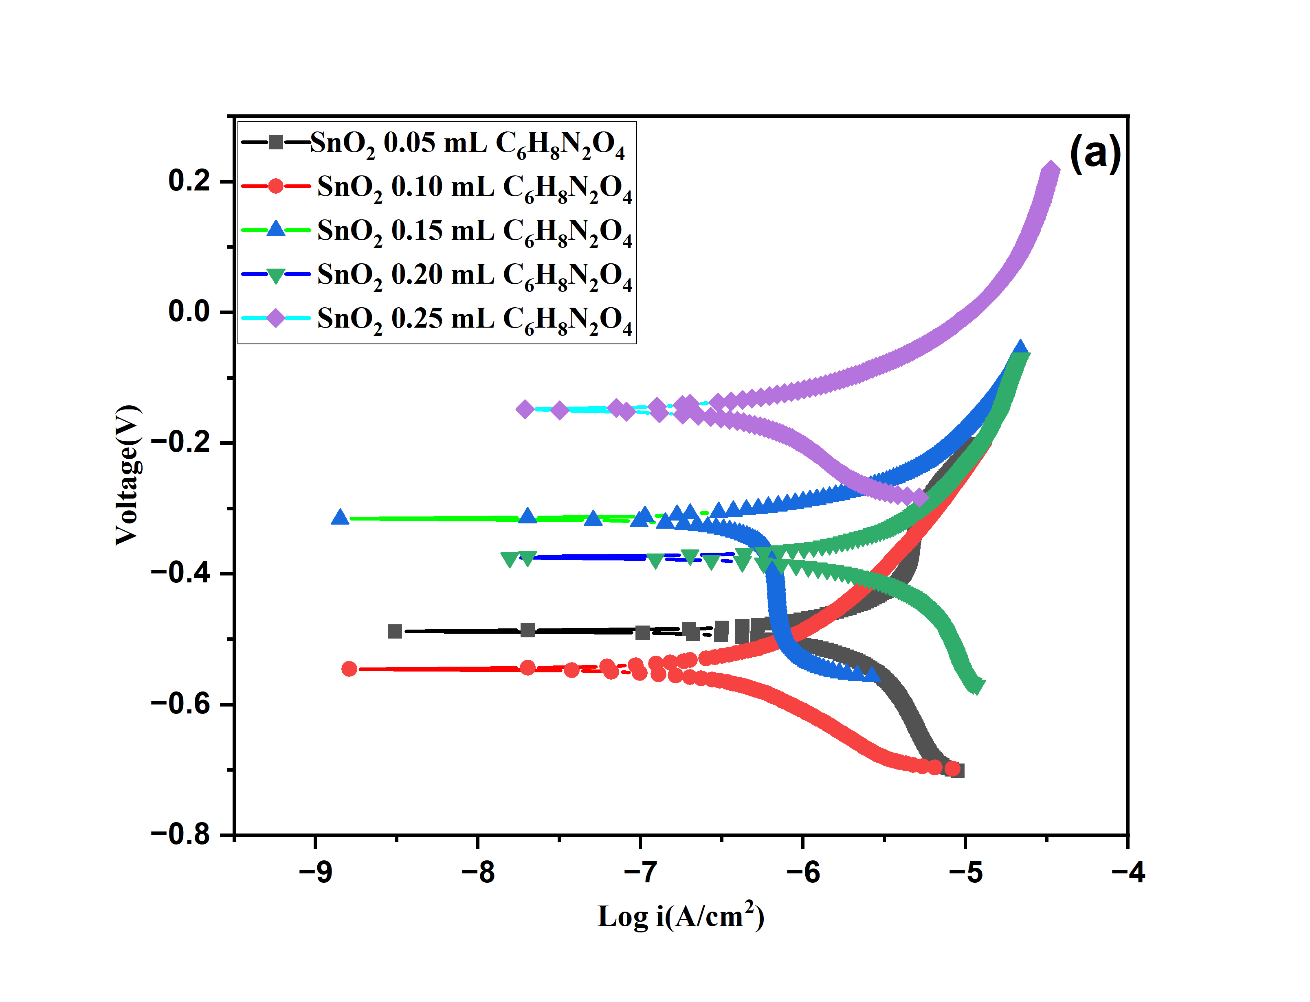

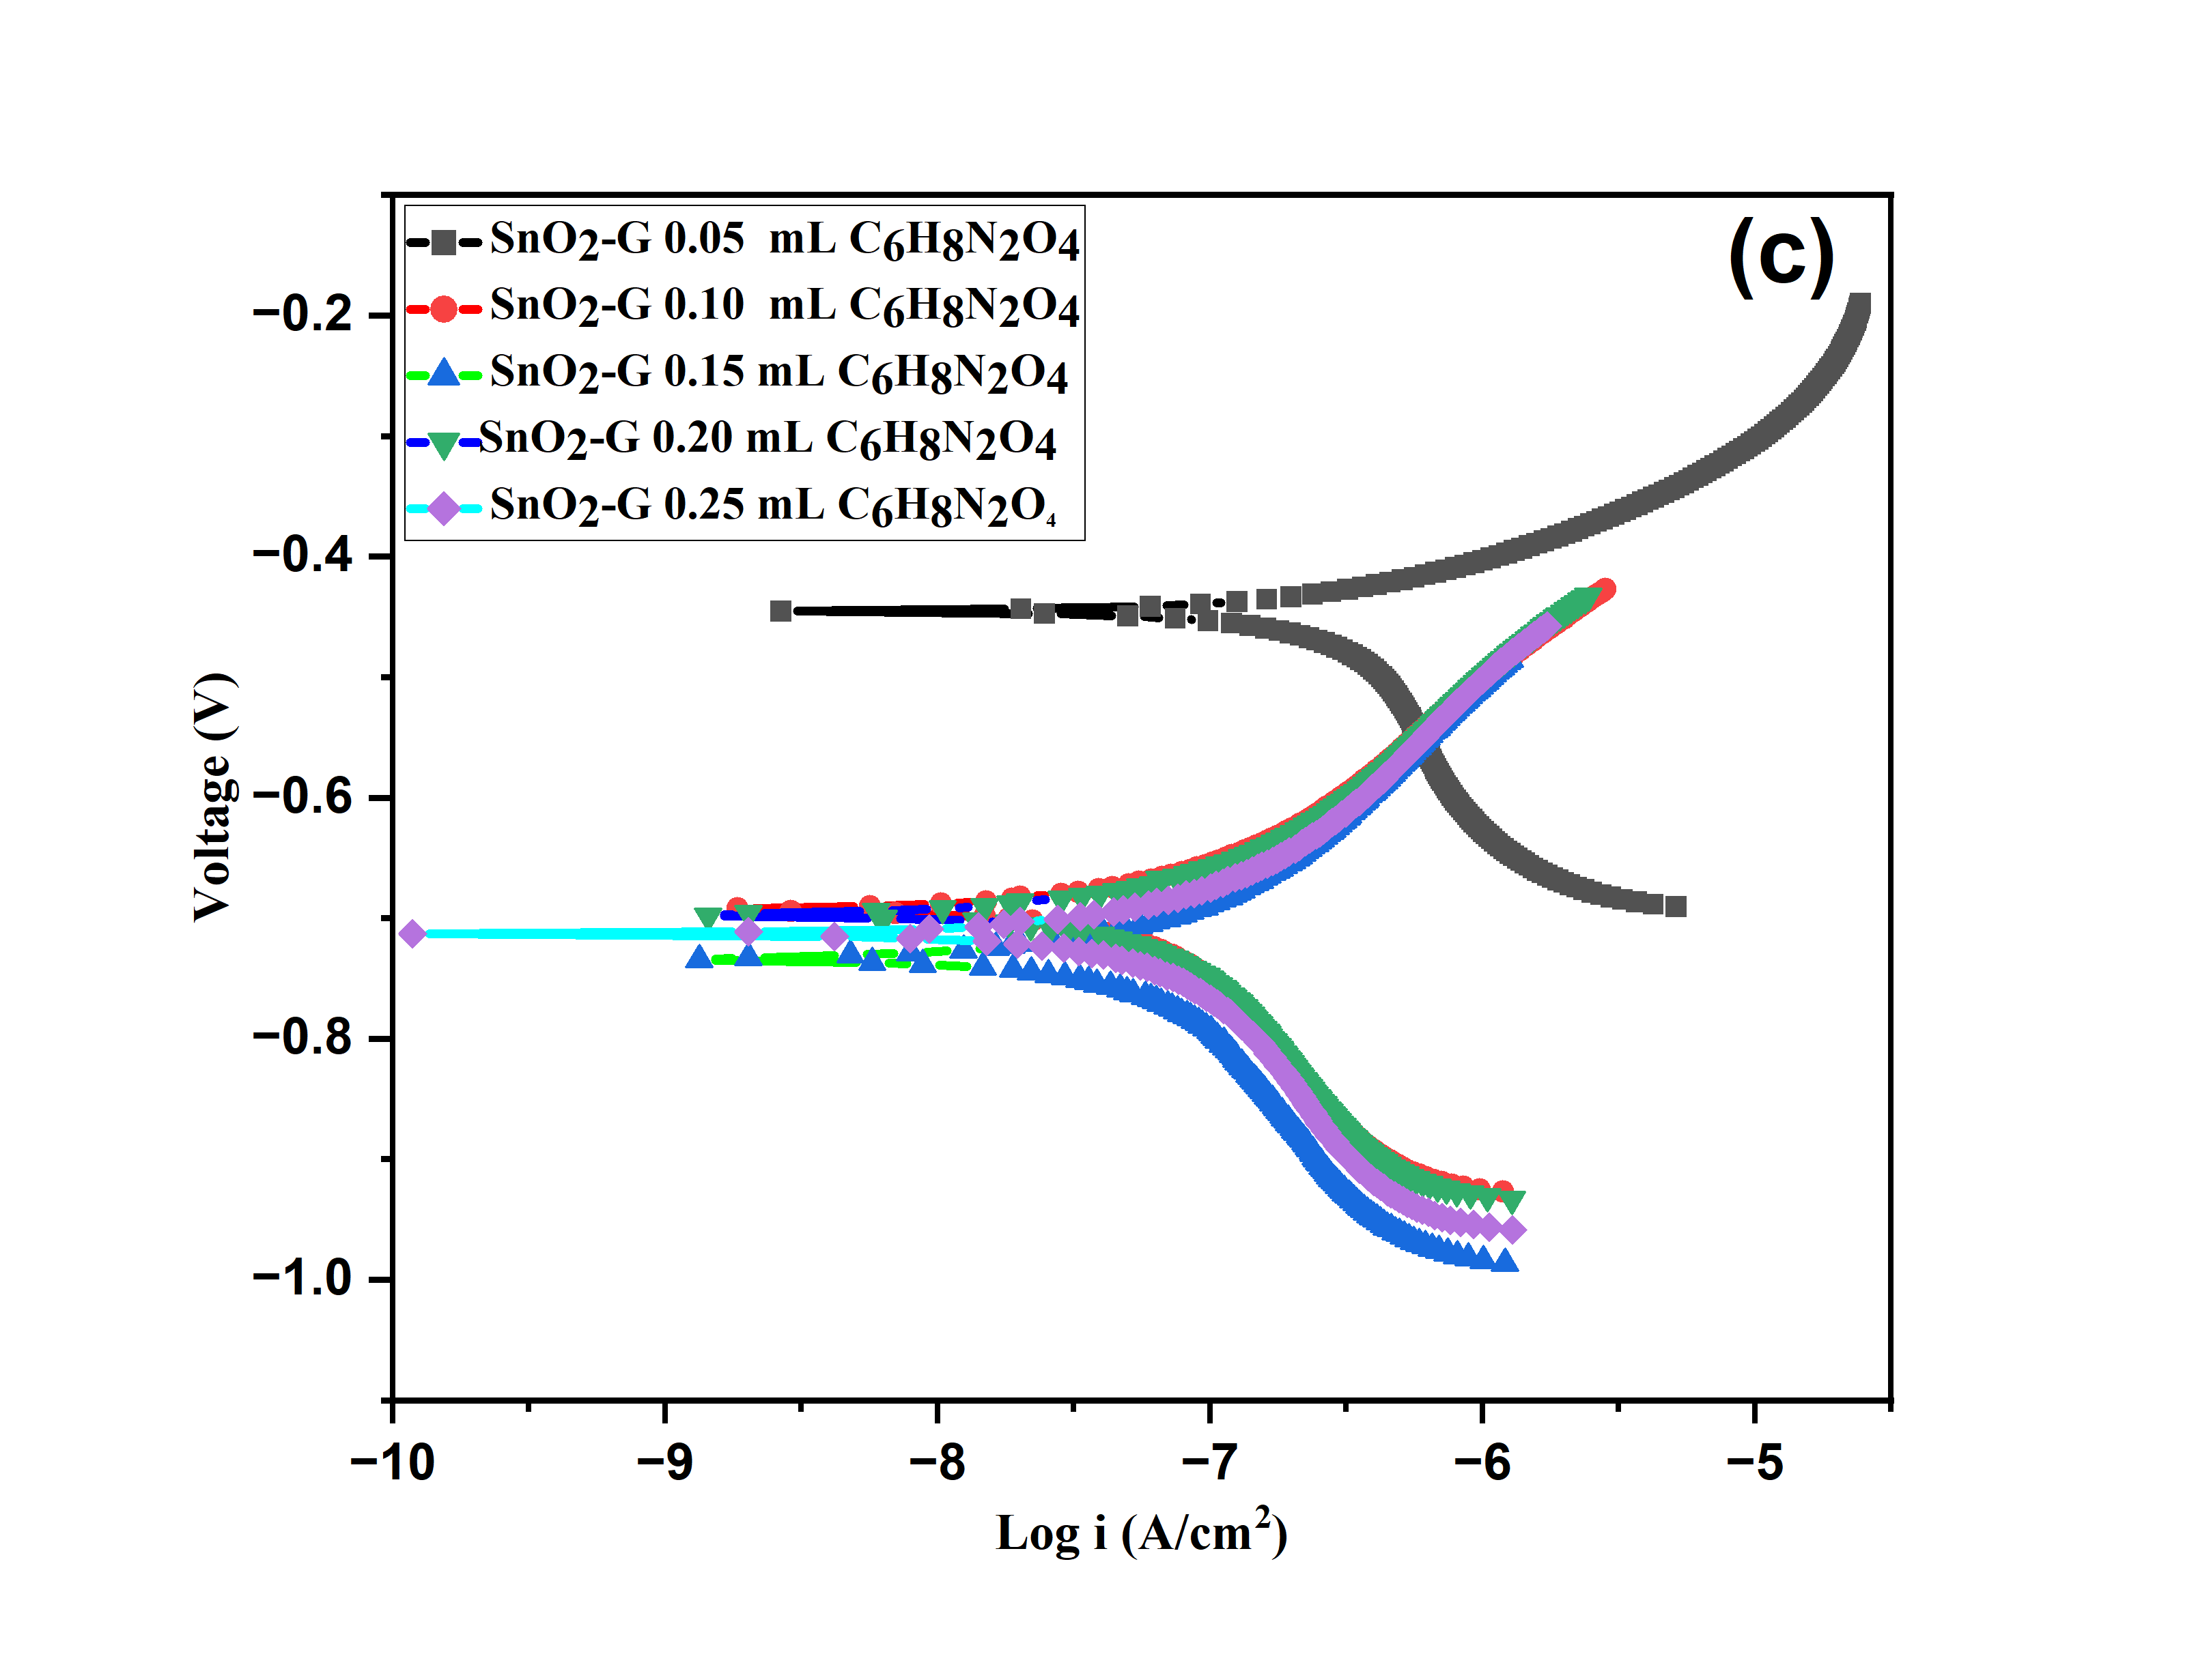
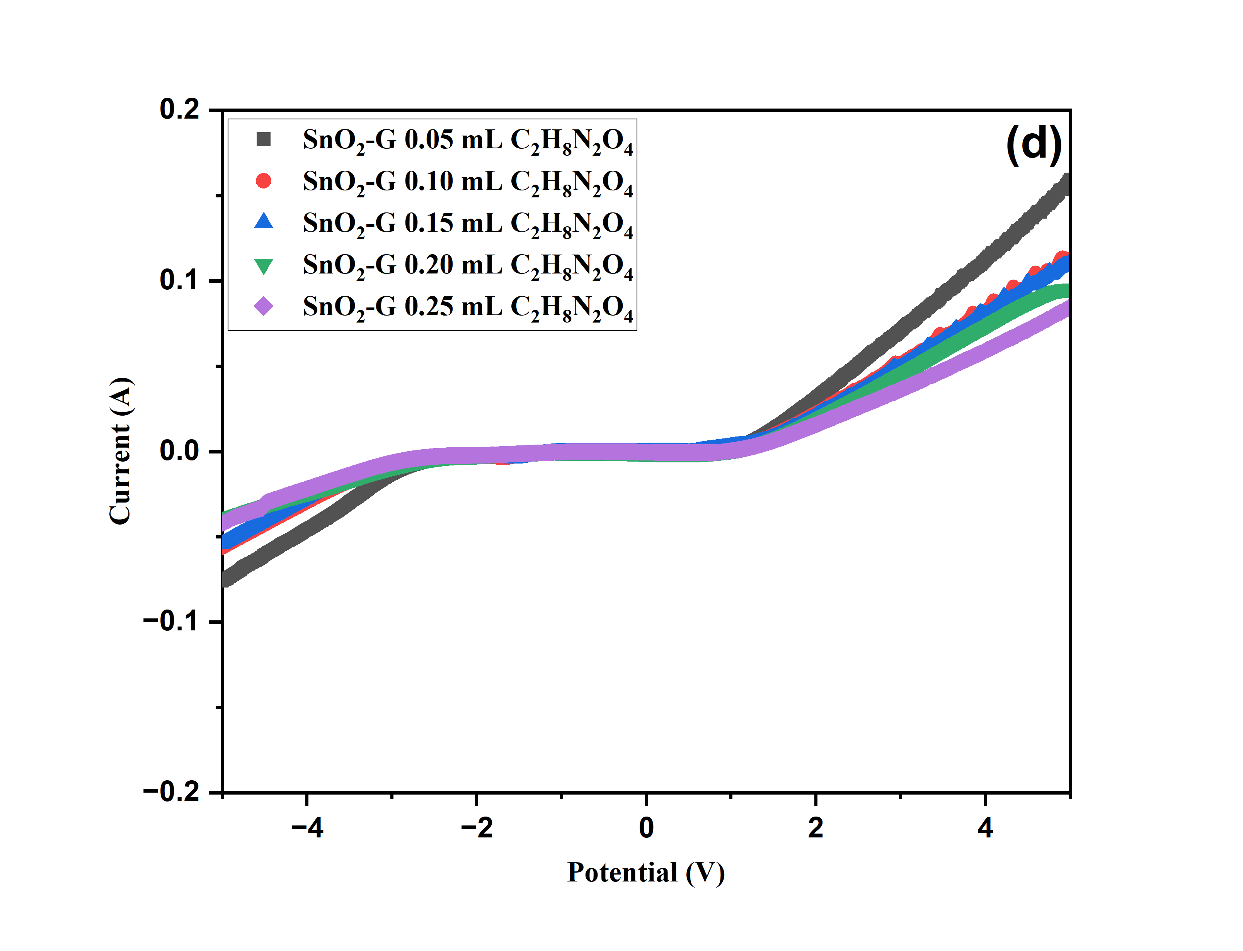

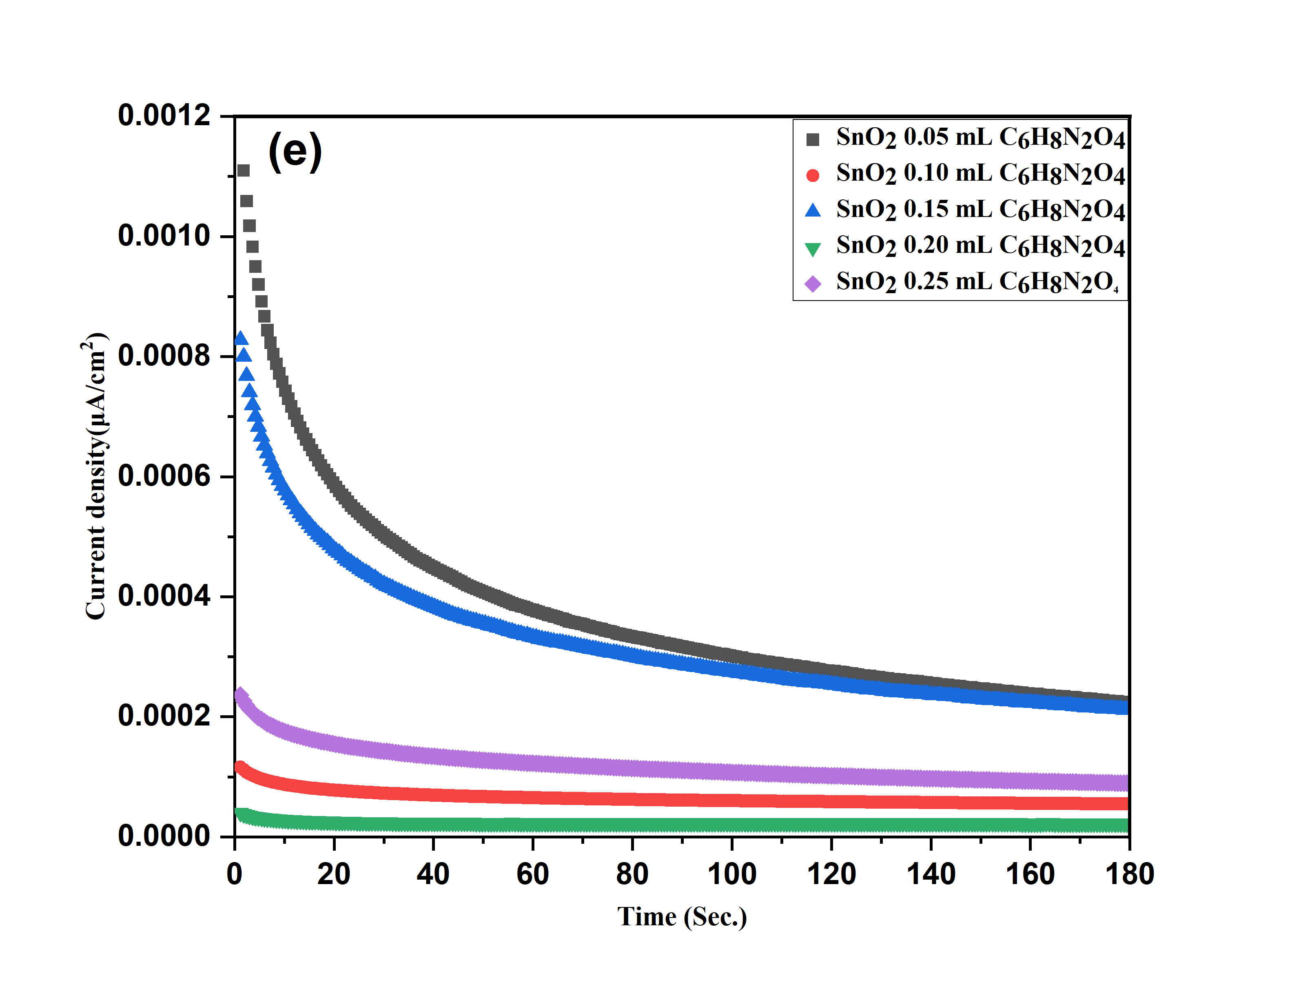
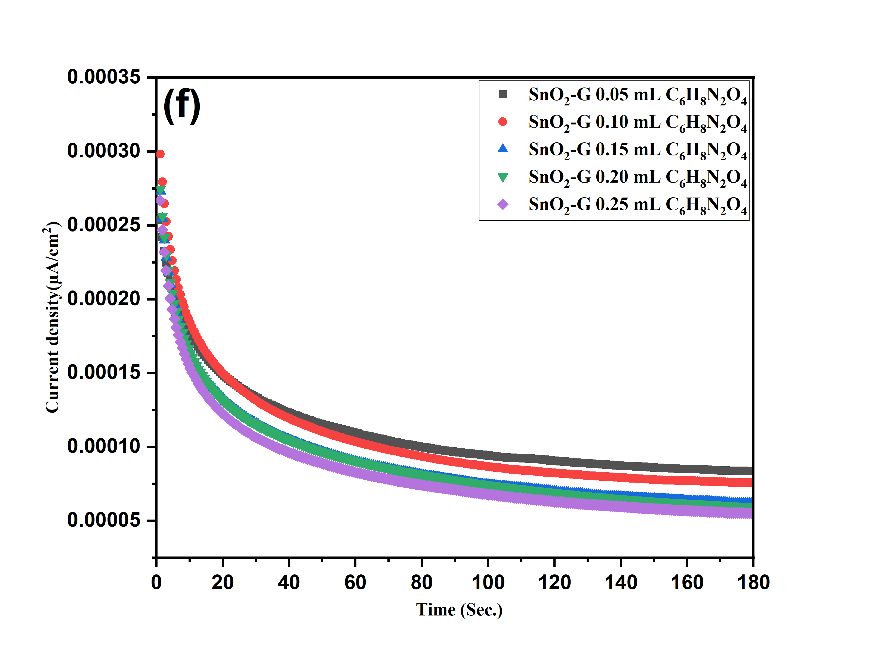

Fig S 3. Tafel and LSV test of SnO₂, and SnO₂-G (a, c and b, d) and chronoamperometry test various concentrations of albumin SnO₂ (e) and SnO₂-G (f).

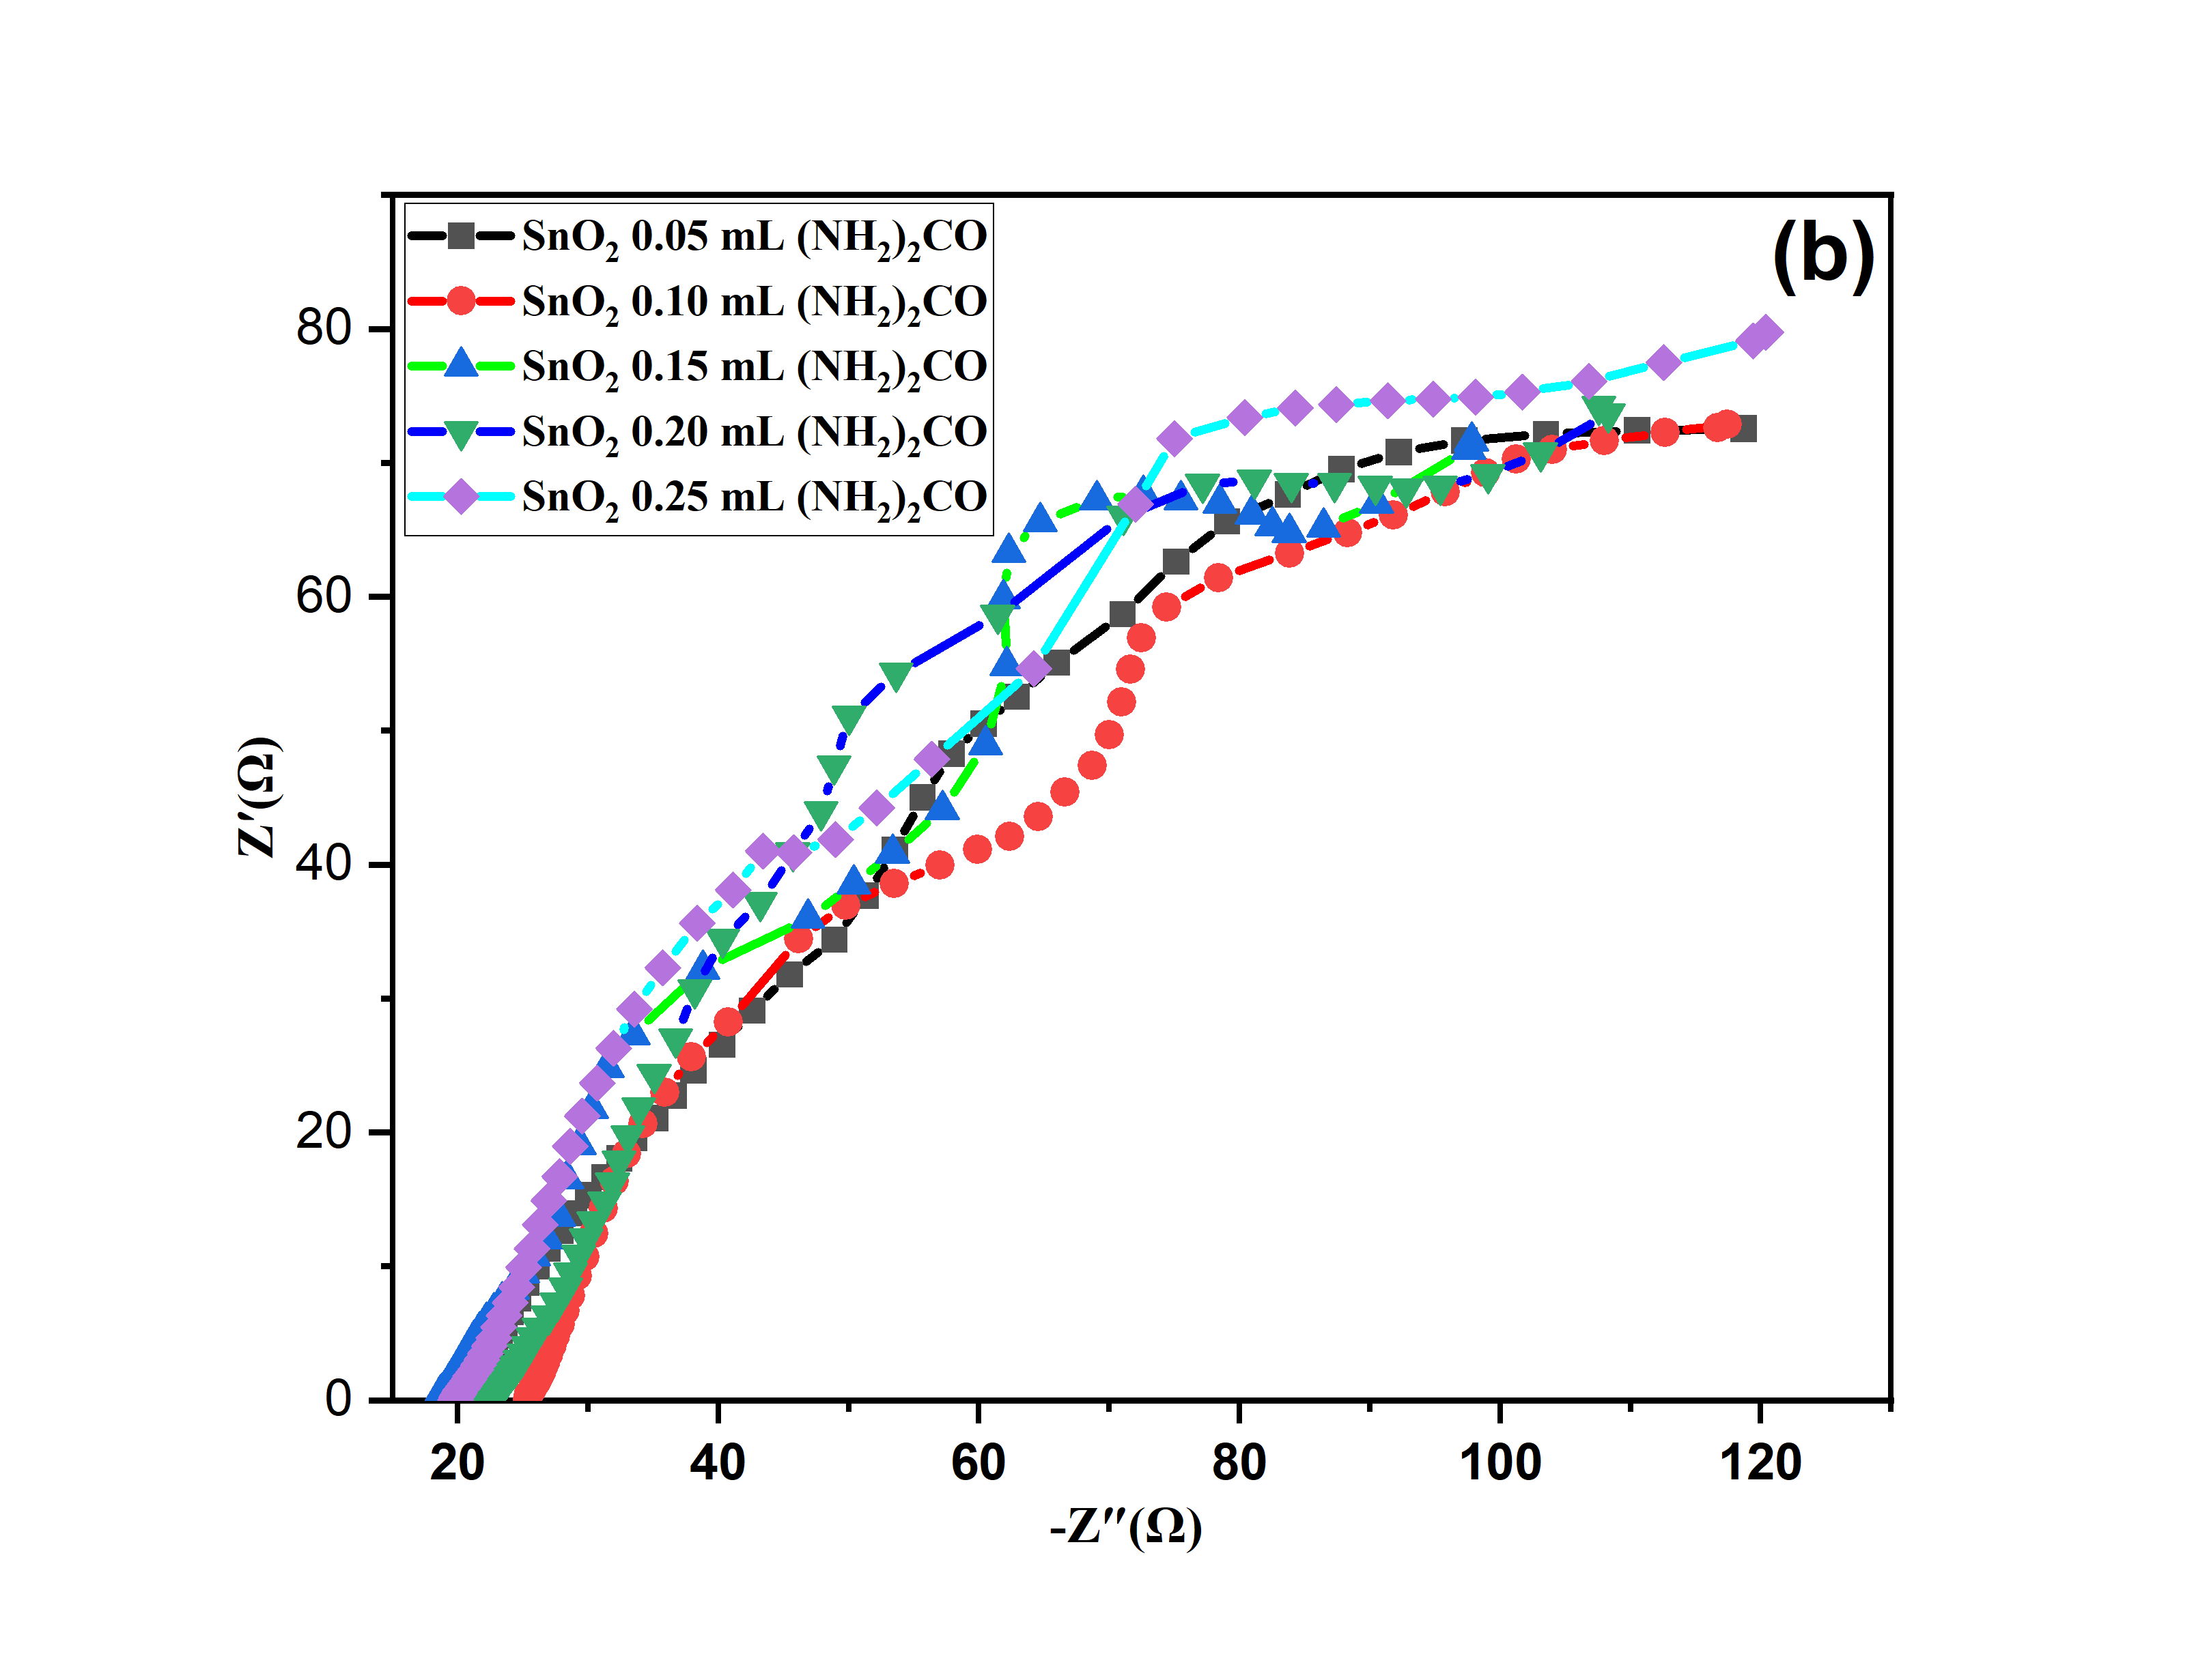
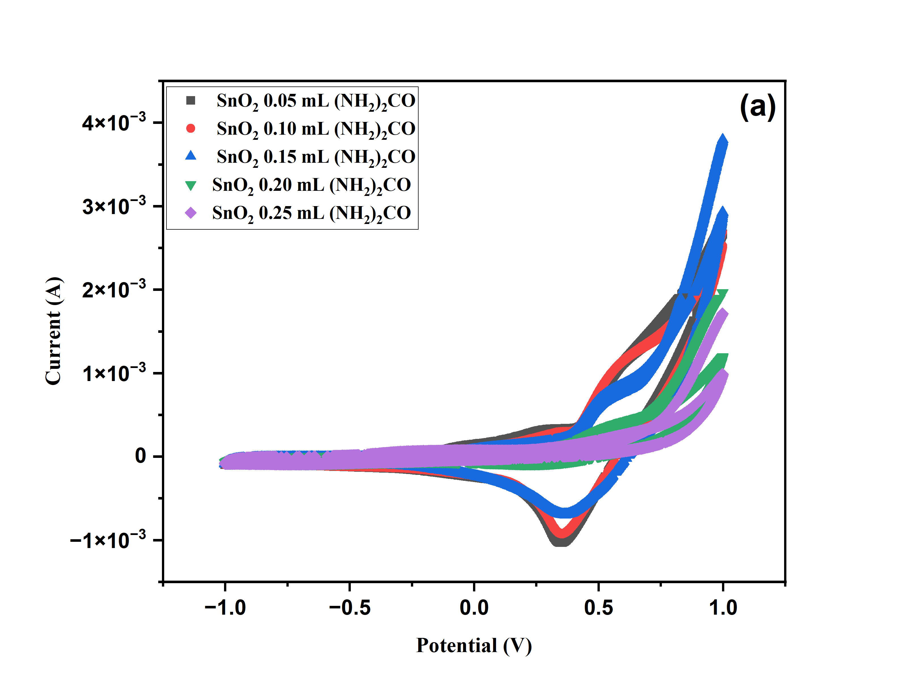

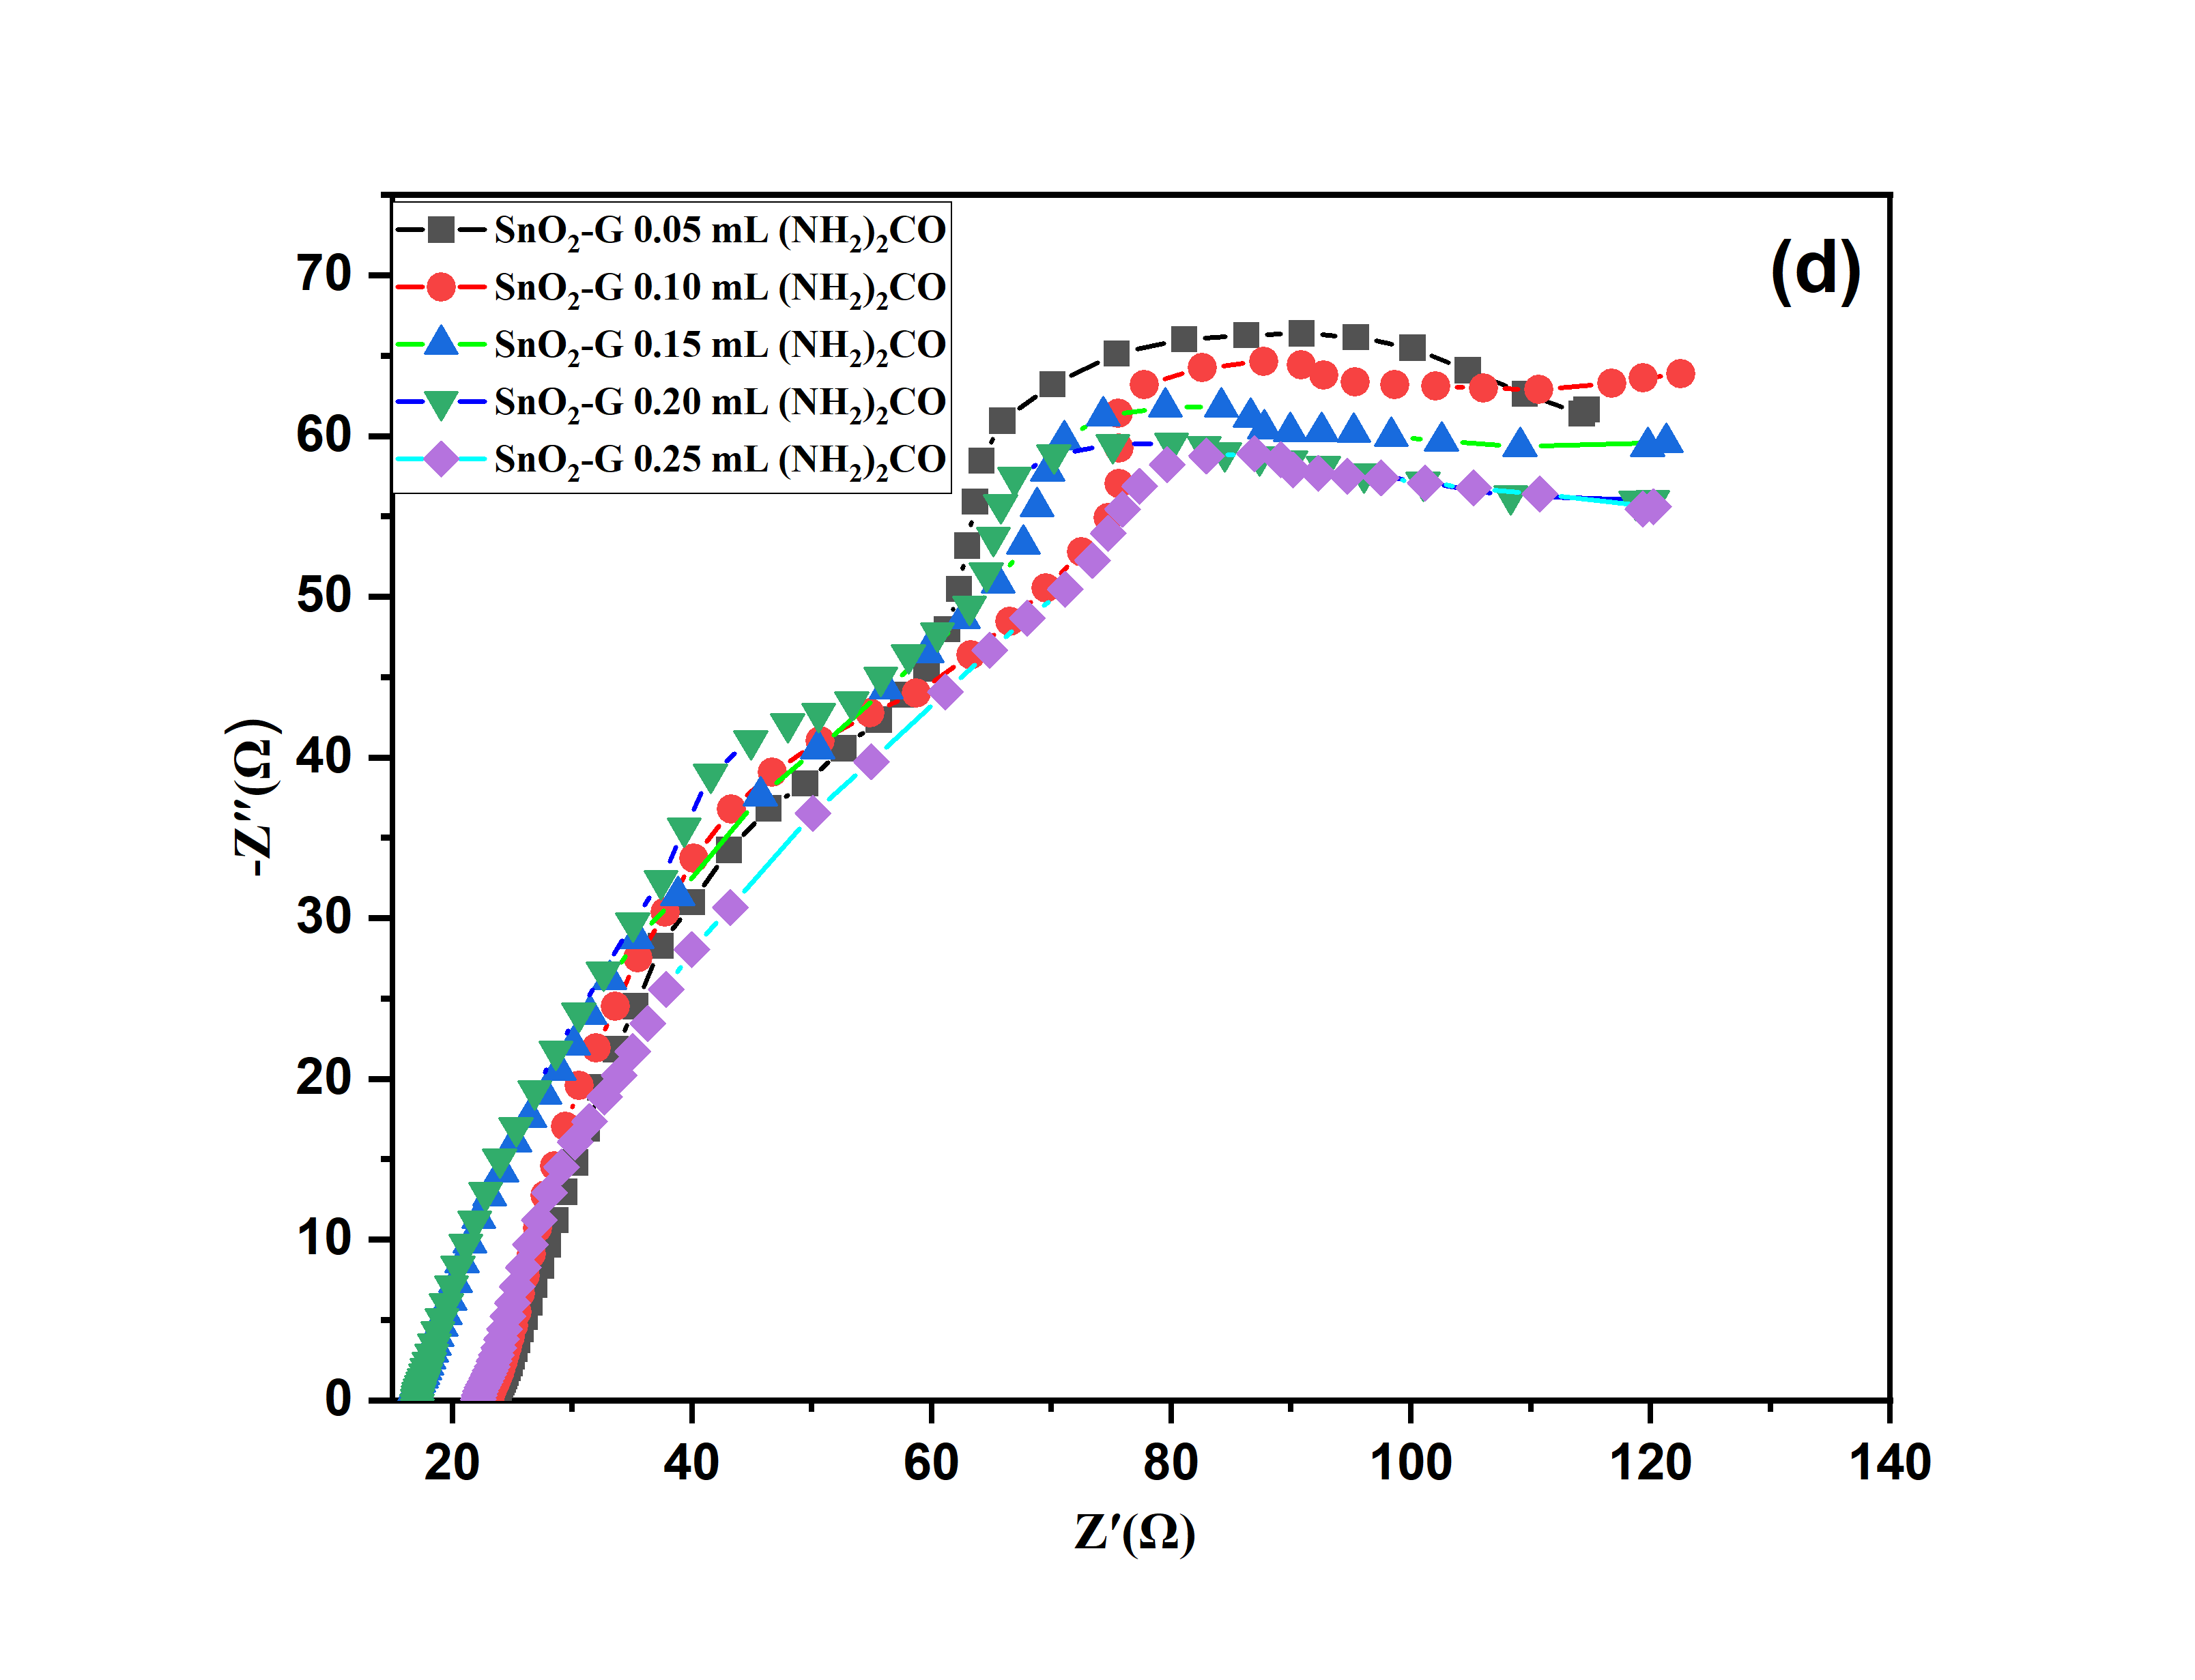
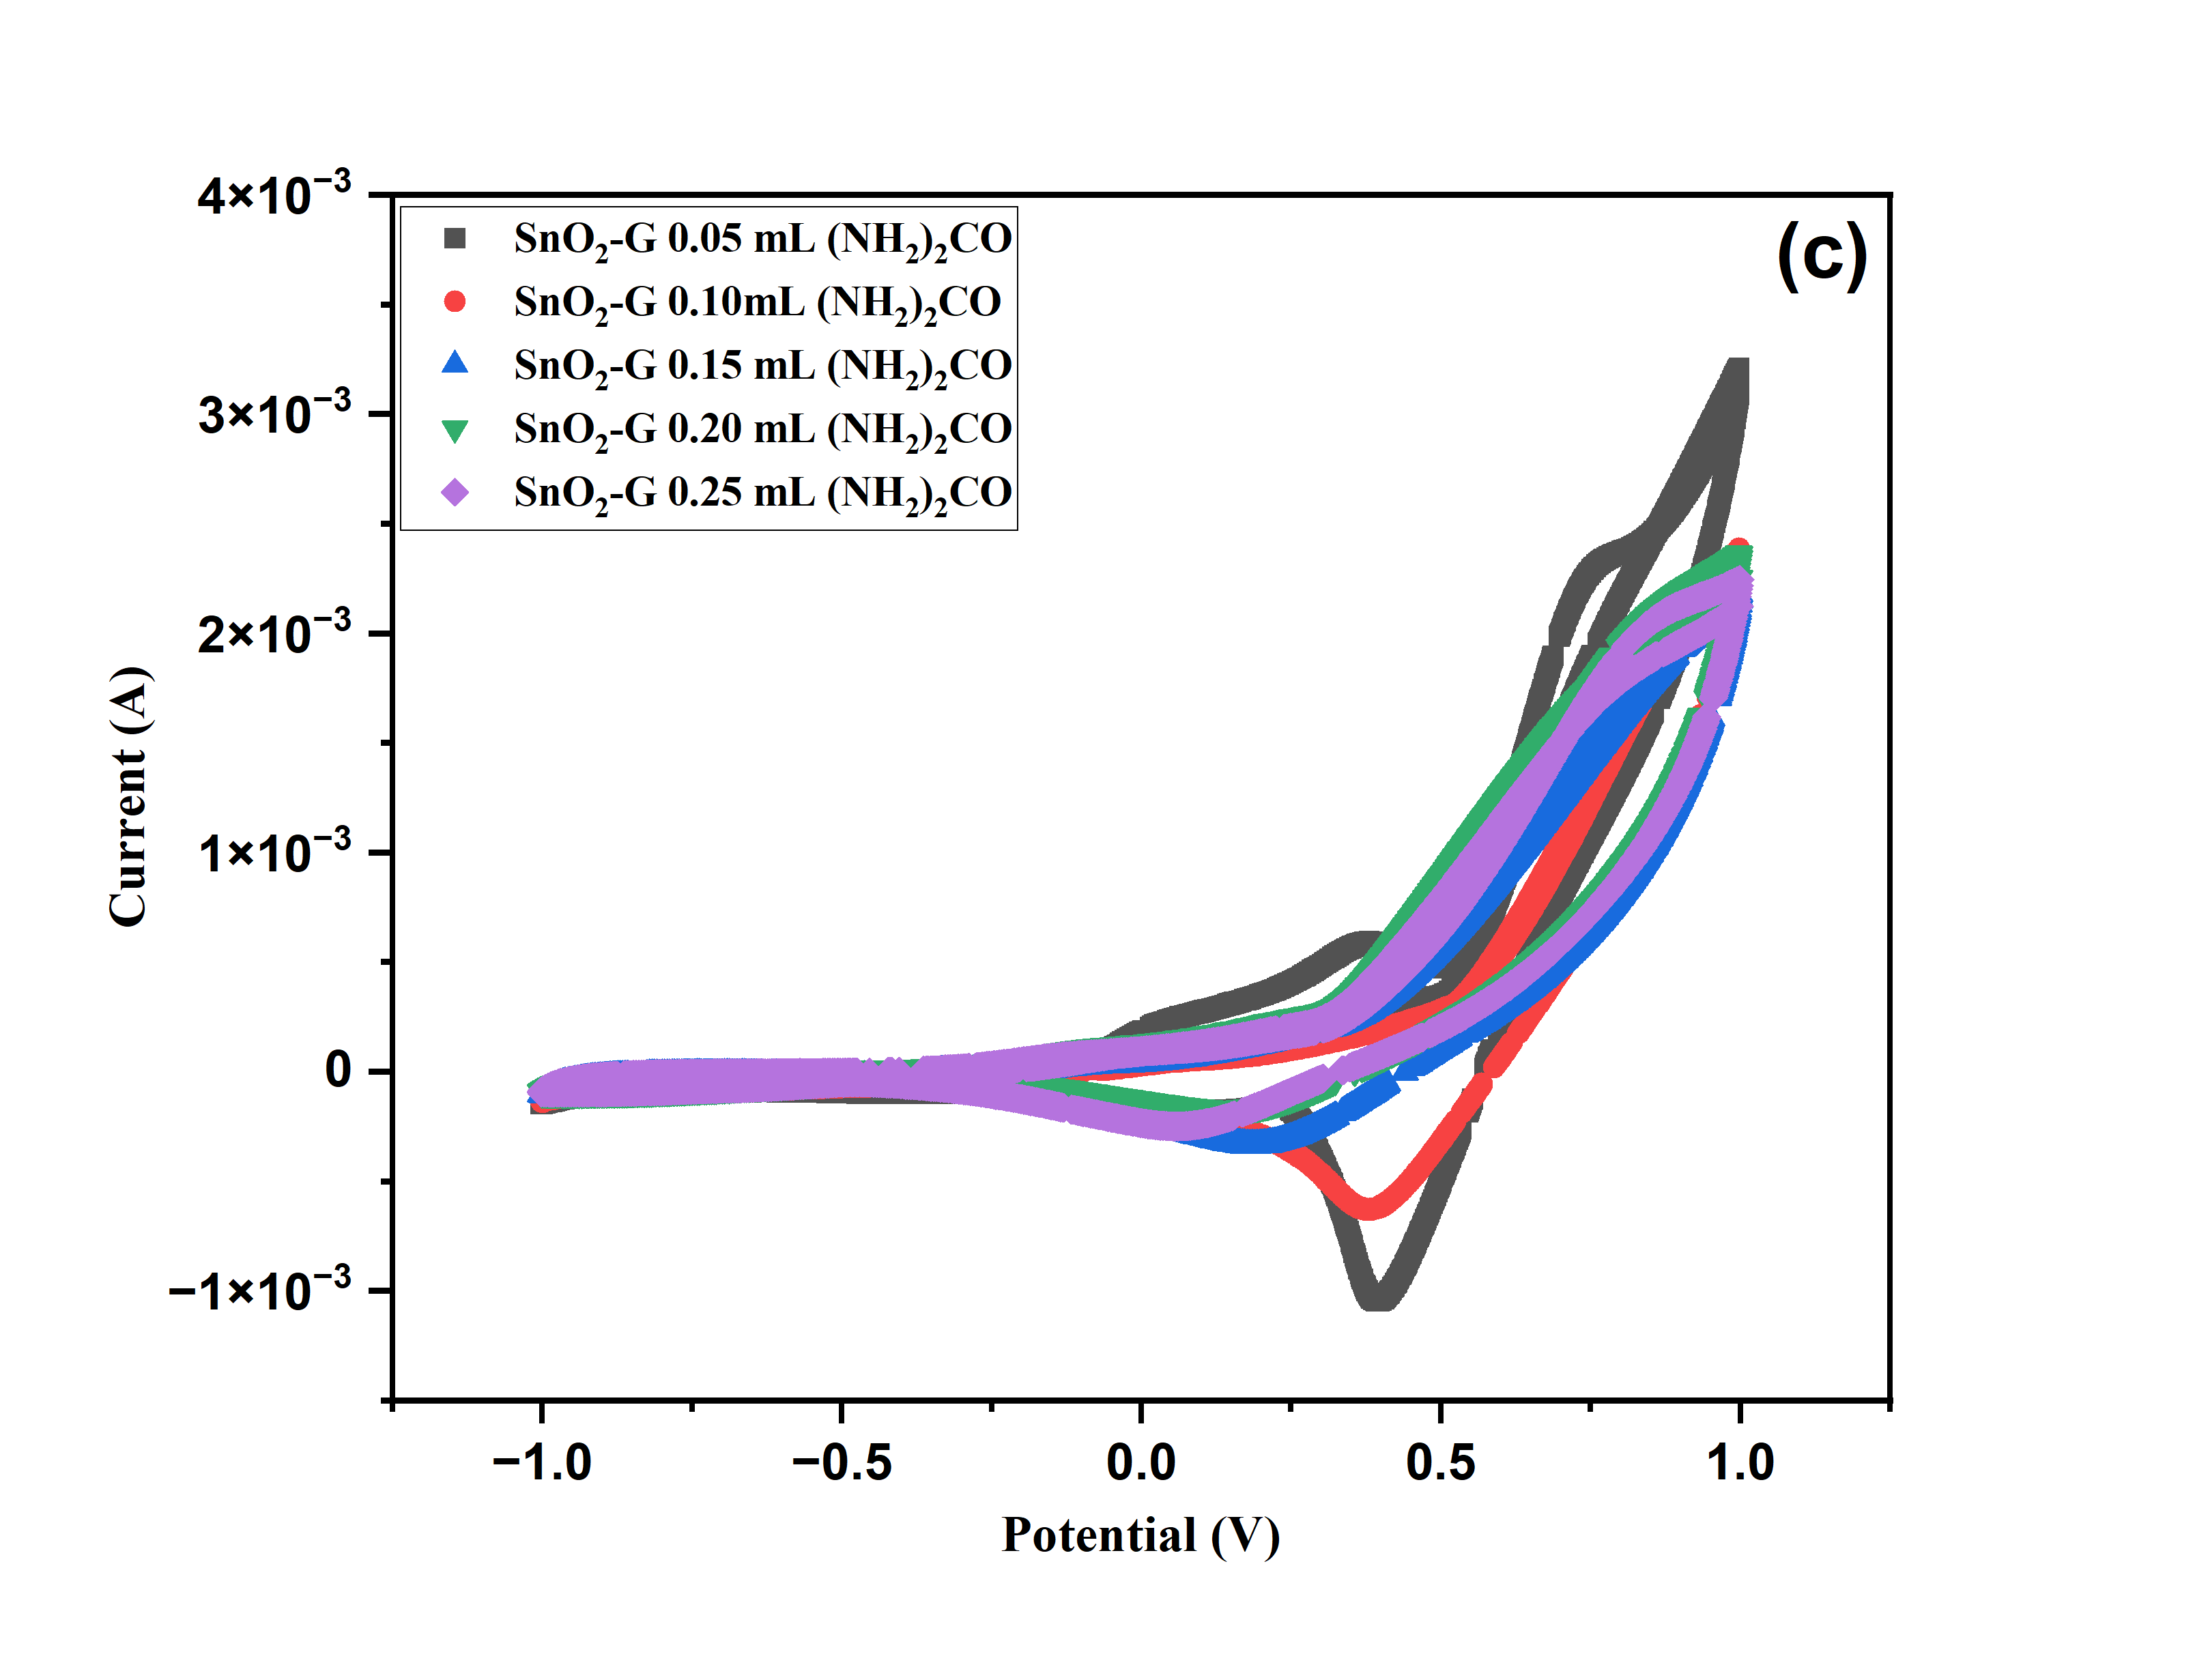

Figure S4 CV test of different concentrations of urea SnO₂, SnO₂-G (a, c); EIS plot of SnO₂ and SnO₂-G (b, d).
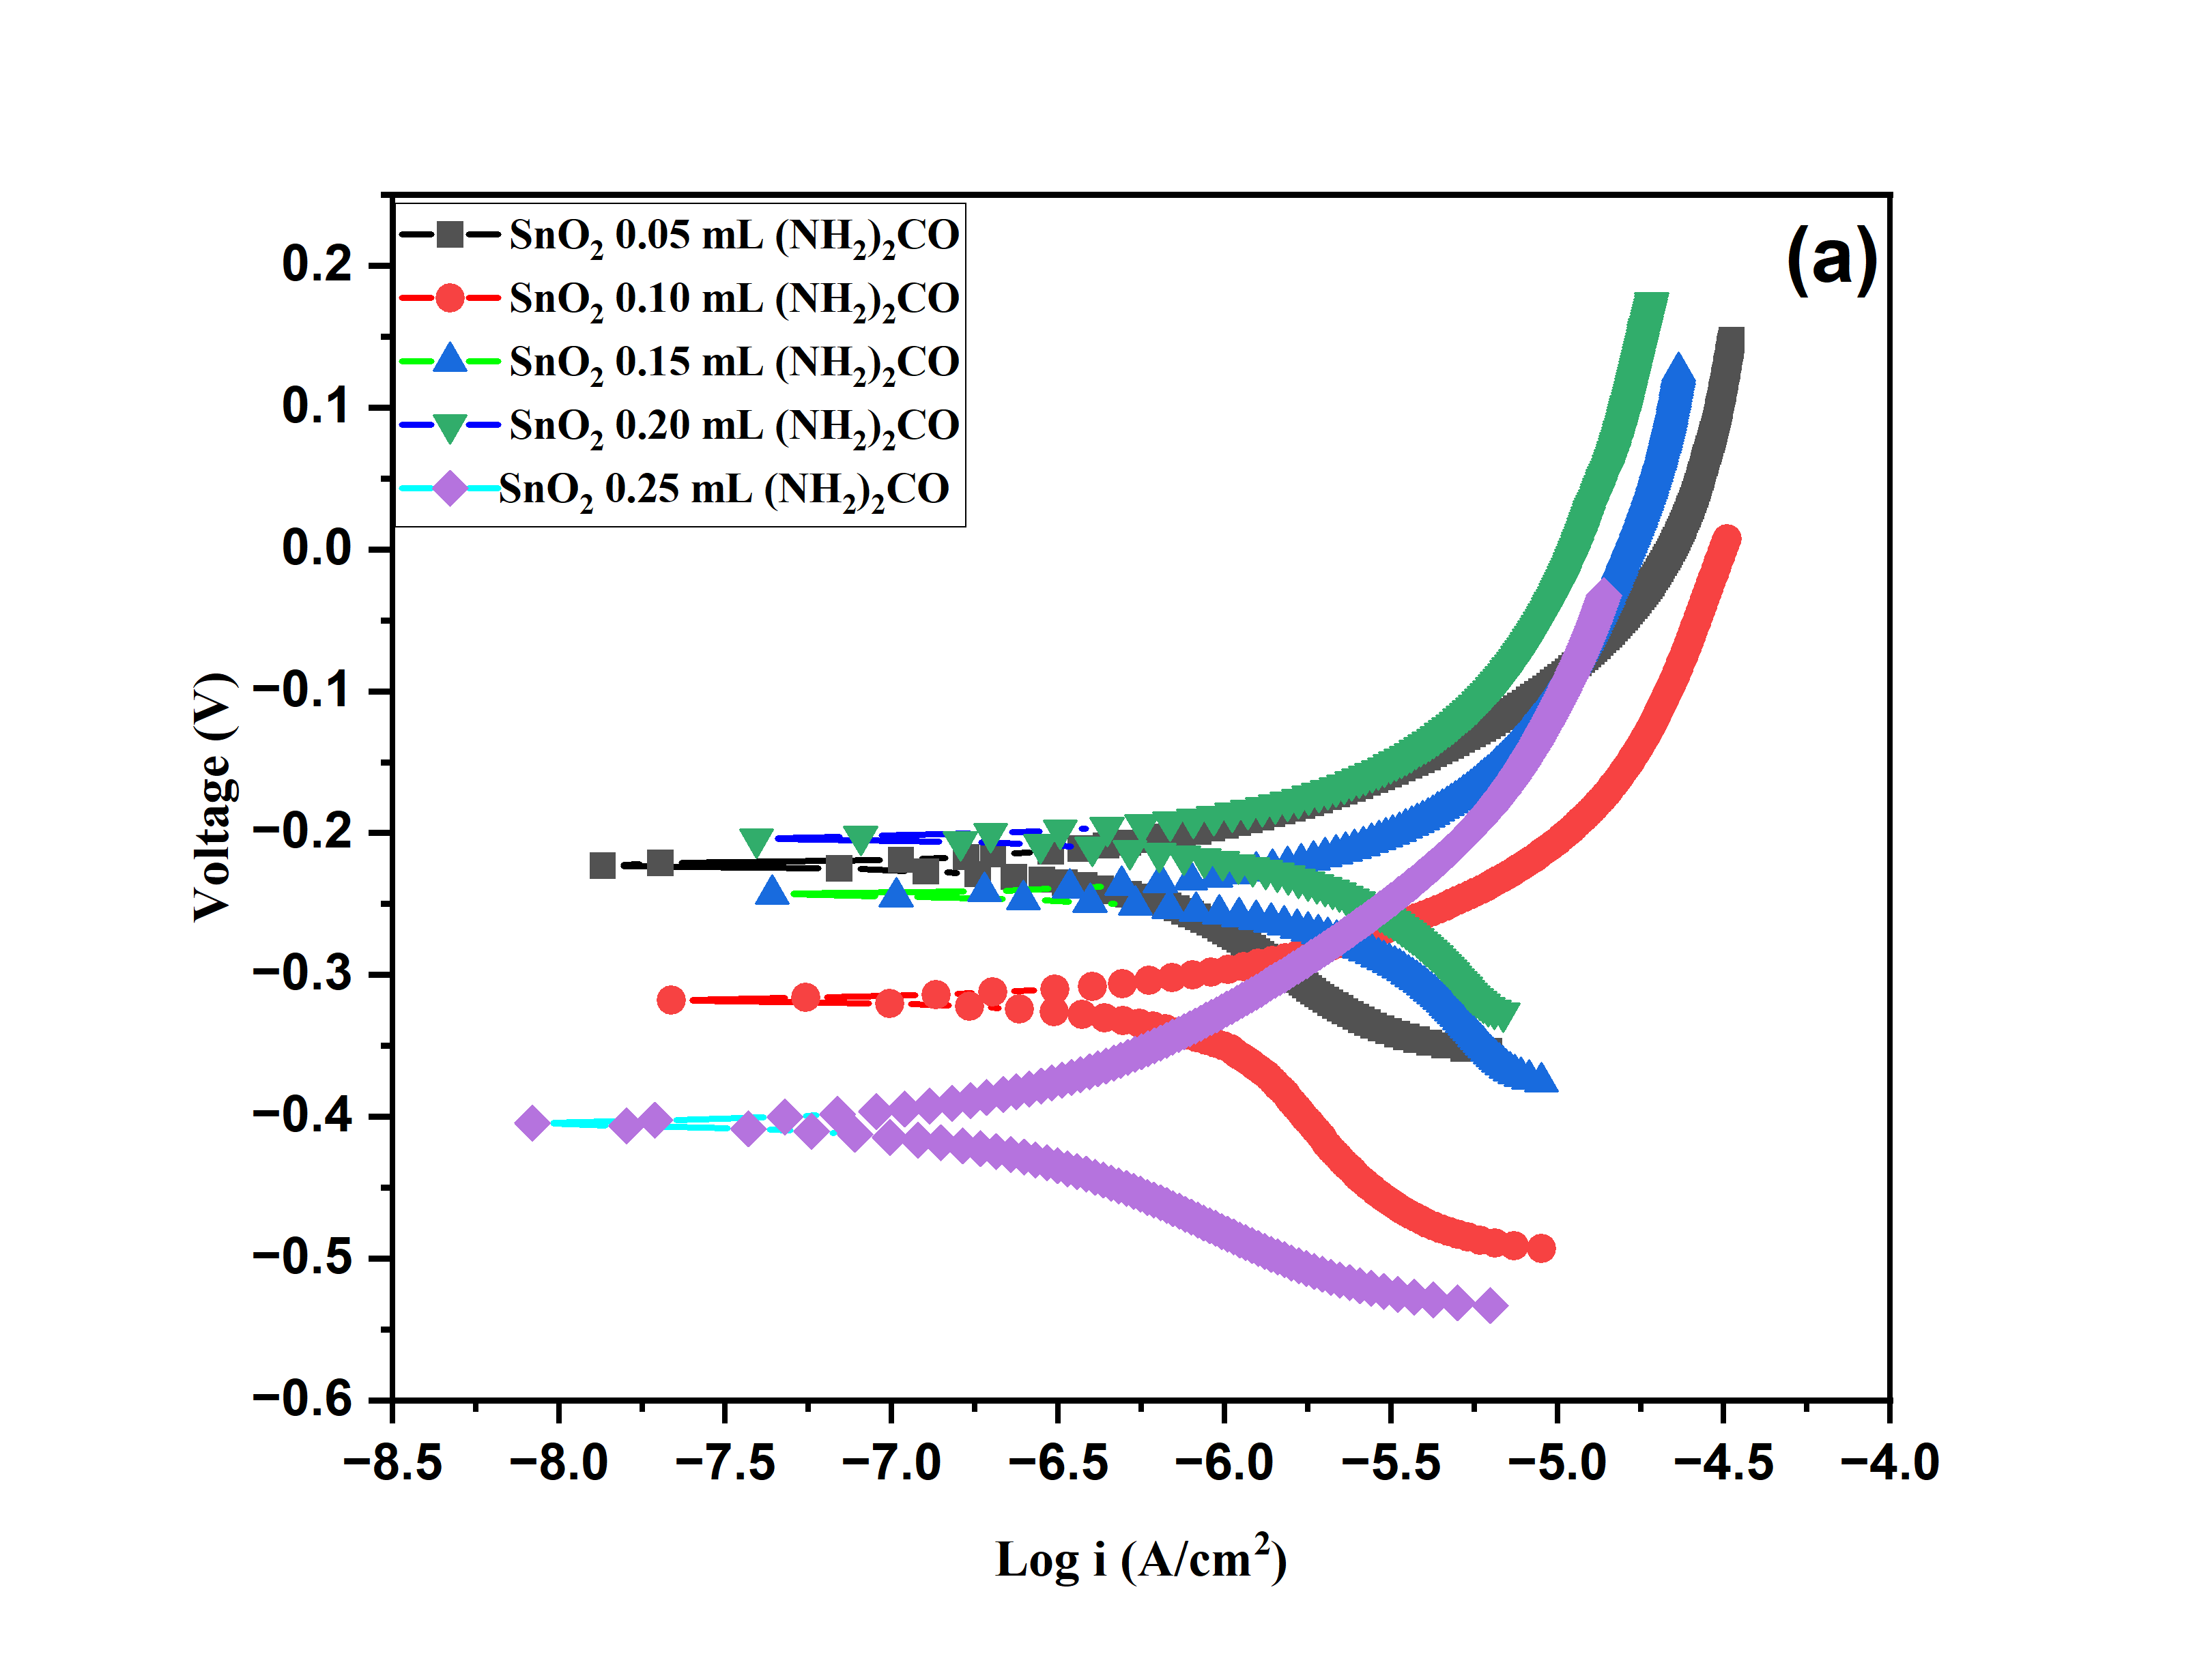
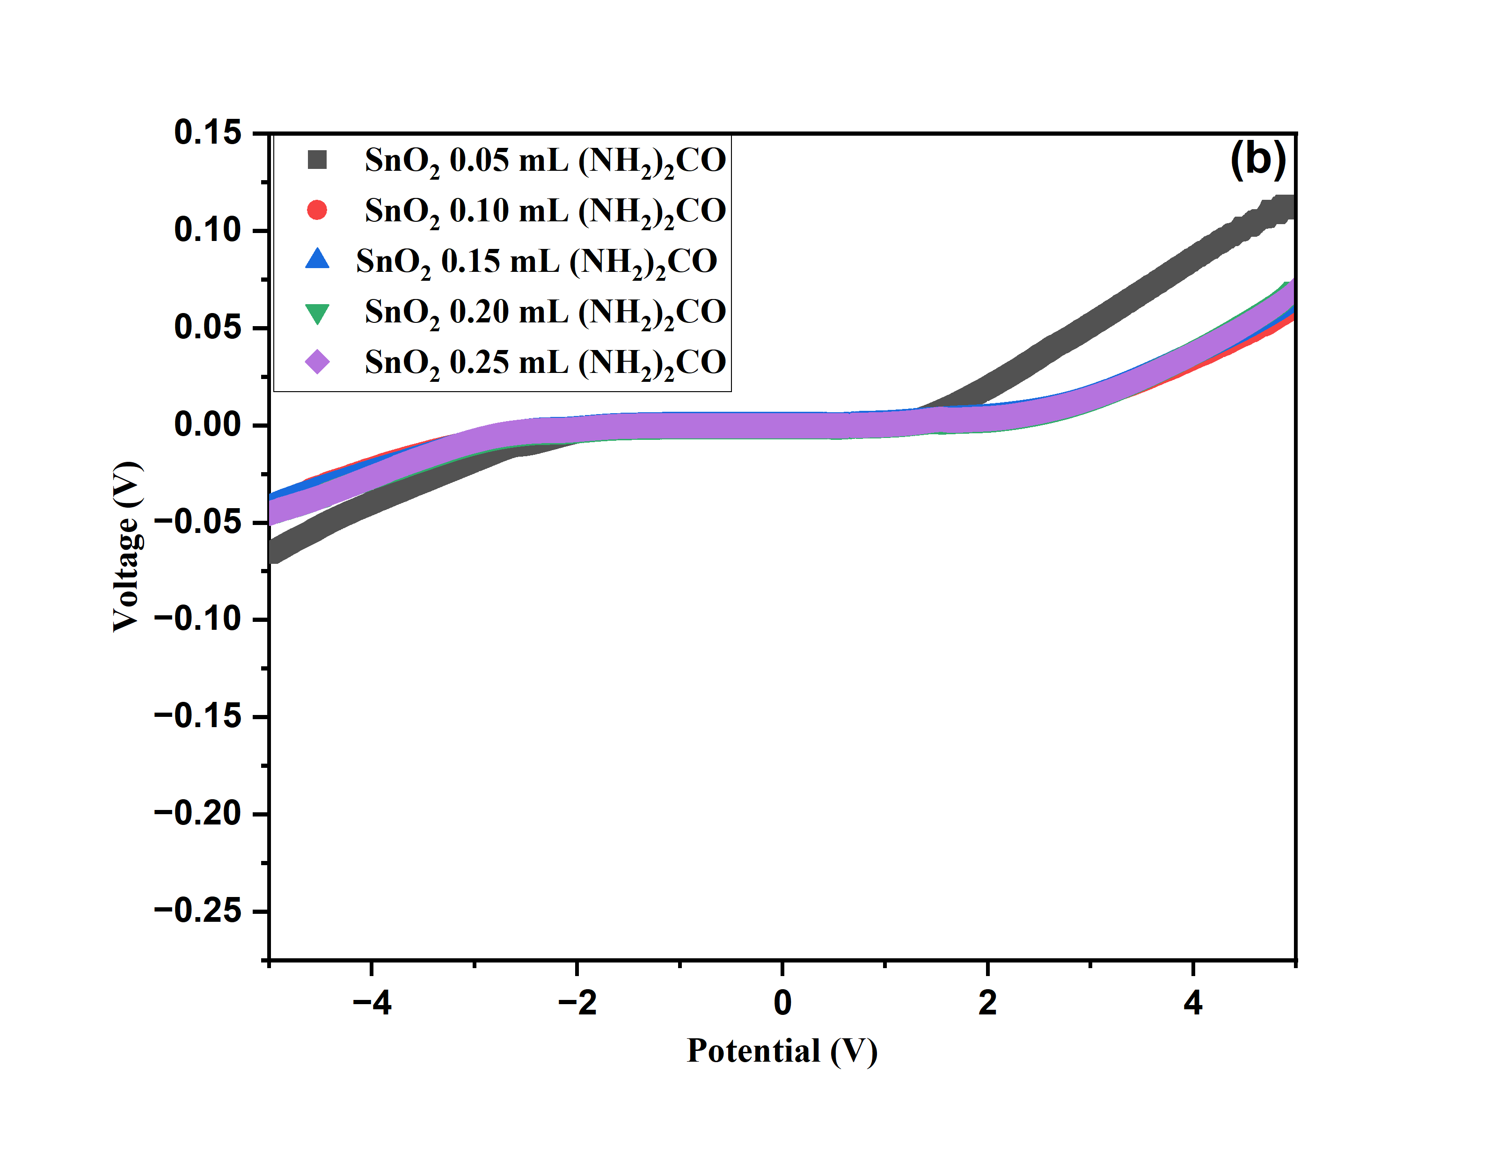

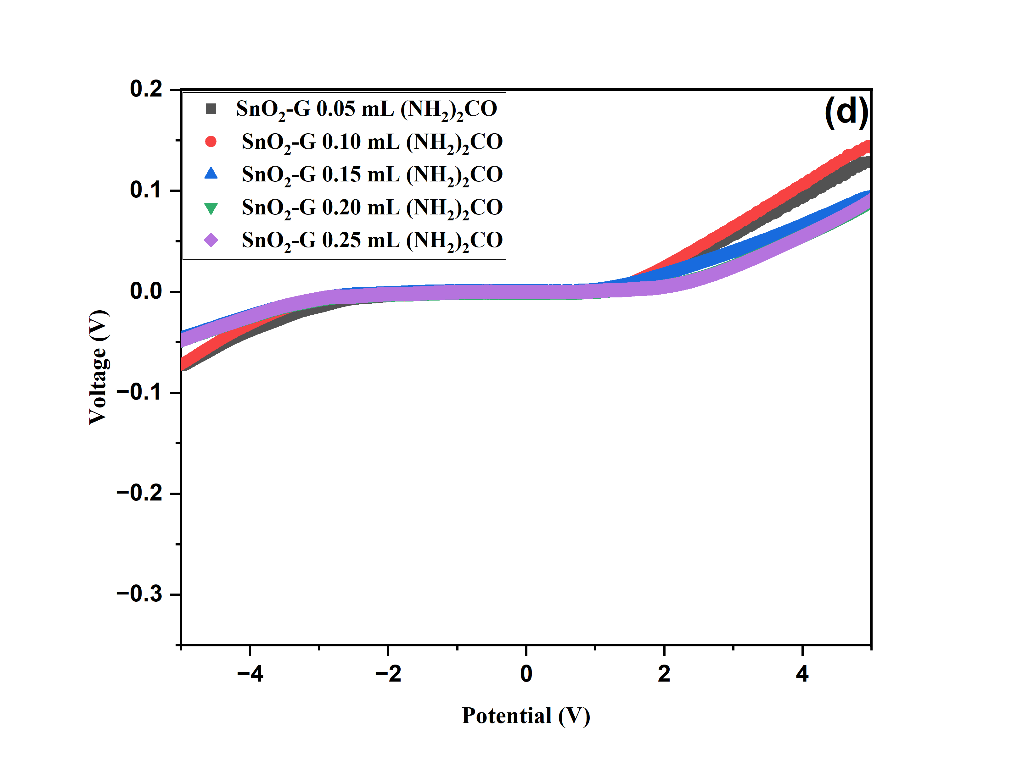
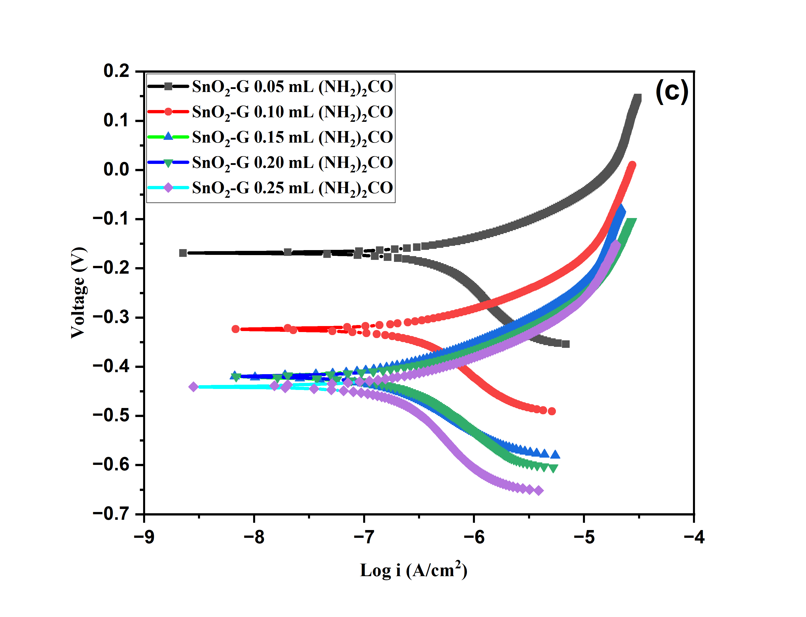

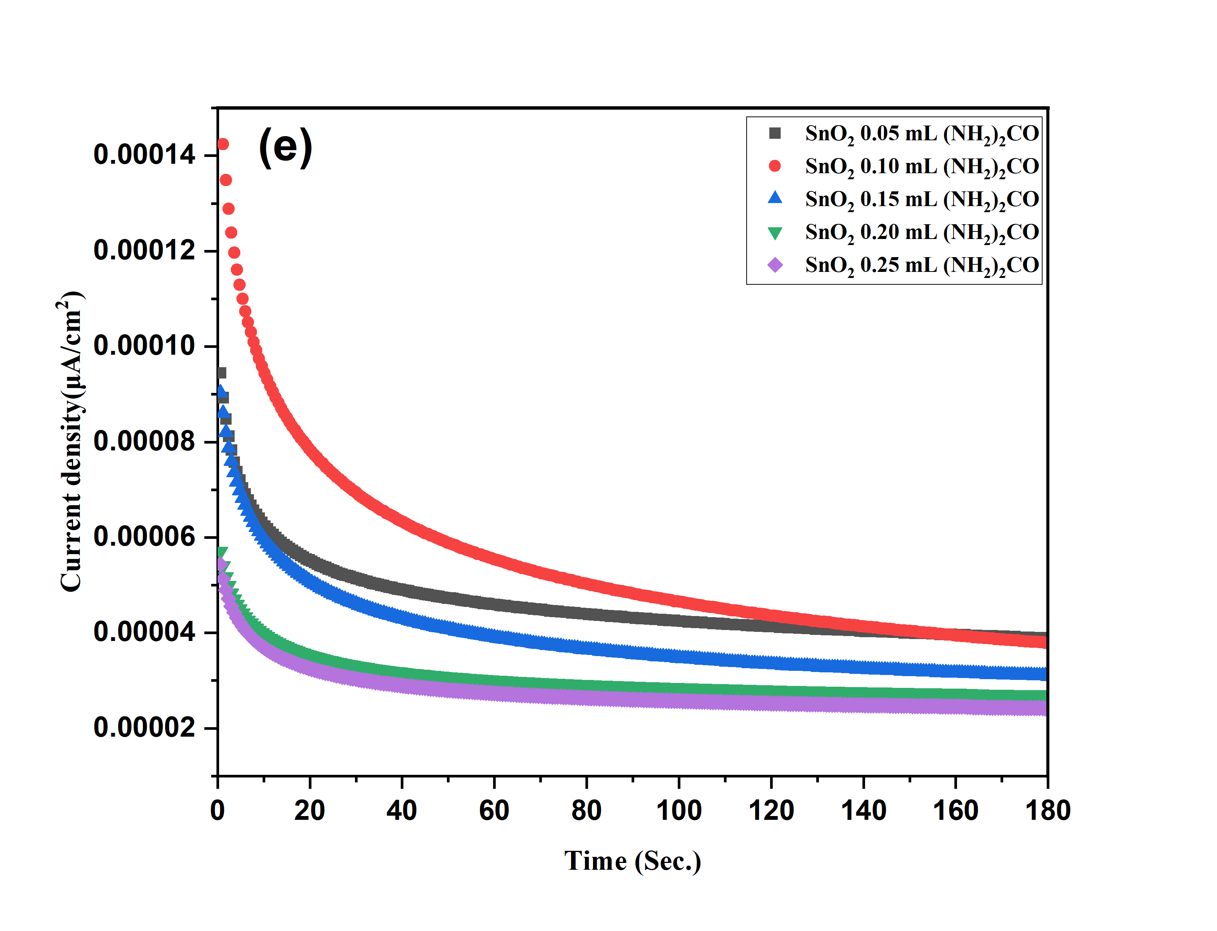
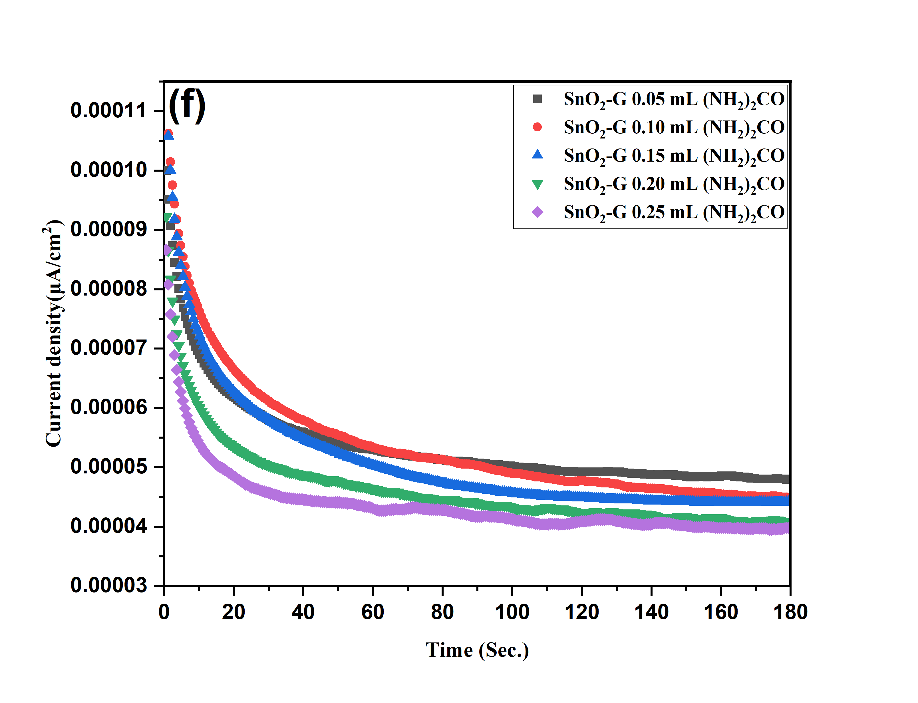

(f)

Fig S5 Tafel and LSV test of SnO₂, and SnO₂-G (a, c and b, d) and chronoamperometry test various concentrations of urea SnO₂ (e) and SnO₂-G (f).

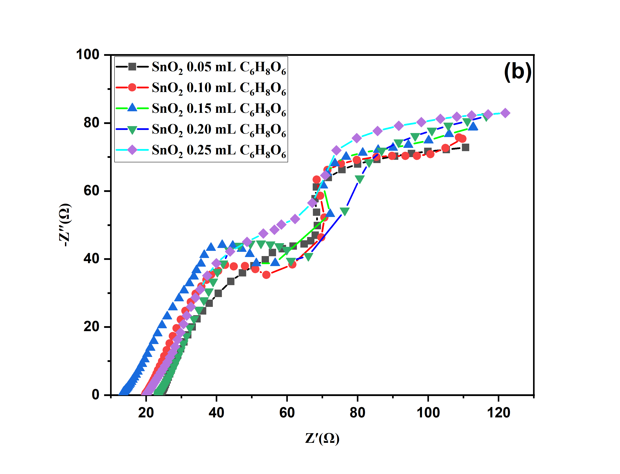
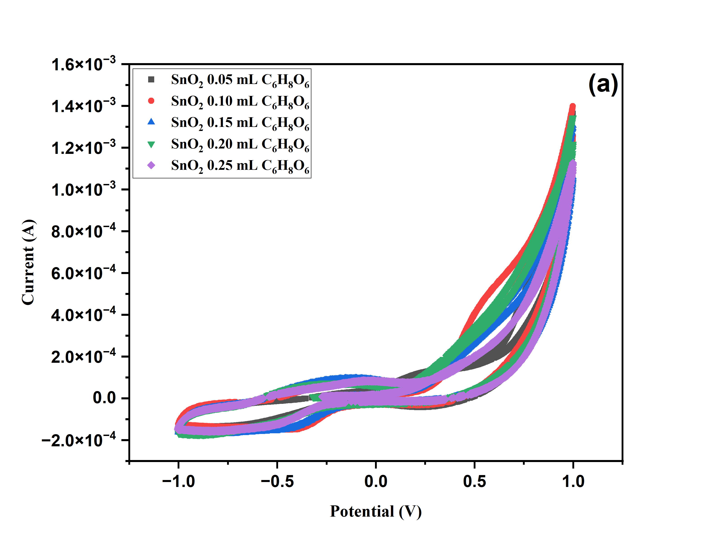

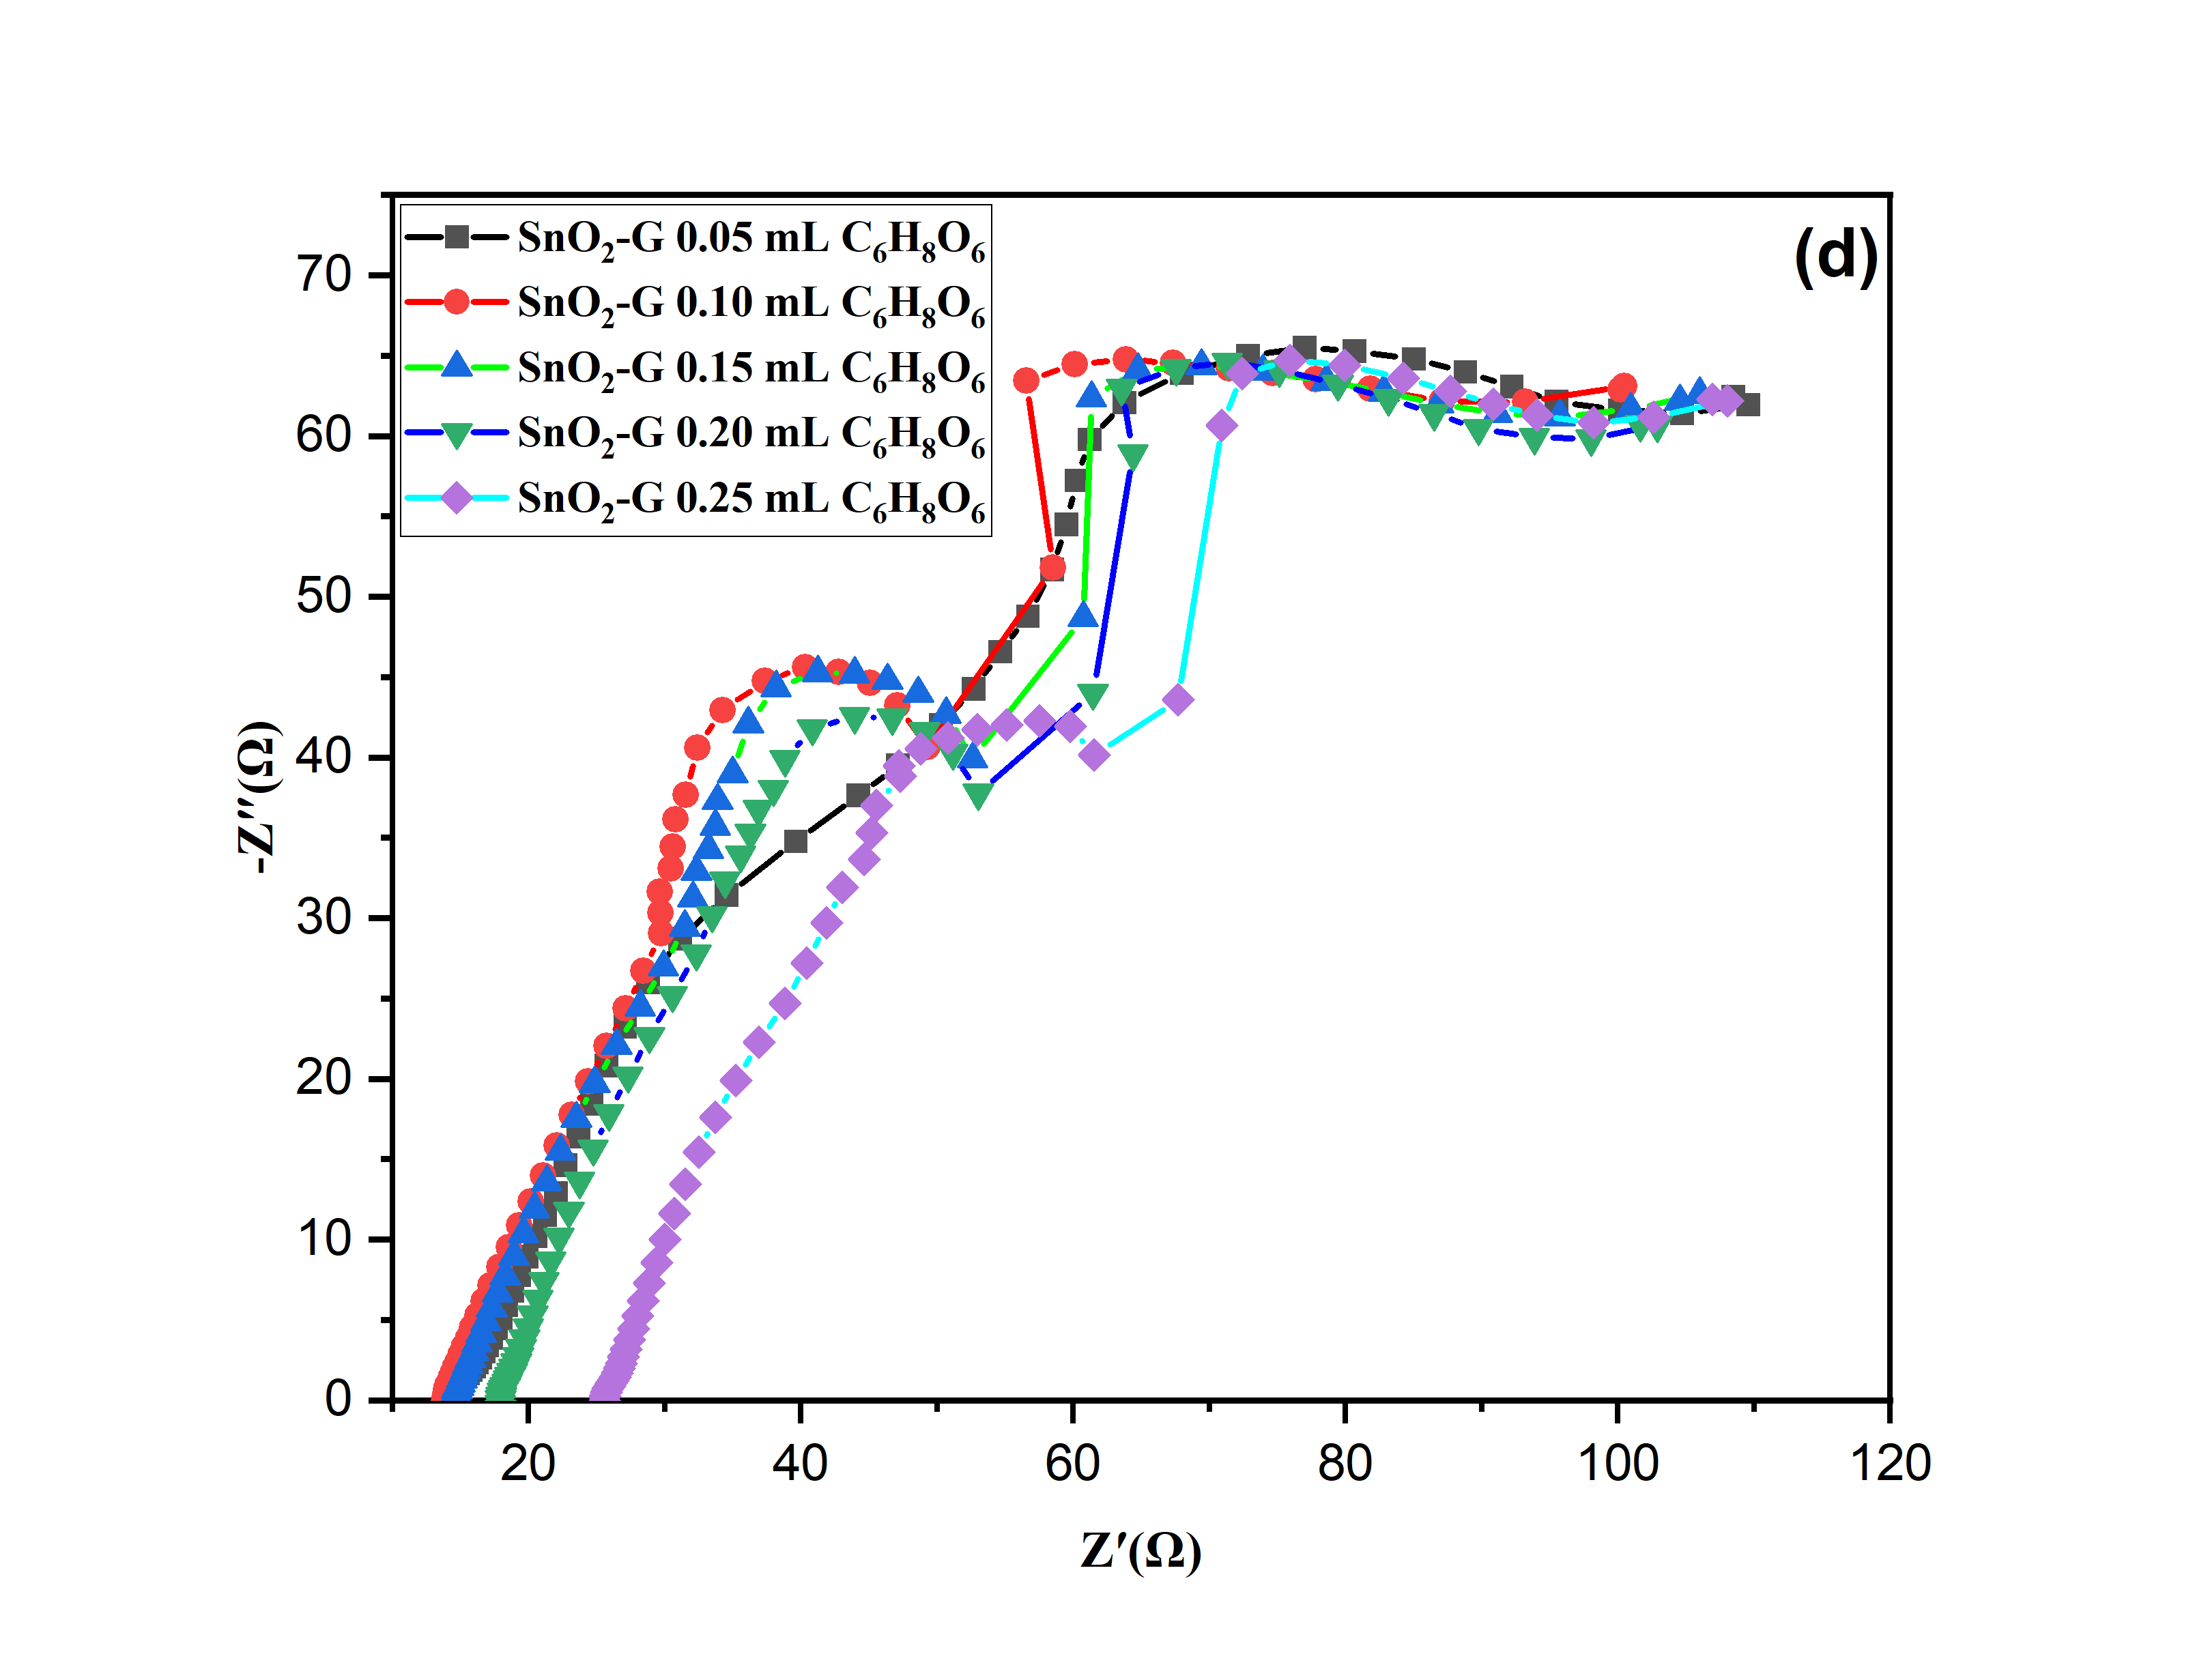
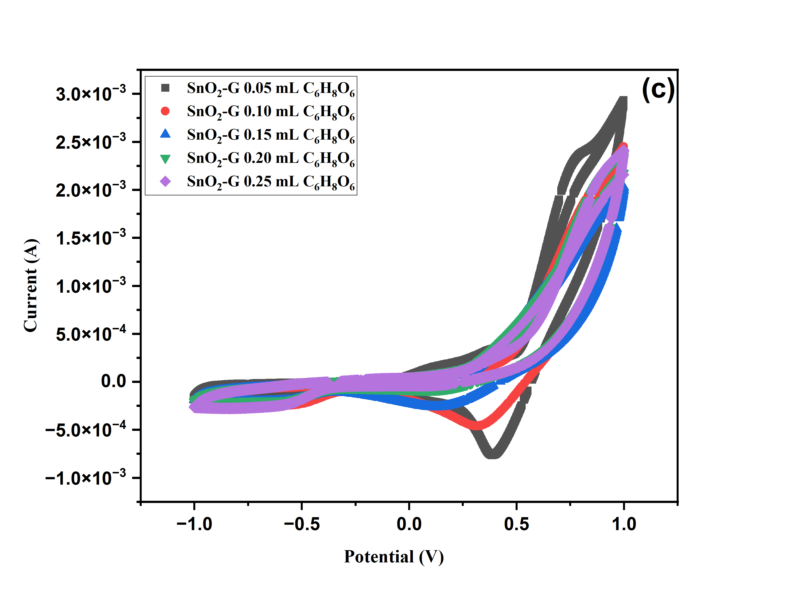

Figure S6 CV test of different concentrations of ascorbic acid SnO₂, SnO₂-G (a, c); EIS plot of SnO₂ and SnO₂-G (b, d).
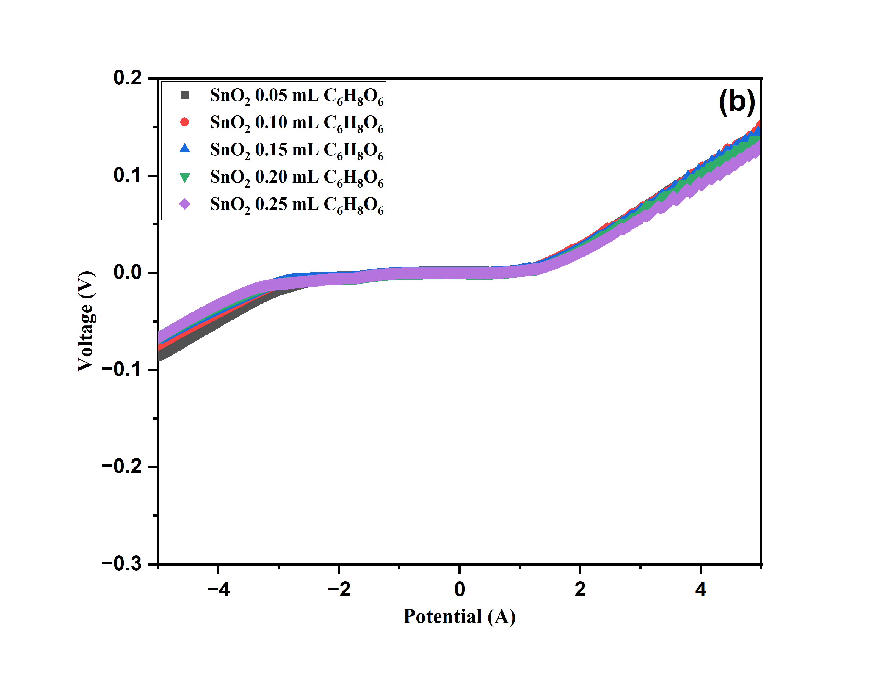
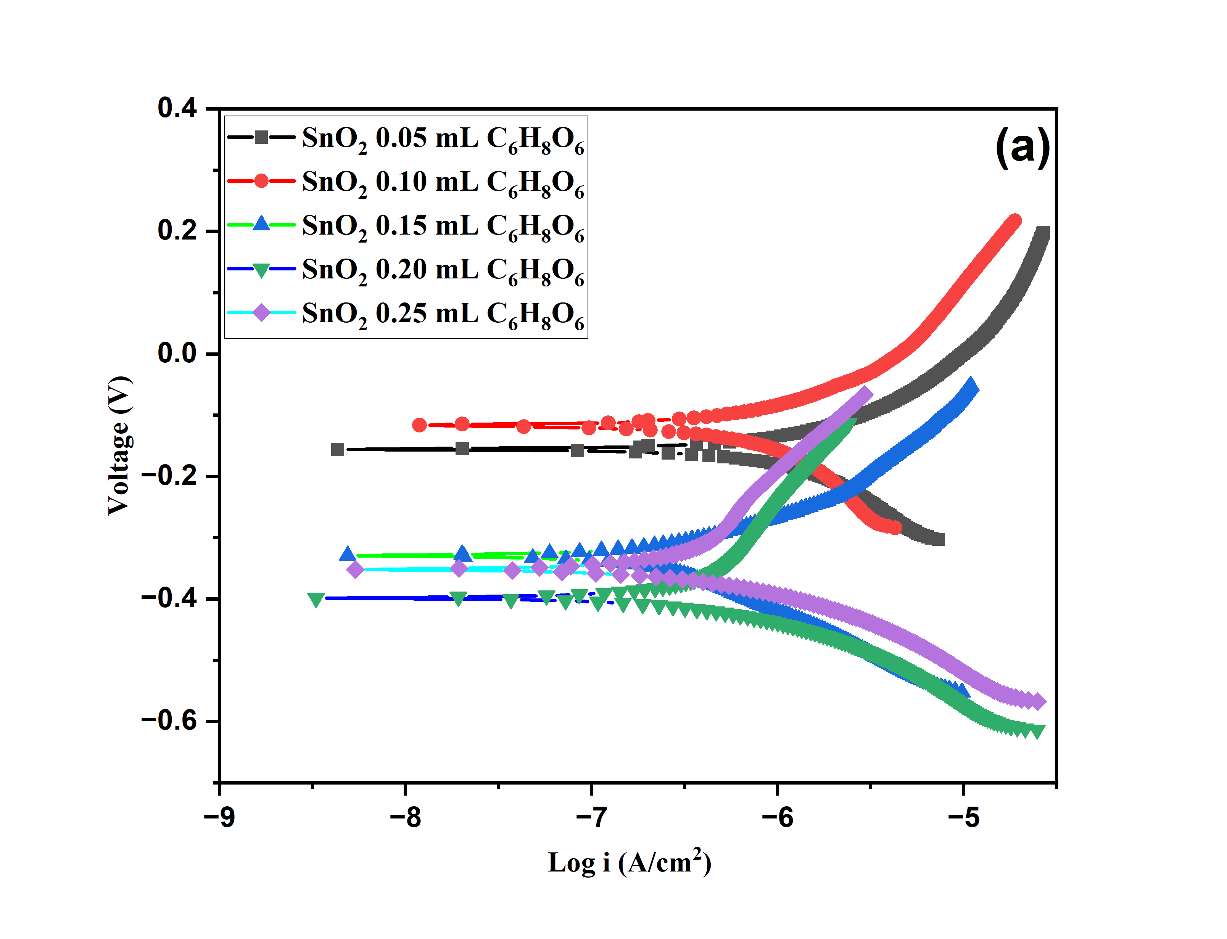

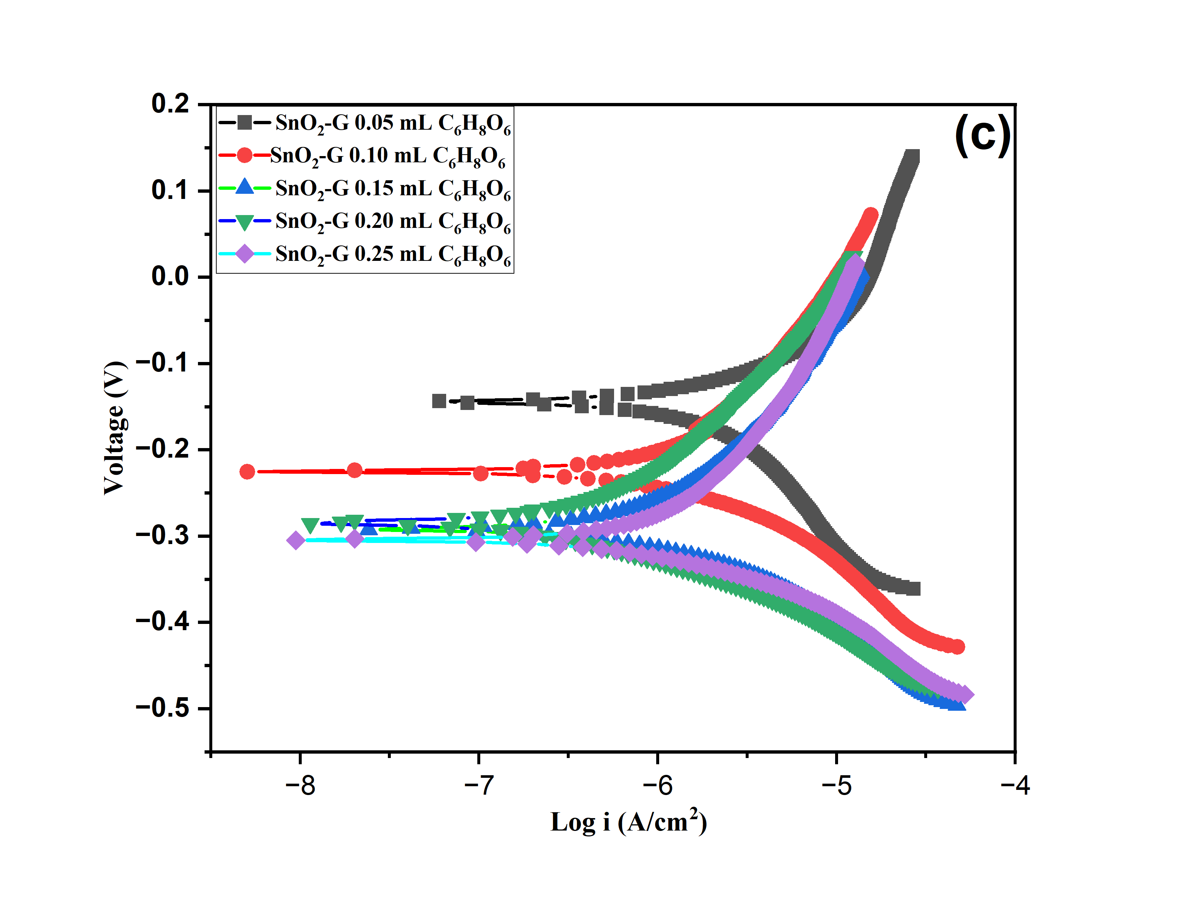

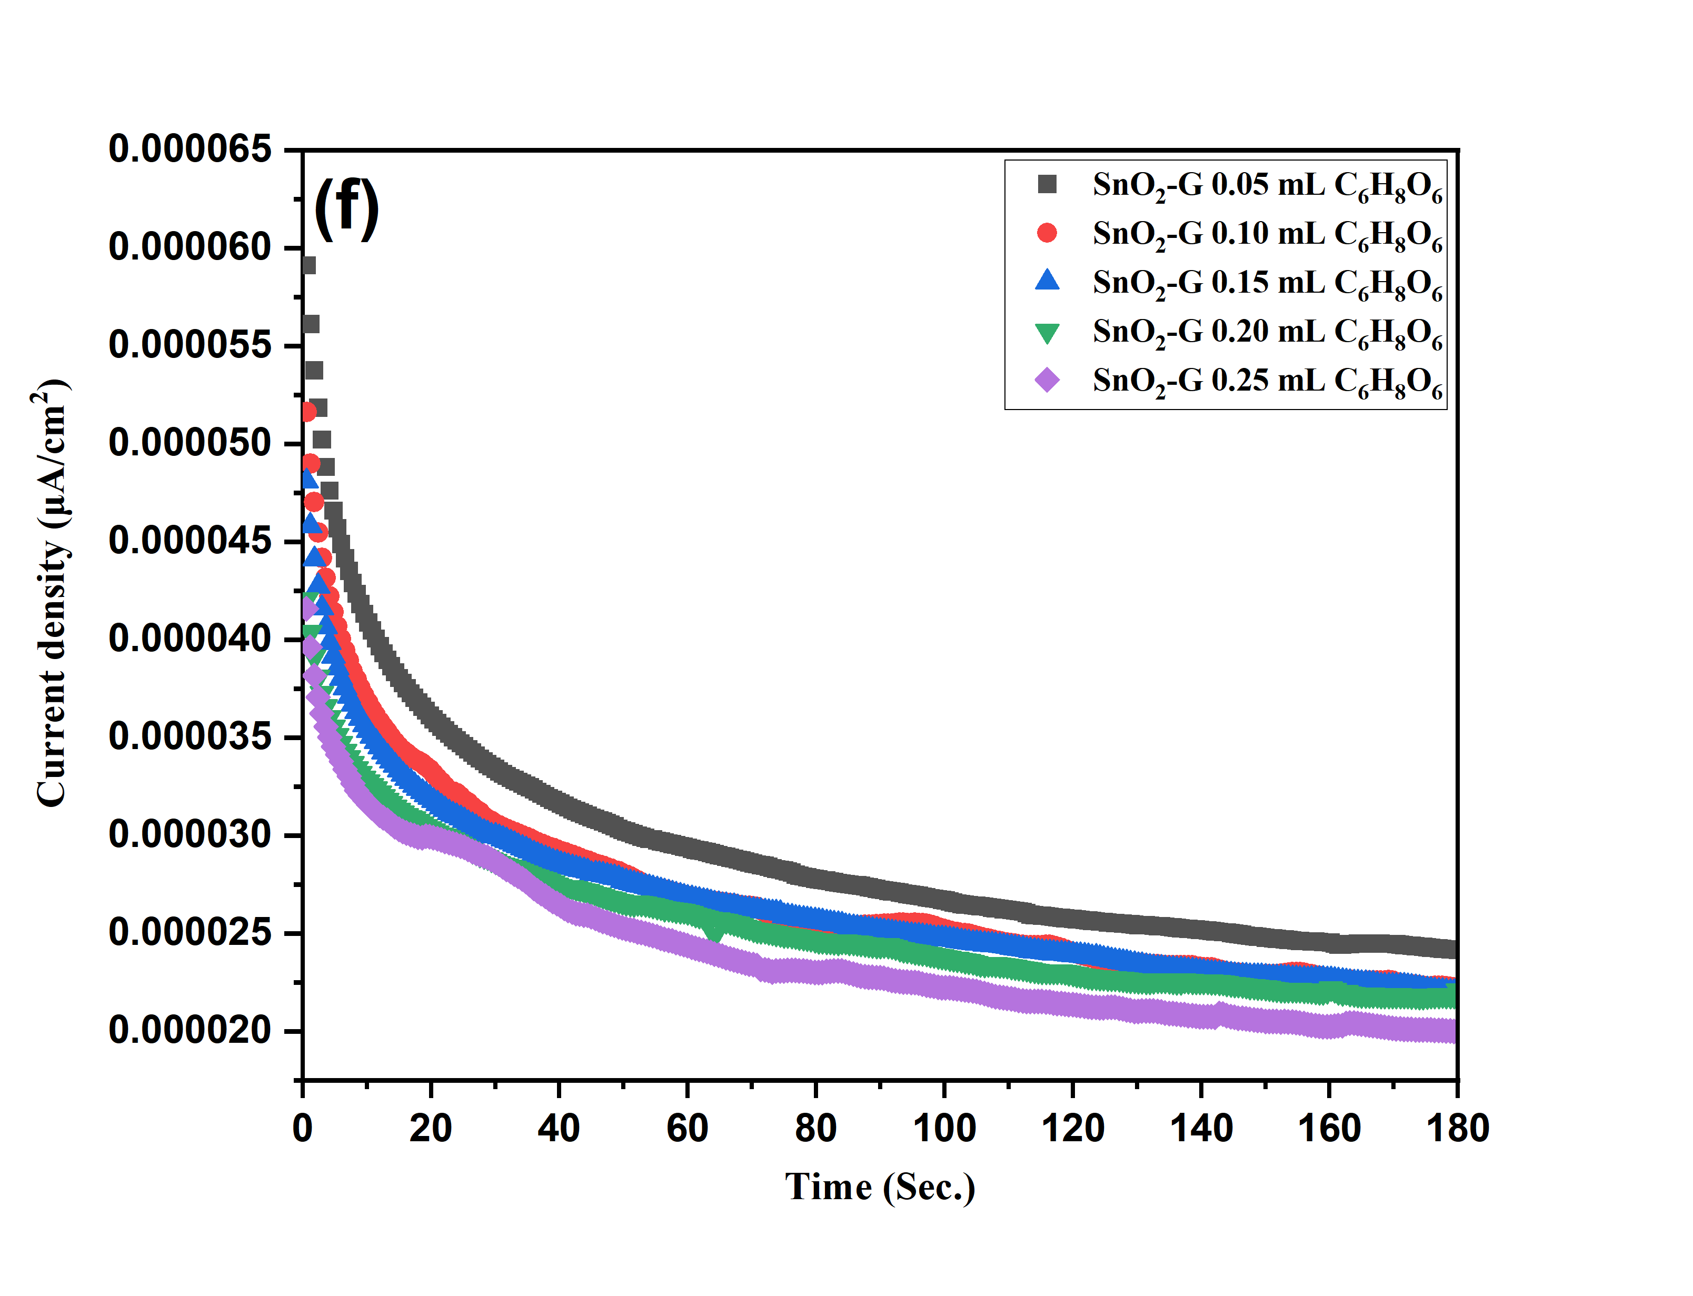

(f)

Fig S7 Tafel and LSV test of SnO₂, and SnO₂-G (a, c and b, d) and chronoamperometry test various concentrations of ascorbic acid SnO₂ (e) and SnO₂-G (f).

Fig. S8 (a) XPS spectra of Sn3d, O1s, C1s, Zn2p element and (b) FTIR spectra of the ZnO-G-SnO₂ nanocomposite.

∗Corresponding author E-mail: wc_oh@hanseo.ac.kr Tel: +82-41-660-1337, Fax: +82-41-688-3352

