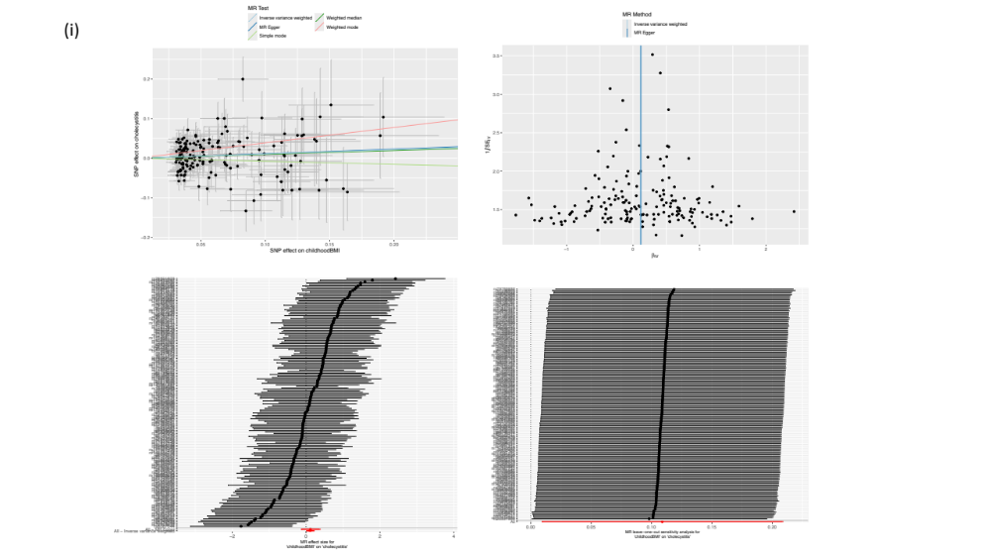

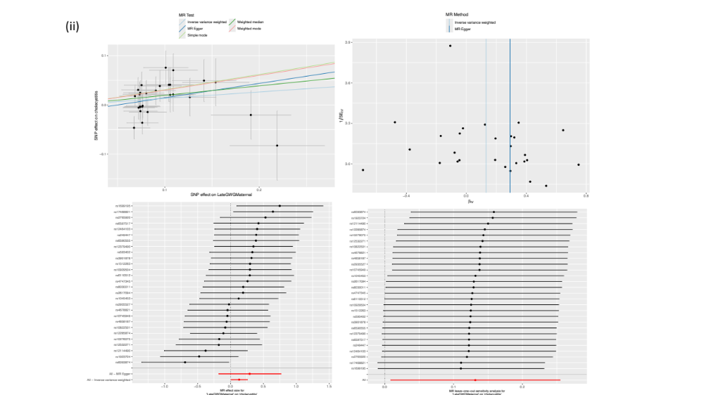

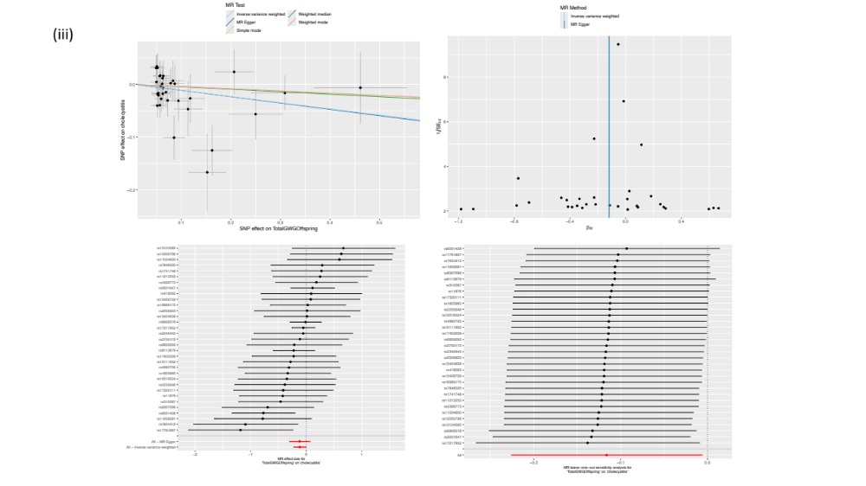

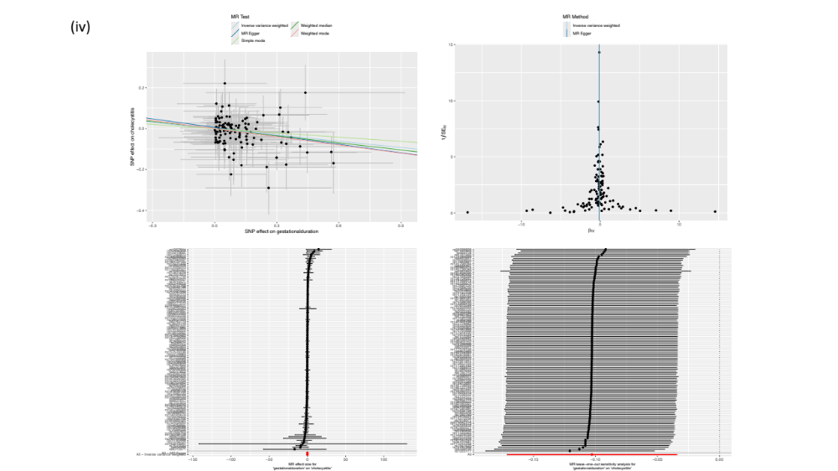

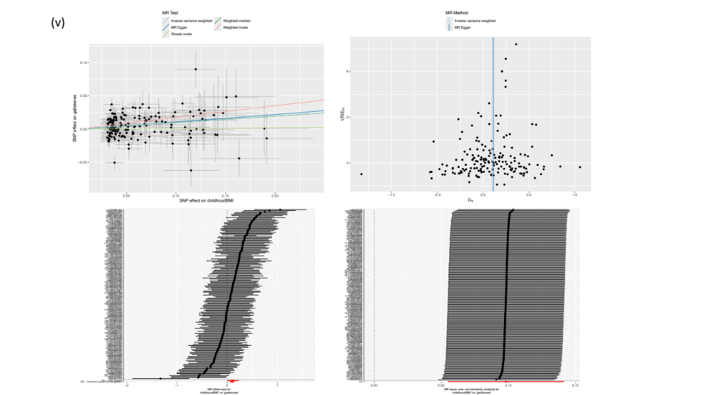

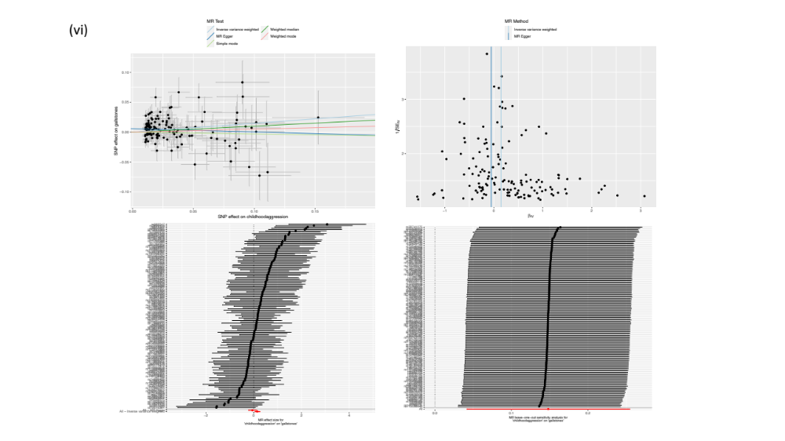

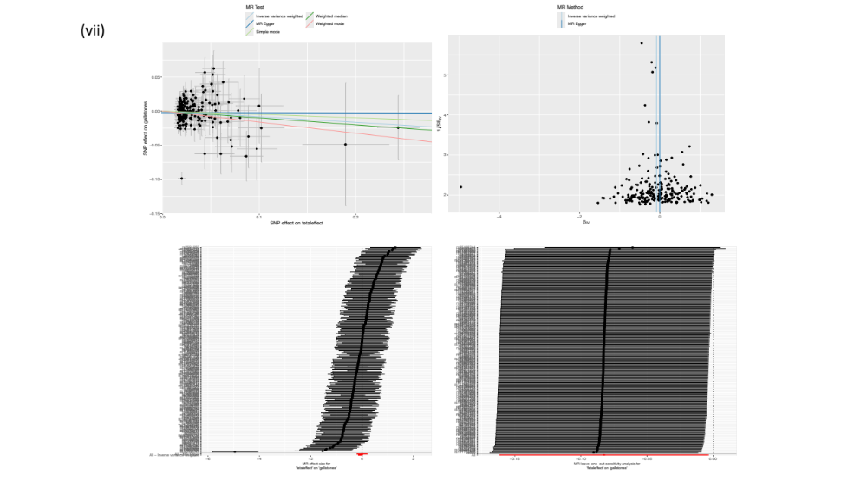

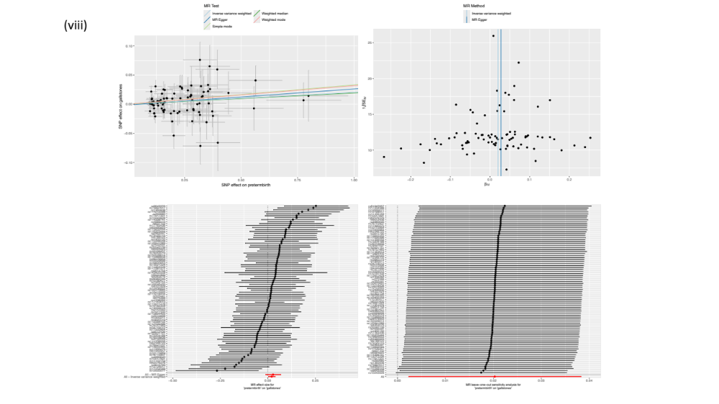

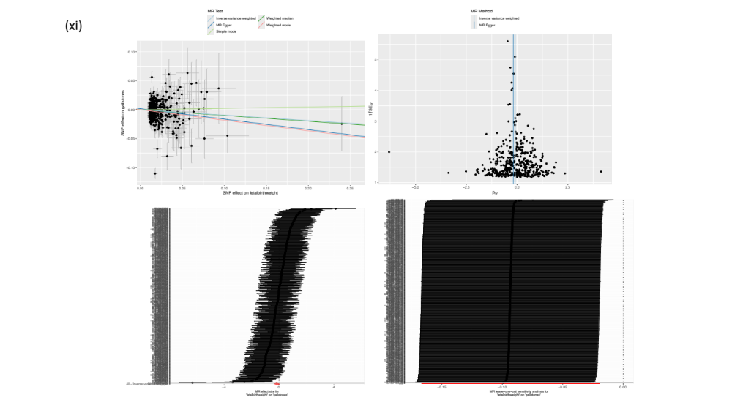

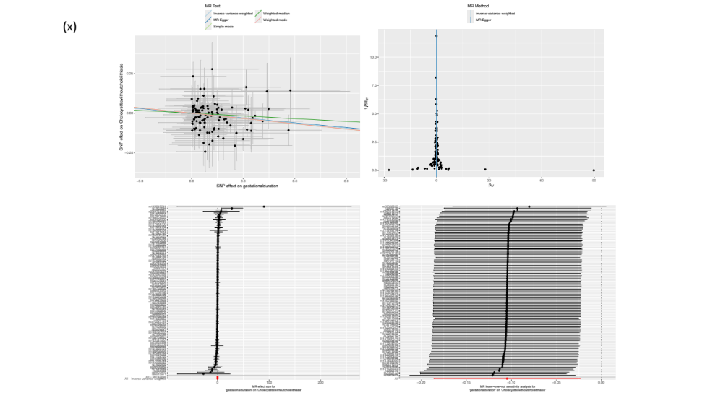

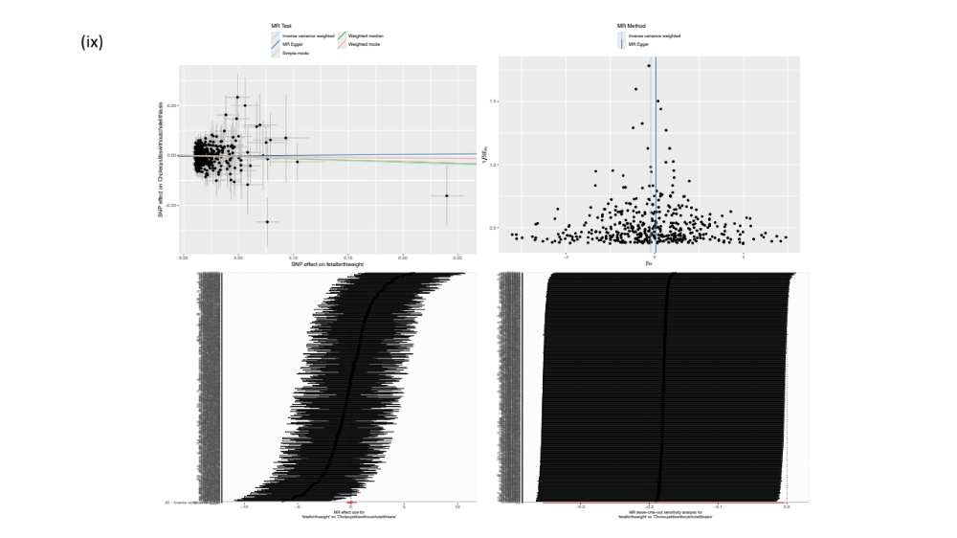

Figure S1: The visualization for various MR and sensitivity tests are arranged as follow: top-panel left scatter plot; top-panel right funnel plot; lower-panel left, forest plot and lower-panel right, leave one out plot for (i) childhood BMI, (ii) late gestation total weight gain (maternal), (iii) total gestation weight gain (offspring), (iv) gestational duration, (v) childhood BMI, (vi) childhood aggression, (vii) individual's own genetic effect (fetal effect), (viii) fetal genetic effect on preterm birth, (xi) fetal birth weight, (x) gestational duration (maternal) and (ix) fetal birth weight. The figures are arranged as the arrangement of exposure and outcome phenotypes in the Table S2.

