Soil and River-water Salinity Dynamics in Coastal Bangladesh

Ahmed Z. Rahman^{1,2,*}, Mohammad Shamsudduha¹, Md. Izazul Haq^{1,3,4}, Md. Hanif⁵, Md. Sanaul Islam⁵, Syed S. Islam⁵, Amarendranath Biswas⁶, Richard G. Taylor³

¹Department of Risk and Disaster Reduction, University College London, London, UK
²Ministry of Public Administration, Bangladesh Secretariat, Dhaka, Bangladesh
³Department of Geography, University College London, London, UK
⁴Department of Disaster Science and Climate Resilience, University of Dhaka, Dhaka, Bangladesh
⁵Soil, Water and Environment Discipline, Khulna University, Khulna, Bangladesh
⁶Salinity Management and Research Centre, Soil Resource Development Institute, Khulna, Bangladesh

*Corresponding author: ahmed.rahman.21@ucl.ac.uk

Supplementary Information

Figure S1. Time-series plots of monthly soil and surface water salinity in southwestern coastal Bangladesh. Salinity is being monitored at 11 soil sampling sites (first 11 plots) and 13 (last 13 plots) river stations by the Soil Resource Development Institute (SRDI), Bangladesh. The month of peak seasonal salinity in each year is marked with red solid circles. Plots of monthly monitoring records of soil and river-water salinity are combined with timing of tropical cyclones shown by vertical dash lines. The orange vertical dash lines indicate cyclones making landfall in April and May, and the grey lines indicate cyclones making landfall during and after the monsoon season. Mean salinity of the entire monitoring period is provided on the top-right corner of each time-series plot.

Figure S1. Continued.

Figure S1. Continued.

Figure S1. Continued.

Figure S1. Continued.

Figure S1. Continued.

Figure S2. Time-series plots of soil and river-water salinity data in Bangladesh. Time-series (Jan 2004 to Jun 2022) of soil and river-water salinity and rainfall at selected stations in the coastal Bangladesh on the left side of the page. The smaller plots on the right-hand side of the page are showing monthly seasonality of salinity and rainfall.

Figure S2. Continued.

Figure S3. Time-series plots of soil and river-water salinity data in Bangladesh. Time-series (Jan 2004 to Jun 2022) of soil and river-water salinity and temperature at selected stations in the coastal Bangladesh on the left side of the page. The smaller plots on the right-hand side of the page are showing monthly seasonality of salinity and temperature.

Figure S3. Continued.

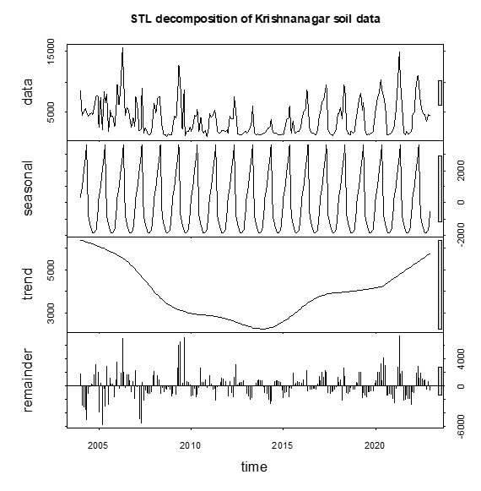
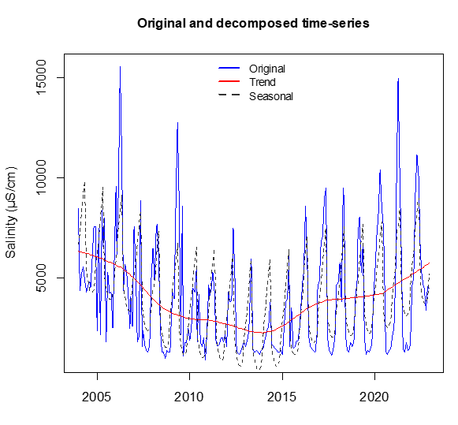
Figure S4. Seasonal-trend decomposition of a soil salinity time-series data. Top panel shows both the original and decomposed time-series data with trend, seasonal and remainder or residual components at Krishnanagar soil salinity data in Khulna. Bottom panel shows the same time-series where the original time-series is plotted with the seasonal and trend components in different colours.
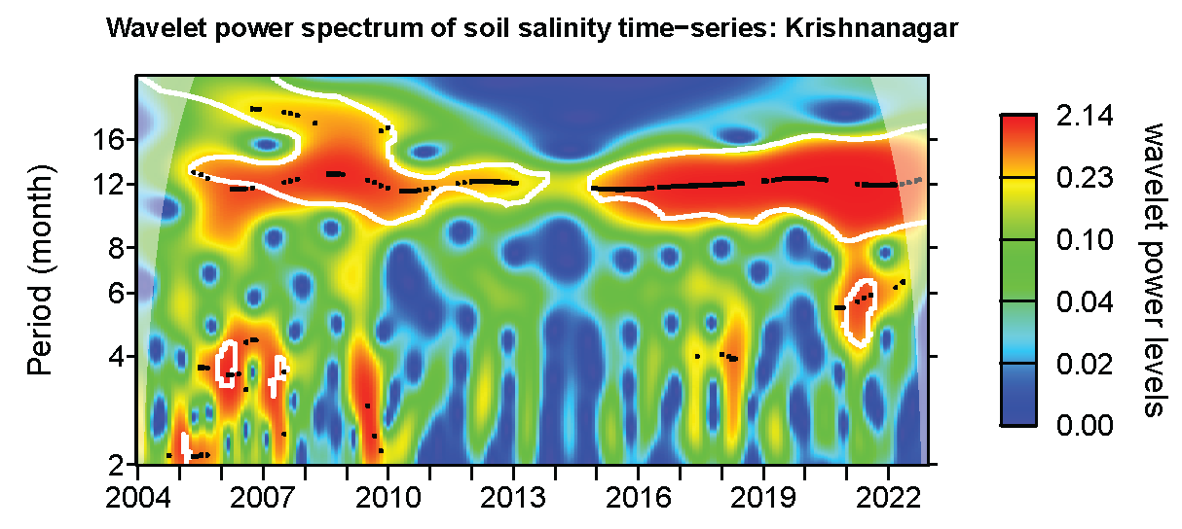

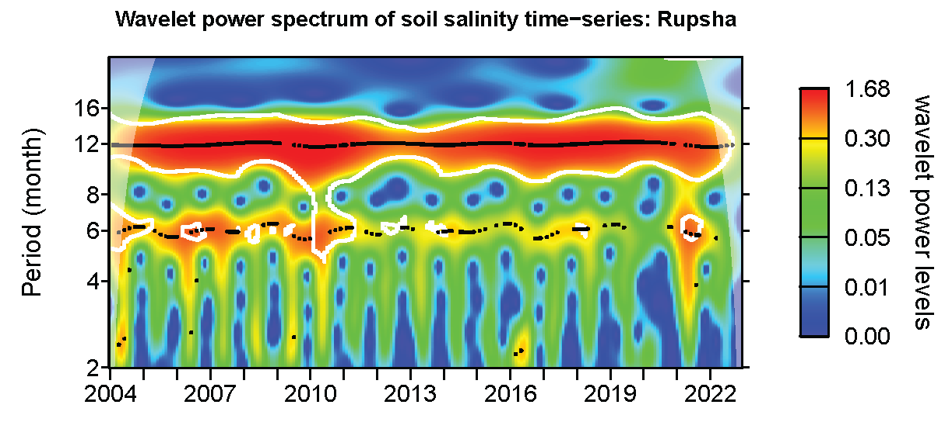

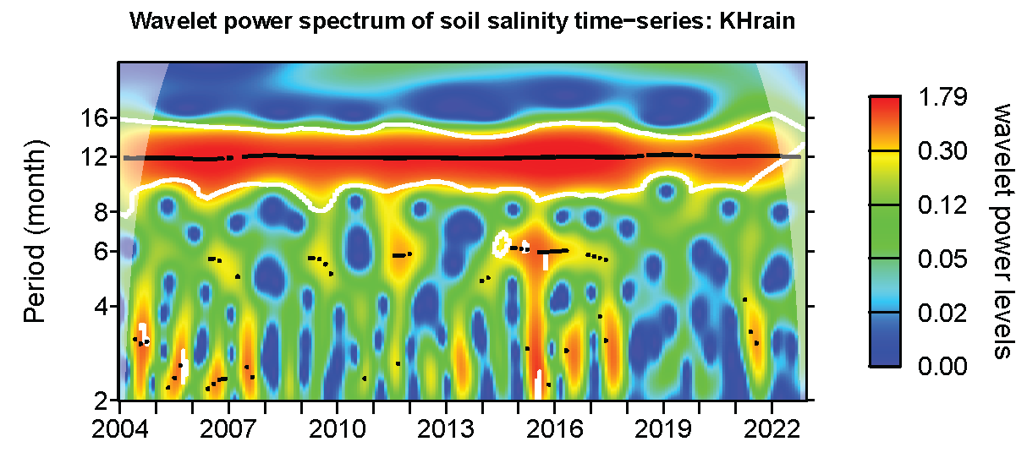

Figure S5. Wavelet analysis of soil salinity time-series data to visualise periodicity. Top panel shows twelve-month periodicity (i.e., seasonality) in soil salinity with the first half of the time-series being not uniform in seasonal patterns. The middle (river-water salinity) and bottom (rainfall at Khulna meteorology station) panels show clear annual seasonality in the time-series records all the way from the beginning to the end of the series. There is a half-yearly periodicity in river-water salinity suggesting sub-annual fluctuations marking the transition between dry and wet seasons.

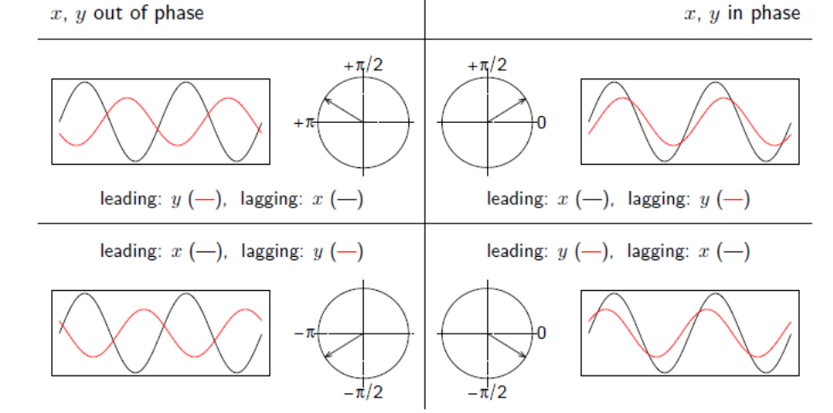
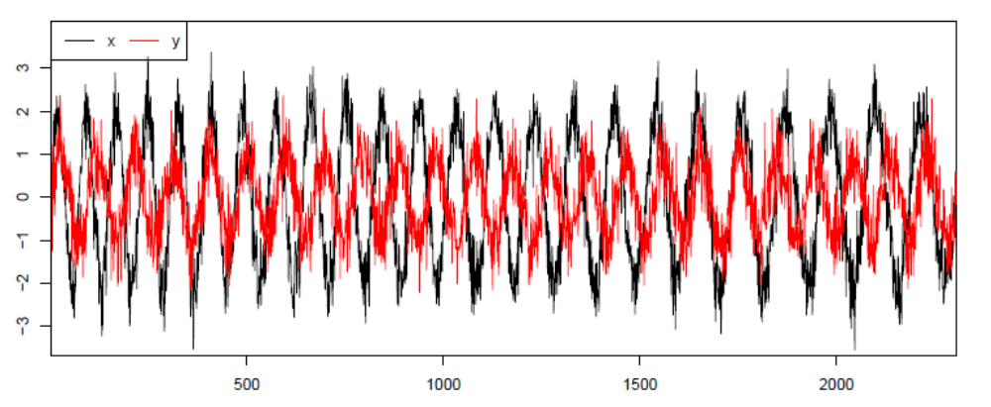
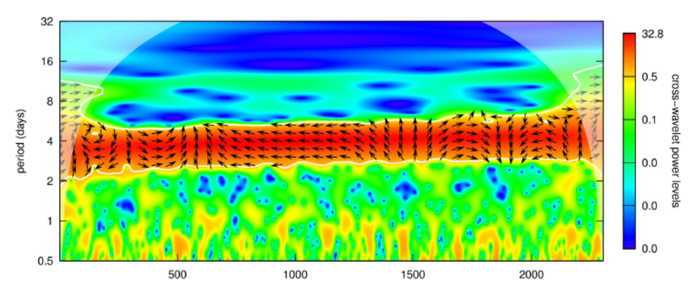

Figure S6. Interpretation of wavelet coherence analysis of time-series data. Top panel shows how to interpret the plots in relation to arrows. In addition to the figure legend, the vertical downward arrows represent negative correlation, while vertical upwards arrows positive correlation between the two time-series data. A zero-phase (i.e., due right or left direction) difference means that the two time series move together on a particular scale. The middle panel shows two hypothetical time-series data, and the bottom panel is the resulting wavelet coherence plots showing how the significant periodicities (e.g., between 2 and 6 days in this example) compared to each other in terms of their correlation along the time.

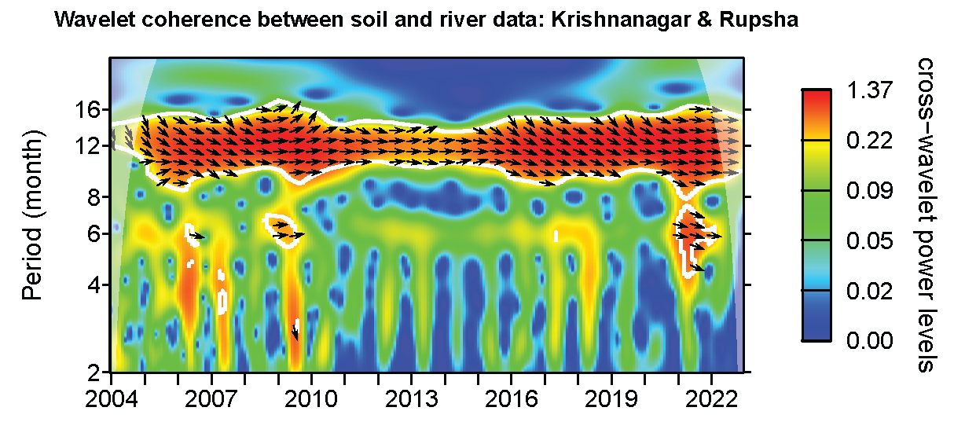

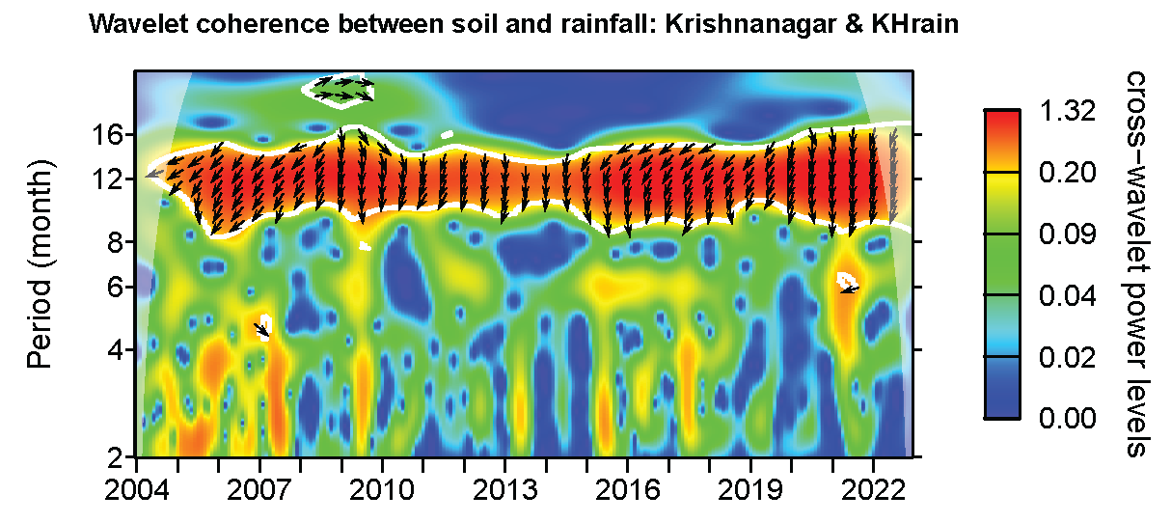

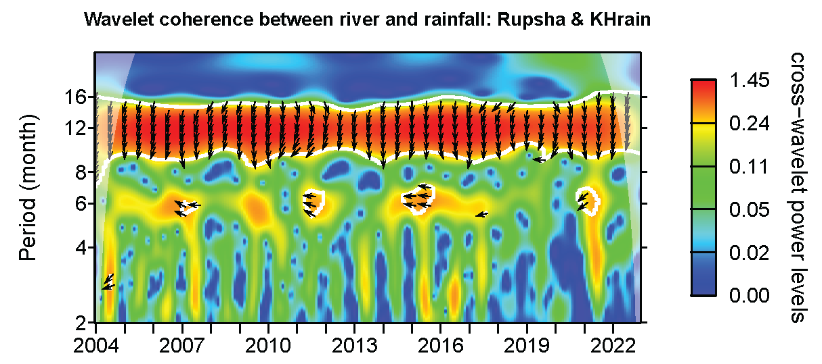
Figure S7. Wavelet coherence analysis of soil, river-water salinity and rainfall time-series data to visualise correlation in periodicity. Top panel shows that soil and river-water salinity data are correlated, and both are in phase with soil salinity leading river-water salinity in some parts of the time-series period. The middle and bottom panels show downward arrows indicating a strong negative correlation between salinity and rainfall with rainfall leading salinity by certain time period.
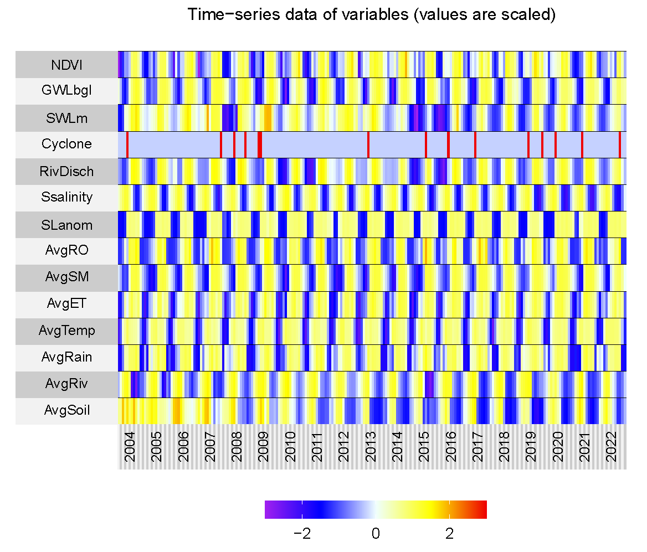
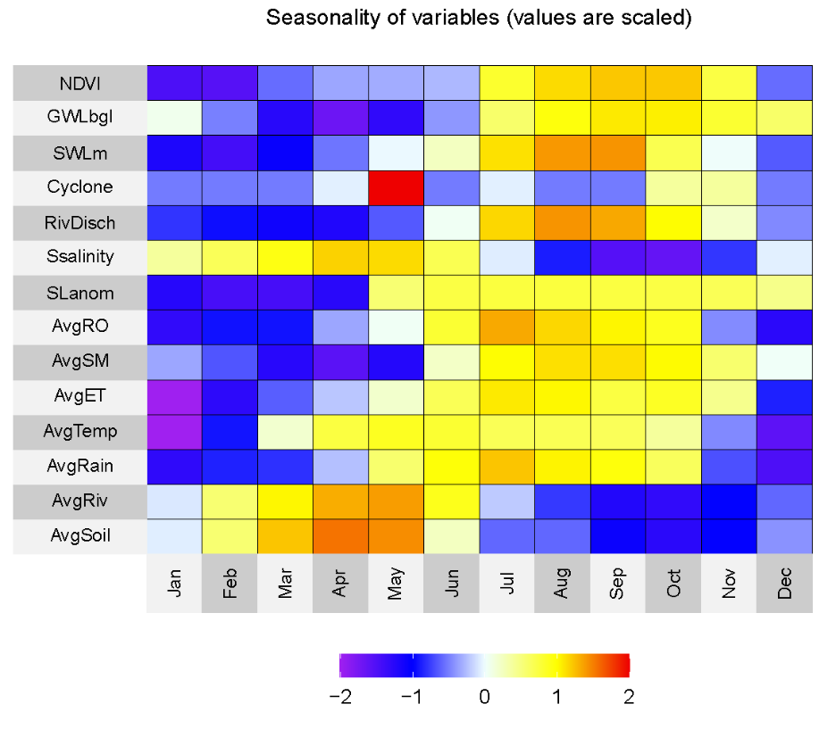
Figure S8. Time-series data of soil and river-water salinity, and twelve covariates. Top panel: scaled time-series of soil and river-water salinity, and twelve covariate datasets used in the models. Bottom panel: scaled seasonality of the same time-series data. All time-series data are monthly. Abbreviations: AvgSoil=mean soil salinity (n=7), AvgRiv=mean surface water (river-water) salinity (n=11), AvgRain=mean rainfall (n=4), AvgTemp=mean temperature (n=4), AvgET=mean evapotranspiration (n=4), AvgSM=mean soil moisture (n=4), AvgRO=mean surface runoff (n=4), SLanom=sea-level anomaly, Ssalinity=sea surface salinity, RivDisch=river discharge, Cyclone=timing and number of tropical cyclones, SWLm=surface water levels (m), GWLbgl=groundwater levels (m, below ground level), and NDVI=Normalised Difference Vegetation Index.

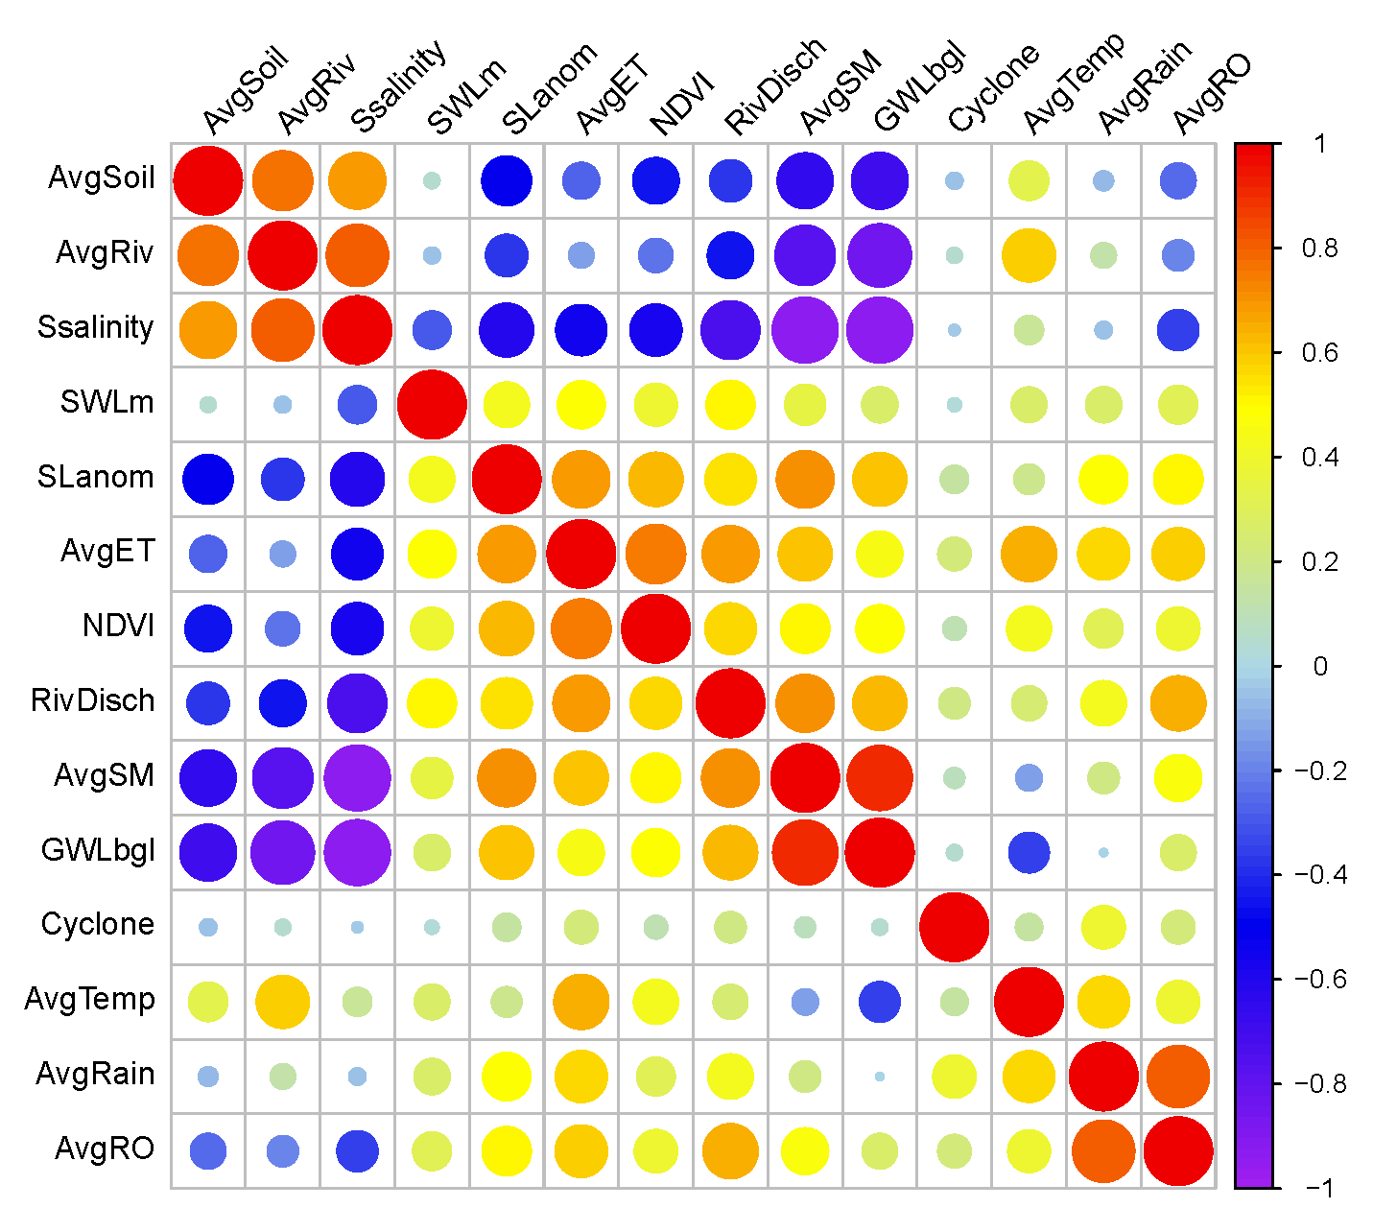
Figure S9. Correlation matrix of time-series data of soil and river-water salinity, and twelve covariates. The colour scale on the right-hand side shows Pearson correlation strength and direction. The size of the circles denotes statistical significance (based on the p values). Elaboration of the name of the variables is provided in Figure S8.

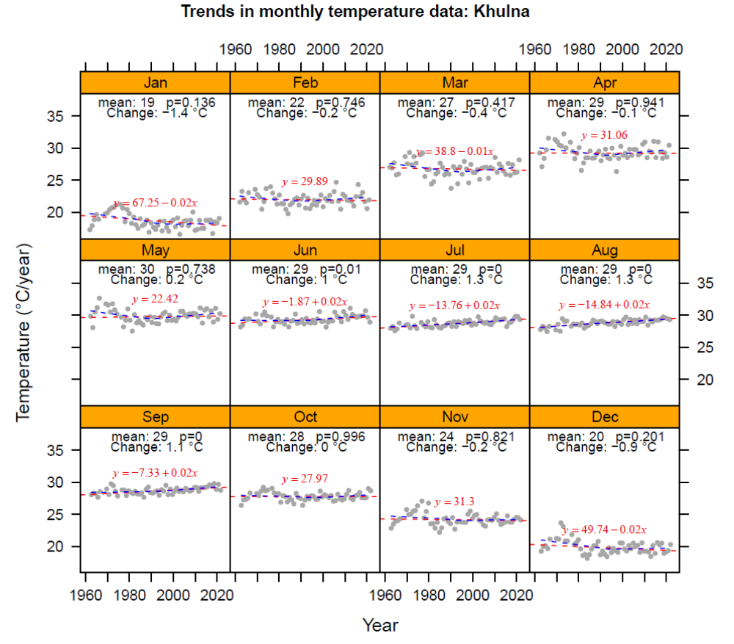
Figure S10. Long-term changes in monthly temperature in coastal Bangladesh. Monthly meteorological data at Khulna station from the Bangladesh Meteorological Department (BMD) are used to calculate linear trends in each calendar month for the period of 1961 to 2022. Long-term temperature is rising in monsoon period (e.g., June to September), but falling in winter and summer months (November to April). Note that not all trends are statistically significant (p <0.05 or the trends are statistically significant at the 95% confidence level).

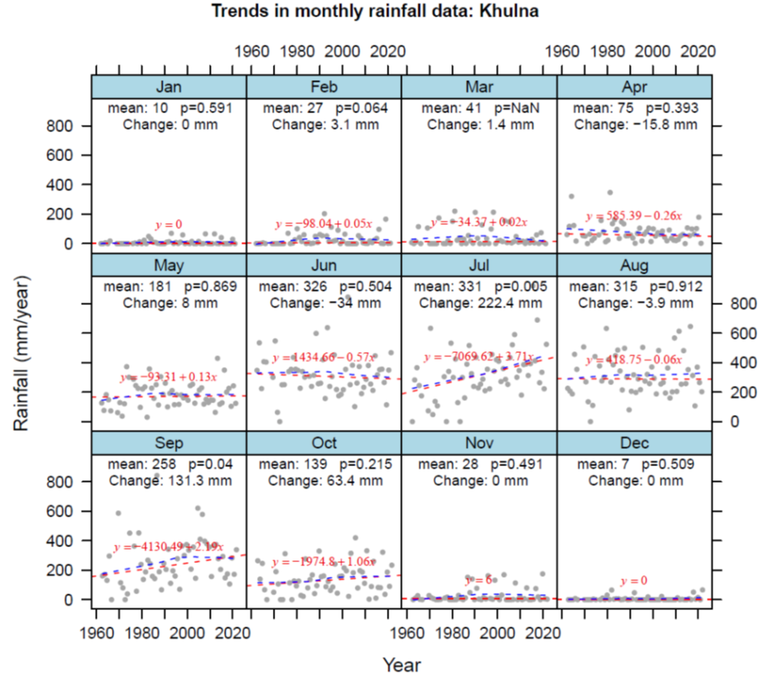
Figure S11. Long-term changes in monthly rainfall in coastal Bangladesh. Monthly meteorological data at Khulna station from the Bangladesh Meteorological Department (BMD) are used to calculate linear trends in each calendar month for the period of 1961 to 2022. Long-term rainfall is rising July, September and October, but falling in April and June. Historically, June has been the month for peak (mean: 326 mm) monsoon rainfall. There is not any change in the winter (November to January) rainfall. Note that not all trends are statistically significant (p <0.05 or the trends are statistically significant at the 95% confidence level).

Table S1. Descriptive statistics, trends and seasonal-trend decomposition of soil salinity data. There are 11 soil salinity monitoring stations in the SW coastal Bangladesh.
Station Name | Boloibunia | Dhansagor | Digraj  Biddarbaon | Fultala | Gutudia | Islampur
StationID | SS01 | SS02 | SS03 | SS04 | SS05 | SS06
Parameter | Soil salinity | Soil salinity | Soil salinity | Soil salinity | Soil salinity | Soil salinity
District | Bagerhat | Bagerhat | Bagerhat | Khulna | Khulna | Khulna
Upazila | Morrelganj | Sarankhola | Mongla | Batiaghta | Dumuria | Koyra
Union | Sadar | Dhansagar | Burirdanga | Batiaghata | Gutudia | Islampur
ECAvgMin | 900 | 1100 | 1600 | 900 | 900 | 1000
ECAvgMax | 18600 | 12000 | 30400 | 28700 | 32300 | 12500
ECAvgLTMed | 2300 | 2882 | 7891 | 3800 | 4550 | 4030
ECAvgLTavg | 4086 | 3875 | 9397 | 4856 | 6746 | 4625
ECAvgLTsd | 3534 | 2432 | 6409 | 4460 | 6524 | 2371
ECAvgDRYavg | 5292 | 4790 | 12157 | 6221 | 8077 | 5539
ECAvgWETavg | 2398 | 2594 | 5534 | 2945 | 4882 | 3345
ECavgLinTD | -114 | -61 | -260 | -179 | -699 | -74
ECavgLNTDerr | 42 | 29 | 76 | 53 | 64 | 28
ECavgLNTDp | 0.008 | 0.039 | 0.001 | 0.001 | 0.000 | 0.009
ECavgSenTD | -46 | -69 | -237 | -60 | -446 | -88
ECavgSenTDp | 0.017 | 0.000 | 0.000 | 0.013 | 0.000 | 0.000
ECavgSSenTD | -29 | -59 | -245 | -50 | -356 | -68
ECavgSTLTD | -106 | 5 | -9 | -149 | -819 | -6
ECavgMKTau | -0.11 | -0.17 | -0.18 | -0.11 | -0.36 | -0.16
ECavgSMKTau | -0.14 | -0.27 | -0.33 | -0.13 | -0.37 | -0.28
ECavgDryTD | -85 | -37 | -231 | -192 | -734 | -41
ECavgDryTDerr | 59 | 40 | 106 | 79 | 93 | 37
ECavgDryTDp | 0.15 | 0.36 | 0.03 | 0.02 | 0.00 | 0.26
ECavgWetTD | -142 | -85 | -272 | -148 | -637 | -111
ECavgWetTDerr | 42 | 28 | 47 | 41 | 67 | 31
ECavgWetTDp | 0.001 | 0.003 | 0.000 | 0.001 | 0.000 | 0.001
ECavgSTLt | 12 | 5 | 5 | 18 | 67 | 8
ECavgSTLs | 51 | 80 | 69 | 46 | 12 | 80
ECavgSTLr | 36 | 15 | 27 | 36 | 21 | 11
Station Name | Khalisha | Kismat_Fultala | Krishnanagar | Shibbari | Shrifalkathi  Ishwaripur
StationID | SS07 | SS08 | SS09 | SS10 | SS11
Parameter | Soil salinity | Soil salinity | Soil salinity | Soil salinity | Soil salinity
District | Khulna | Khulna | Khulna | Khulna | Satkhira
Upazila | Dakop | Batiaghta | Batiaghta | Paikgachha | Shyamnagar
Union | Sadar | Batiaghata | Jalma | Sadar | Ishwaripur
ECAvgMin | 800 | 600 | 900 | 1300 | 1000
ECAvgMax | 14200 | 27300 | 15600 | 39300 | 12500
ECAvgLTMed | 4162 | 2915 | 2600 | 6250 | 3894
ECAvgLTavg | 4704 | 4696 | 4000 | 8065 | 4543
ECAvgLTsd | 2719 | 4266 | 2888 | 5932 | 2371
ECAvgDRYavg | 5824 | 5872 | 5019 | 10104 | 5454
ECAvgWETavg | 3137 | 3050 | 2573 | 5212 | 3267
ECavgLinTD | -90 | -127 | -29 | -249 | -58
ECavgLNTDerr | 32 | 51 | 35 | 70 | 28
ECavgLNTDp | 0.006 | 0.013 | 0.412 | 0.000 | 0.043
ECavgSenTD | -108 | -48 | -33 | -209 | -73
ECavgSenTDp | 0.000 | 0.025 | 0.072 | 0.000 | 0.002
ECavgSSenTD | -84 | -29 | -10 | -190 | -53
ECavgSTLTD | -12 | -82 | -12 | -47 | 7
ECavgMKTau | -0.161 | -0.100 | -0.081 | -0.183 | -0.139
ECavgSMKTau | -0.257 | -0.113 | -0.040 | -0.272 | -0.225
ECavgDryTD | -40 | -115 | 20 | -159 | -27
ECavgDryTDerr | 42 | 74 | 48 | 98 | 37
ECavgDryTDp | 0.34 | 0.12 | 0.67 | 0.11 | 0.47
ECavgWetTD | -148 | -133 | -88 | -356 | -93
ECavgWetTDerr | 33 | 51 | 35 | 68 | 31
ECavgWetTDp | 0.000 | 0.011 | 0.014 | 0.000 | 0.003
ECavgSTLt | 10 | 11 | 15 | 5 | 6
ECavgSTLs | 78 | 48 | 47 | 61 | 83
ECavgSTLr | 12 | 41 | 37 | 33 | 11

Explanation: EC=electrical conductivity; all values are in µS/cm, but for trend it’s µS/cm/year
ECAvgMin = Long-term average minimum salinity
ECAvgMax = Long-term average maximum salinity
ECAvgLTMed = Long-term average median salinity
ECAvgLTavg = Long-term average salinity
ECAvgLTsd = Long-term standard deviation salinity
ECAvgDRYavg = Dry-season average salinity
ECAvgWETavg = Wet-season average salinity
ECavgLinTD = Long-term linear trend in salinity
ECavgLNTDerr = Long-term trend standard error
ECavgLNTDp = Long-term trend statistical significance or p value
ECavgSenTD = Long-term Sen’s slope or trend
ECavgSenTDp = Long-term Sen’s trend statistical significance or p value
ECavgSSenTD = Long-term seasonal Sen’s slope or trend
ECavgSTLTD = Long-term STL trend
ECavgMKTau = Mann-Kendall Tau value (strength and direction of trends)
ECavgSMKTau = Seasonal Mann-Kendall Tau value (strength and direction of trends)
ECavgDryTD = Long-term dry-season trend
ECavgDryTDerr = Long-term dry-season trend standard error
ECavgDryTDp = Long-term dry-season trend statistical significance or p value
ECavgWetTD = Long-term wet-season trend
ECavgWetTDerr = Long-term wet-season trend standard error
ECavgWetTDp = Long-term wet-season trend statistical significance or p value
ECavgSTLt = STL decomposed trend component explaining the variance (percent)
ECavgSTLs = STL decomposed seasonal component explaining the variance (percent)
ECavgSTLr = STL decomposed residual component explaining the variance (percent)
Table S2. Descriptive statistics, trends and seasonal-trend decomposition of river-water salinity data. There are 13 river-water salinity monitoring stations in the SW coastal Bangladesh.
StationName | Daratana | Modhumoti | Panguchhi | Poshur | Bhadra | Kazibachha | Shailmari
StationID | RS01 | RS02 | RS03 | RS04 | RS05 | RS06 | RS08
Parameter | Water salinity | Water salinity | Water salinity | Water salinity | Water salinity | Water salinity | Water salinity
District | Bagerhat | Bagerhat | Bagerhat | Bagerhat | Khulna | Khulna | Khulna
Upazila | Sadar | Mollahat | Morrelganj | Mongla | Dumuria | Batiaghata | Dumuria
Union | Sadar | Udaypur | Sadar | Sadar | Khornia | Batiaghata | Gutudia
ECAvgMin | 480 | 900 | 300 | 300 | 300 | 200 | 200
ECAvgMax | 24900 | 18600 | 26100 | 33700 | 30700 | 33200 | 33000
ECAvgLTMed | 4012 | 2400 | 2680 | 4550 | 3575 | 1909 | 1900
ECAvgLTavg | 6783 | 4091 | 4588 | 8862 | 7845 | 7468 | 6187
ECAvgLTsd | 6229 | 3531 | 4455 | 9495 | 7826 | 9214 | 7498
ECAvgDRYavg | 8466 | 5290 | 6132 | 12466 | 9314 | 11191 | 8631
ECAvgWETavg | 4427 | 2413 | 2426 | 3815 | 5789 | 2254 | 2766
ECavgLinTD | -185 | -113 | -149 | -94 | -81 | -24 | 98
ECavgLNTDerr | 74 | 42 | 53 | 115 | 95 | 111 | 90
ECavgLNTDp | 0.01 | 0.01 | 0.01 | 0.41 | 0.39 | 0.83 | 0.28
ECavgSenTD | -112 | -46 | -80 | -25 | -26 | 7 | 9
ECavgSenTDp | 0.00 | 0.02 | 0.00 | 0.30 | 0.47 | 0.41 | 0.64
ECavgSSenTD | -109 | -29 | -75 | -10 | 14 | 12 | 24
ECavgSTLTD | -58 | -103 | -170 | -10 | 36 | -35 | 72
ECavgMKTau | -0.13 | -0.11 | -0.13 | -0.05 | -0.03 | 0.04 | 0.02
ECavgSMKTau | -0.24 | -0.14 | -0.21 | -0.06 | 0.03 | 0.13 | 0.08
ECavgDryTD | -159 | -86 | -153 | -89 | 24 | -48 | 202
ECavgDryTDerr | 107 | 59 | 76 | 153 | 127 | 152 | 129
ECavgDryTDp | 0.14 | 0.15 | 0.05 | 0.56 | 0.85 | 0.76 | 0.12
ECavgWetTD | -205 | -139 | -128 | -65 | -215 | 46 | -23
ECavgWetTDerr | 79 | 43 | 45 | 122 | 132 | 100 | 87
ECavgWetTDp | 0.01 | 0.00 | 0.01 | 0.60 | 0.11 | 0.64 | 0.79
ECavgSTLt | 3 | 12 | 5 | 1 | 1 | 1 | 2
ECavgSTLs | 79 | 51 | 67 | 84 | 79 | 85 | 76
ECavgSTLr | 18 | 36 | 28 | 15 | 20 | 15 | 22
StationName | Shibsha | Rupsha | Kakshiali | Betna | Kapotakkha | Morichap
StationID | RS09 | RS07 | RS11 | RS10 | RS12 | RS13
Parameter | Water salinity | Water salinity | Water salinity | Water salinity | Water salinity | Water salinity
District | Khulna | Khulna | Satkhira | Satkhira | Satkhira | Satkhira
Upazila | Paikgachha | Sadar | Kaliganj | Sadar | Tala | Ashashuni
Union | Sadar | NA | Sadar | Labsa | Kumira | Sadar
ECAvgMin | 500 | 200 | 400 | 300 | 300 | 400
ECAvgMax | 33600 | 30200 | 36600 | 33000 | 26400 | 35500
ECAvgLTMed | 6700 | 800 | 8750 | 3660 | 1892 | 8350
ECAvgLTavg | 11241 | 5702 | 12257 | 7834 | 4954 | 12134
ECAvgLTsd | 9737 | 7918 | 9902 | 8398 | 6081 | 9904
ECAvgDRYavg | 13709 | 8625 | 14790 | 10045 | 6288 | 14566
ECAvgWETavg | 7785 | 1611 | 8709 | 4739 | 3085 | 8728
ECavgLinTD | -106 | -46 | -110 | -218 | -191 | 10
ECavgLNTDerr | 118 | 96 | 120 | 101 | 72 | 120
ECavgLNTDp | 0.37 | 0.64 | 0.36 | 0.03 | 0.01 | 0.93
ECavgSenTD | -60 | 0 | -55 | -73 | -17 | 24
ECavgSenTDp | 0.32 | 0.72 | 0.50 | 0.06 | 0.34 | 0.73
ECavgSSenTD | -13 | 0 | 0 | -46 | -15 | 85
ECavgSTLTD | 51 | -12 | -69 | -121 | -180 | 202
ECavgMKTau | -0.04 | 0.02 | -0.03 | -0.08 | -0.04 | 0.02
ECavgSMKTau | -0.03 | 0.08 | 0.00 | -0.09 | -0.07 | 0.11
ECavgDryTD | -23 | -72 | -16 | -171 | -154 | 99
ECavgDryTDerr | 156 | 137 | 159 | 136 | 101 | 160
ECavgDryTDp | 0.88 | 0.60 | 0.92 | 0.21 | 0.13 | 0.54
ECavgWetTD | -200 | 20 | -218 | -263 | -232 | -91
ECavgWetTDerr | 159 | 80 | 160 | 129 | 91 | 161
ECavgWetTDp | 0.21 | 0.81 | 0.18 | 0.04 | 0.01 | 0.58
ECavgSTLt | 1 | 1 | 1 | 3 | 4 | 1
ECavgSTLs | 86 | 82 | 87 | 74 | 72 | 87
ECavgSTLr | 13 | 17 | 13 | 23 | 24 | 12

Note: for explanation of the statistics, see Table S1.

