Supplementary
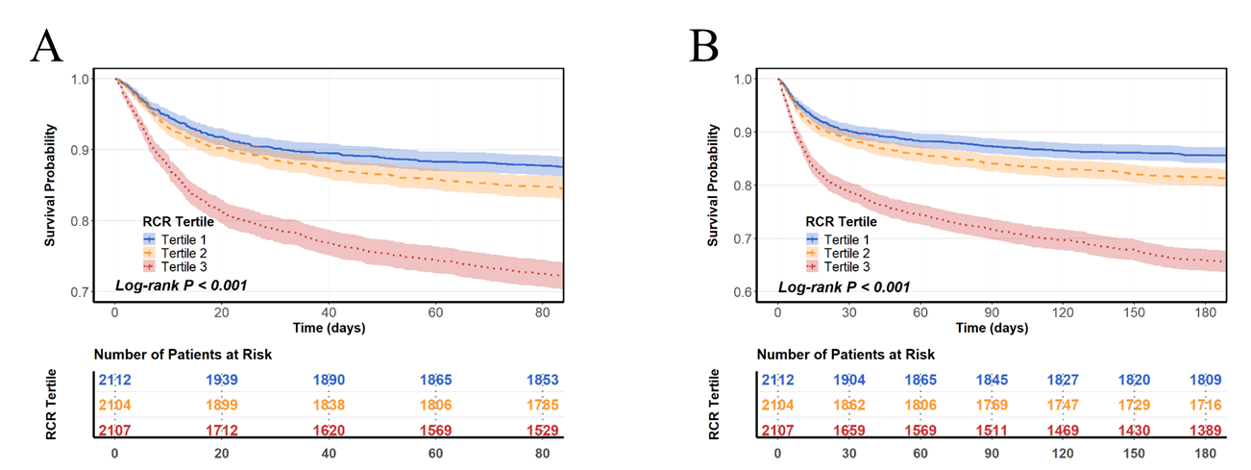Supplementary Figure 1 Kaplan–Meier survival analysis curves for all-cause mortality Kaplan–Meier curves and cumulative incidence of 90-day (A) and 180-day (B) all-cause mortality stratified by RCR

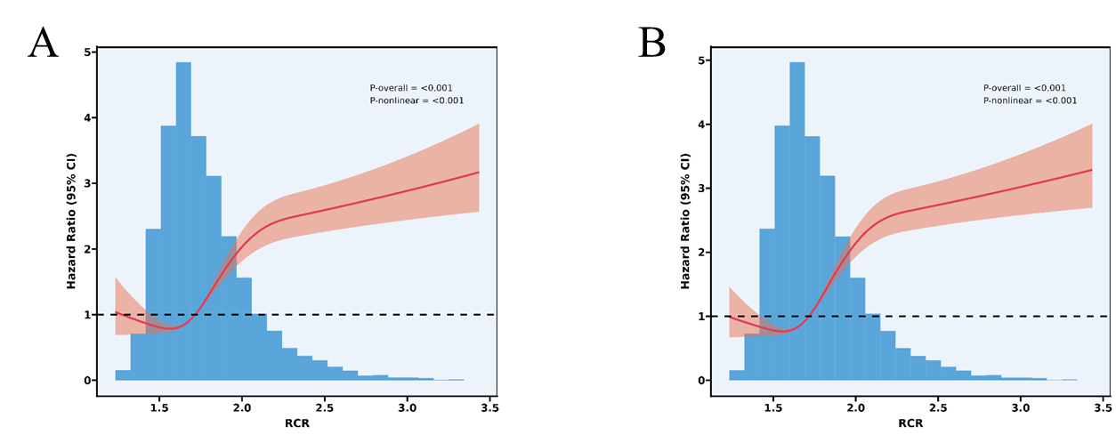
Supplementary Figure 2 Restricted cubic spline regression analysis of RCR with all-cause mortality
Restricted cubic spline regression analysis of RCR with 90-day (A) and 180-day (B) all-cause mortality

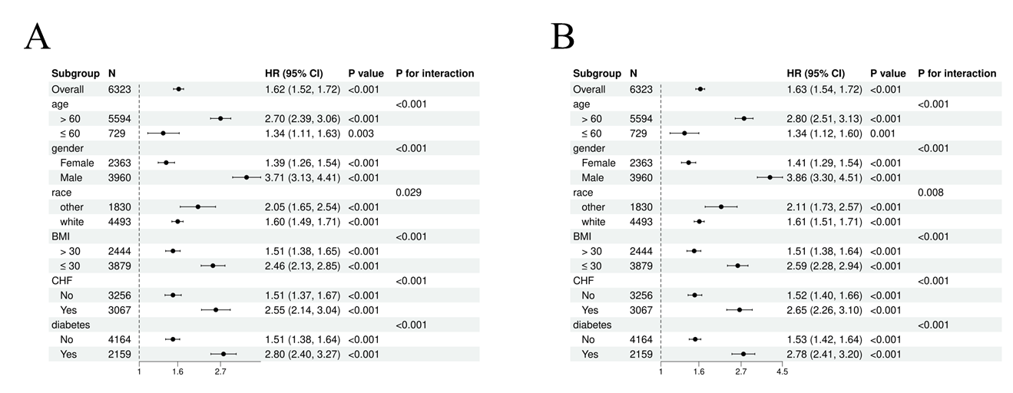
Supplementary Figure 3 Forest plots of stratified analyses of RCR and 90-day all-cause mortality (A), and 180-day all-cause mortality (B)

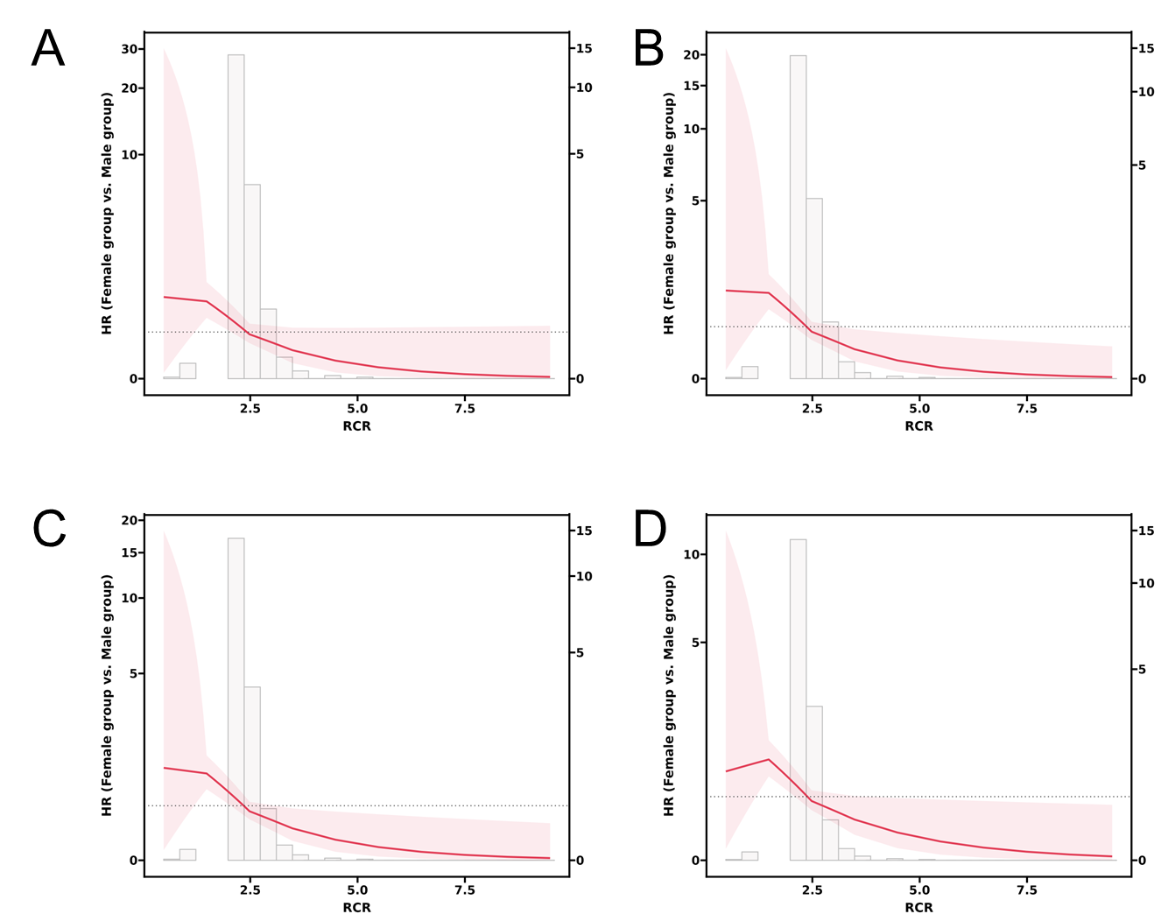
Supplementary Figure 4. Restricted cubic spline analysis showing the relationship between Red Cell Distribution Width-to-Serum Calcium Ratio (RCR) and hazard ratio (HR) comparing mortality risk between female versus male groups at different follow-up periods: (A) 30-day, (B) 90-day, (C) 180-day, and (D) 365-day mortality.

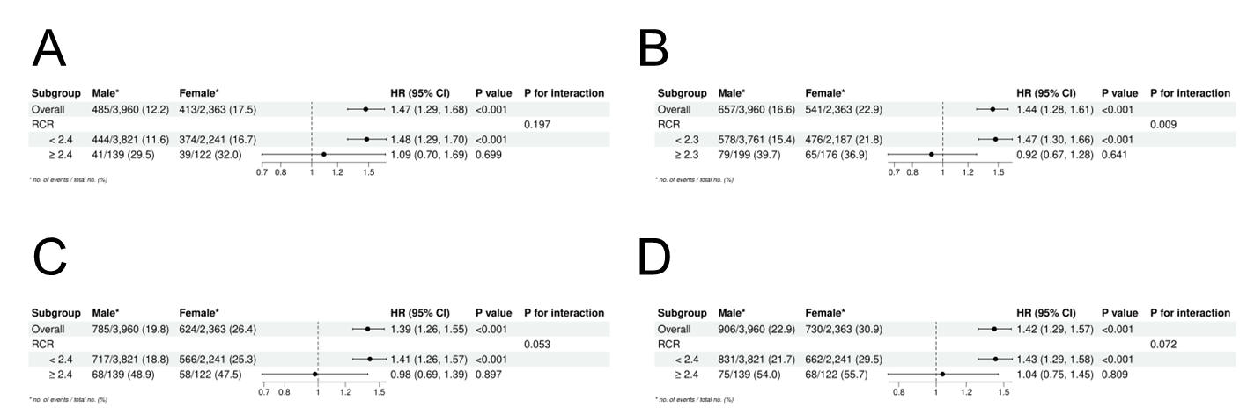
Supplementary Figure 5. Forest plots showing hazard ratios (HR) with 95% confidence intervals (CI) for mortality comparing female versus male groups, stratified by RCR cutoff values at different follow-up periods: (A) 30-day, (B) 90-day, (C) 180-day, and (D) 365-day mortality.

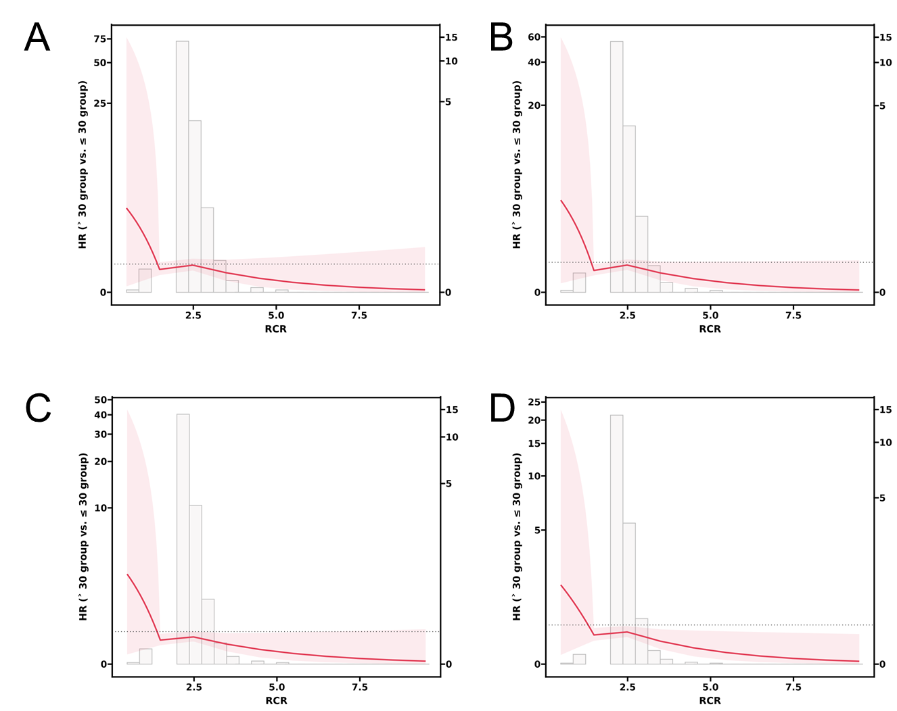
Supplementary Figure 6. Restricted cubic spline analysis showing the relationship between Red Cell Distribution Width-to-Serum Calcium Ratio (RCR) and hazard ratio (HR) comparing mortality risk between BMI > 30 group versus BMI ≤ 30 group at different follow-up periods: (A) 30-day, (B) 90-day, (C) 180-day, and (D) 365-day mortality.

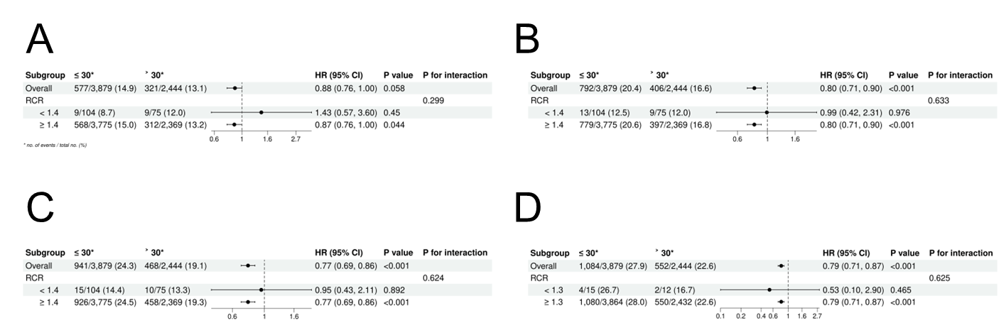
Supplementary Figure 7. Forest plots showing hazard ratios (HR) with 95% confidence intervals (CI) for mortality comparing BMI > 30 versus BMI ≤ 30 groups at different follow-up periods: (A) 30-day, (B) 90-day, (C) 180-day, and (D) 365-day mortality.

