Supplementary Information
A simple fluorescent probe for biothiols detection and imaging of living cells in vivo based on a hemicyanine derivative

Xia Gao¹* ·Xuehan Liu¹· Xinping Zheng¹·Yaxin Liu¹·Jinming Lin¹·Pengbo Zhang¹*

¹School of Public Health, Xinxiang Medical University, Xinxiang 453003, PR China，Corresponding authors, E-mail: 071009@xxmu.edu.cn (Xia Gao); zpbxxmu@xxmu.edu.cn (Pengbo Zhang)

Fig.S₁ ¹H NMR spectroscopy of compound 1

Fig.S₂ ¹³C NMR spectroscopy of compound 1

Fig.S₃ ¹H NMR spectroscopy of the probe HCD

Fig.S₄ ¹³C NMR spectroscopy of the probe HCD (DMSO)
Fig.S₅ MS spectroscopy of the probe HCD

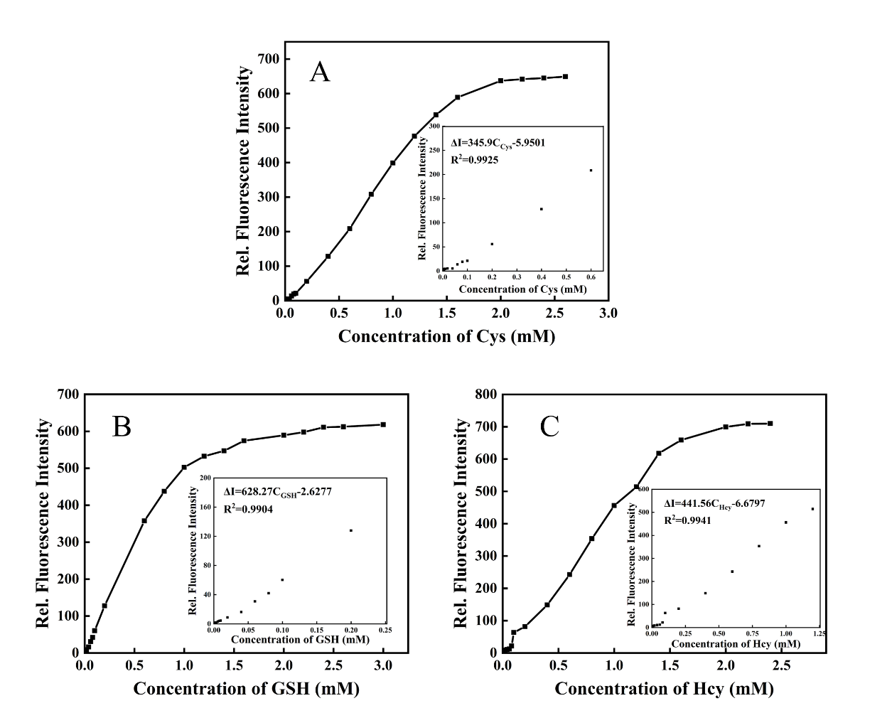

Fig.S₆The fluorescence titration curves and calibration graphs for spectrophotometric determination of Cys(A),GSH(B)and Hcy(C) in the simulated physiological media.([HCD] = 2.00×10⁻⁵ M，[HCO₃⁻]= 1.00×10⁻³ M，[HPO₄²⁻]= 2.00×10⁻¹ M，[H₂PO₄⁻]= 2.00×10⁻¹ M，[Na⁺]= 1.00×10⁻³ M，[K⁺]= 1.00×10⁻³ M，[Ca²⁺]= 5.00×10⁻⁴ M，[Mg²⁺]= 5.00×10⁻⁴ M，[Cl⁻]= 2.00 ×10⁻³ M，pH=7.40 PB buffer, response at 37°C for 40 min)
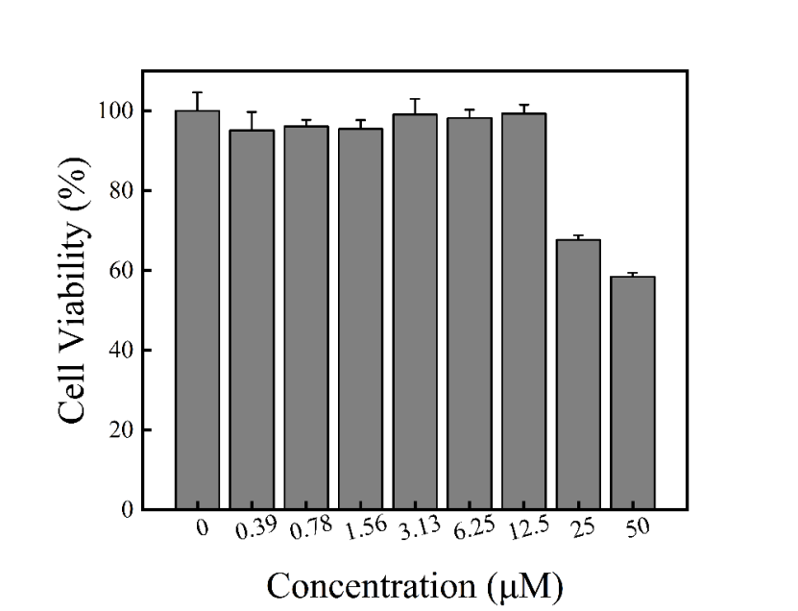
Fig.S₇ Results of the toxicity of HCD to RAW264.7 cells determined by CCK-8 method

Fig.S₈ MS spectroscopy of HCD-Cys

