Additional file 1 Table S1. The sequences of primer pairs used in qRT-PCR

Gene ID | Gene Name | Primer sequences 5′ 3′
Unigene44906_Mp | IKK | F: CACATCATCTTTTTGACGCGA
Unigene44906_Mp | IKK | R: AGATGCAAAGGGGTTTGAAGA
CL1970.Contig1_Mp | DTHD1 | F: AGTGATGCCGACGCTCGATTC
CL1970.Contig1_Mp | DTHD1 | R: AGGTCTCCACGTCCACTCTTCA
Unigene1145_Mp | CTRP2 | F: CAAGTGGCACAGAAAATGGAT
Unigene1145_Mp | CTRP2 | R: TTGTTGTATGCTCCACCGATG
Unigene18023_Mp | BIRC7 | F: GCTGTGGGATGAAGAACTGGGA
Unigene18023_Mp | BIRC7 | R: CGGCGATCTGGCTGTAACCTT
CL7712.Contig2_Mp | PSME3 | F: CTCCGCCTCACAAGTGCAGAAC
CL7712.Contig2_Mp | PSME3 | R: GCATTGGCATTCCGTGGCTTCA
CL7955.Contig1_Mp | ARAF-like | F: TCGCACATCAAGCCACAGTCC
CL7955.Contig1_Mp | ARAF-like | R: TGTTTCTACCGACCGAGCCCTA
CL6541.Contig2_Mp | CREM | F: CGGCAGGTTCTAGCGTTCCTAC
CL6541.Contig2_Mp | CREM | R: GTCCTGGCTCTGACTGCTGTTG
Unigene28341_Mp | IAP | F: TACACACTGATGCAGCCCAGA
Unigene28341_Mp | IAP | R: ACTGTTCGATGCCGCAATCTT
CL2254.Contig4_Mp | MAPKK3 | F: ACATGGCACCTGAGAGGATTGA
CL2254.Contig4_Mp | MAPKK3 | R: GTGGCGGATCTTTGACGACCT
Unigene7289_Mp | TLR4 | F: TGGTTTGTAGAGTGCCGACCG
Unigene7289_Mp | TLR4 | R:ACCTACATCTGCCTCTTGCGA
Unigene7189_Mp | TBK1 | F: CGTCAGCCAGGTCAAACTCAGT
Unigene7189_Mp | TBK1 | R: TGCCACCGTATGCTTGGAAGG
- | MITF | F: ACGACGGAGATAAAGAATGC
- | MITF | R: GATGTTTGAGGAGGAACG
- | DOUX | F: CAAAGAGTGTCTGGTGGTC
- | DOUX | R: ACACCCACTTTCCTTACC
- | β-actin | F: TTGTCTGGTGGTTCAACTATG
- | β-actin | R: GACTGATTTCTTACGGATG
- | EF1a | F: TTGTCTGGTGGTTCAACTATG
- | EF1a | R: TCCACATCTGCTGGAAGGTG

Additional file 2 Table S2. An overview of the assembly

Sample | Total Raw Reads (M) | Total Clean Reads (M) | Total Clean Bases(Gb) | Clean Reads Q20 (%) | Clean Reads Q30 (%) | Clean Reads Ratio (%)
post_F_1t | 21.94 | 21.82 | 1.09 | 97.89 | 89.35 | 99.44
post_F_2t | 21.94 | 21.85 | 1.09 | 97.96 | 89.53 | 99.59
post_F_3t | 21.94 | 21.81 | 1.09 | 97.89 | 89.43 | 99.41
post_M_1t | 21.94 | 21.84 | 1.09 | 97.98 | 89.74 | 99.55
post_M_2t | 21.94 | 21.86 | 1.09 | 98.06 | 89.9 | 99.62
post_M_3t | 21.94 | 21.84 | 1.09 | 97.95 | 89.75 | 99.54
pre_F_1t | 21.92 | 21.84 | 1.09 | 98.33 | 90.75 | 99.63
pre_F_2t | 21.92 | 21.85 | 1.09 | 98.18 | 90.25 | 99.68
pre_F_3t | 21.94 | 21.83 | 1.09 | 97.95 | 89.63 | 99.5
pre_M_1t | 21.93 | 21.85 | 1.09 | 98.05 | 89.48 | 99.65
pre_M_2t | 21.93 | 21.84 | 1.09 | 98.13 | 89.93 | 99.63
pre_M_3t | 21.93 | 21.82 | 1.09 | 98.14 | 90.06 | 99.51

Additional file 3
Figure S1. The GO enrichment analyses of DEGs in Pre_F vs. Post_F and Pre_M vs. Post_M. Notes: A is Pre_F vs. Post_F and B is Pre_M vs. Post_M.

Additional file 4
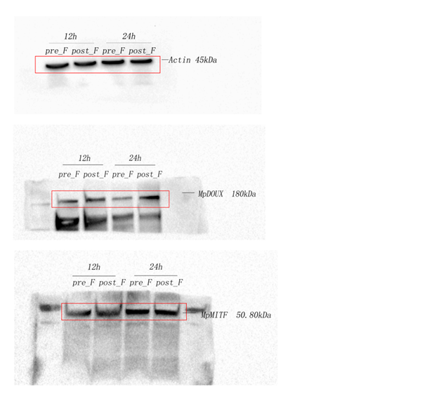
Complete images of Western blots shown in Figure 8. MpDOUX and MpMITF protein expression in the hepatopancreases of M. petechialis at 12 h and 24 h during Vibrio challenge by western blot. Total protein extracted from hepatopancreases at each time point (12 h, 24 h) after the Vibrio challenge mixed by protein from 3 individuals were separated on SDS-PAGE gels, transferred to western blots, and hybridized with antibodies recognizing DOUX (polyclonal antibody catalog no. A8583, ABclonal, USA) and MITF (polyclonal antibody catalog no. A1255, ABclonal, USA). ß-actin served as a loading control. The goat anti-rabbit IgG-HRP antibody (ZSGB-BIO, China) was used as a secondary antibody.

