Supplementary information

DeepSeMS: a large language model reveals hidden biosynthetic potential of the global ocean microbiome
Tingjun Xu^{1,2,$}, Yuwei Yang^{1,$}, Ruixin Zhu^{1,*}, Weili Lin¹, Jixuan Li¹, Yan Zheng³, Guoqing Zhang^{4,*}, Guoping Zhao^{3, 4,*} & Na Jiao^{3,*}
¹ Shanghai Key Laboratory of Maternal Fetal Medicine, Shanghai Institute of Maternal-Fetal Medicine and Gynecologic Oncology, Clinical and Translation Research Center, Shanghai First Maternity and Infant Hospital, School of Life Sciences and Technology, Tongji University, Shanghai 200092, P. R. China.
² State Key Laboratory of Fluorine and Nitrogen Chemistry and Advanced Materials, Shanghai Institute of Organic Chemistry, Chinese Academy of Sciences, Shanghai 200032, P. R. China.
³ State Key Laboratory of Genetic Engineering, Fudan Microbiome Center, School of Life Sciences, Fudan University, Shanghai 200438, P. R. China.
⁴ National Genomics Data Center & Bio-Med Big Data Center, CAS Key Laboratory of Computational Biology, Shanghai Institute of Nutrition and Health, University of Chinese Academy of Sciences, Chinese Academy of Sciences, Shanghai 200031, P. R. China.
$ These authors have contributed equally to this work. Author order was determined by drawing straws.
*Corresponding authors: Ruixin Zhu (rxzhu@tongji.edu.cn), Guoqing Zhang (gqzhang@picb.ac.cn), Guoping Zhao (gpzhao@sibs.ac.cn) and Na Jiao (najiao@fudan.edu.cn).

Contents

Supplementary Figures:
• Supplementary Figure 1 - The neural network of DeepSeMS model.
• Supplementary Figure 2 - Ten-fold cross-validation training of DeepSeMS model on the refined dataset.
• Supplementary Figure 3 - Comparison of DeepSeMS with existing methods on validation dataset of the known BGCs.
• Supplementary Figure 4 - A case study of cryptic BGC, biosynthetic pathway and predicted SM structures for illustrating the interpretability of DeepSeMS.
• Supplementary Figure 5 - Illustration of molecular novelty of the global ocean SMs.

Supplementary Tables:
• Supplementary Table 1 - Performance of the DeepSeMS model on training datasets of the data augmentation strategy
• Supplementary Table 2 - Performance of the DeepSeMS models of ten-fold cross-validation training on the refined dataset.
• Supplementary Table 3 - Comparison of DeepSeMS with existing methods on validation dataset of ‘cryptic BGCs’.
• Supplementary Table 4 - Capacity of the DeepSeMS model on various BGC types in the validation dataset of ‘cryptic BGCs’.

Supplementary Figures

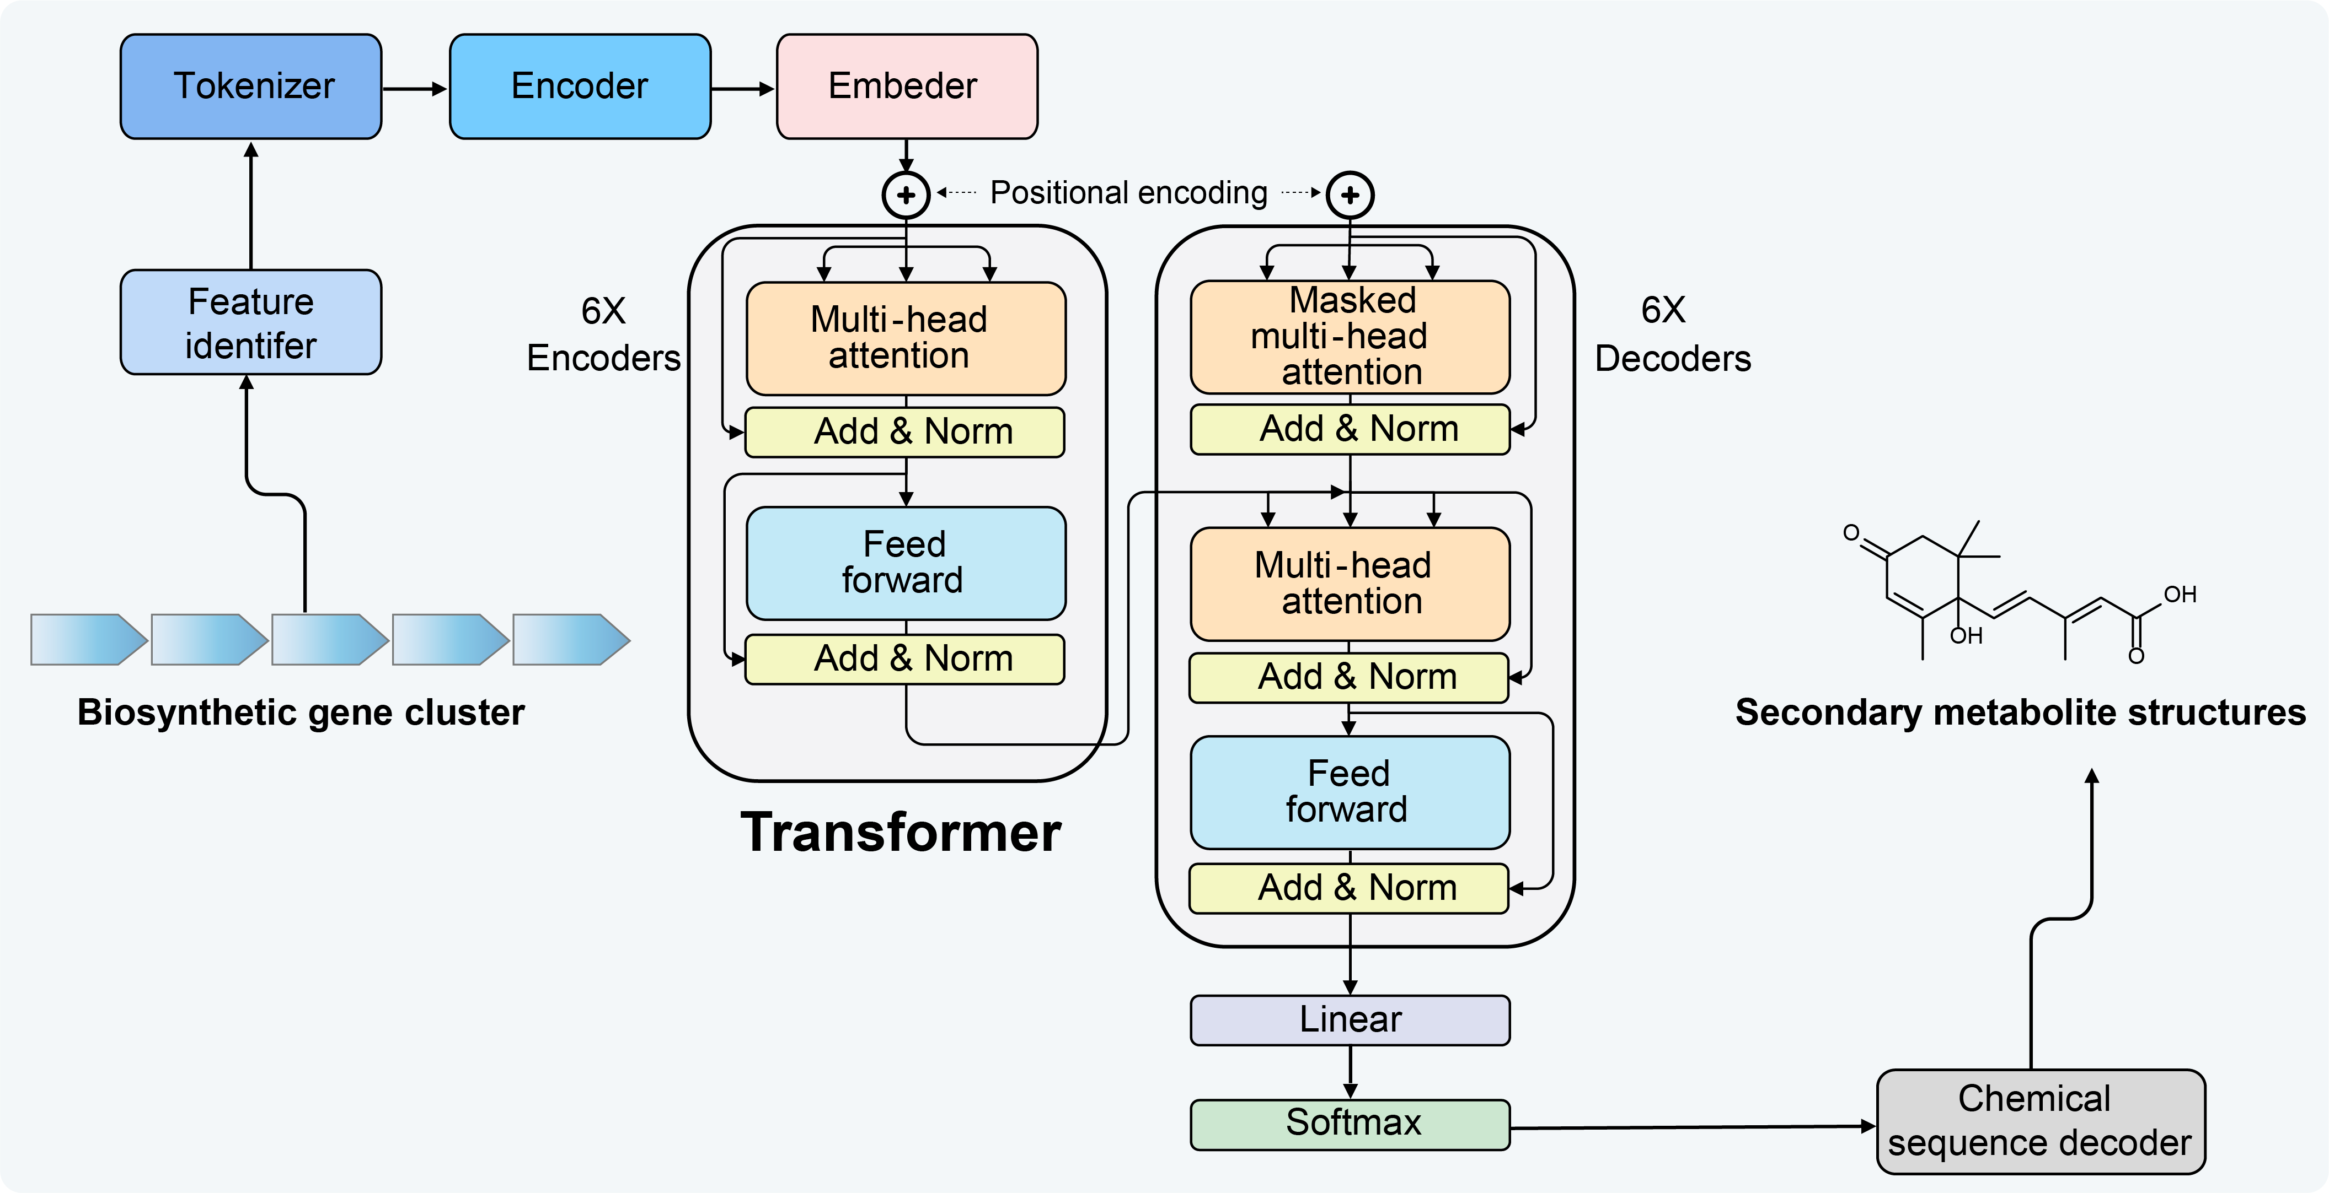
Figure S1. The neural network of DeepSeMS model. DeepSeMS model identified the biosynthetic features of input BGCs as source sequences, tokenized, encoded and embedded into the Transformer neural network, used a chemical sequence to convert the output target sequences to predicted SM structures. The neural network of Transformer consisted of six encoder and decoder layers, and eight attentional layers with embedding dimension of 512, leading to a total of approximately 113 million trainable parameters.

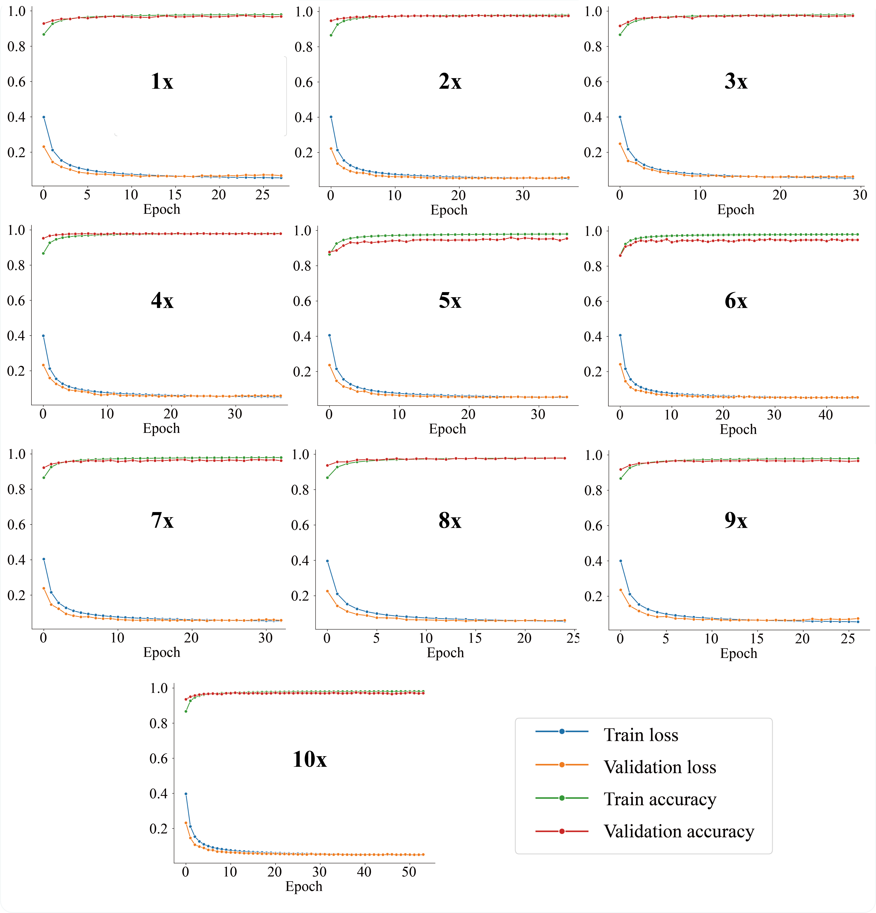
Figure S2. Ten-fold cross-validation training of DeepSeMS model on the refined dataset. The refined dataset (n=55,903) was implemented data augmentation strategy of structural features-aligned SMILES enumeration on the initial dataset. An early stop strategy was employed to avoid over-fitting problem, which would stop model training when the validation performances (validation loss) were not improved in 10 epochs.

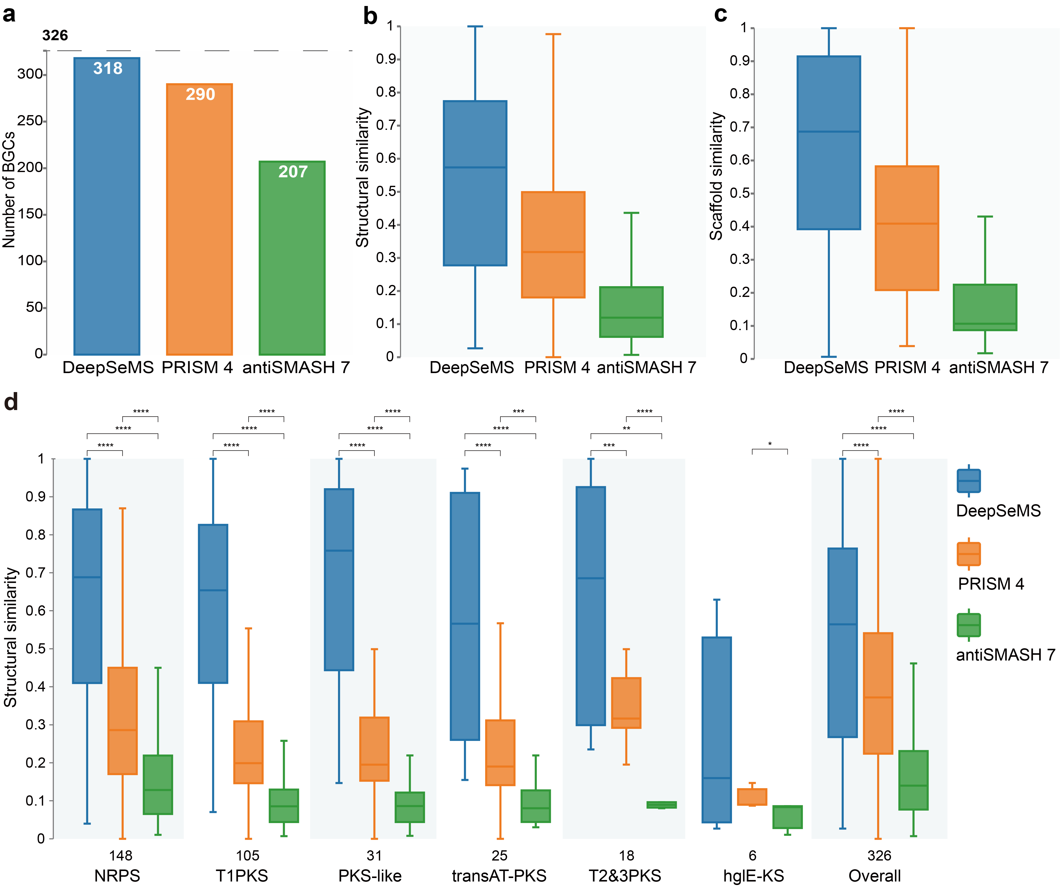
Figure S3. Comparison of DeepSeMS with existing methods on validation dataset of the known BGCs (n=326). a, Number of BGCs predicted at least one chemically valid structure by each method. b, Structural similarity between the valid structures predicted by each method and the ground truth. c, Scaffold similarity between the valid structures predicted by each method and the ground truth. d, Performance of each method on various of BGC types (NRPSs, non-ribosomal peptide synthetases. T1PKS, Type I Polyketide synthase. PKS-like, other types of PKS. transAT-PKS, Trans-AT PKS. T2&T3PKS, Type II & III PKS. hglE-KS, heterocyst glycolipid synthase-like PKS.), *p<0.5, **p<0.01, ***p<0.001, ****p<0.0001, independent samples t-test.

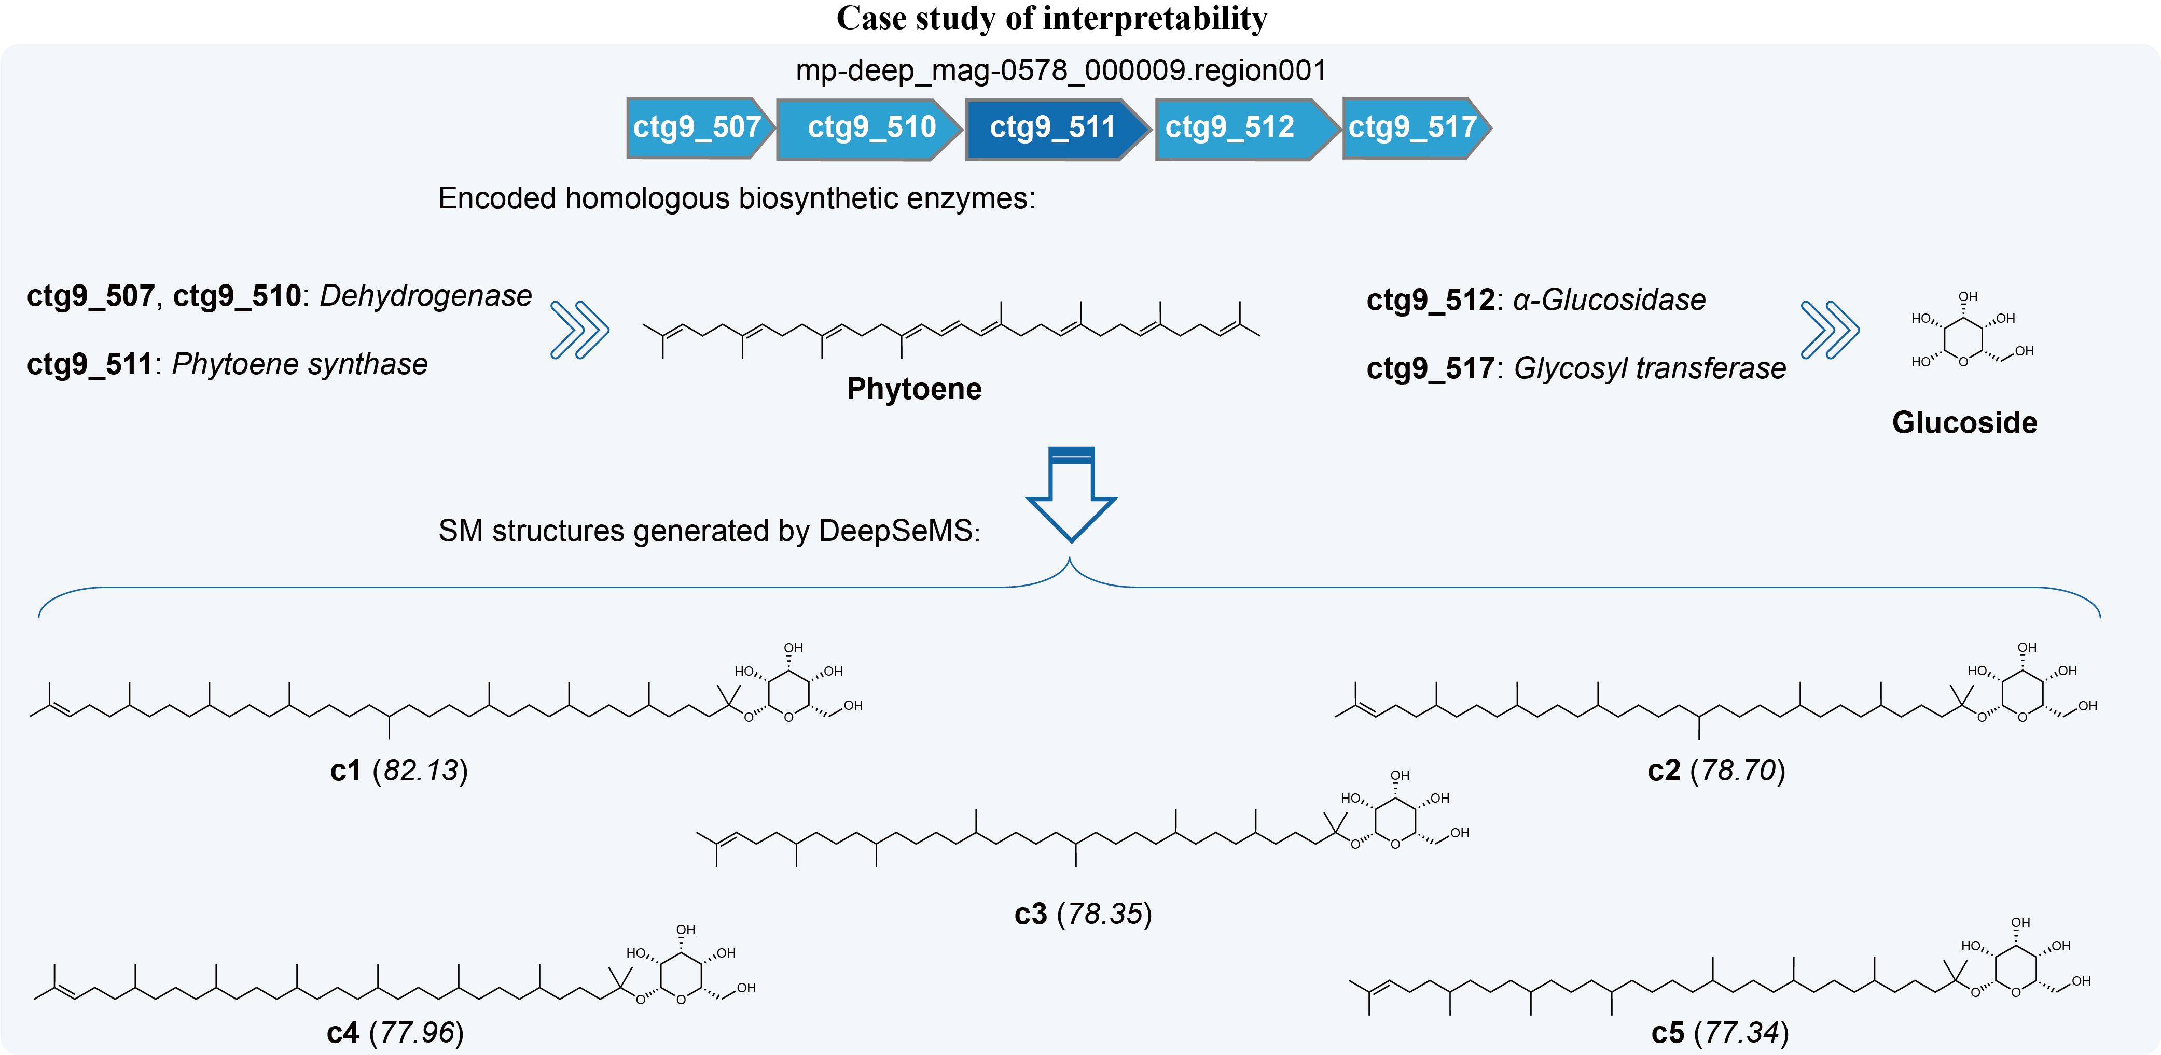
Figure S4. A case study of cryptic BGC, biosynthetic pathway and predicted SM structures for illustrating the interpretability of DeepSeMS. The structures were annotated with identifiers and prediction scores.

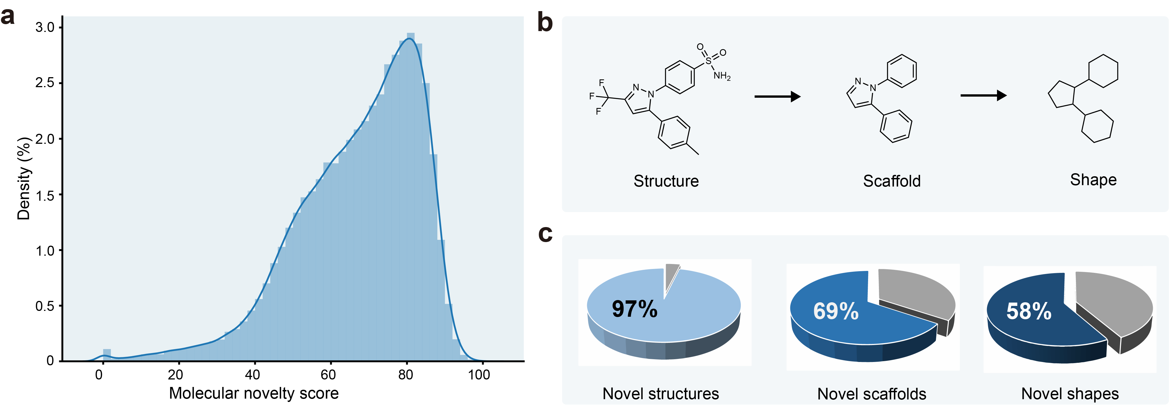
Figure S5. Illustration of molecular novelty of the global ocean SMs. a, Distribution of molecular novelty score of the global ocean SMs. Molecular novelty scores were calculated based on structural similarity between the global ocean SMs and the known SMs (see Methods). b, Illustration of molecular structural types analysis by structure, scaffold, and shape. Molecular scaffold is the core structure or framework of a molecule, molecular shape is the generic framework of a molecular scaffold that provides its overall shape and connectivity, both concepts provide structural and functional foundations for understanding in molecular novelty and diversity. c, Percentage of novel structures, scaffolds, and shapes found in the global ocean SMs.

Supplementary Tables

Table S1: Performance of the DeepSeMS model on training datasets of the data augmentation strategy (Internal validation dataset n=303). The best results are bolded.
Training dataset | Validity¹ | Structural similarity² | Scaffold similarity³ | Structure recovery⁴ | Scaffold recovery⁵
Base (n=2,726) | 37.62% | 0.33 | 0.35 | 3.51% | 13.21%
Randomized SMILES enumeration (n=173,570) | 78.88% | 0.42 | 0.41 | 0.00% | 12.33%
Structural features-aligned SMILES enumeration (n=54,234) | 76.24% | 0.66 | 0.73 | 24.24% | 49.78%
¹The percentage of generated chemically valid SMILES strings for the validation dataset. ²The mean structural similarity between the valid structures and the target structures. ³The mean scaffold similarity between the valid structures and the target structures. ⁴The percentage of chemically identical structures to the target structures. ⁵The percentage of chemically identical scaffolds to the target structures. Source data are provided in Source Data file.

Table S2. Performance of the best checkpoints of the DeepSeMS models in ten-fold cross-validation training on the refined dataset. The best results are bolded.
10-fold | Validity¹ | Structural similarity² | Scaffold similarity³ | Structure recovery⁴ | Scaffold recovery⁵
1x | 68.12% | 0.66 | 0.68 | 8.53% | 28.06%
2x | 82.52% | 0.76 | 0.80 | 27.69% | 55.24%
3x | 80.18% | 0.81 | 0.87 | 22.54% | 57.20%
4x | 80.09% | 0.72 | 0.75 | 20.01% | 46.27%
5x | 80.54% | 0.78 | 0.82 | 26.01% | 57.38%
6x | 85.71% | 0.82 | 0.85 | 34.11% | 62.28%
7x | 74.72% | 0.78 | 0.82 | 24.06% | 51.46%
8x | 79.32% | 0.78 | 0.83 | 19.78% | 54.27%
9x | 75.61% | 0.72 | 0.77 | 13.16% | 42.68%
10x | 80.98% | 0.85 | 0.88 | 34.07% | 62.53%
¹The percentage of generated chemically valid SMILES strings for the validation dataset. ²The mean structural similarity between the valid structures and the target structures. ³The mean scaffold similarity between the valid structures and the target structures. ⁴The percentage of chemically identical structures to the target structures. ⁵The percentage of chemically identical scaffolds to the target structures.

Table S3. Comparison of DeepSeMS with existing methods on validation dataset of cryptic BGCs (n=940). The best results are bolded.
Method | Success rate¹ | # Structures² | Uniqueness³ | Molecular weight⁴ | Synthetic accessibility⁵ | Heavy atoms⁶
antiSMASH 7 | 16.91% | 189 | 24.87% | 111.99 | 3.17 | 7.64
PRISM 4 | 46.45% | 455 | 62.42% | 426.09 | 3.87 | 30.31
DeepSeMS | 96.60% | 5104 | 78.66% | 619.91 | 4.89 | 44.03
¹The percentage of at least one chemically valid structure predicted for each BGC by each method. †The total number of valid structures predicted by each method. ²The percentage of unique structures predicted by each method. ³The mean molecular weight of the predicted structures. ⁴The mean synthetic accessibility of the predicted structures. ⁵The mean number of heavy atoms of the predicted structures.

Table S4. Performance of the DeepSeMS model on various BGC types on the validation dataset of cryptic BGCs.
BGC type¹ | # BGCs² | # BGCs with SM structures³ | Success rate⁴
terpene | 201 | 197 | 98.01%
NRPS-like | 67 | 66 | 98.51%
ectoine | 63 | 63 | 100.00%
hybrid | 59 | 59 | 100.00%
betalactone | 55 | 52 | 94.55%
RiPP-like | 51 | 45 | 88.24%
T3PKS | 50 | 50 | 100.00%
hserlactone | 45 | 44 | 97.78%
T1PKS | 43 | 43 | 100.00%
NRPS | 43 | 42 | 97.67%
arylpolyene | 34 | 34 | 100.00%
redox-cofactor | 31 | 31 | 100.00%
RRE-containing | 27 | 23 | 85.19%
NI-siderophore | 22 | 16 | 72.73%
hglE-KS | 21 | 21 | 100.00%
phosphonate | 21 | 20 | 95.24%
ranthipeptide | 20 | 20 | 100.00%
lassopeptide | 15 | 15 | 100.00%
NAGGN | 11 | 11 | 100.00%
acyl_amino_acids | 11 | 9 | 81.82%
NAPAA | 7 | 7 | 100.00%
other | 5 | 5 | 100.00%
thiopeptide | 5 | 5 | 100.00%
resorcinol | 4 | 4 | 100.00%
thioamitides | 3 | 3 | 100.00%
lanthipeptide-class-i | 3 | 1 | 33.33%
CDPS | 3 | 3 | 100.00%
butyrolactone | 3 | 3 | 100.00%
2dos | 2 | 2 | 100.00%
LAP | 2 | 2 | 100.00%
ladderane | 2 | 2 | 100.00%
indole | 2 | 2 | 100.00%
microviridin | 2 | 2 | 100.00%
cyanobactin | 2 | 2 | 100.00%
T2PKS | 1 | 1 | 100.00%
sactipeptide | 1 | 1 | 100.00%
PUFA | 1 | 1 | 100.00%
lanthipeptide-class-iv | 1 | 0 | 0.00%
furan | 1 | 1 | 100.00%
¹BGC type was annotated by antiSMASH 7.0. ²The number of BGCs belong to each type. ³The number of BGCs successfully predicted with valid SM structures by DeepSeMS. ⁴The percentage of BGCs successfully predicted with valid SM structures.

