Figure S1. Analysis of RNA sequencing. (A) Box-whisker Plot; (B) Gene expression in each sample. (C) Principal component analysis (PCA) display a clear distinction among the transcriptome of leaf rust at different samples.

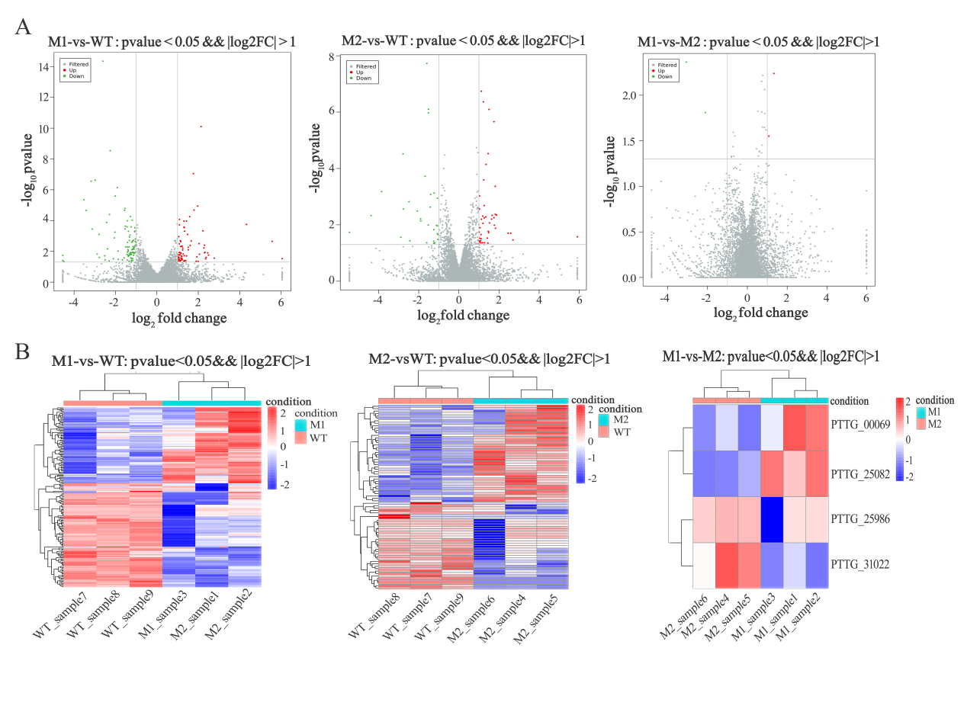
Figure S2. The differentially expressed genes (DEGs). (A) The volcano map, red dot indicates significantly up-regulated gene, green dot indicates significantly down regulated gene, gray dot indicates no significant difference gene; (B) Clustering of the sample-to-sample distances, red indicates significantly up-regulated genes and blue indicates significantly down regulated genes.

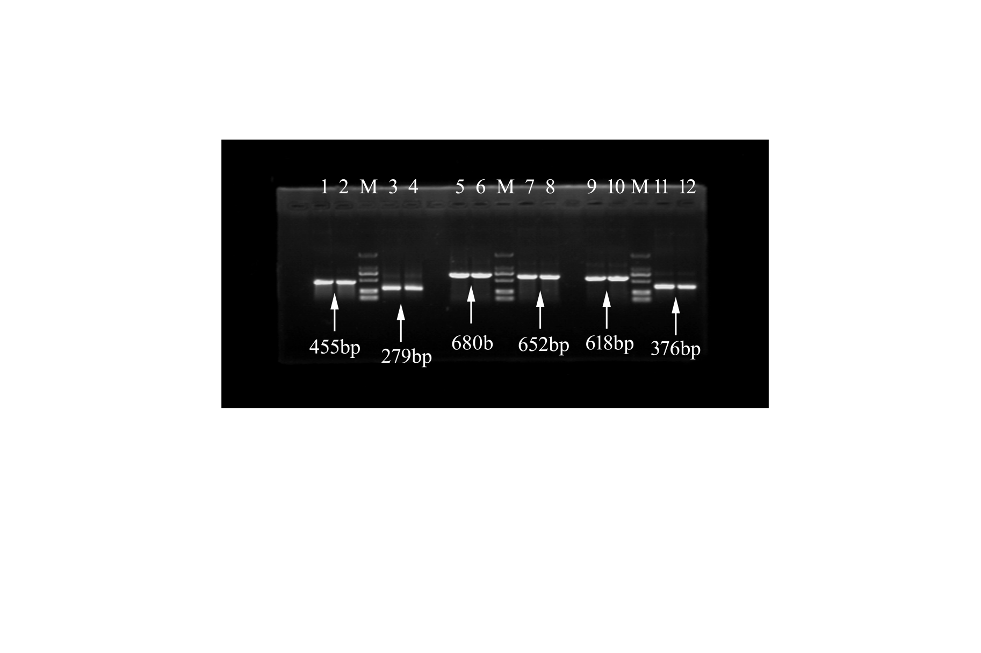
Figure S3. Gel electrophoresis showed the result of final vector construction by Gateway technology. 1-2: PTTG_25521-pEarlyGate103; 3-4: PTTG_27224-pEarlyGate103; 5-6: PTTG_26282-pEarlyGate103; 7-8: PTTG_02590-pEarlyGate103; 9-10: PTTG_27401-pEarlyGate103; 11-12: PTTG_27844-pEarlyGate103. M: Marker.

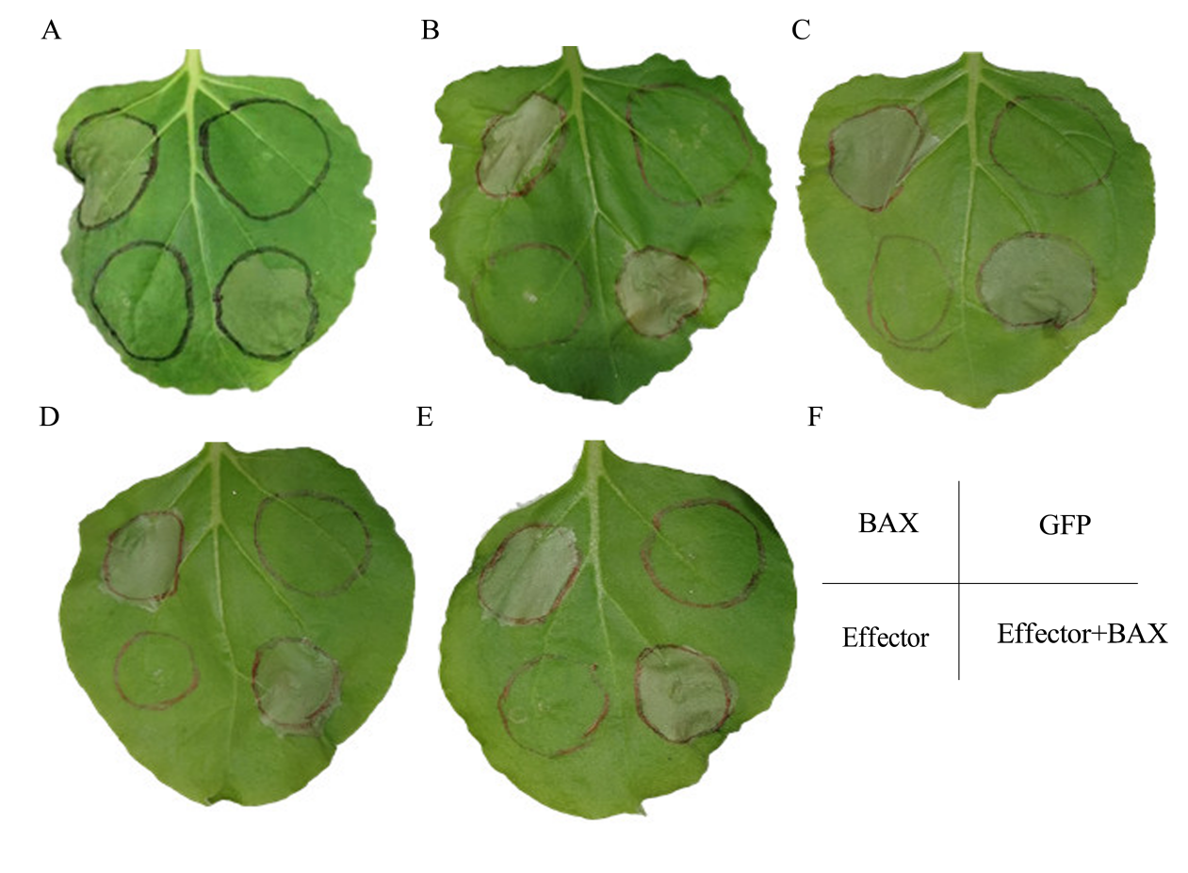
Figure S4. 5 couldn’t inhibit programmed cell death (PCD) induced by BAX in N.benthamiana. (A) PTTG_27844 , (B) PTTG_02590, (C) PTTG_25521 , (D) PTTG_27224 , (E) PTTG_26282 , (F) It’s the schematic of injection.

