DISCOVERY OF BIOACTIVE COMPOUNDS FROM MEDICINAL PLANTS: INSIGHTS INTO WRIGHTIA TINCTORIA AS A POTENTIAL ANTISTAPHYLOCOCCAL AGENT TARGETING CLUMPING FACTOR A

Vidya. S.$L^{a}$, Anantha Bhairavi.$V^{a}$, Sathishkumar.$R^{a*}$.

- Department of Biotechnology, Kongunadu Arts and Science College, Coimbatore- 641029, Tamil Nadu, India.

*Corresponding Author: Sathishkumar R
ORCID ID: 0000-0002-0546-8951
EMAIL: rsathishkumar_bt@kongunaducollege.ac.in

Vidya S L

ORCID ID: 0000-0002-7362-782X
EMAIL: vidyasl95@gmail.com

Anantha Bhairavi V
ORCID ID: 0000-0002-6771-4900
EMAIL: ananthabhairavi24@gmail.com
Supplementary File

Table 1: List of Phytochemicals/ secondary metabolites for respective medicinal plants chosen for the study
S.No. | Compound Name | PubChem ID | Compound Structure
1 | 17 beta-hydroxy-28-norolean-12-ene-3,16-dione | 102067273 | 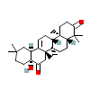
2 | 2,3,3-Trimethyl-2-(4methyl pentanoyl)-cyclopentanone | 573846 | 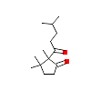
3 | 4-(2-Methoxy phenyl) piperidine | 544738 | 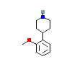
4 | 5-Benzyloxypyrimidine-2-carboxylic acid | 561874 | 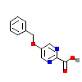
5 | Acacetin | 5280442
6 | Benzofuran 2,3, dihydro | 20209882 | 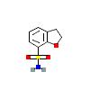
7 | Diethyl Phthalate | 6781 | 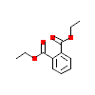
8 | Ephedrine | 9294 | 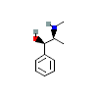
9 | Epicatechin | 72276 | 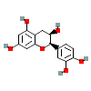
10 | Indirubin | 10177 | 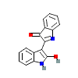
11 | Indigo | 10215 | 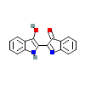
12 | Isatin | 7054 | 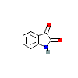
13 | Palmitic acid | 985 | 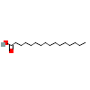
14 | Phytol | 5280435 | 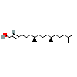
15 | Purpurin | 6683 | 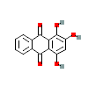
16 | Semiglabrin | 3353369 | 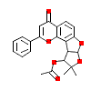
17 | Ursolic acid | 64945 | 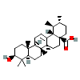
18 | Urs-12-en-3beta-ol | 225688 | 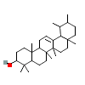
19 | Vasicinol | 442934 | 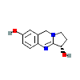

Table 2: Prediction of Pharmacological Activity using PASS online Way2Drug
S.No. | Phytocompound with PubChem ID | Pass prediction
1 | 17 beta-Hydroxy-28-norolean-12-ene-3,16-dione (102067273) | 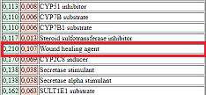
2 | 2,3,3-Trimethyl-2-(4methyl pentanoyl)- cyclopentanone (573846) | 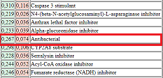
3 | 4-(2-methoxy phenyl) piperidine (544738) | 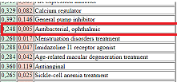
4 | 5- Benzyloxypyrimidine (561874) | 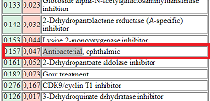
5 | Acacetin (5280442) | 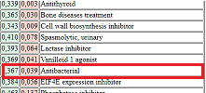
6 | Benzofuran 2,3 dihydro (20209882) | 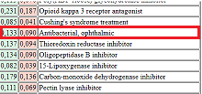
7 | Diethyl phthalate (6781) | 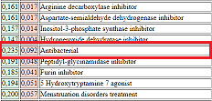
8 | Ephedrine (9294) | 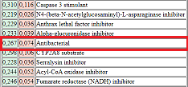
9 | Epicatechin (72276) | 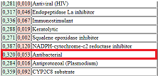
10 | Indirubin (10177) | 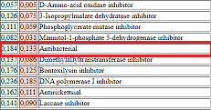
11 | Indigo (10215) | 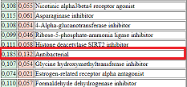
12 | Isatin (7054) | 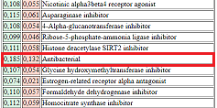
13 | Palmitic acid (985) | 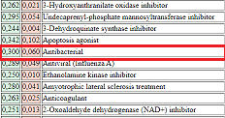
14 | Phytol (5280435) | 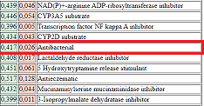
15 | Purpurin (6683) | 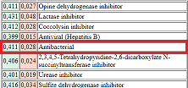
16 | Semiglabrin (156341) | 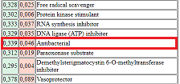
17 | Ursolic acid (64945) | 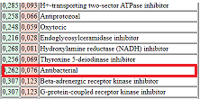
18 | Urs-12-en-3beta-ol (225688) | 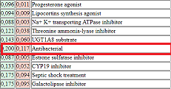
19 | Vasicinol (442934) | 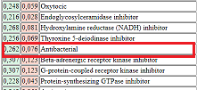

Note: The respective activity predicted for each compound are highlighted.

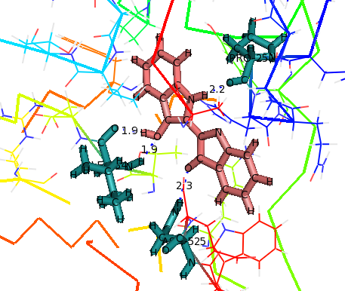  - Indigo (a) | 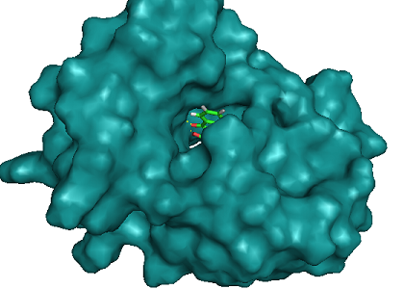  (b)
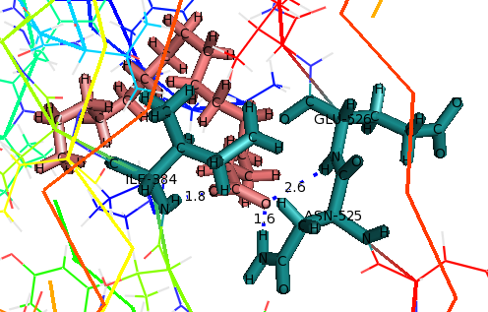  - Palmitic acid (a) | 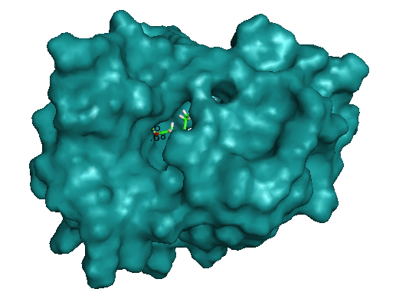  (b)
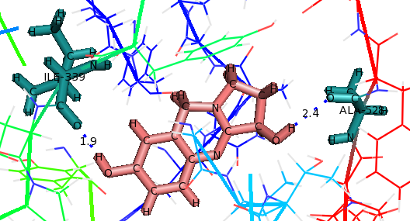  - Vasicinol (a) | 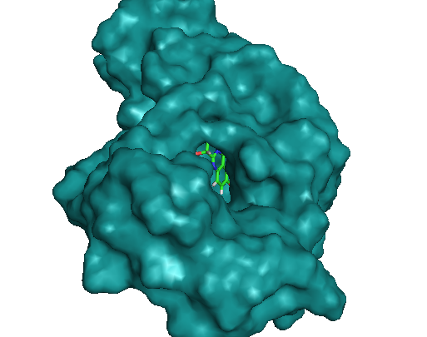  (b)
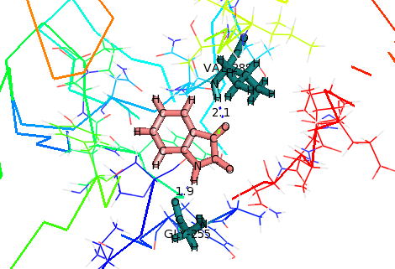  - Isatin (a) | 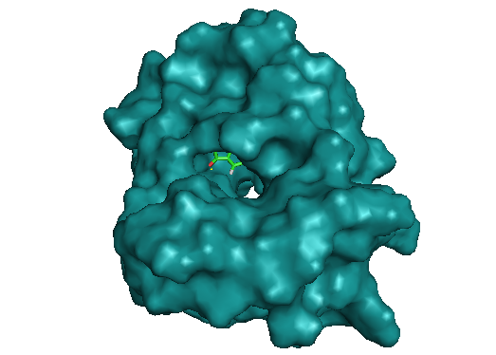  (b)
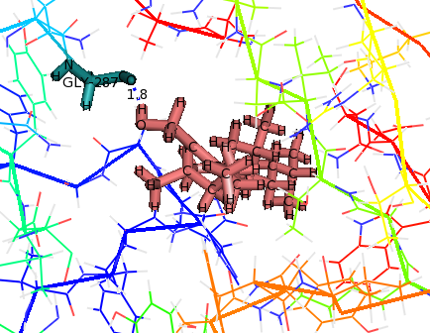  - Phytol (14) | 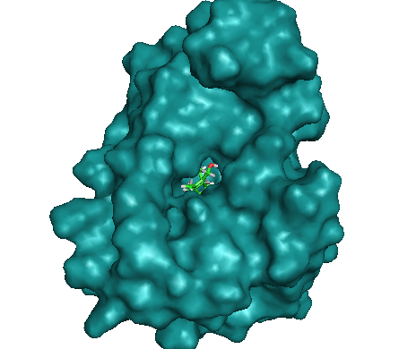  (b)
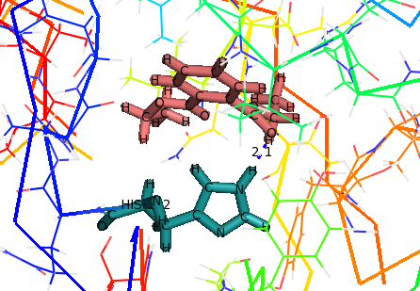  - Diethyl phthalate (a) | 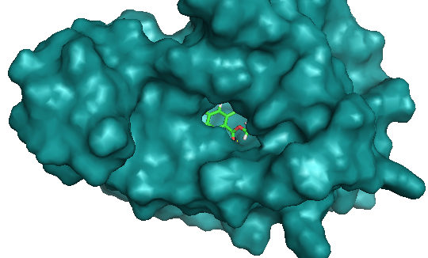  (b)
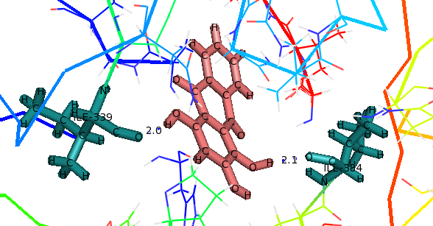  - Purpurin (a) | 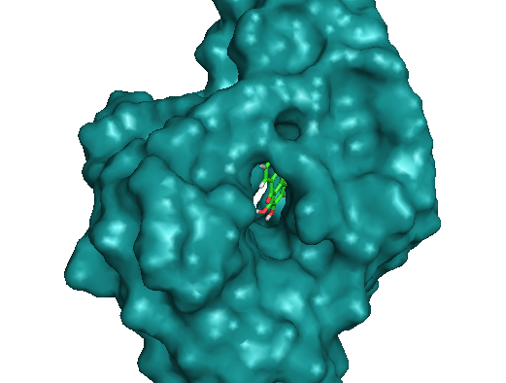  (b)
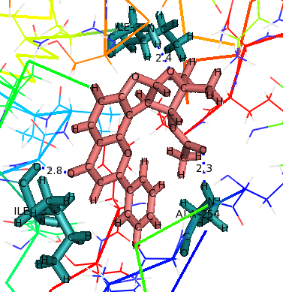  - Semiglabrin (a) | 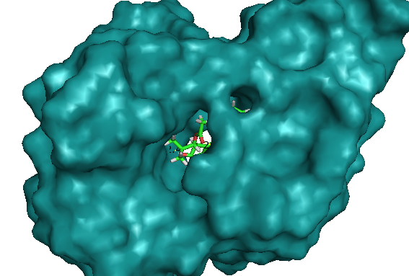  (b)
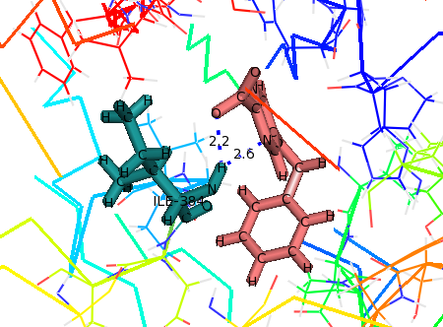  - 5- Benzyloxypyrimidine (a) | 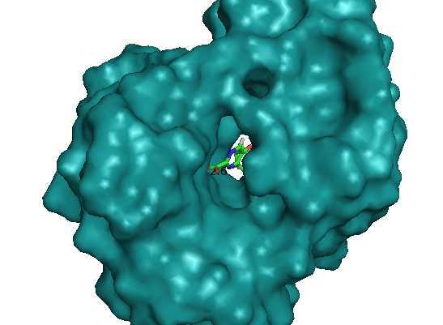  (b)
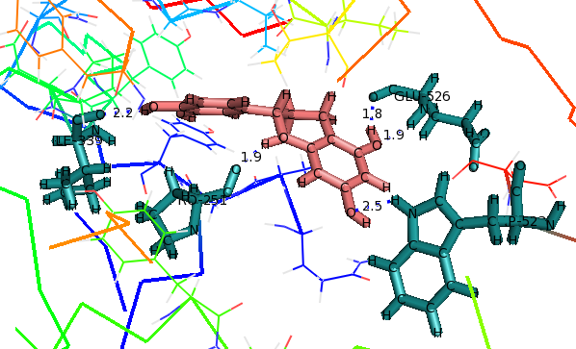  - Epicatechin (a) | 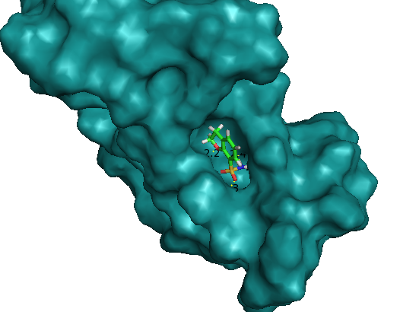  (b)
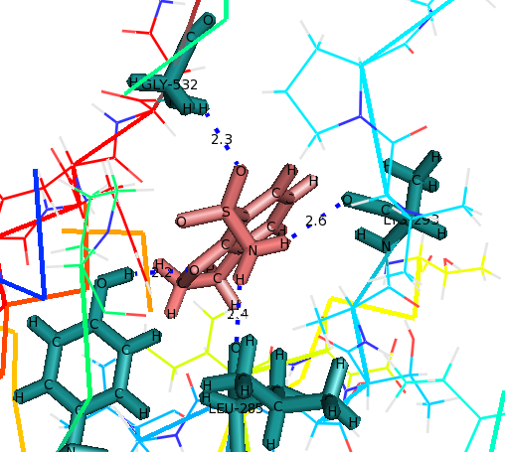  - Benzofuran 2,3 dihydro (a) | 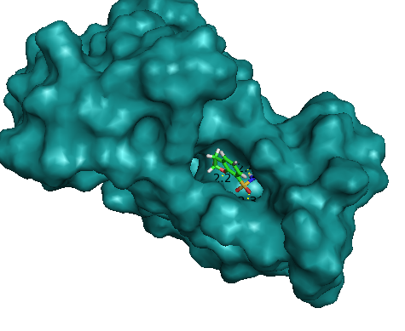  (b)
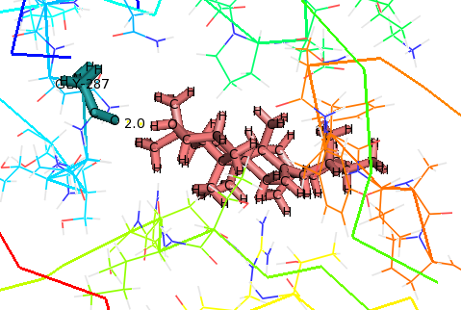  - Urs-12-en-3beta-ol (b) | 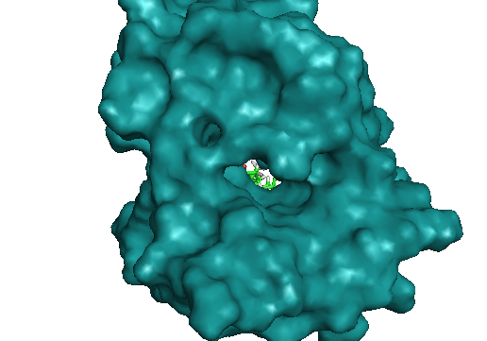  (b)
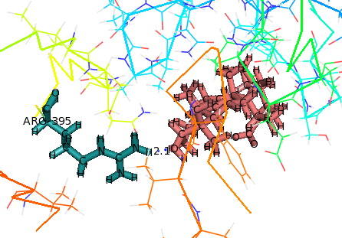  - Ursolic acid (a) | 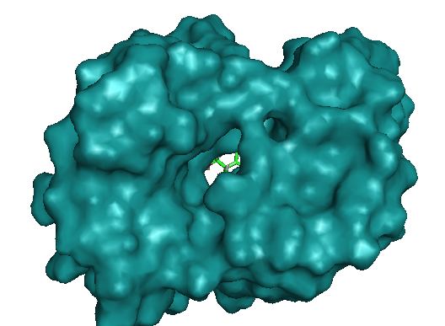  (b)
Fig. 21: Hydrogen bond interaction with target protein Clumping factor A (ClfA: PDB-ID- 2VR3)
Note: The compounds are listed based on their G.score value 1. Indigo; 9. Palmitic acid; 2. Vasicinol; 3. Isatin; 4. Phytol; 5. Diethyl phthalate, 6. Diethyl phthalate; 7. Purpurin; 8. Semiglabrin; 9. 5- Benzyloxypyrimidine; 10. Epicatechin; 11. Benzofuran 2,3 dihydro; 12. Urs-12-en-3beta-ol: 13. Ursolic acid; In the figure a. Represents the hydrogen bond interaction of each compound with the target protein and b. Protein-ligand complex in space filling representation

