TABLE 1: Results of docking of the ligands with TRPV1 ion channel transport protein 3j5p
Name of ligand | ∆G(kcal/mol) | Amino acids | Crystal complex formed
Daucosterol | -10.60 | Chain B: TYR401 SER404 HIS410 TYR495 VAL508 ASP509 SER510 TYR511 SER512 LEU515 PHE522 PHE543ALA546 MET547 THR550 ASN551 LEU553 ARG557 VAL567 ILE569 GLU570 LYS571 ILE573 LEU574 ARG575 LEU577 CYS578 MET581 GLU692 ILE696 LEU699 GLN700 ILE703. Chain A: PHE587 PHE591 ILE661 LEU662 LEU664 ALA665 TYR666 ILE668 LEU669 LEU673 | 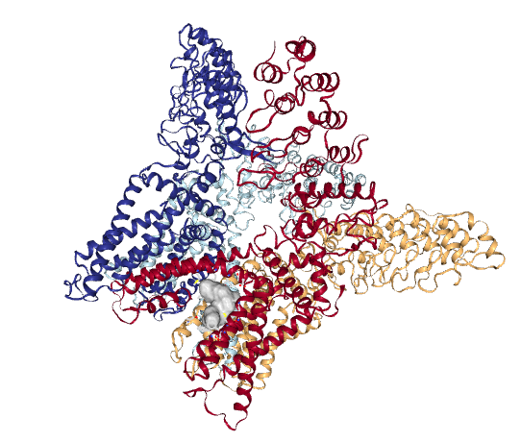
β-sitosterol myristate | -9.80 | Chain C: TYR401 SER404 PHE434 ASN437 VAL440 TYR441 LEU443 TYR444 ILE447 LEU480 SER481 SER483 GLY484 TYR487 PHE488 ARG491 GLN494 TYR495 PHE496 ARG499 PRO501 SER502 VAL508 ASP509 SER510 TYR511 SER512 GLU513 ILE514 LEU515 PHE516 PHE517 VAL518 PHE543 ALA546 MET547 THR550 ASN551 LEU553 TYR554 TYR555 THR556 ARG557 ALA566 ILE569 GLU570 LYS571 ILE573 LEU574 ILE696 GLN700 ILE703 THR704 ASP707 THR708. Chain D: PHE587 PHE591 | 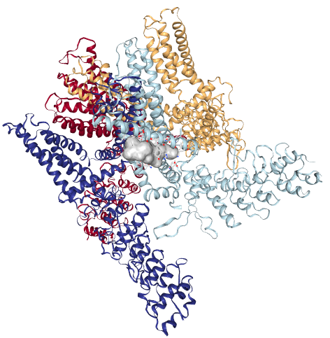
Diclofenac sodium | -8.60 | Chain B: SER404 ARG409 HIS410 PHE434 ASN437 PHE438 VAL440 TYR441 LEU443TYR444 ILE447 LEU480 SER481 SER483 GLY484 GLY485 VAL486 TYR487 PHE488 ARG491 TYR495 ASP509 SER510 TYR511 SER512 GLU513 ILE514 PHE516 TYR554 TYR555 ARG557 VAL567 GLU570 LYS571 LEU574 ILE696 LEU699 GLN700 ILE703 THR704 ASP707 | 